
Introduction to My Placement at Evolve
In this part of my professional journal, I will focus on my placement with Evolve, Swansea Council’s youth service. Evolve supports young people aged 11 to 25 through a variety of services, ranging from drop-in youth clubs to targeted help with issues like mental health, relationships, and education. During my time there, I was involved in planning and running sessions, and I observed how youth workers build trusting relationships and support young people in many ways.
Placement Location
Evolve operates several centres across Swansea, including Townhill, Gorseinon, Stadwen, and Brynhyfryd. These centres are open a few evenings each week, allowing young people to access support close to where they live. Young people can either refer themselves or be referred by professionals such as teachers or social workers. My placement took place at the Brynhyfryd youth club.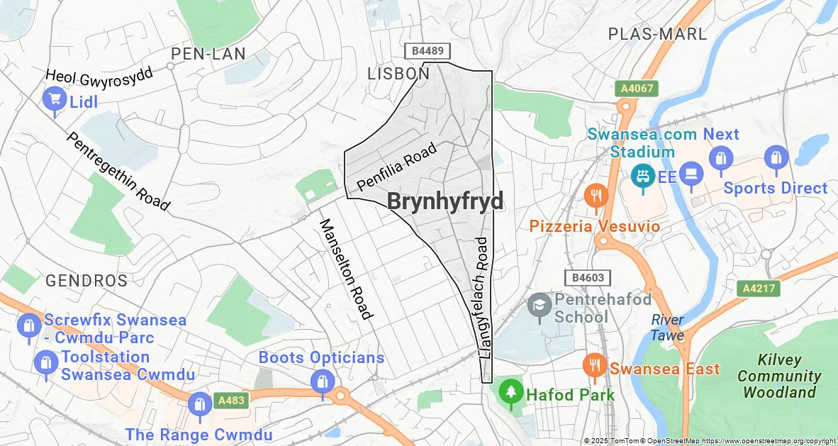
Youth Centre Environment and Supportive Practice
Evolve’s youth centres offer safe, welcoming, and inclusive spaces where young people can relax, socialise, and participate in a range of activities. The centres include areas for hanging out, playing games, and group work, with facilities such as sports equipment, PlayStation consoles, movie nights, and summer events that help create a fun and engaging atmosphere. Informative posters and leaflets on mental health, sexual health, and local services are also displayed, making support easily accessible and the environment both friendly and educational.
The staff at Evolve are key to maintaining this positive environment. They work hard to ensure every young person feels safe, valued, and included. Recognising the diverse challenges young people face such as stress, family difficulties, bullying, mental health issues, and school problems they offer personalised support by listening, giving advice, and simply being there to talk to. Beyond emotional support, the team organises activities like local sports sessions, cooking classes, arts and crafts workshops, and group projects that encourage teamwork and skill-building. Staff handle difficult situations professionally, often guided by youth work frameworks such as the five pillars and Gibbs’ reflective cycle. These approaches help them reflect on their practice and respond thoughtfully to young people’s needs. Overall, Evolve provides a supportive, empowering space where young people can be themselves and work through challenges confidently.

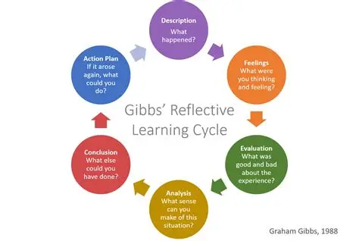
Reflections on Learning and Areas for Improvement
My impression of Evolve is very positive. The staff are supportive, inclusive, and interact well with young people, creating a welcoming atmosphere. Before this placement, I had limited knowledge of youth work, but the experience taught me how to support young people effectively and professionally. The team’s strong communication and teamwork stood out, and they made sure every young person felt included. One area for improvement could be promoting sessions more widely using schools or social media could help reach a more diverse group of young people who might benefit from the service. My time at Evolve gave me valuable practical skills and deepened my understanding of youth work.
Positive Engagement Through Shared Activities
During my placement, I had several experiences that helped me grow personally and professionally. One session that stands out was when we made pancakes together. I prepared the batter and cooked the pancakes, while the young people decorated them creatively. The room was filled with laughter and fun, which helped me build stronger connections with the group. This showed me how important it is to create relaxed, enjoyable activities to connect with young people.

Building Relationships
Over time in my placement, I made good progress with some of the quieter young people who were initially hesitant to engage. I took the initiative to start conversations, ask questions, and show genuine interest in their lives, which helped build trust and encouraged them to open up. This experience reflects Carl Rogers’ person-centered approach, which highlights the importance of empathy, respect, and warmth in making young people feel valued and understood.
I also grew more confident in planning and leading activities. For example, during a chocolate-making session, I learned the importance of balancing structure and fun while being flexible enough to keep everyone involved. This process relates to Kolb’s Experiential Learning Cycle, where learning occurs through hands-on experience, reflection, and applying lessons to improve future sessions.
During my placement, I did face challenges, especially when engaging quieter young people who were initially hesitant to open. It took patience and consistent effort to build trust, reinforcing the importance of empathy and genuine interest, as described in Carl Rogers’ theory. I also had to find the right balance between structure and flexibility in activities to keep everyone involved, which connected with Kolb’s Experiential Learning Cycle as I reflected on each session and adapted my approach.
Conclusion
Overall, my placement at Evolve was a valuable learning experience that deepened my understanding of youth work in practice. I saw how the five pillars empowerment, inclusion, participation, relationships, and education are actively used to create a supportive environment. The staff’s work showed me the importance of safeguarding and confidentiality to help young people feel safe and respected. Challenges like engaging quieter young people helped me develop key skills such as active listening, patience, and empathy, reflecting Carl Rogers’ person-centered approach. Planning and leading sessions also allowed me to apply Kolb’s Experiential Learning Cycle by reflecting and improving my practice. This placement gave me practical skills, insight into youth work realities, and strengthened my passion for a career in this field. I now appreciate how youth workers can make a real difference and the importance of continually developing my skills to support young people effectively.

