R. Kane Morris
Blog Copy
P146833

1.
The Basics
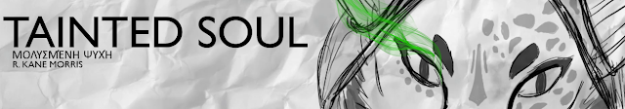
The heart of the project idea is to create a video game based around Pandora's Box. During the project I will be creating the game’s opening cut-scene. This will introduce the main characters show how he gets caught up in the story of the game.
We will be following a thief by the name of "Sarff" (working name) who is tasked with stealing Pandora's Box, but the heist goes horribly wrong as he stumbles upon a ritual taking place. This leaves the thief tainted with the mysteries of the box.

2.
Pandora’s Box
The story is centred around Pandora's box from Greek mythology.
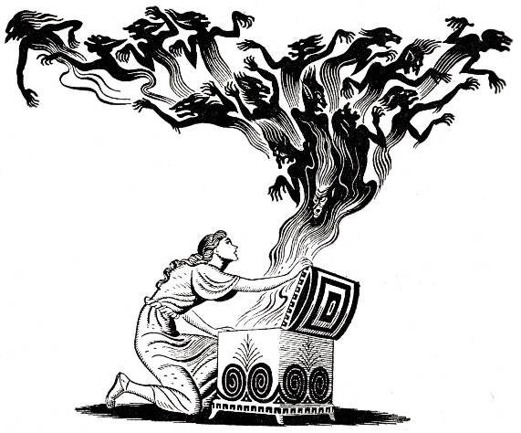
Image Source: https://medium.com/@eruanna317/pandoras-box-2017-278cb0373cb8 Accessed: 01/01/2019)
In its essence, Pandora's box was a gift from the Gods, given to Pandora who was told never to open it as it contained unspeakable evil. Curiosity eventually got the best of Pandora and she opened the box. All that plagues man today from decease to desperation escaped the box. But the last thing to leave the box was "Hope", man’s one tool to deal with that escaped.

[VIDEO] https://www.youtube.com/watch?v=Bcrms7GWVs4
Video Source: https://www.youtube.com/watch?v=Bcrms7GWVs4 Accessed: 02/01/2019)
The Video above covers the story in more detail. With my story, this is used as a guide and what escapes the box is going to be focused as creatures from Greek mythology.

3.
The Script
This Script is for the game trailer:
-Scene: (Night fog in air) rooftops. Source of light: moon and artificial.
character overlooking museum (target) Voice over as character runs over rooftops towards target.
“I have a job for you”
-Cut to Thief’s hideout.
Thief and mysterious man talking over a table. Man “an artifact”, As man throws down paper with picture of Pandoras box onto table (close up of paper) he says, “right for the takin”.
-Cut back to roof tops as thief approaches window above the artifact. (Large circle roof window).
Thief “What the-?” Carma pans down revealing chanters around the artifact, green smoke filling the room floor (but everything still visible). As box opens a claw starts to come out as light shoot up out of the box.
camera follow light up as its shatters window around the thief. As thief falls we have a short section of slow motion before speeding up and cutting to black before thief hits the box.
-Show publishers and team logo-
Thief’s voice over as you see thief waking up under care of another (female) character “The Pandora heist, something went wrong…”
-Cut to flashes of event as he remembers-
“What happened that night?”
-Cut to streets of the museum (in ruins)-
Female voice over “When we pulled you from the rubble, we presumed you dead….. But something began to wake you”.
-trailer music drops here as fades to black-
-fades back in character entering destroyed street-
First mysterious man’s voice over “There’s a power in you…..accent, from Pandora herself”.
-cuts to close up of character clenching his face as green smoke floods from his eye-
“You need to tame it” or “learn to control it”
“Take back our streets”
-Game Title

4.
The Story
It will be my goal to create the opening cut-scene for the game. This will introduce the world and the character as well as the aim of the main character within the story.
The script created for the trailer contains this scene, only as the team is just myself, I will be focusing on this one scene over producing the full trailers as this would require many scenes and charterers to produce the full trailer for the game.
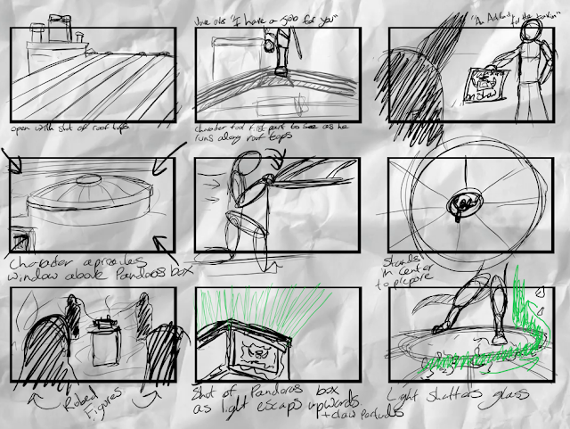
(my storyboard)
The opening cut scene follows Sarff as he runs across rooftops with a vice over, "I have a job for you". These voice overs are from the past, so he is not reacting in the moment to them, however it is to be said at points so the audience viewing/playing know his aim and also what the he is aiming to steal. As he is approaching the scene where the main plot point takes place. The voice over adds, "An artefact, right for the takin". This is said over a cut of a poster advertising a new addition to a museum. This poster shows Pandora's Box.
Sarff is approaching the window overlooking the Box as this stage in the opening scene. The thief is shocked to see a ritual taking place below them. As he watches the chanters opening the box. The room fills with green smoke as it spills from the box. He focuses on the box (his target) as a claw appears from inside the box and green lights shoot up from the box, shattering the window as it does. Sarff then falls towards the box unable to stop the fall as he is about the hit the box the screen cuts to black. The next scene will be the aftermath of the opening. (this scene is not an aim for this current project.)

[VIDEO] located on blog and Disc (Edit01Test.mp4)
This video contains footage from 3 games listed below:
Assassin's Creed Black Flag (2003) Ubisoft
Dishonored (2012) Arkane Studios
Thief (2014) edios montreal
This video above was created an example for the scene of the final trailer, using clips or game play from other games created. The timing is faster within the video though, as I think the final will need more room for the voice overs leading up to the major plot point

5.
The Character
The character development started as a human with a companion (pet), with the development of the story. This "pet" would have ash like powers, with the ability to turn to ashy smoke to move faster or enter areas it could not in normal form. This would add a second playable character to the game, with different game play mechanics. This second character would be based on a fennec fox, large ears, cat like movement.
However, when the character was made to be a thief, it made less sense for them to have a companion as it would double the risk of being seen or heard. The second character (named Ash) was then dropped from the story, His powers would later return to the game, but with the main character instead.
After removing Sarff's companion (Ash) from the project, I felt the game was just going to be another one with a human character. If someone was to try describing my game's character for example,
"That game with the man, with brown hair? a thief?"
" Uncharted?"
Being human the character would simple blend with the other games. The character then was re-imagined. What if I took the animal feature from the non-existent companion. The character is a thief so needs to be agile, I wanted combat to be a huge point in the game, meaning the character would need to also be fast.
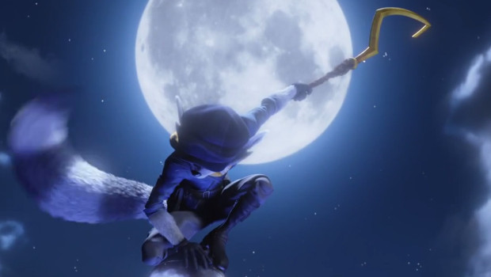

Image Source: https://elmodenafrontline.com/1488/mediaarts/sly-cooper-movie-to-hit-theatres-in-2016/ Accessed 02/01/2019

The character was now planned to be anthropomorphic in design. The image above shows a character known as Sly, from the Sly Cooper Play Station series. This image was chosen in among the other anthropomorphic character based games due to him also being a thief.
Making the character of an anthropomorphic design would allow me more creative freedom and also allow the games character to be easily identifiable.

6.
The Style
My game was aimed to be "dark", targeted at an older audience, with the age rating of 18+. The game will be close to the combat known in the Dark Souls and Bloodborne series.

[VIDEO] Video source: https://youtu.be/_PofO32sS8s Accessed 02/01/2019
The video above is a trailer to a game following the combat mechanics I'd like to feature within my game project. This kind of game focuses on fighting bosses (large, powerful foes). Within my game, these "Bosses" will be from Greek mythology such as Griffins, Cyclops, etc.
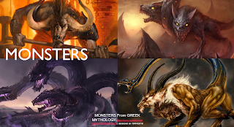(Image source in image)
The Environment will also be dark, mainly destroyed towns. Buildings reduces to rubble as if a war has taken place there.
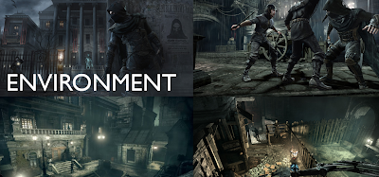
Game in image above 2014's Thief
The game will take place in the streets containing the museum at the heart. The map will be deserted and roaming with the beasts of Pandora. The player must fight to return what escaped the box.
The game will contain blood, both from the player and from the creatures the player must fight. This will separate it from other anthropomorphic games due to it taking a more real and dark approach to the design and game play.

7.
The Character 2
With the theme of the game being dark and more realistic (therefore violent). The characters design has to also follow a realistic approach.
I wanted the character to be light on their feet (as they are a thief), fast (for the combat) and also strong (for the fighting). With these needs the selection of animals was limited. A wild big cat, such as a Lion would work. However, two of the trait's contradicted each other.
Strong would make the character slow (realistically). in order to be nimble and light on the feet, I dropped the strong aspect of the character. Instead Sarff would rely on speed and movement to fight, dodging the attackers and choosing the best time to attack.
This would make the game more than just a button masher in fights as the player must be focused and dodge the deadly attacks as the character is weaker, lighter but fast and nimble.
Big cats were looked at and the Cheetah was selected. This animal had the speed wanted, the power in the legs and back to dodge effectively but the weakness to be vulnerable enough to be hurt or killed. This would make the stakes high when choice to fight a target and introduce some stealth to the game, opening up the opportune to try hit first before the creature has seen the player’s presence.
[VIDEO] Video Source: https://youtu.be/BrGV_A0A2BE?list=LLrut5js3mAFpmYI92ViMO_g Accessed: 02/01/2018
The Cheetah, fast, agile, light on their feet but not built to fight. This would rely on the character to carry weapons. there weapons would have to be light such as a bow or some short swords or daggers.
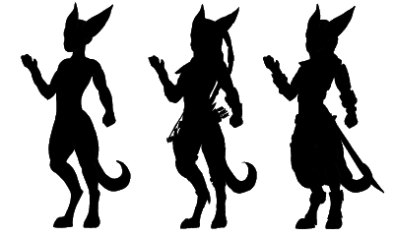
character silhouette crated in Clip Studio Paint
The character will be given leather armor with key movement points a light material to keep movement at its peak. The cloths will be tight fit to the body (not baggy) to allow for easier dodging without getting caught and also keep the drag to a minimum, therefore keeping the character speed high. Legs are powerful both for speed and jumping out of the way. Having the legs powerful would also enable the character to use them in combat if needed, to push themselves or the creature away. Sarff’s movement will be his "Ace" when in combat. (Ears have been increased in size as a design choice and to improve the characters silhouette.)
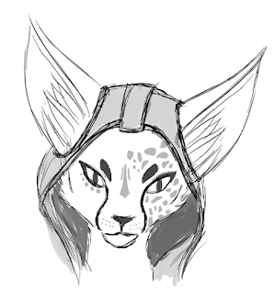
As mentioned in an earlier post, the character is left "tainted by Pandora's Box", this causes one side of his face to become clear with a glowing green eye. This eye at the start is painful to Sarff as they can not control it. It leaks green smoke uncontrollably and puts the character in pain during the story at the start of the game. Sarff later learns to tame these new abilities allowing him to turn to a green ashy smoke for short times and also coat weapons in this smoke allowing more damaging attacks. Sarff's infected eye will be the reference to "Hope" from the story of Pandora's Box.
Currently the character is planned to be a mute. This is done along with the characters body shape to keep the character unidentifiable in sex. In games today, there is a lot of debate in the sex/race/age of characters etc. Gender identification isn't a necessity for concrete character development. I wish for the character to be defined by their actions and nothing more. The actions, motives and plot is what will create the bond between character and player.

8.
Technical Difficulties
During production on the character, my computer started to refuse to turn on, even in safe mode. I reset the computer to a version from 8 days ago, this lost work but restored the computer to a working state. However, when shutting down again, a Windows 10 update was installed and the same problem happened again, problem now was the 8 days ago restore point had been overwritten with the update.
After cancelling work that day so I could use the time to talk with Microsoft support, the end result was the update was not compatible with my computers motherboard. This required me to use commands to force the computer to run the OS from a USB but this would only work by formatting the HDD to allow this. Formatting the computer came at the cost of losing everything on the hard drive. After doing this the computer needed a Microsoft app (for some reason not a default feature) that could block an update taking place, to prevent the computer from installing the non-compatible update.
The computer is still in the process of having all the needed apps reinstalled. (Maya, Photoshop, ZBrush etc)

