Name: Filipka Filipova
Student Number: 1921533
Module Name: Knowledge and Information Management Skills for the Workplace
Module Code: BMSW 5106
Lecturer: Mohamed Kalam

(Task 1: Individual Report)

Executive Summary
Knowledge management (KM) is an interdisciplinary method that helps in creating, sharing, maintaining and using information and knowledge of an organisation. Information regarding knowledge management will be evaluated by considering the case scenario of Amazon Inc. The purpose of this task is that it will help in understanding knowledge management aspects from knowledge acquisition retention-transfer perspectives. For strengthening their knowledge management practices, importance of applying theories such as Sir Francis Bacon Theory, Johari window model theory, Merhabian’s 7-38-55 communication model theory, Bergon (2003) theory, Nonaka and Takeuchi theory have been demarcated. Also, other theories such as Wiggs model, The Von Krogh & Ross model and the Mayer and Zack theory have been described in the report. Recommendations for applying one effective framework of KM have been also evaluated.

Table of Contents
Introduction 4
Section 1: Knowledge and Information Management 4
Background of Organisation 4
Knowledge Management 5
Importance of Knowledge Management in the context of Amazon 7
Ways in which knowledge management is beneficial in satisfying customers and achieving competitive advantage 8
Section 2: Evaluation of Knowledge and Information Management Models/Theories 9
Ways in which knowledge is embedded in products and service concept in tacit knowledge of individuals 9
Ways in which systematic approach help organisation in sharing and exchanging its knowledge base across organisations 10
Section 3: Investigating KM techniques used by Amazon 10
Importance of knowledge in maintaining information systems by Amazon 10
Main outcomes of such procedures 11
Areas of improvement for overcoming challenges 12
Conclusion and Recommendations 19
References 23

Introduction
Knowledge management (KM) is termed as the process that helps in searching, acquiring, sharing and documenting knowledge between people or professionals within an organisation. This interdisciplinary process benefits an organisation in terms of managing information and knowledge in an effective way. It is considered an essential aspect for every organisation as it enhances performance, boosts innovation, help in sharing insights and improves different other pivotal aspects. Through this report, important aspects regarding knowledge management will be evaluated by considering the case scenario of Amazon. The main purpose of writing this report is that it will help in understanding knowledge management aspects from knowledge acquisition retention-transfer perspectives in this organisation. Some theories and models such as Sir Francis Bacon Theory, Johari window model theory, Merhabian’s 7-38-55 communication model theory, Bergon (2003) theory, and Nonaka and Takeuchi theory will be discussed with respect to the case scenario of Amazon. Based on such evaluation, key factors that will help in overcoming challenges by Amazon will be highlighted.

Section 1: Knowledge and Information Management

Background of Organisation
Amazon Inc is a multinational American technology company. The organization was established with the aim of offering services such as cloud computing, e-commerce, digital streaming and artificial intelligence. The establishment of the organisation in 1994 has led in enhancing market base of this multinational corporation in the global market platform. Operational segment through North America-focused websites has led in offering retail services to customers. Besides offering this service, the international segment offers offer retail sales on wide range of goods along with subscriptions of websites (Taplin, 2017). The web service segment of Amazon comprises of sales of compute, storage devices, databases and AWS service offerings. The expansion of the services under different segments has led in recruiting approximately 1.3 million employees by Amazon. As the most influential; brands in the globe, Amazon Inc has been able to compete with companies including Apple, Google, Microsoft and Meta (Facebook). Owing to the negative implications of pandemic, Amazon continued to operate its business by recruiting large number of professionals for its different operational segments. The application of principles and practices of knowledge management have led in adding value for the services offered to customers. Advanced knowledge management techniques that are being applied by the organisations has not only enhanced overall quality of services but has also attracted potential users for different services (Tou et al.2019). Being one of the major players in consumer technology and digital media, the company is re-inventing new methods for maintaining its service quality. As a result, net sales of the company continued to rise despite of the repercussions of pandemic. (Refer to figure 1)

Figure 1: Net sales and income of Amazon Inc (from 1997 to 2020)
(Source: Statista Infographics, 2021)

Knowledge Management
Knowledge management (KM) is an interdisciplinary method that helps in creating, sharing, maintaining and using information and knowledge of a business. The term was first coined for one of the internal studies conducted by McKinSey in the year 1987 on information utilization and handling. This multi-faceted strategy is implemented by most companies as it helps in attaining targeted goals and objectives in an appropriate way (Serenko and Dumay, 2015). In an appropriate manner, utilization of organizational assets enhances competitive base of an organisation and maximizes chances of boosting innovation. As part of the learning process within organisation, knowledge management is considered a vital aspect and the core goal of such interdisciplinary process is to enhance knowledge base of professionals by connecting them with another in terms of encouraging them to participate in team work tasks. Deployment of organizational knowledge is essential for developing overall work proficiency in any particular sector. This discipline recognizes three important forms of knowledge namely, implicit, explicit and tacit knowledge (Girard and Girard, 2015). Implicit knowledge, under this multi-faceted strategy, is considered as hybrid kind that can be codified depending on the requirements of an organisation.
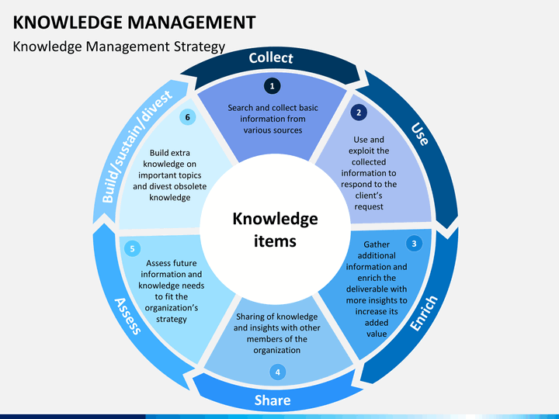
Figure 2: Knowledge Management Strategy
(Source: Omnisci, 2021)
In contrast to this, tacit knowledge is difficult to articulate and thus, many professionals fail to understand as well as share. Innovative thinking and ability of understanding industry-specific body language is essential. Explicit knowledge, which is even termed as codified knowledge or formal knowledge is different from the above discussed knowledge forms. This form of knowledge is readily understood, shared and articulated by any individual. Knowledge manage is an effective aspect that help in utilizing institutional knowledge in an effective way. As part of the knowledge management process, firstly, decision makers analyze the ways of deploying information and knowledge. Secondly, assessment of organizational culture in terms of incorporating human and cultural aspects within the system is analyzed. Lastly, content management along with information taxonomy is done. It is an important factor to be noted that cultural and human aspects of knowledge management and creation is essential. (Refer to figure 2)

Importance of Knowledge Management in the context of Amazon
Amazon Inc, as a multinational corporation offering different kinds of services to users across the globe, needs to focus on knowledge management aspects for enhancing productivity. Besides spending capital for providing safety gear to staffs and for its internal testing initiative named, Project Ultraviolet, the organisation has been recruiting large number of staffs for delivery of products and also for undertaking tasks in warehouse. Although, this corporation utilizes effective knowledge management techniques by encouraging professionals to share vital data with one another, it should prioritize the need of implementing some strategies for developing a learning culture (Heisig, 2015). With a focus on three important areas of knowledge management such as accumulating, storing and sharing knowledge, newly recruited staffs should be encouraged to work collaboratively with the pre-existing workers for learning vital aspects regarding the tasks undertaken by them in different departments. The main purpose of doing so is that it will help in improving overall efficiency of the company. The best practices involved in knowledge management include location of expertise, content management, communities of practice and lessons learned. Among these practices, communities of practice (COPs) and location of expertise can be beneficial for Amazon in several. Through COPs, small groups within organisation can be formed as this will enable professionals to share vital information with one another (Akhavan et al., 2016). Knowledge creation and transfer can be done effectively through this. Location of expertise will help in identifying proficiency of skills of staffs in specific areas and they can be assigned according to that. Moreover, lessons that is learned by professionals through case studies or by analyzing any metric can be beneficial for introducing major changes in operational processes. Furthermore, practices associated with content management can be effective in availing organizational information. Via dashboards, portals or even CMS (Customer Management Systems), contents that can be searched, indexed and related with external data can be availed. KM as an important disciplinary aspect promotes an integrated approach of identifying, evaluating, retrieving, sharing and capturing an organization’s information assets (Massaro et al,.2015). The primary reasons of implementing KM strategies that will benefit organisations like Amazon Inc increasing collaboration, in maintaining security of intellectual property, improvement of quality of information and enhancing efficiency level of accessing information. Therefore, knowledge management is important for every organisation including Amazon.

Ways in which knowledge management is beneficial in satisfying customers and achieving competitive advantage
As discussed previously through the above sections that knowledge management (KM) is an interdisciplinary method that helps in creating, sharing, maintaining and using information within an organisation. It is thus, an integral aspect in customer relationship management (CRM). As KM facilitates sharing, effective services to customers are provided. All customer agents have the accessibility of same product and customer information. In a way, consistent information is shared with customers. A well planned and organized KM system is therefore considered the cornerstone of successful customer experience strategy (Batista et al., 2017). Through KM, employees of an organisation get the scope of tracking number of calls, questions and emails that are addressed or asked. By encouraging customers to share their feedback regarding any service or product, opportunities for making improvements help an organisation to introduce changes that ultimately fulfill requirements of consumers.
External knowledge management benefits customers by providing better insight into products and services. The system maintained for such activities enhances customers’ experience as they get the opportunity of raising queries without waiting for responses of call center representatives. On the contrary, a well-executed KM strategy helps in improving internal work processes of an organisation (Bhosale and Kant, 2016). For instance, self-service portals developed by companies’ addresses queries and support requests made by customers. Due to that, internal support team members are engaged for handling complex tasks for improving service and product quality.
For establishing an effective KM system, it is crucial to analyze solutions that will lower risks relating to sharing of information that may confuse customers. By analyzing behavioral intentions of customers, information that is sought by such users is easily identified. In addition, knowledge gaps or areas that require expansion, deletion and any other kind of changes are identified (Loon, 2019). Based on that, changes are initiated and customers are supported with all required information. Improvement in such ways satisfies potential customers and help in developing competitive base for organisations.

Section 2: Evaluation of Knowledge and Information Management Models/Theories

Ways in which knowledge is embedded in products and service concept in tacit knowledge of individuals
As far as the concepts associated with tacit knowledge is concerned, it is difficult in articulating and innovative thinking and ability of understanding industry-specific body language is essential in this. Considering Nonaka’s tacit and explicit conversion and decision making model, tacit knowledge is subjective and such form of experience based knowledge cannot be expressed in words, sentences formulas or even numbers. Tacit knowledge of individuals acquired from product and service related concepts are shared with other individuals by socialization. The shared experience of interacting with suppliers and customers directly help in capturing knowledge (Champagne et al.2014). This process of transferring knowledge from one individual to another is defined as socialization. Externalization, which is the process of making tacit knowledge explicit, dialogue, forms an important means. This is the most important conversion mechanism. Tacit knowledge is codified into manuals, documents etc. so that they are easily distributable throughout the organisation. The tacit knowledge is not possible virtually to codify and therefore, the extent of this mechanism of knowledge is therefore debatable. Combination, is the process of explicit to explicit and is the most simple form, which includes several sources of codified knowledge that are combined for creating new knowledge through tools like documents. Finally, Internalisation is the process of explicit to tacit. As the explicit sources are usually learned and used, the knowledge gained is internalised and this modifies the existing tacit knowledge of the user. This is one of the ways in which the knowledge is embedded in services and products and the knowledge gained continuously created and converted as the users of the knowledge collaborate, practice, learn and interact (Spencer, 2018). The SECI Model Knowledge Creation is therefore, a dynamic model and a visual representation of the continuous learning process that takes place within an organisation. Therefore, it can be said that Nonaka model results in true knowledge and actionable understanding and this comes from the gut level belief and commitment of the organisation for satisfying the needs of the customers. The employees would be able to understand the needs and requirements of the customers and therefore through the proper learning extend their services in the right way as required by the customers. As within an organisation including Amazon, there are five enablers for creating knowledge, vision, strategy, structure, system, and staff, it can be said that conveying and building of knowledge requires shared feelings, emotion, experiences, mental models and also empathy spaces (Kaur, 2015).
(Refer to figure 3)
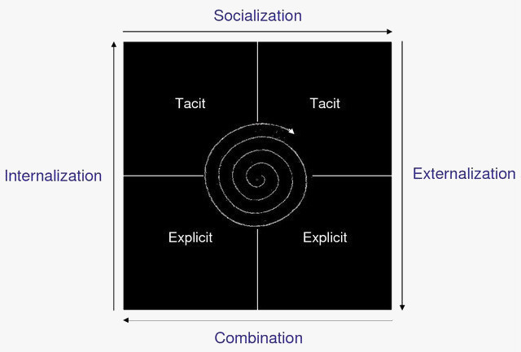
Figure 3: The SECI (Socialization, Externalization, Combination and Internalization) Model
(Source: Hajric, 2021)
Sir Francis Bacon Theory - knowledge is power
It can be said that human beings have always conceived different ideas in the form of weapons which have helped them in fulfilling their desires and interests. According to Sir Francis Bacon, if a human being wishes something was true, they would overcome the various kinds of obstacles they might encounter in the process of gaining knowledge. It can be said that most of the barriers that the individuals will face are located in the cognitive capacity of the human being (Sitaula, 2017). This keeps the employees of Amazon motivated as they believe in this theory. They have started to understand that if they are facing any obstacles, it is due to their cognitive capacity. According to Bacon, there are four false notions that could act as an obstruction in the understanding of the human being which can prevent them from discovering the truth. The employees of Amazon work rigorously towards understanding this theory and implementing it in their practice so that they can achieve the best results for the company by attaining the goals objectives (Bosco, 2017).
Johari window model theory
The Johari window model is a model which creates an understanding of self-awareness and communication between the employees. This model has been utilised by the employees of Amazon in order to provide information regarding their ability and the motivational factors along with having a better understanding of their emotions and attitudes. The managers and leaders of Amazon have been able to delegate tasks in a better way which has helped them in the process of training and development purposes. This model has also been utilised for the purpose of gathering information about the various relationships and bonding between the team members within Amazon (Osmanoğlu, 2019). This has been informative enough to be useful for collaborations of intergroup and sharing of knowledge. The four quadrants of the Johari window have helped in understanding the degree of socialization between the organisational members.
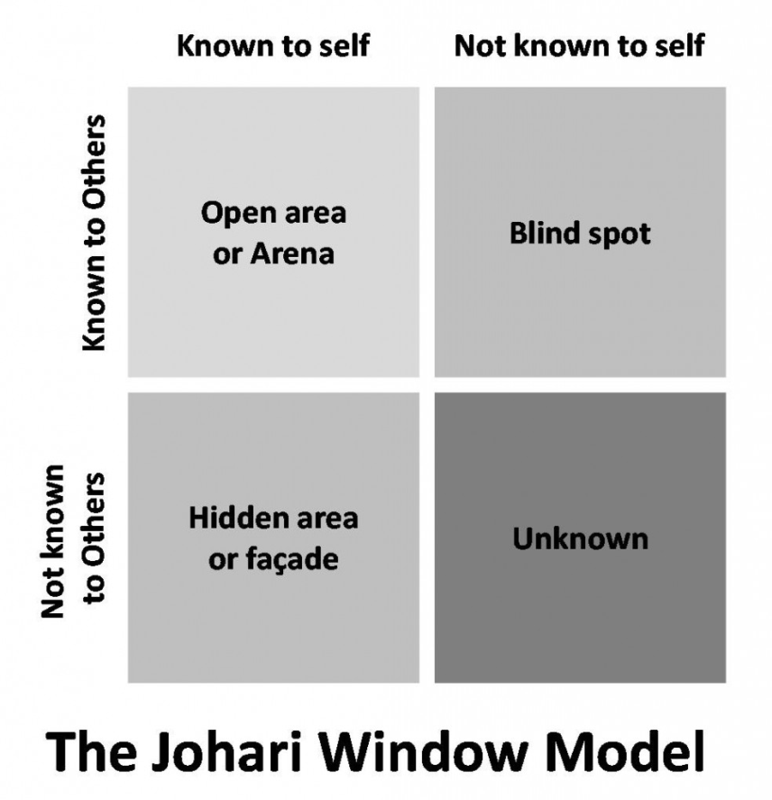
Figure 4. The Johari Window Model
(Source: Osmanoğlu, 2019)
Merhabian’s 7-38-55 communication model theory
This model is particularly used for the purpose of illustrating the various important factors which are crucial and understand the words alone when it comes to conveying meaning for interpreting meaning. It is also necessary to take care of the considerations of various contexts of communication which include expression, tone, style, facial expression and body language So that the employees have a better understanding of the general rule that can help in transferring any given communication situation within Amazon (Henry, 2019). It has been crucial that their employees understand how to convey and interpret various types of meanings which are essential for the purpose of effective communication, building relations and fostering management within Amazon.
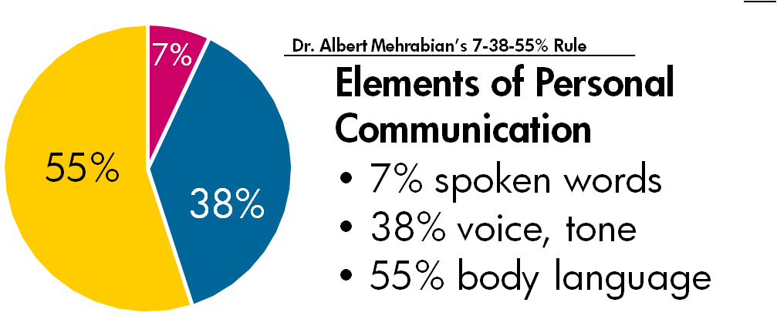

Figure 5. Merhabian’s 7-38-55 communication model theory

(Henry, 2019)

Ways in which systematic approach help organisation in sharing and exchanging its knowledge base across organisations
Knowledge management system includes the systems that are developed for capturing, refining, creating, tagging and circulating information that is used for making improvements in business productivity of an organisation. There are three basic ways in which knowledge system is managed:
- Undertaking the utilisation of information systems and technology for improving business efficiency.
- Undertaking the organisational method for improving the business efficiency.
- The third way is to create a healthy workplace that would result in enhancing the efficiency of the business operations (Gitman et al., n.d.).
There are different business productivity software such as spread-sheet, word processing, and graphic programs for undertaking a number of tasks within an organisation. Companies like Amazon also make use of such hardware and software for managing the organisation’s information and is known as management information system. These elements of management information system supports decision making within an organisation, and also helps in the collection and storage of the organisation’s key data and produce certain information needed by the managers for controlling, analysis and decision making (Hwang et al., 2018). Factories of the organisations make use of the computer based information system to automate the process of production and also monitor and order inventory. Most of the organisations also use the information management system to process and handle the orders of the customers and also billing and payments of vendors. Many organisations have different types of the information management systems that start with systems to process transactions. Some of the management systems that could be undertaken by organisations like Amazon include Transaction Processing System (TPS), the Decision Management Support Systems, the Decision Support System, the Executive Information system, and the Expert Systems (Choudhary and Jadoun, 2016).
Wiig’s model
The Karl Wiig KM model (1993) emphasises the underlying basic concept: material must be organised in order to provide useful and meaningful information. Depending on how the information will be used, it should have been structured accordingly. The amount of relevant expertise obtainable from a particular source is referred to as completeness. Human minds and knowledge bases are examples of sources. Researchers must first establish that the knowledge is created; expertise may be comprehensive if all available material on the subject is provided, but if no one is aware of its presence, it cannot be used. Another well and well-defined relationships between the different knowledge objects are referred to as interconnectedness. Usually knowledge objects are linked to one another; the more linked knowledge and understanding is, the more comprehensive the material is and the more valuable it is. Perspectives and intention refers to the phenomenon of knowing some from a given viewpoint for a specified reason. Researchers use the two main dimensions of viewpoint and purpose to organise a lot of our information. When all of the information, conceptions, viewpoints, values, assessments, and relational ties here between entities are coherent, the base of knowledge is said to have been coherent. The vast majority of specific knowledge will fall short of such expectations (Sánchez et al., 2020).
In context of Amazon, the firm utilize their resources to build more knowledge about the customers’ needs and wants, build expertise on the product development process and train employees accordingly.
The Von Krogh & Ross model
Organizational knowledge is viewed as a self-organizing structure in which humans are translucent to external information, according to a cognitively epistemological approach. In this view, the brain can indeed be viewed as a computer built on logic and detection systems, which does not allow for contradictory statements. As a result, the organisation gathers data from its surroundings, which it then processes logically. Appropriate responses will be developed through searching and various cognitive capabilities - all of that is based on the mobilisation of individual computational functions. The brain does not analyse consecutive symbols, but rather senses the overall outlook, global qualities, models, and synergies, as is well known. The rules that control how the various components interact are known as learning rules. Information is not only gathered from the outside world; it can also be produced in the body. Learning occurs as a result of acquaintance and practice (tlu, 2021).
In Amazon, the Von Krogh model is applied through a digitized system in which the information is transferred through channels and knowledge is transferred through the training process.
Meyer and Zack theory
Meyer and Zack's model emphasises the "refinery" in defining the distinct phases of a KM cycle. Gathering, elaboration, information retrieval, dissemination, and presentation or usages are the degrees of research technique to convert into usable knowledge.
To ease examination of the knowledge base and unambiguous identification of each stage of the KM cycle, every one of these stages is networked using pure logic. Overall integrity and timeliness of the data are prioritised during the information stage. This can include things like scope, width, depth, credibility, authenticity, appropriateness, significance, cost, scarcity, and so on, depending on where the event consisted from and what requirements they bear. Information must be stored after it is obtained, however not all information may be stored. To begin, the data must be turned into knowledge packets. This makes future search and processing more convenient (Supermane and Tahir, 2018).
Amazon uses physical, logical, cleaning, standardisation, storage and retrieval and distribution processes to share knowledge and grow as an organisation.

Section 3: Investigating KM techniques used by Amazon

Importance of knowledge in maintaining information systems by Amazon
Amazon Inc has become one of the largest global companies in the world. For establishing its position in the global technology industry, new kinds of services under e-commerce, digital streaming, cloud computing and artificial intelligence has been introduced by this company. Although, it has acquired a large market share in the technology industry with approximately 7.7% share in market, knowledge management has become an important area for this company. In this organisation, knowledge management has become primarily essential as it encourages employees to document and distribute important internally for developing effectiveness of overall work proficiency. With KM, knowledge efficiency has been enhanced and workforce of Amazon has been collaboratively working for attaining targets. Management information system (MIS) of Amazon has been used as a vibrant tool that streamlines management activities and ensures that diverse services are offered to customers (Nascimento et al., 2018). Firstly, with the integration of customer relationship management and information management as part of the business strategy, miscommunication between employees and customers has lessened as they get the scope of sharing vital information with one another and professionals take decisions accordingly. The knowledge management technique that is applied by Amazon has led in sharing authentic information with buyers. As appropriate information is shared by employees besides providing accurate to customers, miscommunication reduces. By creating and sharing data, integration of information has led in enhancing knowledge regarding management of development practices. Based on the Johari window model theory, delegating tasks to the employees by the managers become one of the most essential factors that help the management of organisation in boosting the performance of the employees and bring about profitability within the company (Geisler and Wickramasinghe, 2015). However, in Amazon Inc, learning interaction between professionals is not done effectively and this aspect does not result in encouraging them to share information with each other. Secondly, for internal communication, knowledge has become increasingly important (Loon, 2019). Due to communication gaps, many new recruited employees fail to acquire data regarding business from existing staffs of this organisation. As a result, it does not promote transparency in accessing appropriate data about operational processes. MIS aids organisation and its system in maintaining synergy between information system and interaction between people. Therefore, for internal communication, reliable information about business is not shared by professionals (de Souza et al., 2015). For instance, in MIS, employees of the concerned organisation have often failed to access information regarding personal data and purchasing habits of consumers. Lastly, according to Bacon, there are four false notions that could act as an obstruction in the understanding of the human being which can prevent them from discovering the truth. The employees of Amazon work rigorously towards understanding this theory and implementing it in their practice so that they can achieve the best results for the company by attaining the goals objectives. They have been able to get a better understanding of their follies and obstacles so that they can overcome those in order to bring profitability and productivity within the workplace of Amazon. For sharing, collecting, maintaining and deploying organizational knowledge in improving efficiency of MIS, the knowledge and information management culture needs to be developed in Amazon Inc.

Main outcomes of such procedures
In maintaining management information system (MIS), Amazon Inc has faced constraints in several aspects. Due to lack of knowledge sharing between professionals, miscommunication between customers and employees has developed a gap. The procedure of sharing knowledge between employees has resulted in deteoriating efficiency of workforce. As learning interaction between professionals are not done effectively, negative outcomes in managing information system within the organisation has been analyzed. Moreover, in internal communication, due to lack of information sharing, newly recruited staffs of Amazon have faced several kinds of challenges in undertaking tasks in warehouses and in delivery products to customers (Chen and Fong, 2015). Internal communication is pivotal for ensuring reliable data is shared between professionals and they can further proceed with other tasks that are associated with it. From knowledge acquisition retention-transfer perspectives, such procedures have maximized potential knowledge management challenges for Amazon Inc. The role of enterprise resource management (ERP) systems needs to be stated in this aspect as employees of Amazon does not utilize such system effectively for integrating internal and external information that may influence management functions.

Areas of improvement for overcoming challenges
Based on the analysis in the above sections, it has been identified that Amazon Inc may face several constraints due to lack of efficient utilization of information. Knowledge management has become crucial for the organisation for different reasons and the areas that are required to be improved has been highlighted in the following section:
- With the usage of management information system (MIS), Amazon Inc needs to create awareness regarding knowledge management by professionals of different departments. By encouraging employees in terms of creating, sharing, maintaining and using information and knowledge relating to business, learning interactions between staffs will help them to integrate internal and external information. For instance, information in e-commerce platform needs to be shared appropriately so that customers can understand and raise queries regarding any product or service. The application of Johari window helps in understanding the illustration and improvement of the factors that create self-awareness along with forming mutual understanding between the different employees of Amazon as well as the group of team members (Geisler and Wickramasinghe, 2015).
- For developing knowledge and information management culture, professionals of this organisation need to be encouraged for engaging in internal communication processes. From knowledge acquisition retention-transfer perspectives, strengthening such knowledge management practice is essential for this multinational company. For instance, the application of the WIIG model, Amazon has been able to conduct its business activities successfully in an organised manner. The application of this model has helped Amazon enact intelligently by facilitating various other activities for the purpose of creating, accumulation, deployment and the utilisation of quality knowledge. It has helped the management of the company in terms of building knowledge from the various external and internal knowledge sources. It has also been able to hold and pool knowledge along with applying knowledge in the context of organisational activities. The von Krogh and Roos is one of the models that help the organisation in differentiating between the knowledge of individuals and the knowledge of the social groups. The application of this model helps in analysing why and how the different aspects of knowledge get to the workers of the company. It also analyses why and how the arrival of knowledge takes place within the organisation of Amazon along with analysing the various barriers of knowledge management within the organisation. Values, strategies and assumptions that results in discouraging employees in not sharing information with each other can be changed for developing an efficient environment. Motivated employees will then be able to acquire knowledge and share them for utilizing different kinds of technologies.
- Manual errors in different kinds of tasks that are undertaken by professionals in Amazon Inc can be reduced through KM. A knowledge and information management culture can be developed for maintaining effective customer relationship management through application of the principles of techno-centric theory. As per this theory, the processes that are followed for designing technology will help in facilitating flow of knowledge and information storage by employees (Miglani, 2014). In order to share personalized data with customers and storing vital information, employees of Amazon Inc will be able to enhance quality of services.

Conclusion and Recommendations
The discussion through the first task of the report has helped in examining the importance of knowledge management (KM) for creating, sharing, maintaining and using information and knowledge in organisations such as Amazon Inc, a global based technology company. Apart from applying principles of the three theories, namely, Sir Francis Bacon Theory, Johari window model theory, Merhabian’s 7-38-55 communication model theory, Nonaka and Takeuchi theory, other theories such as Wiggs model, the Von Krogh & Ross model and the Mayer and Zack theory can also be helpful. It is recommended that the framework of location of expertise in the KM can be beneficial for the organisation. Through this, senior employees can identify proficiency of skills of staffs in specific areas and they can be assigned for undertaking specific tasks as per that. As they will be engaged for performing tasks as per their expertise, they can be trained for enhancing skills, ability and knowledge. It will help in developing knowledge and information management culture in Amazon as employees will utilize effective collaborative tools and share knowledge for providing high services to customers. The proposed framework can be developed by Amazon Inc within 2 months and it can be implemented within 3 months for boosting performance by strengthening knowledge management practices.
Slide 1
Task 2

Title: Practical Evaluation of the Proposed Knowledge Management Framework for Amazon
Introduction
The purpose of the presentation is to throw some light on the major challenges related to knowledge management faced by Amazon. Through the presentation certain recommendations would be provided to the organisation for strengthening their knowledge management practices from the perspectives of knowledge acquisition-retention-transfer. The purpose of presenting the poster is also to evaluate the proposed knowledge management framework of Amazon that would include the potential drawbacks and benefits of the proposed framework of knowledge management for the organisation. Although Amazon has been able to connect to their customers with large amount of information about the products, the company’s knowledge management framework is still not enough for satisfying the needs of the customers. Therefore, the presentation provides some recommendations for adding more value to the customer’s experience.
Amazon’s potential knowledge management challenges
The potential knowledge management challenges that might be faced by Amazon include the ever-evolving technology and the employee motivation for keeping up with the changes.
The technology is ever evolving and what has worked well till the present date soon becomes out-dated. Finding particular information for the customers become inconvenient when compared to the previous information providing system the organisation provided. This could be seen in the insufficiency of the customer satisfaction even after the efforts of Amazon to connect “zillions” of people with vast range of information. Although the organisation has been able to enhance the customer experience and provides them the ability to find for whatever information they want easily and quickly, the customers have become so acquainted with the advanced technologies and the provisions of more personalised data that they want more from Amazon’s services (Inkinen, 2016).
Yet another challenge that might be faced by the organisation includes Employee motivation. Lack of motivation of the employees to learn new things every time with the developing and advancing knowledge and technologies would result in no lasting benefit to an organisation. Thus, acceptance of the employees in such cases depends on the knowledge management tools that are adopted by the company. If the tools being used are out-dated and eventually very difficult or time-consuming for the employees to use, the acceptance of learning is somewhat rejected by them (Asrar-ul-Haq and Anwar, 2016).
Recommendations for strengthening Amazon’s knowledge management practices
In order to strengthen Amazon’s knowledge management practices in the places where it lacks, the organisation could follow some of the knowledge management theories:
The Johari window model is a model which create an understanding of self-awareness and communication between the employees. This model has been utilised by the employees of Amazon in order to provide information regarding their ability and the motivational factors along with having a better understanding of their emotions and attitudes. The managers and leaders of Amazon has been able to delegate tasks in a better way which has helped them in the process of training and development purposes. This model has also been utilised for the purpose of gathering information about the various relationships and bonding between the team members within Amazon (Osmanoğlu, 2019). This has been informative enough to be useful for collaborations of intergroup and sharing of knowledge. The four quadrants of the Johari window have helped in understanding the degree of socialization between the organisational members.
Sir Francis Bacon Theory Knowledge is Power
As per Sir Francis Bacon’s theory regarding knowledge management, “knowledge” is perceived to be the power itself. Sir Bacon has established the concept of sharing and attaining knowledge that has been the basis of reputation and influence. According to Bacon, science has driven human knowledge, power and control over nature (Rothberg and Erickson, 2016). Amazon can consider implications of this theory in its operational perspectives for integration of knowledge across the organisation in order to impart significant power and authority to the employees and other stakeholders. Knowledge related to updated technologies and modern business processes along with the market requirements and preferences considering diverse socio-economic factors can provide significant power, control and authority to the leaders and managers of Amazon to impart productivity and profitability for its business (Henry, 2019).
Evaluation of the proposed knowledge management framework for Amazon
The proposed theories or the frameworks that Amazon might undertake to mitigate the challenges that it might face includes several benefits as follows:
By undertaking both the Johari Window Model and Sir Francis Bacon theory, Amazon would be able to ensure an increase in the customer satisfaction. This is because the Johari Window Model would help the organisation to spread awareness amongst the employees regarding their job roles as well as their capabilities, which motivates them to undertake developmental activities and improve the organizational outcomes (Yahyapour et al., 2015).
The proposed knowledge management strategy promoted the cultural and innovative changes. This is done by the encouragement of idea sharing, access to the latest information and collaboration. By undertaking the “Knowledge is power” theory proposed by Sir Francis Bacon, the details of the roles, the changes within the workplace, the shift in knowledge that is mandatory to function in the changed job role (Abubakar et al., 2019). According to this theory, Amazon can incoprporate effective knowledge management practices to impart significant power and authority to individuals associated with the organisation for enhancing effectiveness and accuracy of operations. The managers of Amazon would make a better learning environment for the employees in which the knowledge is gained, retained and shared by the employees for better customer service (Lima, 2021).
The framework proposed would also result in a better decision making and also speeds up the access to information and knowledge (Karlinsky-Shichor and Zviran, 2016).
On the other hand, several drawbacks for implementing the knowledge management theories for Amazon might include:
The knowledge management tools might be very complex for the employees of the organisation and requires the need of undertaking costly training.
Also, if the managers of the company are unable to utilise the knowledge management tools in a proper way both time and money is wasted and operational efficiency also gets prevented (Abubakar et al., 2019).

References
Abubakar, A.M., Elrehail, H., Alatailat, M.A. and Elçi, A., (2019). Knowledge management, decision-making style and organizational performance. Journal of Innovation & Knowledge, 4(2), pp.104-114.
Asrar-ul-Haq, M. and Anwar, S., (2016). A systematic review of knowledge management and knowledge sharing: Trends, issues, and challenges. Cogent Business & Management, 3(1), p.1127744.
Dayan, R., Heisig, P. and Matos, F., (2017). Knowledge management as a factor for the formulation and implementation of organization strategy. Journal of Knowledge Management.
Imhanzenobe, J., Adejumo, O. and Ikpesu, O., (2021). A review of knowledge management and its application in the contemporary business environment. African Journal of Business Management, 15(10), pp.274-282.
Inkinen, H., (2016). Review of empirical research on knowledge management practices and firm performance. Journal of knowledge management.
Karlinsky-Shichor, Y. and Zviran, M., (2016). Factors influencing perceived benefits and user satisfaction in knowledge management systems. Information Systems Management, 33(1), pp.55-73.
Lima, M., (2021). Knowledge–Knowledge Management in Learning Innovative Organizations. Innovation Economics, Engineering and Management Handbook 1: Main Themes, pp.209-215.
Rothberg, H. and Erickson, S., (2016), September. Putting knowledge to work: the intelligent learning organization. In European Conference on Knowledge Management (p. 780). Academic Conferences International Limited.
Yahyapour, S., Shamizanjani, M. and Mosakhani, M., (2015). A conceptual breakdown structure for knowledge management benefits using meta-synthesis method. Journal of Knowledge Management.

References
Akhavan, P., Ebrahim, N.A., Fetrati, M.A. and Pezeshkan, A., (2016). Major trends in knowledge management research: a bibliometric study. Scientometrics, 107(3), pp.1249-1264.
Batista, F.F., Massaro, M., Dal Mas, F. and Garlatti, A., (2017). The relationship between knowledge management and innovation in large companies: A structured literature review. In 18th European Conference on Knowledge Management (ECKM 2017). Academic Conferences and Publishing Ltd.
Bhosale, V.A. and Kant, R., (2016). Metadata analysis of knowledge management in supply chain: investigating the past and predicting the future. Business Process Management Journal.
Bosco, M.L., (2017). Francis Bacon. The Rosen Publishing Group, Inc.
Champagne, F., Lemieux-Charles, L., Duranceau, M.F., MacKean, G. and Reay, T., (2014). Organizational impact of evidence-informed decision making training initiatives: a case study comparison of two approaches. Implementation Science, 9(1), pp.1-14.
Chen, L. and Fong, P.S., (2015). Evaluation of knowledge management performance: An organic approach. Information & Management, 52(4), pp.431-453.
Choudhary, S.K. and Jadoun, R.S., (2016). Study about the Types of Information Technology Service for Supply Chain Management. In Proceedings of the World Congress on Engineering and Computer Science (Vol. 2).
Dayan, R., Heisig, P. and Matos, F., (2017). Knowledge management as a factor for the formulation and implementation of organization strategy. Journal of Knowledge Management.
de Souza, É.F., de Almeida Falbo, R. and Vijaykumar, N.L., (2015). Knowledge management initiatives in software testing: A mapping study. Information and Software Technology, 57, pp.378-391.
Geisler, E. and Wickramasinghe, N., (2015). Principles of knowledge management: Theory, practice, and cases. Routledge.
Girard, J. and Girard, J., (2015). Defining knowledge management: Toward an applied compendium. Online Journal of Applied Knowledge Management, 3(1), pp.1-20.
Gitman, L., McDaniel, C., Shah, A., Reece, M., Koffel, L., Talsma, B. and Hyatt, J., n.d. Management Information Systems. [online] Opentextbc.ca. Available at: <https://opentextbc.ca/businessopenstax/chapter/management-information-systems/> [Accessed 13 December 2021].
Hajric, E., (2021). The SECI Model & Knowledge Conversion. [online] Knowledge-management-tools.net. Available at: <https://www.knowledge-management-tools.net/knowledge-conversion.php> [Accessed 13 December 2021].
Heisig, P., (2015). Future research in knowledge management: results from the global knowledge research network study. In Advances in knowledge management (pp. 151-182). Springer, Cham.
Henry, B., (2019). Communication in Palliative and End-of-Life Care. In Handbook of Nutrition and Diet in Palliative Care (pp. 101-111). CRC Press.
Hwang, Y., Lin, H. and Shin, D., (2018). Knowledge system commitment and knowledge sharing intention: The role of personal information management motivation. International Journal of Information Management, 39, pp.220-227.
Jaaron, A.A. and Backhouse, C.J., (2017). Operationalising “double-loop” learning in service organisations: a systems approach for creating knowledge. Systemic Practice and Action Research, 30(4), pp.317-337.
Kaur, H., (2015). Knowledge creation and the seci model. International Journal Of Business Management, 2(1), pp.1-10.
Loon, M., (2019). Knowledge management practice system: Theorising from an international meta-standard. Journal of Business Research, 94, pp.432-441.
Massaro, M., Dumay, J. and Garlatti, A., (2015). Public sector knowledge management: a structured literature review. Journal of knowledge management.
Miglani, S.A., (2014). Concept Study for a Techno Centric Energy System Modeling Framework (Master's thesis, ETH Zurich).
Nájar Sánchez, O. and Morales Morgado, E.M., 2020, October. Knowledge Management and Collective Intelligence through Web Tools. In Eighth International Conference on Technological Ecosystems for Enhancing Multiculturality (pp. 1078-1084).
Nascimento, A.M., da Cunha, M.A.V.C., de Souza Meirelles, F., Scornavacca Jr, E. and de Melo, V.V., (2018). A Literature Analysis of Research on Artificial Intelligence in Management Information System (MIS). In AMCIS.
Omnisci.com. (2021). What is Knowledge Management? Definition and FAQs | OmniSci. [online] Available at: <https://www.omnisci.com/technical-glossary/knowledge-management> [Accessed 13 December 2021].
Osmanoğlu, D.E., (2019). Expansion of the open area (Johari Window) and group work directed to enhancing the level of subjective well-being. Journal of Education and Training Studies, 7(5), pp.76-85.
Serenko, A. and Dumay, J., (2015). Citation classics published in knowledge management journals. Part I: articles and their characteristics. Journal of Knowledge Management.
Sitaula, R., (2017). Sir Francis Bacon and Tectonics.
Spencer, B., (2018). Organizational Knowledge Creation Ikujiro Nonaka. Retrieved from pagebaldwin. com: http://pagebaldwin. com/fa57/docs/KM_Organizational_Knowledge_Creation. pdf.
Statista Infographics. (2021). Infographic: Amazon's Incredible Long-Term Growth. [online] Available at: <https://www.statista.com/chart/4298/amazons-long-term-growth/> [Accessed 13 December 2021].
Supermane, S. and Tahir, L.M., (2018). An overview of knowledge management practice among teachers. Global Knowledge, Memory and Communication.
Taplin, J., (2017). Move fast and break things: How Facebook, Google, and Amazon have cornered culture and what it means for all of us. Pan Macmillan.
tlu, (2021). The von Krogh and Roos Model of Organizational Epistemology | Theoretical Models of Information and Knowledge Management. [online] Tlu.ee. Available at: <https://www.tlu.ee/~sirvir/IKM/Theoretical_models_of_Information_and_Knowledge_Management/the_von_krogh_and_roos_model_of_organizational_epistemology.html> [Accessed 29 December 2021].
Tou, Y., Watanabe, C., Moriya, K., Naveed, N., Vurpillat, V. and Neittaanmäki, P., (2019). The transformation of R&D into neo open innovation-a new concept in R&D endeavor triggered by amazon. Technology in Society, 58, p.101141.

