Tutorial Tasks
Managing Movies and Bookings with Transactions and stored procedures

Objective:
- Understand how to manage transactions (commit, rollback) within a database context.
- Use transactions: BEGIN, COMMIT, ROLLBACK and SAVEPOINT.
- Handle a simple booking scenario and avoid inconsistent state.

Materials:
- MySQL Workbench or any MySQL interface

Scenario:
Imagine you are managing a small cinema. The cinema shows multiple movies every day, and each movie has a fixed number of seats. Customers come to book seats online or at the counter. Your job is to manage the database that keeps track of:
Movies Table:
• MovieID (Primary Key, Auto Increment)
• MovieName (VARCHAR(50))

Seats Table:
• SeatID (Primary Key, Auto Increment)
• MovieID (Foreign Key)
• SeatNumber (VARCHAR(10))
• IsBooked (BOOLEAN, default FALSE)
Bookings Table:
• BookingID (Primary Key, Auto Increment)
• MovieID (Foreign Key)
• SeatID (Foreign Key)
• CustomerName (VARCHAR(50))
• BookingTime (DATETIME, default CURRENT_TIMESTAMP)

Task 1: Create the Tables
Write SQL queries to create the Movies, Seats, and Bookings tables as described above. inserting sample movies and seats(A1–A5).
CREATE DATABASE cinema;
USE cinema;
CREATE TABLE Movies (
MovieID INT AUTO_INCREMENT PRIMARY KEY,
MovieName VARCHAR(50) NOT NULL
);
CREATE TABLE Seats (
SeatID INT AUTO_INCREMENT PRIMARY KEY,
MovieID INT,
SeatNumber VARCHAR(10),
IsBooked BOOLEAN DEFAULT FALSE,
FOREIGN KEY (MovieID) REFERENCES Movies(MovieID)
);
CREATE TABLE Bookings (
BookingID INT AUTO_INCREMENT PRIMARY KEY,
MovieID INT,
SeatID INT,
CustomerName VARCHAR(50),
BookingTime DATETIME DEFAULT CURRENT_TIMESTAMP,
FOREIGN KEY (MovieID) REFERENCES Movies(MovieID),
FOREIGN KEY (SeatID) REFERENCES Seats(SeatID)
);

INSERT INTO Movies (MovieName)
VALUES ('Avengers');

Movie table:
MovieID | MovieName
1 | Avengers
INSERT INTO Seats (MovieID, SeatNumber)
VALUES
(1, 'A1'),
(1, 'A2'),
(1, 'A3'),
(1, 'A4'),
(1, 'A5');
Seat table
SeatID | MovieID | SeatNumber | IsBooked
1 | 1 | A1 | 0
2 | 1 | A2 | 0
3 | 1 | A3 | 0
4 | 1 | A4 | 0
5 | 1 | A5 | 0

Task 2:-Transaction
Method:1
A customer (John Doe) wants to book Seat A4 for a movie Avengers.
Perform the following steps to book a seat and commit the transaction:
- Begin a transaction
- Mark seat A4 as booked
- Insert a booking record for customer John Doe
- Commit the transaction
- Display all seats and bookings to verify the changes

START TRANSACTION;

UPDATE Seats
SET IsBooked = TRUE
WHERE MovieID = 1 AND SeatNumber = 'A1';

INSERT INTO Bookings (MovieID, SeatID, CustomerName)
VALUES (1, 1, 'John Doe');

COMMIT;

Verify the Booking
SELECT * FROM Seats;

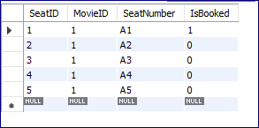

SELECT * FROM Bookings;

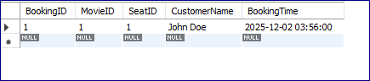

Method 2:- Retrieving seatID from seat table (it’s a bit complex)-optional method to try
-- Start the transaction
START TRANSACTION;

-- Mark the seat as booked
UPDATE Seats
SET IsBooked = TRUE
WHERE MovieID = 1 AND SeatNumber = 'A2';

-- Insert a booking record for the same seat
INSERT INTO Bookings (MovieID, SeatID, CustomerName)
VALUES (
1,
(SELECT SeatID FROM Seats WHERE MovieID = 1 AND SeatNumber = 'A2'),
'John Kenedy'
);
-- Commit the transaction
COMMIT;

Explanation:
SELECT 1, SeatID, 'John Doe' FROM Seats
→ Instead of giving explicit values for SeatID, we select it from the Seats table.
→ 1 is the MovieID being inserted.
→ 'John Doe' is the customer name.
→ SeatID comes from the row(s) in Seats matching the WHERE condition.
WHERE MovieID = 1 AND SeatNumber = 'A2'
→ Finds the specific seat for Movie 1, seat A2.
→ Only the SeatID from that row is used in the INSERT.

Seats table:
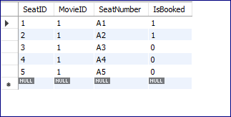
Bookings table:
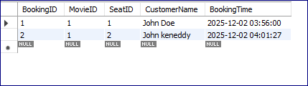

Task 3: Create a Simple Stored Procedure
A customer Kirsty Smith wants to book Seat A3 for a movie Avengers.(movieID=1)
Perform the following steps to book the seat using the stored procedure:
• Create a procedure to mark Seat A3 as booked in the Seats table and
• to insert a new booking record into the Bookings table for Kirsty Smith.
•create CALL statement to execute the stored procedure with MovieID = 1, SeatID = 3, and customer name “Kirsty Smith”.
• After running the procedure, check the Seats table to confirm the seat has been updated.
• Check the Bookings table to confirm the new booking record has been added.

SQL Code to implement this:

DELIMITER $$

CREATE PROCEDURE BookSeatSimple(
IN in_movie_id INT,
IN in_seat_id INT,
IN in_customer_name VARCHAR(50)
)
BEGIN
-- Mark the seat as booked
UPDATE Seats
SET IsBooked = TRUE
WHERE SeatID = in_seat_id;

-- Insert booking record
INSERT INTO Bookings (MovieID, SeatID, CustomerName)
VALUES (in_movie_id, in_seat_id, in_customer_name);
END $$

DELIMITER ;

CALL BookSeatSimple(1, 1, 'Kirsty Smith');

Verify the Booking
SELECT * FROM Seats;

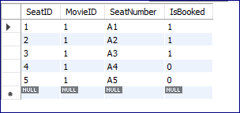

SELECT * FROM Bookings;


