WORKSHEET 3 – QUESTION

A person wants to grow carrots in a vegetable bed. The person has never grown carrots before, but has read that each carrot requires 64cm² of soil area for optimum growth. (8cm x 8cm patch per carrot)

Allow the person to enter the dimensions of their vegetable bed (you can assume that the vegetable bed is square or rectangular). Calculate how many carrots the user can grow in their vegetable bed.

For example:

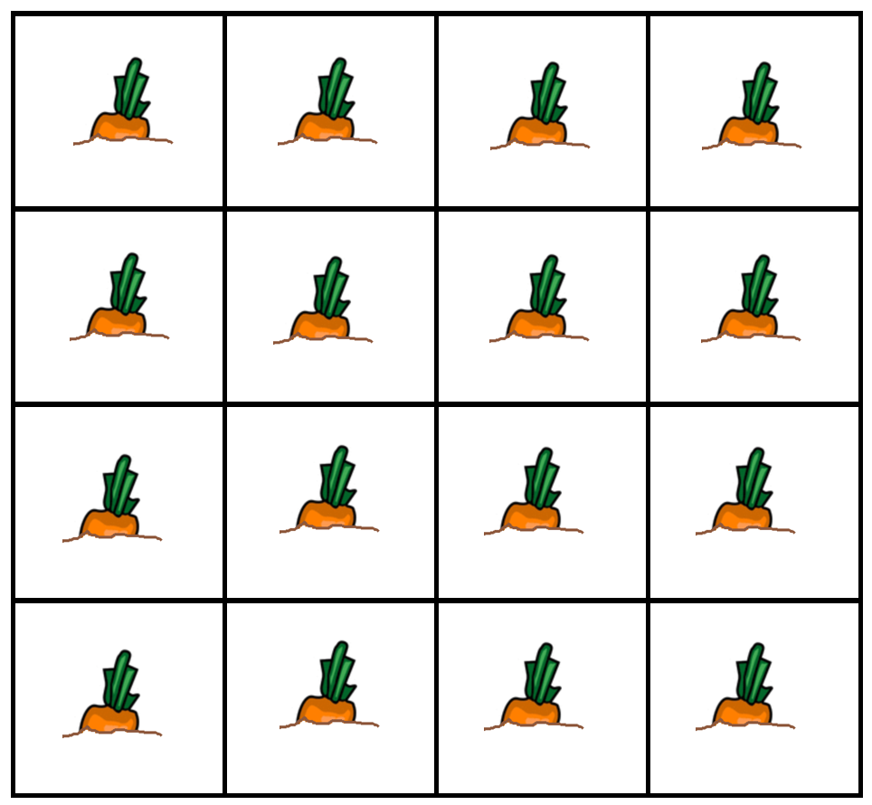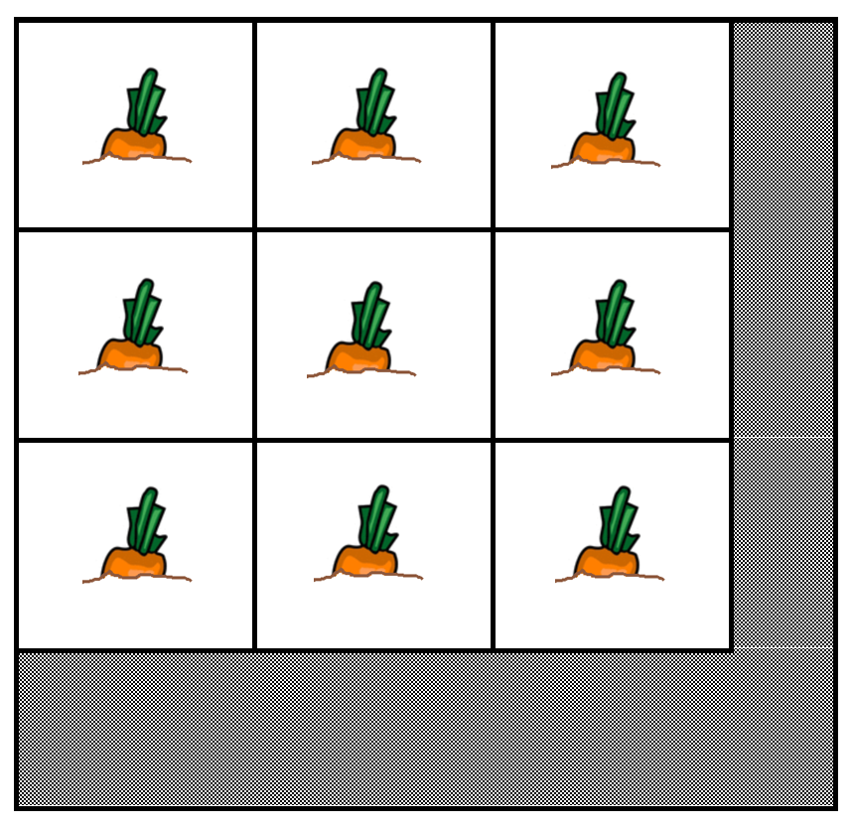
Vegetable bed = 32cm x 32cm = 16 carrots Vegetable bed= 27cm x 30cm = 9 carrots

(Hint: remember that you cannot grow half a carrot and stunted carrots are not permitted! )

Use validation in your code where appropriate to prevent the user from entering inappropriate values.

