
2021
Student Name: Suraya Begum
Student ID: 1712135
Lecturer: Nauman Ali
Assignment Title: Leading and implementing workplace change
Module Code: BMSW 6103

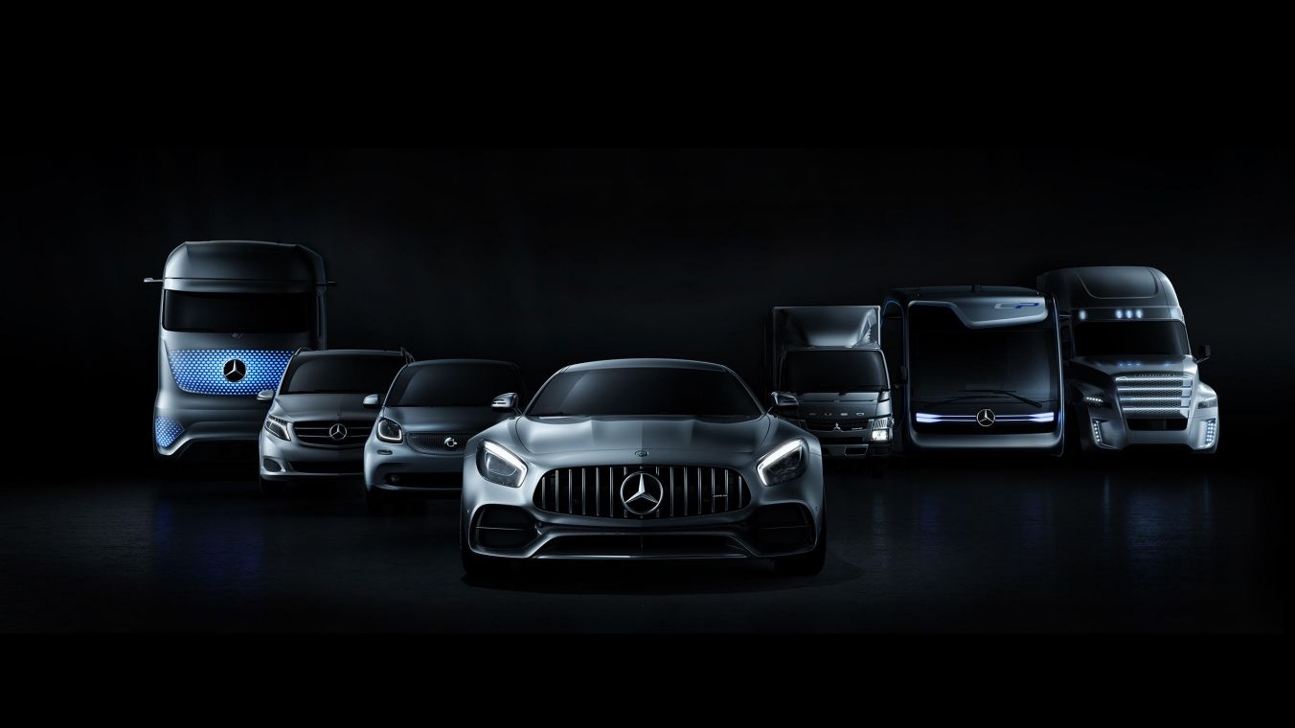
Mercedes Benz Company
Table of Contents
Introduction 3
Organisational information 3
Mercedes Benz’s current position 4
Mercedes Benz- Vision 4
Mercedes Benz Goals and Actions 5
The Plan 5
Business Model Canvas 6
Mercedes Benz SWOT Analysis 8
Two main Factors od Swot Analysis 9
Weakness 9
Threats 9
Regulations- Changing Trends 10
Conclusion of SWOT analysis 10
External Environment Analysis 11
PESTLE 11
Their technology plans 11
Porter’s 5 forces On Mercedes Benz 12
Mercedes Benz 12
Bargaining Power of suppliers 12
Bargaining Power of Buyers 12
Threats of substitute 12
Stakeholders & Change 14
Importance of stakeholders 15
Strategic change 17
The need for change 17
Change management 18
What is change management? 18
Importance of change management approach in any organisation 19
Leadership style 21
Mercedes Benz Leadership Style 21
Their main leadership style is Democratic. Their style is a combination of three styles. 21
First, it is democratic because no strict control is imposed on the employees since they operate based on healthy competition just like any kind of community. 21
Change management & organisation 22
Organisational Structure / Design 22
Organisational Culture 24
Meeting their objectives 25
Reflection 26
Identified problem 26
What I have learnt? 27
What can I improve? 27
Consultant prospective 27
Current knowledge 27
New learning? 27
What can be improve? 28
References 29

Introduction

Organisational information
Daimler AG's Mercedes Benz brand is one of the most well-known and well-established premium brands in the world. The company that invented the modern-day motorcar has since gone on to shape its development more enduringly and diversely than any other manufacturer.
Mercedez Benz has pledged to become a leader in the field of connectivity and automated driving, as well as alternative drives, with their forward-looking innovations. They joined the climate pledge on August 27th, 2020. This year Mercedes-Benz is doubling down on its commitment to "Ambition 2039," a roadmap to carbon-neutral mobility. The company is looking at ways to eliminate carbon throughout its entire value chain, from development to procurement, and from production to the electrification of products and beyond, as well as to ensuring renewable energies for the use of electric vehicles.
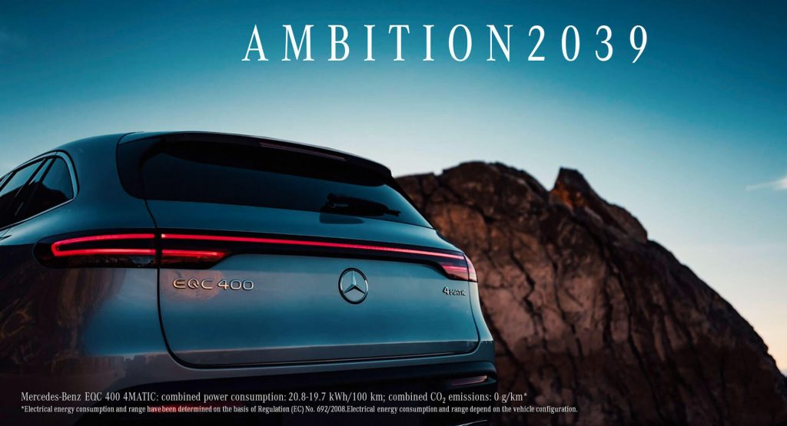
In this portfolio we will looking at how Mercedes Benz will implement change into their business in order to meet their CO2-neutral mobility Ambition by 2039 in this portfolio we will be looking at their current position of Mercedes Benz, the organisations internal and external factors, we will be looking at the stakeholders, shareholders, strategic change and the need for the change. We will try to identify what the organisation culture is and their leadership style.
Source (google Image- Mercedes Benz)

Mercedes Benz’s current position
Mercedes Benz plans to have battery electric vehicles available in all segments it serves by the end of 2022. Following that, all new vehicle architectures will be electric-only starting in 2025, and customers can choose an all-electric model for every model that the company delivers starting in 2025.Mercedes Benz intends to manage this accelerated transformation while sticking to its profitability targets.

Mercedes Benz- Vision
Its goal is to achieve CO2-neutrality by 2039 and no relevant impact on city air quality by its new fleet of cars. Mercedes Benz is committed to climate protection and air pollution control.
For In order to be climate-wise, Mercedes-Benz takes a holistic approach, covering all stages of the automotive value chain- from technical development to raw material extraction, production, and service life and recycling. Mercedes Benz Paris agreement on climate protection is more than a commitment it is a conviction.
It is absolutely clear that Mercedes Benz is using every opportunity to reduce emissions rapidly and sustainably. They are developing new and ever more efficient drive technologies and putting them on the road. The aim of emission-free mobility includes a systematic model offensive focusing on plug-in hybrids and purely battery- electric vehicles.
Mercedes Benz plans to become an all-electric company by the end of the decade, if the market conditions permit it. Moving from electric first to electric only, the world's preeminent luxury car maker is pushing towards an emission -free and software-based future.

Mercedes Benz Goals and Actions
Around one fifth of all ozone harming substance outflows in Europe are delivered because of transport of individuals and products on roads and streets and this is rising. Subsequently, Mercedes Benz is going to think lengths to balance this pattern and have made environment security a centre component of their business methodology. They will likely make their whole new vehicles armada CO2-impartial by 2039 and to guarantee that it no longer has any applicable consequences for air quality in downtown areas.

The Plan
Mercedes Benz plan to achieve this goal is by using a holistic approach which includes ambitious targets for all stages of automotive value creation- from the supply chain to production, the vehicle uses phase and vehicle disposal and recycling.

The Ambition 2039: the road to CO2-neutrality
Their driven is practical objectives. Their producer is inspecting the issues of manageability along the whole worth chain. They will likely change the full scope of traveller vehicles into a carbon-nonpartisan item range as of year 2039.
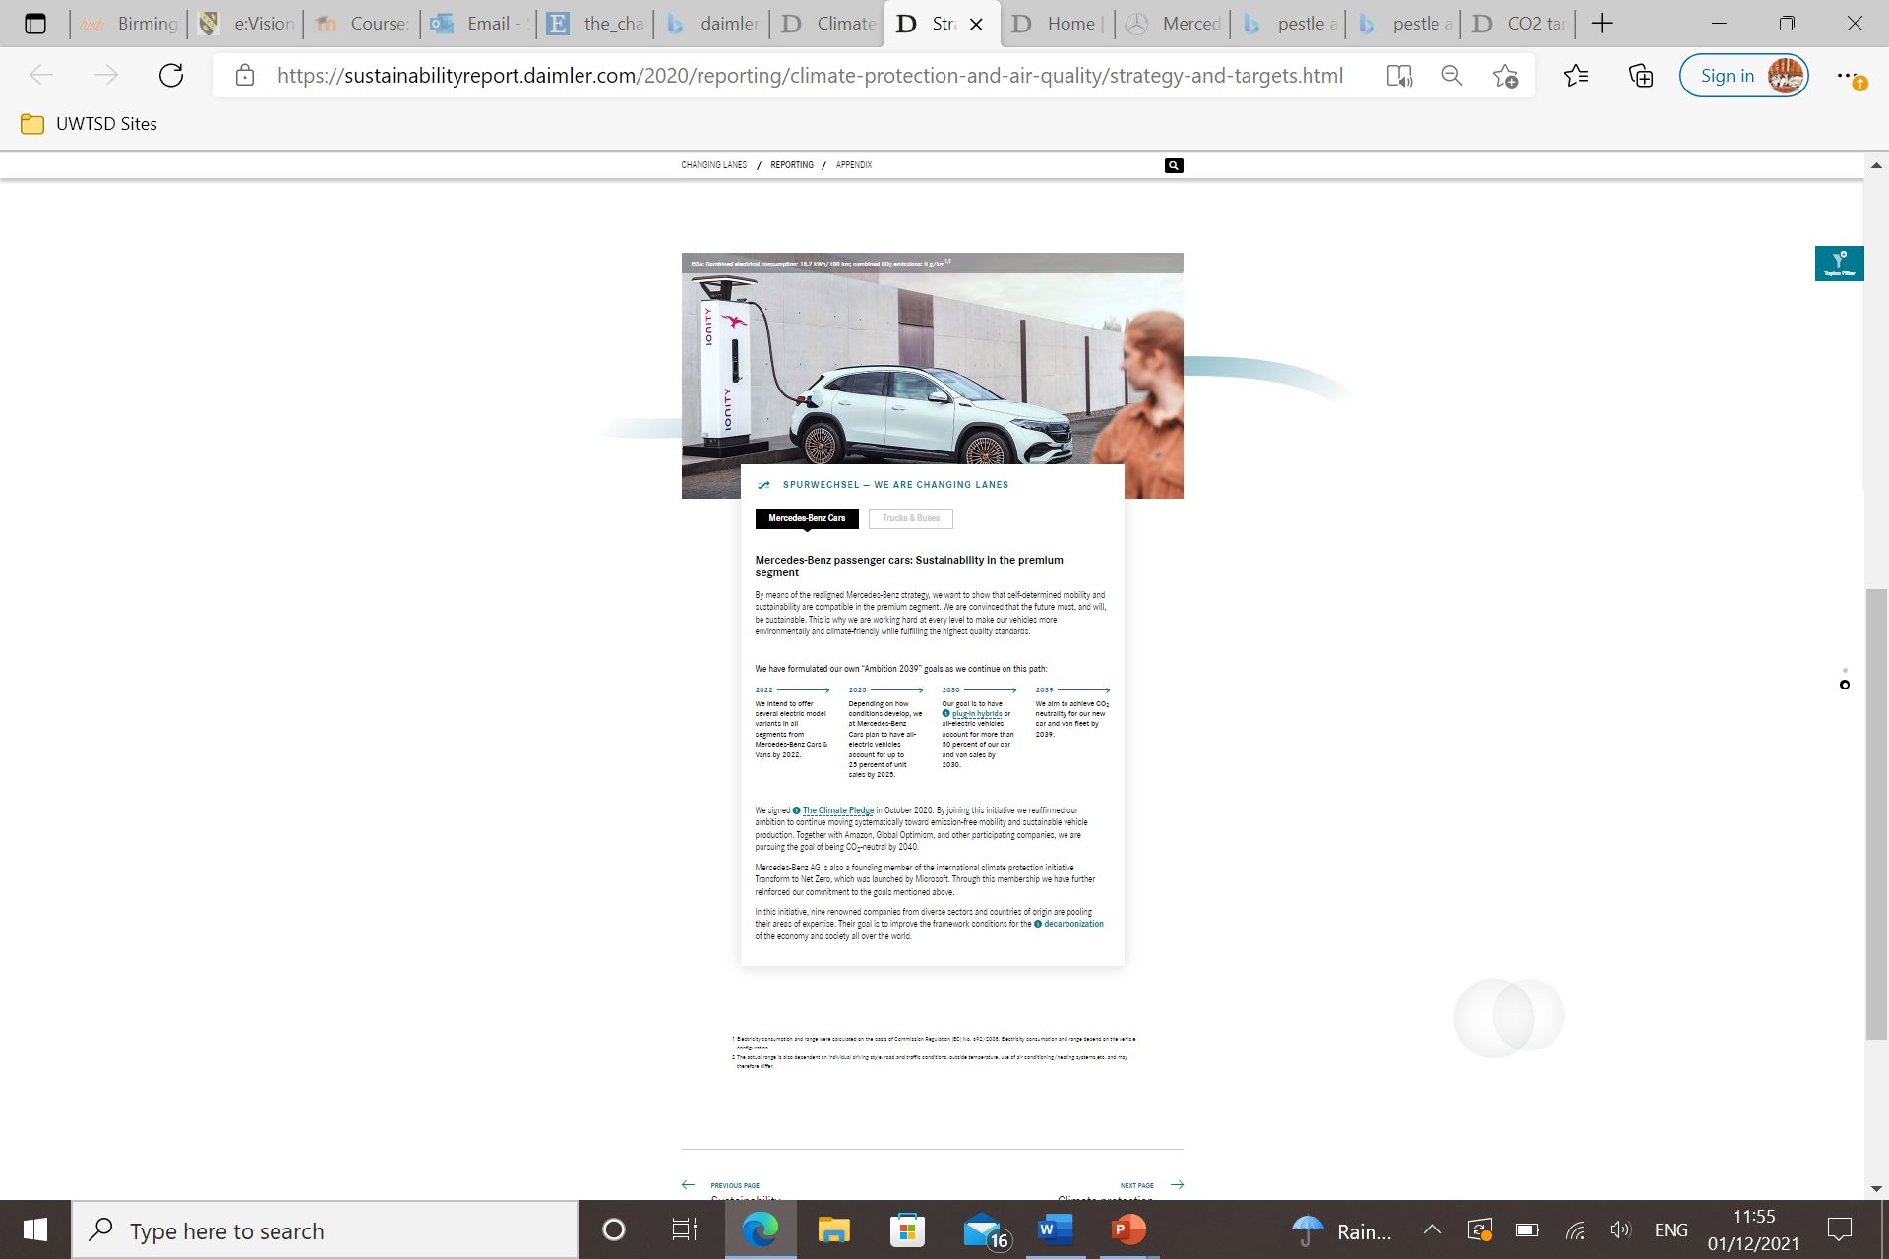
This includes from socially and climate -friendly degraded raw materials, through the supply chain, and the production of the vehicles. All stages are up to the use of phase as well as recycling concept.

Business Model Canvas
A business model canvas is a model where it explains who the customer is and how to deliver value to the customers. It is a strategic management tool that lets you visualise and assess the business idea and concept.
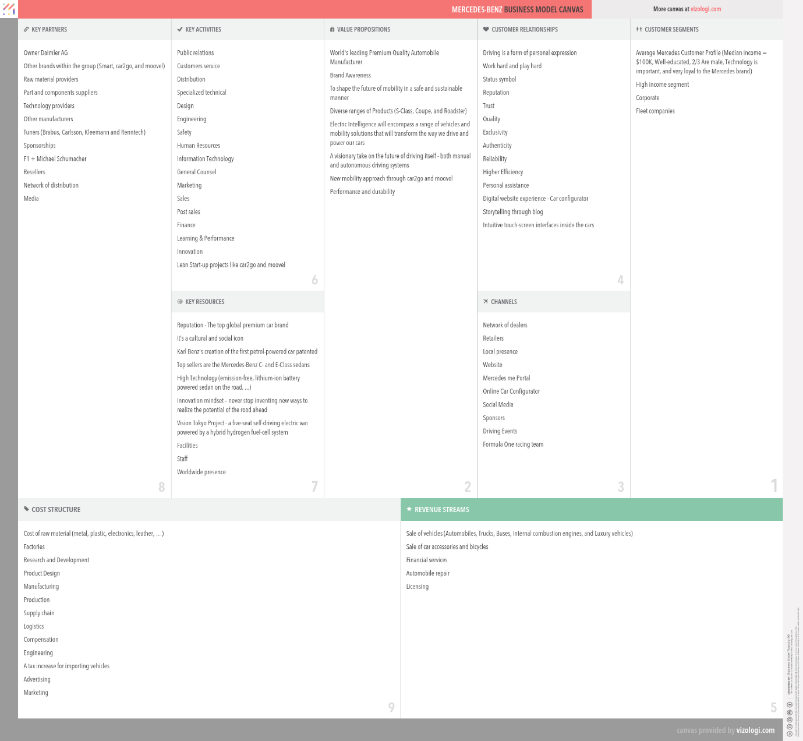
Below is Mercedes Benz business model canvas:

In this business canvas you can identify the following, the table shows who their customers are and the customer relationships. The channels, Revenue streams, key activities, key resources, key partners, cost structure and value proposition.

Mercedes Benz SWOT Analysis
SWOT examination is a system instrument that is utilized by all organizations to assess an organization's serious situation in the market by distinguishing the qualities, shortcomings, openings and dangers. The SWOT investigation is basic evaluation model that actions what an association can and can't do, and what its expected chances and treats are.
SWOT analysis of Mercedes Benz AG is a commercial and luxury automotive manufacturing German multinational company.
The Annual Revenue of Mercedes Benz in 2020 was 98.58 billion euros. Mercedes Benz’s parent organization is Daimler AG, and the overall gain was 4.1 billion euros.
Mercedes Benz top rivals in the vehicle business are Honda, BMW, Tesla, Toyota, Hyundai, Ford, Audi, Volvo, Aston Martin, Volkswagen, Ferrari, Jaguar and Porche.
To discover what Mercedes Benz current position is in the business the accompanying swot investigation would be completed. We will be checking out the chances, dangers, shortcoming and qualities of Mercedes Benz.
We will be identifying the internal factors by analysing the strength and weaknesses. The external factors by the opportunities and threats.
Internal Factors can impact the business from the inside which can be controlled by company, making small changes. Whereas the external impact can be difficult to control as its from the outside and which is out of our hands and control.

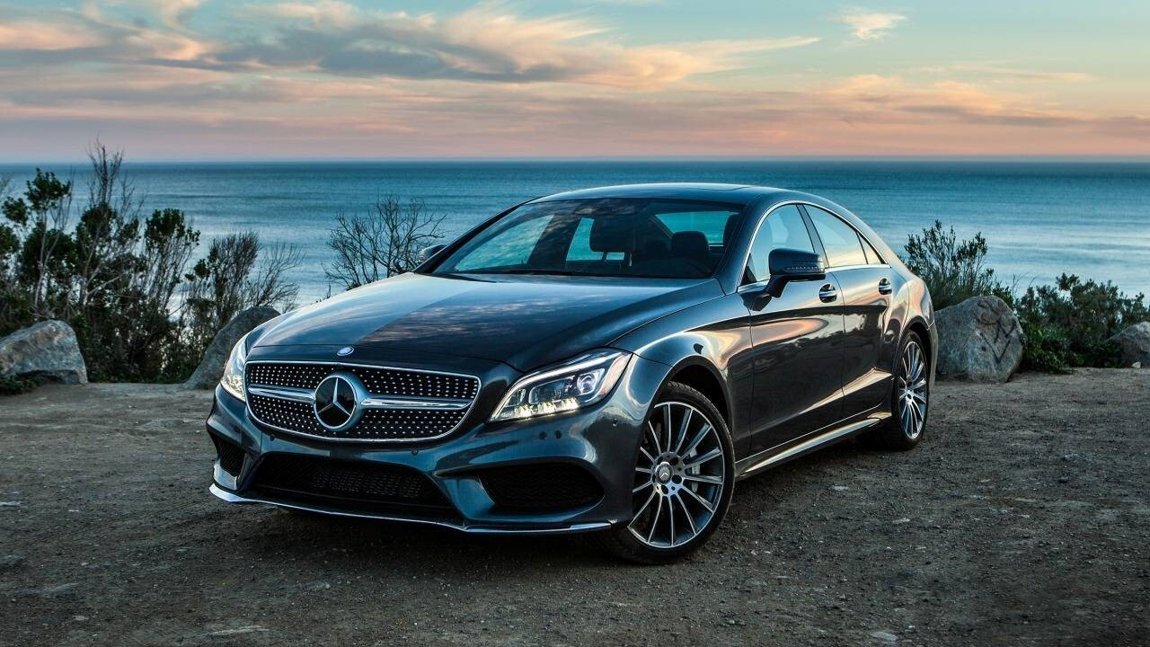

Google image Mercedes Cars
MERCEDES BENZ STRENGTHS ARE  - Cost efficiency  - Research and development  - Customer- centred  - Sponsorship  - Production facilities  - Brand equity  - Brand recognition  - Global brand  - Marketing  - Brand value | MERCEDES BENZ WEAKNESSES ARE  - Competition  - Lawsuit  - Vehicle Recall  - Brand image  - High Maintenance cost  
MERCEDES BENZ OPPORTUNITIES  - Alliance and Partnerships  - Developing Markets  - Hybrid and electric cars  - Increased income and purchasing power in developing countries | MERCEDES BENZ THREATS  - Government regulations on CO2 emissions  - Covid-19 Pandemic  - Competitors  - Changing trends  - Substitute  - Rising fuel prices

Two main Factors od Swot Analysis

Weakness
Here the two main important factors due to the climate change is Mercedes Benz needs to focus on the lawsuit as this is their current weakness and threat.
In 2020 the parent company of the brand Daimler came under some serious issues when it was observed that they had installed certain software in their vehicles that can cheat on the air pollution tests. Mercedes had to pay a big fine due to the claims that was made.
These types of sandals can bring the reputation down and completely tarnish the biggest of all brands such Mercedes Benz itself.

Threats
When the pandemic of covid-19 hit the world like a storm and has impacted the company in a significant way. As the lockdown came in and everything was standstill, Mercedes Benz was no exception and had a decrease in their annual revenue.
People did not buy as many cars as they did in previous years, and this impacted the sales.

Regulations- Changing Trends
In the current day an ever-increasing number of new guidelines are coming in because of the environmental change and many individuals are more centred around giving the environmental change the significance and what should be possible to forestall it. Various state run administrations all over the planet are presenting new natural and fossil fuel by-product guidelines, punishments and fines. This large number of new guidelines and changes are making it extremely trying for Mercedes Benz to work their business all around the world as they have done beforehand.
These new changes are enforcing the company to spend more and to keep up with the regulations and standards. As many people are choosing to shift to more organic, electric or less harmful alternatives.

Conclusion of SWOT analysis
There is no question that Mercedes Benz is without a doubt the universes most driving assembling organization, yet to endure Mercedes Benz needs to battle the difficulties that they are confronting like the new guidelines and cutthroat business sectors and attempt and stick to working on their image by going CO2 nonpartisan.
Mercedes Benz should grow their business sectors and dispatch more monetary amicable vehicles, for example, electric vehicles as there are other cutthroat vehicle organizations who have effectively dispatched numerous electric vehicles.


Source (Google image Mercedes Benz)

External Environment Analysis
PESTLE
Pestle analysis is a tool that analyses the environmental factors used to scan the component of strategic management. Basically, this tool helps to determine how these factors affect the performance and activities of the business in the long-term.
Pestle of Mercedes Benz and its strategic analysis, it includes all factors of micro-environment and how the political, economic, social and technological along with legal and environmental factors impacts the development of the business.
We will focus on the main concerns which are being critical to sustain the business and its growth strategy.
Mercedes is a notable association, as of late the opposition has expanded, and targets financially savvy measures as a basic viewpoint that offers worth to clients.
We will focus on the innovation and lawful side of it, as Mercedes have productively distinguished the requests of individuals' decisions, so being economically changed it has effectively perceived individuals and their relationship with vehicles to satisfy future needs.
It has become a common view about UK that it is regarded as one of the counties practising environmental concerns in the world, so it does encourage for research and development to incorporate eco-technology. This means the use of hybrid cars by advancing in technology and even driverless cars in order to reduce number of accidents and harms on environment.
Mercedes is identified to be positive when it comes to meet with the environmental standards of the UK and has joined hands with agencies for climate enforcement laws.

Their technology plans
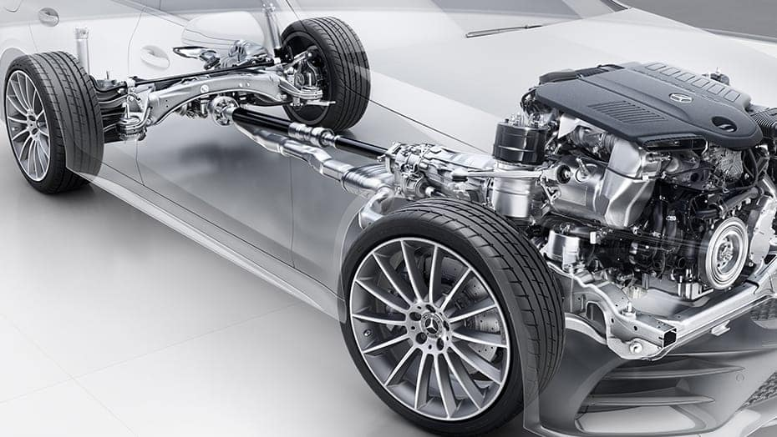
Mercedes Benz is unveiling a comprehensive plan which includes significantly accelerating R&D. In total, investments into battery electric vehicles between 2022 and 2030 will amount over 40 billion.

Porter’s 5 forces On Mercedes Benz
In the world of premium and luxury vehicles, Mercedes Benz is without question one of the most well-established and well-known brands. This brand is extremely well known. Apart from its stylish vehicle models, the company is also known for its innovative technology and high-performance cars.
Mercedes Benz have continued to innovate their models in order to cater to the changing market dynamics and customer preferences.
Several factors are reshaping the future of mobility, inducing changes to regulations, legal factors, and growing demand for electric vehicles right now, which have caused the automobile industry to experience a major shift in recent years.
Due to the pandemic the competitive position of Mercedes Benz has been impacted but because Mercedes Benz is an innovative brand it has managed to maintain its leading position in the industry.

Bargaining Power of suppliers
Bartering force of Mercedes Benz Supplies is low because of many variables. Mercedes Benz is a huge organization all over the planet and mostly depend in this brand because of its enormous business power, hence Mercedes Benz holds its huge bartering control over its providers and edges the guidelines for them to adhere to.

Bargaining Power of Buyers
It is moderately high in its bargaining power of buyers. Due to the changes in the market, Mercedes Benz continues to hold bargaining power of buyers in the automobile industry. Mercedes Benz makes premium and luxury vehicles, which holds Mercedes Benz to stay high in their position as their purchases is large. they focus on maintaining a strong brand image in order to retain their popularity and the level of customer demand.
Some of the factors that’s limit the bargaining power of buyers include the brand image, product quality, customers experience and the innovations.

Threats of substitute
Mercedes Benz no questions have rival brands like Audi, BMW, and Porsche as they are additionally very extravagance vehicles on the lookout. In any case, the treat from substitute brands are little as Mercedes Benz organization has a place with an exceptionally unmistakable class of premium versatility. They have fabricated a particular lofty personality in the business for themselves which makes them stick out. Their high prominence has assisted them with keeping up with its request and limit the dangers of substitute items.
Source (Google image Mercedes Benz)

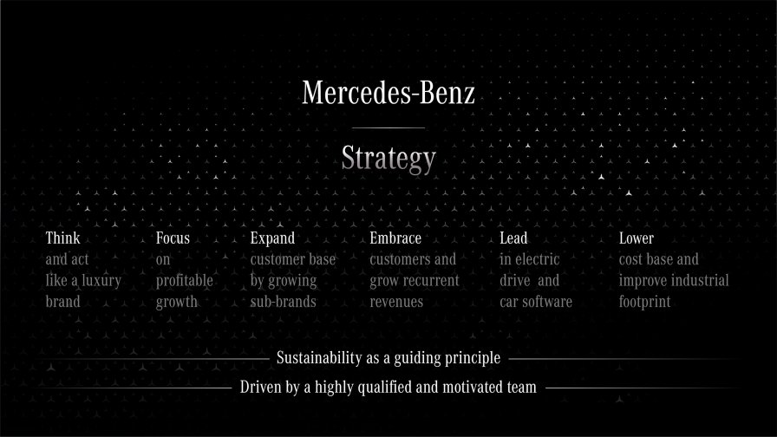
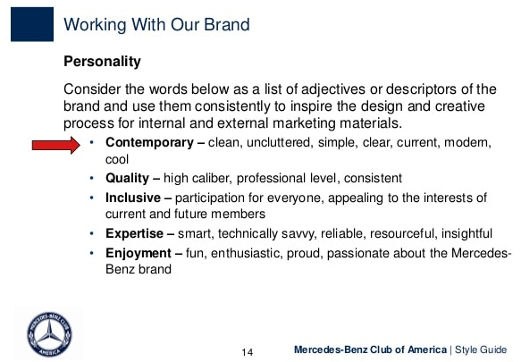
Stakeholders & Change
Mercedes Benz Internal and external stakeholders’ analysis
Primary | Secondary
- Customers  - Suppliers  - Creditors  - Employees  - Shareholders | - Government  - Media  - Communities and public policy  - International environment

Above you can see the internal and external stakeholders of Mercedes Benz
Matrix table of identified stakeholder’s are as follows below:
KEEP SATISFIED  Customer  Suppliers  Employees  Government | MANAGE CLOSELY  International environment  Legal requirements  Shareholders  Board of directors
MONITOR  Competitors  Community policy  Customers  Regulations | KEEP INFORMED  Supplier’s  Shareholders  Media  Government

High

P
O
W
E
R

Low
Low High
I n t e r e s t
I have placed the selected stakeholders in their relevant boxes because to me I feel they play an important part in those areas.

Importance of stakeholders
The stakeholder’s analysis takes a glance at the connections between an association and others in its inside and outside environment.
The selected stakeholders are as follows:
- Customer
- Employees
- Government
- Investors
- Suppliers
These were selected because they played a significant role to the organisation of Mercedes Benz.
Customers – Customers are very Important in any business as without them we would be nothing. Happy customers are those who get the great customer service and in order to give the great service the employee also needs to receive good service from the employers.
Employees- employees are the primary internal stakeholders for any company. Mercedes Benz are the administration and the representatives. Both gatherings are concerned with the level of inside natural incredibleness that a firm shows.
Government- the government is the stakeholder in this area, the local state and federal regulatory agencies. There are five basic principles that should be applied to managing community and public policy stakeholders.
- The organisation should establish an open communications policy as the foundation for trust.
- The organisation should use a varied array of communication methods, such as fact-finding, mediation, arbitration, participatory planning, focus groups and strategic alliances.
- The organisation should establish a proactive and participatory role in the lives of communities and regulatory rule-making activities.
- The organisation should establish a process for self-audit and disclosure of environmental aspects and impacts.
- The organisation should ensure accurate perceptions of environmental risks posed by its activities.
All stakeholders hold an important position in any business as they have considerable power in forming the opinions of shareholders.
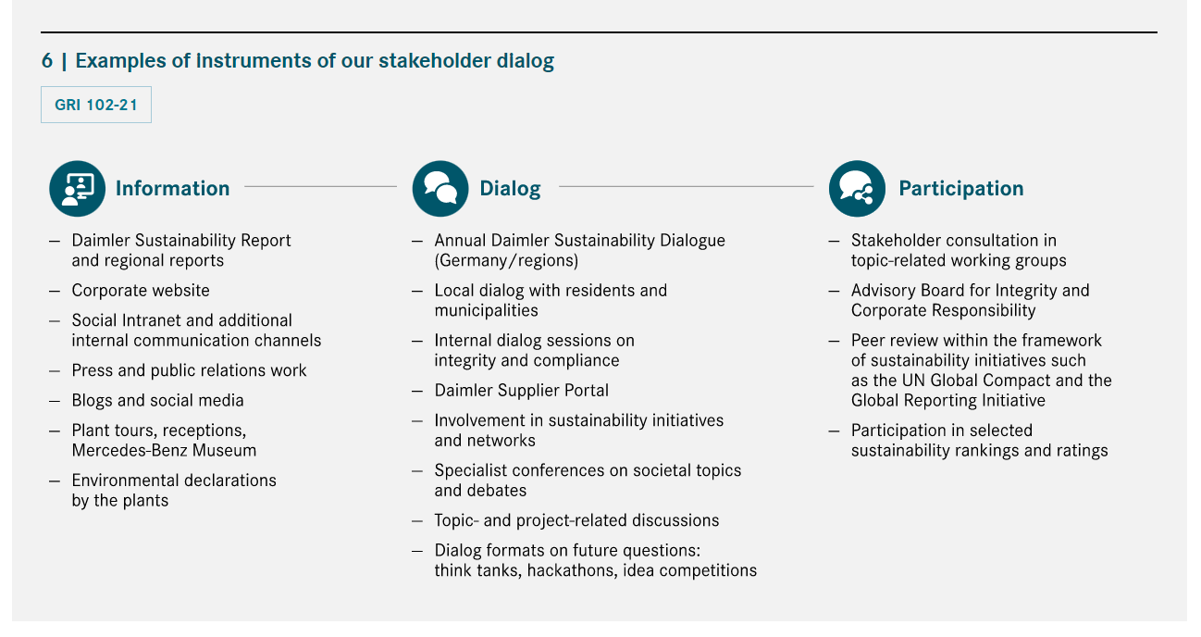
Mercedes Benz considers it to be very important to engage in a continuous dialog with all of their interest groups. This allows then to consider various perspectives on their involvement with sustainability issues, identity and address new trends, and share experiences.
Source Google image (Mercedes Benz)

Shares by Ownership (in% of registered capital stock September 30, 2021)
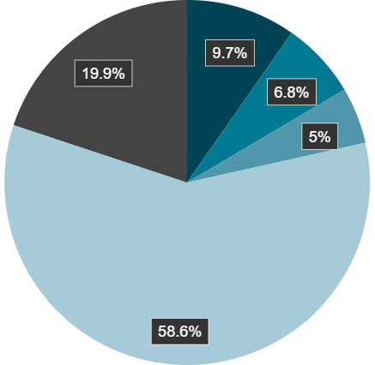

Retail investors – 19.9%
Tenacious3 prospect investment limited 9.7%
Kuwait Investment Authority 6.8%
BAIC group 5%
Institutional investors 58%

Shares by Region (in % of registered capital stock September 30, 2021)
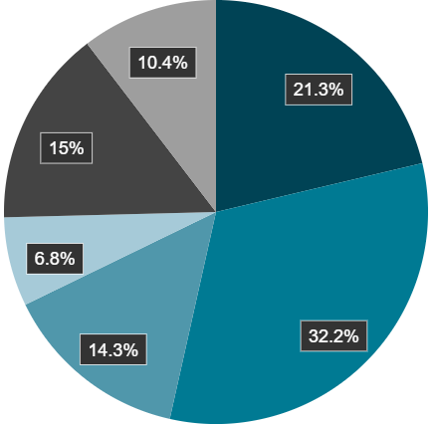

Europe excel Germany 21.3%
Germany 32.2%
USA 14.3%
B Kuwait 6.8%
Asia 15%
Other 10.4 %

Strategic change

The need for change
The need for change is the climate pledge, where everything is more focused on CO2 emissions regulation worldwide.
Carbon dioxide is a scentless and dreary gas that remaining parts in the environment for a normal of 120 years.
Aside from oxygen, CO2 is the main gas needed to support life on the planet.
The climate change agreement has been agreed across 195 countries. The agreement includes a global action plan, which is to limit global warming to well below 2C in order to combat climate change. Greenhouse gasses are responsible for global warming.
Mercedes Benz have decided to reduce their vehicle emissions a further by 37.5% between 2021 and 2030. Mercedes Benz has agreed on 31 percent reduction of CO2. This value has set an extremely ambitious goal which Daimler as a vehicle manufacturer must face. There is an interim solution in place until 2025: a reduction of 15 percent is to be achieved by then.
Daimler has clearly committed itself to the CO2 targets for fleet consumption. The roadmap is in place and the strategic decision for the implementation have been made.
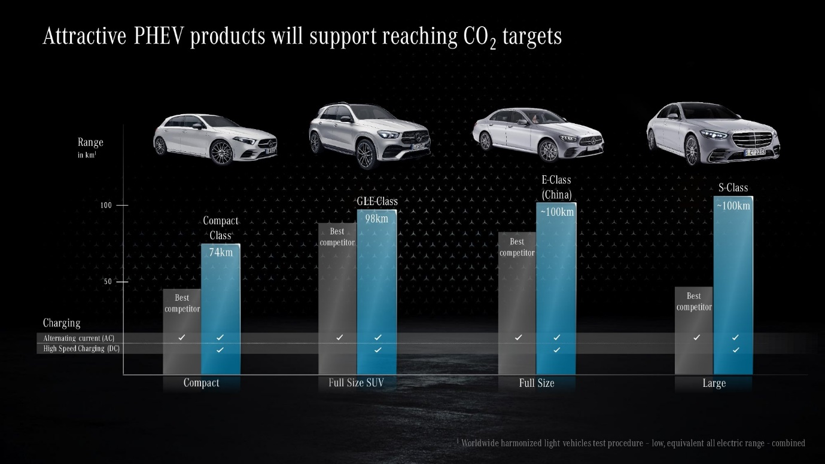
The Manufacturers will have to pay a penalty if they fail to achieve the specific target therefore the ned of change is a must and better for everyone.

Source Google image (Mercedes Benz)

Change management

What is change management?
It’s a approach for all to prepare, support and help individuals, teams, and organisations in making organisational change.
Change management is explained as a method of manners of which a company uses to implement changes within the external and internal process.
This includes making arrangement s to support the employees, establishing the needs for the change and monitoring pre and post change activities to ensure successful implementation.
Organisational change can be challenging it mainly requires many levels of co-operation and can involve different independent entities within an organisation, creating a structured approach to change is very critical to ensure the help is a beneficial transition while mitigating obstacles.
Having an effective communication is one of the most important aspect as the success factor for effective change management is important.

Importance of change management approach in any organisation
To Achieve strategic change an organisation needs to manage many different change initiatives in comparison.
This means setting up many small teams, where each team is focused and resourced to actively achieve a specific outcome. (H. Macmillan p192, 2000)
Change management is often needed to ensure continued survival or business relevance. Combining change management with the management of project-work offers the best potential for delivering new results and capabilities, successfully embedding the change ands enabling the required benefits.
Change management process links strategy with execution and deployment with operational and the ultimate realisation of the expected benefits.

Do I understand why? Think

Project outputs Do I intend to co-operate Feel

Do I know what to do? Act

Mercedes Benz Change management plan is as follows:
Step1. The need for the change is the climate change, global warming and the CO2 emissions regulation. They need to comply with the lawsuit and follow the government regulations. Leaders of Mercedes Benz will have to agree on making the changes in the best interest of their company and customers.

Step2. They will have to put a guiding coalition, they will need to have trust, shared objectives, team opinions and have proven leaders to be able to make the process of change.
Step3. Mercedes Benz has a vision of complying with the change which clarifies how they planned to have vehicles made for the future. Their vision is very ambitious.
Step4. They have already communicated their visions and goals with the relevant people such as their shareholders, suppliers and manufacturers.
Step5. They have already empowered many people out there where they have interest in making these changes happen. They have their supporters on their side.
Step6. They have given themselves a timeline to reach their goals by reducing certain percent of their fuel emissions by expected deadline.
Step7. They have a plan already in place on how they will make these changes and what is needed to be done in order to achieve their goals.
Step8. They aim to continue to grow bigger and better by innovation new ideas continuously as they are a branded company and hold that high position already in the markets.
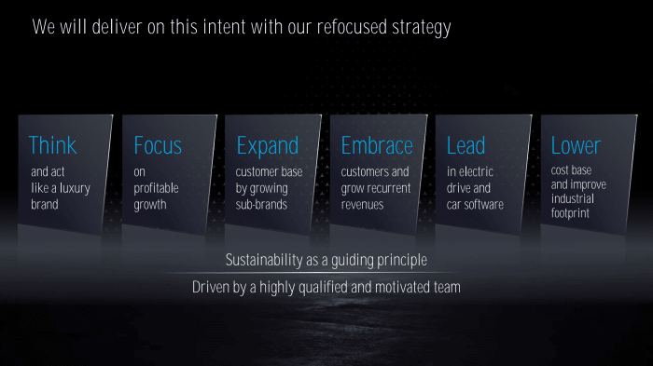
Source Google image (Mercedes Benz)
Below is an example of the 8steps change model:


Source google image (Kotter’s 8 steps change model)
It is important to have a vision and mission to implement any type of change in the industry as this gives the company a direction, a guide to accomplish their goals. Its important to have a structure of how these changes are going to be implemented in a given timeframe.

Leadership style
Solid administration and viable administration are crucial components of systems zeroing in on organizations' functional and monetary achievement. These might fluctuate across ventures and areas and be adjusted in light of the business needs. The organizations can pick whatever model of administration, or the board procedure best suits the prerequisite of their fragment of the economy and the climate they work in to arrive at their goals.

Mercedes Benz Leadership Style
Their principal administration style is Democratic. Their style is a mix of three styles.
To begin with, it is popularity based in light of the fact that no severe control is forced on the workers since they work dependent on sound rivalry very much like any sort of local area.
Furthermore, there are components of value-based administration styles since all working environment relationship is constrained by agreements and prizes.
Third, the company’s leadership style is partially transformational because the system of healthy competition implies the desire for self-development while the focus on individualism and teamwork are the constituents of the specific value system.
Finally, the style is as well laisses-faire because the company’s employees are granted freedom in their activities since it is operation under the healthy competition that determines, who has enough knowledge and skills to work for Mercedes Benz. In addition to it, employees are free to make offers on improving the performance of their company. It is motivated by the senior management’s openness and the fact that the interests of teams are taken into consideration when making vital decisions.
In this way, Mercedes Benz has fostered its remarkable initiative style which is portrayed by the consolidation of key components of different administration styles being scrutinized. The organization has figured out how to track down the ideal harmony between equitable, free enterprise, ground-breaking, and conditional styles. The spotlight is as yet made on the necessities and interests of workers and their activity under sound rivalry implies that the most persuasive part of the organization's authority style is majority rule.
Despite the fact that the way towards becoming novel and observing the right equilibrium was long and testing, Mercedes Benz has demonstrated that these are individuals, who are the most significant assets of an organization taking a stab at turning into a pioneer and that totalitarian authority styles are inadequate in the cutting edge universe of opportunity majority rules system.

Change management & organisation

Organisational Structure / Design
The leading group of the executives is responsible for separately overseeing and addressing the association in exchange with outsiders, while administrative board directs the arrangements of the leading group of the board individuals and oversees the executives.
Connection of both load up is limited significance you cannot be an individual from the leading group of the executives simultaneously as the administrative board as well as the other way around. Mercedes Benz - Daimler is at present exploring the fortifying the gatherings' divisional construction through the development of lawfully independent substances. The inspiration on the divisional construction is planned to assist with fortifying the future development and income in different business sectors. As a car maker Daimler faces explicit difficulties to this industry. (Daimler. N.d.)
Having a structure in a business is very important, a structure to a business is like a bone in a body, without bones in our body we will not be able to stand up, we will be a pile of flesh. A business needs a structure to keep it standing up strong in the industry.
Each part of an organisational structure plays an important part in the business, just like each bone in our body has a responsibility to help us to function properly and move around. You have to work hand in hand to build a strong foundation.
Organisational structure is important for any growing company such as Mercedes Benz, to provide guidance and clarity on responsibilities, and reporting relationships. It can serve as a roadmap for hiring employees and future expansion, it can improve decision making and help communicate effectively.
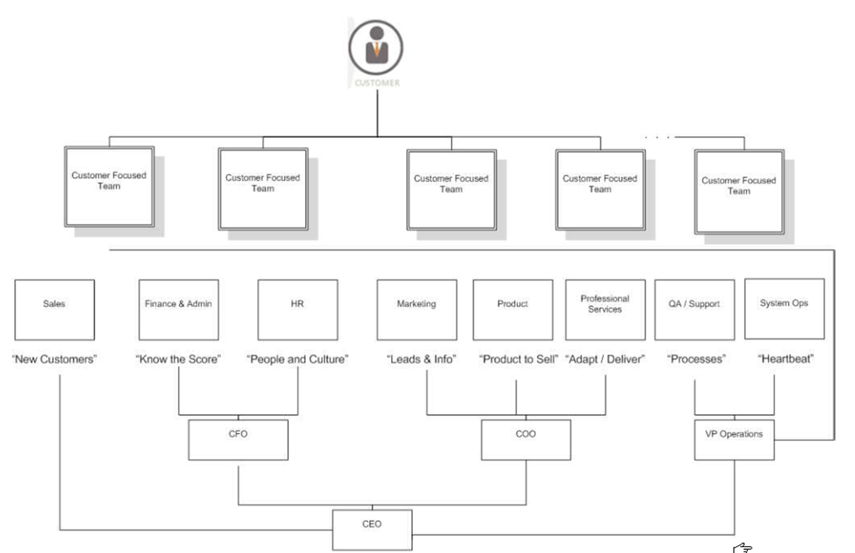
below are some examples of Mercedes Benz organisational structure.
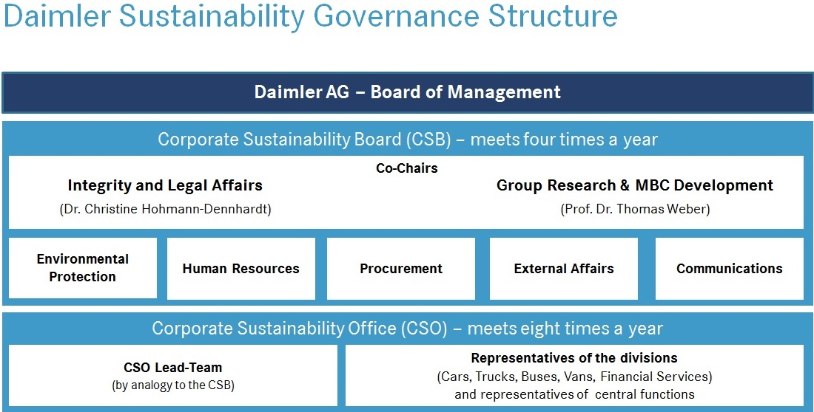
Source Google image (Mercedes Benz)
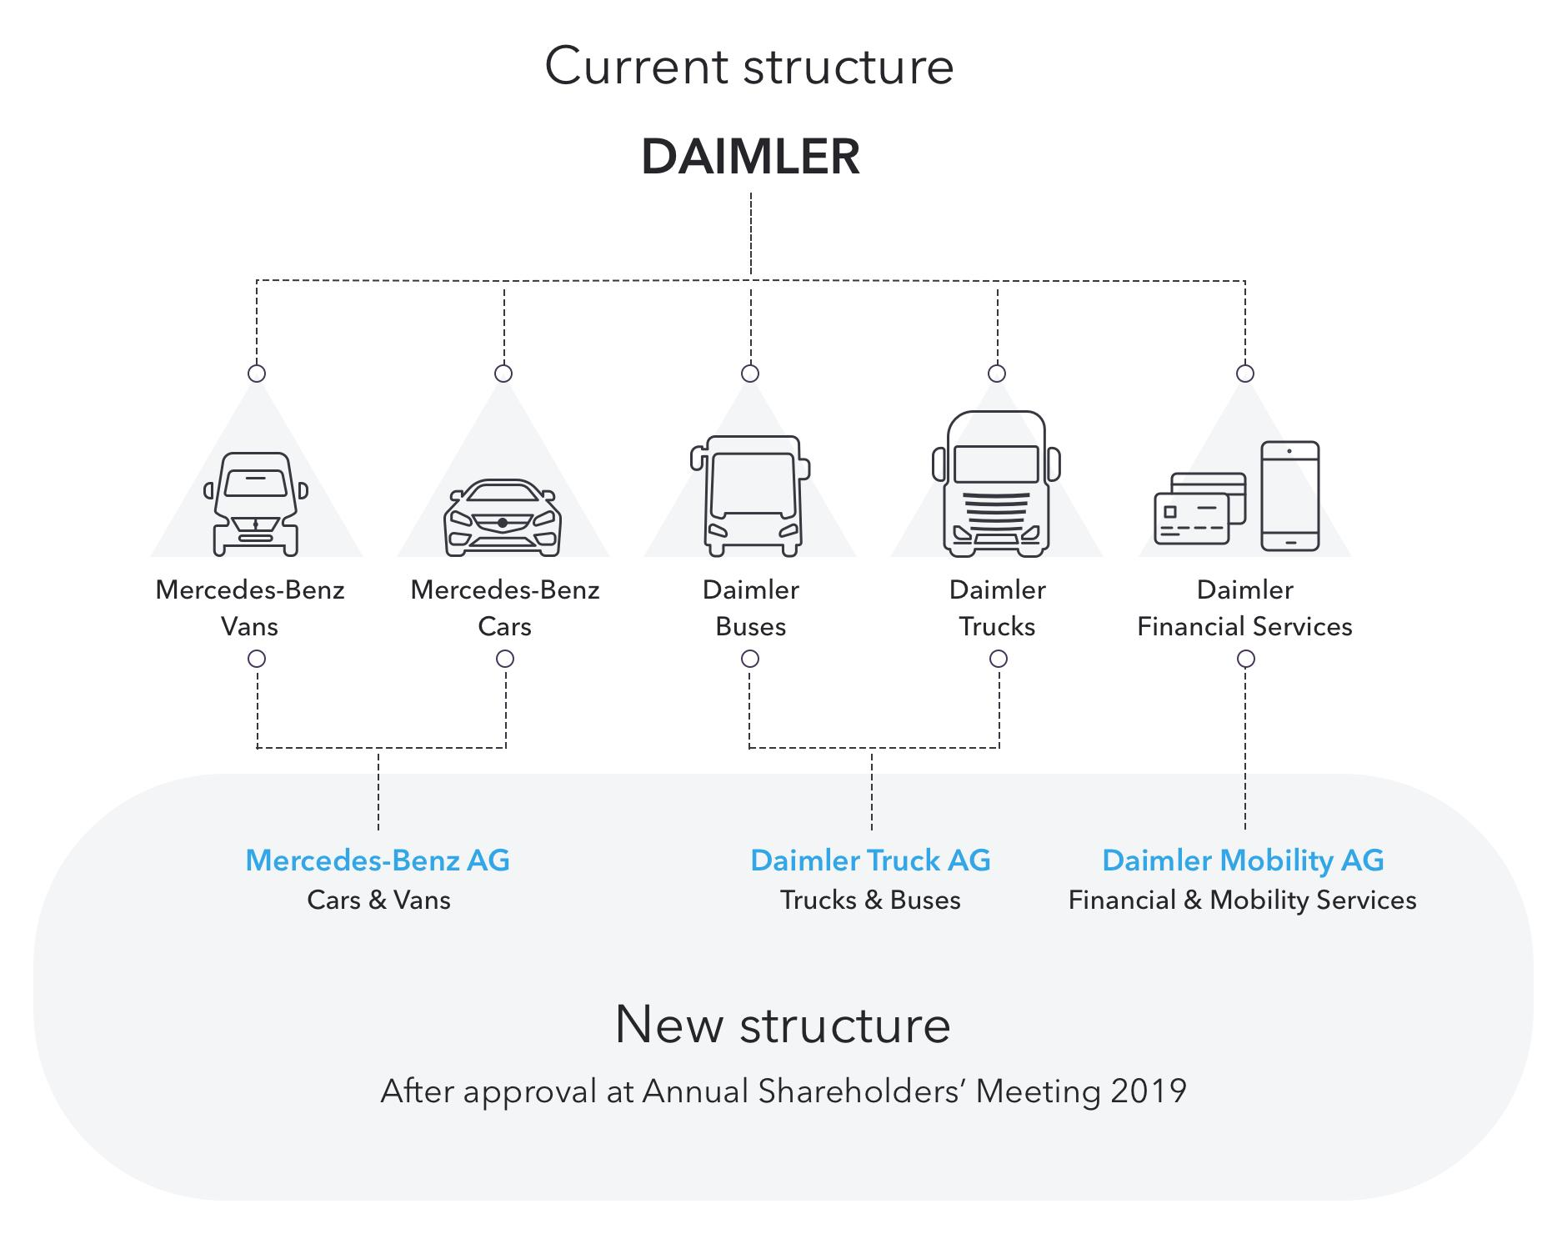
Source Google Image (Mercedes Benz)

Organisational Culture
Hierarchical culture of Mercedes Benz addresses the particular pre-characterized arrangements that give direction to the workers and provide a feeling of guidance. It is an intricate framework that contains the common convictions, qualities and presumptions and administers the business' conduct inside the association. These fundamental suppositions convictions and qualities add to the extraordinary and particular mental and social climate.
At Daimler there is one thing that is an unmistakable concentration for individuals. They take care of their workers from five ages and in excess of 150 countries and ensure they feel quiet with Mercedes Benz.
They guarantee that thoughts rapidly arrive at the top by empowering a culture of inventiveness and trust. They depend on the idea of co-creation, advance toward the top. Through an open culture loaded with innovativeness and trust.
They are expanding on the idea of co-creation, they will have the chance to flourish in different, interdisciplinary groups that permit them to take advantage of their natural abilities and set forward their thoughts uninhibitedly.

There are many advantages at Daimler from adaptable work time models, worldwide tasks and individual self-awareness freedoms to an assorted wellbeing and sports program and an appealing compensation with extraordinary advantages.

Meeting their objectives
Mercedes Benz will make moves to improve and recalibrate its market procedure. These will zero in on streamlining the harmony among volume and cost.
Extend client base by developing sub-brands, as its all around very notable, it will stay the directing star. The new technique will take them to a higher level-speeding up their turn of events, with clear designated plans to open their latent capacity.
Embrace costumers and develop intermittent incomes Mercedes Benz is focused on cultivating deep rooted associations with its clients. The point is to get clients to adore claiming a Mercedes Benz and to be fulfilled by the relationship that they stay with the brand for long as they can.
Lead in electric drive vehicle programming with goal-oriented item advancement targets and the sped-up presentation of innovation. They shift significantly a greater amount of its item advancement assets and skill to electric drive and will put resources into new innovations and ideas to speed up electric reach and effectiveness.
Cheaper base and work on modern impression, this will work on its productivity and money age and make moves to plan for the future and to speed up the progress to electric drive.
The new Mercedes Benz strategy and its financial ambitions will be a refocused approach and should deliver an improvement in commercial performance via better mix and pricing an improved product portfolio and growth in recurrent revenues.
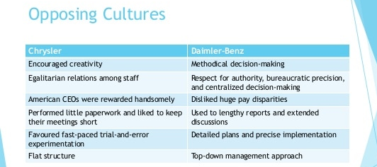

Source Google image (Mercedes Benz)

Reflection

Identified problem
The identified issue found for Mercedes Benz is that they have a big ambition where they have agreed to reduce emissions from the transportation sector by signing the climate pledge which calls on new signatories to be net zero carbon across their business by 2040- a decade ahead of the Paris agreement goal of 2050.
Mercedes Benz is committed to ambitious action to address climate change; they will continue to innovate and decarbonize the transportation sector and tackle the climate crisis.
They have also agreed to deliver 1,800 electric vehicles to amazon delivery fleet in Europe. The only issue that is seen if they fail to fulfil their promises and follow the regulations then they will be in big trouble.
They have rival company’s such as Audi, BMW, Hyundai etc that have already started their journey towards a more environmentally friendly vehicle. This can cause Mercedes to lose revenue and sales.
Since Mercedes is forever innovating and have a big, branded position I fell they will be able to succeed in their journey.
However, in a recent news article Mercedes Benz and other brands are among the car firms who have backed a pledge made at the COP26 climate conference to eliminate new car emissions by 2040- but most of the world’s largest manufacturers and several key countries haven’t backed the deal. The declaration was agreed by attendees at the United Nations climate summit in Glasgow and aims to help accelerate the transition to zero-emission vehicles. The non-binding pledge has been signed by groups including national, regional and local governments, car makers, fleet and mobility operators and investor in automotive manufacturers.
Mercedes Benz organisation prospective is that they have clear bold vision of where they want to be and they have a goal and step by step stages planned to get there. They are a strong company and know exactly what they have to do to meet the climate pledge zero-emissions position. Their roadmap to CO2 -neutral mobility is already in place and their commitment to meet their goals are also in place by 2040.

What I have learnt
I have how important it is to understand each step of the process of implementing a change and what responsibilities each stage has in the process of change.

What can I improve?
I feel I can improve myself on understanding the importance of process and have patience in the process regardless of how long it takes to get to my goal. Time is precious.

Consultant prospective
As a consultant of Mercedes Benz, looking at their whole strategy, plans, vision, goals and innovation, I feel they have got a very strong roadmap to get to where they want by the end of their set time of 2039. I can see the heart of Mercedes Benz is to transform the company to become the Number 1 for electric mobility and all-encompassing digitalisations. There is clear focus on the structural improvement of profitability, with sustainability as guiding principle. I feel the basis for the success of the new strategy is provided by their highly qualified and motivated team. With its focused and motivated team Mercedes Benz strategy should be able to deliver an improvement in commercial performance via better mix and pricing, an improved product portfolio and growth in recurrent revenues.
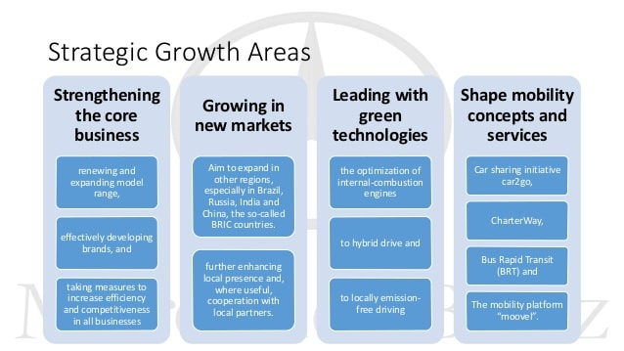

Current knowledge
It takes so much communication in a business to make things work. You must communicate with everyone involved in the business from your employees to your customers to your stakeholders etc. communication is key to a successful business. having a plan, vision and the right people in your business can take you far towards meeting your goals and making revenue.

New learning?
In order to be a successful business owner, you need a motivated team. Have a plan, think, focus, expand, embrace and then lead to the world.

What can be improve?
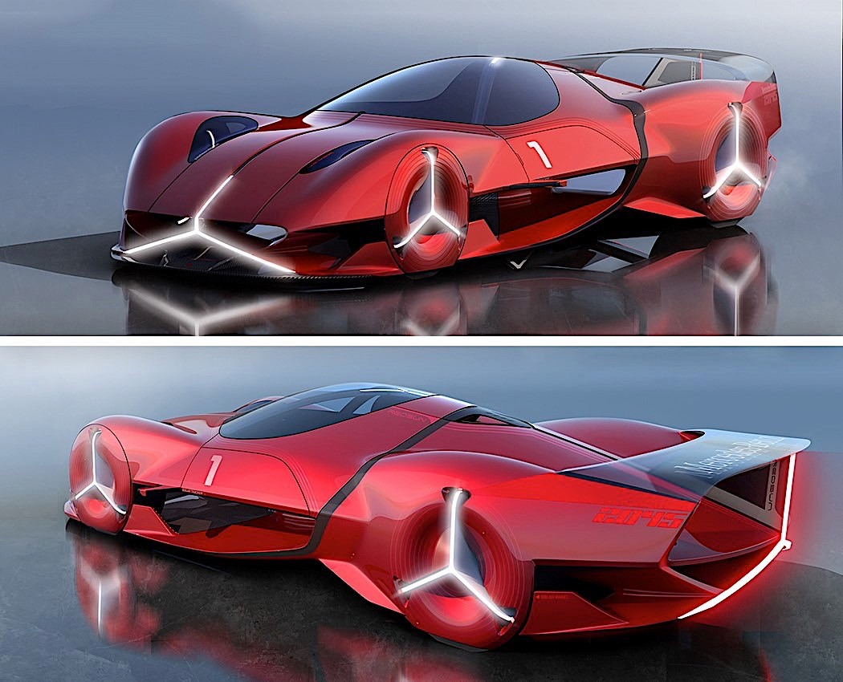
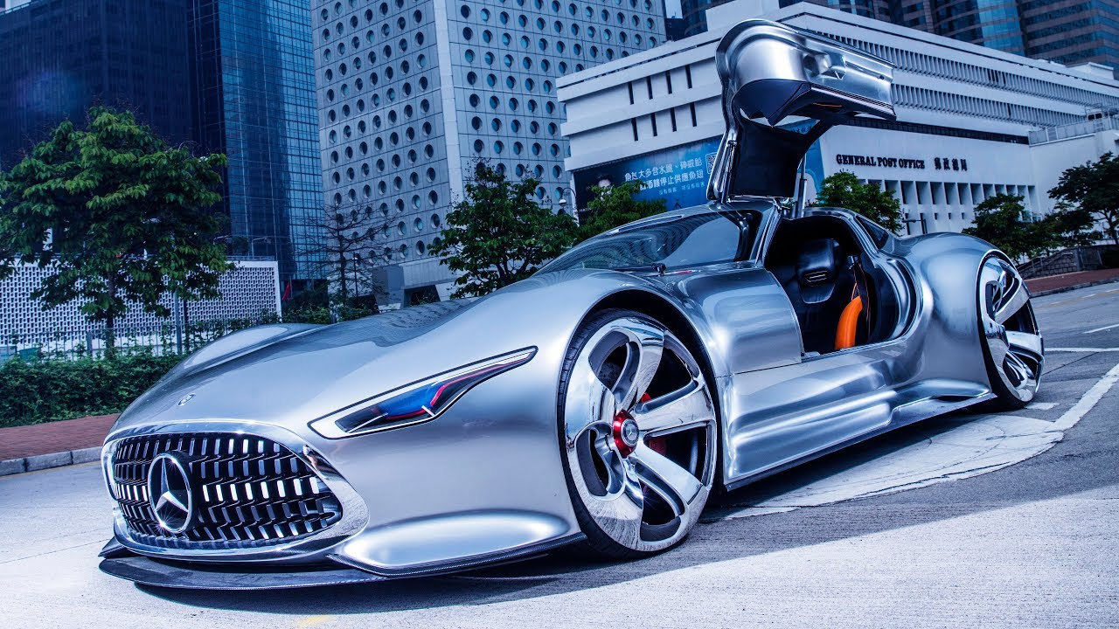
There’s always room to improvement, something can go right now and then also backfire so you will only learn from your mistakes, and that’s the key point in life, never give up always thrive to do your best. Accepting failure this is the only way you can move forward and learn.

References
Mercedes me media. (n.d.). Mercedes me media. [online] Available at: https://media.mercedes-benz.com/mbsu. [accessed on 29/11/21]

Kenton, W. (2021). Strength, Weakness, Opportunity, and Threat (SWOT) Analysis. [online] Investopedia. Available at: [Accessed on 29/11/21] https://www.investopedia.com/terms/s/swot.asp.

Shaw, A.A. (2021). SWOT Analysis of Mercedes Benz. [online] SWOT & PESTLE Analysis. Available at: https://swotandpestleanalysis.com/swot-analysis-of-mercedes-benz/. [Accessed on 1/12/21]

‌pestleanalysis.com. (n.d.). Mercedes-Benz SWOT Analysis 2021. [online] Available at: https://pestleanalysis.com/mercedes-benz-swot-analysis/. [accessed on 1/12/21]

‌Vizologi | rethinking business model design. (n.d.). Mercedes-Benz business model canvas. [online] Available at: https://vizologi.com/business-strategy-canvas/mercedes-benz-business-model-canvas/. [Accessed on 2/12/21]

Athuraliya, A. (2019). Business Model Canvas Explained | a Step-by-Step Guide with Templates. [online] Creately Blog. Available at: https://creately.com/blog/diagrams/business-model-canvas-explained/. [accessed 2/12/21]

Vizologi | rethinking business model design. (n.d.). business model canvas. [online] Available at: https://vizologi.com/business-strategy-canvas/n-business-model-canvas/ [Accessed 8 Dec. 2021].

‌TMQ Research. (2020). PESTLE Analysis Automobile Industry: Mercedes. [online] Available at: https://tmqresearch.com/pestle-analysis-automobile-industry-mercedes-uk/. [Accessed on 3/12/21]

‌Kenton, W. (2021). Strength, Weakness, Opportunity, and Threat (SWOT) Analysis. [online] Investopedia. Available at: https://www.investopedia.com/terms/s/swot.asp. [Accessed on 4/12/21]
‌ notesmatic. (2020). Mercedes-Benz five forces analysis. [online] Available at: https://notesmatic.com/mercedes-benz-five-forces- [Accessed 8 Dec. 2021].

Writers, T.Q. (2021). Mercedes-Benz Stakeholder’s Analysis. [online] Top Quality Writers. Available at: https://www.topqualitywriters.com/mercedes-benz-stakeholders-analysis/ [Accessed 8 Dec. 2021].

‌Daimler (2018). Daimler. [online] Daimler. Available at: https://www.daimler.com/investors/share/shareholder-structure/. [Accessed on 4/12/21]

https://www.apm.org.uk/resourses/what-is-project-management/what-is-change-management/
Free Essays. (n.d.). Mercedes Company: Leadership and Management Essentials - 3303 Words | Assessment Example. [online] Available at: https://ivypanda.com/essays/mercedes-company-leadership-and-management-essentials/#:~:text=That%20said%2C%20Mercedes%20Benz%E2%80%99s%20leadership%20style%20is%20a [Accessed 8 Dec. 2021].

ASQ (2019). What is Change Management? Organizational, Process, Definition & Tools | ASQ. [online] Asq.org. Available at: https://asq.org/quality-resources/change-management.

‌Team, B.P. (2021). 5 Reasons Organizational Structure is Important. [online] Balance Point. Available at: https://balancepointhcm.com/5-reasons-organizational-structure-is-important/#:~:text=Organizational%20structure%20is%20important%20for%20any%20growing%20company. [Accessed on 7/12/21]

‌Daimler (n.d.). Culture & Benefits. [online] Daimler. Available at: https://www.daimler.com/career/about-us/culture-benefits/#:~:text=There%20are%20many%20benefits%20at%20Daimler%20-%20from [Accessed 8 Dec. 2021].

‌Autocar. (n.d.). Major car firms fail to back COP26 EV pledge. [online] Available at: https://www.autocar.co.uk/car-news/industry-news-environment-and-energy/major-car-firms-fail-back-cop26-ev-pledge [Accessed 8 Dec. 2021].
‌

