LCCB4005 The Global Business Environment
Environmental Analysis of Automobile Industry

Impact of the pandemic on the automobile industry

Assignment 2

Student Name: Florentina Fistoleanu
Student ID: 2115309

Table of Contents
Introduction 3
Impact of the pandemic on automobile industry 4
Develop survival and success factors for automobile industry 6
The crisis as a chance: new opportunities for auto manufacturers 7
Strategies of Ford Motor Company in pandemic 8
Conclusion 10
References 11

Introduction
The benefits of globalization are being taken advantage of to the fullest degree feasible by international businesses. Extending beyond the boundaries of air, sea and land is what they're doing. Businesses are always looking to expand into new areas throughout the globe in order to boost their revenue and market share. However, despite the fact that internal markets provide a wealth of opportunities, companies face a variety of challenges and impediments when attempting to expand their operations. When it comes to automotive innovation and technology re-imagination, Ford is a global automotive leader (Harel, 2021). The study will focus on the impact of a pandemic on the automobile industry and on the success, criteria developed by Ford Motor Firm to assist the company to survive in a pandemic crisis.

Impact of the pandemic on the automobile industry
Covid-19 has an immediate and major influence on today's internationally linked automobile industry, and it will continue to have a rapid and dramatic impact in the foreseeable future. Initially, there were fears about a halt in Chinese component shipments, but the focus swiftly shifted to broad industrial disruptions throughout Europe as a result of the incident. Additionally, a global supply base that is becoming increasingly challenged is being placed under tremendous strain, in addition to the closure of assembly sites in the United Kingdom (Ha, 2021). Corporate covenants are at risk of being breached, putting them in a situation where they will be forced to seek financial assistance from financial institutions. Global demand will most certainly be harmed as a consequence of the pandemic's effect on the global economy, which will result in greater merger and acquisition activity as prospects for sector consolidation present themselves to private equity firms.
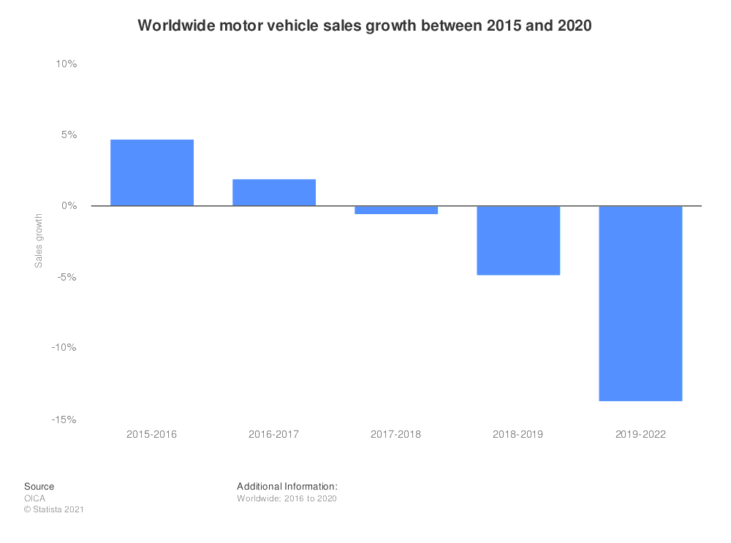
Figure 1 – Sales of motor vehicles worldwide from 2015-2022 (Duhan et al., 2020)
Predicted sales of vehicles worldwide would fall just short of 70 million units in 2021, down from 97 million units (cars and light commercial vehicles, of which 73 million were automobiles) in 2017, according to industry predictions (cars and light commercial vehicles, of which 73 million were cars). During the 2019-2022 period, revenue is expected to drop by 13.8 per cent, demonstrating the continuation of a declining trend that began in 2018 (Austin and Yan, 2020). The pandemic, of course, was the primary reason for this drop in the population.
Long-term impact on automotive companies
- An extended fall in consumer demand, which occurs while nations go through different lock-down scenarios, has the potential to trigger a worldwide recession, resulting in widespread loss of consumer confidence and a severe effect on car sales and profitability.
- Automobile manufacturers may be forced to curtail investment on research and development for advanced technology projects and other discretionary activities in order to support their ongoing operations in order to remain profitable.
- Therefore, it is likely that strategic choices to abandon unprofitable global markets and vehicle categories will be made more quickly, which will result, among other things, in a large reduction in production capacity due to the rationalization and consolidation of manufacturing capacity (Zhao et al., 2020).
- If market circumstances continue to worsen at their current pace, suppliers that are experiencing liquidity issues may yield to market demands, resulting in wide-ranging disruption and potentially devastating consequences throughout the whole global auto manufacturing ecosystem.
- There will likely be a large amount of reorganization in the vehicle retail industry, as a consequence of the incapacity of dealers to adapt fast enough to changing market circumstances.
BCGs flatten-fight-future method, which includes knowledge of classical shapes as well as a study of the multiple forms each shape may take, was utilized to estimate the predicted recovery from the current viral epidemic, according to the findings of the research (Sikich, 2020). A study was conducted to determine whether or not the attempts to flatten the curve and the following first dip in sales were connected. Aside from that, researchers looked at the length of the virus-fighting phase as well as the speed with which the infection may be suppressed.
In this study, researchers took into account the present epidemiology as well as factors that may have an influence on it, such as containment measures, regulatory restrictions on public life and industry, and advancements in healthcare delivery. Consumer and business confidence in the economy is eroding, consumption and investment are declining, insolvencies are on the rise, unemployment is on the rise, and the gross domestic product is shrinking (Oh et al., 2019). COVID-19, as shown by these four archetypes, has the potential to have an influence on the automobile sector in the future.

Develop survival and success factors for the automobile industry
The automobile sector, which is one of the world's biggest, is undergoing fast transformation. Customers' interactions inside and outside of their cars, as well as the performance of supply chains in a complex, global economy, are changing as a result of new technological developments. Increasing discretionary incomes in emerging markets, rising energy costs, and the introduction of new factors raise even more concerns.
The outbreak of the coronavirus has had a considerable detrimental impact on the industrial sector in recent years. OEMs and component suppliers have not yet fully recovered from the hurricane's effects and restored to full production capacity. As a result, there might be a broad variety of ramifications for the sector, including delayed new car model debuts, broken supply chains, financially drained SMEs, and lower vehicle sales in the first quarter of 2020, among other things (Rajabifard et al., 2021). Those ramifications will continue to echo into the second quarter, with unfulfilled orders being delivered as a result of the ongoing industrial slowdowns. Among other things, this scenario is projected to exacerbate the plethora of challenges that the automobile industry is presently dealing with, including higher CO2 emission standards and more expenditures on new technologies. Following the publication of three separate scenarios, it gives insight into the impact of a pandemic on international light vehicle production by major OEMs in important locations such as North America, Europe and the Asia Pacific, as well as China and India.

Strategic Imperatives
As a result of the worldwide COVID-19 outbreak and the ensuing recession-like global economic downturn, governments and markets have found themselves in a state of directionless confusion and uncertainty (Liebowitz, 2020). Companies and leaders in the face of a looming global recession, which has been exacerbated by the uncontrolled spread of the Coronavirus, always fail to make timely decisions, resulting in them losing out on prospective chances at a time of tremendous misery. As a result, a complete scenario-based study was carried out, which was concentrated on the current global situation in major sectors such as Automotive across numerous markets in order to help customers survive the present and prosper in the future.

The crisis as a chance: new opportunities for auto manufacturers
Looking toward the future, we anticipate that the present economic crisis will eventually come to an end and that the car industry will look quite different in the post-Covid-19 period. In recent years, the industry has undergone a true globalization process, with everything from production networks to supply chains and highly advanced logistical systems, to mention just a few instances. According to Jedynak and Buk (2019), customers also have an almost endless number of specific types to pick from (particularly when it comes to German OEMs). Most businesses were able to preserve their competitiveness via gradual efficiency improvements and reasonable risk management, according to the findings of the study. During the post-coronavirus era, it is quite likely that this will change.... By building regional or even local manufacturing networks, OEMs have the ability to lessen their dependency on global supply chains and cut their costs. Along with local supply chain networks, warehouse and reserve planning are significant concerns in the manufacturing industry.
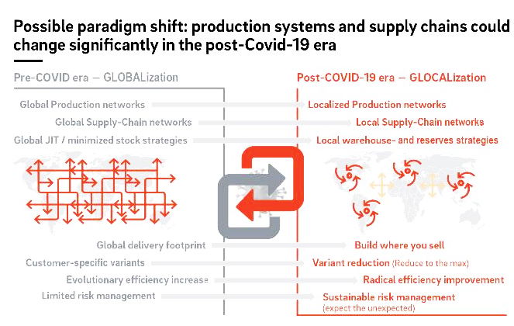
Figure 2 – Possible changes in the system considering COVID-19 (Harel, 2021)
There must be a fundamental shift in business models and new, innovative approaches to boost efficiency in order for the current system to work. It's important to promote the use of agile working methods, streamline existing processes and decision-making pathways, take advantage of digitalization's advancements, and reduce capital expenditures for individual companies. Examples of these include strengthening partnerships and collaborating across companies (Ha, 2021). Businesses now have the chance to experiment with new approaches to existing problems in order to stay afloat in the face of the crisis.

Strategies of Ford Motor Company in pandemic
Ford's creative move is only the latest example of a brand altering its approach in reaction to the epidemic, which has occurred several times. Brands including KFC, Hershey, Coors, and Axe have either withdrawn their advertisements off-air or put a stop to the release of new campaigns in recent weeks due to fears about being associated with the fatal illness. When it comes to marketing in general, marketers are taking additional pains to avoid coming out as tone-deaf or insensitive during the epidemic.
Globalization is the reduction of trade obstacles that exist beyond national borders in order to promote interdependence, integrity, and interconnection of capital assets and the manufacturing process. It is sometimes referred to as "trade liberalization." In a complicated way, it facilitates the movement of resources, currency, and the import and export of commodities across several nations, hence promoting economic development and global commerce (Duhan et al., 2020).
Consumer Needs
Customers are increasingly disinclined to acquire automobiles that are not fuel-efficient, according to recent research findings. Because of both economical and ethical factors, this has been decided upon. In the face of rising gas costs, people are becoming increasingly concerned about fuel economy, and governments are ready to provide incentives in return for customers purchasing more fuel-efficient automobiles. There is a societal interest in boosting the total use of sustainable energy sources since the economy of the United States is dependent heavily on fossil fuel use – and because fossil fuel sources are becoming scarcer across the globe. Ford must not just admit but also embrace this new reality if it wants to stay competitive in the long run.
If Ford does not respond swiftly to address this evolving customer demand, domestic and international automakers will gain a competitive advantage (Blakeslee et al., 2012). GM is the leader in big hybrid car models and continues to introduce new hybrid vehicles every year. It has been made obvious by China's government and local automakers that they plan to become their country the world's next hub for hybrid and light vehicle development. As the clock continues to tick down, Ford's window of chance is becoming smaller.
Sustainability at Ford
It's imperative that Ford devote resources to developing environmentally friendly vehicles in all vehicle classes. These models must be contrasted to their conventional counterparts when it comes to ticket price. Customers should not be saddled with new operational issues, expenses, or maintenance difficulties as a result of Ford's technological advancements.
The development of hybrid cars, natural gas vehicles, and electric vehicles are examples of sectors that have the potential to be beneficial. While other alternative fuel vehicles need a more complicated infrastructure, electric and hybrid vehicles are the most straightforward (Austin and Yan, 2020). Priority number one is to establish and expand Ford's hybrid car fleet, even if all alternatives must be studied. According to Ford, its hybrid program is already a long way along, and it would need a less amount of money to keep developing.

Conclusion
Although the Ford Motor Corporation confronts huge challenges, the company is certain that it will overcome them via innovation and a deeper commitment to environmental and financial sustainability (Amann and Stachowicz-Stanusch, 2012). Ford has been a revolutionary force for most of its history, and it is only via comparable severe revolutions and breakthroughs that Ford will be able to contribute to the ushering in of a new era in the worldwide automotive industry.

References
Amann, W., and Stachowicz-Stanusch, A. (2012). Business integrity in practice. Business Expert Press.
Austin, L., and Yan, J. (2020). Social media and crisis communication.
Blakeslee, K., Patel, D., and Simon, M. (2012). Crisis standards of care. National Academies Press.
Duhan, P., Rajpal, A., and Agrawal, P. (2020). INDIAN AUTOMOBILE INDUSTRY: POST-COVID CHALLENGES AND STRATEGIES. International Journal Of Social Science And Economic Research, 5(7), 1730-1747. https://doi.org/10.46609/ijsser.2020.v05i07.006
Ha, G. (2021). Comparative Analysis of Management Efficiency of the Automobile Industry before and after COVID-19. Regional Industry Review, 44(3), 307-325. https://doi.org/10.33932/rir.44.3.13
Harel, R. (2021). The Impact of COVID-19 on Small Businesses’ Performance and Innovation. Global Business Review, 097215092110391. https://doi.org/10.1177/09721509211039145
Jedynak, P., and Bąk, S. (2019). Risk management in crisis.
Liebowitz, J. (2020). The business of pandemics.
Oh, M., Dohner, R., and Herr, T. (2019). Global value chains in an era of strategic uncertainty.
Rajabifard, A., Paez, D., and Foliente, G. (2021). COVID-19 Pandemic, Geospatial Information, and Community Resilience.
Sikich, G. (2020). Protecting your business in a pandemic. Praeger.
Zhao, S., Wong, J., Lowe, C., Monaco, E., and Corbett, J. (2020). COVID-19 pandemic, crisis responses and the changing world.

