Laurice Keogh (2115745)
uwtsd

Usability Engineering
ACCB6017
Contents
Table of Figures 1
Introduction 2
Design Storyboards 3
Start-up page 3
Rotate Screen Message 4
Home page 4
Game mode 4
Game Type 5
Create/Join Game 5
Lobby 5
Single player (with bots) 5
‘Pass the device’ players 6
Global Lobby 6
Friend lobby 6
Shake device message 7
Game arena 7
3 Bad grades result 8
Modules collected 8
Other player’s turn 8
Winner screen 8
Loser screen 9
Feedback Collection and Analysis 9
Data Collection for a Working Version 10
Balancing Usability and User Experience 11
Conclusion 12
References 12
Appendices 13
Appendix A: Full-colour storyboard designs. 13
Appendix B: Personas 18

Table of Figures
Figure 1 - Start up screen 4
Figure 2 - Rotate screen message 4
Figure 3 - Main Menu 5
Figure 4 - Main Menu 5
Figure 5 - Game Type 5
Figure 6 - Create/Join Game 6
Figure 7 - Single player (with bots) 6
Figure 8 - 'Pass the Device' 7
Figure 9 - Global lobby 7
Figure 10 - Friend lobby 7
Figure 11 - Shake device message 7
Figure 12 - Game arena 8
Figure 13 - 3 bad grades result 8
Figure 14 - Modules collected 9
Figure 15 - Other player's turn 9
Figure 16 - Winner's screen 9
Figure 17 - Loser's screen 9
Figure 18 - How to play 14
Figure 19 - How to play (continued) 14
Figure 20 - Global leaderboard 14
Figure 21 - Friend Leaderboard 15
Figure 22 - Settings 15
Figure 23 - Profile page 16
Figure 24 - Change password 16
Figure 25 - Change profile icon 17
Figure 26 - Log out confirmation 17
Figure 27 - Achievements 18
Figure 28 - Error message 18
Figure 29 - Sign up page 19

Introduction
This project is inspired by the popular dice game ‘Zombie Dice’. Key concepts of this game are used to form the new UWTSD themed game ‘Scholar Scramble’. In a previous report the initial wireframes were created and evaluated through gathered feedback. The following report offers improvements to the initial wireframes in the form of full-colour storyboards, including showing the path of the user, prioritising usability features and user experience.
The usability of the mobile game is a top priority as it helps keep users engaged through familiarity. Good game usability is achieved by having thoughtfully considered [1] interface design, navigation, and error feedback/response. User Experience is also a priority as it reflects on the user’s engagement and enjoyment. [2] This is done by having an intuitive and easy to use game, lessening the need for cognitive load. The usability and user experience should be investigated for a diverse group to allow maximum inclusion. [3] Nielsen’s heuristics (Nielsen, 1994) and [4] Norman’s 3 levels of emotional design (Norman, 2004) are key to ensuring key functions and elements are included to produce a game that satisfy the target users. Furthermore, the collaboration of usability and user experience allow for positive responses.
This report later details the storyboard feedback methods, results, and a discussion of data collection from the working mobile game. The report is concluded with a reflective summary on the mobile game in line with usability and user experience.

Design Storyboards
These storyboards are mobile phone shaped because most people game via this device according to prior research. The storyboards were created via [5] ‘miro’ where they provide the mobile phone shape and all icons apart from the logo/page headers which were created first hand, and the rotate phone image taken from [6] vecteezy. The background of the game is a deep teal colour which reflects the colour of UWTSD graduation robes. All text is displayed on a light background such as the light brown frequently used, this is because it is still very contrasting and easy to read the writing but according to [7] W3C it can help people who have dyslexia. When dice are rolled an animation will play, but this can be turned off for personal preference. When a button is clicked everything around it will dim for 0.5 seconds to make the selection stand out. There is a back button on all pages applicable, in the same space for consistency as this was appreciated in the prior feedback. Based on feedback from Robert previously, screen reader and voice control has been added to the game where players can say the words on the buttons to navigate. This is a feature that can be turned on in settings. Other storyboards are detailed in appendix A.

Start-up page
The theme colour and the logo are in the centre/line of sight. This page allows the user to recognise that their command is being followed and indicates which game they are playing. The progress bar animation is a new addition and indicates how far loaded the game is, avoiding irritation.
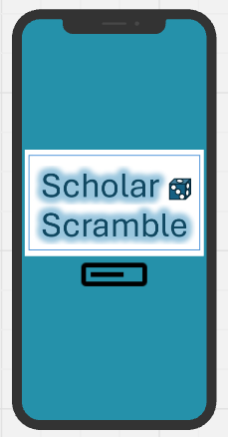
Figure 1 - Start up screen

Rotate Screen Message
Like the initial wireframe the users are directed to rotate their phone, but the storyboard offers image guidance as well as the text for more clarity.
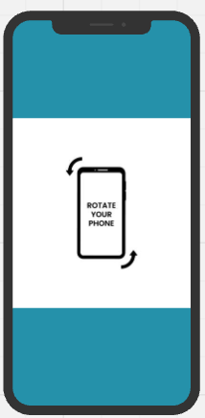
Figure 2 - Rotate screen message

Home page
Users are then taken to the home page. The same options as the wireframe are shown as well as the new profile icon as per ‘Laura’s’ request in the wireframe feedback. Profile allows personal details to be viewed and changed. The buttons are shaped like dice adding an element of fun. The play button takes you to game options followed by the game arena, the rules explain how to play, the leaderboard shows global and friends’ ratings, and settings allows game customisation.
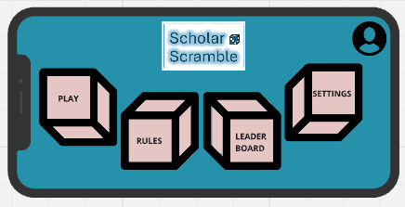
Figure 3 - Main Menu

Game mode
After clicking ‘play’ the users are asked to choose a game mode. All text is on contrasting background to easily read. The capital letters reflect main titles, and the standard represents descriptions. The wireframe format was kept due to positive feedback from both personas. The page title is in the style of the game logo for familiarity. The buttons are coffee cups because coffee is an icon on the dice. The options are single player, pass and play, multiplayer online and multiplayer friends.
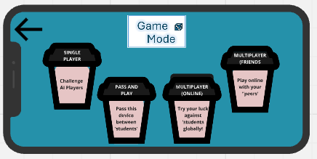
Figure 4 - Main Menu

Game Type
Users selecting a local game (single player/pass the device) are taken to the game type page. There are only two buttons for simplicity and lesser cognitive load. The buttons reflect degree certificates. Users can play a classic or quick play game. Quick play was a desired feature by most people in prior feedback due to short gaming sessions.
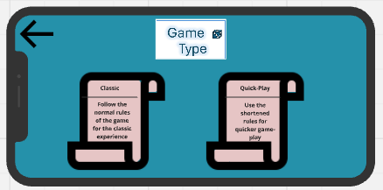
Figure 5 - Game Type

Create/Join Game
Multiplayer gamers (online or friends) are directed to the create/join a game page. The layout is the same as the wireframes. Users can generate a code to share or enter a friend’s code.
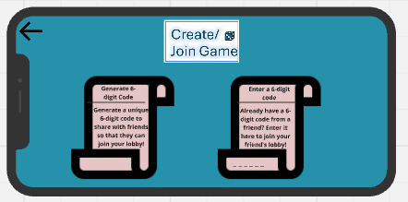
Figure 6 - Create/Join Game

Lobby
There is a different lobby style depending on which game mode was selected. This is the same concept as the wireframes. Any names added can be typed in on device keyboard, or if using the voice control option users can say ‘add’ followed by a name/bot.

Single player (with bots)
The minimum players are in bold text. Additional bot players can be added by tapping add bot player and choosing an intelligence level. The play button is very clear in the top right corner as the familiar dice. The small arrows clearly indicate a drop-down menu feature as an intuitive design.
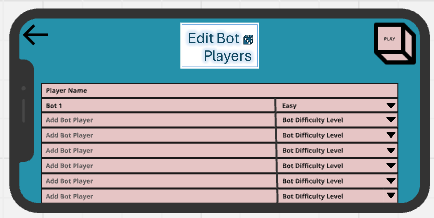
Figure 7 - Single player (with bots)

‘Pass the device’ players
A similar layout is followed for the pass the device lobby. Two player names must be entered highlighted by the bold text. Other players can be added by tapping to add player.
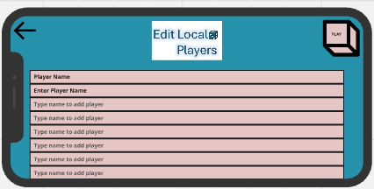
Figure 8 - 'Pass the Device'

Global Lobby
A similar layout is on the global lobby, but it automatically populates the players.
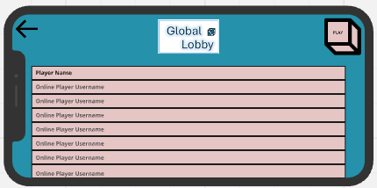
Figure 9 - Global lobby

Friend lobby
A similar layout is on the friend lobby, but it automatically populates the players.
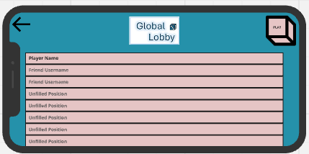
Figure 10 - Friend lobby

Shake device message
In the place of the page title, the pop-up message about shaking the device to roll is displayed for 5 seconds. This has been added after Robert advised this feature needed to be made clear.
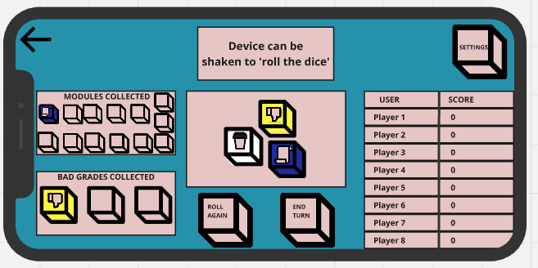
Figure 11 - Shake device message

Game arena
Laura liked being able to access the settings from the game arena, so this has been kept. All buttons except the back button are displayed as dice for familiarity. The buttons include settings, roll again, and end turn. Laura also appreciated the current player’s name being displayed. The dice colours have been chosen as they represent the UWTSD theme. The 13 modules and 3 bad grades are blanked out until they are collected. Scores are displayed in the table. The dice move in an animation when the player rolls. White dice represent the safest while yellow represents the hardest.
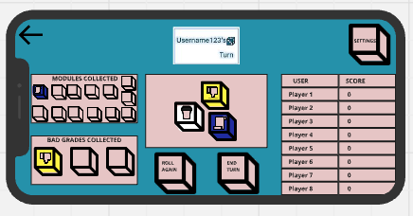
Figure 12 - Game arena

3 Bad grades result
When three bad grades are collected all 3 dice are coloured and two buttons get replaced by a message indicating they didn’t collect points and whose turn it is next. No buttons need to be pressed.
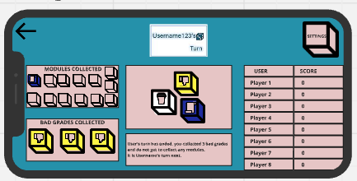
Figure 13 - 3 bad grades result

Modules collected
Either after the 3 rolls or when the player decides not to roll, a message is displayed saying how many modules have been collected and whose turn is next. It also updates the score table.
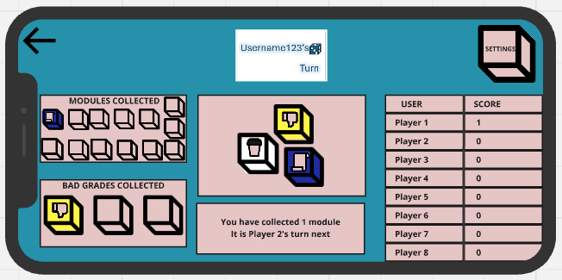
Figure 14 - Modules collected

Other player’s turn
If it is not your turn, there are no game buttons to press as they are replaced by a message indicating that it is not their turn for further clarity.
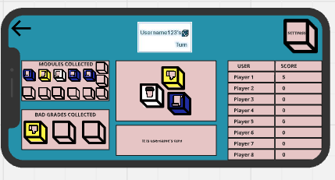
Figure 15 - Other player's turn

Winner screen
If you have won the game, the dice arena gets taken away and replaced by a message congratulating you. A die appears at the bottom to return to the main menu, and all other buttons are removed for clear path.
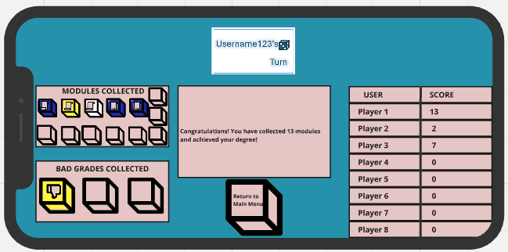
Figure 16 - Winner's screen

Loser screen
If someone else has won, you are commiserated and must click the return to main menu button.
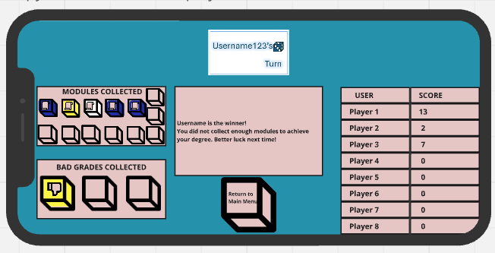
Figure 17 - Loser's screen

Feedback Collection and Analysis
Storyboard feedback was collected in the same format as the wireframe feedback. The same 6 people were tested for consistency in the personas and the results. The benefits of using the personas ‘Laura’ and ‘Robert is that between them they cover diverse usability levels and preferences. These users would notice where their feedback has been implemented and offer further improvements. The storyboards were printed out in full colour, and each one was in proportion to an iPhone 16 for text readability testing. All feedback was verbal and recorded, after analysis it was deleted for data protection.
Both Robert Laura appreciated the order of the settings features being moved, grouping slicers and having similar features together.
Laura appreciated the page name shown for clear navigation, and buttons being in consistent places. Laura advised moving the achievements from being accessed via a small button on the leaderboard page, to being accessed through the profile section which was not available before. Laura likes the new profile section because it adds a personalisation element, heightening engagement. Laura is enticed by collecting badges. Laura appreciated buttons being changed to fit the theme like dice, coffee cups, and degree certificates. Laura believes that the game arena buttons should be coffee cups so that the counters aren’t also confused for buttons. Laura thinks the layout has a good balance of fun and simplicity for ease of use.
Laura did not like the placement of the pop-up message about shaking the device to roll, it would be better suited in the how to play with a reminder in the blank space on the page so that the player’s name isn’t covered at all. Laura liked the achievements having a progress indicator but would prefer having a progress bar and percentage as it is more visually interesting.
Robert noted a preference for voice control for the game and was delighted with this being an option to turn on in the settings page. Whilst Robert could not try the voice command feature due to being printed on paper, he appreciates the inclusion. Whilst a text reader wasn’t desired by Robert, he also appreciated this functionality when considering their friends. Robert appreciated the inclusion of the pop-up for shaking the device.
Robert would prefer one icon for buttons such as just using dice or just using coffee and it would prevent any confusion and offer consistency. Robert would prefer to be able to turn the shaking the device option off in settings as he feels he would shake it accidentally and ruin his game. The log in should be clearer because the multiplayer games cannot be played without logging in, but you are only directed to create an account after having an error message pop up which whilst it is informative it is also negative feedback. Text should be in a consistent format, such as all buttons labelled in capital letters.
Based on the feedback the main features to change before the working version is released would be placing the ‘shake to roll’ message in the how to play/rules page with a reminder in the blank space on the game arena page. Another change would be to add in a slicer on the settings page to turn off the ‘shake to roll’ function. On the first load up of the app there should be an account creation page to avoid any errors later when trying to play online. The achievement progress would be changed to be shown as a progress bar per Laura’s preference. All buttons should be changed to have capital letters for consistency. The game arena buttons should be coffee cups.
These results were mostly to be expected such as liking the consistent buttons, and the shake to roll function. Robert’s preference for the inclusion of voice control was not previously anticipated but its inclusion is important to having a wider user base. Robert also mentioned the need for a clearer log in process which is understandable as error messages whilst productive can be seen as negative.

Data Collection for a Working Version
Once the working mobile app is rolled out, to make informed improvements in the future, data collection is essential. Usage data and emotional data should be collected to inform these changes. Usage data involves tracking time (session length, time per game), user retention, button usage, metrics for different game modes, and counting incomplete games. Software such as [8] GameAnalytics can be installed to measure these metrics automatically. These features will show an analyst which aspects of the game are popular/essential, and aspects need refining. Retention and session frequency will inform the analyst of how engaging the game is.
Whilst functionality and usability are important, it is also important to measure emotional responses because games should require a low cognitive load for optimal enjoyment. A manual data collection method can be through an in-game pop-up inviting users to complete an optional questionnaire. The questionnaire could ask them to rate their mood, the navigation, whether any elements are confusing, and what their overall experience is. This feedback is anonymous allowing for more honest qualitative feedback, which automatic data capture cannot predict/uncover. [9] Software like Qualtrics allows the creation and storage of the in-game surveys, and results can be easily downloaded. In a controlled room, a range of users could be observed playing the game using eye-tracking software. Software like [10] imotions can track the movements of a user’s eye through a camera. Eye tracking shows the focus of the user’s attention and would highlight whether essential information/actions are found instantly or if the user is searching for them. Eye-tracking can be done using the mobile phone inbuilt camera for this experiment. Intuitive design leads to a good emotional response and eye trackers will reveal any areas for improvement. An additional software in relation to eye tracking is [11] affectiva, which uses facial recognition to analyse the user’s feelings, tracking subtle facial movements.
The combination of both automatic and manual data collection methods will inform decisions on where to alter the game in future releases. Usage data will identify the pages/buttons that are not being used often and investigation could see them moved to more visible areas. Features such as voice control can be tracked such as how often it is used, and whether these players are gaming for shorter periods/abandoning games showing frustration with the software. Negative emotions can be seen if users are terminating gameplay in the same place. Negative feedback from manual data collection is more specific and improvement areas can be easily identified such as having too many buttons or a cluttered page layout. Covering these aspects will ensure the game is user friendly to all abilities, engaging to all demographics, and is usable by everyone regardless of disabilities. [12] In line with the ICO Guide to Data Protection, all person identifiable data gathered in these tests should be discarded as soon as possible such as any video footage should be discarded but their tracked movements can be stored for analysis.

Balancing Usability and User Experience
Usability and user experience are both key elements to having an easy to use but engaging game. It can be difficult to get the balance right without making it too difficult or too boring. [3] Jakob Nielsens’s 10 heuristics for usability design emphasise the importance of elements such as user control including having appropriate exit buttons for when users make a mistake like ‘Scholar Scrambles’ consistent back buttons. Another is having consistency so having buttons labelled as the same thing consistently, an example of this is having settings called ‘settings’ everywhere mentioned. Another example is keeping buttons the same shape/size/colour for consistency. This is a conflict between usability and user experience because Laura appreciates the use of different shapes for the buttons for engagement purposes, but Robert would prefer the simplicity of one shape for buttons. This can be addressed by choosing a dice shape for all buttons but changing the colour. [3] Nielsen also advises that only necessary information is included, because unnecessary features add to cognitive load. This is another conflict because Laura appreciates the profile section of the account and the engagement involved with unlocking badges, whereas if this game was based on usability alone it would be deemed unnecessary and weaken the positive engagement features of the game. The impact that prioritising only usability has on user experience is that there could be a lack of colour, pictures, and too much text which would further deter users.

Conclusion
Usability and user experience were the top priority when designing Scholar Scramble. User feedback was crucial for developing the wireframes and storyboards because they mitigate issues before game release. The designing process proved that users like iterative navigation, as expected, but also some unexpected recommendations such as voice control. [4] Norman’s emotional design framework proved that a visually exciting game helps establish emotional connection, while [3] Nielsen’s heuristics offered key insights into usability and intuitive controls. Overall, this project has highlighted the need for user feedback because this provides perspectives not yet considered in the design. It has also shown functionality and engagement when carefully balanced, create a successful game like Scholar Scramble.

References
Bibliography
[1]
A. Suleiman, “What Is Usability And Why Does It Matter In App Development? | UX 4Sight,” ux4sight.com, Jan. 23, 2023. https://ux4sight.com/blog/what-is-usability-and-why-does-it-matter-in-app-development
[2]
UXPin, “Game UX — Blending Game Design and User Experience,” Studio by UXPin, Feb. 20, 2023. https://www.uxpin.com/studio/blog/game-ux/
[3]
J. Nielsen, “10 Heuristics for User Interface Design,” Nielsen Norman Group, Jan. 30, 2024. https://www.nngroup.com/articles/ten-usability-heuristics/
[4]
Achintha Isuru, “Don Norman’s 3 Levels of Emotional Design - Bootcamp - Medium,” Medium, May 15, 2023. https://medium.com/design-bootcamp/don-normans-3-levels-of-emotional-design-95706dd69a47 (accessed Jan. 10, 2025).
[5]
L. Keogh, “Scholar Scramble Storyboards,” Miro.com, 2025. https://miro.com/app/board/uXjVLxb0NP4=/ (accessed Jan. 10, 2025).
[6]
Muhammad Rizal Abdie, “rotate your phone icon. rotate your smart phone orientation vector icon symbol,” Vecteezy, 2024. https://www.vecteezy.com/vector-art/32838049-rotate-your-phone-icon-rotate-your-smart-phone-orientation-vector-icon-symbol (accessed Jan. 10, 2025).
[7]
“Optimal Colors to Improve Readability for People with Dyslexia - Text Customization for Readability Online Symposium,” W3.org, 2012. https://www.w3.org/WAI/RD/2012/text-customization/r11
[8]
“GameAnalytics | Player Tracking & Analytics - 100% Free,” GameAnalytics. https://gameanalytics.com/
[9]
Qualtrics, “The Leading Research & Experience Software | Qualtrics,” Qualtrics, 2024. https://www.qualtrics.com/
[10]
“iMotions: Unpack Human Behavior,” imotions. https://imotions.com/
[11]
“Home - Affectiva,” Affectiva, 2017. https://www.affectiva.com/

Appendices

Appendix A: Full-colour storyboard designs.
How to play
The buttons to click to the walk-through tutorial and the video tutorial are clear, well positioned, and a familiar button, the ‘degree paper’. There is a scroll bar to prevent the need to click to read more information. Scroll bars are familiar and intuitive. The text is split up into bitesize sections for better readability.
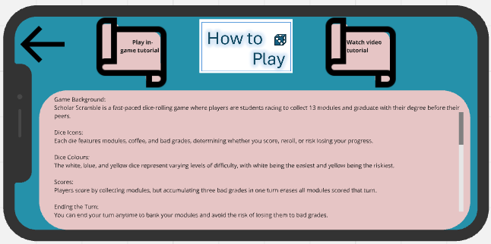
Figure 18 - How to play
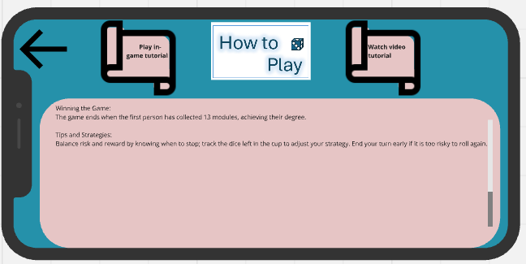
Figure 19 - How to play (continued)
Global leader board
There is one leaderboard page, but the toggle changes the view between global and friend leaderboards. The selected page is the same colour as the table, and the heading is also underlined for further clarity. There is a ranking order in the first column which is a new feature. The usernames and scores and clearly shown. There is another scroller which is a familiar tool on websites and mobile devices, and this feature is new because it lessens the cognitive load having less buttons.
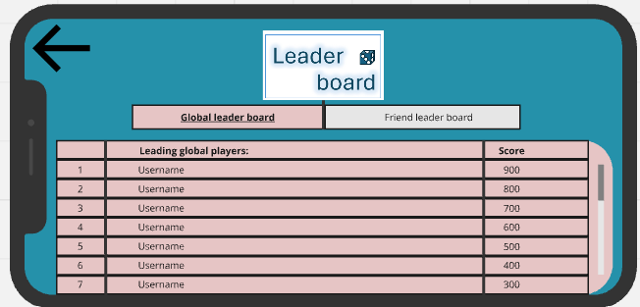
Figure 20 - Global leaderboard
Friend leader board
The friend leader board follows the same concept as the global leaderboard page.
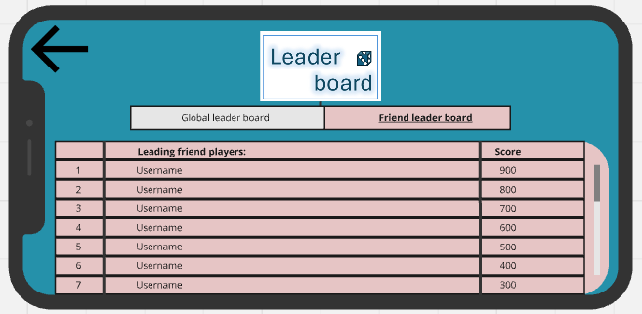
Figure 21 - Friend Leaderboard
Settings
The settings page received constructive criticism from the user feedback which included grouping all the settings with slicers to be grouped together. The order was carefully considered to have similar functioning options next to each other. The full colour story boards allow the toggle to be the familiarly used brown colour when on, and a dimmed out grey colour when they are off. The voice control option is new based on prior feedback because some users would benefit from playing hands free. When this option is turned on the game can be navigated by commands. For those who have visual impairments the screen reader has been added since the wireframes as it will describe everything. The profile page is also accessible from within the settings because it is a page that allows for further game customisation such as with the profile picture page.
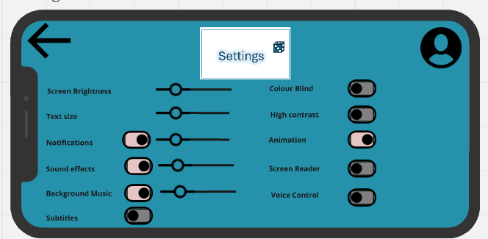
Figure 22 - Settings
Profile Details
The profile section was creation due to a suggestion from ‘Laura’ who thought that the achievement page would be better suited in a more personal section than a branch off the leaderboard page. All personal details are displayed on the last hand side of the page. Familiar buttons with the bold outline such as the dice and the achievements are easily recognisable as buttons to click. The dice allow the user to change their password if they have forgotten it, alter their profile picture that is shown on the centre of the page, and log off if they wish to do so. The other button is the winners cup which takes the user to view their achievements. The profile pic is changeable for an element of personalisation and increased engagement.
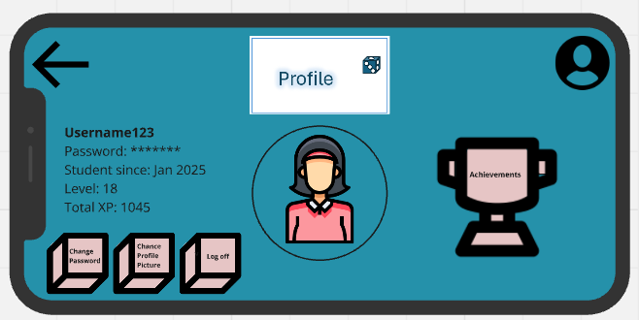
Figure 23 - Profile page
Change password
If the user chooses to change their password, they can find the 6 digit code sent to their email address and then type their new password twice. The confirm button is familiar and clear.
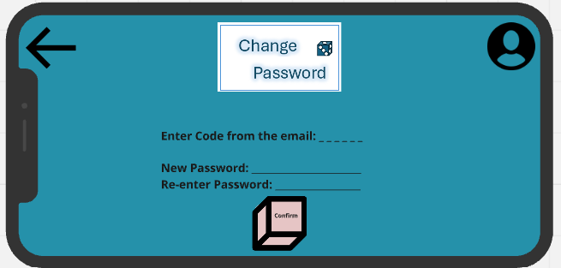
Figure 24 - Change password
Change profile icon
The currently selected profile icon is large on the right side of the screen. It also has a coloured background in its position by the other avatars. It is important to have a personalisation element because it keeps engagement. This was not requested in the user feedback, but it is mentioned by Nelson when talking about emotion. The confirm button is familiar and clear.
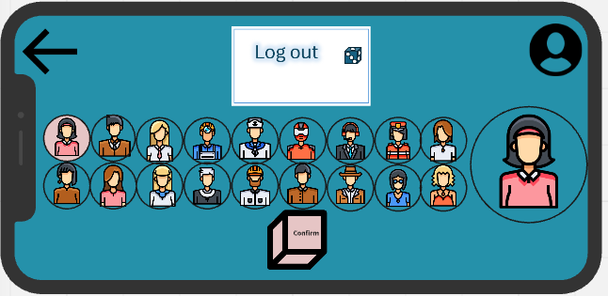
Figure 25 - Change profile icon
Log out confirmation
When the log out button is pressed on the profile page the next page gives confirmation that their request was carried out and the ‘return to main menu’ button is enlarged in the line of sight. This button is the focus because it is directing the user to navigate without having cognitive load. This page is a new feature and it is because users are happier when they have freedom according to Nelson, and being able to log out gives users an element of control over their gaming.
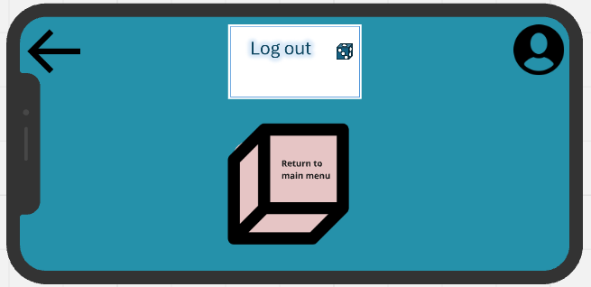
Figure 26 - Log out confirmation
Achievements
The achievement page was featured in the wireframes; however it has been improved so that the user can collect badges, and their progress is now stated next to the achievement. The progress acts as a motivation tool and increases engagement. Based on user research people respond well to challenges. When the badges have been won, the background colour changes to indicate this change. The app will add new achievements/goals regularly so the scroller allows the user to view more awards with ease.
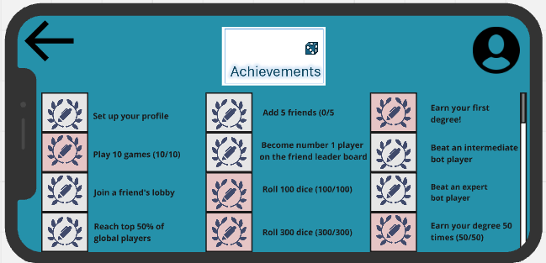
Figure 27 - Achievements
Error message
The multiplayer games are online only, and you can only play with other people if you have an account. If the user clicks multiplayer before logging in they are presented with an error message. The user is only able to navigate to the profile set up page which minimises confusion.
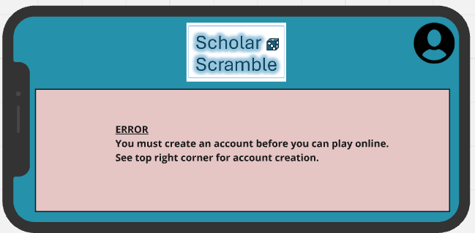
Figure 28 - Error message
Sign up page
The signup page collects details such as username, password, email, and date of birth. The date of birth is a useful metric to record to demographic of users. The email is essential for password resets. The password should be entered twice to minimise risk of error, which users would be familiar with since this is common procedure. Once they click the familiar confirm button they are taken to the main menu where they can now play all game modes. The sign-up page was not available previously, but it is essential to enabling users to play online. Furthermore, avatars and other fun customisations can only be applied with the account.
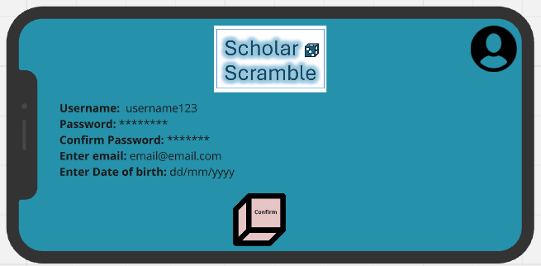
Figure 29 - Sign up page

Appendix B: Personas
Persona 1:
Persona Name: Robert
Age: 50
Occupation status: Full-time employment
Gaming habits: Only uses mobile games a few times a year, and only for less than 10 minutes at a time. Gaming happens on a smart phone, at home or when travelling, whenever there’s time for it in his busy schedule.
Game preferences: Likes games that include quick-play rounds and leaderboards, particularly puzzle and sports related games. Has found dice games long and boring in the past but likes the chance/luck elements provided there are quick rounds.
Accessibility & interface requirements: Has a visual impairment and doesn’t like small or difficult to read menus. Customisable text sizes would help reduce the effect of the visual impairment. Light and dark themes are favoured, sound is deemed important to an enjoyable game. Preferred method of rolling a dice would be tapping and using the touch screen.

Persona 2:
Persona Name: Laura
Age: 17
Occupation status: Student
Gaming habits: Mobile gaming occurs daily for 10-30 minutes, and she doesn’t always game at the same time of day just whenever she finds the time. This usually happens at home or while travelling on a smart phone.
Game preferences: Laura likes to play puzzle or adventure games the most, and keeps engaged through daily streaks, quick play options, single and multiplayer options, challenges, and also leaderboards. They are only a little familiar with dice games but enjoy the chance/luck aspect, and socialising. The feeling of accomplishment and challenge keeps her engaged. The challenges that they have faced with dice games include no single-player modes and time consuming.
Accessibility & interface requirements: Laura has no impairments or accessibility requirements, but does appreciate intuitive controls, different text sizes and light/dark theme and learning through interactive tutorials. The feedback they enjoy the most are text and visual. Laura believes that sound isn’t essential to her gaming experience. The preference for rolling dice method is shaking the device and would like to read the icons on the dice rather than have text pop-ups. Laura would like to see an option to provide feedback to the designers within the game.

