DS 1 Template

My Screenshots/Photos
- Please add 4–6 screenshots or photos of your digital life.
- You can use your phone or laptop.
- For each screenshot, write one or two sentences explaining what it shows.

Screenshot/Photo 1
[Insert Photo/Screenshot below]
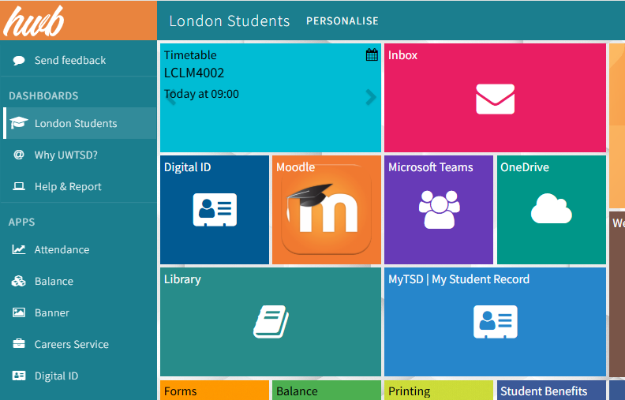
I use hwb at university to access the different resources

Screenshot/Photo 2
[Insert Photo/Screenshot below]
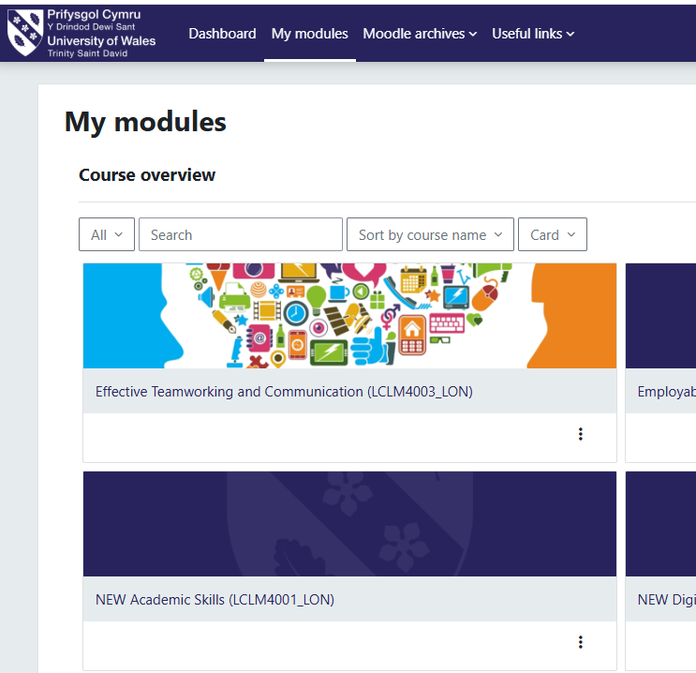
I use Moodle to access the modules which I study.

Screenshot/Photo 3
[Insert Photo/Screenshot below]
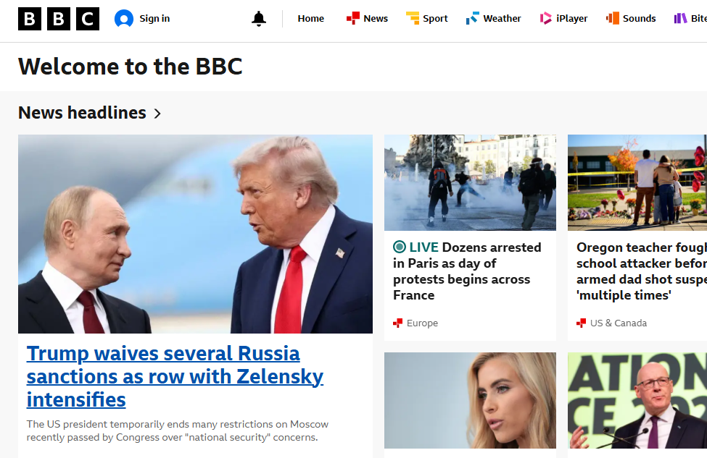
I use BBC to get updates about the news.

Screenshot/Photo 4
[Insert Photo/Screenshot below]
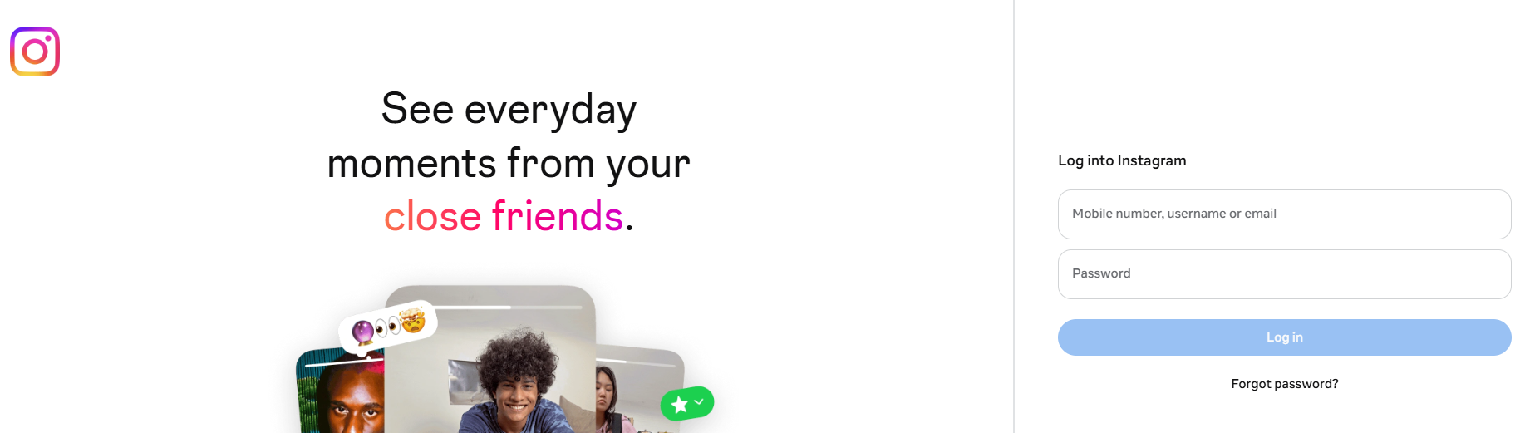
I use Instagram to socialise with friends and family.

Screenshot/Photo 5
[Insert Photo/Screenshot below]

[Write what this shows of your digital life]

Screenshot/Photo 6
[Insert Photo/Screenshot below]
[Write what this shows of your digital life]

My Short Reflection
- Write 5–8 simple sentences about your digital life.
- You can use the sentence starters below if helpful.
- I want to improve my digital and academic skills.
- I often use these tools: To get access to the resources and content.
- I sometimes feel nervous about using the tools that I have never used before.
- I hope this module will help me to develop the essential skills that is required in today’s job market.
- Digital skills are important for me because it requires for my future education as well as career progression.

Sentence starters
- I use digital tools to …
- I feel confident when I …
- I want to improve …
- I often use these tools: …
- I sometimes feel nervous about …
- I hope this module will help me …
- Digital skills are important for me because …
You can write more if you want.

Submission Checklist
Before you submit, please check:
​​​ ☒ I added 4–6 screenshots
☒ I wrote short sentences for each screenshot
☒ I wrote my short reflection
☒ My work is my own
☒ My file opens correctly
​​☒ My file opens correctly

