BSc (Hons) Health and Social Care

Module: Changemakers: Creativity and Value Creation
Module Code: BMHP5014

Assignment Title: Component 2: Assignment (Report)

Submission deadline: 19th December 2025

Student ID: Student ID:2336190

Lecturer: Caroline Salami (Module leader)

Table of Contents
Poster 3
Pitch 4
References 8

Poster

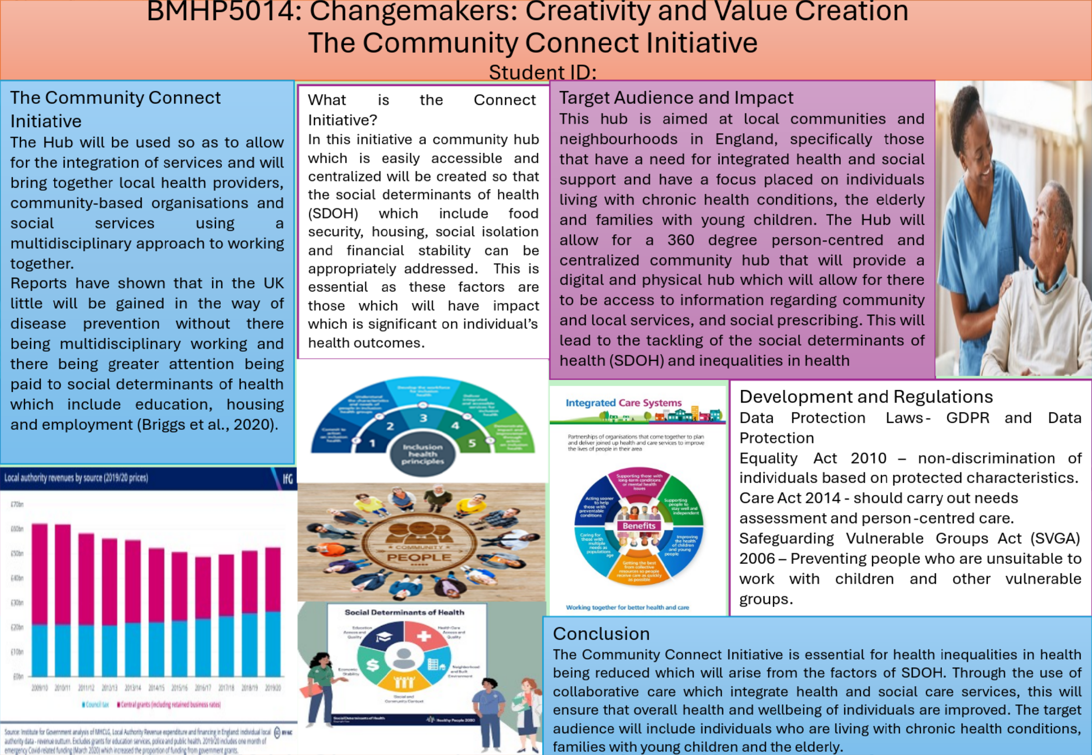

Pitch
The Community Connect Initiative
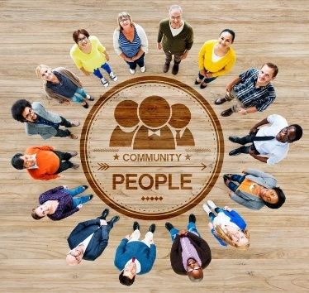

Overview
The Community Connect Initiative proposes the establishment of a centralised, accessible community hub infrastructure across England to systematically address social determinants of health (SDOH), encompassing housing stability, food security, social isolation, and financial wellbeing. This intervention is predicated on substantial evidence demonstrating that these factors exert considerable influence on individual health outcomes. The Hub model facilitates service integration by enabling collaboration among local health providers, social services, and community-based organisations within a unified framework.

Identified Gaps in Health and Social Care Provision
Contemporary scholarship has documented increasing recognition of healthcare systems' capacity to influence social determinants of health (Alderwick and Gottlieb, 2019; Alderwick et al., 2018). Bibby (2018) conceptualises social determinants as encompassing employment status, income levels, housing conditions, and other social factors that interact dynamically to shape the conditions under which populations live. These determinants play a pivotal role in producing and perpetuating health inequalities (Braveman and Gottlieb, 2014), with their influence mediated by policy interventions at local, national, and regional levels (McGovern, 2014).
The integration of health and social sectors has emerged as a critical imperative, reflecting its growing salience within public policy discourse and societal priorities (National Academies of Sciences, 2019). Integration denotes collaborative efforts to align and synthesise resources, activities, and infrastructure across health and social sectors to enhance population health and wellbeing (WHO, 2016). Nevertheless, health and social care integration constitutes a complex, iterative process that continues to evolve in response to demographic transitions, political contexts, and social transformations (Antunes and Moreira, 2011).
Healthcare systems confront substantial challenges emanating from SDOH, population ageing, and the escalating burden of chronic diseases. Integration of health and social sectors offers potential to deliver more efficient, patient-centred care that addresses both clinical presentations and underlying social determinants (Figueroa et al., 2019). This approach seeks to transcend traditional sectoral boundaries between healthcare and social services, thereby facilitating more coordinated, person-centred support that acknowledges the broader social determinants influencing health outcomes (Czypionka et al., 2020).
The European Commission (2021) articulates that this integration process necessitates the development of collaborative frameworks linking local governments, health institutions, and social care organisations, frequently underpinned by regional or national policy initiatives. Such partnerships enable enhanced coordination, optimised resource allocation, and more seamless service experiences for patients and families. However, implementation approaches exhibit substantial cross-national variation attributable to divergent healthcare delivery models, governance architectures, and financing mechanisms (European Commission, 2021).

Target Population and Anticipated Impact
This intervention targets local communities and neighbourhoods across England, with particular emphasis on populations demonstrating significant need for integrated health and social support. Priority cohorts include individuals with chronic health conditions, older adults, and families with young children (Alderwick et al., 2018). The Hub operationalises a 360-degree person-centred care model through a centralised community infrastructure comprising both physical and digital platforms. Core functions include: provision of comprehensive information regarding local and community services; social prescribing mechanisms to facilitate referrals to non-clinical interventions (e.g., health education workshops, financial wellness coaching); and proactive outreach with sustained community engagement strategies. This multi-dimensional approach is designed to systematically address SDOH, reduce health inequalities, and consequently improve population health outcomes.

Implementation Timeline
The Hub deployment follows a four-phase, data-driven framework designed to ensure flexibility and responsiveness to community needs.
Phase 1: Planning and Research (Months 1-6)
This foundational phase encompasses comprehensive needs assessment through mixed-methods approaches, including surveys and focus groups conducted with community organisations, healthcare professionals, and service users to elucidate local health and social care requirements. Stakeholder engagement protocols will be established with key actors—including healthcare providers, local government authorities, charitable organisations, and social services—to forge collaborative partnerships. Baseline data collection will document current service utilisation patterns, health outcomes, and salient social determinants of health within target communities.
Phase 2: Infrastructure Development (Months 7-12)
This phase focuses on establishing the Hub's operational infrastructure, including the designation and preparation of a physical community location and development of a comprehensive online resource portal. Personnel recruitment and training will be conducted for community navigators and volunteer programme coordinators. Patient education materials and workshop curricula will be co-developed in consultation with community stakeholders to ensure alignment with locally identified needs.
Phase 3: Launch and Initial Implementation (Months 13-24)
The initiative will be formally launched with targeted outreach prioritising high-need demographics, specifically older adults and families with young children. A structured programme of health promotion workshops addressing both mental and physical health will be implemented. Systematic monitoring of referral pathways between the community hub and healthcare providers will be established to ensure integration effectiveness and identify bottlenecks in service coordination.
Phase 4: Expansion and Sustainability (Ongoing)
This phase emphasises adaptive programme evolution and long-term viability. Service expansion will be guided by community feedback mechanisms, potentially incorporating innovations such as technology-enabled home monitoring for selected patient populations. Continuous evaluation will assess initiative performance against predetermined objectives using integrated quantitative and qualitative metrics to inform iterative improvements. Evaluation findings will be systematically disseminated to stakeholders to demonstrate impact, thereby facilitating sustained funding streams and partnership commitments.

Regulatory Framework and Compliance (Development and Regulation)

The initiative operates within a comprehensive regulatory framework to ensure legal compliance and ethical practice. Key legislative instruments governing implementation include:
Data Protection Legislation – The General Data Protection Regulation (GDPR) and Data Protection Act (2018) establish mandatory protocols for safeguarding the confidentiality and security of service users' personal data. The Equality Act 2010 provides legal protection against discrimination based on protected characteristics, including age, gender, sexual orientation, and religion, thereby ensuring equitable access to services (Gov.UK, 2025). The Care Act 2014 mandates comprehensive needs assessments prior to service provision and stipulates that care delivery must align with service users' personalised needs and preferences. Furthermore, the Safeguarding Vulnerable Groups Act (2006) establishes mechanisms to prevent individuals deemed unsuitable from accessing employment involving children and vulnerable adults (Gov.UK, 2025).

Technology Integration
The initiative incorporates strategic technology integration as a core operational component. Digital health technologies are increasingly recognised for their capacity to fundamentally transform health and social care delivery through diverse software and hardware applications across healthcare domains (Allcock et al., 2024). The Hub's technological infrastructure will enable online access to referral systems, virtual counselling services, and digital financial wellness coaching. Additionally, a comprehensive digital platform will provide centralised access to information regarding local services and community assets. This technological integration is anticipated to enhance solution effectiveness by improving service accessibility, thereby contributing to improved population health and wellbeing outcomes.

Dissemination Strategy
Information dissemination will employ multi-channel communication strategies, including targeted media campaigns across social media platforms, television, outdoor advertising (billboards), and radio broadcasting. Public health communication initiatives will complement these efforts. This diversified approach has been selected based on evidence demonstrating that multi-channel campaigns achieve broader population reach and enhanced message penetration, thereby maximising awareness and service uptake (Wakefield et al., 2014).

Conclusion
The Community Connect Initiative represents a strategic intervention designed to reduce health inequalities stemming from social determinants of health. Through collaborative care models that systematically integrate health and social care services, the initiative aims to enhance overall population health and wellbeing. Priority populations include individuals with chronic health conditions, older adults, and families with young children. By addressing structural barriers to health through coordinated, accessible, and person-centred care, this initiative contributes to the broader objective of achieving health equity across England's diverse communities.

References
Alderwick, H. and Gottlieb, L.M. (2019) Meanings and misunderstandings: a social determinants of health lexicon for health care systems. Milbank Quarterly, 97(2), pp. 407–419. Available at: https://www.milbank.org/quarterly/articles/meanings-and-misunderstandings-a-social-determinants-of-health-lexicon-for-health-care-systems/ (Accessed: [add date]).
Alderwick, H., Gottlieb, L.M., Fichtenberg, C.M. and Adler, N.E. (2018) Social prescribing in the U.S. and England: emerging interventions to address patients’ social needs. American Journal of Preventive Medicine, 54(5), pp. 715–718. Available at: https://www.ajpmonline.org/article/S0749-3797(18)30071-0/fulltext (Accessed: [add date]).
Allcock, J.A., Zhuang, M., Li, S. and Zhao, X. (2024) Landscape of digital technologies used in the National Health Service in England: content analysis. JMIR Formative Research, 8, e51859. doi: 10.2196/51859.
Antunes, V. and Moreira, J.P. (2011) Approaches to developing integrated care in Europe: a systematic literature review. Journal of Management & Marketing in Healthcare, 4, pp. 129–135.
Bibby, J. (2018) What makes us healthy? An introduction to the social determinants of health. London: The Health Foundation. Available at: https://www.health.org.uk/publications/what-makes-us-healthy (Accessed: [add date]).
Braveman, P. and Gottlieb, L. (2014) The social determinants of health: it’s time to consider the causes of the causes. Public Health Reports, 129(Suppl 2), pp. 19–31. Available at: https://journals.sagepub.com/doi/10.1177/00333549141291S206 (Accessed: [add date]).
Commission on Social Determinants of Health (CSDH) (2008) Closing the gap in a generation: health equity through action on the social determinants of health. Geneva: World Health Organization. Available at: https://apps.who.int/iris/bitstream/handle/10665/43943/9789241563703_eng.pdf (Accessed: [add date]).
Czypionka, T. et al. (2020) The patient at the centre: evidence from 17 European integrated care programmes for persons with complex needs. BMC Health Services Research, 20, 1102.
European Commission (2021) State of Health in the EU: Companion Report 2021. Brussels: European Commission.
Figueroa, C.A., Harrison, R., Chauhan, A. and Meyer, L. (2019) Priorities and challenges for health leadership and workforce management globally: a rapid review. BMC Health Services Research, 19, 239.
McGovern, L. (2014) The relative contribution of multiple determinants to health. Health Affairs. Available at: https://www.healthaffairs.org/do/10.1377/hpb20140821.404487/ (Accessed: [add date]).
National Academies of Sciences, Engineering, and Medicine (2019) Integrating social care into the delivery of health care: moving upstream to improve the nation’s health. Washington, DC: The National Academies Press.
Solar, O. and Irwin, A. (2010) A conceptual framework for action on the social determinants of health. Geneva: World Health Organization. Available at: https://www.who.int/sdhconference/resources/ConceptualframeworkforactiononSDH_eng.pdf (Accessed: [add date]).
Wakefield, M.A., Loken, B. and Hornik, R.C. (2010) Use of mass media campaigns to change health behaviour. The Lancet, 376(9748), pp. 1261–1271. doi: 10.1016/S0140-6736(10)60809-4.
World Health Organization (2016) Framework on integrated, people-centred health services. Geneva: World Health Organization.

