Global Business Environment Assessment 2

Student name: Stanislav Dragov
Student ID: 1919084

Table of Contents
Introduction 2
Explain the major forces shaping the business environment of the car manufacturing industry. In your analysis, you should explain how the industry has changed in the last few years. 3
Provide a critical assessment of the opportunities and challenges that these forces present and discuss how firms can best position themselves to gain a competitive advantage 7
Conclusion 10
References 11

Introduction
Bentley is one of the leading car manufacturing company in UK and headquarter is in Crewe it had established in the year of 1919. Automobile industry in UK is always competitive and company like Bentley focuses on providing superior quality cars and are not concerned about the prices that much as their targeted market are for affluent customers or clients. Several factors affect companies that work within automobile industry so these factors also affect Bentley. Bentley is a prominent competitor in the UK and global automotive industry (Achinas, Horjus, Achinas and Euverink, 2019). But, the company must use opportunities and address threats macro-economy, as exposed PESTLE analysis. Various peripheral factors affect Bentley as working in automotive industry. Keeping these factors in concentration, the company’s executives must progress tactics and programs to support business progress and steadiness. Bentley can uphold its position as a leading global company by successfully addressing the things highlighted in the PESTLE analysis below-

Explain the major forces shaping the business environment of the car manufacturing industry. In your analysis, you should explain how the industry has changed in the last few years.


Figure 1: PESTLE Analysis (Chanaron, 2016).

PESTLE Analysis
Political Environment
The political firmness is an opening for Bentley to rise with slight political strain. The UK government’s support for sustainable products is a prospect for the company to expand and to satisfy or exceed environmental prospects (Zhang, Zhu, Wang and Sun, 2015). In this height of Bentley’s PESTLE analysis, the main political factors provide opportunities for the business.
1. It was reported that the UK government has begun to encourage a directive for the minimum usage of local contented materials in locally mass-produced cars hence all mechanisms must be produced within the area of the UK (Chanaron, 2016).
2. Innovative Equipment Makers may enjoy price reduction of about 10-25% so it is an opportunity for Bentley to grab at both hands since no levies and low charges inducement for introduced cars and its components.
3. The Uk government trying to promote the whole car manufacturing industry even after the Brexit issue and ensures better days are coming within the industry so Bentley will manufacture more and sell more and will have its impact on the overall economy (Montshiwa, 2018).
Economic Environment
Economic inclinations impact Bentley’s organizational progress. Bentley’s most significant economic external factors in the remote or macro-environment are as follows:
1. Several types of research about the car industry in the UK exposed that the progress of commercial vehicles will be a bit slackening due to several factors including the recent impact of COVID-19 on the overall economy and the business of the UK and the whole world (Genba, Ogawa and Kodama, 2016) Though the market for passenger vehicles was not that bad still the overall car industry has gone through a tough time. Hopefully, demand for cars will increase in the upcoming days and the industry will grow further so as Bentley.
2. Growth of Vehicles will increase by 21% between 2019 and 2023 and approximately 430000 new registrations for cars will be seen by 2023.
3. Gradual growth of UK Economy and Bentley has its impact on the economy.

Social Environment
Bentley has the effects of social factors. In Bentley’s case, the following are the main social external factors in the firm’s remote or macro-economy:
- Cumulative interest in hybrid cars.
- Growing attention in electric cars.
- Spreading affluence gap.
Bentley has the prospect to make available more products that gratify customers’ growing interest in hybrid and electric vehicles. However, the company must consider the spreading affluence gap, which is intimidation as it corresponds to a weakening middle class (Nemcová and Fifeková, 2020). In this aspect of Bentley’s PESTLE analysis, the social external influence of the spreading affluence gap is a worrying sign.
Technology Environment
Technological aspects influence Bentley as it is a technological business. This aspect of the PESTLE analysis model governs the effect of technological trends (Zhang, Lang and Wang, 2013). In Bentley’s case, the following are the most distinguished technological factors in the company’s macro-environment:
- The growing use of e-commerce.
- Mobile technology development.
Bentley has the prospect to expand its e-commerce competencies. Bentley has the prospect to boost its apps to rise customer commitment and reliability. This dimension of Bentley’s PESTLE analysis model shows key technological openings, although the company must ensure suitable technological security measures.

Legal Factors
Legal structures influence Bentley’s business. This aspect of the PESTLE analysis model defines the laws and principles that move business. In the case of Bentley, the succeeding is the most substantial legal external factors in the macro-economy:
- Refining intellectual property laws.
- Progressively complex environmental laws.
- Progressively complex consumer laws.
Bentley has the prospect to grow with condensed concerns for contravention of its intellectual property rights as governments are working towards refining intellectual property protection (Genba, Ogawa and Kodama, 2016). Bentley also has the prospect to provide higher quality cars that gratify the necessities based on environmental laws. Besides this, the company can exploit the chance of presenting safer and more satisfactory cars to accomplish consumer laws. This aspect of Bentley’s PESTLE analysis model displays that the legal factors are bringing major opportunities for the firm.
Ecological Factors
Bentley needs to comprise ecological apprehensions in its planned decision-making. In the case of Bentley, the major ecological external factors in macro-economy are as follows:
- Climate fluctuating rapidly day by day.
- Lessening global oil reserves.
- The growing emphasis on business sustainability.
Bentley has prospects to deliver more environmentally welcoming products, in that case, electric cars or cars with better fuel efficacy (Uniyal, Dhodi, Dhodi and Sharma, 2012). The company also has the prospect to raise its sustainable performance through advancing in business procedures efficiently. So these major ecological factors present chances for Bentley that the company can use for additional growth.
Product Life Cycle
There is no hesitation that the product life cycle analysis is really vital for the marketing scrutiny of any company. As for the Bentley the cars of the company are at the maturity stage of the life cycle. It deals with the fact that Bentley is a renowned car manufacturing company and people know it very well and feel righteousness to own a car of this company (Chanaron, 2016). Bentley has succeeded to remain at one of best-selling Cars over the time.
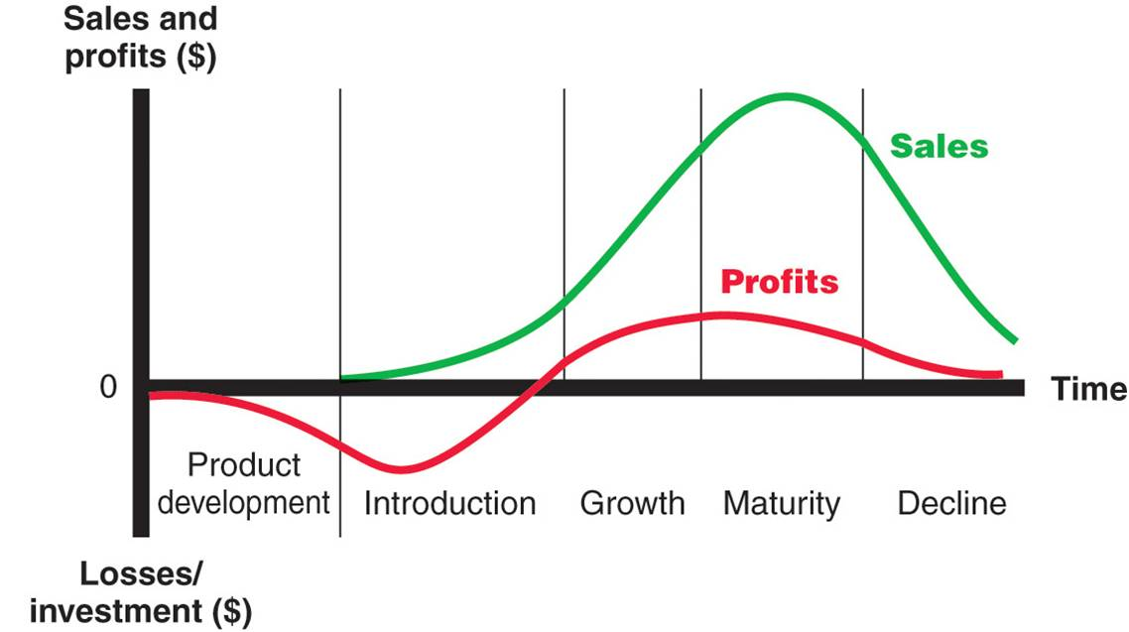
Figure 2: Product Life Cycle (Kolios and Read, 2013).
It is crucial to lay the strain on the circumstance that the maturity stage of product lifecycle is the most beneficial for the Bentley. The selling of the cars is very profitable, has numerous trustworthy customers and persistent market share. Right now, the Bentley is renowned on the market and so large marketing expenses are not needed (Nemcová and Fifeková, 2020). The main goal of the company is to exploit the time of the several models cars presence in the maturity stage to avoid moving on to the declining stage so easily.

Industry trends over the time
It is then presumed the market will return to progression, as the UK displays symbols of retrieval from Brexit and manufacturers portfolios are restored to conform with emissions regulation, mounting slowly by 1.8% CAGR from 2020 to reach nearly 2,390,000 registrations by 2023.Two of the major changes in the UK car industry have been the inevitable rise of the SUV and the enlarged investment by car manufacturers into electric vehicles. In 2018, 5.4 million SUVs were registered in Europe and the market share improved from 29.2% to 34.6% (Genba, Ogawa and Kodama, 2016). When it comes to Electric cars, the burst has not yet to happen. There are several reasons for this including-
- As a result of the high cost grants have been cut.
- Uncertainty over the distance that these Vehicles can travel on a full charge.
A further decline in new car sales may occur as a result of increasing in used car sales. Customers are eager to accept prevailing conditions rather than personalization. Slackening on electric car sales. Moreover any sharp rise in fuel prices may severe pressure on the industry.

Provide a critical assessment of the opportunities and challenges that these forces present and discuss how firms can best position themselves to gain a competitive advantage
Bentley is a British automobile producer. It is well known all over the world. It is headquartered is in Crewe, England. There are several strengths, weaknesses, opportunities, and threats for the company (Chanaron, 2016). Reputation is one of their strengths whereas changing fuel prices and other norms are threats for the company.
SWOT Analysis
There will be a SWOT analysis of the company to focus on its present strength and future threats to grab opportunities so that weakness can be reduced significantly.

Strengths | Weaknesses
- Popularity  - Car Designs  - Brand Value  - Technology  - Exclusiveness | - Small targeted group  - Not reached Worldwide  - Not always environment Friendly  - Extensive Waiting
Opportunities | Threats
- Emerging Markets  - M & A  - Promotions  - Focus on being environmental friendly | - Competition  - Increasing Fuel price  - Changing Norms

Figure 3: SWOT Analysis
Strengths
The following are the main strengths of the Bentley car manufacturing company. Now explaining in detail-

- Popularity: As a result of their exclusive mix of extravagance and sporty nature the cars of this brand are very popular not only among the people of the UK but also worldwide. They also can weigh on German built-up in their parent company (Zhang, Lang and Wang, 2013).
- Car designs: Bentley makes beautiful cars in the world and has a good portfolio that excites an auto specialist and the company has captivated the world with its polished and recent car designs.
- Brand Value: Because of extraordinary Brand value they are less susceptible to competition. They have targeted markets for themselves (Achinas, Horjus, Achinas and Euverink, 2019). So it has enlarged the obstacles for new entrants to enter into the market.
- Technology: Bentley cars that are made are superior in quality, which is way above the technology that generally gets used in case of other normal cars. Cars speed and durability are fabulous.
- Exclusiveness: Ownership of Bentley makes the customer feel superior.

Weaknesses
Though Bentley has several strengths still it has some weaknesses which are going to be mentioned and explained below-
- Small Target Group: Bentley a niche part of the population. So very little opportunity to grow further in the industry.
- Not Reached Worldwide: Bentley is not present in every country so their reach is limited and to preserve high standards they are losing out on emerging markets (KAGAWA, 2016).
- Extensive Waiting: Bentley generally produces a limited quantity of cars every year to ensure that they are maintaining their high-quality standards. Clients have to wait for a long period to order their cars.
- Not always environmentally friendly: The cars of Bentley are exposed to high environmental pollution. One of their manufacturing units working on the Loop River Power Canal. Bentley has been contaminating this canal (Kolios and Read, 2013). The existence of surplus heat is instigating unwanted changes in the environment.

Opportunities

- Bentley has some opportunities to grow their business and so their market share, so the following opportunities are-
- Emerging Markets: Bentley should focus on the wealthy class in the developing markets and start supplying them as well.
- Mergers and Acquisition: Bentley can obtain other subordinate brands and start providing to other parts of the population. The brand name can be used for higher returns (Nemcová and Fifeková, 2020).
- Environmental friendly: They should focus on becoming environmentally friendly and jump towards better thermal fuel substitutes like hybrid or electric
- Promotions: Bentley can sponsor superior events to uphold its brand name and increase its reputation worldwide.

Threats
Following are threats faced by the company-
- Changing norms: The laws are becoming sterner towards pollution. So Bentley needs to overlook the necessary changes.
- Increasing Fuel Prices: The rise in fuel prices is a thoughtful issue for the automobile industry. So Bentley should focus on alternative fuels (Uniyal, Dhodi, Dhodi and Sharma, 2012).
- Competition: Bentley’s competition is growing day by day. This can impede growth.

Porter’s Five Forces model
It can be analyzed using porter’s five forces model also. In the model, five things are used including rivalry, new entrants, power of suppliers, Power of Buyers, Substitutes. Rivalry brings more competition whereas new entrants are always alarming for any company and the more powerful the suppliers are the more domination in the market. Meanwhile, substitutes give the option to the buyers to purchase other close things that are available in the market.
- Rivalry: The viable rivalry in the car industry is tremendously high. There is intense competition on Bentley motors Limited fronts in the luxury car market (KAGAWA, 2016). Competitors are prospective towards avoiding a price war, as the low-cost company will continue to earn profits so Bentley should focus on reducing overall production costs to make ensure they are earning a lot of profits even in a highly competitive market.
- Power of buyers: The power of buyers in the extravagance car industry is also reasonable. Buyers can have information accessible to them about the pricing and cost of manufacturing cars.
- Power of Suppliers: The power of Bentley as a supplier can be rated as fair. As one of the Cost leaders, they can captivate greater price rises before it must raise prices to customers.
- New Entrants: New entry is restricted to some points as it needs to go through tough standard procedures. The new entry is not that much barrier to Bentley at that time (Kolios and Read, 2013).
- Substitutes: Substitutes to luxury car brands are not that much available compared to other industries. So Bentley is not that much concerned about the substitutes available to customers right now.

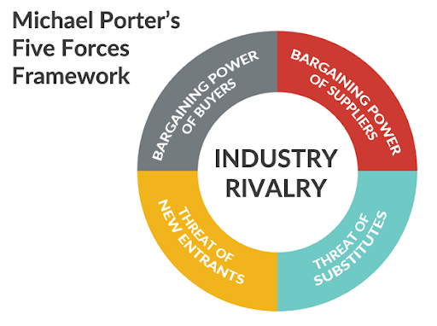
Figure 4: Porter’s Five Forces Model (Zhang, Lang and Wang, 2013)
Porters Value Chain Analysis
According to Porter's value chain, each activity can produce benefits in costs or differentiation Both aspects are of major attention in the Automobile industry. By looking at the variables it can be seen that customer immediacy is of substantial concern (Achinas, Horjus, Achinas and Euverink, 2019). So Bentley can be perceived as a differentiator that is not focusing on low costs but trying to deliver superior cars in terms of excellence, design, modernization, and expertise. Such traits can act as sole values that customers give value to and are prepared to pay for with a price premium.

Conclusion
In sum, it can be said that Bentley Motors Limited provides superior Cars to its customers though customers or clients need to wait for a longer period for newly released models of the company. Bentley does ensure customers are getting value for the invested money of their cars (KAGAWA, 2016). They are one of the technology leaders in the industry. In SWOT analysis it has shown that they have some weaknesses which are not that many barriers to their growth as they have some better strengths and opportunities which they can focus on in increasing their reputation and market share. All the factors that affect Bentley in its business are shown on PESTLE analysis. From porter’s five forces model and value chain analysis, it can be summarized that superior quality is what they do focus on that differentiate them from others within the industry.

References
Achinas, S., Horjus, J., Achinas, V. and Euverink, G., 2019. A PESTLE Analysis of Bentley motors in Europe. Sustainability, 11(21), p.5981.
Chanaron, J., 2016. Life Cycle Assessment practices: benchmarking selected European automobile manufacturers. International Journal of Product Lifecycle Management, 2(3), p.290.
Genba, K., Ogawa, H. and Kodama, F., 2016. Quantitative analysis of modularization in the automobile and PC industries. Technology Analysis & Strategic Management, 17(2), pp.231-245.
KAGAWA, S., 2016. Life Cycle Analysis of Lifetime Changes of Durable Goods: The Case of Automobile. Journal of Life Cycle Assessment, Japan, 6(2), pp.102-109.
Kolios, A. and Read, G., 2013. A Political, Economic, Social, Technology, Legal and Environmental (PESTLE) Approach for Risk Identification of the car Industry in the United Kingdom. Energies, 6(10), pp.5023-5045.
Montshiwa, A., 2018. Regional automobile parts makers' competitive advantages analysis. International Journal of Applied Management Science, 10(2), p.87.
Nemcová, E. and Fifeková, E., 2020. RESTARTING THE EU CAR INDUSTRY – LONG-DISTANCE RACE?. PROGNOSTICKÉ PRÁCE - PP (FORESIGHT, ANALYSIS AND RECOMMENDATIONS - FAR), 12(1).
Uniyal, M., Dhodi, D., Dhodi, D. and Sharma, S., 2012. SWOT Analysis of car Industry of UK. Paripex - Indian Journal Of Research, 3(2), pp.299-300.
Zhang, S., Zhu, C., Wang, J. and Sun, L., 2015. Product Life Cycle of Automobile Parts Concerning Piracy. Applied Mechanics and Materials, 20-23, pp.826-832.
Zhang, Y., Lang, M. and Wang, D., 2013. The Market Analysis of Railway Car Liner Trains Based on BP-NN Model and SWOT Method. Applied Mechanics and Materials, 361-363, pp.1982-1987.

