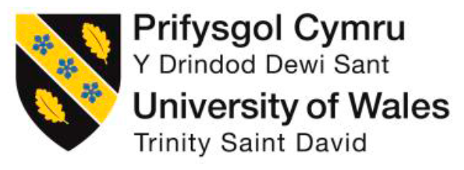

Rebecca Broomfield
Student Number: 1709322
Reflection on Clinical Leadership

DSAW7057

University of Wales Trinity Saint David

Content:
Assessment component 1
Learning log ………………………………………………………………………………… 3
Personal Leadership Development Goals ………………………………………………. 8
Reflection of personal leadership style ………………………………………………….. 8
Word count: 1501 Words

Assessment component 2
Influence of Personality Traits ………………………………………………………….. 13
Effective Team Working …………………………………………………………………. 16
The Neuroscience of Leadership ………………………………………………………. 20
Imposter Syndrome ………………………………………………………………………. 23
Leading and Influencing …………………………………………………………………. 25
Word Count: 6153 Words

Total Word Count: 7654 Words

Assessment component 1:
Learning Log September 2017- September 2018
Activity | Intuition/Speaker | Topics Covered | Date
Wales Induction: Deanery | Quentin Sandifer: Medical Director Public Health Wales | Practical aspects of being a medical director | 06/09/2017
Wales Induction: Welsh Government | CMO and DCMO, Chief Pharmaceutical Officer, Director General Health and Social Services | Introduction to healthcare system in Wales, individual job roles and responsibilities within Welsh Government. | 07/09/2017
National Induction London | Faculty of Medical Leadership and Management | Thinking about personal branding.  Introduction to Westminster and health policy development | 11-13/9/2017
Emergency Medicine celebration of 50 year anniversary  Wellbeing morning | Dr Sara Edwards | Physical activity and mindfulness for wellbeing | 13/10/2017
Medical Leadership Programme (Session 1) | Academi Wales | Introduction to the course and academic study.  Action learning introduction. | 18/10/2017
Public Health Wales Conference, Newport | Public Health Wales | Designing for the future; how we influence environment to improve health.  https://www.wrenpaediatrics.com/blog/public-health-wales-conference-2017 | 26-27/10/2017
Leaders in Healthcare Conference, Liverpool | Faculty of Medical Leadership and Management, ‘Happy Henry’! | Breakout sessions attended: joy at work, growing resilience, compassionate leadership and coaching.  https://www.wrenpaediatrics.com/blog/how-can-we-be-leaders-in-healthcare | 31/10 – 01/11/2017
ASPiH conference | Cherrie Evans, Gabriel Reddy, ASPiH | Conference focusing on the use and development of simulation within Health care. Key note speeches and breakout sessions.  https://www.wrenpaediatrics.com/blog/its-all-about-simulation | 6-8/11/2017
Medical Leadership Programme (Session 2) | Academi Wales  Patricia Oakley | Political context for healthcare, how government decisions influence locally. | 09/11/2017
Welsh Paediatric Society  Autumn meeting | Multiple | https://www.wrenpaediatrics.com/blog/welsh-paediatric-society-autumn-clinical-meeting | 10/11/2017
Medical Education operational Group | Medical Education team | Committee meeting focusing on concerns in training and action plans for trainees within Cardiff and Vale Health board. | 14/11/2017
Coaching Session | Nicola Williams | 1:1 Coaching session | 15/11/17
Deanery Commissioning Visit meeting | Wales Deanery  Len Richards, Graham Shortland | Meeting between deanery and health board to ensure adequate training for trainees who are placed in Cardiff and Vale alongside decision on finances and the future. | 29/11/2017
Medical Leadership Programme (Session 3) | Academi Wales, 1000 Lives | Leading Improvement: QI techniques, human factors. Patient impact project presentations. | 5-6/12/2017
Medical Education operational Group | Medical Education team | Committee meeting focusing on concerns in training and action plans for trainees within Cardiff and Vale Health board. | 14/12/2017
Clinical senate | Cardiff and Vale | Opportunity to attend Clinical Senate which is a showcase for the work which is taking place within the health board and the outline of the Health Boards vision: Caring for people, keeping people well. | 15/12/2017
Coaching Session | Nicola Williams | 1:1 Coaching session | 18/12/2017
Cardiff Trauma Course | Emergency department | Faculty for delivery of multidisciplinary trauma simulation course | 9/01/2018
Resilient Leadership Course | Sylvia Vacher | Course on Leadership styles and personal resilience provided by the Wales deanery for paediatric Trainees | 11-12/01/2018
Medical Leadership Programme (Session 4) | Academi Wales | Understanding self and others: Myers-Briggs personality type indicator.  Action Learning Set | 16/01/2018
Coaching Session | Nicola Williams | 1:1 Coaching session | 30/01/2018
Medical Leadership Programme (Session 5) | Academi Wales | ‘Reality Check’ regarding accountability, risk management and Healthcare Inspectorate Wales. | 31/01/2018
Undergraduate Simulation teaching | Cardiff University | Simulation teaching based on university designed Paediatric scenarios. Faculty member to deliver this. | 1/02/2018
Clinical Directors Forum | Cardiff and Vale Health Board | Course run by Cardiff and Vale Health Board for the development of their new Clinical directors. | 8/01/2018
Resilient leadership | Syliva Vacher | Follow up session to reinforce learning from previous 2 day course. Provided by Wales Deanery for Paediatric trainees. | 14/02/2018
Medical Leadership Programme (Session 6) | Academi Wales, Andrew Scocroft  Nita Clarke | Influencing different kinds of organisations. | 15/02/2018
Leadership and Management Course | Miad Healthcare | Cardiff and Vale provided course focusing on personal effectiveness and communication within leadership. | 19-20/02/2018
St David’s day conference | Nina Modi | https://www.wrenpaediatrics.com/blog/rcpch-wales-st-davids-day-conference-2018 | 22/02/2018
Medical Education Meeting | Rebecca Broomfield | Presentation providing information on the simulation program and Cardiff and Vale health board and progress we have made. | 26/02/2018
Coaching Session | Nicola Williams | 1:1 Coaching session | 27/02/2018
Wales Deanery Trainee engagement forum | Rebecca Broomfield | Presenting information about the Welsh Clinical Leadership program | 8/03/2018
QIST conference | Chris Jones | Information on QIST progress and importance. Ran a leadership workshop with Dr Laura Potts and Dr Anton Saayman | 16/03/2018
Welsh Government | Chris Jones | Shadowing with the opportunity to see the problems and day-to-day life within Welsh Government. | 20/03/2018
Medical Leadership Programme: Residential Learning Community, Elan Valley Lodge | Academi Wales | Team building: Belbin team roles. Effective working.  https://www.wrenpaediatrics.com/blog/building-a-team | 21-23/03/2018
Applied Neuroscience, MIT Sloane Business School, Boston, USA | Dr Tara Swart | Techniques for self-care to maximise cognitive ability, creative problem solving. Opportunity for networking with leaders from a diverse range of backgrounds.  https://www.wrenpaediatrics.com/blog/neuroscience-for-leadership  https://www.fmlm.ac.uk/news-opinion/the-neuroscience-of-leadership | 27-28/03/2018
SIM Centre | Harvard Simulation Centre | Visit to simulation centre in Boston USA, experience of ow they run a simulation course and discussion about the future pathways of simulation. | 29/03/2018
Foundation Doctor Simulation Teaching Program F1 | Rebecca Broomfield | Teaching simulation to foundation doctors focusing on common paediatric scenarios | 5/04/2018
GP Simulation Teaching | Cardiff and Vale | Simulation for GP trainees focusing on common Paediatric scenarios as a part of their regular teaching plan. | 9/04/2018
LIPS Program | Dr Mark Hodder | Proven techniques that anyone can use to become happier and more successful. Applicable to work for increasing engagement and productivity and home for making more of life. | 12/04/2018
LIPS Program | Nick Tyson – Knowledge and Improvement Manager | Tools to understand the system – process mapping, fishbone diagrams, Pareto, stakeholder analysis, motivation theory etc. | 13/04/2018
Shadowing Medical Director | Graham Shortland | Day spent with Cardiff and Vale Medical Director shadowing and having access to board meetings. Recognising the day-today job of a medical director. | 17/04/2018
Foundation Doctor Simulation Teaching Program F2 | Rebecca Broomfield | Teaching simulation to foundation doctors focusing on common paediatric scenarios | 19/04/2018
TALK Course | @TALKdebriefing | Focusing on the utilisation of a tool to enable and encourage safe, effective debriefing within multi-disciplinary teams | 20/04/2018
Southampton half marathon | Rebecca Broomfield | Completed the Southampton half marathon raining money for Southampton PICU with my younger sister. | 22/04/2018
Medical Education operational Group | Medical Education team | Committee meeting focusing on concerns in training and action plans for trainees within Cardiff and Vale Health board. | 24/04/2018
Medical Leadership Programme (Day 8) | Academi Wales | Project presentations and action learning set. | 25/04/2018
EPIC Simulation course teaching | Cardiff University | Faculty member delivering Simulations on Paediatric Emergencies to Medical Students undertaking the intercalated EPIC BSc | 26/04/2018
Falls Project Simulation teaching | Ward A4 | Ongoing project as a part of my patient improvement project teaching the ward team to teach simulation. Scenarios based on falls. | 27/04/2018
Undergraduate Simulation Teaching | Cardiff University | Simulation teaching based on university designed Paediatric scenarios. Faculty member to deliver this. | 3/05/2018
Coaching Session | Nicola Williams | 1:1 Coaching session | 08/05/2018
Medical Leadership Programme (Session 9) | Academi Wales | Leading to influence; push and pull approaches to leading. Considering ‘mental toughness’. | 10/05/2018
Reflective My Practise | Cardiff University | 6 sessions over 6 weeks. Working with final year medical students to encourage their reflective practise. | 11/05/2018
LIPS | John Pringle | Leadership – Plain and Simple | 15/05/2018
LIPS | Matt Tite | Model For Improvement | 16/05/2018
LIPS | Jenny Bramhall | Creativity and reliability models | 17/05/2018
Launch event  Woods Simulation Ward | Cardiff and Vale Health Board | Organised the opening Launch Event for the Woods Simulation Ward within Cardiff and Vale. Paediatric emergency trauma day, falls simulation and wet lab running. | 18/05/2018
Medical Leadership Programme (Session 10) | Academi Wales  Worth Consulting | Introduction to the OSCAR method for coaching conversations, practical session involving trying coaching methods to enhance performance. | 23/05/2018
Medical Education operational Group | Medical Education team | Committee meeting focusing on concerns in training and action plans for trainees within Cardiff and Vale Health board. | 24/05/2018
PERUKI UK Meeting | Dr Damian Roland | Update on the research projects which PERUKI has involvement in and ongoing projects within Paediatric emergency medicine which it will be possible to get involved in. | 4/06/2018
Medical Leadership Programme (Session 11) | Academi Wales | Review of academic course requirements, action learning sets. | 05/06/2018
ARCP Panel member F1’s | Cardiff and Vale Health Board | Panel member for the foundation doctor’s ARCP processes to enable progression in training and full registration with the GMC. Management of struggling trainees. | 8/06/2018
ARCP Panel Member F2’s | Cardiff and Vale Heath Board | Panel member for the foundation doctor’s ARCP to enable completion of the foundation program. Management of struggling trainees. | 11/06/2018
Paediatric Made Easy Simulation Course | Dr Zoe Roberts | Multidisciplinary simulation course focusing on Paediatric emergency’s from pre hospital to hospital setting. Part of faculty delivering simulations. | 12/06/2018
Train the Trainer Course | Bristol Simulation Centre | Course focusing on the designing and running of effective simulation and skills in debriefing. | 13-14/06/2018
Learning a new skill | Crochet Course | Taking on board the advice from the MIT Boston course – Increasing neuroplasticity by learning new skills. | 15/06/2018
Medical Leadership Programme (Session 12) | Academi Wales | Social media and media training workshops | 20/06/2018
LIPS | Cardiff and Vale Health Board | How are we doing? Pursuit of perfection | 21/06/2018
WPS Spring meeting | Dr Elaine Boyle | Strong focus on neonatology, update on projects which have been ongoing in Wales. Update on progress curriculum. | 22/06/2018
Coaching Session | Nicola Williams | 1:1 Coaching session | 26/06/2018
Bevan Commission International Conference, Newport | Martin Bromiley, Shaun Lintern, Professor Alision Leary | Achieving the vision of prudent healthcare, thinking about equality of access.  Leadership for Innovation, predicting happiness and its effects on health. | 03-04/07/2018
Medical Leadership Programme (Session 13) | Academi Wales | Applying positive psychology and action learning. | 05/07/2018
Manchester Patient Safety Conference, Manchester | HSJ | Human factors within healthcare, simulation teaching, patient stories running throughout the sessions. Focus on quality improvement and patient safety. My poster entry in the Education and Training Category won first place in its category. | 09-10/07/2018
Medical Education operational Group | Medical Education team | Discussion of the GMC survey responses and action plan for concerns | 17/07/2018
Medical Leadership Programme presentation day | Academi Wales | Presentation day learning from the other clinical fellows what their projects have been doing during the year | 18/07/2018
360⁰ Feedback | Academi Wales | Feedback from my 360⁰ feedback | 28/08/2018
STEME conference | Wales Deanery | Education conference for clinical supervisors – poster presented on Multidisciplinary team work within simulation training | 03-04/09/2018
A healthier Wales: A leadership challenge | FMLM | Wales conference from the FMLM | 13/09/2018
LIPS | Cardiff and Vale Health Board | Presentation day for team projects | 21/09/2018
Clinical Senate | Cardiff and Vale Health Board | Presentation to the Board and Clinical Leaders our work on Falls | 27/09/2018
ASPiH Conference | ASPiH | Attendance at the ASPiH Conference, funded kindly by Cardiff and Vale to present the work we have been doing during my Clinical Fellowship Year | 13-15/11/2018

Personal Leadership Development Goals
Over the year my personal targets have included:
- To gain a greater understanding of myself, my leadership style and how these qualities impact on other people
- To gain a greater understanding of what makes an effective team and what I can do to influence this
- To take time to explore and understand my imposter syndrome to remove this as a barrier for success
- To have an understanding of the neuroscience behind leadership strategies and how to utilise the most up to date research to become a more effective leader.
Reflection on a Personal Leadership Style
I believe I am a “natural born leader”, I am comfortable and thrive in leadership situations. My year as a clinical leadership fellow has been an exploration of myself alongside learning how to hone my leadership skills. I have discovered how to utilise my strengths as well as develop my weaknesses.
I believe my biggest strengths as a leader are leading with compassion and engaging other team members. I have excellent communication skills and being an extrovert, I am fully able to put these to good use to communicate a shared vision and achieve a common aim.
Kouzes and Posner (2012) outlined the top ten effective traits which a leader has. This included being; Honest, Forward-looking, Inspirational, Competent, Fair-minded, Supportive, Broad-minded, Intelligent, Straightforward and Dependable. I aspire to these. I aim to be a compassionate, fair leader. Creating a culture focused on the wellbeing of the team and promoting excellence as a way of inspiring other team members. For me, leadership always involves a responsibility to people, it is about creating an environment which enables others to grow and develop alongside yourself.
Good leadership is about making performance happen and I believe the most important part of becoming a good leader is to know yourself, something which this year has enabled me to do and I will explore in greater depth in assessment component 2. Leadership is effective when in the short, medium and long term it enables the team and the leader to achieve success and manage conflict.
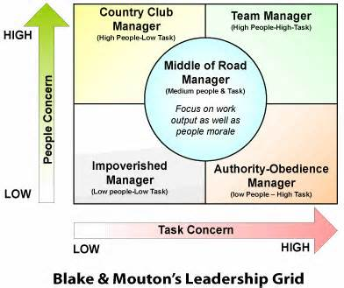
The above assessment of my leadership style was compounded by The Blake and Mouton Managerial Grid self-assessment questionnaire (Vaucher S 2018). This describes a person’s leadership style in 2 dimensions: concern for production and concern for people.
Figure 1 Blake and Mouton's Leadership Grid (Vacher S 2018)
I come out in the centre of the ‘Team Leader’ Box (Figure 1) with a score of 6 for the ‘people’ dimension and 5.9 for the ‘task’ dimension. This means that I tend to lead by positive example and encourage other members of my team to reach their potential both as team members but also as people. Using the ‘Team Leader’ approach can often lead to the most productive teams. It is important to recognise however, that even when focusing on development of relationships conflict can and does still occur. When necessary this should be addressed rather than avoided. Avoiding conflict in pursuit of the maintenance of good relationships is the largest potential problem with a ‘Team leader’ approach and something which I feel I need to be aware of.
I am an overwhelmingly positive person which was reflected throughout the year but most acutely in the action learning sets when we utilised De Bono’s Hats (2005). Edward De Bono describes the ability to overcome a problem and therefore become a more effective leader is to be able to look at situations from a variety of perspectives. He describes these in the six thinking hats. (Figure 2)
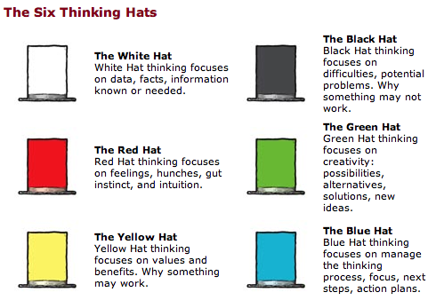
As a leader I embrace the yellow hat. I tend to focus on the benefits and why something would work rather than putting on a black hat and outlining the potential problems and pitfalls. Utilizing this method of reflecting on a situation or looking at a problem has been extremely beneficial to developing myself as a more effective leader. Prior to this year, I was almost afraid to look at the potential negative outcomes for fear of cursing a project of judging a situation too harshly. I now recognise that by exploring the negative aspects you are able to prepare for these and perhaps prevent issues from occurring.
Figure 2 de Bono's 6 hats (De Bono thinking group 2005)
Utilising the Six Thinking Hats is a good technique for looking at the effects of a decision from a number of different points of view. The opportunity for creativity within decision making is opened up and it enables emotion and scepticism to be brought into rational decisions. Projects and plans developed using the '6 Thinking Hats' technique will be more resilient than would otherwise be the case. Importantly for myself, I tend to jump in head first to a new project, utilising this tool may help me spot good reasons not to follow a course of action before I have committed to it.
My largest weakness as a leader is coping with challenge and seeking out feedback. I will address the feedback issue as a part of my imposter syndrome specific reflection as I believe this is all related and justifies a prolonged reflection in assessment component 2. I enjoy challenge, and this was reflected in both the 360⁰ feedback and the mental toughness personal evaluation we undertook. I question reasoning behind decisions and am not afraid to challenge behaviours. But I recognise that I struggle with being challenged and part of this, I believe, is due to not being able to see the other persons point of view. I need to continue to develop myself as an effective leader by becoming more comfortable with people challenging my ideas and beliefs.
De Bono’s six hats can also be useful in developing a personal ability to view things from different perspectives, which is especially useful when taking a systems/organisational view. I can then use this technique to become more comfortable with challenge but may also be useful in resolving conflict. Sometimes conflict can occur due to an inability to see the other person’s viewpoint. By developing this element of my leadership skills, I feel I am better able to see things from another’s point of view. It is important to remember that you do not necessarily need to agree with a point of view in order to see it. Just by strengthening my ability to understand and explore different perspectives conflict situations have been resolved and more resilient solutions and discussions have emerged.
Negative experiences can also be useful in developing a leadership style. Bennis and Thomas (2002) suggest that adaptive capacity and hardiness are vital to lead through difficult times. They suggest that leaders who are effective learn from and find meaning in negative experiences. Not all the things we have experienced this year have been easy to face or positive, but I believe these experiences will have contributed to making me a better leader. Utilizing the Kolb (1984) model for reflection alongside De Bono’s hats (2005) has provided me with a firm basis to utilise both positive and negative experiences to strengthen my development.
Part of knowing yourself is also about becoming more aware of your weaknesses. Anacona et al (2007) suggests when leaders are open to acknowledging their weaknesses as well as their strengths they will work more collaboratively together with others. This has the benefit to make up for their missing skills. A collaborative leader is better adapted to lead in times of uncertainty because the likelihood of addressing the interpersonal, intuitive, creative and intellectual capacities of the followers is increased. Followers expect and need these things to be addressed and the authors suggest that a successful leader needs to be actively involved in communicating a vision, making sense of the current context, nurturing a culture of trust and creating a future through innovation and invention. I believe that following this year, I am more aware where my weaknesses are, and this will in turn enable me to ensure that I am able to cover these areas.
It is also vital to be able to adapt your leadership style and this only comes from the ability to acknowledge your strengths and weaknesses as a leader. Just because a particular leadership style does not come as naturally to you does not mean you shouldn’t be able to recognise when it might be useful. By doing this it is possible to stretch yourself outside your comfort zone to achieve a goal or recognise that a member of your team may be better placed to do this. Affiliative and coaching styles of leadership are both styles of leadership which I would identify with. They have a focus on people and relationship development. These styles are useful in times of conflict, but both take time to develop and can delay a task focused achievement. I also need to be aware that in order to succeed it is sometimes necessary to employ a directive style in a crisis situation or visionary style to provide guidance and be an expert figure. I feel that I am better able, after completion of this Clinical Leadership Fellow year, to adapt my leadership style both in terms of context but also in terms of being open to opportunities for growth and personal development.
In conclusion, I have become more aware this year that rather than aiming to fit into a particular ‘effective leader’ box it is more important to acknowledge your strengths and weaknesses, have a flexible leadership style being able to adopt different techniques in different situations and communicate well to create a vision for your team. Leadership for me still remains largely about people but I recognise there are times when I need to be task orientated in order to achieve a goal.

Word Count: 1501 words
Assessment component 2
Influence of Personality Traits
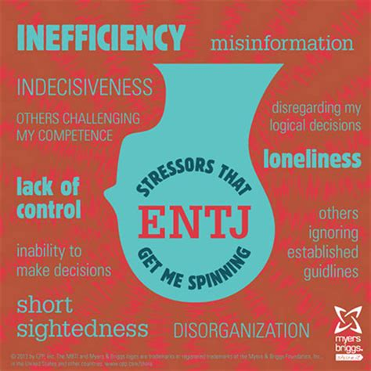
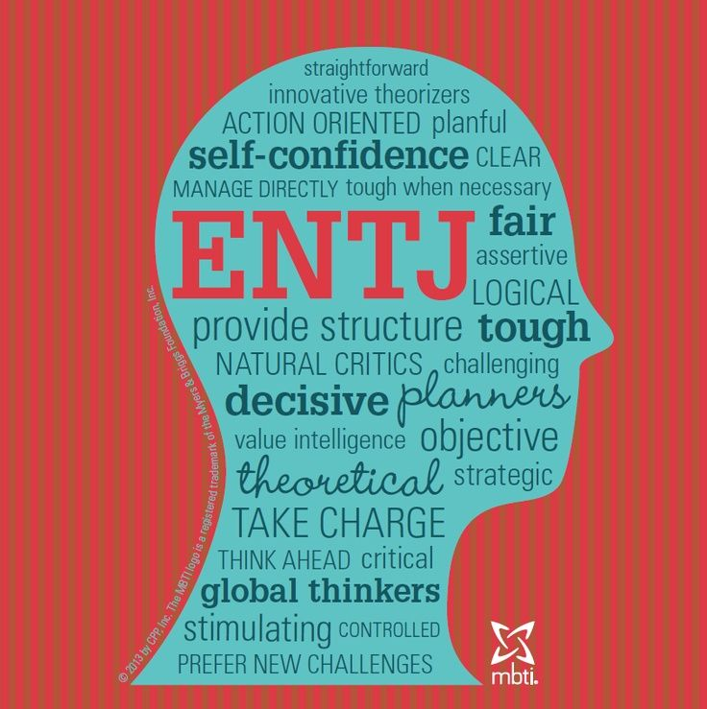
Knowing and understanding my personality type has had a significant impact on my personal development and the development of my leadership qualities. I have a greater understanding of my natural strengths and weaknesses and how these impact on members of my team. According to my Myer-Briggs my personality type is ENTJ: Extroverted, understanding the world through intuition, making decisions through thinking and organising life by judging. Prior to our assessment I would have been sure of the extroversion, and the intuition but I was less clear about the feeling and judging aspects and reading through the initial assessment I was still not certain these were the correct sections for me to be in. ENTJ’s are described as the world’s natural leaders (Richmond 2008).
Figure 3 ENTJ Myers-Briggs Kummerow et al (2003)

When on form and functioning well ENTJ’s are not afraid to make tough decisions in order to move forward, they thrive in fast growing environments which rewards achievements and fosters competition. Personally, I enjoy being in charge and I find healthy competition inspiring rather than intimidating.
But people who are inefficient, indecisive or disorganised can cause an ENTJ to become stressed. When stressed the negative side of an ENTJ can come out. These include becoming hypersensitive, emotional, domineering and inflexible. I can identify strongly with this, when I am stressed I am now more aware that I have the potential to come across badly and offend people due to abruptness and lack of taking other people’s feelings into account.
I am extroverted and this fore fills the traditional outgoing confident leader image which is projected as a good leader. However, in the more in depth exploration I am out of preference for the expressive personality section. This means that while I am extroverted I have a private, vulnerable part which I find hard to reveal. I utilise my extroversion to avoid talking about things which I feel are too personal.
I enjoy social situations and have managed to gain new contacts and experiences from networking at various conferences we have attended over the year. My project was based within simulation and I attended the Association for Simulated Practice in Healthcare (ASPiH) alone at the start of this year. This was a daunting experience, even for an extrovert like myself. I was able to utilise my love of active participation to develop connections with other members of the national simulation team. I have been able to grow these connections and contact them to help the development of my project. I feel that my networking skills have helped develop my leadership skills, I am able to effortlessly make conversation with strangers who can open doors and have an impact on both my own personal development or development of a project that I am involved in. I have recently started leading a national project which required collaboration between many participants and combining a variety of ideas. The contacts which I made while at ASPiH through utilising my networking skills have been instrumental in these developments.
As an ENTJ there is a risk that I could rely too much on my thinking and as a result forget to compliment people when I should. This is something which I have actively been working on throughout the year once I was aware of this potential flaw. I now frequently contact people either directly or through their clinical supervisors to thank them for their contribution or congratulate them on their achievements. This has been particularly relevant now I have returned to clinical practise. At the end of the shift I thank my team for their hard work and I make a point of contacting people’s supervisors if they have either worked exceptionally hard or achieved something. This has had a significant impact on creating a positive culture within my team and encourages a growth mindset where people can develop and grow together. I have found that other members of the team are now more open to celebrating success of others and work together for a united goal. I have also introduced the ‘greatix’ to my clinical department. This is where team members can nominate other team members for recognition of an achievement. This can be for providing support, being a good team player or remaining calm when in a busy challenging environment. Greatix have been proven to promote a positive culture amongst teams and a positive culture promotes greater productivity and successes. (North Middlesex Hospital NHS Trust 2018)
I could also use my out of preference sections to my advantage. For example, the spontaneous section that I have of the overall judging preference could be utilised to make myself more flexible and adaptive when completing tasks. Being exceptionally organised is a strong part of my personality, so in order to take advantage of this I have organised areas of my diary which are specifically blanked out time to be spontaneous and work on different projects which arise rather than sticking to a strict set of pre-decided projects without the time or flexibility to embrace new challenges. This has enabled me to become involved in the organisation of a national conference, take part in an existing simulation program and present at a national conference. All because I have specific time in which to complete spontaneous activities thus utilising my planning and organisational traits to allow my spontaneous and pressure prompted preferences to excel.
Knowing my preference for enjoying challenge and embracing change has also led me to become more aware of how overwhelming and dominating my personality type could come across to others. I need to ensure that members of my team are encouraged to come up with ideas and given the space by myself to express them. This also gives me the opportunity to get to know the individual skills of the members of my team, thus identifying when a particular task would be better accomplished by them. Ancona (2007) describes this as an essential skill for a leader in the imperfect leader.
The quality delivery plan for the NHS in Wales (2012) emphases the need for board level leadership to drive quality improvement in the Welsh Healthcare system. My patient improvement project enabled me to get involved in a health board at board level. I was able to confidently present my project in clinical senate and ground round gaining the support of the chief executive in promoting and focusing senior leadership on simulation. I have returned to ASPiH this year to present a variety of my projects at this national conference. My ENTJ personality lends itself to presentation and sharing of ideas which has been fundamental in senior engagement with my project and promotion nationally of the quality improvement projects I have been running via the medical education team. We have demonstrated that we are able to have a significant impact on patient safety and engaging board level leaders will support and drive this quality improvement.
Being aware of the Myers-Briggs personality types has also made it easier for me to accept some of the challenges I have faced with other personalities. Primarily I now recognise the need to allow space (and silence!) for introverted members of the team to feel able to express their views. When chairing meetings I attempt to ensure that everybody has the time to express their ideas rather than following the excitement and flow of the loudest, excitable extroverts. I also have a greater appreciation for those who focus on details and identify potential flaws in my plans. I am able to recognise this as a valuable skill necessary on a team and therefore enhancing my leadership ability, rather than becoming increasingly frustrated with an over negative viewpoint or a failure to move a project on as quickly as I would like.

Effective Team Working
This section should be read with the Nickelback song “What are you waiting for?” playing in the background. This song encapsulates the learning from a fantastic immersive team building experience. Nestled somewhere near the middle of Wales, with very limited phone signal and Wi-Fi that intermittently functions was an amazing place to learn about my own team working preferences and develop ways to improve and strengthen the teams which I work within and lead. During the residential course we studied the Belbin Team Roles, how they interact together and our personal preferences. My team was facilitated by Phil Davies, who is an ex Wales international player and currently the Head coach at the Nambian national Rugby union side. As a head coach of an international team, Phil offered a different perspective on team working from the traditional NHS viewpoint. Team-working is something which often doesn't get enough time within the NHS. By being aware of its importance and how you function within a team I feel that I am more able to successfully achieve my goals.
A team role as defined by Dr Meredith Belbin (2010) is "A tendency to behave, contribute and interrelate with others in a particular way". He has grouped these roles into 9 clusters of behaviour. The outline of the roles is described in the figure 4. You don't need a person for each role to create a successful team but as a leader it is vitally important to try to consider all perspectives. The team role perspective can also be utilised to evaluate a team which isn't functioning to its best, does everybody within that team have the same preference and therefore the same perspective on a problem. Having the same preference can be a source of conflict as well as preventing the team achieving its goal. As a group of Leadership fellows, we had surprisingly diverse results, reinforcing that no type is better or worse in a leadership role.
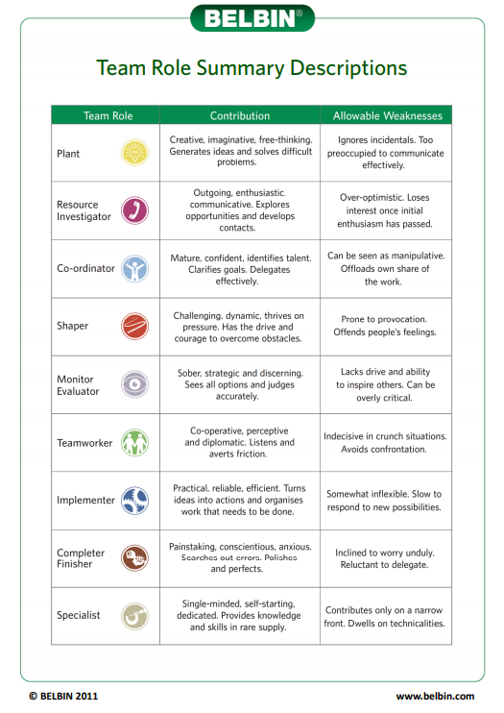
Figure 4 Belbin Team Roles (Belbin RM 2010)

My primary preference was the 'Shaper' role with my secondary preference being 'Resource Investigator' As a shaper my primary contribution was to thrive under pressure and motivate the team to overcome obstacles. The ‘Shaper’ is the task leader of a group and often impulsive and emotional as well as outgoing. The weakness of this role is that it is easy to offend other people’s feelings while a team member or steamroll their ideas.. The ‘Shaper’ role fits with my ENTJ Myers-Briggs personality type (Richmond SL 2008) with the same strengths and weaknesses coming through. A ‘Resource Investigator’ also fits with these personality preferences. The major role of this behaviour cluster is to identify opportunities and develop contacts, but we have the habit of becoming disinterested once the initial excitement wears off. The ‘Resource Investigator’ is a social member of the team networking and making connections in order to bring information and ideas back to the team members. Unsurprisingly the ‘Completer Finisher’ behaviour cluster was one of my lower scores. I struggle to finish tasks once I have started them and often wander off to the next exciting opportunity. I need to be aware of this preference and select members of my team who will push me to complete tasks before moving onto new ideas.
The report was slightly different from the other personality or preference reports we have completed this year. Instead of looking at areas to develop we were encouraged to focus on developing our strengths rather improving on our weaknesses. Spending a little time exploring your team members as a leader may enable you to create a highly successful productive team by allocating the correct tasks to each member. This demonstrates recognition of the incomplete leader (Ancona et al 2007), knowing the preference of your team member allows you to distribute workload to their strengths and identify areas which your team in deficient in, actively recruiting people for these roles (Ancona DG 2007).
We explored the Belbin theory with practical applications. The teams were selected in order to ensure that the majority of the roles were covered in within team.
The morning focused on goal based tasks. Each task started had a time limit and started with a printed instruction. Each task had rules which could not be broken and a goal which needed to be achieved. An example of one of the tasks we undertook was a maze task: a maze was laid out, out of sight from the team and we were put into a large square laid out on the ground unable to see the maze. Our team was only allowed to communicate within the box, only 1 team member was able to leave the box at any one time and all members had to successfully navigate their way across the maze to complete the task. There was of course a time limit on this. We had to work out, remember and communicate a pattern of boxes which we could step on to get across to the other side of the maze. This task acutely demonstrated to me the importance of others perspectives and the importance of communication. People like to be communicated with differently depending on their thought processes, which is something that I had not considered and shocked me because I believed I had excellent communication skills. I struggled with only being able to communicate within a box and only view the maze 1 person at a time. It also exposed potential pitfalls in my own perspective. As previously identified, I am a big picture person rather than a person who thrives on details. The first member of my team returned from viewing the maze and gave an extremely detailed and well communicated description of the puzzle in front of us. I would not have been able to do this, and this was valuable for the successful completion of the task. Every single member of the team had a shared vision of the maze which had been relayed by the first person, this underlined the importance to me that sometimes details are extremely valuable, and I need to know which members of my team have an affinity for these.
The afternoon was structured slightly differently. The whole cohort was brought back together, and we were to function as subsections of an overarching team. The team goal was to earn 'money'. The money would then be spent on unlocking clues which would give us the location of a prize which we were aiming to achieve. We could earn money by completing a variety of tasks. Tasks were diverse, and each has a value attached to it. We split into our sub-groups and decided which tasks we wanted to complete in order to earn money and then spend the afternoon working through these tasks. Again, of course there was a time limit set on this. All the subgroups had to come back together to decide how this money was spent.
​Some of the afternoon tasks were more adventurous and required taking team work to a whole other level. My personal favourite task was the "leap of faith". This involved climbing up a tiny rope ladder onto a small triangle platform which was positioned high into the trees and then jumping off. You were harnessed, and your team members were in control of the ropes. In order to work your way up the ladder you needed to trust your team members not to let you fall with the ropes, you needed a team member to anchor your ladder to stop it flapping about in the wind and enable you to climb straight and you needed encouragement from the team when halfway up you suddenly realised that it was a long way down! Despite ripping a pair of jeans, I managed to get to the top and jump. It was a good exercise in overcoming barriers and how important support and trust were within a team.
I learnt a surprising amount about myself and team roles from participating in the practical tasks. The most important of these was communication. The role of communication in good team-working cannot be underestimated. It is vitally important especially when I realised that people don't all think like me or have the same perspective as I do. Obviously, this covers the face-to-face communication when outlining a task but also the importance when managing a large busy team in communicating the overarching vision of the team which you want all members to progress towards. It is very difficult to motivate and drive forward a team when you do not all have a shared vision as to what you want to achieve. On reflection many problems I have experienced in clinical and non-clinical teams have been due to a lack of communication or a misunderstanding caused by poor communication.
Listening is a vital part of communication. However, it's importance can often get overlooked when concerned about getting your opinion heard and shouting loud enough to have your say in a team activity. I need to be speciality aware of this as a ‘Shaper’ and extrovert. Communication works best when you actually listen to the people in your team. Since giving people my full attention and actively listening when communicating with them. Reacting to their answers rather than ploughing on with my own pre-planned responses to get my point across. I have noticed a significant improvement in my communications and my ability to influence change.
Other than communication the importance of looking at things from others perspectives was emphasised to me throughout these personally challenging activities. When faced with a problem, taking on a different viewpoint or consulting a member of my team with a different skill set can fundamentally change how to tackle the problem. As a part of this it is also important to remember the importance of your role within your team, you may have a perspective which nobody else has considered.
Another area which I identified as needing to develop during the practical tasks is preparation and full understanding of the problem, translating into making sure I know the background and what I want to achieve when going into an important meeting or conversation (Covey 2004). I am quick to get started and move forward with projects but then reach a halt or discover that I have gone in a completely wrong direction which could have been avoided if I had taken a bit of time at the start to identify the main problems or focus areas.

The Neuroscience of Leadership
I was privileged to have the opportunity to attend a Leadership Course at Massachusetts Institute of Technology. “​Applied Neuroscience: Unleashing Brain Power for You and Your People”. The course was facilitated by Dr Tara Swart She is an executive coach and is passionate about disseminating simple, pragmatic neuroscience-based messages that change the way people work.
Even with the ongoing leadership training provided there has never been a room where, as a medic, Imposter Syndrome has a more appropriate setting. The course was not aimed at medics but was instead full of chief executives and people who have multi-million pound contracts in their back pockets. I feel that we would have benefited from a slightly more rigorous focus on the scientific evidence for some of the science taught on the course, however, this was not its aim and in fact may have alienated some of the audience who were present. The problems encountered and the neuroscience to increase behaviours and lead change are relevant to both the medical and the commercial setting. The insight which mixing with leaders from completely different worlds to our own has allowed us to gain was worth attending the course alone. On reflection interacting with a group of people who were not qualified medics but had reached the pinnacle of their companies was an eye opening experience. The Chief Medical Officer for Wales Dr Frank Atherton, during his keynote at the FMLM Wales leadership conference, referenced the fact that the NHS has much to learn from commercial companies and their leaders. The leaders in Boston were much more cut throat than would be experienced in the NHS. Underperformance is not acceptable.
This course was clearly very different from the majority we had attended as Leadership Fellows. At the back of the room were juggling balls, skipping ropes and standing desks. There were refreshments available through the whole day (although, caffeine was removed at 14:00 because of its impact on sleep quality after this time) and at the start we were actively encouraged to access refreshment as needed and walk around the classroom freely. While the skipping only occurred in the breaks some people did take advantage of the juggling balls and juggled at points throughout the teaching. Physical activity, as we learnt on the course is the second biggest influence on wellbeing in the workplace. By standing up and engaging in a physical activity such as skipping or juggling we were actively engaging our brains and increasing our neuroplasticity, which is the brain's ability to reorganize itself by forming new neural connections throughout life. Old neural connections are held onto, in order to create new pathways, you need to rest, fuel, hydrate and oxygenate your brain. By exercising you increase the release of brain derived neurotrophic factors (BDNF) which helps with the formation of new pathways (Swart et al 2015).
Neuroplasticity is an important concern when thinking about the neuroscience of leadership. We do not unlearn habits or behaviour, this is not possible, but we are able to overwrite these pathways. When we think about the application of this fact to inspire greater leadership ability this could be as simple as giving people in your team an alternative option rather than simply managing an undesirable or ineffective behaviour by saying "don't do that". Therefore, after this course I aim to offer a suggestion for a new pathway to be created rather than just focusing on a negative behaviour. Making new neural connections for behaviour is tough, but it is the first time which requires the most effort. As you repeat the same pattern of behaviour you strengthen this pathway and therefore make it more automatic. (Swart 2018)
Communication is a key area where neuroscience can give us the edge over others. ​​Using your limbic system to promote bonding and enhance the emotions above can give you an edge in leadership. Trust is the number one emotion, but trust uses more resources than mistrust, and is therefore more difficult to gain and use. Creating a trust relationship instantly is vital to be an effective leader. And it's as simple as eye contact (Swart 2015). Since attending this course, I have tried a communication trick taught there; when communicating face to face with somebody actively look with your right eye into their left eye. This will activate their right limbic system which has been shown to create a strong bond. A bond enables colleges to feel more valued and creates a better working culture and environment. As far as I know since my return from the course, nobody has thought I've been looking at them strangely or even been aware that I am trying out this technique. I feel that it has enabled me to shortcut some relationship building and create a quicker more valuable relationship.
Stress is one of the recognised threats to your brain power in work, others include uncertainty and uncontrollability. As a leader I have the power to influence them for my team. I have been trying since returning from Boston to adapt my leadership in order to make my team feel more empowered and in control of the tasks which they are performing. Therefore, reducing uncertainty and eliminating a potential risk to their productivity. As a leader when a suggestion is made by a member of your team the automatic response is to say "No". In order to say yes it requires more mental energy, but by doing this I have been able increase the level of control which my team feel they have and promote the positive emotional drivers outlined above.
In order to explore this further and an exercise to practise this was to, tasked in pairs of making a suggestion to overcome a problem to our partner. Initially they had to respond with "No" Then we had to re-ask the question and they had to a respond with "Yes, but .." thus entertaining the idea but outlining the potential barriers stopping this from happening. As the questioner we than had to once again make the same suggestion but our partner needed to respond with "Yes, and..." Using "Yes, and .." reduces the social isolation of your team and increases the attachment and bonding created. Social safety comes above physical activity and is the most important determinant of wellbeing within a workplace. Oxytocin, which is released when creating a good bond, shapes the neutral circuitry of trust adaption. Reward and attachment emotions regulate emotion and improve decision making. Thus, by utilising this type of leadership within your team you can promote good decision making and reduce stress (Swart 2018). There is a lot to gain. ​A ten percent improvement in performance is equivalent to an extra twenty three working days annually. I enjoyed this exercise and feel that it has had significant impacts on my strategy as a leader. I have re-framed my thinking and now aim to give my team significantly more control to complete a task than previously.
During the course we were also encouraged to focus on our own strengths and weaknesses and what we can do to improve our leadership while increasing our own resilience and mental toughness. If we can maintain our mental toughness and resilience as leaders then we promote a culture within our organisation that it is important to do the same. Dr Swart prompted "Nobody would get into a car without filling it up or maintaining it - Why do we not do this with ourselves?" (Swart 2018)
My largest area of weakness was sleep. The idea is to focus on small changes which have the potential to have a big impact on my reserves in order to maximise my potential. The course used a Neurozone questionnaire in order to gain insight into the areas we were strong in and those which we could improve. Since returning I have cut caffeine out after two pm to increase my sleep quality and aim to have a larger quantity of sleep. This has been more difficult than I imagined. I have also taken the screens out of my bedroom and eliminated blue light in the hour before bedtime.
Most importantly What am I doing differently as a leader since the course? I am employing eye contact to quickly develop a trust relationship. I am using positive feedback as motivators for my team and trying to say ‘yes and’ rather than no when somebody comes up with an idea.
The course was an amazing opportunity to understand some of the rationale behind current leadership techniques and put a neuroscience basis to their implementation. I have a lot of areas to work on to maximise my own leadership potential and am looking forward to trialling these out over the coming years.

Imposter Syndrome
This is my largest weakness as a leader, I will use the Gibbs cycle (1988) of reflection to explore this.
Description: What is imposter syndrome? The signs and symptoms of imposter syndrome are feelings of self-doubt and an inability to take credit for their accomplishments. People who experience this perceive that others evaluate them to be more capable and adequate than they themselves perceive they are and is also explained as “intellectual self-doubt”. People who have experience this are often high achievers. Imposter syndrome can provide a motivating factor to preserved and, but it has significant negative effects causing people to overwork and overprepare leading to burnout (Perksy 2018).
Feelings and Evaluation: I do not believe that I belong in a leadership role and spend a large amount of my time expecting to be found out. It is exhausting and undermining as a leader because while it drives me to do and be better it also causes increased anxiety and can hinder me making any significant decisions. This is particularly true when surrounded by people who are experts in their field or strong personalities.
Analysis: Using the Healthcare Leadership Model 360⁰ Tool (NHS, 2014) it was immediately obvious that my perception of my own skills differs significantly to the viewpoints of my peers, direct reports and line managers. Through this I have realised quite how much I underestimate and undervalue my own leadership capabilities. This was particularly evident in the Connecting our service section and Holding to account section, where my viewpoint differed significantly from the other respondents. I was pleased however, that the majority of people commented on my excellent communication skills.
The ‘Shaper’ role which was my predominant role in the Belbin (2010) diagnostic also fits in with imposter syndrome. The ‘Shaper’ can come across as exuding self confidence but underlying this are strong self doubts. They are the member of a team most prone to paranoia, sometimes edgy and often frustrated.
The ‘MTQ48’ analysis we did during the Academi Wales was where this really influenced me. I had been working through this with a professional coach and felt like I had been improving on these feelings. When reading the report, I scored between medium and high for all areas, including challenge as discussed above. However, my overall score for confidence was three. This was made up of an interpersonal confidence score of eight and a confidence in my abilities score of one. Each section is scored out of ten, with one to three being in the low space for the area and eight to ten being in the high space. It is not efficient to be in the high space for everything but rather in the middle. I feel that the high zone score for interpersonal confidence reflects my ENTJ personality type but the low score for confidence in my abilities reflects a lack of self-belief, self-critical nature and underestimation of my skills and abilities.
This diagnostic outlined to me that I still have a significant problem with imposter syndrome.
Conclusion: I have been working throughout the year with a professional coach, with her support I have actively sought feedback from those more senior then myself as well as my team members. Surprisingly this has been an overwhelmingly positive experience and any criticism has been constructive, useful and delivered kindly. My favourite tool utilised during this process is editing my internal dialogue by creating characters who have a voice and imagining them to be like an orchestra. I am the centre of this orchestra and thus control the volume and timing of all the internal dialogues.
I have also investigated the work of Professor Amy Cuddy. Her TED talk (Cuddy A, 2011) was inspirational. After first viewing I attended a significant meeting between my health board and the deanery. It was very interesting to watch the body language of the most senior people in the room and if defiantly had an affect on the way they spoke, the general tone of the language they used and the reception to them in the meeting. As a point moving forward, I now actively pay attention to not closing of my body and adopting a more open ‘power pose’ when in leadership positions.
Action Plan: I need to embrace the power of Neuroscience for Leadership and increase my neuroplasticity, not erasing old paths but creating a new script for my internal dialogue (Swart 2015). I need to actively seek out feedback, which is something that I have been doing more of especially since my return to clinical work. I also need to build relationships with my team and focus on being able to recognise when a more negative dialogue is becoming my predominant mindset. Using the Healthcare Leadership Model 360⁰ Tool (NHS, 2014) combined with my own insight into imposter syndrome, emphasises that this is a journey which I have only just entered and will probably never be complete. My experiences this year and working with a coach have begun this process and given me a variety of strategies to overcome what I view as my most significant personal leadership challenge.

Leading and Influencing
I particularly enjoyed the sessions which focused on culture, leading and influencing as I feel that they will have a long-lasting impact on my future leadership styles alongside demonstrating to me how important clinical leadership is within an organisational context. The Keogh Report (2013) highlighted a disconnect between leadership and workforce which resulted in increased mortality rates in healthcare organisations which were failing. I believe if you have the skills to lead and influence well then this can lead to a relational approach to leadership and potentially avoid this disconnect. Gabriel (2015) suggested that judgement on a particular leader is based not only on their competence but also on how ethical the actions they undertake are seen to be by their followers.
How you lead, and the meaning of your communication comes from the response you get. In order to influence your team and followers you need to have integrity. In order to achieve this you must take into account ethical, emotional and logical viewpoints. Covey (2004) suggests that a paradigm is a way of thinking that determines how we interpret and respond to situations. He hypothesises that in order to be a successful leader you need to be able to change what you see, performing a paradigm shift, in order to change your practises and therefore get different results. This once again reinforces what I discussed utilising De Bono’s six hat theory (De Bono E 2005), that the ability to see other viewpoints can be the key to success or failure as a leader. I have attempted to increase my ability to do this over the leadership year.
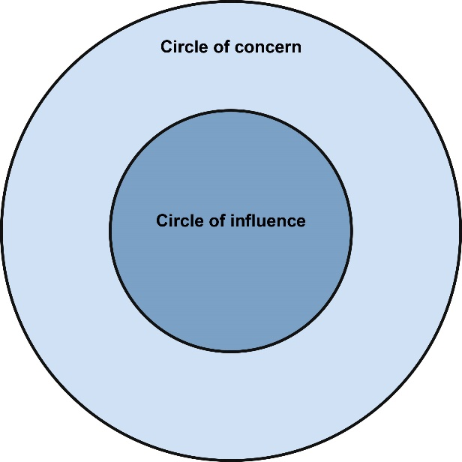
Covey (2004) also advocates working within your circle of influence, figure 5. He suggests that all leaders have a circle of influence and a circle of concern. Where your attention goes as a leader is where the energy will follow. You do not have any control over your circle of concern therefore if your attention and energy as a leader is focused here then your circle of concern will grow, decreasing by proportion your circle of influence. If you focus on what you can do and concentrate your energy on your circle of influence then this will grow.
Figure 5 Covey (2004) Circle of influence vs circle of concern
Therefore, it is necessary to nurture your first followers. As a leader you need to have the determination and drive to stand alone, you need to make it easy for people to follow you and then nurture the first people who choose to do so. Then you will create second followers and your leadership will gain momentum.
Looking at leadership and creating momentum from Covey’s angle has made it very approachable and accessible to me. Having led projects this year progress is made much more quickly and is more sustainable if you start by focusing on those who are already invested in your ideas. You can optimise the atmosphere and use neuroscience to increase neuroplasticity (Swart 2018) while working on issues inside your circle of influence. I have utilised the science of persuasion skills taught in this Academi Wales workshop alongside tips from the neuroscience of leadership (Swart 2018) to create an emotional bank account (trust) which has a high balance and therefore a positive compassionate culture which functions to aid productivity.
The culture of an organisation also has an influence on how to create influence within your teams. I have found it important to be adaptive to the culture when choosing a leadership style to achieve the best results (Handy 2009). For example, in a ‘Zeus’ culture which is led by an overarching controlling figure with power retained in the centre you need to discover what is on ‘Zeus’ agenda, focus on impact and success and offer solutions in order to influence and lead change. However, in a ‘Dionysus’ culture which has no obvious structure and mutual trust and respect the approach must be completely different. With ‘Dionysus it is important to develop individual relationships and allow the results generated to be seen, therefore speaking for themselves. During this year I have learnt to read the culture of an organisation before attempting to change it. I am aware that if I don’t pick the correct strategy then this could decrease my culture of influence and therefore my ability to bring about change.
In conclusion, I have experienced and learnt a great deal about myself and my leadership style throughout my year as a Welsh Clinical Leadership fellow. I have learnt the importance of including people in the process of change, leading by example and had the opportunity to learn about leadership by actually doing it. I have explored in this reflection some of my more relevant strengths and weaknesses and I believe it is the enhanced knowledge about myself which will have the greatest impact on my leadership skills in the future.

Word Count: 6153 words

References
Anacona DG (2007) X-Teams: how to build teams that lead, innovate and succeed. Boston: Harvard Business School Publishing Corporation.
Ancona D, Maline TW, Orlikowski WJ, Senge PM (2007) In praise of the incomplete leader. Harvard Business Review, September 2007; Boston: Massachusetts.
Belbin RM (2010) Team Roles at work. 2nd Edition. Oxford; Butterworth-Heinemann
Bennis WG and Thomas RJ (2002) Crucibles of leadership. Harvard Business Review, September 2002; Boston: Massachusetts.
Covey SR (2004) The Seven Habits of Highly Effective People. London: Simon and Schuster UK Ltd
Cuddy A – TED talk (2011): Your body language shapes who you are. https://www.ted.com/talks/amy_cuddy_your_body_language_shapes_who_you_are?language=en Accessed 17/11/2018
Cuddy A (2015) Presence Orion Books; Great Britain
De Bono E (2005) ‘6 thinking hats’ de Bono Thinking Systems The McQuaig Group Inc; Toronto
Gabriel Y (2015) The caring leader – What followers expect of their leaders and why? Leadership 11(3), pp316-334
Gibbs (1988) Learning by Doing https://www.mindtools.com/pages/article/reflective-cycle.htm accessed 19/11/2018
Handy C (2009) Gods of Management Souvenir Press Ltd; London
Keogh B (2013) Review into the quality of care and treatment provided by 14 hospital trusts in England: Overview report. London. HSMO
Kolb DA (1984) Experiential learning; experience as the source of learning and development. Prentice Hall; Englewood Cliffs; New Jersey
Kouzes JM and Posner BZ (2012) The Leadership Challenge Fifth Edition San Francisco; California; Jossey-Bass; ISBN13: 9780470651728
Kummerow JM and Quenk NL (2003) Understanding you MBTI Step II results United States of America; CPP, Inc
MTQ48 (2018) Development report Rebecca Broomfield Via Academi Wales
NHS Leadership Academy (2014) Healthcare Leadership Model. London; NHS Leadership Academy
Persky AM (2018) Intellectual Self-doubt and How to Get Out of It American Journal of Pharmaceutical Education. Mar; 82(2): 6990.
Peters S (2012) The Chimp Paradox. The mind management programme for confidence, success and happiness St Ives; Cornwall; Vermilion, an imprint of Ebury Publishing
Richmond SL (2008) Introduction to Type and Leadership. Sunnyvale; CPP, Inc
North Middlesex Hospital NHS Trust: (2018) Greatix as a tool to learn from patient and parent feedback Presented at HSJ Patient Safety Congress 2nd -3rd July 2018 Manchester
Swart T (2018) “​Applied Neuroscience: Unleashing Brain Power for You and Your People”. Massachusetts Institute of Technology. Boston
Swart T, Chisholm K and Brown P (2015) Neuroscience for Leadership. Harnessing the brain gain advantage Basingstoke; Palgrave MacMillian
Syed M (2011) Bounce. The myth of talent and the power of practice. London; Fourth Estate an imprint of HarperCollinsPublishers
Syed M (2016) Black Box Thinking. Marginal Gains and the Secrets of High Performance. Edinburgh; John Murray Publishers
Thaler RH and Sunstein CR (2009) Nudge. Improving decisions about health, wealth and happiness. London; Penguin Books
Vacher S (2018) Fundamentals of Resilient Leadership Development program. Objectives Training and Development 11th-12th January 2018

