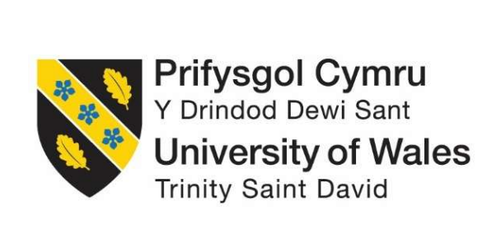
Institute of Inner-City Learning London Campus
Master of Business Administration
LCMB7035 - Dissertation

Topic: Role of Influencer Credibility in Shaping Purchase Intention for Skin Care products Brands in the UK

Research Proposal
Student ID: 2431085
Total Words: 2500

AI use Acknowledgement
This is a formal statement affirming that the proposal “Role of Influencer Credibility in Shaping Purchase Intention for Skin Care products Brands in the UK” is entirely done using secondary desk-based research without using any kinds of generative AI tools.

Table of Contents
1. Introduction 4
1.1 Research Background and Rationale 4
1.2 Research Gap and Problem Statement 4
1.3 Research Aim and Objectives 5
1.3.1 Research Aim 5
1.3.2 Research Objectives 5
1.4 Research Questions 5
1.5 Research Significance 5
2. Literature Review 6
2.1 Concept of Influencer Credibility within Skincare Marketing 6
2.2 Influence of Trustworthiness, Expertise and Attractiveness on Consumer Purchase Intention 6
2.3 Influencer-Generated Content Affects Consumer Engagement and Brand Trust 7
2.4 Recommendations for Skincare Brands regarding the Effective Use of Influencer Marketing Strategies 7
2.5 Theoretical Perspectives 7
2.6 Literature Gap 8
3. Methodology 8
3.1 Research Philosophy and Approach 8
3.2 Research Method 8
3.3 Data Collection Methods 9
3.3.1 Data Sources 9
3.3.2 Search keywords 9
3.3.3 Time Period of Literature 9
3.3.4 Application of PRISMA 10
3.3.5 Inclusion an Exclusion Criteria 10
3.4 Analysis Technique 11
3.5 Ethical Considerations 11
4. Expected Findings 12
5. Limitation 12
6. Timeframe 13
7. Conclusion 13
Reference List 14

1. Introduction

1.1 Research Background and Rationale
With the rise in the usage of social media, the buying behaviour of customers has changed significantly, particularly in the skin care market of the UK (Chan, 2022). The market size of skin care in the UK was expected to be worth approximately USD 4.59 billion in 2025 and would gradually keep increasing due to rising interests of the consumers in beauty products and personalised skin care products (Mordor Intelligence, 2024). In addition, the influencer marketing market in the UK will grow to the amount of USD 3.1 billion by the end of 2025, which indicates the importance of influencers in brand promotion (Imarc, 2025). This topic was chosen because consumers in the UK market are turning to influencers for their skincare recommendations, and influencer credibility plays an important role in this process.
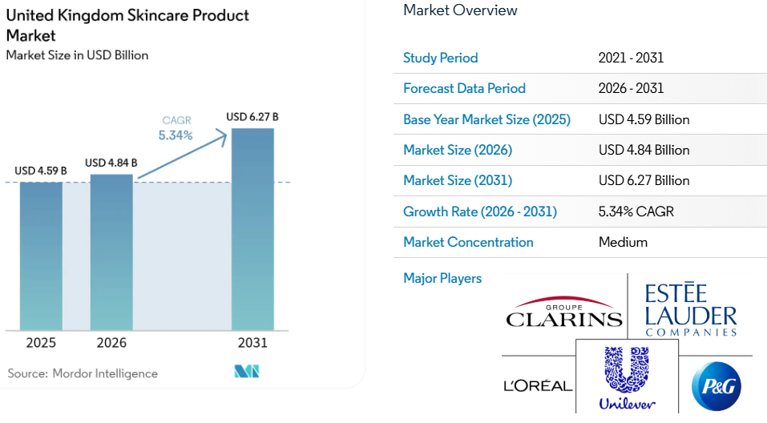
Figure 1: Skincare Product Market in UK
(Source: Mordor Intelligence, 2024)

1.2 Research Gap and Problem Statement
Previous studies like Nwori and Uchegbulam (2025) have established the effectiveness of influencer marketing in increasing the level of purchase intention and trust in beauty industry consumers. However, most of the studies have been carried out in the overall cosmetic industry or outside the UK. The relative weight of trustworthiness, expertise and attractiveness has remained inconclusive and fragmented. As concerns over authenticity and consumer trust in influencer marketing increase in recent literature such as Nazara, Nugrahaningsih and Abdillah (2025), it is essential to follow the ethical guidelines to make sure that the information provided by the influencers is accurate.

1.3 Research Aim and Objectives

1.3.1 Research Aim
The aim of the research is to examine how the purchase intentions for skincare brands in the UK are affected by the credibility of the influencers.

1.3.2 Research Objectives
- To examine the perception and belief of influencer credibility and trustworthiness within skincare marketing.
- To examine the effects of trustworthiness, expertise and attractiveness on purchase intention of the consumers.
- To understand how influencer-generated content concerns buyer engagement and brand trust in the skincare market in the UK.
- To provide suggestions regarding the most effective brands of skincare products and the marketing strategies used.

1.4 Research Questions
- What is the role and feature of the credibility of influencers in skincare marketing?
- In which way do consumers' purchase intentions towards skincare brands vary in relation to trustworthiness, expertise and attractiveness of the consumers?
- How does social media content generated by influencers affect engagement with consumers and brand trust in the UK skincare market?
- How can skincare companies increase and develop their influencer marketing campaigns?

1.5 Research Significance
The theoretical significance of this research work will be the development of knowledge related to the significance of influencer credibility in purchase intention in the UK skincare market, which will be systematic and novel to the current body of knowledge. Practically, the findings of this research will help skincare companies and marketers develop effective campaigns through influencer marketing and build consumer trust and customer engagement.

2. Literature Review

2.1 Concept of Influencer Credibility within Skincare Marketing
Influencer credibility refers to the degree of consumers' trust in the influencer regarding his or her trustworthiness, expertise, and attractiveness, according to Iqbal (2023). In the era of social media platforms, consumers have begun to depend on social media influencers in their search for information about the product and their reviews, which results in increasing the role of credibility in skincare marketing (Abu-Rahme et al., 2025). Authenticity and transparency as important attributes of consumers of skincare products have been highlighted by previous research, including Ünalmış, Dirsehan and Erdoğmuş (2026), especially when dealing with health and beauty-related products.

2.2 Influence of Trustworthiness, Expertise and Attractiveness on Consumer Purchase Intention
According to Garg and Bakshi (2024), there are three important dimensions of an influencer's credibility, which affect the intention and behaviour of the consumer to purchase the products, and these are trustworthiness, expertise and attractiveness. The former involves truthfulness and honesty, helping consumers to trust recommendations for the products (Kothari et al., 2025). Attractiveness is related to the beauty of a person or presentation and has the ability to be used to increase emotional connection and engagement of an audience (Edelblum, Frank and Palmer, 2025). According to various research studies, both trustworthiness and expertise have a more positive effect on purchase intention than attractiveness since consumers value authenticity more than the influence of celebrities (Garg and Bakshi, 2024). On the other hand, according to several researchers, including Khwela et al. (2024), the beauty industry is affected by attractive influencers since people are following them out of admiration of their appearances.

2.3 Influencer-Generated Content Affects Consumer Engagement and Brand Trust
The content made by influencers has a major and considerable effect on consumer engagement and brand credibility (Parashar, 2025). As was indicated in the past research (Castillo‐Abdul, Pérez‐Escoda and Núñez‐Barriopedro, 2022), customer tend to like, comment, and discuss interesting things on their social media pages. Previous research (e.g., Castillo‐Abdul, Pérez‐Escoda and Núñez‐Barriopedro, 2022) has demonstrated that interesting content can create a strong bond between the consumer and the brand due to likes, comments, sharing, and discussions. Furthermore, useful and interesting information about skincare products can be a source of enhancing the credibility of the brand and eliminating uncertainties (Yee et al., 2025).

2.4 Recommendations for Skincare Brands regarding the Effective Use of Influencer Marketing Strategies
Some of the ways which have already been employed previously can be helpful in making influencer marketing more effective in the skincare industry. First of all, companies should collaborate with those influencers who share similar values and audience as that of the company (Okonkwo and Namkoisse, 2023). Second, by selecting those influencers who have built a reputation for themselves in relation to their credibility in terms of their expertise related to skincare, consumers' trust can be enhanced (Khwela et al., 2024). Third, companies should emphasise authentic storytelling along with disclosing branded partnerships in order to enhance their trustworthiness. Several researchers, such as Gerlich (2023), recommend collaborating with micro-influencers as they are more connected to their followers and receive more engagement compared to celebrities. Also, companies should engage in long-term collaboration in order to ensure consistency and credibility (Rabby, Murthy and Bansal, 2025).

2.5 Theoretical Perspectives
The basis for the study is founded on two theories, which include Source Credibility Theory (SCT) and Theory of Planned Behaviour (TPB). Source Credibility Theory gives information about the effect of credibility, expertness and attractiveness in influencing the audience and persuasion (Iqbal, 2023). On the other hand, the Theory of Planned Behaviour argues that attitudes and subjective norms motivate buying behaviours (Jingyi and Ali, 2025). Together, these theories are appropriate enough to evaluate how the attitudes, trust and intentions to purchase skincare products in the UK market are affected by the characteristics of the individuals who influence consumers (Leonov et al., 2023).

2.6 Literature Gap
Even though there have been various investigations into influencer marketing practices, few studies concentrate on the issue of the UK skincare industry. The existing literature concentrates mostly on the issues of cosmetics or fashion industries and on the international level in particular (Jia, Fu and Dai, 2024; Parashar, 2025). The existing literature concerning the relationship between factors such as trustworthiness, expertise and attractiveness is ambiguous. There is limited information concerning the merging roles of consumer engagement, brand trust and purchase intention created by the influence generated by consumers (Garg and Bakshi, 2024; Edelblum, Frank and Palmer, 2025).

3. Methodology

3.1 Research Philosophy and Approach
This research will adopt a qualitative methodology that uses inductive research strategy and interpretivism research philosophy that will be used to evaluate the subject matter accordingly. For instance, considering the consumer perceptions to different qualities of the influencer, including credibility, expertise and attractiveness, are socially constructed through the experiences and interactions of the consumers in digital platforms, thus interpretivism acts as the appropriate methodological framework to adopt (Junjie and Yingxin, 2022).
An inductive approach will be conducted that could help to come up with some patterns, themes and insights from the reading of the literature rather than the hypotheses that had been predetermined (Proudfoot, 2023). Along with this, a qualitative secondary research design will be used since the study seeks to explore and interpret the way the influence credibility affects consumer behaviours through the review of the literature from academic as well as industry sources.

3.2 Research Method
This study will make use of qualitative research design where the design of the research with a mono-method choice considering the approach of Systematic Literature Review (SLR). This means that the SLR method stands to be well-structured and clear when it comes to selecting, evaluating, and synthesising scholarly studies, papers, as well as reports concerning the subject matter in the UK skin care industry (Cabrera and Cabrera, 2023).
The application of secondary research is considered suitable since the subject matter of influencer marketing, skin care consumption, and purchase intentions have been extensively discussed in the literature. At the same time, there is sufficient literature for conducting an extensive study of the research problem. The researcher will be able to analyse in a critical manner and thereby synthesise accordingly considering the results of existing studies through secondary data and identify gaps in the literature without conducting any primary research (Costa, 2024).

3.3 Data Collection Methods

3.3.1 Data Sources
The data will be collected using secondary sources, which will be searched in a systematic manner from credible online databases. The key online databases to be used include Google Scholar, Scopus, ScienceDirect, Emerald Insight, Taylor & Francis, and Sage Journals, which are sources of credible peer-reviewed information related to influencer marketing and consumer behaviours.
The sampling focuses on considering 60 articles which will be taken into account by using the specific data sources to maintain credibility and relevance to the aim of the study.

3.3.2 Search keywords
A variety of search terms will be employed to identify appropriate studies such as ‘influencer credibility', ‘purchase intention', ‘UK consumers' and ‘consumer behaviour'. Different combinations of these keywords will be used to ensure optimal retrieval of relevant studies with the use of logical Boolean operators such as “AND” and “OR.”

3.3.3 Time Period of Literature
The review will focus primarily on the literature used which are thereby published within the year range of 2019 to 2026 to keep up to date with the most recent advances in the skincare industry and influencer marketing.

3.3.4 Application of PRISMA
For the study, the systematic review process will focus on including identification, screening, eligibility, and finally the selection of studies using the framework of PRISMA which will increase the credibility and quality of research.
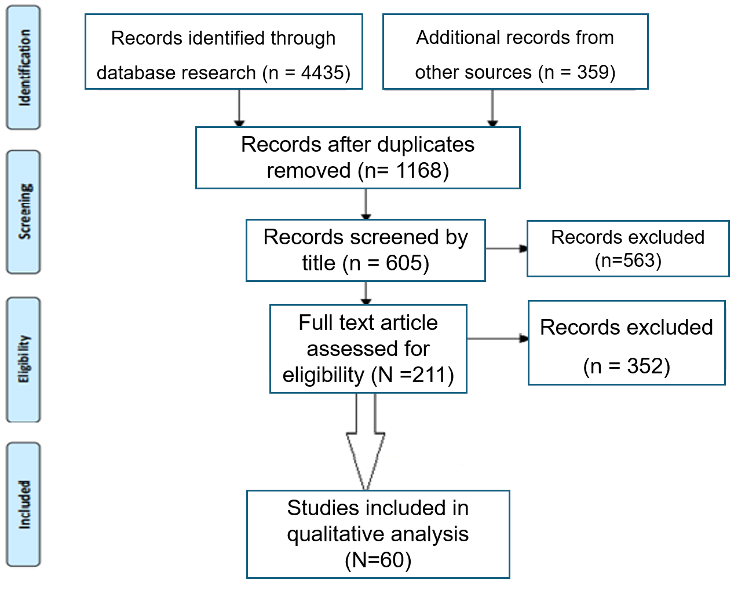
Figure 2: Applying PRISMA
(Source: Self-created)

3.3.5 Inclusion an Exclusion Criteria
The application of the following criteria will ensure that only relevant literature will be used in the study and will contribute towards increasing the validity and reliability of the results of the study.
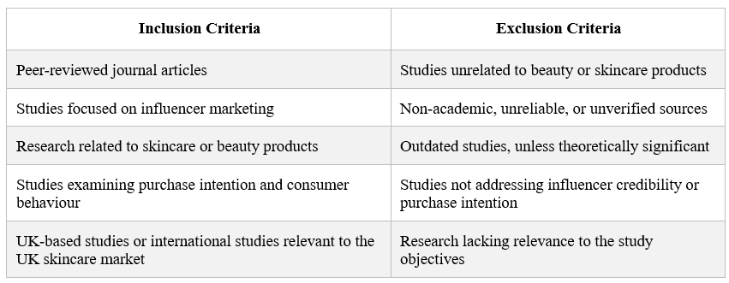

3.4 Analysis Technique
The consideration of the method of thematic analysis will be done to analyse the selected literature using the six-step model as presented by Braun and Clarke (2022). This method will be appropriate to use in the reviewed literature because thematic analysis involves recognizing, organizing, and interpreting patterns in order to come up with key findings (Chaudhry et al., 2023). The main findings from the literature will be sorted into themes regarding the issues of influencer credibility and consumer purchase intention within the UK skincare market.
Braun and Clarke's Six Steps | Application in the Study
Familiarisation with data | Reading and reviewing selected studies repeatedly.
Generating initial codes | Identifying important concepts related to influencer credibility.
Searching for themes | Grouping similar codes into broader themes.
Reviewing themes | Comparing themes across different studies for consistency.
Defining and naming themes | Refining and clearly labelling final themes.
Producing the report | Interpreting findings and linking themes to research objectives and questions.
Themes are likely to be focused on areas such as influencer trust and authenticity, influencer expertise in skincare knowledge, physical attractiveness and presentation style, consumer engagement with skincare content, impact on brand trust, and influence on purchase intention.

3.5 Ethical Considerations
As this research project will use published secondary data from academic as well as industrial sources, there is no need for any requirement of informed consent or the consideration of confidentiality of participants because there will be no primary approach for collection of data (Costa, 2024). At the same time, the ethical considerations will be maintained through proper referencing, paraphrasing the works of the author, thereby focusing on preventing plagiarism (Mulenga and Shilongo, 2024). The three aspects of the credibility of influencers will be critically evaluated, and these aspects include trustworthiness, expertise, and attractiveness ensuring that the literature will be analysed systematically and unbiassed manner.

4. Expected Findings
The primary purpose of this research study is to examine the influence of credibility of the influencers on the purchase intention of the consumers regarding skincare product brands in the UK. Based on the past literature, it can be expected that there is a positive relationship between the three dimensions of the credibility of influencers, such as considering aspects of trustworthiness, expertise, and attractiveness with the purchase intention of the consumers.
Along with this, the findings will highlight the importance of credible and expert influencers in creating engagement of consumers and building brand trust. Furthermore, the results could be beneficial for skincare brands who are trying to improve their influencer marketing campaigns in the UK market.

5. Limitation
The potential weaknesses of this research could include secondary research as the findings will depend on existing literature which should be of high quality and relevant to the topic and it may lack in-depth discussion in some respects (Lim, 2025). At the same time, the research on the period of 2019 to 2026 may overlook some old literature which is relevant to the topic but published outside the specified time period.
Additionally, the literature review will mainly be based on already existing and published literature that is likely to result in publication bias (Cabrera and Cabrera, 2023). This research will not collect primary data, meaning that consumer perceptions will not be captured in the research. However, the limitation will be addressed through conducting the SLR using several academic databases, as well as highlighting the selection process of the articles in terms of credibility and reliability.

6. Timeframe

Figure 3: Gantt Chart
(Source: Self-created)

7. Conclusion
This proposed study will be designed accordingly to explore how the credibility of the influencers allows to impact the purchase intention of consumers in regard to skin care product brands in the UK. The study will further focus on the main trustworthiness dimensions such as expertise and attractiveness considering how they influence consumer involvement and brand trust. The study will be carried out by a thorough and proper methodology; that is, by using SLR approach and thematic analysis. At the same time, the results of this study are expected to provide some important academic as well as managerial implications for the future of influencer marketing strategy for skin care brands.

Reference List
Abu-Rahme, M.O., Abu-Loghod, N.A., Omeish, F., Alharthi, S., Joudeh, K.J. and Joudeh, J.M., (2025). Investigating the impact of misleading information via social media platforms on the trust and image of beauty and skincare companies, as perceived by customers. Journal of Posthumanism, 5(1), pp.569-584. https://www.researchgate.net/profile/Fandi-Omeish-2/publication/390540696_Investigating_the_Impact_of_Misleading_Information_via_Social_Media_Platforms_on_the_Trust_and_Image_of_Beauty_and_Skincare_Companies_as_Perceived_by_Customers/links/67f40e2995231d5ba5ba4394/Investigating-the-Impact-of-Misleading-Information-via-Social-Media-Platforms-on-the-Trust-and-Image-of-Beauty-and-Skincare-Companies-as-Perceived-by-Customers.pdf
Braun, V. and Clarke, V., (2022). Conceptual and design thinking for thematic analysis. Qualitative psychology, 9(1), p.3. https://uwe-repository.worktribe.com/index.php/preview/7165036/Conceptual%20and%20design%20thinking%20for%20thematic%20analysis.pdf
Cabrera, D. and Cabrera, L.L., (2023). The steps to doing a systems literature review (SLR). Journal of Systems Thinking Preprints. https://www.scienceopen.com/document_file/022953c9-0797-4d30-a8cd-b301bff8e331/ScienceOpenPreprint/SLR%201.pdf
Castillo‐Abdul, B., Pérez‐Escoda, A. and Núñez‐Barriopedro, E., (2022). Promoting social media engagement via branded content communication: A fashion brands study on Instagram. https://burjcdigital.urjc.es/bitstreams/07c5eadf-6be3-4a9c-b352-81db7b98139f/download
Chan, F., (2022). A study of social media influencers and impact on consumer buying behaviour in the United Kingdom. International Journal of Business & Management Studies, 3(07), pp.2694-1449. http://mail.ijbms.net/assets/files/1659111546.pdf
Chaudhry, M., Shafi, I., Mahnoor, M., Vargas, D.L.R., Thompson, E.B. and Ashraf, I., (2023). A systematic literature review on identifying patterns using unsupervised clustering algorithms: A data mining perspective. Symmetry, 15(9), p.1679. https://www.mdpi.com/2073-8994/15/9/1679
Costa, J., (2024). Mixed methods in educational large-scale studies: Integrating qualitative perspectives into secondary data analysis. Education Sciences, 14(12), p.1347. https://www.mdpi.com/2227-7102/14/12/1347
Edelblum, A., Frank, A. and Palmer, J., (2025). The beauty backfire effect: How extreme attractiveness undermines fitfluencer relatability and engagement. Psychology & Marketing, 42(11), pp.2981-2995. https://onlinelibrary.wiley.com/doi/pdf/10.1002/mar.70023
Garg, M. and Bakshi, A., (2024). Exploring the impact of beauty vloggers’ credible attributes, parasocial interaction, and trust on consumer purchase intention in influencer marketing. Humanities and Social Sciences Communications, 11(1), pp.1-14. https://www.nature.com/articles/s41599-024-02760-9.pdf
Gerlich, M., (2023). The power of personal connections in micro-influencer marketing: A study on consumer behaviour and the impact of micro-influencers. Transnational Marketing Journal, 11(1), pp.131-152. https://transnationalmarket.com/menu-script/index.php/transnational/article/download/296/303
Imarc (2025). UK Influencer Market Size, Share, Outlook 2025-2033. [online] Imarcgroup.com. Available at: https://www.imarcgroup.com/uk-influencer-marketing-market (Accessed: 19 June 2026).
Iqbal, A., (2023). Investigating the Influence of Trust, Attractiveness, Perceived Expertise, and Perceived Credibility on Attitude Toward the Influencer: The Mediating Role of Attitude Toward the Influencer and Moderating Role and Perceived Risks. KASBIT Business Journal, 16(3), p.41. https://www.researchgate.net/profile/Asif-Iqbal-55/publication/374870096_Investigating_the_Influence_of_Trust_Attractiveness_Perceived_Expertise_and_Perceived_Credibility_on_Attitude_Toward_the_Influencer_The_Mediating_Role_of_Attitude_Toward_the_Influencer_and_Moderating_/links/6532d4095d51a8012b5865ba/Investigating-the-Influence-of-Trust-Attractiveness-Perceived-Expertise-and-Perceived-Credibility-on-Attitude-Toward-the-Influencer-The-Mediating-Role-of-Attitude-Toward-the-Influencer-and-Moderati.pdf
Jia, W., Fu, L. and Dai, Y., (2024). Increasing trust in influencer marketing: The effects of sponsorship disclosure and endorser type. Journal of Promotion Management, 30(4), pp.615-638. https://www.researchgate.net/profile/Lunrui-Fu/publication/376276535_Increasing_Trust_in_Influencer_Marketing_The_Effects_of_Sponsorship_Disclosure_and_Endorser_Type/links/6721e414db208342dedba8b4/Increasing-Trust-in-Influencer-Marketing-The-Effects-of-Sponsorship-Disclosure-and-Endorser-Type.pdf
Jingyi, W. and Ali, S.K.B.S., (2025). A systematic review of the relationships between attitude, subjective norms, perceived behavioral control, and exercise intention. The Open Public Health Journal, 18(1). https://openpublichealthjournal.com/VOLUME/18/ELOCATOR/e18749445394456/FULLTEXT/
Junjie, M. and Yingxin, M., (2022). The Discussions of Positivism and Interpretivism. Online Submission, 4(1), pp.10-14. https://files.eric.ed.gov/fulltext/ED619359.pdf
Khwela, N.P., Msosa, S.K. and Ntshangase, B.A., (2024). Social media influencers and their role in the purchase pattern of products among females: gender aspects of business leadership in the skincare industry. Business Ethics and Leadership, 8(4), pp.173-185. https://armgpublishing.com/wp-content/uploads/2025/01/BEL_4_2024_12.pdf
Kothari, H., Choudhary, A., Jain, A., Singh, S., Prasad, K.D.V. and Vani, UK, (2025). Impact of social media advertising on consumer behavior: role of credibility, perceived authenticity, and sustainability. Frontiers in Communication, 10, p.1595796. https://www.frontiersin.org/journals/communication/articles/10.3389/fcomm.2025.1595796/pdf
Leonov, Y., Nakonechnyi, O., Khalimanenko, V., Nikolaiko, H. and Heraimovych, V., (2023). Analysis of the influence of psychological factors on consumer behavior and the decision-making process. Economic Affairs, 68(3), pp.1643-1651. https://www.researchgate.net/profile/Leonov-Yaroslav/publication/375038862_Analysis_of_the_Influence_of_Psychological_Factors_on_Consumer_behavior_and_the_Decision-making_Process/links/66150f50f7d3fc28743d66a7/Analysis-of-the-Influence-of-Psychological-Factors-on-Consumer-behavior-and-the-Decision-making-Process.pdf
Lim, W.M., (2025). What is qualitative research? An overview and guidelines. Australasian marketing journal, 33(2), pp.199-229. https://journals.sagepub.com/doi/pdf/10.1177/14413582241264619
Mordor Intelligence (2024). UNITED KINGDOM SKINCARE PRODUCT MARKET SIZE & SHARE ANALYSIS - GROWTH TRENDS AND FORECAST (2026 - 2031) [online] Mordorintelligence.com. Available at: https://www.mordorintelligence.com/industry-reports/uk-professional-skincare-product-market (Accessed: 19 June 2026).
Mulenga, R. and Shilongo, H., (2024). Academic integrity in higher education: Understanding and addressing plagiarism. Acta Pedagogia Asiana, 3(1), pp.30-43. https://tecnoscientifica.com/journal/apga/article/download/337/188
Nazara, D.S., Nugrahaningsih, H. and Abdillah, F., (2025). The Future of Influencer Marketing: Trust, Authenticity, and Consumer Behavior in the Social Media Age. Jurnal Informatika Ekonomi Bisnis, pp.345-349. https://infeb.org/index.php/infeb/article/download/1138/549
Nwori, B.O. and Uchegbulam, J.C., (2025). A Comparative Study on the Influence of Social Media on Consumer Purchase Behavior in the Fashion, Beauty and Personal Care Sector of the United Kingdom and Nigeria. Saudi J Bus Manag Stud, 10(9), pp.446-460. https://saudijournals.com/media/articles/SJBMS_109_446-460c.pdf
Okonkwo, I. and Namkoisse, E., (2023). The role of influencer marketing in building authentic brand relationships online. Journal of Digital Marketing and Communication, 3(2), pp.81-90. https://tecnoscientifica.com/journal/jdmc/article/download/350/174
Parashar, V., (2025). Influencer Marketing and Its Role in Brand Building and Customer. International Journal of Engineering Science & Humanities, 15(4), pp.707-718. https://www.ijesh.com/j/article/download/593/625
Proudfoot, K., (2023). Inductive/deductive hybrid thematic analysis in mixed methods research. Journal of mixed methods research, 17(3), pp.308-326. https://journals.sagepub.com/doi/pdf/10.1177/15586898221126816
Rabby, F., Murthy, Y.S. and Bansal, R., (2025). Brand evangelism in the digital era: The impact of data-driven influencer marketing. Journal of Open Innovation: Technology, Market, and Complexity, 11(2), p.100552. https://www.sciencedirect.com/science/article/pii/S2199853125000873
Ünalmış, E., Dirsehan, T. and Erdoğmuş, İ.E., (2026). Consequences of influencer-created content on influencers’ authenticity in the beauty and personal care industry. Journal of Marketing Communications, 32(2), pp.203-229. https://www.tandfonline.com/doi/pdf/10.1080/13527266.2024.2371833
Yee, L.S., Hoo, W.C., Wolor, C.W., Bakar, S.M.S.A. and Nurkhin, A., (2025). Analysing the impact of social media advertising on consumer interactions, trust, and purchase intentions in the cosmetics and personal care sector. Journal of Applied Data Sciences, 6(3), pp.1708-1722. https://bright-journal.org/Journal/index.php/JADS/article/download/669/457

