BA BUSINESS MANAGEMENT

Module: Global Business Environment
Code: LCBB4005
Lecturer: Dr.Rexon Nting
Name: Rosiyana Domozetska
Student ID: 2217516

Global Business Environment
Assignment 1

Contents
- Introduction
- Introduction of Nepal
- PESTEL Analysis
- Porter’s Five Forces Model
- The opportunities and challenges face by Reebok company
- Recommendations use effective tactics to do business in Nepal
- Conclusion
- Appendix

Introduction
International Business refers to businesses that want to open companies in new countries. Globalization has provided opportunities for companies to sell , promote and deliver products and services in different countries all over the world. In the modern world where we are living, many opportunities can be used to increase companies and their profits. ( Hamilton and Webster, 2018).
“Globalisation involves to the creation of linkages or interconnections between nations. It is usually understood as a process in which barriers ( physical, political, economic,cultural) separating differen tregions of the world are refused and removed, there by stimulating exchanges in goods, services, money,and people”. (Hamilton and Webster, 2018, p.8) . International Business has expanded and flourished since the 1980s.The corporation enters an International Business Environment when it extends beyond its territorial boundaries. The company with local customs and culture, as economic and social differences, is a long process. ( Wikipedia, 2022). Analyses of political, economics, society, technology, law, and the environment are taken into account for the entire company. This report will be about Reebok International Limited. It is an American fitness clothing and footwear manufacturer. It was established in England in 1958. With a range of products, the company plan to expand its business in Nepal. To enter there the company needs to investigate in advance many factors that can influence the business. The report will analyse some of them. Also, new businesses will face many challenges and opportunities.
Introduction of Nepal as a selected country
Nepal is located in South Asia with a population of 30,752 million. (Britannica, 2022).Nepal is situated between two big countries: India to the east, west, and south and the Tibet Autonomous Region of China to the north. In 1991 the kingdom established a multiparty parliamentary system. The constitution of the republic created a Federal Democratic system that gives significant government powers to its states. ( Britannica , 2022). The country has a wide range of ethnic and cultural diversity, and it is interesting for foreign businesses.
Nepal is one of the least developed nations in the world. In the last year China, the United Kingdom, and Germany have provided economic assistance to Nepal.( Britannica,2022)
PESTLE Analyses
PESTLE Analyses are very important to creating a successful business in a new country. Political, economic, social, technological, legal, and environmental are the factors that refer to PESTLE analyses. In this report, they will be discussed individually.
Political factors
They include government policies, leadership, political reforms, tax policy, labour law and so more. ( Sumpton , P. 2016). The local and central government gave their specific policies which may be different when the new party come. Reebok’s company must follow the Governments norms and the law. Nepal is a Federal Democratic Republic. Executive power is in the Prime minister and his cabinet. A head of state is the President, whose primary responsibilities are representative. (Nations, 2022). The parliament consisted of 602 members. Nepal is a sovereign country that was never colonized. Priority actions for politics are identified to encourage green energy, sustainable transport, and good economic development strategy.

Economy factors
These factors have long-term effects on businesses. They are macro-economical and micro-economical factors. They include interest rates, inflation rates, and foreign exchange rates. (Sumpton , P, 2016). Nepal is in the top 30 list of the poorest country in the world. Nepal’s economy is based on agriculture, tourism, carpets, and tea. In 2011 was established the Department of railways developed and constructed a rail network in Nepal. Agriculture is the mainstay of the economy providing jobs for 80% of the population and 30% of the GDP. The economic environment in Nepal has changed slowly. The economic policy includes financial and monetary policies. Their actions can directly impact business organizations. The new businesses must carefully study the political situation before entering the country.
Socio-Cultural Factors
Socio-cultural factor refers to population, ethnic groups, social classes, religion, and education. The socio-cultural environment also plays a role in the market. Nepalese society can be classified into three main groups: High class, middle class, and lower class. Their behaviour, needs, and interest are different. It also impacts the business which must investigate how to reach all classes. According to the Constitution of Nepal 2011, 81.3% of the population are Hindus, and the second is Buddhists 9%. Another significant element of the socio-cultural environment is education. Good education should impact the economy and the country’s growth. Only 65.9% of the people are literate. ( Wikipedia , 2022).
Technological Factors
Technological factors have a positive impact on the development of the industry. In Nepal, technology and science should be developed in the future. Because the country is poor, developed countries should invest in that sector. New businesses which want to enter the country can import new technology. The country has weak technology. Only 89.9% have access to electricity, and 5% of the population have access to telephones. ( World bank 2022).
Ecological Factors
Climate change has become a very important point for businesses. The greenhouse effect changes the business trades. The last decade increase the demand for environment-friendly products. Nepal’s main environmental issues include deforestation, climate change, energy, and global warming.

Legal Factors
Legal factors are these factors that refer to consumers’ rights and laws, health, and safety. Each country has its regulations and new businesses must know them in advance. (Sumpton , 2016). Nepal is an attractive destination for international investors because of the structural reforms of the corporate tax rates. It is better if International businesses use local finance experts to help them organize their finances.
The legal environment of a business lies in business laws, low administrators, and Courts of law.
Porter’s Five Forces Model
Reebok’s company must analyze the strengths and the weaknesses in Nepal’s industry. It will help the company to create strategies on how to enter the market successfully.
An Industry’s strengths and weaknesses can be ascertained by identifying and analyzing Porter’s Five Forces Model that all industries share. (Investopedia, 2022)

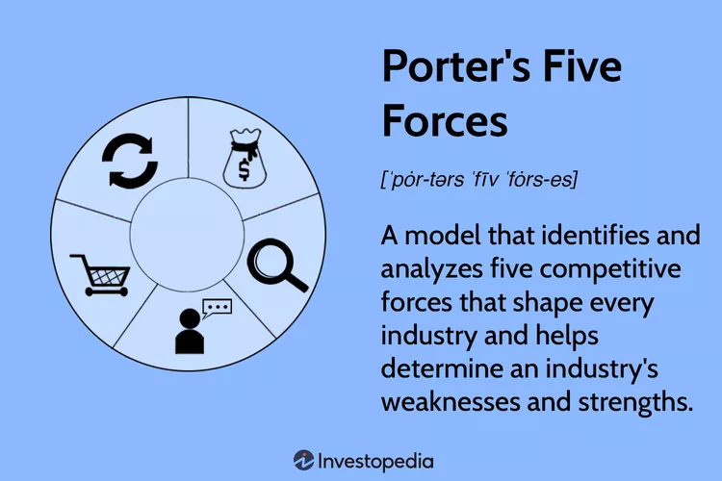
Porter‘s Five Forces Model was published in Michael E. Porter‘s book, Competitive Strategy: Techniques for Analysing Industries and Competitors in 1979.
1. Industry analysis and competition
It speaks of the quantity of rivals and their ability to undercut a business. More competitors make the company have less power. If the competitors gave lower prices the new company cannot be able to do successful business. When the competitors cannot give lower prices, the company has greater power to achieve higher sales and profit. Nepal’s footwear industry is small. It is very important to improve basic organizational and management skills. ( World Bank,2018). The government of Nepal can help by improving the investment climate.
- Potential of New Entrants into an Industry
For existing businesses, a sector with high entry barriers is optimal. Enter a business with less money and time gave power to the competitors. (World Bank, 2018 ). Reebok does not need some special technology to produce shoes and new businesses can enter easily.
- Power of suppliers
The next factor in Porter‘s Five Forces Model addresses how easily suppliers can drive up the cost of inputs. On the other hand, when there are many supplies a company can keep its input costs lower. ( Investopedia , 2022 ). Reebok can easily enter the market because the footwear industry in Nepal is not strong. The company can get the opportunity to produce and sell its products successfully.

- Power of customers
It depends on how many buyers a company has. A company that has many customers with a low budget need to charge higher prices than lower ones. The customers in Nepal have low income and that will impact the business. The new footwear business has to offer a wide variety of products and lower prices to increase profitability.
- Threat of Substitutes
Companies that produce goods or services for which there are no close substitutes will have more power to increase prices.
Substitute products refer to the products which face customers’ needs effectively.
All these forces influence the profitability of the company.
It is very important to understand them before entering a new country.
The opportunities and Challenges Face by Reebok
When doing business in Nepal, Reebok will encounter both difficulties and chances. Below is a list of the available opportunities and challenges.
Nepal welcomes foreign businesses to enter its market.
The footwear industry currently produces only 20% of its capacity. (New Business Age.2022) . A population of 30 million people needs 30 million shoes every day. The country has a multicultural and multi-ethnic population which means that there are different demands. Caste systems can also play a significant role in the market. The footwear sector grows and gives opportunities. Reebok can enter the country and do business there successfully. The company can use skilled employees at affordable compensation. To attract foreign investment, the government pushed through several pieces of legislation including the Foreign Investment and Technology Transfer Act. The government has a long-term to invest in electricity transmission and road maintenance sectors. (Trade.gov.2021). The stated long-term goal of this administration is to construct new hydroelectric power plants with a combined capacity of 15,000 megawatts over the course of the following ten years. (Trade.2021). Multilateral development banks fund a lot of infrastructure projects. Hospitality and tourism are growing industries. There is a lot of interest from foreign hotel chains to do business in Nepal
Nepal is a small contributor to the global environment. Its annual Gros Domestic Product is about USD 24.9 billion. The high level of corruption and weak implementation of laws and regulations kept investors away. Also, political instability creates too much risk for new businesses. Nepal also has natural resources which will give significant commercial potential. Hydroelectric power could be a major source of income. Agriculture which gave jobs to 80% of the population also can offer good investment. Another potential investor could be the IT sector. (World Bank, 2022)
Nepal needs to significantly improve its infrastructure. Being aware of this necessity in its finances, plans, and policies, the government gives infrastructure development priority. The development of energy, mostly hydropower, and transportation infrastructure continues to receive substantial funding.
Overall, Nepal has a lot of the ingredients for an economy that is growing. A young population and growing middle class will result in new markets and better goods and services.
Imports of goods and services (% of GDP) in Nepal were reported at 38.6 % in 2021, according to the World Bank. The value of all products and other market services that are imported from other countries is represented by imports of goods and services. New companies can import goods and services easily.
On the other hand, new businesses may face some challenges
One very important challenge for foreign businesses could be the high level of corruption. Nepal is the117 least corrupt nation out of 180 countries, according to the 2021 Corruption Perceptions Index reported by Transparency International.(TransparencyInternational.2022).

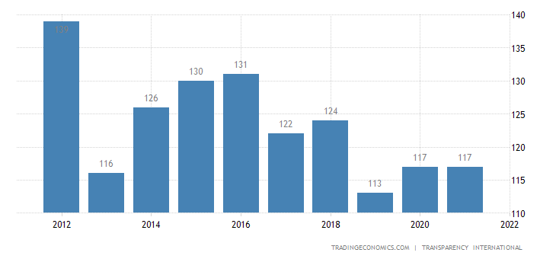
Graphic of corruption
Foreign investors commonly complain about convoluted and opaque government processes as well as working-level attitudes that are more antagonistic than receptive to the private sector. Another problem is frequently a lack of interagency coordination. In the years to come, there will probably still be delays because of the additional administrative and bureaucratic obstacles this has brought about. (International Trade Administration, 2021)
A lack of qualified labour may provide another difficulty for the company. Nepal produces competent labour, but the nation’s bleak economic outlook and low wages push millions of individuals to seek employment elsewhere.. According to International Trade Administrative, businesses frequently lament the ongoing need to hire and re-train new employees. To comply with the rules of the new Social Security Fund, which was implemented in 2018, many small and medium-sized businesses (SMEs) are having difficulty.
Recommendations use effective tactics to do business in Nepal
Nepal offers good profitability to the market. With a good marketing plan, any new business can be successful. The country has a wide range of customer demands and new businesses must cover them with different products and lower prices. Good target marketing is very important because the people in the country have different religions, cultures, and demands. If the company does not make a good marketing plan it cannot be profitable. Another very important strategy is to create a good relationship with the customers. Establishing a strong relationship with them can remove the competition. To find fresh ways of engaging with customers, marketers will need to be more creative than before. They must also do it in a manner that is both honest and appropriate for each customer. The focus of marketing in the future will be on developing memorable customer experiences that people will want to tell their friends and family about. (Wikipedia, 2022).
Conclusion
Products are now readily available worldwide because of globalization. Businesses are expanding quickly thanks to their creativity and effective methods. As the firm size grows domestically, it intends to expand its business operations abroad. Some external influences, like PESTEL and Porter’s Five Forces, were examined in this paper. They were employed to assess the factors involved with Reebok’s company departure for Nepal. After the analyses, it has become clear that the company will benefit if enter the country. The company also can face many challenges but with good marketing strategies, the company can overcome the competitor. The author’s opinion is that if the new company applies a differentiation strategy it could be successful in the market. Good marketing planning and investigation of the market before entering is recommended. Additionally, the organization will be sure to attain its aims and objectives thanks to the marketing techniques. Nowadays Reebok sells its products in over 28 countries worldwide. (Reebok, 2022). The company knows how to enter new markets and entering Nepal will be successful.

Reference list
- Britannica, (2022), Nepal/place, history, map, population, economy, facts.[0nline]Encyclopaedia. Britannica. Available at:https://www.britannica.com/place/Nepal/History. [ Accessed: 12/11/2022]
- Hamilton, L. and Webster, Ph.,(2018).’The International Business Environment‘.4th ed.Oxford UniversityPress. P.4
- International trade administration (2022)’ Nepal-Market opportunities. (trade.gov. available at: https://www.trade.gov/country-commercial-guides/nepal-market-opportunities.[ Accessed: 20 Nov.2022].
- Investopedia team,(2022).’Porter’s Five Forces Explained and how to use the model’ Available at:https://www.investopedia.com/terms/p/porter.aspe.[ Accessed: 21st Nov.2022].
- Reebok (2022). ‘Information. Available at:https://www.highsnobiety.com/tag/reebok. [Accessed: 10 Nov.2022].

- Sherpa, R., and B.K.H (2022) ‘New Business Age 2022, ‘Made in Nepal Footwear Becoming Popular ‘(4th July 2022) Available at: https://www.newbusinessage.com/MagazineArticles/view/3559. [Accessed: 20th Nov. 2022]
- Sumpton, P. (2016) Marketing Theories PESTEL Analysis. Professional Academy. Available at:https://www.investopedia.com/terms/p/porter.asp. [Accessed: 12 Nov.2022].
- Trading Economics,(2022)’ Nepal-Imports of goods and Services’ Available at : [https://tradingeconomics.com/nepal/imports-of-goods-and-services-percent-of-gdp-wb-data.html. [ Accessed: 19 Nov. 2022].
- Transparency International (2022)’ Nepal Corruption Rank’ [available at: https://tradingeconomics.com/nepal/corruption-rank. [Accessed on 20 Nov.2022].
- Wikipedia,(2022). ‘Demographics of Nepal’. Available at: https://en.wikipedia.org/wiki/Demographics_of_Nepal. [Accessed: 15 Nov.2022]
- Wikipedia. (2022).’International business’.Available at:https://en.wikipedia.org/wiki/International_business. [Accessed: 12.11.2022]
- World Bank,(2022).‘Footwear Sectoral Analysis: Nepal’. World bank. Washington
- World Bank (2022).’ Electricity uses.Available at: .https://data.worldbank.org/indicator/EG.ELC.ACCS.ZS?locations=NP. [ Accessed: 19 Nov.2022].

Appendix:

