Portfolio A – Part 3 – Thesis.
A discussion of Amarna art as an expression of monolatry.
Emerging during the reign of Neferkheperure, the coronated name of Amenhotep VI, the Amarna period, spanning an age of over thirty years, is an intriguing and unique period of history that has fascinated scholars, archaeologists and art historians since the discovery of the Amarna site in 1887 during an expedition by Napoleon. The more commonly known name of Amenhotep VI, Akhenaten, gives us an insight into the radical changes in which the pharaoh introduced new and dangerous shifts in the Egyptian world. Amarna is viewed as a dramatic shift from the traditional Egyptian spheres, through facets like art, politics, culture and religion. This thesis will discuss how the art of the Amarna period reflected and illustrated all of the facets discussed, and how the ideological changes that Akhenaten made, were always in the name of his newly created monolatrous state. Breaking ties with the century’s long tradition of a polytheistic pantheon and widely diverse religious practice, Akhenaten, with influence from his father and previous pharaoh, Amenhotep III, moved the country eventually to a solar-based religion, with the Aten in the driver’s seat. During Akhenaten’s childhood, he grew up in Thebes, where Amun reigned as the patron deity at a period where Amenhotep III had ushered in an age of prosperity and grew Egypt’s empire into a world dominating powerhouse at the time. A turning point for the increased emphasis on solar religion during the reign of Amenhotep III was in Nubia, specifically the Soleb Temple, where Amenhotep began to be venerated as a solar deity himself, linking to the Aten, the personification of the sun disk. We can through this see where Akhenaten’s solar based influences originated, and where ultimately, where ‘Amun is satisfied’ would begin his notorious and legendary reign. Coming to the throne in his teenage years after the death of his father, Akhenaten oversaw the completion of the Soleb Temple in Nubia, and the third pylon at the Temple of Amun in Karnak, honouring his deceased father, but also solidifying his alignment to the solar cult. Akhenaten would eventually erect a stela in Karnak which would turn the tide of Egyptian history. He denounced all other gods and goddesses, ceasing them to exist, ushering in the age of the Aten. During his fifth regnal year, Akhenaten would move the capital of Thebes, to a desert plateau along the Nile, and create Akhetaten – ‘Horizon of the Aten’, which would commonly be known as Amarna today. This thesis will aim to explore the concept of monolatry, and provide evidence to explain why Akhenaten’s world was monolatrous, rather than monotheistic.
Defined by the Oxford English Dictionary as ‘the worship of one god, especially, where other gods may be supposed to exist.’ Wilkinson provides great commentary into the religious sphere during the reign of Akhenaten. He states that ‘The Aten’s relationships with other gods were also complex. Akhenaten may have supressed the cults of other deities, but there is clear evidence to show that other gods were admitted into the Atenist theology.’ Akhenaten clearly viewed the Aten is the primary deity in his monolatrous society, however, other solar gods are able to be linked to solar religion itself, not just during the Amarna period, but throughout the timeline of Ancient Egypt. Re, ruling as the King of the Gods in the traditional pantheon, was part of the solar barque. We can see in the images that certain deities are portrayed in the solar barque; Re, the King of the Gods, Khepri, the representation of the dawning sun, Aker, the leonine guards of the horizon, and many other solar-based gods and goddesses. The image of Re is anthropomorphised into various forms, phoenix, scarab, heron, serpent, bull, cat and lion. Mainly solar based imagery is depicted in New Kingdom funerary tombs through the image of Re, and further solar worship is evidenced through ben-ben and the pyramid structures. Darnell and Darnell eloquently put that ‘reduced to its simplest and most essential features, Egyptian religion was a solar religion… sunrise and sunset…defined Egyptian religion. Upsetting the solar cycle meant the end of life.’ We can see that Amenhotep III somewhat disrupted the solar cycle during his reign. He created a new city – Malqata. Similarly to his son, Amenhotep III began to shift his religious centres outside of Thebes and eventually meshed Malqata into the Waset. Carrying out the barque procession around this area incorporated the pharaoh into form of Re on earth. This is evidenced through the Third Pylon, built a few decades after the beginning of Amenhotep II’s reign. The whole site surrounding the Third Pylon, are detailed with amazing carvings, which depict Amenhotep III, arguably, Akhenaten, however this has been highly debated amongst scholars, and various deities on the solar barque procession. The new city allowed Amenhotep III to rename himself colloquially as The Dazzling Sun Disk. Much of the mythology surrounding solar cults is clearly expressed through imagery, rather than narratives.
There have been numerous arguments amongst scholars to decide if Atenism is either monotheistic, henotheistic or monolatrous. Defined by Hoffmeier as a term coined in the 19th century as a ‘faith community that worships single deity, which coexists with other gods and goddesses; nor is the worshipper of that one divinity intolerant toward other deities.’ However, many believe that Akhenaten’s reign, and more specifically the earlier years of his reign were actually monotheistic. Through the stela creation in Karnak, in which Akhenaten denounced all other gods other than the Aten, he inadvertently created a monotheism, separating the country from its traditional polytheistic roots.
Throughout all civilisations, the artistic portrayal of the human body has been specific to each unique culture. Examples of this can be seen through classical Greek sculptures, or ancient Māori cave art. What is iconic about the portrayal of the human body in the Ancient Egyptian style is a structured and clearly unique design. Arlette David, in his book Renewing Royal Imagery, Akhenaten and Family in the Amarna Tombs sees the art of the Amarna period as a progressive and almost modern art style. He claims that ‘Akhenaten’s attention-grabbing new imagery was conceived as a vehicle for the global reform implemented by the King, imposing a disconcerting ‘modernity’ in the Egyptian visual horizon by resensitizing the viewers brain into his own concept of kingship.’ Reflective of its politico-religious changes, the imagery and depictions of the royal family of Akhenaten alter somewhat, from the traditional lone style to an expressive and emotive family-style. The earliest known images of Akhenaten can be found in a traditionally ‘Egyptian’ style, where his proportions and facial imagery fall in line with the art style of the period. He holds no emotive facial expressions, and falls into the category of generically traditional Egyptian. Traditional art styles that were used in the most part of Ancient Egyptian history uses a grid in which elements of the human body were designed in accordance with this structure. Eighteen squares were given to design a human figure, and the figure of each human, whether they be a pharaoh, priest or deity all fell into this layout. However, with this being said, the most iconic expressions of art in the Amarna period can be seen through the Colossi. These fantastic representations of Amarna art changed the art style, adding an extra two squares into the formula, making twenty squares the design iconic of this period. ‘Extra space inserted at the chest, between the armpits and the navel, and also at the neck, elongating these areas.’
The most notable visual depiction of the royal family can be seen through the limestone carving of Akhenaten, Nefertiti and their three daughters. On display in the Egyptian Museum and Papyrus Collection in Berlin, can understand what radical leaps were taken during the reign of Akhenaten. As in previous dynasties, and more traditionally “Egyptian” works, very rarely are the pharaohs families depicted alongside him, let alone in an almost loving expression. The facial expressions of the family convey a sense of joy, basking in the glow of the Aten’s rays, and upholding their status as the chosen family under the god. Nefertiti in this image almost meets her husband in terms of power – only separated by the height of Akhenaten and his closer reach to the Aten. The Aten as a tangible and benevolent force that contrasts with the more abstract and mysterious depictions of gods in traditional Egyptian art.
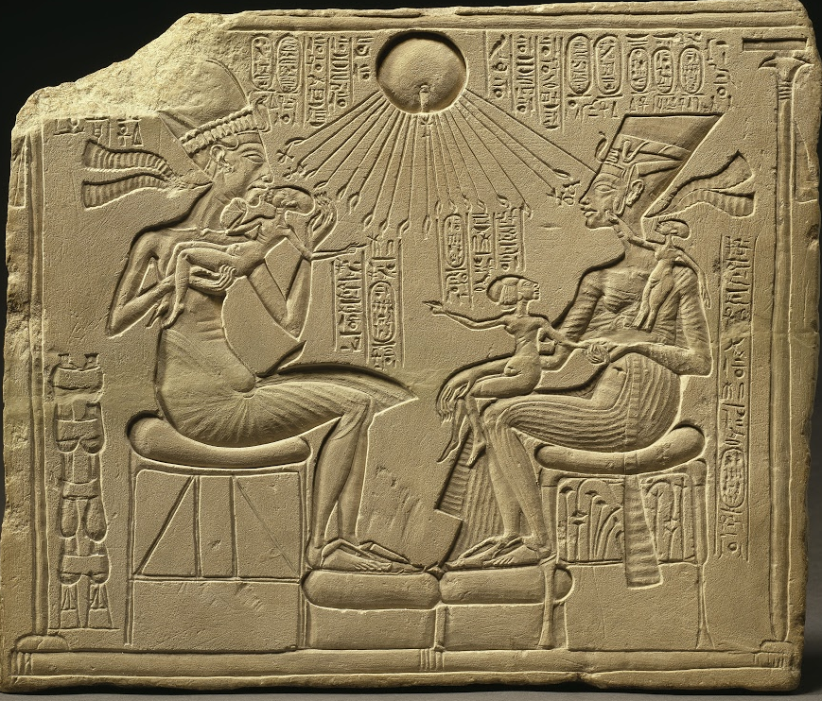
Figure 1 - Akhenaten, Nefertiti and Three Daughters under the Radiation Aten, limestone, ÄM 14145
This also showcases scenes of Akhenaten and his family engaging in activities such as worshiping the Aten, receiving the god’s blessings, and participating in royal ceremonies. These scenes emphasize the close relationship between Akhenaten and the Aten, reinforcing the idea of monolatry and the singular devotion to this new deity. This is very different to how the relationships between man and god have been portrayed in the other periods of Ancient Egyptian history.
In the more traditional Egyptian art styles, the relationship and depiction between man and god has been shown in a completely different way. Another way in the art of the Amarna period differs greatly from that of the traditional spheres is the anatomy of Akhenaten. Akhenaten is shown throughout Amarna art as having an abnormal height, a large belly, an elongated neck and in some images, breasts. Scholars have suggested numerous reasons for this. Some have suggested hat Akhenaten actually suffered with genetic diseases which could explain why he was created in this manner. Diseases such as Frölich’s syndrome have been used as reasonings behind Akhenaten’s peculiar shape. With this being said however, many have compared the figure of Akhenaten to that of Hapi, the god of the Nile. Hapi along with other deities are pictured in an androgynous style, reflecting both masculine and feminine traits. It could be suggested that Akhenaten wanted the world to see him no as a human being, but that of a god, and through this Akhenaten could be seen in a androgynous, and on times bizarre manner.
Described by Teeter, ‘The precepts of Atenism were not set down in a clear fashion as an asset of commandments or laws. Rather, they came directly from the King, who received them from the god itself in the form of divine revelations. If we look at the Aten before the induction of Amenhotep III and Akhenaten, it is simply viewed as the traditional name for the sun disk itself. The Tale of Sinhue, a tale which describes a fictional man – Sinhue, who flees and then returns to Egypt, giving a good background to stories of the Aten, pre-Eighteenth Dynasty. It describes Amenemhat I, who unites with his creator – The Aten.It is only during the time of the New Kingdom that we see the Aten becoming a sole deity, as originally, they were considered to be part of a composite deity. Amun-Re, and future Re-Horakhty was propelled into existence by both the Middle and New Kingdom rulers and quickly took the mantle of supreme god. Leading supreme as an amalgamation of Amun, Re and Montu, Amun-Re eventually took control of the Theban land, adjoining with his consort Mut, and son Khonsu, he had numerous facets of worship throughout Egypt and was know in many different forms. The most important form that will be discussed here however is that of his solar form. Wilkinson cleverly links Amun-Re to his eventual connection with Akhenaten:
‘…called the ‘eldest of the gods of the eastern sky’ an epithet reflecting both his primeval character and solar-associated nature, and an eighteenth-dynasty hymn to Amun preserved on a stela in the British Museum refers to Amun when he rises as Horakhty, directly fusing the hidden one with the visible sun. When he was syncretized with the god Re, as the composite Amun-Re, Amun took on a number of aspects of the solar deity, though these were clearly secondary to his hidden nature and the god was regarded as antithetical to the sun during the Amarna Period.’
After the state-wide conversion to Atenism, and the formation of Amarna, the beginnings of monotheism began. Akhenaten has obelisks created to remove any traces of deity worship, and the art styles began to envision beings with long necks and odd bodies. The Aten was considered the principle god and all atempts to remove other gods were undertaken, however, the connection of the Aten, Akhenaten and Nefertiti echoed the older world gods; Maat, Shu and Tefnut and thus the worship of these gods continued well into the Amarna period.
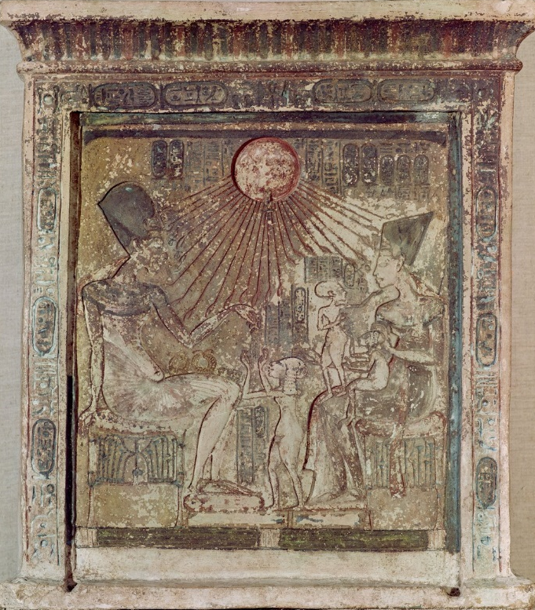
Figure 2- Stela depicting the Aten giving life and prosperity to Amenophis IV, his wife, Nefertiti and three of their daughters, from Tell el-Amarna, New Kingdom, c.1353-1337 BC
When looking at religious iconography from a pre-Atenism standpoint, we can see a plethora of animal votives, colourful offerings, jewellery and a personal touch to everyday items. Each person, whether they were a commoner or a priest, had their own personal deities which they venerated over others, and gods they worshipped in times of hardship. Tawaret, the hippopotamus goddess was revered as the protector of the sun, and played a role in both birth and rebirth. Bastet, one of the many lioness deities was mainly associated with the protection of women, motherhood and pregnancy. Khonsu was a moon god, mainly linked to the Theban triad of Amun, Mut and himself. Each of these deities would have had temples dedicated to them, and various shrines, votive offerings and physical representations. Also, Egyptians would call upon the blessings or help of certain deities throughout the year. Hapi, the Nile deity, depicted with a blue fat belly and breasts, was often worshipped to encourage the arrival of the Nile Delta floodings, guaranteeing crop growth and the giving waters of the Nile itself. This widespread example of polytheism is what would be easily identified as the traditional Egyptian world.
Iconography of religion during the time of Akhenaten’s reign was far more streamlined and succinct. As a now monolatrous state under the rule of Akhenaten, Aten was viewed as the primary deity above all else, however, archaeologists have uncovered evidence of worship to other gods. The over three-thousand-year history of Egyptian deities could not be so easily removed from the country, and personal worship remained. Whilst Akhenaten’s Egypt does not have any evidence of punishment or fine for the worship of other deities, it can be said that the country was extremely religious, and a general fear of the wrath of the gods would always accompany people, this would naturally make people conform to the will of the pharaoh, as he was, in essence, the physical manifestation of a god on Earth. It can also be argued that the existence of the Aten, consequentially brings with it the existence of other deities. The structure of the solar religion, would always bring with it, the existence of Re. As the creator deity, he would eventually permeate the religion.
In conclusion, the art style that denoted the Amarna period was somewhat an expression of monolatry. The succinct style that gave Amarna art its infamous depiction is most widely recognised as the one aspect of the period that has stayed so fresh. We can definitely see how the colourful and vibrant literature and archaeology of pre-Akhenaten somewhat changed to a devout and systematic veneration of a sole deity.

Bibliography
Arlette, David, Renewing Royal Imagery, Akhenaten and Family in the Amarna Tombs, (Leiden, The Netherlands ; Brill, 2021)
Brewer, Douglas. J, Teeter, Emily, Egypt and the Egyptians, (Oxford University Press, 2007)
Darnell, Colleen, Darnell, John, Egypt’s Golden Couple, When Akhenaten and Nefertiti were gods on Earth, (The History Press, 2022)
Hoffmeier, Herman K., Akhenaten and the Origins of Monotheism, (Oxford University Press, 2015)
Pinch, Geraldine, Egyptian Mythology: A Guide to the Gods, Goddesses and Traditions of Ancient Egypt (Oxford University Press, 2004)
Teeter, Emily, Religion and Ritual in Ancient Egypt, (Cambridge University Press, 2011)
Stevens, Anna, Amarna: A Guide to The Ancient City of Akhenaten, (The American University in Cairo Press, Illustrated Edition, 2020)
Wilkinson, Richard H., The Complete Gods and Goddesses of Ancient Egypt, (Thames & Hudson LTD, 2017)

Oxford English Dictionary Online, ‘Monolatry’ definition, Accessed 10/05/2024 , https://www.oed.com/search/dictionary/?scope=Entries&q=monolatry
Galan, José M, ‘The Ancient Egyptian Sed-Festival and the Exemption from Corvee’, Journal of Near Eastern Studies, 59.4 (2000), 255–64 https://doi.org/10.1086/468860
The Tale of Sinhue, New Kingdom, Nineteenth Dynasty, 1295-1186BC, Limestone & Ink, The Ashmolean Museum Oxford, SL.3.2015.31.2, https://www.metmuseum.org/art/collection/search/591471
Codaccioni, Jean-Louis, Bernard Conte-Devolx, and Bruno Argémi, ‘Was Akhenaten Really Sick?’, Annales d’endocrinologie, 74.3 (2013), 231–33 https://doi.org/10.1016/j.ando.2013.04.003

Figure 1 - Akhenaten, Nefertiti and Three Daughters under the Radiation Aten, limestone, Ägyptisches Museum und Papyrussammlung (Egyptian Museum and Papyrus Collection), ÄM 14145, https://www.smb.museum/en/museums-institutions/neues-museum/online-offers/detail/looked-at-house-altar-featuring-akhenaten-nefertiti-and-three-of-their-daughters-under-the-solar-aten/
Figure 2 - Stela depicting the Aten giving life and prosperity to Amenophis IV, his wife, Nefertiti andthree of their daughters, from Tell el-Amarna, New Kingdom, c.1353-1337 BC, https://www.meisterdrucke.uk/fine-art-prints/Egyptian-18th-Dynasty/422284/Stela-depicting-the-Aten-giving-life-and-prosperity-to-Amenophis-IV-%28Akhenaten%29-%28c.1352-1336-BC%29-his-wife%2C-Nefertiti-and-three-of-their-daughters%2C-from-Tell-el-Amarna%2C-New-Kingdom%2C-c.1353-1337-BC-%28lim.html

Aidan Dodson, Amarna Sunrise, 2014, p.69
Anna Stevens, Amarna: A Guide to The Ancient City of Akhenaten, 2020, p.11
Oxford English Dictionary Online, ‘Monolatry’ definition, Accessed 10/05/2024.
Richard H. Wilkinson, The Complete Gods and Goddesses of Ancient Egypt, 2017, p.238
Geraldine Pinch, Egyptian Mythology: A Guide to the Gods, Goddesses and Traditions of Ancient Egypt, 2002, p.182-184
John Darnell & Colleen Darnell, Egypt’s Golden Couple, When Akhenaten and Nefertiti were gods on Earth, 2022, p.28
José M. Galan, The Ancient Egyptian Sed-Festival 0and the Exemption from Corvée, Journal of Near Eastern Studies, Vol. 59, No. 4, 2000, p.255
Richard H. Wilkinson, The Complete Gods and Goddesses of Ancient Egypt, 2017, p.209
James K. Hoffmeier, Akhenaten and the Origins of Monotheism, 2015, p.207
Arlette David, Renewing Royal Imagery, Akhenaten and Family in the Amarna Tombs, 2021, p.1
Anna Stevens, Amarna: A Guide to The Ancient City of Akhenaten, 2020, p.19
Jean-Louis Codaccioni, Was Akhenaten really sick?, Annales d’Endrcrinologie, Vol. 74, Iss. 3, 2013, p.231-233
Emily Teeter, Religion and Ritual in Ancient Egypt, 2011, p.183
The Tale of Sinhue, New Kingdom, Nineteenth Dynasty, 1295-1186BC, Limestone & Ink, The Ashmolean Museum Oxford, SL.3.2015.31.2
Richard H. Wilkinson, The Complete Gods and Goddesses of Ancient Egypt, 2017, p.92
Richard H. Wilkinson, The Complete Gods and Goddesses of Ancient Egypt, 2017, p.93
Douglas J. Brewer, Emily Teeter, Egypt and the Egyptians,2007, p.53
Richard H. Wilkinson, The Complete Gods and Goddesses of Ancient Egypt, 2017, p.113, 178, 185
Geraldine Pinch, Egyptian Mythology: A Guide to the Gods, Goddesses and Traditions of Ancient Egypt, 2002, p.136

