Small Museums and Digital Technology: A Case Study of The Bath Medical Museum
Introduction
This essay looks at how a small, local museum with limited space and resources uses digital technology to engage with the public and bring its collection to a wider audience than would otherwise be possible. It starts with a brief background to the museum, then looks at the museum’s current digital offering and evaluates how effective its use of digital technology is, and how it fits into the research and literature on digital humanities.

About the Bath Medical Museum
The Bath Medical Museum (BMM) was founded in 2012, with a mission to:
preserve and promote the history and importance of medicine in the city of Bath, with a focus on the importance of its thermal waters in treatment, therapy and wellbeing; and to advocate the benefits of education, health and wellbeing for all. (BMM, n.d.)
It was initially based in the Royal National Hospital for the Rheumatic Diseases (RNHRD), formerly the Royal Mineral Water Hospital, in central Bath, to display the historic collection of the hospital to the public. The hospital building (known as ‘The Min’) was sold in 2019 as the RNHRD was moving to a new site, so a new home had to be found for the collection. Having gained charitable status in 2017, the BMM applied for funding and began to search for a site for a permanent medical museum in Bath. Initially parts of the collection were displayed at various locations in Bath, however the majority of the collection remained in storage.
The Museum is run by a board of trustees supported by volunteers, many of them students. It is a very small specialised museum that relies heavily on its supporters and volunteers to operate. Its physical site is open on Saturday afternoons, and Tuesday afternoons for well-being activities.
During the COVID 19 pandemic, the public could not visit the various locations, so this is when the Museum’s website came into its own, with much development of the online presence being carried out during this period. In 2023, the Museum acquired the use of The Hetling Room, a former pump room, a fitting base for a museum focussing on health and wellbeing. Through the acquisition of this space, the museum moved towards its aim of being a ‘museum without walls’ spread across the city (BMM, n.d.).

The Museum’s Digital Offering
The Museum’s website up until 2023 was fairly ‘static’, containing information about the collection and articles about medical links to Bath; this was partly because the Museum had lost its physical base and so was unable to promote events and visits to the site, and also due to lack of technical skills (Watts, 2025). In 2023 the Museum recruited a trustee with experience in website development, whose expertise transformed the website into the more dynamic offering that exists currently (Watts, 2025). Figure 1 shows the current home page.
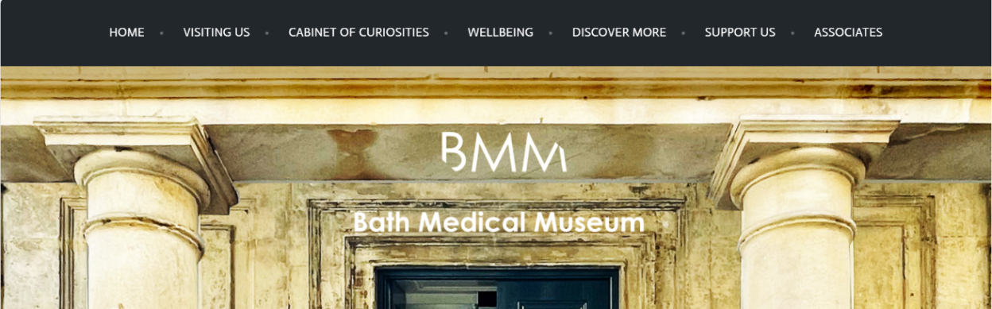
Figure 1: BMM website – home page

The ‘Cabinet of Curiosities’, ‘Wellbeing’ and ‘Discover More’ menus contain content specific to the medical focus of the museum. The Cabinet of Curiosities menu comprises the Cabinet of Curiosities itself, a virtual tour of the 1740s hospital (the ‘Virtual Min’), and a 360⁰ tour of the hospital when it closed in 2019.
The Cabinet of Curiosities comprises photographs of objects from the Museum’s collection which the user can click on to find out more about. This is used as a way to bring objects to the public that cannot be put physically on display due to lack of space.
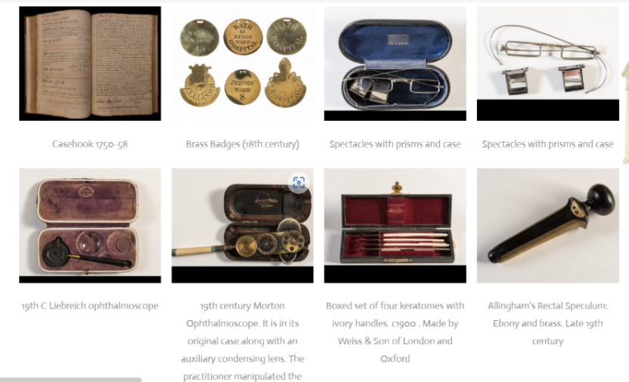
Figure 2: BMM website – Cabinet of Curiosities

Figure 3 shows an example of the further information displayed when the user clicks on an item.
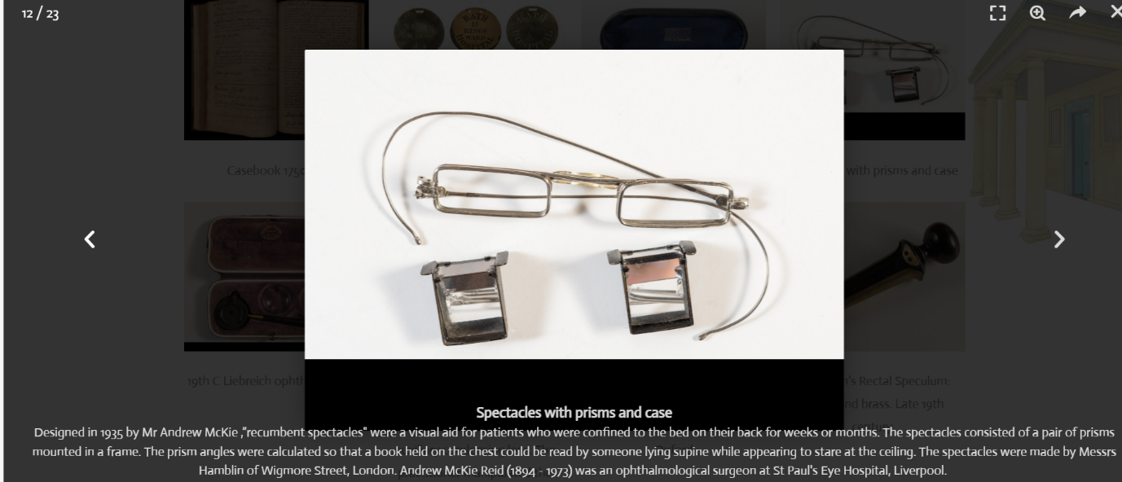
Figure 3: Further details of object in the Cabinet of Curiosities

Alongside the development of the website, funding was obtained to employ a Bath University Architecture graduate to create a virtual reconstruction of the Royal Mineral Water Hospital and bring it to life as it would have been in the 1740s (Wyatt, n.d). This ‘Virtual Min’ takes users on a virtual tour of the hospital, entering wards and operating theatres, looking inside drawers and cabinets, and listening to imagined audio recordings of members of staff and patients from the period.
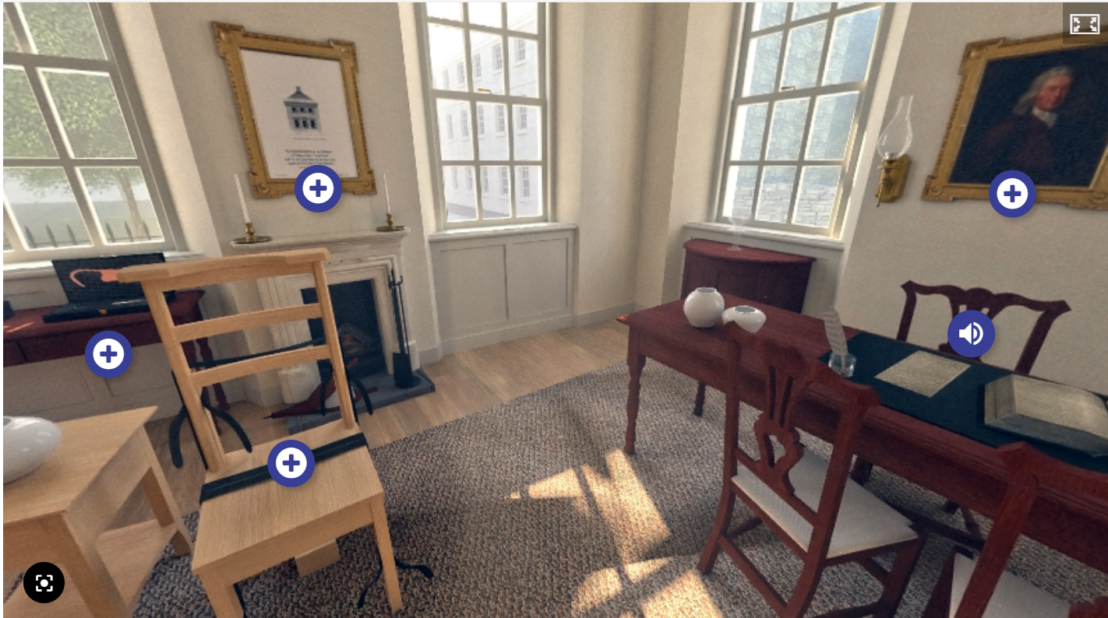
Figure 4: The Virtual Min – Surgeon’s Room

Figure 4 shows the Surgeon’s Room from the virtual tour, with ‘hotspots’ that lead to relevant artefacts from the museum and a speaker icon, which plays an imaginary recording of Jeremiah Peirce, the senior surgeon at the hospital.

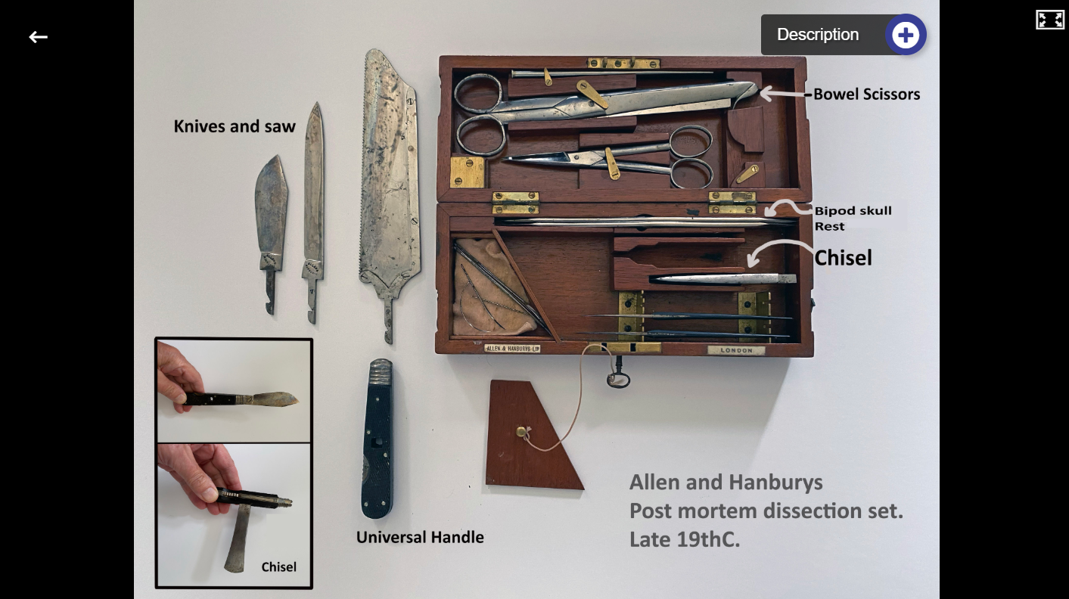
Figure 5: The Virtual Min – Contents of Cabinet

Figure 5 shows the content displayed when the user clicks on one of the hotspots in the Surgeon’s Room. There is a further hotspot which displays a detailed description of what is shown.
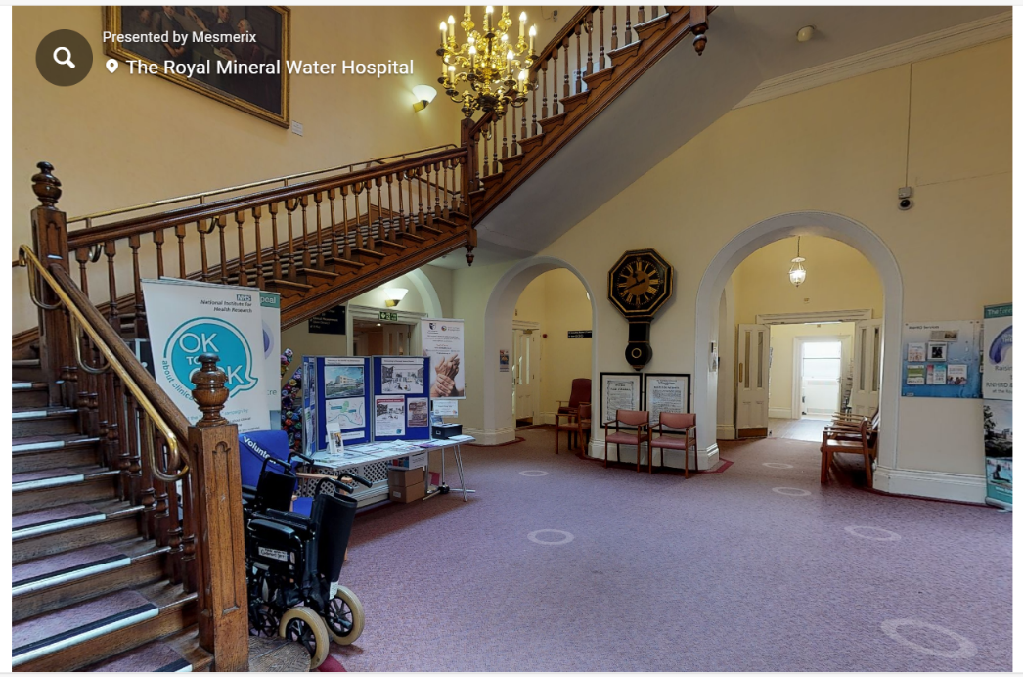
Figure 6: 360⁰ tour – the hospital in 2019

Figure 6 shows the main entrance hall from the hospital as it was before closing in 2019. This virtual tour allows the user to explore many of the rooms, empty of patients or staff for the first time since the hospital opened in 1742. This is a work in progress with plans to add videoed interviews with former patients and staff. This work is based on a crowdsourcing model, with a request for further volunteers on the website (BMM, n.d.).
The Museum has also used social media since 2016, particularly in the period when it did not have a physical base.
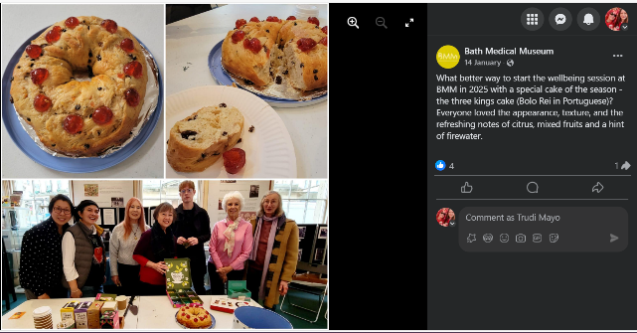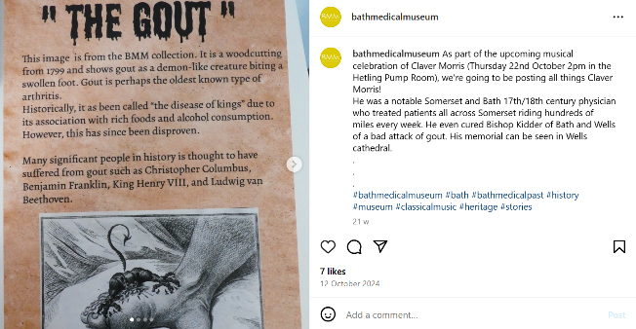
Figure 7: Example Facebook and Instagram posts (BMM, 2025)
Both the Facebook and Instagram accounts are used to promote events at the site and also used to share regular updates such as “#BathsMedicalMarvels” – weekly posts containing links to short articles on the website on medical themes to keep engagement with the museum going (BMM, 2025 and 2025a). Social media provides a balance between the museum’s digital and physical offerings through links to Wellbeing sessions, pop-up exhibitions, and talks at the museum and other locations.

Evaluation of the Museum’s Digital Offering
The Museum’s digital offering comes under the umbrella of the ‘digital humanities’, which has developed over the last forty years as the use of digital technology has grown rapidly across many disciplines, both within and outside of academia. Initially focussing on databases containing digital versions of texts, artworks and maps, the discipline has expanded to allow sophisticated searching and manipulation of data, with this data becoming available to a much wider audience than previously possible (Berry, 2019). Digital humanities projects typically use digital methods as part of their research methodology, dissemination plan and public engagement, however there is a wide variation, with some projects using it throughout the project lifecycle and some solely for public engagement (DHI, 2025).
The BMM’s digital offering is an example of a project that uses “digital methods as part of their impact and public engagement plans” (DHI, 2025). Its virtual tours and use of crowdsourcing particularly are an example of a “creative, expressive, critical and experimental” type of digital humanities project (Schnapp, 2019). It is also an example of a project that bridges the ‘theory-practice’ divide by making (for example, the Virtual Min, 3D tour of the 2019 hospital and Cabinet of Curiosities) and also interpreting, by publishing the outputs on the website to disseminate knowledge to the public (Fitzpatrick, 2012). The Virtual Min in particular allows online visitors to “deconstruct and reconstruct” the 3D model however they choose (Robson et al, 2012, p.97).
The BMM’s digital presence is an example of a digital offering in its infancy, restricted by lack of funding, permanent staff and technical expertise. As a registered charity, the museum receives no government or local authority funding so relies on charitable donations and self-generated revenue (BMM, n.d.). Its charity status means that it has to rely on the expertise of trustees and volunteers, all of which are part-time and likely to be short-term, especially students. Most of the recent website development and the entire Virtual Min project were dependent on specialist input from skilled people, with the Virtual Min also requiring a grant and fundraising to complete (Watts, 2025).
The Museum fits well with the definition of a ‘small museum’ in that it has authenticity of location (its base being in a former pump room), it has a specific collection theme (Bath’s links with the medical world), its staff are passionate about the collection, it displays a large number of objects in a small space, and attracts visitors who are already interested in the subject (Calvi & Vermeeren, 2024). Small museums have a particular set of problems when it comes to attracting visitors through their online presence and Calvi and Vermeeren recommend that such places should avoid innovation for innovation’s sake and instead build on the strong ties that they have with the local community. The BMM’s strategy of using social media and online virtual tours to draw people in and compensate for their lack of physical size, combined with the use of pop-up exhibitions at different sites and events, can be seen as an attempt to do just that.
In common with many museums and galleries across the world, the COVID-19 pandemic meant that in-person visits were severely curtailed for a prolonged period. For many institutions, this caused a ‘backward’ move towards museums returning to their historical practice of storing and preserving treasures in a closed environment (Vajda, 2020). However for other organisations, including the BMM, the pandemic opened up new opportunities for digital engagement, indeed ‘going digital’ was the only way for museums to remain open during that period (Li et al, 2024). With work concentrated on developing their online presence during the pandemic and the subsequent improvement of the website, between January and June 2024 there were nearly 30,000 website visitors, an increase of 60% from the whole of the previous year (Watts, 2025). This ties in with Bailey-Ross’s assertion that “the COVID-19 pandemic has had a beneficial impact on audience engagement with, and openness to, cultural digital experiences” (Bailey-Ross, 2021).
The increased engagement with the Museum’s online offering has persisted following the end of the pandemic as users have become used to this new way of interacting with cultural heritage. This is in line with the public expectation that museums should have a digital offering hosting at least a proportion of their content online (Bailey-Ross, 2021). The website and social media accounts have had a positive effect on visitor numbers to the physical museum site following its re-opening after the pandemic, mainly through advertising of events online and the opportunity for the user to book these events online (Watts, 2025). This fits with the ‘virtuous circle’ concept of connecting a museum’s physical and online presence (Barry, 2006).
The goal of the BMM’s digital presence is to increase the number of visitors, boost online engagement and reach out to the less engaged (Hunt, 2024). In surveys of visitor expectations, one of the most prominent responses was that people were unaware of the Museum’s existence (Hunt, 2024). By increasing digital engagement, they are hoping to attract more visitors to the museum itself. Methods used include posting on social media for several consecutive days rather than once a week, which increased the number of people reached from 150 to over 1,000, and publishing ‘reels’ on social media to tap into mainly younger audiences who are accustomed to frequent new content (Hunt, 2025). Although these digital initiatives are in their infancy, small increases in posts do lead to gains in engagement. The museum is still battling with low visitor numbers (an average of 33 per Saturday) and plan to increase their digital presence further by establishing themselves on Trip Advisor so that they appear when visitors are looking for things to do in Bath, and by setting up a YouTube channel to present oral history videos collected by one of the trustees (Hunt, 2024).
The ‘interactivity’ of the museum’s online presence fits into level 2 of Nina Simon’s Hierarchy of Social Participation, where an individual moves beyond merely reading information but also interacts with content (for example by exploring the Virtual Min or Cabinet of Curiosities). The aim is to move up the hierarchy of participation so that users can see and comment on others’ contributions and provide collective social interaction by building an online community (Simon, 2007).
The Museum’s wellbeing sessions, which are held in-person but are publicised and bookable online, fit with the current drive for museums to improve people’s physical and mental health (Museums Association, 2013), for visitors to be active participants in the Museum’s activities (Gil-Fuentetaja & Economou, 2019) and as part of the Digital Social Innovation framework (Haitham, 2019). Having content online also contributes to the Museum’s accessibility and inclusion. Users who cannot access the physical space (which, although it is wheelchair accessible, has no access to toilets or running water) can view and interact with the online offering. However more development is needed to address online accessibility requirements such as the ability to zoom in on images and text, and the option to have text read aloud. An audit against the Web Content Accessibility Guidelines (WCAG) would be a useful way forward (Rojas et al, 2020; WAI, 2024).
Overall the trustees and volunteers at the Bath Medical Museum have made the best of the limited resources they have to develop an engaging and informative digital presence. It links well to the physical offering and is effective in working towards their mission to “advocate the benefits of education, health and wellbeing for all” (BMM, n.d.). It is an excellent example of a small museum ‘punching above its weight’ by using its existing resources and buying in technical expertise when the funding allows it.
(2,198 words)

References
Bailey-Ross, C. (2021) ‘Online User Research Literature Review: UK Gallery, Library, Archive and Museum (GLAM) Digital Collection’. Zenodo. doi: 10.5281/zenodo.5779826.
Barry A. (2006) ‘Creating A Virtuous Circle Between A Museum’s On-line And Physical Spaces’, in J. Trant and D. Bearman (eds.). Museums and the Web 2006: Proceedings, Available at: https://www.archimuse.com/mw2006/papers/barry/barry.html (Accessed 3 March 2025).
Bath Medical Museum (n.d.) Available at: https://bathmedicalmuseum.org/ (Accessed 21 February 2025).
Bath Medical Museum (2025) [Facebook]. Available at: https://www.facebook.com/bathmedicalmuseum (Accessed 1 March 2025).
Bath Medical Museum (2025a) [Instagram]. Available at: https://www.instagram.com/bathmedicalmuseum/ (Accessed 5 March 2025).
Berry, D.M. (2019) ‘What are the digital humanities?’ Available at: https://www.thebritishacademy.ac.uk/blog/what-are-digital-humanities/ (Accessed 2 March 2025).
Calvi, L. and Vermeeren, A. P. O. S. (2024) ‘Small museums designing new visitor experiences: needs, limitations and opportunities’, Museums & Social Issues, pp. 1–21. https://doi.org/10.1080/15596893.2024.2415648 (Accessed 4 March 2025).
Department for Digital, Culture, Media and Sports (DCMS). (2018). ‘Culture is Digital’. Department for Digital, Culture, Media and Sports, https://assets.publishing.service.gov.uk/media/5aa68f84e5274a3e3603a65e/TT_v4.pdf
Digital Humanities Institute, University of Sheffield (2025) ‘What is a Digital Humanities Project?’ Available at: https://www.dhi.ac.uk/what-is-a-digital-humanities-project/ (Accessed 1 March 2025).
Fitzpatrick, K. (2019) ‘The Humanities, Done Digitally’. Available at: https://www.jstor.org/stable/10.5749/j.ctttv8hq.5 (Accessed 2 March 2025).
Gil-Fuentetaja, I. and Economou, M. (2019). ‘Communicating Museum Collections Information Online: Analysis of the Philosophy of Communication Extending the Constructivist Approach’. Journal on Computing and Cultural Heritage. 12 (1), article 3 (February 2019). Available at: https://doi.org/10.1145/3283253. (Accessed 9 March 2025).
Haitham, E. (2019) ‘Digital Social Innovation and the Evolving Role of Digital in Museums’ MW19: MW 2019. Published January 12, 2019. Available at: https://mw19.mwconf.org/paper/digital-social-innovation-and-the-evolving-role-of-digital-in-museums/ (Accessed 9 March 2025).
Hunt, J. (2024) ‘Audience Development Plan 2024/2025: Bath Medical Museum’. Unpublished.
Hunt, J. (2025) Email to Trudi Mayo, 4 March.
Li, J., Zheng, X., Watanabe, I., and Ochiai, Y. (2024) ‘A systematic review of digital transformation technologies in museum exhibition’, Computers in Human Behavior, 161 (2024). Available at: https://doi.org/10.1016/j.chb.2024.108407 (Accessed 4 March 2025).
Museums Association (2013) ‘Museums Change Lives: The MA’s Vision for the Impact of Museums’. Available at: https://archive-media.museumsassociation.org/26062013-museums-change-lives.pdf (Accessed 9 March 2025).
Robson, S., MacDonald, S., Were, G. and Hess, M. (2012) ‘3D Recording and Museums’ in Warwick, C., Terras, M. and Nyhan, J. (eds) Digital Humanities in Practice. London: Facet Publishing, pp. 91-115.
Rojas, H., Renteria, R., Acosta, E., Arévalo, H. and Pilares, H. (2020) ‘Application of accessibility guidelines in a virtual museum,’ 3rd International Conference of Inclusive Technology and Education (CONTIE), Baja California Sur, Mexico, 2020, pp. 73-79, doi: 10.1109/CONTIE51334.2020.00022. (Accessed 11 March 2025).
Schnapp, J. (2019) ‘A History of Digital Humanities’, HarvardX online course. Available at: https://moodle.uwtsd.ac.uk/mod/resource/view.php?id=328982&forceview=1 (Accessed 1 March 2025).
Simon, N. (2007) ‘Discourse in the Blogosphere: What Museums Can Learn from Web 2.0’, Museums & Social Issues, 2(2), pp. 257–274. doi: 10.1179/msi.2007.2.2.257. (Accessed 8 March 2025).
Vajda, A. (2020) ‘Museums and Online Spaces: The Society-Building Role of the Museums during the Pandemic. Acta Universitatis Sapientiae Communicatio, 7, pp. 42-53. Available at: https://doi.org/10.2478/auscom-2020-0004 (Accessed 1 March 2025).
Watts, L. (2025) Email to Trudi Mayo, 22 February.
Web Accessibility Initiative (2024) WCAG 2 Overview. Available at: https://www.w3.org/WAI/standards-guidelines/wcag/ (Accessed 11 March 2025).
Wyatt, H. (n.d.) ‘Preserving the Min: Bringing the Royal Mineral Water Hospital to Life’. Available at: https://bathmedicalmuseum.org/bringing-the-royal-mineral-water-hospital-to-life/ (Accessed 24 February 2025).

