

LCLM 4001_Lon
Academic Skills

Assignment Title: Reflective report

By
Ahmed Hassanen
2413130
Lecture: Sylvia Hoffmann

Table of Contents
Introduction 1
Gibbs' Reflective Cycle: A Framework for Learning 2
Academic Writing Skills 2
Research Skills 4
Referencing Skills 6
Conclusion 7
References 8

Introduction
This reflective report aims to develop three key academic skills: research competence, ability to write academically and formatting and citation competence. In line with this, the current report shall adopt Gibbs’ Reflective Cycle as the framework through which the development of these aptitudes via the academic skills module shall be reflected.

Gibbs' Reflective Cycle: A Framework for Learning
Another way of thinking systematically about an event is through using Gibbs’ Reflective Cycle (Adeani, Febriani and Syafryadin, 2020). It comprises six stages: description, feelings, evaluation, analysis, conclusion and action plan.
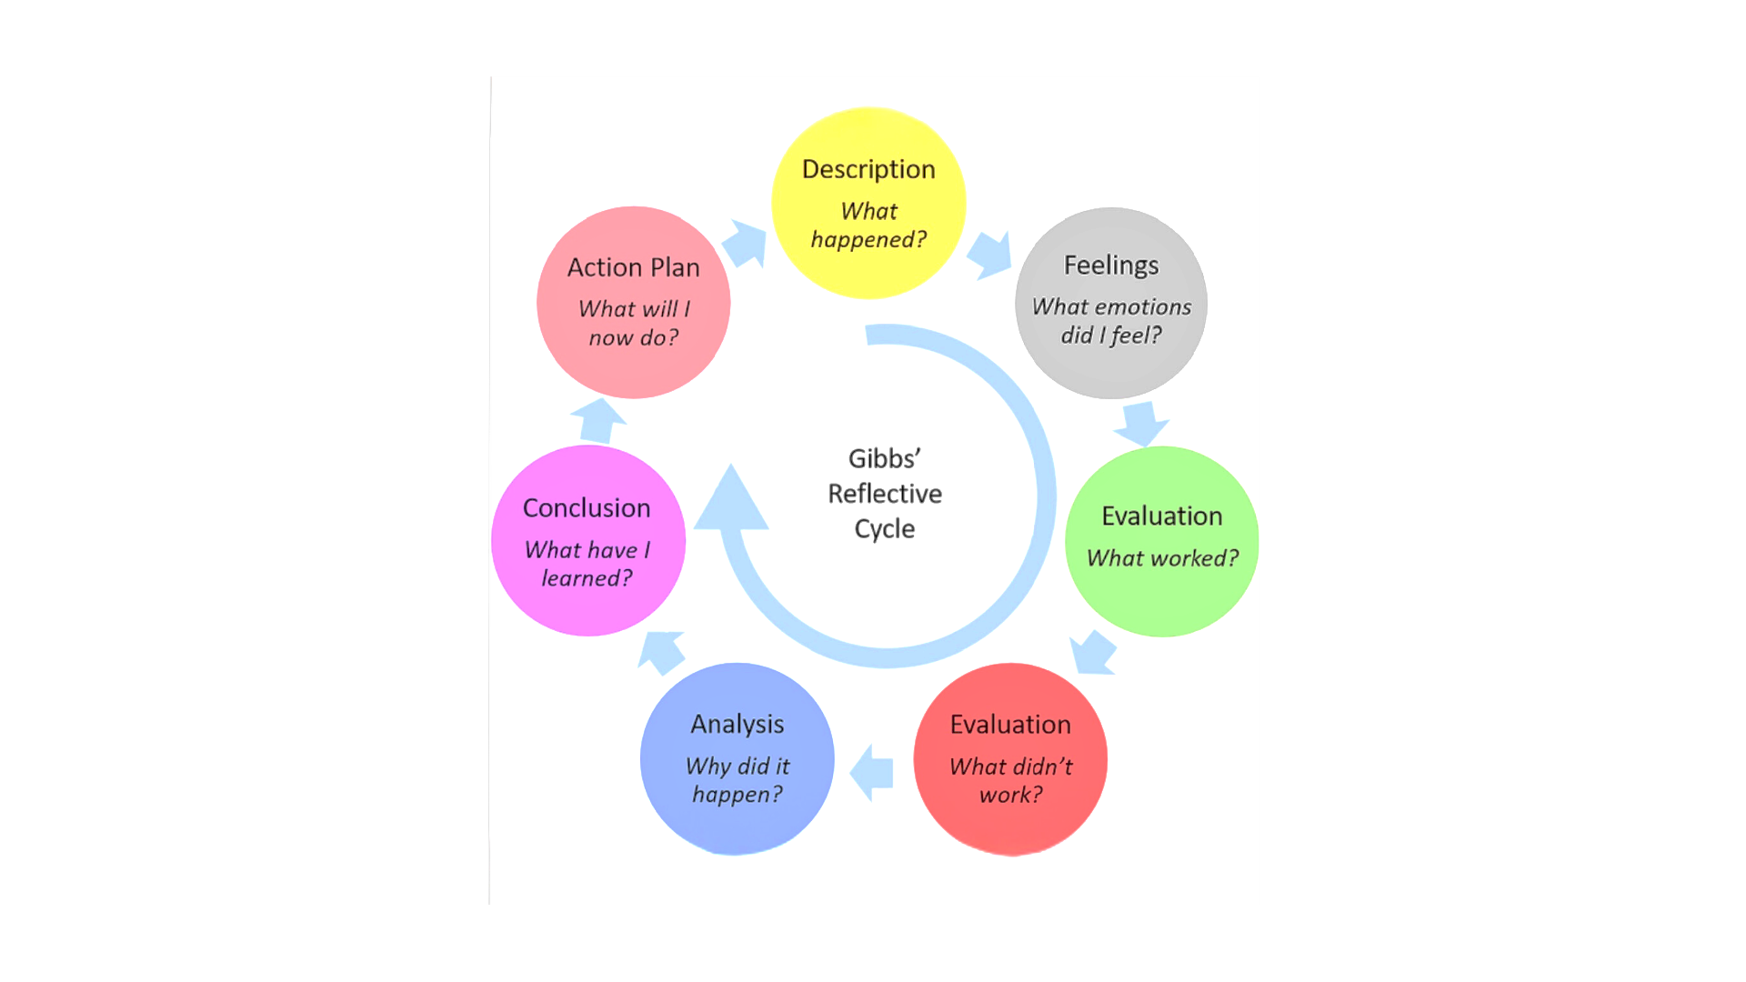
Figure: Gibbs' Reflective Cycle (Harrington-Atkinson, 2022).

Academic Writing Skills
Description: This module provided general information on the nature of academic writing such as its structure, style, clarity and thinking. We wrote essays, reports, and critical analyses as part of our writing activities (Bailey, 2018).
Feelings: At first time, I didn’t think that academic writing was for me at all. The expectations of high-quality work accompanied by pressures of time constraints left one feeling so compromised. But as the module went on, I began to build my confidence in that area as well. Despite having some experience in study, the constructive feedback from tutors served plus for me to discover my problematic areas.
Evaluation: In all, the module was successful in focusing on issues of academic writing. Its structure, especially clear rules and easy practicable sessions formed a good ground for enhancing my writing skills. Especially important here I found the focus on the argumentation supported by critical thinking: it has helped me to write in a more elaborated manner (Cottrell, 2019).
Analysis: Thus, caring about different writing styles and formats helped me develop a proper attitude to writing depending on the specific academic discipline. For example, I realised that an Academic English writing style should be quite formal and, thus, one does not write ‘I’ in the paper. I also had to pay particular attention to simple and unambitious style, making the main message of the book as clear as possible to the reader. It served my purpose to get specific areas of weakness such as sentence construction, grammar and punctuation pointed out to me by my tutors.
Conclusion: The efficiency of this module has enhanced immensely my academic writing. Having worked on this assignment, I am now assured of how to develop a logical flow of arguments, appropriate language to use in the assignment, and how to cover my source’s credentials. Another skill that I have seen improvement in is the skill to evaluate information critically and argue with support.
Action Plan: To improve my writing skills more, I will write often, ask others to review my essays and use extra writing strategies. I will also attend to genre mourning and adhering to academic language by being clear, and concise and keeping as close to the topic as possible. Besides, I will make use of free writing resources on the internet in a bid to enhance grammar, punctuation and general writing style (Wischgoll, 2016).

Research Skills
Description: The sixth module covered the tutorial on Library databases, the internet and critical appraisal of literature. It helped us to make a search for the required material, organise the notes received during the research and, also, to systematise the results received (Booth et al., 2016).
Feelings: At first the gases of knowledge that can be found on the Internet were unbelievably immense. At some point, I was always confused about where to begin or what to expect next. Nevertheless, the module made the sight of research more structured; thus, it made the process more orderly for me.
Evaluation: I consider I have learned what is truly important in a broad spectrum of the offered module: that is how to search for the information needed for preparing a paper properly. The focus on analyzing information and evaluating sources helped me establish the way to reach only relevant data. Some of the most beneficial types of assignments included hands-on things like library instruction and database use (Ward, 2019).
Analysis: With the skills learned in the research, I was able to compile adequate material for my assignments. What I found helpful is how one is taught to look at sources, analyse for biases, and then integrate information from both sides of the given perspective. I also notably improved my skills in organizing and structuring the discovered information properly to maintain the progressive flow of further ideas. Precisely the input from the tutors proved useful in the formulation of better-posited questions for my research projects and sharpened my literacy skills in information-searching strategies and about critical appraisal of the information then retrieved (Allison et al., 2016).
Conclusion: In my mind, I have enhanced the research skills that I have gained from the module. At present, I have gained more self-confidence in finding good resources, searching for information, and stepping up my skills in managing search results. I have also enhanced on evaluation of information and integrating results from a variety of sources (Collaborators, 2024).
Action Plan: For the enhancement of my research skills, I shall make it a culture to think critically and familiarise myself with improved and innovative research methods and trends in research. I will also endeavour to improve information search competency to facilitate effective search in the huge and expanding online world. Further, I will aim for chances to cooperate with other researchers and participate in multidisciplinary research work (Eshkulovich and Tashbaevich, 2020).
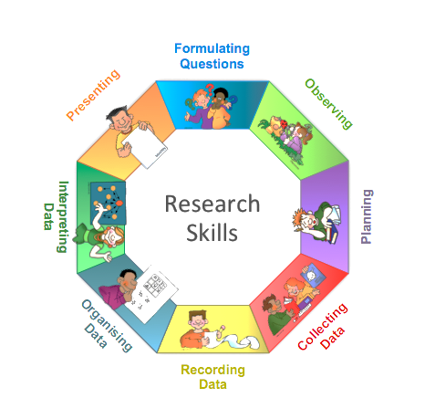
Figure 2: Research Skills (Profile, 2017)

Referencing Skills
Description: The existing module also provided knowledge about the Harvard referencing style and its significance to the module. We were also able to learn the right way to use citations in the body of the text as well as the reference lists (Neville,2016).
Feelings: At first, I thought referencing was a complicated process, but the module explained it in simple stages, where I found it easy to follow. I no longer had issues regarding the unclear rules and regulations of practices, and it also helped me gain the much-needed confidence.
Evaluation: The principles of academic referencing were well explained in the module. Paying much attention to the issue of accuracy, consistency, and clarity of work was quite helpful in minimizing cases of experimental errors. The practical lessons including the referencing quizses as well as the referencing workshops were useful, especially in consolidating what I learned about Harvard referencing (Pears and Shields, 2019).
Analysis: Personally, the policy of maintaining the Harvard referencing style has been helpful in maintaining the quality of the work. I understood how to quote sources correctly, how not to copy, and give the original authors their credit. I also became more attentive to style while performing the references to align them properly. This suggested that comments from tutors were quite useful in pointing out whether I got it right or wrong about referencing (Williams and Davis, 2017).
Conclusion: From this module, my referencing skills have been enhanced by a big notch. Now I feel more confident about myself, especially about citation and non-occurrence of any kind of academic dishonesty. I have also acquired better knowledge concerning the issue of academic integrity as well as the ethical uses of referencing.
Action Plan: To improve my referencing skills, I will make sure that I use the Harvard referencing style throughout my academic studies, check to see whether there are other guidelines from the publisher worth using and use any referencing aid available. I will also work towards improving my knowledge of the ethical use of referencing, different sources of information and acknowledging other authors.

Conclusion
This reflective report has proven that the academic skills module has immensely helped to enhance my academic writing, research as well as referencing skills. The Gibbs’ Reflective Cycle has helped me understand the learning experiences so that I can enhance my learning experience. The module has provided some of the resources that I required together with the knowledge that is needed in my academic work.

References
Adeani, I.S., Febriani, R.B. and Syafryadin, S. (2020). 'Using Gibbs Reflective Cycle in Making Reflections of Literary Analysis,' Indonesian EFL Journal, 6(2), p. 139. https://doi.org/10.25134/ieflj.v6i2.3382.
Allison, B., Hilton, A., O'Sullivan, T., Owen, A., and Rothwell, A. (2016). ‘Research skills for students’, Routledge eBooks. https://doi.org/10.4324/9781315041780.
Bailey, S. (2018) Academic Writing: A Handbook for International Students. 5th ed. Routledge.
Booth, W. C., Colomb, G. G., Williams, J. M., Bizup, J. and FitzGerald, W.T. (2016). The craft of research.
Cottrell, S. (2019) The Study Skills Handbook. 5th ed. London: Palgrave Macmillan.
Collaborators, Q. (2024) Research Skills: What they are and Benefits. https://www.questionpro.com/blog/research-skills/.
Eshkulovich, U.D. and Tashbaevich, S.K. (2020). 'Developing pupils’ learning and research skills on the basis of physical experiments,' 65.2.176.223 [Preprint]. https://doi.org/10.61841/xc2x2a94.
Harrington-Atkinson, T. (2022). Gibbs’ reflective cycle - paving the way. https://tracyharringtonatkinson.com/gibbs-reflective-cycle/.
Neville, C. (2016). The Complete Guide to Referencing and Avoiding Plagiarism. 3rd ed. Maidenhead: Open University Press.
Pears, R., and Shields, G. (2019). Cite Them Right: The Essential Referencing Guide. 11th ed. Red Globe Press.
Profile, V. (2017). 'Approaches to learning,' Research Skills, 4 June. https://freedomofexpressionrights.blogspot.com/p/approaches-to-learning.html.
Ward, Z. (2019). Research and study skills. https://www.leeds.ac.uk/undergraduate-teachers-supporting-students/doc/research-study-skills.
Williams, K. and Davis, M. (2017). Referencing and understanding plagiarism. Red Globe Press.
Wischgoll, A. (2016). 'Combined training of one cognitive and one metacognitive strategy improves academic writing skills,' Frontiers in Psychology, 7. https://doi.org/10.3389/fpsyg.2016.00187.

