Operating Systems
Nicholas Gelstharp (2211042)
Computer Architecture and Operating Systems
3/25/24

Contents

Introduction 2
Task 1: Key functions of general operating systems 3
Task 2: Use of Windows OS CLI Commands 7
Task 3: Use of Linux OS CLI Commands 9
Task 4: Use of Windows OS Scripts 12
Task 5: Use of Linux OS Scripts 15
Conclusion 17
References 18
Appendix 19

Introduction

This reports will look closely at the command line interfaces that are present in both the Windows and Linux operating system environments. It will begin by looking at a range of different functions that are present before moving on to scripting, and the combination of these functions and features into scripts that require user input before performing routine actions. The report will also examine the key features that are present within operating systems in general and provides some use case scenarios and explanations of why they are required to be present and functioning in order for systems to operate as expected.

Task 1: Key functions of general operating systems

A good definition of what an operating system is can be found in the modern operating systems book, it says
“computers are equipped with a layer of software called the operating system, whose job is to provide user programs with a better, simpler, cleaner, model of the computer and to handle managing all the resources” [1]
With this in mind there are a few key features:
File management
File Management is the process used by Operating systems to create, access and manage files stored within the device. This has evolved over time and for a home user can be quite basic, however for a network administrator that manages files within a domain this could include access rights, and nuances within these rights for things like editing, reading or removing files and folders which is built on permissions. This is constantly evolving to ensure compatibility with the ever growing number of devices that need to communicate with each other [2]. Windows operating systems allow navigation through file explorer which can be seen below.
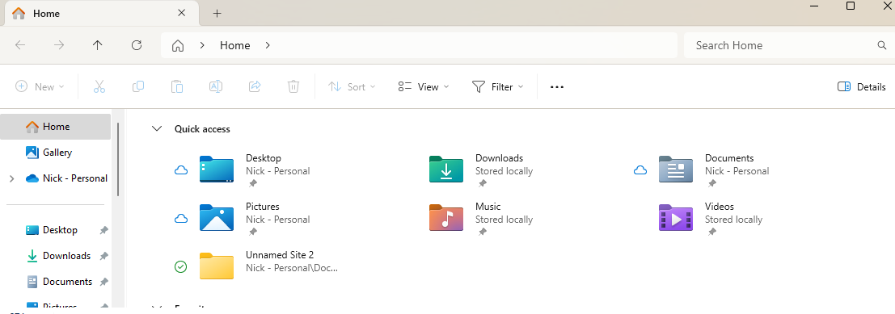
Network Management
Almost every device that is used today is connected to a network, and therefore the OS is required to ensure maximum compatibility with a variety of different hardware to ensure connectivity is possible. This will require things like DHCP being enabled by default as well as conformity with TCP/IP so that the general user can make use of network functionality. Some operating systems also come with automated issues resolution as well as highlighting potential issues. Most network management will also be accompanied by data security in the form of cryptography which is controlled by the OS [3]. These features can often be accessed in many different ways, one of which is the command prompt, which includes functions such as ipconfig that will allow the user to see the current local settings.
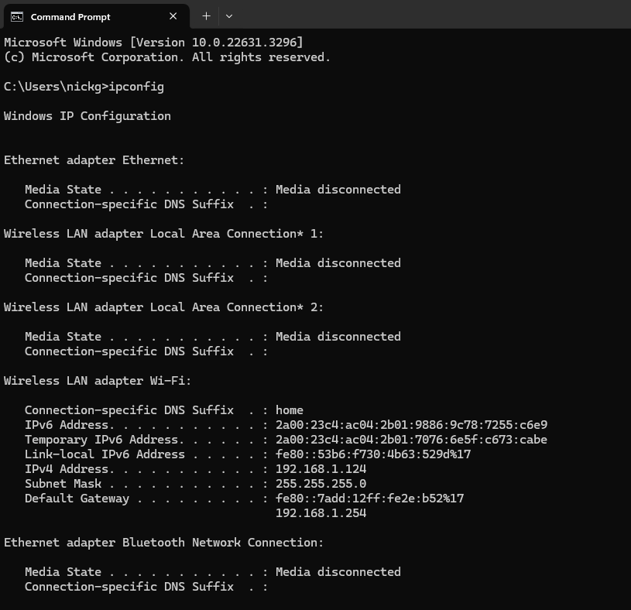
Some additional information on network performance can also be accessed through the task manager in Windows. The majority of this information can be ascertained from within the command prompt however, the task manager is a more user friendly and graphically intuitive application more targeted at home users.
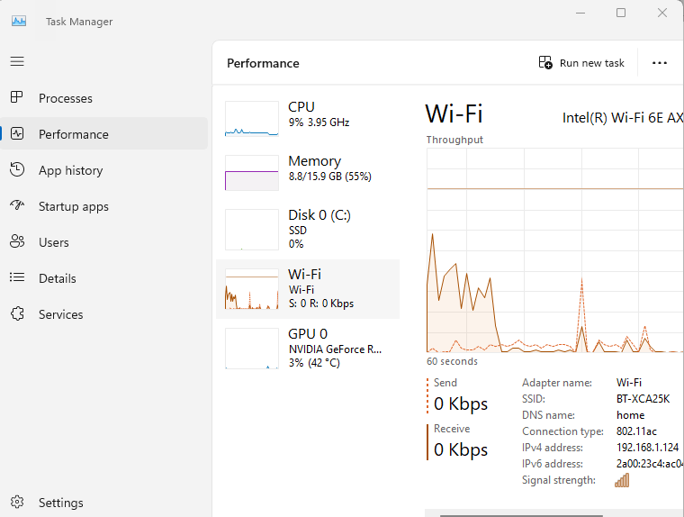
Memory & Device Management
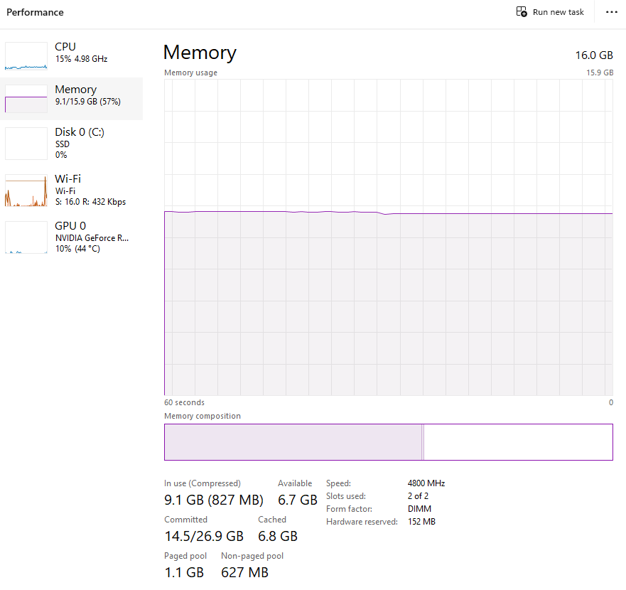
From within the task manager Memory management which shows the available memory and its current allocation. Memory management is another key feature within an operating system as it ensures proper management through allocation to active processes that enable a system to function [4].
Device Management works in a similar way, defining physical of a system and allocating drivers and resources to them to allow them to communicate with each other and allowing the system to run

System Security
With computers being in the possession of most people these days and often times connected to personal details including banks accounts system security is a key feature of an OS. These can come in the form of anything from a password, to biometric scanners which are found on most smart devices and laptops. Most will have multi-factor authentication which will often rely on access to another device or account. However, hacking into these systems is the focus of attention for many illicit purposes with governments home and abroad throwing many resources at this. Even multi factor authentication can have its own inherent security flaws [5]. Multi factor (device) authentication has become common place as both devices would need to be compromised in order for access to be granted.

Task 2: Use of Windows OS CLI Commands

Microsoft have invested heavily in the development of different scripting languages due to the user created demand for having a ‘baked in’ scripting language that was easy to use. [6].
Windows CLI commands are often used to automate tasks [7]. Two of the most basic commands are ‘dir’, which will show the currently file directory contents and ‘cd’, which will allow you to change the directory that the user is in within.
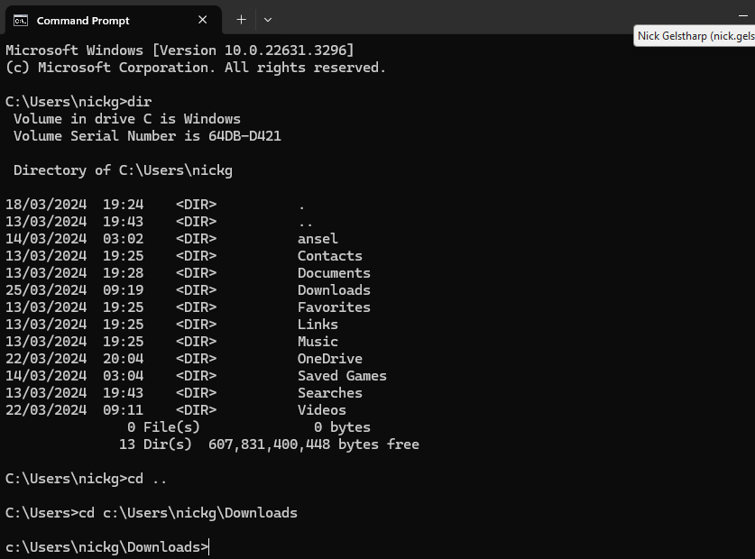
The ‘echo’ command is used to display text to a user. This text can either be set as text within the command or through using the ‘set’ command a variable can be set by the user which can then be used by the echo. This is shown below with the output on the left, and the .bat file on the right
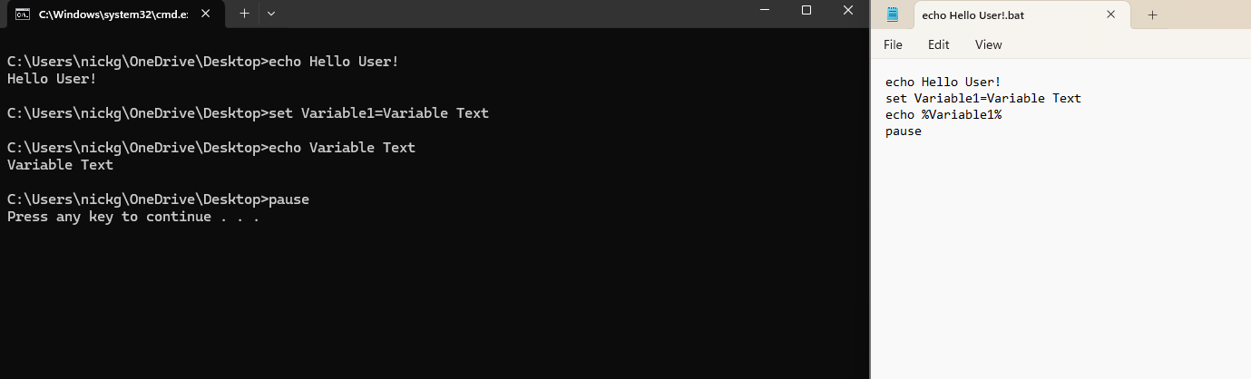
Using these concepts you can create a basic user interface within, using the ‘set /p’ command will prompt the user for an input. In the images below the ‘date /t’ command is used to get the current date in combination for the ‘for /f’ command which is used to create a loop and the ‘delims’ command. This is used to break the date up by / and create 3 variables one of which (%%C) would be the current year. Finally the ‘set /a’ command is used to make the program perform calculations. In this example the variable created for the current year (%%C) is subtracted from the variable entered by the user (%birthyear%) [8].
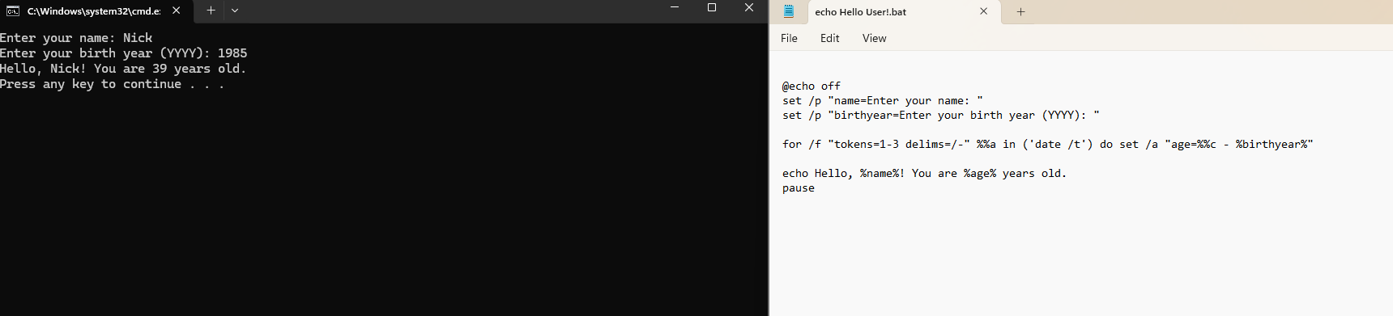
IT Professionals and service desk also have some commands that are likely to be used. The ‘ipconfig’ command can be used in numerous ways where shortcuts could be created in .bat files to run common diagnostics or fixes as seen below.
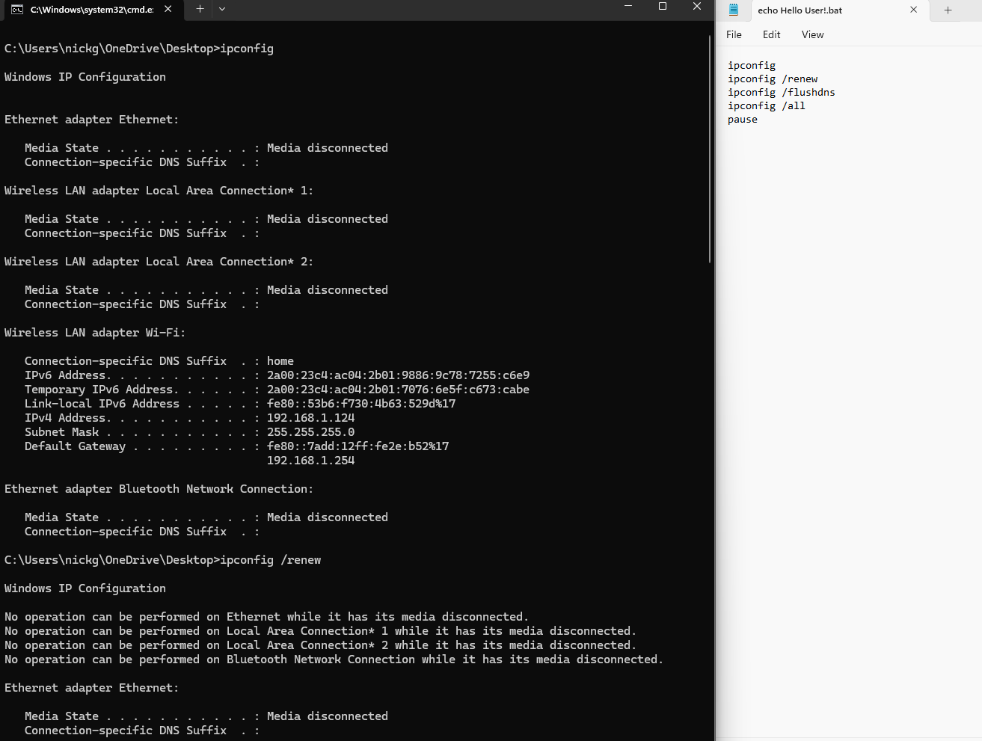
The command ‘ipconfig /renew’ and ‘ipconfig/flushdns’ are commonly used to resolve DHCP issues on local machines as it will result in new IP address for the machine. Ipconfig is repeated here only to show connection details before and after were it to run with proper administrative rights.

Task 3: Use of Linux OS CLI Commands

See appendix 1a for engagement with certified online course. CLI commands in the Linux operating environment are similar to the function found within Windows. The Linux operating system is open source and extremely popular and is being user on many different devices [9].
The ‘ls’ command is used to list directories
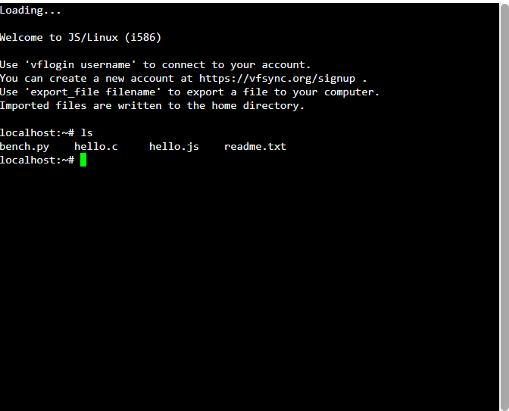
The command to change directory is the same as windows ‘cd’ with .. being used to go up one level as shown below. The ‘pwd’ command is used to show the current directory.
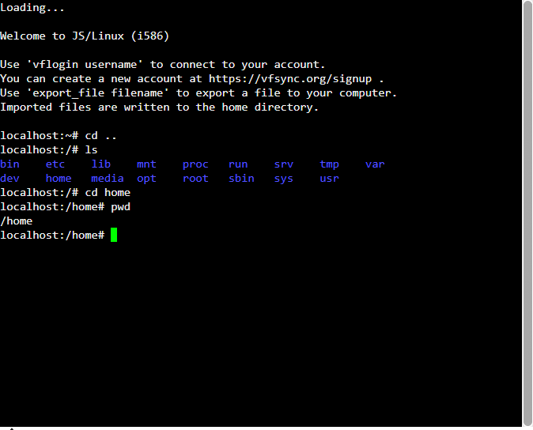
The ‘ls -l’ command can be used to show all of the files contained within a folder, and their associated permissions. The ‘mkdir’ command is used to create a directory within the current folder and the ‘cp’ command is used to create a copy of a file within the current folder. Both shown below
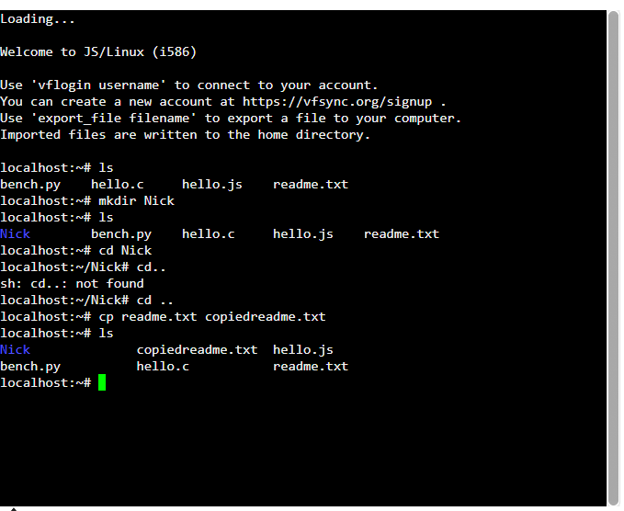
To create a variable in bash you simply enter the name of the variable that you want to create followed by the = symbol. The ‘echo’ command is used to display text to the user or display the contents of a variable. In the example below the username and age have been manually entered and then the username is called by the echo command.
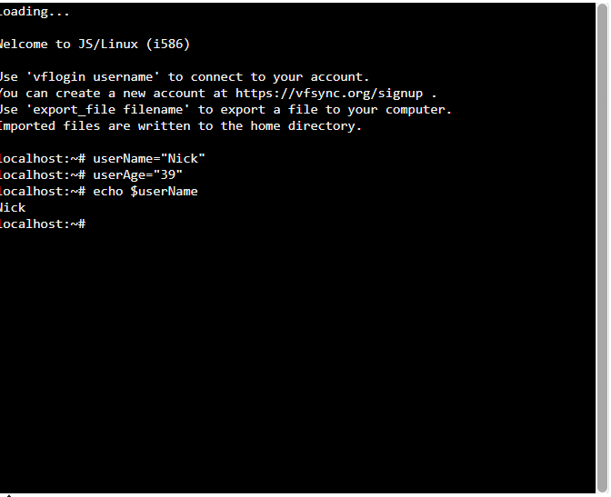
The ‘cat’ command can be used to show the contents of a file, the ‘head’ and ‘tail’ commands show the first and last lines of a file respectively
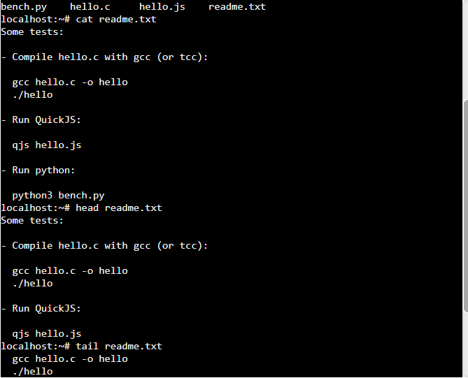

Task 4: Use of Windows OS Scripts

Windows OS scripts can be created by either CMD or PowerShell and scripting using .bat files will allow automation of many taks that are considered routine. Scripts within the Windows Operating system environment can be used for many different purposes from network diagnostics to the general monitorings of systems performance and either reporting to a user or asking for inputs [10].
The script below will determine whether or not to map a network drive depending on the department that is entered by the user. A label called department_input starts the page followed by a user input prompt for either Training or Security. The if statement will first of all check if the work Training has been entered and if it has it will show the user tex, if not it will check if the word Security has been entered and if it has a network drive is mapped to N. If neither have been entered a message will appear to show an invalid entry followed by reurning the user back to the start of the process. This could be adopted to easily change network drives depending on the user.
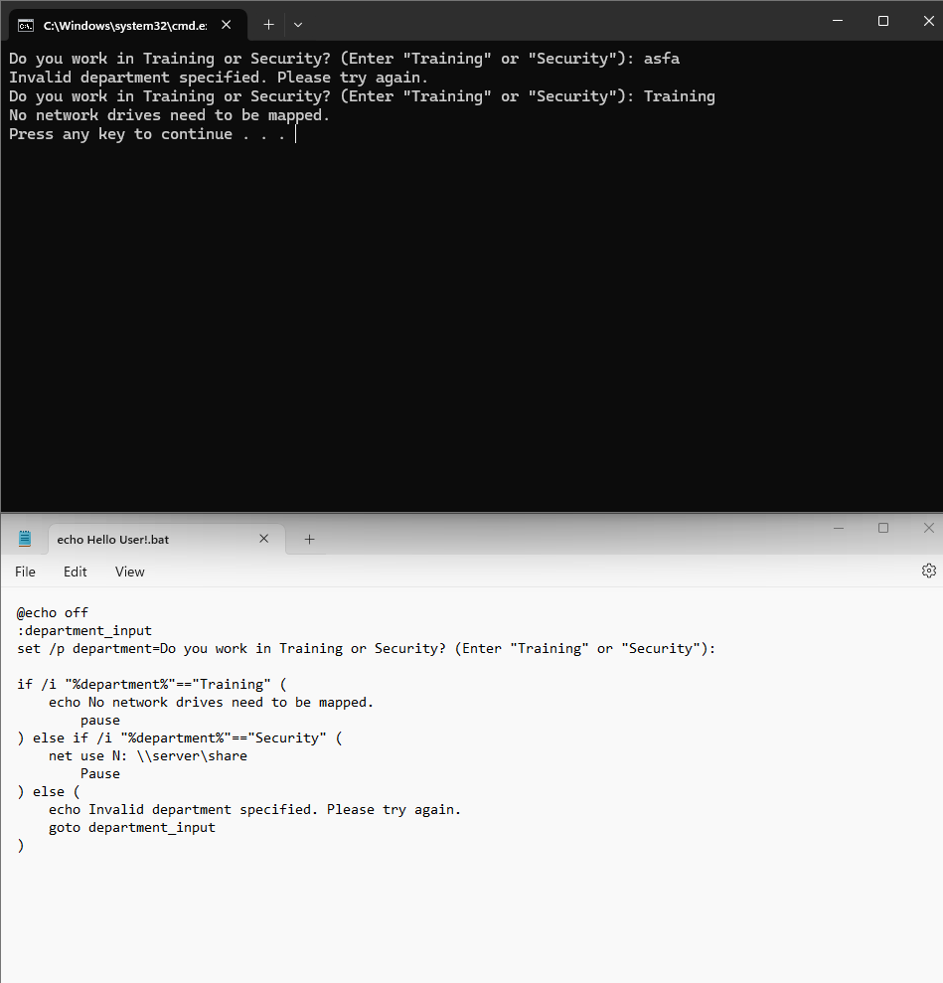

The next script shows a more complex utility tool that will develop on some previously mentioned commands. The script will begin by giving the user 3 options. If option 1 is selected the speedtest utility will run (if installed) and return an internet speed. If option 2 is selected the Ip address will display and if option 3 is selected the the IP address will be renwed and dns flushed. After selection on any 1 of the 3 items the user will be returned back to the options menu.
@echo off
:title
cls
echo Welcome
echo --------------------------------
echo 1. Check the speed of my internet
echo 2. Check IP address
echo 3. Reset Network Settings
echo --------------------------------
set /p choice=Enter your choice (1/2/3):

if "%choice%"=="1" goto check_internet_speed
if "%choice%"=="2" goto check_ip
if "%choice%"=="3" goto reset_ip_dns

echo Invalid choice. Please enter a valid option.
pause
goto :title

:check_internet_speed
echo Checking internet speed...
speedtest
pause
goto :title

:check_ip
echo Checking IP address...
ipconfig | findstr IPv4
pause
goto :title

:reset_ip_dns
echo Resetting IP address and flushing DNS cache...
ipconfig /release
ipconfig /renew
ipconfig /flushdns
echo IP address reset and DNS cache flushed.
pause
goto :title

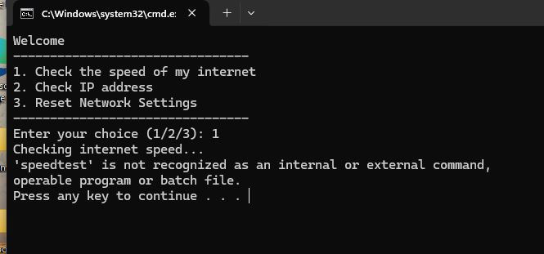

Task 5: Use of Linux OS Scripts

Within the Linux operating system scripts are created using bash which was developed in the 1990s by Paul Falstead whilst he was a student in Princeton University [11]. Again the functionality and the features within Linux are very similar to those found within Windows, with the most significant change being to syntax. In the space below I have created a script using bash for a Linuz OS. The purpose of this script is to check if the person using it can legally drive in three different countries. To start a function called check_driving_age is defined where an if statement check the user entered age and return the appropriate response
check_driving_age() {
case "$1" in
"United States")
if [ "$2" -ge 16 ]; then
echo "You are old enough to drive in the US."
else
echo "You are not old enough to drive in the US."
fi
;;
"United Kingdom")
if [ "$2" -ge 17 ]; then
echo "You are old enough to drive in the UK."
else
echo "You are not old enough to drive in the UK."
fi
;;
"Japan")
if [ "$2" -ge 18 ]; then
echo "You are old enough to drive in Japan."
else
echo "You are not old enough to drive in Japan."
fi
;;
*)
echo "Invalid country selection."
;;
esac
done
}

The next part of this script is to create a loop that will check if the user has given a valid entry when asked to choose a country where if they do not it will continue to ask them for a valid entry. If they do enter a valid country it will go to the variable that has been named for each country and then do the check on the age that has been entered giving the appropriate response.
While true; do

echo "Please choose one of the following countries:"
echo "1. United States"
echo "2. United Kingdom"
echo "3. Japan"
read -p "Enter the number corresponding to your choice: " country_choice

case "$country_choice" in
1)
country="United States"
break
;;
2)
country="United Kingdom"
break
;;
3)
country="Japan"
break
;;
*)
echo "Invalid choice. Please try again."
;;
esac
done

The final part of this script is to provide the user with the opportunity to enter their age and to capture this in a variable and also to prompt the function that was created (check_driving_age) to run
read -p "Enter your age: " age

check_driving_age "$country" "$age"

Conclusion

In conclusion Windows and Linux both have extremely powerful CLI integration baked into their respective operating systems. Their functionality and use cases are very similar with many of the commands such as echo even sharing the same naming conventions. However, the syntax is generally different and the more complex features make this deviate even further. The use case of automating routine tasks through either automated scripting or activating through user input based interfaces can make the lives of IT professionals significantly easier than having to repeat tasks or having to walk through an end user through the process of something such identifying network details or host names.

References

[1] | H. B. Andrew S.Tenenbaun, Modern Operating Systems, Pearson, 2014.
[2] | P. Mcdougall, “Windows 8 File Management: Four new Management Features Emerge,” Informationweek - online, 2011.
[3] | L. Qi, X. Lv, L. Sun, T. Yao, J. Yu and L. Wang, “Operating System network security enhancement scheme based on trust storahe,” vol. 4, no. 2, pp. 127-141, 2023.
[4] | R. Sheldon, “Memory Management,” Tech Target, June 2022. [Online]. Available: https://www.techtarget.com/whatis/definition/memory-management#:~:text=Memory%20management%20is%20the%20process,to%20carry%20out%20their%20operations.. [Accessed 25 March 2024].
[5] | D. Wang, X. Zhang, Z. Zhang and P. Wang, “Understanding security failures of multi-factor authentication schemes for multi-server environments,” vol. 88, p. 101619, 2020.
[6] | T. Yager, Unix Review's Performance Computing, vol. 16, no. 9, pp. 19-23, 1998.
[7] | M. Huculak, “How to create and run a batch file on Windows 10,” Windows Central, 5 August 2022. [Online]. Available: https://www.windowscentral.com/how-create-and-run-batch-file-windows-10. [Accessed 25 March 2024].
[8] | dostips, “File age in days,” dostips.com, [Online]. Available: https://www.dostips.com/?t=Batch.FileDate. [Accessed 25 March 2024].
[9] | C. Littler, Command Line Interfaces, 2018.
[10] | Anonymous, Sciprts for Monitoring Systems Performance, Windows Scripting Solutions, 2007, pp. 14-16.
[11] | A. Kidwai, C. Arya, P. Singh, M. Diwakar, S. Singh, K. Sharma and N. Kumar, “A Comparative study on shells in Linux: A Review,” Materials Today, vol. 37, pp. 2612-2616, 2021.

Appendix

Appendix1a)
demonstration of engagement with certified course


