Course Title: Effective Team Working and Communication.
Course Lecturer: Molly Jack
University Wales Trinity Saint David,
Student Name: Lusenja Kebbi,
Student Number: 1908218

Introduction
This essay will present a variety of thoughts and suggestion on Teamwork importance, communication in the workplace. Why, how, it is important to communicate effectively. A look at various and types of Communication theories and conclude with differences and to conclude we will look at differences in the types of communication and lesson drawn from the Moodle , impact in relationship to workplace.
Wageman, Gardner, Mortensen (2012) posits that a team is a “bounded and stable set of Individuals interdependent for a common purpose”. While teamwork has to do with a group of people, who join and work together to achieve a specific task.
Furthermore Hackman (2009) suggests five basic considerations that makes a group a team “team must be real, “team need a compelling direction”, “team need enabling structures”, “Team Need a Supportive Organization”, Finally “team Need expect coaching. He concludes teamwork is dynamic and highly variable cross -industries as success for companies.
The importance’s of teamwork in the workplace it helps to improve management and measurement of team task, and performances. it’s also increase productivity in goods and services offered by the workplace. like in the healthcare company, we are allocated, and must feedback at the end of each shift, what, why, when and how our residents were cared for at the end of the day, this is called team briefing.
Teamwork facilitate group process, by sharing roles, working as one, strengthen each other, respect each team member, and include everyone makes the job easier and better. Teamwork helps in problem solving as task, and communication issues are broken down and sorted out in group before they escalate .We are encouraged in our workplace to effectively communicate and work together irrespective of our differences, the need to be in a team and work together in vital to all from management to carer, residents and other healthcare Partners..
Andrew Maud et al, suggests in his book that Communication is the exchange of words, thoughts, information, or cues, that may lead to mutual understanding between two or more people. The process of information is enclosed by a medium, channelled and imparted by a sender to a receiver through a medium.
The organisation we relate to is the Excel care Provider for health and social. it provides care for the Elderly, They are Specialist in mental health cases and end of life care in residential and nursing homes , across the united kingdom. The types of communication that takes place in the Excel care organisation are both verbal and non-verbal communication. It is done in formal and informal ways through written letters, Memo, emails, Texts messages for reminders and updates, Phone calls to hospitals, adult social services, Advocacy teams , with regards to resident care Needs and updates health and social care needs. They also use objects of Preferences, use of Face -to-face communication in team briefing meeting, general staff meetings. We use translators and interpreters to meet and support residence with English as a second Language.
While Non- verbal types of communication also take in our workplace by Management, staff, and residents via their body language is a very powerful tool of non-verbal communication. This done by observing the person we communicate their body language, we indicate if they are fed-up, interested, annoyed or paying attention. For example, manager shaking their body when talking to staff. Rosalie Marsh (2012) her book on skills for employability suggests use of appropriate Non -verbal skills like our postures, facial expression, Proximity to each other when communicating at work. The author advice on not pointing, or showing aggressions, but instead remember the “C”s keep cool , calm, and collected, when communicating to management, colleagues, and other healthcare partners.
To better understand and develop effective communication in the workplace practise is vital especial in the healthcare sector, therefore in this paragraph we will look at importance’s of communication in the workplace, its helps to build a good team. It helps in facilitating and sharing of tasks at work for example during team brief we are given allocation. Communication helps in decision making and good leadership. communication also assist in developing good working relationship at work, with management, colleagues and other h external healthcare partners.
Communication also assist in clear, brief and accurate information sharing, especially about residents care needs . Example During Doctor’s Rounds in our home, we need to book the resident, and state clearly all care plan reviews, current health concerns, and feedback the Doctors. Communication provides support and assistances to colleague. It also helps to identify individuals care needs and meet up the needs of the residents. communication helps and provides means for assessment, sharing and monitoring information via staff, Manager, and other Healthcare Partners, with families included
There are two types of communication Namely Verbal and Non-verbal. Based on the process of communication channels the verbal is done by written, face-to-face forms of communication. while Non -verbal is based on style and purpose of communication. Communication can also be look at as formal and informal. Mehrabian’s (1981) Suggests our Verbal cues that is (words) content Just 7% while the Vocal Cues which is our (Pitch, volume , tone) contents 38% while 55% is all about Non-verbal communication.
Verbal communication is the use the use of words, sounds to share a message to other. Robinson and Robinson (1982) he suggests if a speaker is to be consistently efficient at sending a message, their intended meaning to the receiver, the intended meaning may be interrupted due to the factor of Noise leading to failure in understanding the sender. This type of communication is used in my workplace, on daily basis, through letters, staff meeting, Memo, emails on training update via management to staff. Staff team brief meeting, on verbal explanation of what, why, when, and how the resident was cared for. phone calls, one-to-one face communication with the team on allocation. All this form facilitates effective communication, and good teamwork.
On the other Non – verbal communication also refers to wordless communication. This has to do with ways, methods, and how we communicate with families, colleague, and management team at our workplace. Therefore, when looking at Non-verbal communication cues such as Postures, facial expressions, eye contact, body language, Vocal qualities, Proximity, all this aspect contribute to the way message are interpreted.
Goleman (2006) said an individual “words” can be difficult to understand, but his or her non-verbal cues will help the listeners , to use a subjective frame of reference to interpret the non- verbal expression of the other. This is used a lot by management via staff in the workplace, like point of hands, shaking of body movement, during communication. Senior staff also do a lot of eye contact, facial expression to help resident, and other colleague, this aspect of communication has led to a lot of complaints and feedback from internal and external team. Therefore staff and management needs full training , in order to make the workplace environment conducive.
Theories of Communication
There different types of communication theories: Shannon – Weaver Model of Communication, Schramm’s Model of communication, and Berol’s model of communication. Communication theories can also be looked at in the different content and what they suggest. We view what the different Theories stand for like dealing with the sender, medium, noise and the receiver. While another emphasizes on contexts and situations, feedback. finally another concentrates on level or members of cultural.
Shannon and weaver’s theory of communication:(1949) cited in Al-Fedaghi (2012) is well documented and approved as a theory of communication. The theory suggest communication includes 4 different stages. Communications starts with a sender and ends with a receiver. The sender is the information source and that message is transmitted through a channel and it could be a letter, text or email. The message is then decoded by the receiver, then message is considered to have reached its destination. In this model, communication only takes place when a message reaches the final destination. The model also highlights the relevance of noise in disrupting the flow of information which may result in the receiver get a wrong message. However, Shannon and weaver’s method of communication has been criticised for failing to recognise the complexity of human beings because the model presents communication as a linear or straight-line process and it fails to consider non-verbal communication. 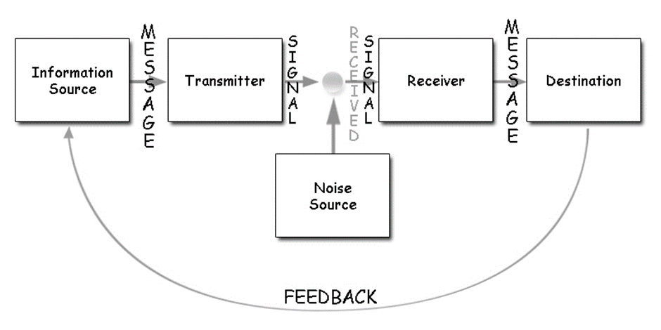

The Shannon and weave-model of communication is helpful in the work place because it allows for communication to reach the receiver. The sender has a duty to ensure the message they are sending gets to the receiver for communication to have taken place. For example: if working with clients with learning difficulties, carers have to ensure that reasonable adjustment are made for the service user to understand any information provided. The model will also suggest all communication in the work place should consider external factors that can distort the information. For example: using a quiet room to speak to a service user with hearing impairment.
Berlo Model of Communication (1960) cited in Narula (2006). According to Berlo there are four components to communication, he refers to them as source, message, channel and receiver.

The sources of a message refer to the origin of the message and the sources includes five key elements:
• communication: the person sending the message must be a skilled communicator.
• attitude: what they intern to get out of the message they are sending.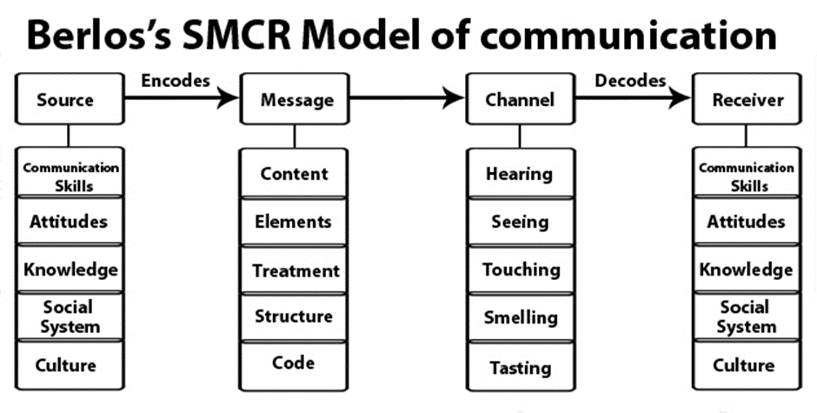
• Knowledge: the person sending the message needs to be aware of the subject matter of their message.
• social system: this relates to understanding value systems, beliefs, it is about determining where communication should take place.
• Culture: it is about understanding societal culture.
In reference to the message component, Berlo suggest the following are important:
• Content of a message is relevant when sending a message.
• Elements: this includes things like language used, gestures, tone of voice etc.
• Structure: this refers to how the message is arranged into different parts
• Code refers to what form the sender sends the message
• Treatment refers to the way the message is conveyed or delivered.
Channel component includes: seeing, hearing, touching, smelling and tasting. According to Berlo, communication can take place using all five senses.
Receiver component includes: communication, attitude, knowledge, social system and culture which is similar to the elements under the source component. Berlo beliefs the source and the receiver need to be on the same level to establish effective communication.
Berlo was the first person to introduce the effect aspect of communication. Berlo argue that message have some effect on individuals and that could be positive effect or negative effect. Berlo model is unrealistic in the work place because the sender and receive will not always be on the same level. However, this model will help professionals pay attention to the content of their messages and how the messages are conveyed either to service users, colleagues or carers.

schramm model of communication

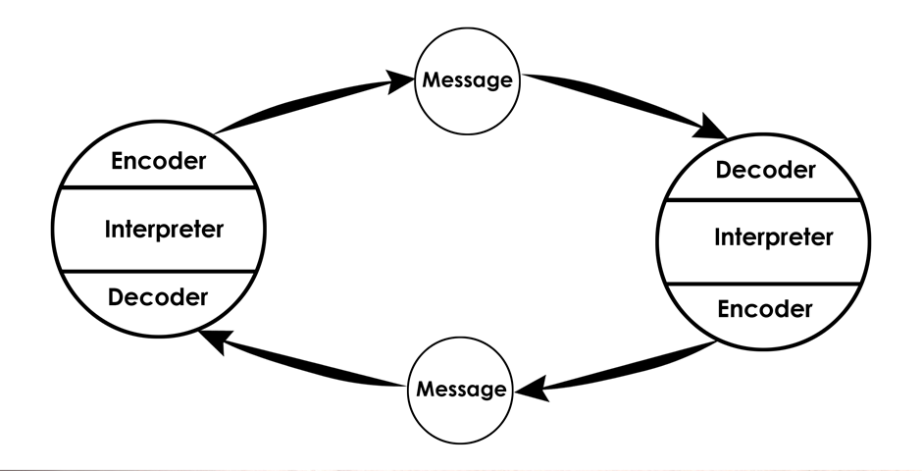

Reference List:
Andrew Maund ,Michaela Schriek ,Paul K.Tinkler, :Certificate in higher Education skills for the Workplace students Year book.Sage Publication 2017
Al-Fedaghi, S. (2012). Awareness of context and privacy. American Society for Information Science & Technology (ASIS&T). Bulletin. 38 (2).
Karen Holmes; the employability skills handbook 2 edition 2017 Trotman education
Narula, U. (2006). Models of Communication. Available at: https://books.google.co.uk/books?hl=en&lr=&id=nDRn9PAlSBwC&oi=fnd&pg=PR5&dq=berlo+model+of+communication&ots=rZPtpsqxPZ&sig=Oan8ZXmvVQliqefbtE5IXntZuVk#v=onepage&q=berlo%20model%20of%20communication&f=false. [Assessed: 11 December 2019]
Rosalie Marsh Skills for employability part-one pre- employment Christal publishing 2012
Published by Palgrave Macmillan Ltd .uk
Stella Cottrell: skills for success personal Development& employability 2 edition 2010

Appendix


