Student Name: Nina Sokhan Kalashnikova  Student ID: 2234899  Module Title: Foreign Languages & Cultural Awareness  Module Code: BMIH5003  Lecturer: Lisa Bassler, Heidi Prosser  Date: 9th February 2024 by 23:59PM | 
ASSIGNMENT 1: PORTFOLIO
(4 Components)

Component 1: Professional Reflection
Scenario Outline
Goglia & Wolny (2022) reported that in the hotel restaurant during dinner service, a significant cultural misunderstanding occurred during my Level 4 placement at the Inclusivity Hotel & Spa. A visitor, from a nation with unique traditions and dialects, asked for a particular dish to be changed because of dietary requirements. Unfortunately, the request was inadvertently ignored by the server, who was not aware of the guest's cultural dietary practices. The customer's dissatisfaction and sense of being misinterpreted resulted in a breakdown of communication and an unsatisfactory dining experience. The misunderstanding was caused by cultural factors originating in language and food habits. The guest's request, which was made in a way that was subtle and representative of their cultural eating customs, called for more knowledge than the server had. In addition to language barriers, the miscommunication resulted from a lack of knowledge about the guest's unique cultural expectations for meal preparation.
Reflection
Language, customs, and expectations differences are often the root cause of complex cultural misunderstandings in the hospitality sector. This example shows how important it is to be culturally aware when providing outstanding guest experiences. The incident demonstrated how inadvertent service errors and unhappy customers can result from a lack of familiarity with varied cultural customs. When I think about it, I realise that in order to avoid more cultural misunderstandings, I constantly need to improve myself and acquire new skills. Crucial elements include proactive awareness of guests' individual needs, proficient cross-cultural communication, and a greater appreciation for varied customs. It is clear that developing cultural sensitivity is not only a personal obligation but also an essential component of every employee's professional growth in the hospitality industry (Hasan & Xiong, 2022).
Identified Skills for Development
Katsoni & Şerban (2022) stated that going forward, I understand how critical it will be to improve my language skills in order to better understand and serve the varied needs of my guests. Furthermore, my goal is to participate in ongoing cultural competency training so that I can become knowledgeable about different customs and practices. Preventing future misunderstandings of this kind will require developing a keen understanding of cultural quirks in dining preferences, communication styles, and guest expectations. I hope to help create a more welcoming and culturally aware atmosphere in the hospitality sector by encouraging these abilities (Goglia & Wolny, 2022).
References:
Goglia, F. and Wolny, M. (2022) Italo-romance dialects in the linguistic repertoires of immigrants in Italy. Cham: Springer International Publishing, Imprint: Palgrave Macmillan.
Hasan, A.M. and Xiong, L. (2022) Proceedings of the 31st ACM International Conference on Information & Knowledge Management. New York: Association for Computing Machinery.
Katsoni, V. and Şerban, A.C. (2022) Transcending borders in tourism through innovation and Cultural Heritage: 8th International Conference, IACuDiT, Hydra, Greece 2021. Cham: Springer International Publishing AG.
Component 2: Training Plan
Identified cultural misunderstanding (in a few words):
According to Forney (2020), a key skill in today's international hospitality sector is the ability to navigate a variety of cultural environments. Cultural differences in expectations, customs, and communication styles can often lead to miscommunication. A customised training programme is required to address this and provide all staff members with the knowledge and abilities needed to handle similar circumstances (Xie & Just, 2021).
Enhancing Cultural Competence in Hospitality
For the Inclusivity Hotel & Spa to address and minimise any possible cultural misunderstandings, a comprehensive training programme is necessary. This plan aims to equip hotel staff with the knowledge and skills necessary to handle a range of cross-cultural scenarios. Enhancing communication, developing cultural sensitivity, and raising cross-cultural awareness are the objectives of the training modules (Marson & McKinney, 2020).
Training plan (Why/What//Who/Where/When):
Module 1: Cultural Sensitivity and Awareness
This module emphasises the value of cultural sensitivity in day-to-day interactions by focusing on developing a foundational understanding of diverse cultures. By means of captivating lectures, insightful case studies, and interactive dialogues, staff members will acquire knowledge about diverse cultural subtleties, cultivating compassion and deference (Selvi & Yazan, 2021).
Module 2: Effective Cross-Cultural Communication
This module focuses on building strong cross-cultural communication skills because it acknowledges the vital role that communication plays in the hospitality sector. Employees will be able to confidently navigate linguistic and non-verbal cues with the help of workshops and role-playing exercises that offer practical experience (Xie & Just, 2021).
Module 3: Conflict Resolution Strategies
The capacity for amicable conflict resolution is essential in the event of a cultural misunderstanding. Employees will leave this module with the skills necessary to find common ground, defuse difficult situations, and actively listen. Case studies and real-world scenarios will be combined to mimic possible difficulties and promote hands-on learning (Selvi & Yazan, 2021).
Module 4: Embracing Diversity in Team Dynamics
Any hospitality establishment's success is largely dependent on its team cohesion. The goal of this module is to promote an accepting team environment that values diversity. Interpersonal relationships among employees will be strengthened through the implementation of collaborative projects, team-building activities, and cultural exchange programmes (Marson & McKinney, 2020).
Module 5: Continuous Learning and Adaptation
Cultural environments are ever-changing, necessitating a constant state of learning and adjustment. This module highlights the value of ongoing education by providing access to cultural resources, feedback sessions, and frequent workshops. Workers will be encouraged to contribute to a group learning environment by sharing their experiences.
By carrying out this training programme, the Level 4 Placement Hotel hopes to actively foster a work environment that values diversity and fosters understanding among coworkers, in addition to resolving previous cultural misunderstandings (Robertson & Schlager, 2022). By making investments in the professional growth of its employees, the hotel not only improves the quality of its services but also solidifies its standing as a welcoming and culturally aware facility. Through the lens of cultural sensitivity and awareness, this extensive training programme reflects the hotel's dedication to providing exceptional hospitality.
References:
Forney, G.R. (2020) Rebels, rascals, and ruffians: Profiles from early Montana. Norris, MT: Raven Publishing, Inc.
Marson, S.M. and McKinney, R.E. (2020) The Routledge Handbook of Social Work Ethics and values. London: Routledge, Taylor & Francis Group.
Robertson, S. and Schlager, N. (2022) International Directory of Company Histories. Farmington Hills, MI: St. James Press.
Selvi, A.F. and Yazan, B. (2021) Language teacher education for global englishes: A practical resource book. Abingdon, Oxon: Routledge.
Xie, B. and Just, T. (2021) Understanding China’s real estate markets: Development, finance, and Investment. Cham, Switzerland: Springer.
Component 3: Student Self-Reflection
I set out on a self-reflection journey, guided by the stages of the reflective model, to explore the complex web of cultural awareness in the hospitality industry. Through experiences and conscious attempts to embrace diversity, my understanding of cultural awareness has evolved in a transformative way (Robertson & Schlager, 2022).
Description: At first, I had a very basic understanding of cultural awareness, mostly limited to identifying outward distinctions. But as my academic and professional career developed, I was exposed to a variety of settings that stretched and sharpened my perspective. My experience with a culturally complex scenario during my Level 4 placement at Inclusivity Hotel & Spa was one of the turning points in my career (Forney, 2020).
Reflection: This encounter made me think carefully about the nuances of cross-cultural communication and how important it is to the hospitality industry. Thinking about the subtle cultural differences in guest interactions, I realised how important it is to understand things deeper than just the obvious. My perception of cultural diversity changed from being merely acknowledged to actively engaging with it and appreciating its influence on the provision of services (Elsaid & Sayed, 2022).
Positivism: Positively, I became more culturally intelligent as a result of this self-discovery journey. My exposure to a variety of cultures both in the classroom and in real life has helped me recognise similarities and value differences. I started asking myself important, introspective questions like, "How can I help create a more welcoming hospitality environment?" How can I more effectively anticipate and cater to the various needs of our visitors?
Interpretation:
My journey's specific examples clearly show the evolution. As I interacted with visitors from different cultural backgrounds, I made an effort to learn about their preferences and anticipate their needs by changing my communication style. This interpretive strategy promoted a feeling of respect and connection in addition to increasing guest satisfaction (Brown, 2020).
Outcome:
The combination of these encounters highlighted how crucial cultural sensitivity is to the hospitality sector. It goes beyond simple acceptance and becomes an active celebration of differences. In addition to improving the visitor experience, acknowledging and valuing cultural differences fosters a positive, inclusive workplace culture (Avi, 2022).
In summary, my journey of self-reflection has shed light on the transformative potential of cultural sensitivity in the hospitality sector. Transitioning from a passive recognition of cultural diversity to a proactive involvement in it has enhanced my professional skills and fostered a more welcoming and peaceful work environment. My dedication to cultural sensitivity is unwavering as I continue to work in the hospitality industry because I understand how important it is to building lasting relationships and providing guests with experiences that are second to none (Abushihab, 2016).
References:
Abushihab, Dr.I. (2016) ‘The effect of cultural awareness on motivating students to learn English as a foreign language in Jordan’, Journal of Foreign Languages, Cultures and Civilizations, 4(1). doi:10.15640/jflcc.v4n1a6.
Avi, M.S. (2022) ‘Hotel revenue manager and Hotel Marketing manager: Winning team only with 4 P + 2’, International Journal of Tourism and Hotel Management, 4(2), pp. 17–29. doi:10.22271/27069583.2022.v4.i2a.54.
Brown, K. (2020) The routledge companion to Digital Humanities and art history. New York: Routledge, Taylor & Francis Group.
Elsaid, H. and Sayed, M. (2022) ‘The impact of electronic word-of-mouth (ewom) on the tourists’ purchasing intentions in tourism and hotel sectors’, International Academic Journal Faculty of Tourism and Hotel Management, 8(2), pp. 129–153. doi:10.21608/ijaf.2023.132451.1042.
Forney, G.R. (2020) Rebels, rascals, and rffians: Profiles from early Montana. Norris, MT: Raven Publishing, Inc.
Robertson, S. and Schlager, N. (2022) International Directory of Company Histories. Farmington Hills, MI: St. James Press.

Component 4: Training Presentation
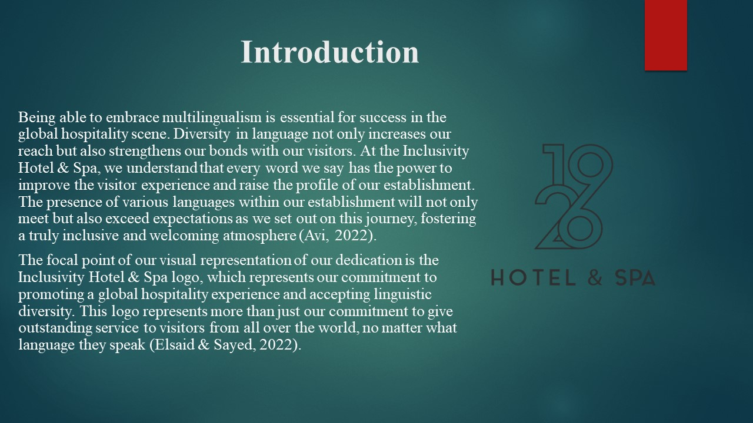
Brief Overview:
Being able to embrace multilingualism is essential for success in the global hospitality scene. Diversity in language not only increases our reach but also strengthens our bonds with our visitors. At the Inclusivity Hotel & Spa, we understand that every word we say has the power to improve the visitor experience and raise the profile of our establishment. The presence of various languages within our establishment will not only meet but also exceed expectations as we set out on this journey, fostering a truly inclusive and welcoming atmosphere (Avi, 2022). The focal point of our visual representation of our dedication is the Inclusivity Hotel & Spa logo, which represents our commitment to promoting a global hospitality experience and accepting linguistic diversity. This logo represents more than just our commitment to give outstanding service to visitors from all over the world, no matter what language they speak (Elsaid & Sayed, 2022).

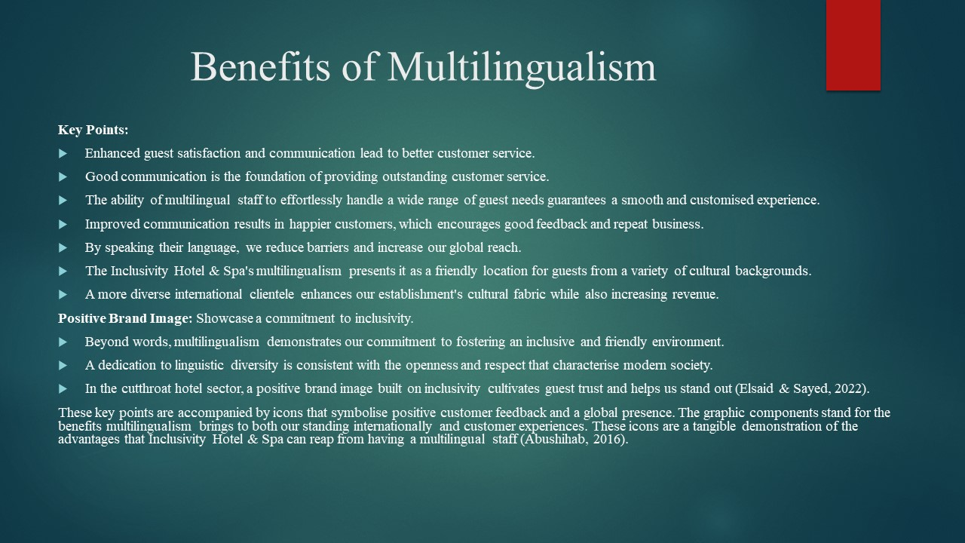
Key Points:
- Enhanced guest satisfaction and communication lead to better customer service.
- Good communication is the foundation of providing outstanding customer service.
- The ability of multilingual staff to effortlessly handle a wide range of guest needs guarantees a smooth and customised experience.
- Improved communication results in happier customers, which encourages good feedback and repeat business.
- By speaking their language, we reduce barriers and increase our global reach.
- The Inclusivity Hotel & Spa's multilingualism presents it as a friendly location for guests from a variety of cultural backgrounds.
- A more diverse international clientele enhances our establishment's cultural fabric while also increasing revenue.
Positive Brand Image: Showcase a commitment to inclusivity.
Beyond words, multilingualism demonstrates our commitment to fostering an inclusive and friendly environment.
A dedication to linguistic diversity is consistent with the openness and respect that characterise modern society.
In the cutthroat hotel sector, a positive brand image built on inclusivity cultivates guest trust and helps us stand out (Elsaid & Sayed, 2022).
These key points are accompanied by icons that symbolise positive customer feedback and a global presence. The graphic components stand for the benefits multilingualism brings to both our standing internationally and customer experiences. These icons are a tangible demonstration of the advantages that Inclusivity Hotel & Spa can reap from having a multilingual staff (Abushihab, 2016).
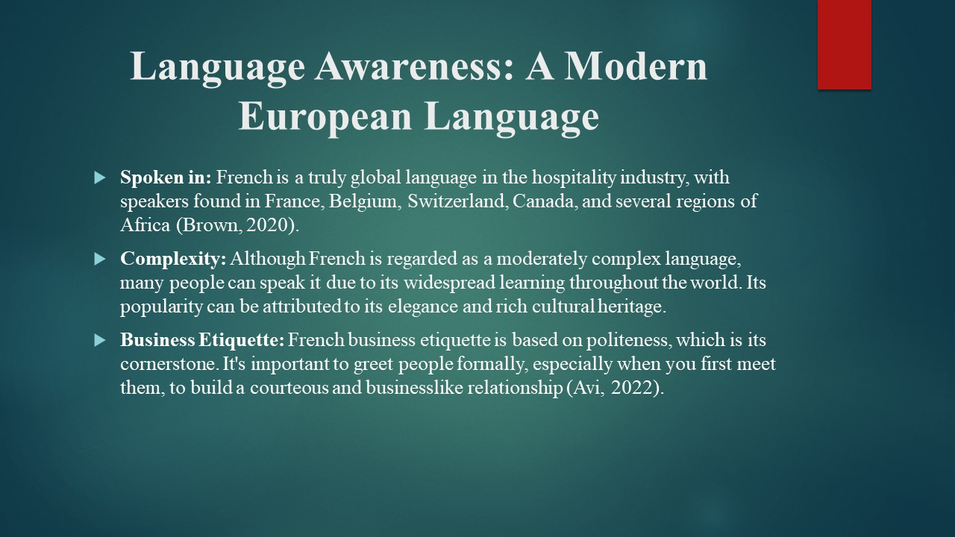
Language Awareness: A Modern European Language
Spoken in: French is a truly global language in the hospitality industry, with speakers found in France, Belgium, Switzerland, Canada, and several regions of Africa (Brown, 2020).
Complexity: Although French is regarded as a moderately complex language, many people can speak it due to its widespread learning throughout the world. Its popularity can be attributed to its elegance and rich cultural heritage.
Business Etiquette: French business etiquette is based on politeness, which is its cornerstone. It's important to greet people formally, especially when you first meet them, to build a courteous and businesslike relationship (Avi, 2022).

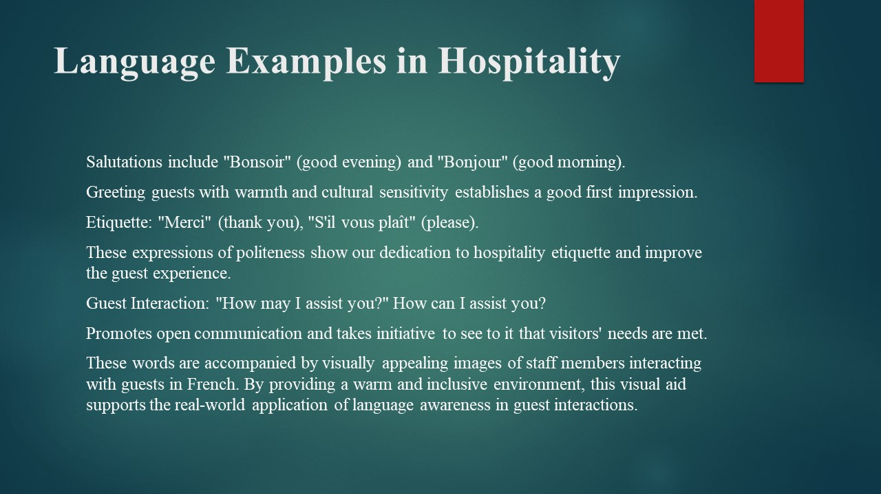
Salutations include "Bonsoir" (good evening) and "Bonjour" (good morning).
Greeting guests with warmth and cultural sensitivity establishes a good first impression.
Etiquette: "Merci" (thank you), "S'il vous plaît" (please).
These expressions of politeness show our dedication to hospitality etiquette and improve the guest experience.
Guest Interaction: "How may I assist you?" How can I assist you?
Promotes open communication and takes initiative to see to it that visitors' needs are met.
These words are accompanied by visually appealing images of staff members interacting with guests in French. By providing a warm and inclusive environment, this visual aid supports the real-world application of language awareness in guest interactions (Elsaid & Sayed, 2022).

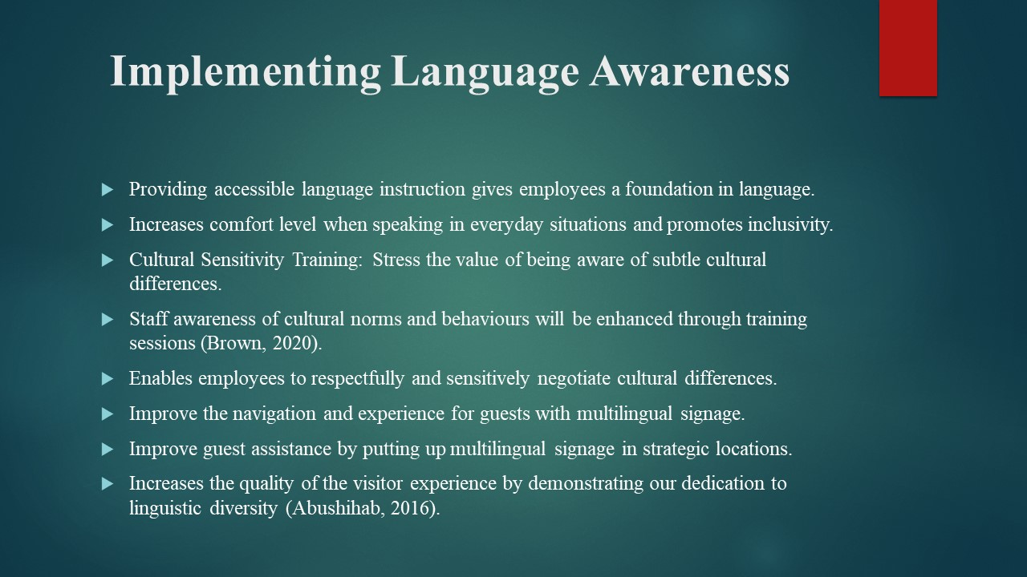
Providing accessible language instruction gives employees a foundation in language.
increases comfort level when speaking in everyday situations and promotes inclusivity.
Cultural Sensitivity Training: Stress the value of being aware of subtle cultural differences.
Staff awareness of cultural norms and behaviours will be enhanced through training sessions (Brown, 2020).
Enables employees to respectfully and sensitively negotiate cultural differences.
Improve the navigation and experience for guests with multilingual signage.
Improve guest assistance by putting up multilingual signage in strategic locations.
Increases the quality of the visitor experience by demonstrating our dedication to linguistic diversity (Abushihab, 2016).

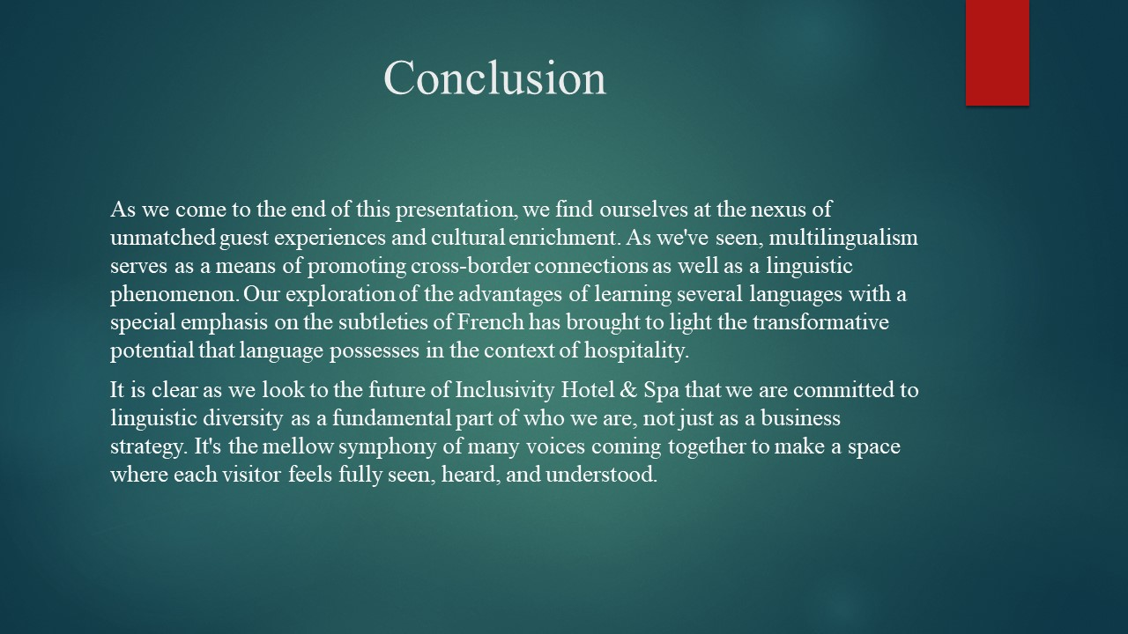
As we come to the end of this presentation, we find ourselves at the nexus of unmatched guest experiences and cultural enrichment. As we've seen, multilingualism serves as a means of promoting cross-border connections as well as a linguistic phenomenon. Our exploration of the advantages of learning several languages with a special emphasis on the subtleties of French has brought to light the transformative potential that language possesses in the context of hospitality.
It is clear as we look to the future of Inclusivity Hotel & Spa that we are committed to linguistic diversity as a fundamental part of who we are, not just as a business strategy. It's the mellow symphony of many voices coming together to make a space where each visitor feels fully seen, heard, and understood.
References:
Abushihab, Dr.I. (2016) ‘The effect of cultural awareness on motivating students to learn English as a foreign language in Jordan’, Journal of Foreign Languages, Cultures and Civilizations, 4(1). doi:10.15640/jflcc.v4n1a6.
Avi, M.S. (2022) ‘Hotel revenue manager and Hotel Marketing manager: Winning team only with 4 P + 2’, International Journal of Tourism and Hotel Management, 4(2), pp. 17–29. doi:10.22271/27069583.2022.v4.i2a.54.
Brown, K. (2020) The routledge companion to Digital Humanities and art history. New York: Routledge, Taylor & Francis Group.
Elsaid, H. and Sayed, M. (2022) ‘The impact of electronic word-of-mouth (ewom) on the tourists’ purchasing intentions in tourism and hotel sectors’, International Academic Journal Faculty of Tourism and Hotel Management, 8(2), pp. 129–153. doi:10.21608/ijaf.2023.132451.1042.

