Report: Site-Specific Exhibition

Name: Rebecca Davies
Site Specific Exhibition Title: Entr'acte

Rationale 300
- Clearly articulate why the chosen site is meaningful. What historical, cultural, or social importance does it hold? How do these attributes align with the conceptual framework of your work?
- Conceptual/Contextual Ideas: Discuss your group and individual interpretations of the broader themes your exhibition explores, such as identity, memory, community, etc.

The Palace Theatre is Grade II listed, clearly representing the idea that this site holds a deep architectural, cultural, and social presence, whereby its historical significance spans over a century. Opened in 1888, this site started as The Pavilion, whereby it functioned as a music hall. Not long after, the site became The Empire, and it not only functioned as a music hall but also displayed early movie pictures. Although the site was popular during those times, it was most famously known for hosting Charlie Chaplin and Marie Lloyd. Through deeper research it was discovered that The Palace Theatre was one of the first places in Wales to highlight a silent movie, emphasising its deep historical significance. Furthermore, despite this site being referred to as People’s Bioscope Palace in the early 1900s, it was officially named The Palace Theatre in 1912, a name which has remained part of its identity ever since. While most of Swansea’s city centre was destroyed in the Swansea Blitz of 1941, the Palace Theatre remained standing, during which it was used as a temporary morgue to handle victims from the devastating raids. This highlights how its role through wartime and ongoing city regeneration was deeply important not only to society but through historical stances as well.
In more recent years, the site has evolved into a cinema, bingo hall, and nightclub. However, after 2007 when the nightclub shut down, the place fell into despair and was left abandoned for over a decade. The building then suffered a devastating fire that left it severely damaged but not destroyed. This event led to a major (£6.9m+) restoration by Swansea Council, whereby in November 2024 the site became a tech and creative business hub known as Tramshed Tech, which holds offices and workshops, while also collaborating with a cafe named Da, allowing the site to maintain its connection to its local community.
Growing up in Swansea has led me to have a more personal connection to this building than some others in my group. Over the years I have observed this site, through my own eyes, evolve and transform into the building it is now. However, despite watching this happen I was still unaware that this site had now been opened to the public and was collaborating with the community. After talking to some friends, family, and people around me few people in Swansea knew about the reopening of this site, let alone the new development of its identity. This personal aspect is a major reason why throughout my project I was drawn to the historical emptiness of this site, as I experienced this emptiness from an outsider’s view, with the knowledge I will never truly get to see the emptiness from within, and that although it is now full I can still get the feeling of emptiness from it. There is this feeling that every time I step out of the building, I am witnessing its emptiness all over again. It feels as though this building has a sense of vacancy and liminality attached to it that I do not believe will ever truly leave it.
Our exhibition, Entr'acte, explores these attributes through the medium of art. By engaging with the themes of liminality, memory, and transformation, we have created an exhibition that responds to a variety of elements of the building itself. My own work Vacant explores the emptiness of the building’s history (between 2007 and 2024) within the context of its modern presence, whereby I highlight the in-between stages that exist between past and present. This is created with a focus on the traces of light and sound within archival recordings, whereby I created a short video which was projected onto the old theatre’s fly machine, an object that has acted as a silent witness to all the building’s historical stages. Millie Jones and Amelia Peacock’s Interval of Use extends my explorations of archival resources, whereby they used historical images of the building’s distinct functions and stages over time to display within the space. This was done by embedding imagery and text from the archive and online sources into everyday objects such as coasters and chairs. They explore a different element of the building’s history by focusing on the idea that the building itself has become history. Their installations within the cafe space act as literal intervals, in simple terms a pause, allowing visitors to interact with a space full of history and feel as if the space has not changed. Our works were both heavily influenced by the deep historical meaning behind the building itself and the transformation between past, pause and presence, exploring the relationship between memory and identity through that prolonged in-between space of the building’s evolutions.
Jamie Sides’ short silent film Dream Palace responds to the theatre’s transformation of past and present, whereby the building itself is presented as a living archive with deep historical significance. This video was projected into the cabinet space to allow more emphasis on the idea that this building has now become something it was not originally intended to be, and that randomness is reflected in the way it was presented. This production was heavily influenced by our deep dive into the theatre’s history, whereby we found that the Palace Theatre was one of the first places in Wales to highlight a silent film. Furthermore, Libby Turner’s Porosity investigates the permeable boundaries between the interior and exterior of the building. She does this by displaying the blending of prolonged exposure images on an old TV and sound from outside the theatre to create an immersive experience. This project emphasises the relationship between the perceptions of the building’s outside and the reality of the inside, exploring the contrast between each element. These themes were developed from the ideas of historical changes of the building over the years, showing its fluidity of identity as well as the disconnection from the community this building suffered during its decade of abandonment.
This exhibition engages with memory, history, and community, highlighting the theatre’s existence. Through archival imagery, media, and site-specific installations, our work reveals the different layers of historical experiences this building holds. Visitors get to witness a space where the past and present coexist not just within our work but within the building itself.

Referenced List:

Bbc.co.uk. (2025). BBC NEWS | Wales | Southwest Wales | Oldest theatre under hammer. [online] Available at: http://news.bbc.co.uk/1/hi/wales/south_west/3239364.stm [Accessed 11 Dec. 2025].
Dalling, R. (2020). The treasured Swansea building, it is amazing past, and the 15 years of uncertainty it’s faced. [online] Wales Online. Available at: https://www.walesonline.co.uk/lifestyle/nostalgia/treasured-swansea-building-amazing-past-17578694 [Accessed 11 Dec. 2025].
R&M Williams Ltd. (2022). Secret doors and major hidden feature found at historic Swansea theatre - R&M Williams Ltd. [Online] Available at: https://rmwgroup.co.uk/news/2022/03/secret-doors-and-major-hidden-feature-found-at-historic-swansea-theatre/ [Accessed 11 Dec. 2025].
Swansea Council (2024). Historic Swansea Palace Theatre building reopens - Swansea. [online] Swansea. Available at: https://www.swansea.gov.uk/article/33255/Historic-Swansea-Palace-Theatre-building-reopens.
Tech, T. (n.d.). Tramshed Tech | Space to Innovate in Wales | Home. [online] www.tramshedtech.co.uk. Available at: https://www.tramshedtech.co.uk/.
Williams, K. (2019). Firefighters battle fire at Swansea’s famous Palace Theatre. [online] Wales Online. Available at: https://www.walesonline.co.uk/news/wales-news/live-updates-swanseas-palace-theatre-16885415 [Accessed 11 Dec. 2025].

A Summary of the Research.

- Provide a concise overview of the research you have conducted over the past semester that has led you to the production of your site-specific intervention.
- Demonstrate your understanding of primary and secondary research skills taught over the past 18 months in developing your ideas from concepts to final installation. (Site visits/ practical experimentation, data collection etc.)
- Use visuals!

For my individual project, I conducted and collected research during the development of our group exhibition, whereby I focused on themes of emptiness, memory, material presence, and transformation. The Palace Theatre served as both the subject and starting point for the themes of my project. While conducting research I approached this site as a piece of historical architecture, in which it acts as a container of layered meanings, identities and histories, rather than just a reconstructed building. These perspectives of the site were shaped through a combination of theoretical reading, archival research, site observations, and experimentation. Throughout the exploration of research my focus was on the theatre’s extended period of abandonment and the cultural significance of its emptiness, by which I explored online reports, redevelopment documents, and historical timelines that highlighted the years of inactivity after the building shut down. This vacancy surrounding the building became the conceptual foundation of my work. I decided that instead of perceiving the historical emptiness as a gap within its cultural past, I chose to view this site as a space that holds traces of the deep history such as past performances, audiences, and community. Furthermore, my research extended into broader interpretations of emptiness itself, whereby it was highlighted that while the Palace Theatre appeared unused, the site was in fact full of material and emotional presence. This includes changes in light, shifting shadows, and the subtle sounds of the building’s surrounds, which explained the idea that the building was kept alive through its historical traces.
A key part of my research focused on the theatre’s remaining fly machine. I investigated how it was used, why it had been kept when much of the building had been stripped out, and what its presence meant within the space. Its stillness and signs of age made it feel like a quiet witness to the theatre’s past, whereby the machine became more than just a piece of equipment, it acted as a material memory of the building. During this research I explored some key information from previous modules that also explored themes of memory and traces, such as the book Objects of the Dead by Margaret Gibson. This research helped to shape my understanding of how abandoned objects can hold significant traces of their history, sometimes holding deep meaning without anyone’s knowledge. This led me to use my ideas of projection and sound onto the fly machine to bring this piece of equipment back into motion and give it a renewed sense of presence.
Research for the exhibition focused on how to create a coherent group show while also allowing each person in the group to maintain their own conceptual ideas within their work. We looked through examples of group exhibitions from previous years as well as from online sources, whereby they displayed balance, unity, and individuality. This helped us shape our shared themes of pause, presence, and embedded histories within the Palace Theatre. During the planning of our exhibition, I occasionally took on an organisational and communication role, whereby I kept Millie fully updated while she was away so she remained involved in all decisions, and I acted as the main communicator for Amelia, who did not have access to WhatsApp or social media. I kept her informed on every update to ensure her ideas were included throughout. I also supported the group with administrative responsibilities, such as helping Millie and Libby with email writing to the archive and the Tramshed Tech manager. On several occasions, I drafted full messages that Libby then sent on behalf of the group, to help her workload and delegate some responsibility. This made communication with external contacts clearer and helped keep the exhibition preparation organised.
For some context, my intention had always been to support the visual consistency of the exhibition rather than take over the ticket design. As I am aware I struggle to articulate myself through text alone and I did not want there to be any confusion, I created quick digital sketches and mock-ups to better communicate what I meant. I chose to speak with Libby privately instead of in the group chat because I believed it would be more respectful and prevent any impression of directing the group. I also made it clear that the ideas were optional and based on what everyone had said the day before. However, despite this, the message did not come across as I intended. Once we discussed it, Libby explained that too many outside ideas felt overwhelming and that she preferred to work independently on the ticket. I fully understood her position and stepped back to respect her role and avoid adding any pressure.
After addressing the miscommunication, we agreed on a clear division of responsibilities to support smoother collaboration moving forward. I focused primarily on the poster, and Libby led the ticket design. Although having this disconnection within the marketing materials sometimes felt as though I was unaware of design choices for the ticket, once Libby had made a design the group were able to suggest any alterations and changes. To keep communication positive, I avoided sending further mock-ups unless requested and instead concentrated on my own tasks. In the end, Libby reviewed what I had previously shared and incorporated a few elements she felt worked well, including some fonts from my designs and a layout idea for the ticket. This meant the final ticket became a balanced combination of her work, my contributions, and the wider group’s ideas. The experience strengthened our teamwork overall and helped us communicate more clearly, maintaining respect for each other’s roles while still supporting a cohesive exhibition identity.
My project used a wide range of primary and secondary research methods that informed both my own work and the overall exhibition. Primary research was central to my process, whereby I carried out weekly site visits to the Palace Theatre, in which I documented the space through photographs, sound recordings, and observational notes. These visits helped me to study the light movement, internal and external sounds, and the material textures of the architecture. I recorded the theatre’s natural soundscape, which later became a key starting point of my installation. During this I also conducted practical experiments, which included projection tests, sound trials, and exposure variations in my photoshoots. I also observed the workshops held on-site, whereby I was able to witness how this building interacts with its local community. This highlighted the deep relationship that is forming between the building, company, and its local community. I also regularly spoke with the site manager, which allowed us to maintain a consistent and clean process throughout our exhibition journey. A surprising element of these visits was gaining the opportunity to speak to the artist of the paintings that are pasted around the site. I found this part interesting as we got to discuss his view on the site itself as well as its history and cultural importance.
Secondary research provided the context for my decisions, whereby I gathered a range of archival materials such as posters, programmes, newspaper articles, and videos from different decades of the theatre’s history. Many of these later contributed to and inspired my projected visuals. I also explored academic texts, artist inspiration, and readings on memory, atmosphere, the theatre’s history, and site-responsive installations. Artists such as Tony Oursler and Olafur Eliasson influenced how I approached projection, light, and environmental interaction in my work. I also found information from a Chinese philosopher that states an empty room will only ever be full of light, which is something that started the foundations for my projection work and looking into lightwork. Throughout the project, I worked closely with Millie to keep detailed notes that documented research findings and recorded our decision making, in which a combination of visual observation, historical research, theoretical texts, and practical experimentation allowed me to create a final installation that was both conceptually grounded in my work and connected my project to the site.

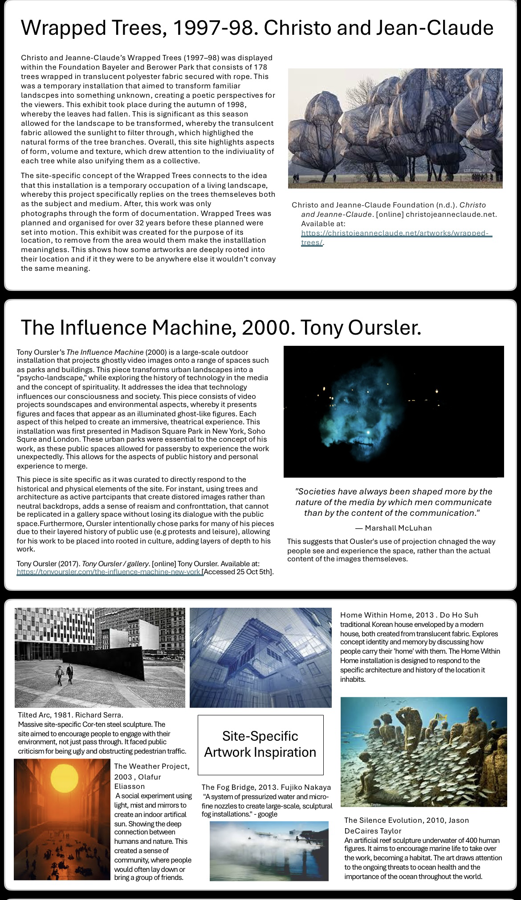
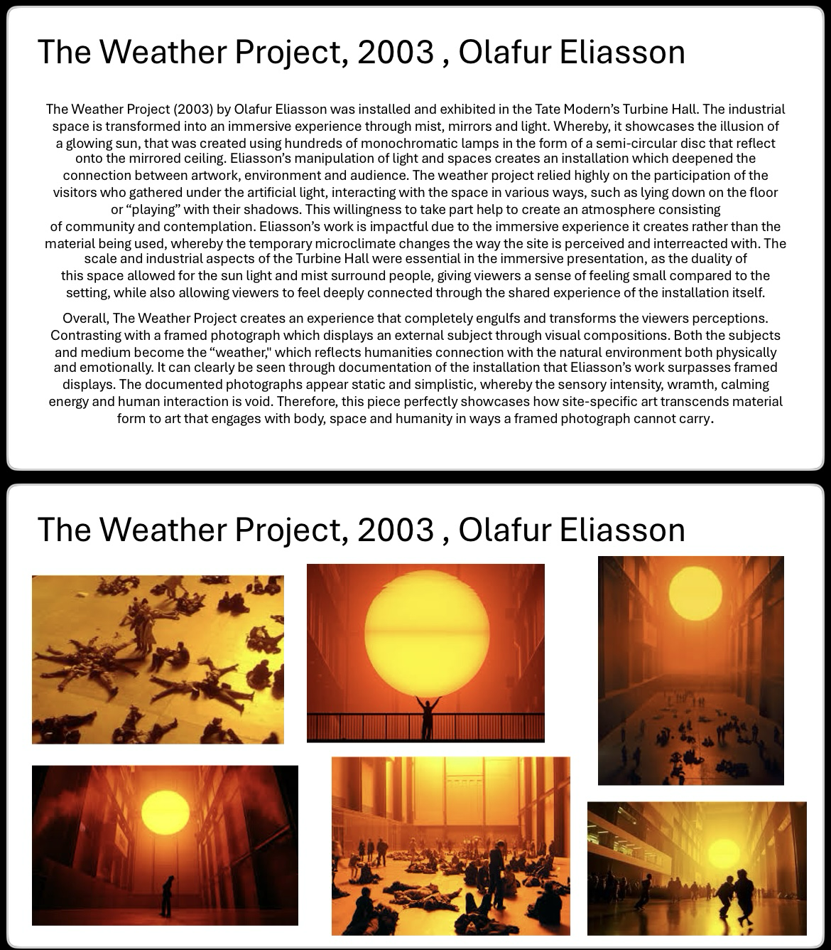

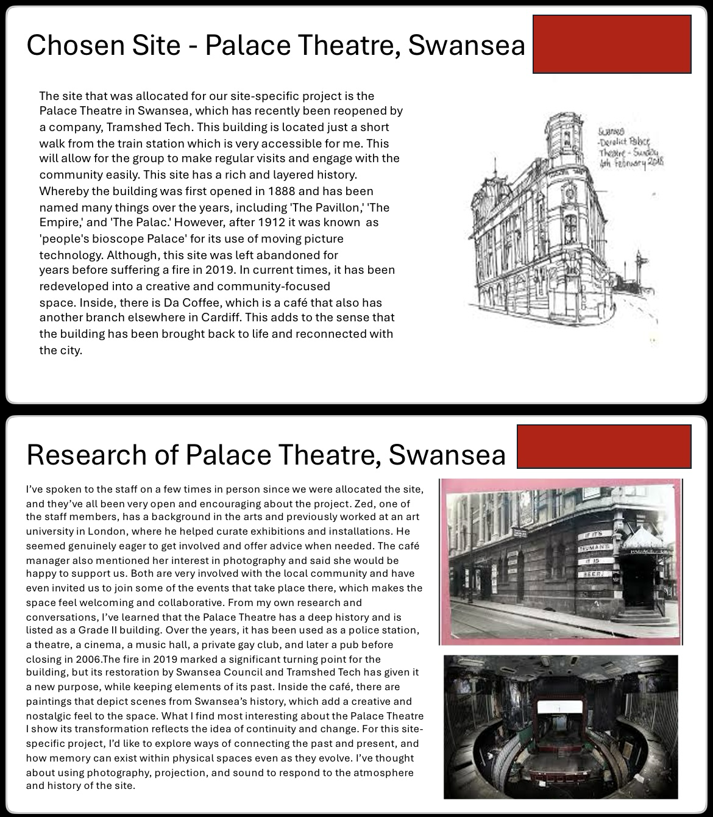

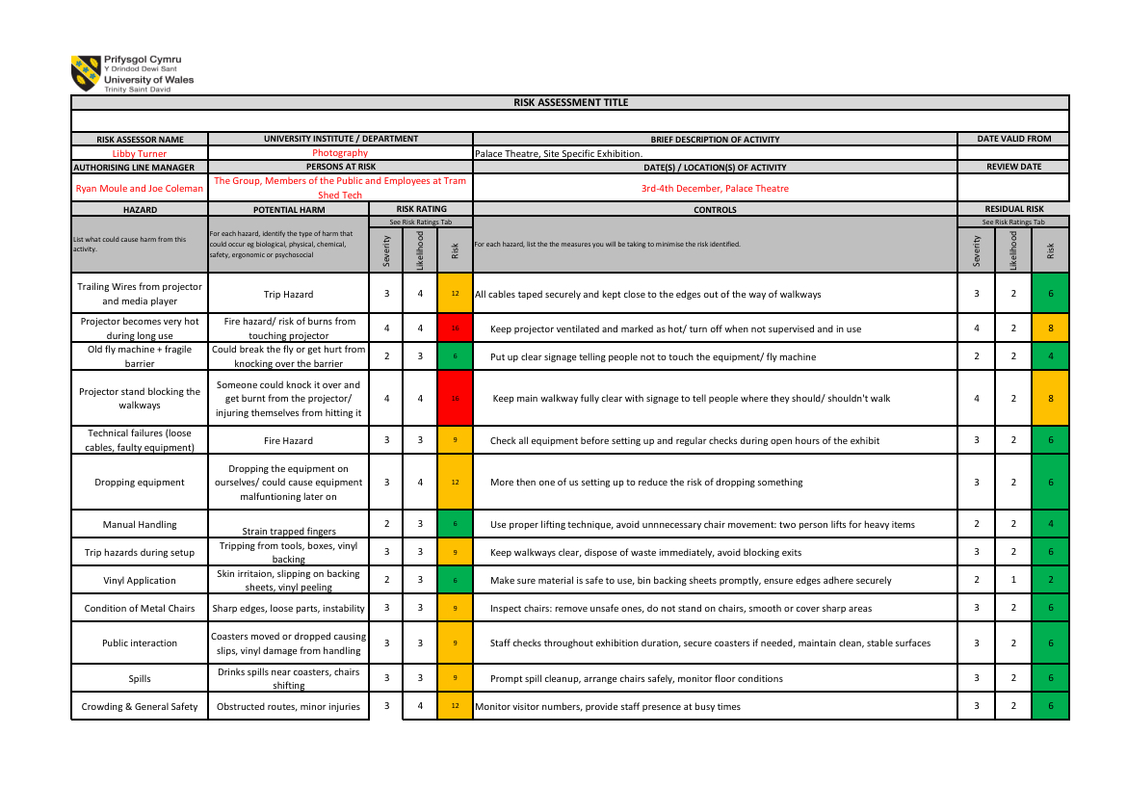

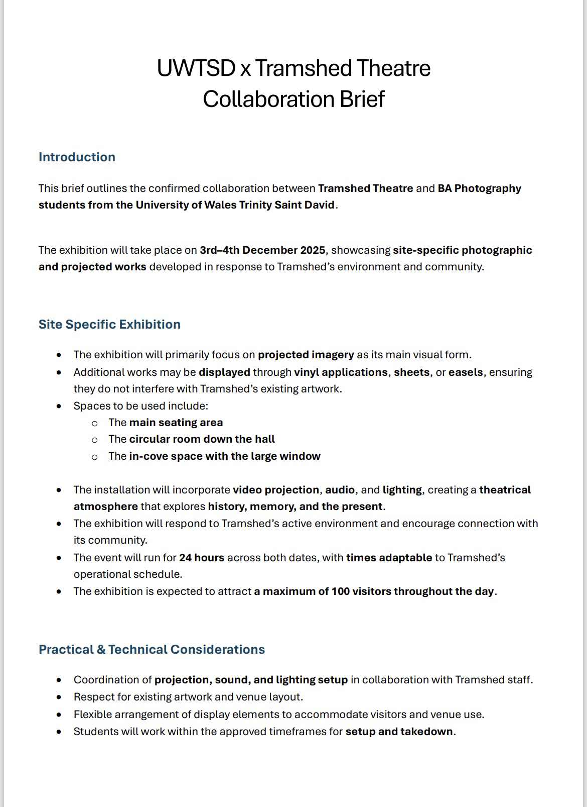

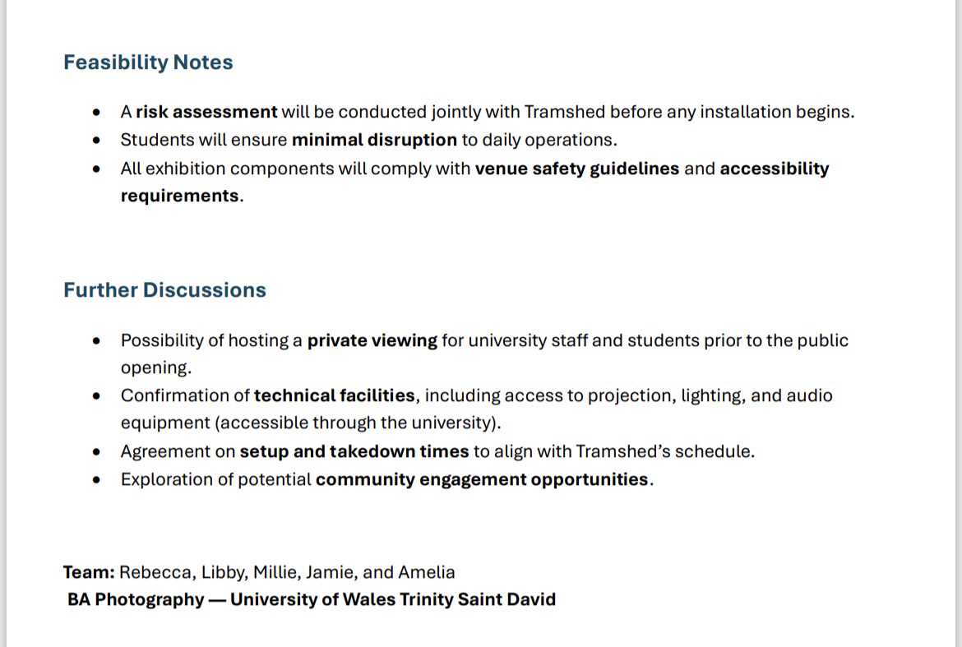

Reference List:
D’Agostino, A., Pepi, R., Rossi Monti, M. and Starcevic, V. (2020). The Feeling of Emptiness: A Review of a Complex Subjective Experience. Harvard Review of Psychiatry, [online] 28(5), pp.287–295. Doi: HTTPs://doi.org/10.1097/HRP.0000000000000269.
Guardian staff reporter (2021). Enter the void: photographs that find beauty in emptiness – in pictures. [online] the Guardian. Available at: https://www.theguardian.com/artanddesign/gallery/2021/jan/05/paul-cupido-photographs-beauty-chinese-philosopher-zhuangzi-japan-series.
Oursler, T. (2019). Tony Oursler. [online] Tony Oursler. Available at: https://tonyoursler.com/influence-machine-stockholms-university [Accessed 11 Dec. 2025].
Public Delivery (2019). Olafur Eliasson’s ‘Weather Project’ - Why did he try to recreate the sun? [online] Public Delivery. Available at: https://publicdelivery.org/olafur-eliasson-the-weather-project/.
Strategic Intelligence (2025). Why empty space is not really empty. [online] Verdict. Available at: https://www.verdict.co.uk/analyst-comment/quantum-empty-space-vacuum-activity/ [Accessed 11 Dec. 2025].
Tony Oursler. (2000). Tony Oursler / gallery. [online] Available at: https://tonyoursler.com/the-influence-machine-new-york.
Wikipedia. (2022). Fly system. [online] Available at: https://en.wikipedia.org/wiki/Fly_system.

Techniques Developed for the Production of Your Body of Work

- Outline the tools, materials, or methods employed in creating your work. Highlight innovations or adaptations that you have considered to align with notions of ‘site specificity.’
- Practical Application: Describe how these techniques contributed to the final exhibition and supported its conceptual aims.
- Use visuals!

The development of my work for Entr’acte involved a wide range of technical, practical, and conceptual methods, which allowed me to visually respond to the themes of history and presence within the context of the Palace Theatre. The focus of my work was the use of projection and video editing, whereby I edited historical footage of theatrical performances, clubbing videos and documentation of the fire incident. Through Premier Pro I explored and experimented with a range of different elements. One example was chopping and rearranging certain clips into particular areas, as well as manipulating the timings and rhythms to reflect the theatre’s diverse history. One element that I struggled with at first was making the video have the illusion of never ending. I did this through looping the video into a seven-minute-long piece and constant testing to check the fluidity of the video. Another example is layering sounds, whereby I abstracted the sound from each video and blended them together to create an overstimulating sound of noise. To further this experimentation, I also adjusted the speed and timings of the sound to create a distorted, unrecognisable noise that seemed eternal.

Despite having some previous knowledge of video editing, one aspect that was completely new to me was projection, whereby I explored using projection mapping, keystone correction and image formatting to ensure the video aligned smoothly with the surface of the fly machine. This was the most time consuming part as I can be quite a perfectionist, so I ended up testing this a few times whereby I changed the sizing of the video, explored different formatting and experimented with the projector’s settings in order to fit the video exactly where I envisioned. Another aspect of this was using a Bluetooth speaker for the sound. I learnt a lot about how the location of sound can affect the visitor’s view and where their eyes are drawn to. One struggle I experienced was accessing the sound through an SD card. I had a few difficulties with this at first, although I later noticed I had made the simple mistake of not changing the file format from video, which is MP4, to sound, which is MP3.

Throughout the development of my work, I used an extensive range of practical photographic techniques, including long exposure, manipulating images in Photoshop, mounting work and digital analogue printing. During this process I learnt how to create templates for printing, reformat files and extract videos from online sources for both research purposes and video editing. I also developed my skills in measuring spaces, furniture, and digital materials, such as poster sizes, coasters, chairs within the site and a plinth stand, for my projection work as well as assisting Millie and Amelia. These material aspects such as coasters, vinyl and posters created physical elements of interaction for visitors, whereby they were encouraged to move through the site and engage with its textures and details. Furthermore, during this module I developed my skills in graphic design, whereby my key role in marketing was to create posters for promotional value. Although I enjoy making graphic materials, it is not my main field of work, so I appreciate all the practice I can gain. During this module I used tools such as cameras, tripods, USB drives, speakers, and projectors to support the technical aspects of my work. To ensure safety and professionalism I conducted a risk assessment for my individual work as well as assisting in a group assessment for our exhibition. Overall, every tool and method used helped to transform research into an immersive, sensory experience. The collaboration of sound, projection, historical material, and site-specific objects allowed our group to create multiple installations that invited visitors to explore the layered history the theatre holds.

Over the past few weeks, I have engaged in workshops to support the development of my technical understanding. I attended a digital to analogue workshop with Daf, whereby I experimented with transforming digital negatives into analogue materials. Although this did not become part of my final installation, it helped me to consider a range of alternative processes, not only for my current work but also for future projects. Additional to this, I participated in mounting and projection workshops, whereby I developed my digital skills, such as projection mapping, as well as skills in applying materials directly onto objects connected to the site, such as business cards and a tile from their reconstruction. These workshops encouraged me to think further into site responsive materials and how we can integrate our work into the site itself. I found the mounting workshop extremely useful for our exhibition as Millie and Amelia curated the idea of pasting vinyl onto coasters and chairs, which helped create a space where these images were integrated into the site itself rather than simply added to it.

For my project, I adapted my techniques to connect with the complex contexts within the Palace Theatre. In particular, the fly machine became an element of conceptually grounding my work, while also becoming a technical obstacle that I had to work with collaboratively. To allow my project to work with the unique structure rather than against it, I experimented with projection mapping, video sizing, and keystone adjustments. Therefore, by responding to the site using the frame of the machine, my projection helped to emphasise the themes of emptiness, memory, and the passage of time. In terms of the videos, I used to create my final piece, I collected a mixture of archival videos, documentaries, and online clips, whereby my archival exploration helped not only to shape my work but also the concepts around the site itself. When creating my work, the key focus was to construct a piece that communicated the architecture and social history of the theatre, as well as the idea that materials can carry meaning and embody traces of the past. In conclusion, these methods and techniques helped me to create work that directly supports my conceptual aims, whereby the combination of sound, light and moving image connected visitors to the theatre’s relationship between past and present.

During our first practice of setting up our exhibition work, I noticed that there was an issue with the video not being bright enough. This was due to the lighting conditions around the theatre requiring technical adjustments. Although after some discussion it was concluded these lights were unable to be turned off. To improve the quality of my work, I adapted the brightness and contrast of my video and refined the settings of the projector to ensure visibility. Despite this being a complication, I was able to resolve the installation, which helped me strengthen my technical adaptability. This challenge highlighted the importance of being able to problem solve and adapt, as well as teaching me the significance of conducting practices and tests for setting up work before the final event.

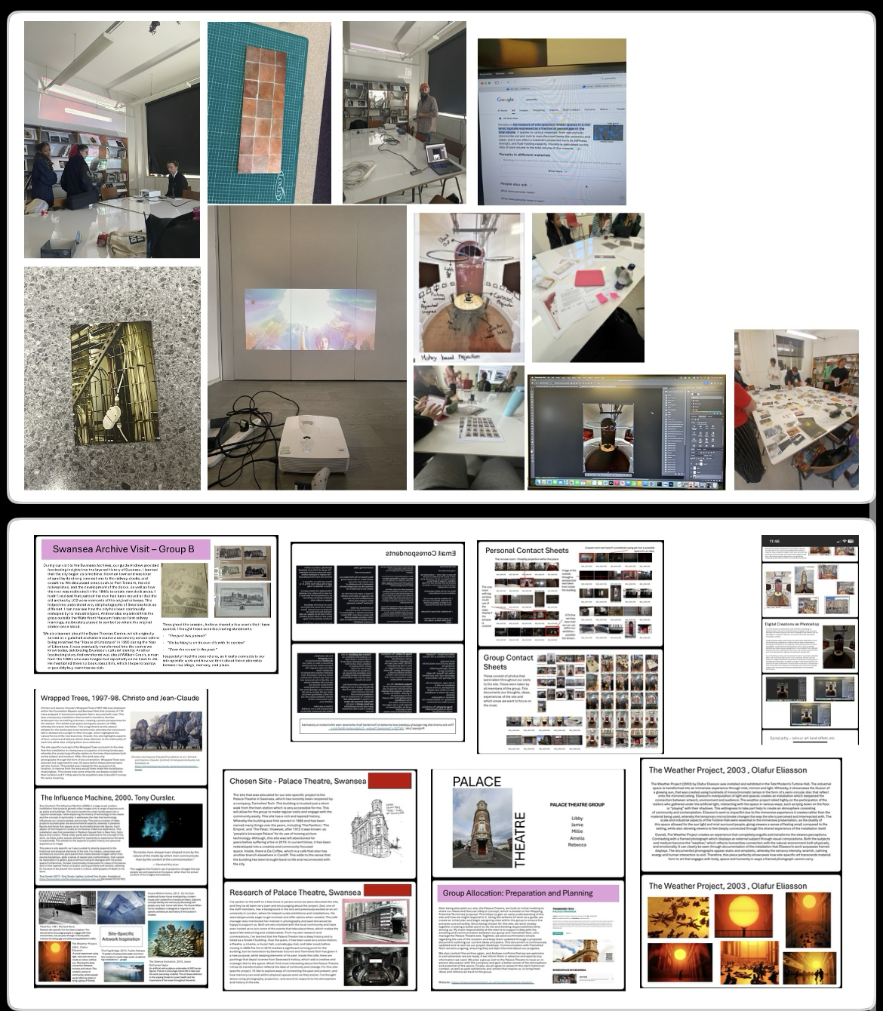

Individual and Group work overview
- Provide a summary of your contribution to production of a final site-specific exhibition.
- What role did you take in the group?
- What have you found challenging throughout the process?
- How have you overcome any hardship that you have delt with both in the making of your work and working with others.
- what team and personal skills have you learned/practiced that might be useful in your professional development for future career opportunities?

Throughout the development of our site-specific exhibition, I played a significant role in organising, coordinating, and supporting the group. My contribution combined marketing, administration, communication, and general teamwork. I carried out a large part of the promotional work, including designing posters, creating social media content, printing materials, and drafting a full ticket layout. I also promoted the exhibition through my own account to widen its reach and encourage public engagement. Furthermore, I helped with establishing our professional relationship with Tramshed Tech. I did this by writing the first project brief and assisting with communication to both the archive and the theatre. Millie and I also regularly took notes during meetings, noted decisions or updates, created summaries, and reminded the group about deadlines. I also supported Libby with email writing when needed to ensure clear and professional communication. My role also involved helping group members with practical and creative tasks, whereby I supported Millie and Amelia in finding online resources, cutting, and printing materials, as well as measuring certain areas. I helped Libby by brainstorming her project title and printing her materials. I also acted as a communication link for Amelia, who did not use WhatsApp or social media, and updated Millie daily while she was away. I made sure both were fully informed and involved in all decision making. Over time, Millie and I naturally developed a shared secretary style role, helping the group stay organised and consistent throughout the project.
My role developed into a mixture including leader of marketing, administrative coordinator, communication link, and widespread support for the group. During this process I always tried to keep everyone in the group well informed, involved and supported while also contributing my own visual and practical work. I was very aware that there was a lot of work to do, and I ensured I did my best to help everyone in the team, as I did not want anyone to feel overwhelmed or stressed by the workload. Also, I worked closely with external organisations, whereby I learned how to draft professional emails, how to request information clearly and how to maintain a consistent professional tone. This helped to build my confidence in professional communication. I also learned how to balance my input with the rest of the group. I contributed ideas when needed but also respected moments when others preferred to work independently. This balance helped the group feel more unified and allowed each member to maintain their own creative identity within a shared exhibition.
The initial challenge I experienced was navigating different working styles within the group. I noticed very quickly that some members of the group preferred independent working, while others preferred regular check ins and strong group collaboration. Although this was easy to overcome, I did find this hard to juggle at the start, leading me to feel isolated and academically behind. To overcome this, I had to have a lot of patience, awareness, and careful communication to make sure everyone understood each other's working styles and felt comfortable. A challenge that some of us in the group faced during the creation of the marketing materials was a clash of creative roles and boundaries. There was the issue whereby I unintentionally overlapped with Libby’s assigned responsibility for the exhibition ticket design. After a group discussion whereby, everyone shared what they wanted included in the ticket design, we created a drawn mock-up of some ideas that Libby could use for her final design. Although I expressed many of my opinions during this meeting, I left the meeting with many other ideas that reflected the group’s collective input, which I did not have time to discuss with Libby afterwards. So, I messaged Libby privately about these ideas and clearly expressed that these mock ups were just ideas and there was no pressure to use any of them at all. My aim was to show her some visual suggestions I had developed based on the group’s ideas to support her work moving forward. However, the way I shared these ideas was not communicated as clearly as I had intended, whereby from Libby’s perspective it felt as though I was in control of a task that she preferred to manage independently.
I faced a few personal challenges as well; the main one was with my own confidence. Sometimes I struggled to explain my ideas clearly, whereby I often felt overwhelmed by my own expectations to improve on this. I noticed that visual tools, email correspondence and practising by communicating with the group and the company helped to improve my issues with clearly articulating myself. On the other hand, I was also worried that I might sound too direct. I am good at making quick decisions and explaining my choices, although this can sometimes come across as harsh or rude. To improve on this, I allowed myself to take the time to think about my thoughts and how I could communicate these in a way that suited the person I was talking to, based on how they respond to feedback and constructive criticism. Furthermore, I found the fast-paced environment difficult to grasp at first, whereby all the latest information was constantly appearing, and decisions were changing before I had time to think about them. This sometimes made me feel behind or led to comparing myself to others. I noticed that I have a challenging time keeping up with things when I have multiple tasks overlapping each other and I often get carried away with the things that interest me, forgetting about other important things. However, I quickly noticed these challenges, and I made slight adjustments in the way I conduct my work. For instance, I kept detailed bullet point notes to stay up to date, I communicated openly to avoid any misunderstandings, I allowed myself to explore ideas before deciding on them and I also relied on the support of my team, especially Millie who helped me stay organised and grounded. These changes helped me become more confident in organising my time and expressing thoughts professionally.
Overall, this experience helped us grow as a team. Our communication became clearer, responsibilities became more defined, and each member felt respected in their role. For me personally, the project strengthened my confidence, my organisational skills, my communication abilities, and my ability to balance independence with collaboration. It prepared me well for future group projects and gave me valuable experience in professional creative practice.
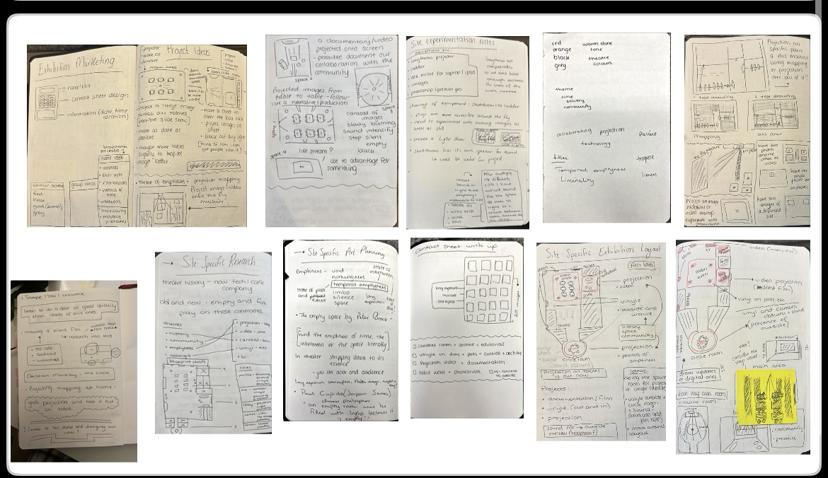
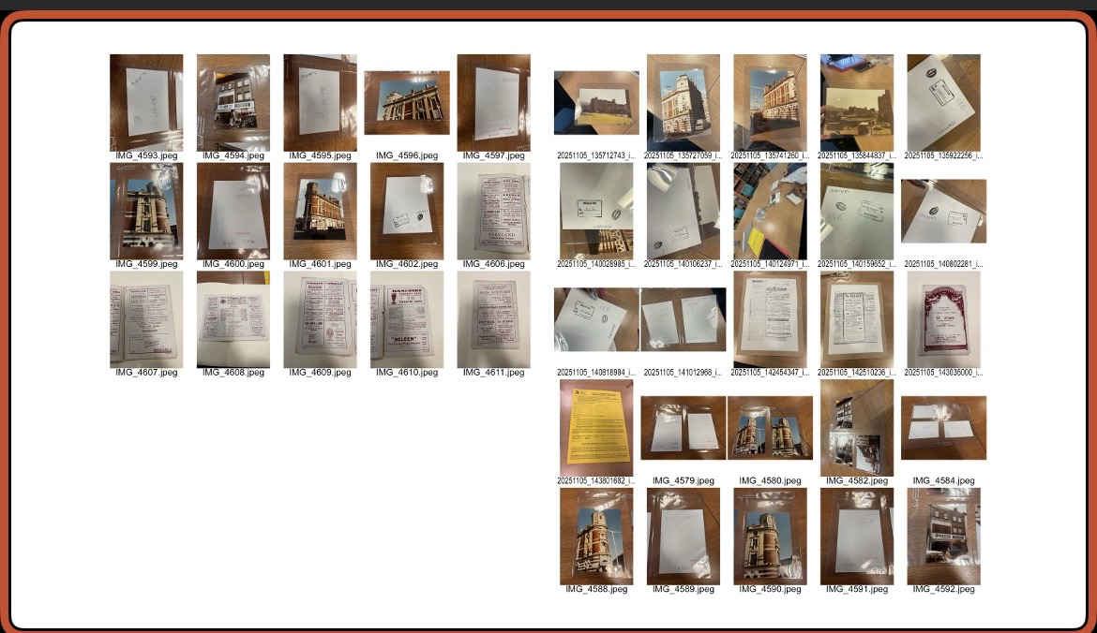

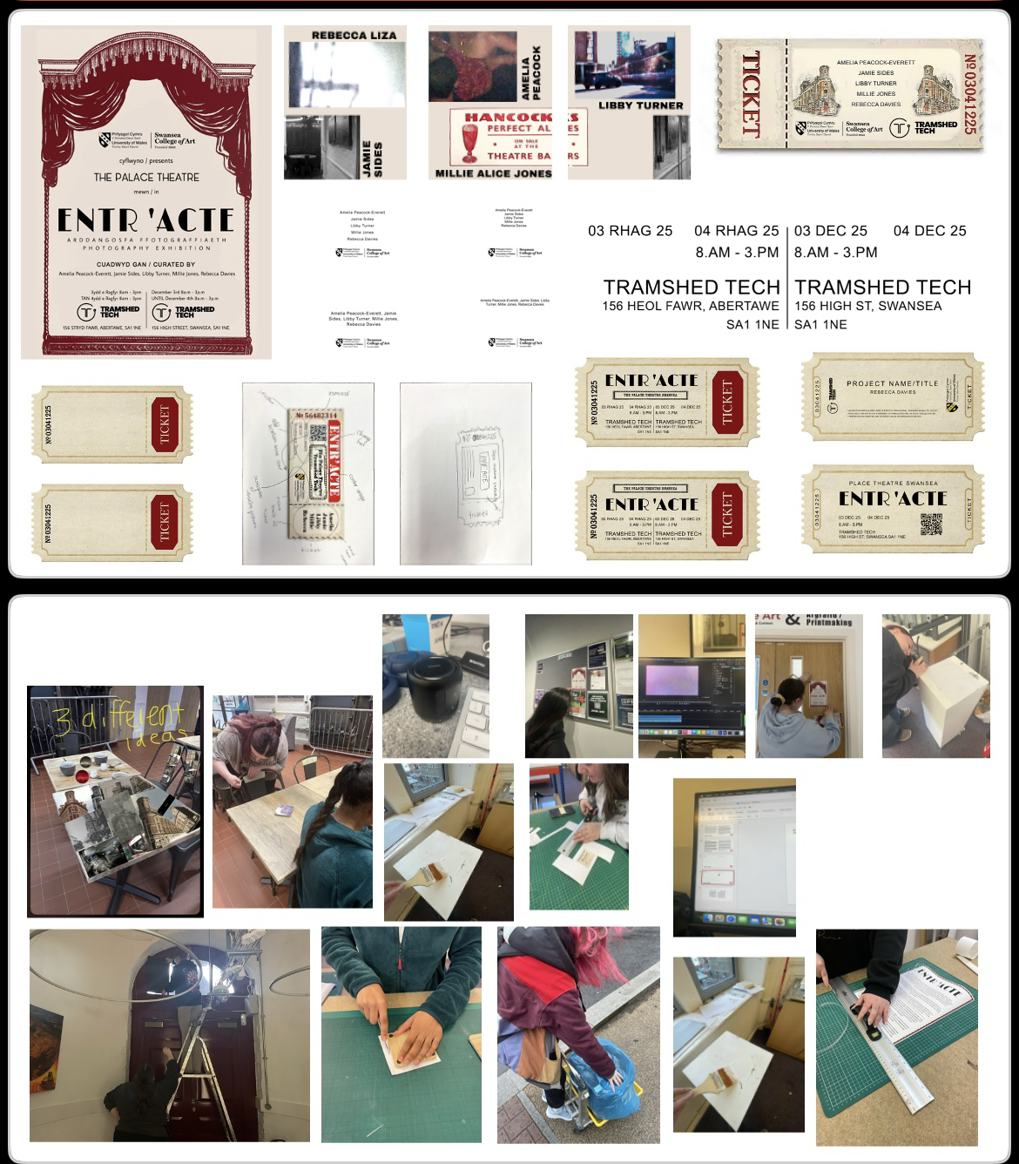

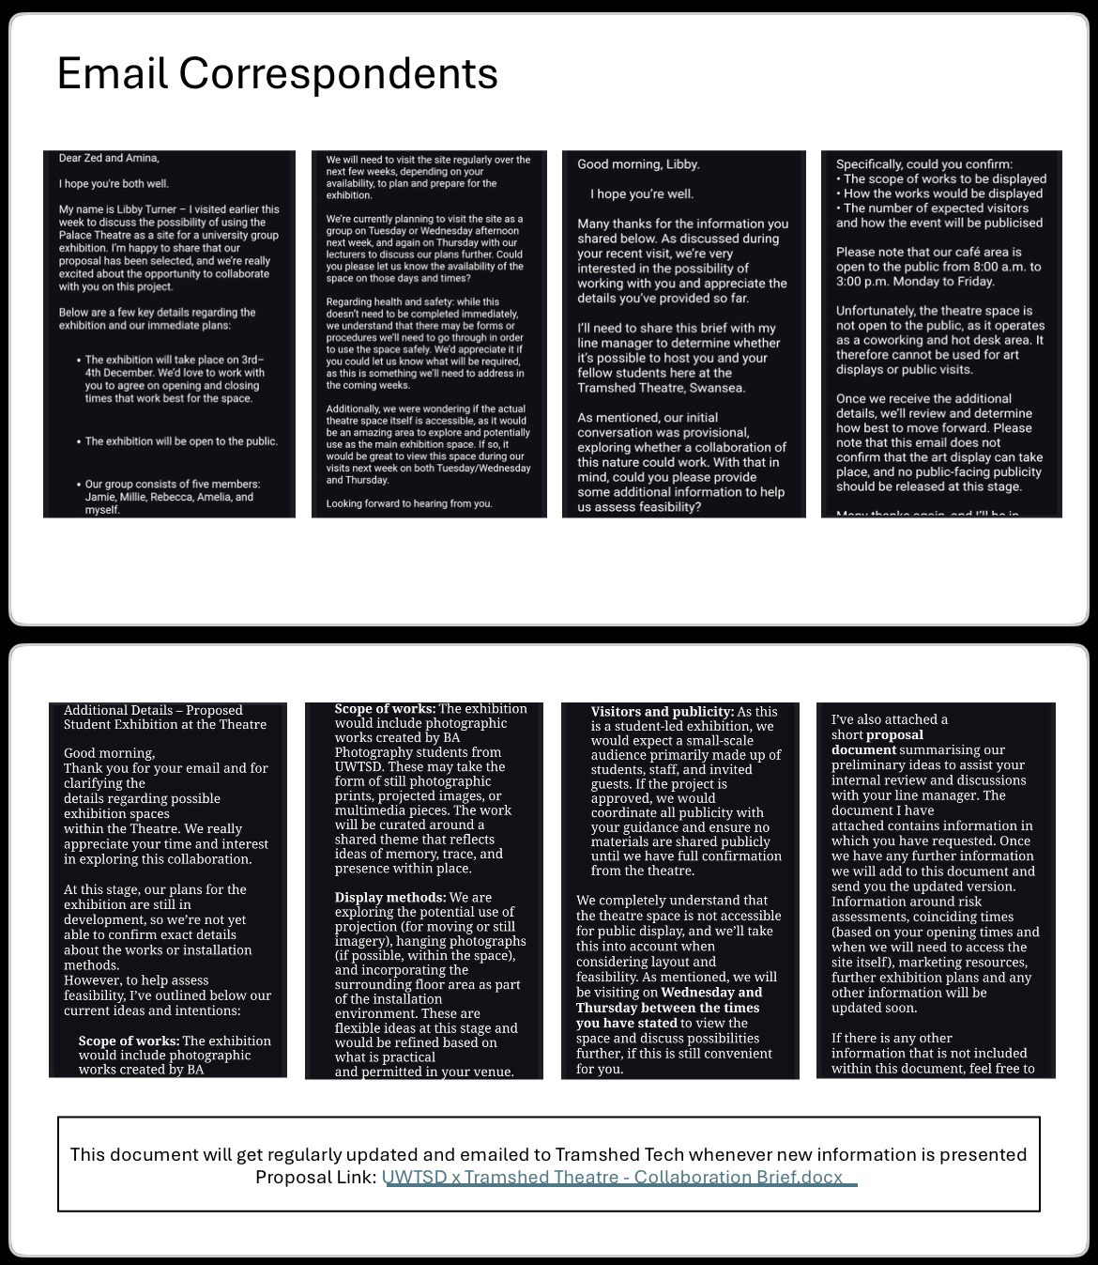

Evaluation of the Exhibition

- Execution: Assess the success of the exhibition in addressing the site’s history, community, or spatial dynamics. Provide install shots of your exhibition work.
- Audience Interaction: Discuss how the audience engaged with your work and the site. Provide photographs that document this process.
- Reflection: Identify areas for improvement and potential future directions for your practice.

Based on our feedback, one of our biggest strengths was the cohesion between each piece. I strongly agree with this. The overall execution of our exhibition was successful in addressing the Palace Theatre’s history, spatial dynamics, and ongoing relationship with the local community. It was highlighted to us that our communication and collaboration within the group was extremely effective. As a group, we created a clear narrative that connected to our three themes of history, community, and presence, whereby each theme was intertwined with one another rather than separate. This allowed the space to hold artworks that responded to several aspects of the site, while also communicating a shared view on the building’s cultural, social, and historical significance. Fortunately, the audience interaction was strong throughout the exhibition since Tramshed Tech had workshops running during the same time, which helped to increase audience engagement. We had a wide range of visitors interacting with our work such as members of Tramshed Tech, the public, students from our course and our family and friends also attended. A particular part of audience interaction that I found extremely valuable was speaking with someone from the Tramshed’s creative team. During our exhibition they seemed genuinely interested, not only in our work but also the future of our group work and individual careers, whereby they had many questions that we were more than happy to answer. After some long discussion, we got to know more about the creative team and how they aim to help people thrive in the creative sector. A few of us in the group were extremely interested in this and we discussed the possibility of exchanging emails so we could have feedback on our exhibition, as well as the opportunity to discuss further potential future opportunities with them.

Although the exhibition had a great turnout, I recognised that there was still an opportunity for a greater amount of visibility and public engagement. I believe that we could have increased these numbers through more focus on the promotional side. This includes improving our social media presence, distributing posters in key locations around Swansea and potentially asking the student union to send out an email to help promote our event. These strategies would help to strengthen our visibility and ensure that our exhibition reaches a wider audience in the future. My own work was a projection positioned to the side of the main cafe area. This received consistent attention from visitors, whereby many watched the projection while sitting in the main area or just passing through the space. This placement seemed to allow for ongoing engagement throughout the day, as I witnessed several people stopping to take in the video and read my statement.

During the exhibition, we noticed that many visitors were especially drawn to the vinyl on the chairs and the coaster designs, which encouraged active interaction with the space itself. At first, some people seemed unsure whether they were allowed to use the coasters or if they were just for a show. To fix this issue, we set out cups and glasses on them to signal that they were functional. This simple adjustment increased engagement with the objects significantly. Another area of improvement in terms of audience interaction was with the TV installation. Our initial plan was for visitors to sit and watch the video, but many seemed unsure whether to sit in the space or just watch from the outskirts. In the future, we could add clear cues such as seating markers, signage or arrange the chairs more purposefully to help guide audience behaviour, like our idea with the coasters. When looking back on this module there are several areas, I believe the group, and I could improve for future work. This includes
- Group coordination and roles
- Marketing and online presence
- Lighting and technical adjustments

In terms of group coordination, while we communicated effectively throughout the module, I think we could have further discussed the possibility of distributing roles more evenly. Before I explain further, I acknowledge the fact that some people have personal and professional responsibilities and demands, so even if this was discussed further, we may not have been able to change much, but it is just something I noticed we did not discuss much at all. I also notice that this is as much my fault as the rest of the group, no blame, just an observation. I noticed that during this module some members of the group, such as Millie Jones, took a larger amount of administrative responsibility. Although she managed this well, a clearer division of tasks would have made the workflow feel smoother and more balanced. I noticed that some members with more tasks experienced more stress during busy periods, and this could have been easily reduced with both Millie delegating more and others taking more responsibility. While I tried to take as many jobs and work duties from Millie as I could, it still was not enough. Another aspect was that I noticed that in the group many people worked differently. Some worked more independently, and others were more involved with the group. The only issue was that this led to a lack of group input and updates, leading to some people being misinformed or unaware of any group updates. We did solve this by communicating effectively, asking for frequent updates, and making consistent notes to share with the group on OneDrive, so anything missed was there for them. We also took the initiative to ask for updates and information from others in the group if we needed it.

As a group, we made the decision to not create our own social media page for the exhibition and had hoped that we would be able to follow through with the opportunity to post through Tramshed Tech after getting the manager to confirm the marketing team would very likely accept this offer. However, we were informed they would not be going ahead with this extremely late into our preparations, so we were not even allowed to think about the possibility of making our own page and building an online presence. In hindsight, creating a dedicated exhibition account from the beginning would have given us more freedom and consistency in promoting our work. This would have led to more traction and attention for our exhibition.

In terms of my own work, I would have preferred the lights in the main area to be turned off during the day. Although my projection was still visible, this would have reduced the amount of light disrupting my work and therefore made my projection brighter and more prominent. However, after some discussion with the manager we found this was not possible, so I adapted to this by brightening and adjusting the video settings to suit the lighting around the site itself. For developing my work, I would like to continue expanding the video piece by experimenting and incorporating a wider range of things such as finding more footage, including more sensory elements, and exploring editorial aspects of video making. I aim to build more confidence and consistency with moving images, so that my practice is not limited to still photography and allows me to explore further artistic styles. In addition to this, I would like to further explore the themes of liminality within my overall interest in themes of memory and traces, as I feel this would allow me to explore deeper into my initial interests. I hope to further this throughout my future projects, while also possibly exploring more artistic forms such as video, projection mapping, audio, and visual installation.

As a group, a few of us have discussed the potential for further opportunities with Tramshed Tech, whether this be supporting our individual careers or future group projects. Our main idea was to approach Tramshed Tech in Cardiff to explore the possibility of holding a collaborative exhibition or event that would be a development from our previous work with them. This opportunity could be more plausible due to Jamie previously visiting their space earlier in the term, giving us a natural starting point for conversation. Furthermore, during our exhibition we spoke with a representative of the creative sector, whereby he mentioned that Tramshed Tech are involved in multiple creative projects across Wales and beyond, including London. This could allow us the opportunity to explore multiple possibilities for networking and displaying our work. While we did discuss a range of things they do, he also explained that they run podcasts. This offers us another potential platform we could explore to further discuss our work, concepts, process, and individual developments. In conclusion, this company has a wide range of creative departments and opportunities, so building a relationship further with them could be beneficial not only for the group but as individuals as well.


