Suicide awareness

SUPPORT IS AVALIABLE!

World health organization (2019) state that there are nearly 800,000 deaths a year on a macro level, due to suicide. Many more individuals who attempt it also. It says that this act is the third highest cause of death of people between the ages of 15 and 29. World Health Organisation (WHO) inform that families, communities and entire countries are also affected by heart breaking circumstances such as this.
Office for national statistics (2018) found that 6,507 deaths by suicide were registered in the UK, Wales had the second highest number being 349 deaths. It states that this figure drastically increased from 2017 which shows a significant increase since 2013. Three quarters of this figure were men, this ratio has been consistent since the mid-1990’s. The statistics show that people aged 45 to 49 had the highest suicide sated of 603 deaths. Shown below on the chart:
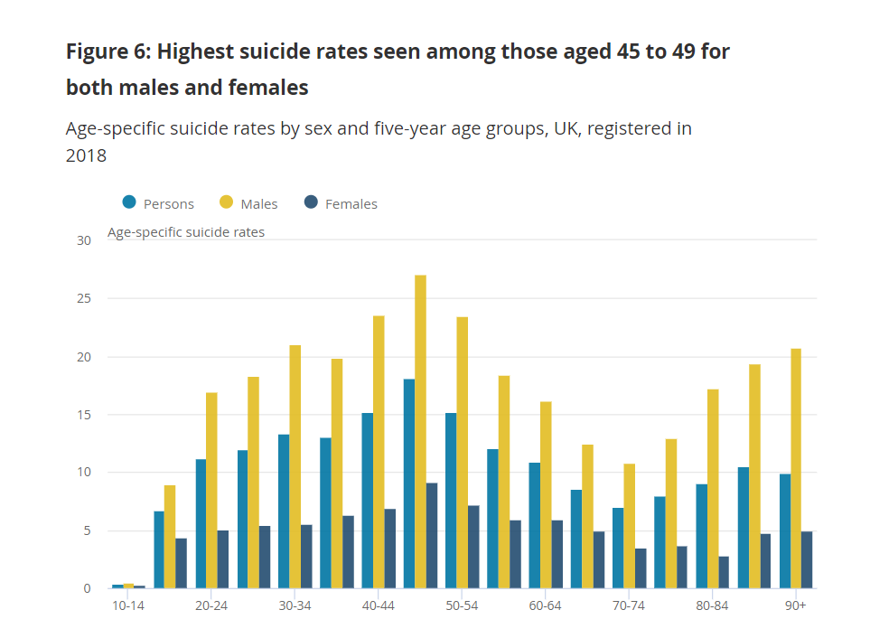
You are not alone! Seek help!
About this leaflet.
This leaflet will look to inform you on the act of suicide as a issue in todays society, looking at theories relating to the subject, including Thomas Joiners theory and look at the policies in which are in place to attempt to have a positive effect on people who are experiencing suicidal thoughts and for the families around individuals who have either attempted to carry out this act or have. But what is suicide?
According to Time to change (N.D) the act of suicide is a complex issue and there are a variety of suicidal feelings. Feeling such as:
- Life becoming too difficult due to symptoms relating to mental health.
- They are having thoughts that are out of their control about suicide and voices that are telling them to take their own life.
If you are having feelings similar to the ones listed above, they are common. Although it is difficult to know exactly how common these feeling are due to a high ratio of people not feeling comfortable to ask for support. However time to change (N.D), recently undertook a survey that shows that 20% of the population will have these feeling at some point in their life.

What is ITP?

Interpersonal Psychotherapy as mentioned is a treatment. According to Kimberly Holland, medically reviewed by Timothy J. Legg (2016) it is a form of psychotherapy that focuses on a persons relationships with others when that person is experiencing depression. It is approached in this way due to the thought that a person’s private relationships are the main reason for psychological problems.
This does NOT mean that these personal connections are the only reason for depression, although it does effect connections with others and create interpersonal relationship problems.
Studies have been carried out that supports that ITP works as an antidepressant, it can be used along side medication to support individuals also.

Understanding the theory of suicide.
A theory relating to suicide awareness was written by Thomas Joiner in 2005. Joiner claims that past theorists have looked past the concepts that individuals who intend to end their own lives have to have the ability to do so as well as the desire. Individuals who have attempted to end their life multiple times, stress how difficult it is. Joiner follows on from this stating the reasoning for this is due to humans having the basic instinct; self-preservation. According to Kim Van Ordan (N.D.), Joiner was the first theorist to consider the capability of inflicting harm upon themselves as well as the initial desire.
In Joiner’s book, Why people die by suicide (2005), he writes that on multiple occasions theorists and researchers have worked hard in order to develop different theories of psychopathology, this being the term used to refer to mental illness according to Social work degree guide (N.D.) Joiner (2005) continues to claim that when these theorists have gotten to the stage in which they are applied, that there is missing knowledge between the theory of the matter and the application. His view was that this was due to the applications being developed in a clinic without the theory being applied.
Joiner continues to write that there are good treatments available, one titled ‘Interpersonal Psychotherapy’ (IPT) which was developed in the 1970’s by Gerald Klerman.
You can also write a letter or visit one of their branches.
Policy relating to suicide awareness includes Preventing suicide in England: fourth progress report of the cross-government outcomes strategy to save lives (2019). The policy outlines the key areas in which they see that action needs to be taken in order to decrease the rates of suicide. Looking at this policy, focussing on referring to young and middle aged men it is stated within this document that men are less likely to look for help regarding suicide, perhaps feeling uncomfortable to connect with health and support services.

Local areas need to be finding ways to reach out to these men. The Department of Health and Social Care (DHSC) is currently working with other local support to observe the suicide prevention plans locally to reflect on what is working well and not. These groups of people have also worked to make sure that the first funding given to tackle this issue is to be used in different areas to test different ways in which to approach men in local communities.
Help available
Samaritans
Samaritans (N.D.) list signs to look out for, some of these are:
- Feeling tired
- Feeling restless
- Finding it difficult to concentrate
- Finding it hard to manage with everyday life.
Samaritans list more of these feeling, however also tell people to get in touch even if they are not sure if they are experiencing these feeling or even if they believe they do not have these feelings at all.
If you want to get in touch with the Samaritans you can:
Call: 116 123
Email: jo@samaritans.org

Rethink Mental Health
Rethink mental illness (N.D) encourage individuals to:
- Not jump to make a decision
- Be aware of what your triggers may be.
- Don’t let drugs and alcohol influence you
- Go somewhere safe
- Talk to and be around people
- Distract yourself.
There is more depth on these and more on their website: rethink.org
There is a wide variety of different contact information on their website including:

There is more information available on these sources of help online on the Rethink Mental Health website.

Papyrus
Phone: 0800 068 41 41
Switchboard
Phone: 0300 330 0630
Sane
Phone: 0300 304 7000
Shout
Text: 85258

Rationale
This leaflet is aimed to inform individuals on suicide and the feeling that a person may have or the individuals around them. Thomas Joiner’s (2005) theory is included in the leaflet in order to provide a more in depth level of understanding on the act of suicide, this is done by relating the need to have the ability as well as the desire for someone to commit suicide. Interpersonal psychotherapy is also mention due to it being relevant to the reader that there are treatment available to people who may need it, providing information on what it is so the reader is informed and are aware that help in available without needing to take medication if that would be preferred. The reasoning for this to be included is that Rethink Mental Illness (N.D) state that some individuals may not believe that it is right to take medications for their mental well-being.
The leaflet continues to give information on the policies that look at how the government in England are looking to improve the level of suicides in the country by narrowing down the reasons that suicidal risks take place and ways in which to minimise them, this may help the reader to be aware of their own or others feelings.
Statistics are included for people to be aware of the severity of this societal issue. A graph is shown to make this message clearer. (Office of National Statistics, 2018) The last two pages of the leaflet give information on the wide variety of help connections available to people if they are having any thoughts relating to the issue. This includes the Samaritans and re think mental heath that gives multiple sources of help for people, it can help individuals to feel more comfortable to seek for help. It is important that these ways of support are in hand held items like leaflets as within the UK alone there are over five million people who have never used the internet. (T. Wyatt, 2019).

References

HM government (2019) Preventing suicide in England: fourth progress report of the cross-government outcomes strategy to save lives. Available at: https://assets.publishing.service.gov.uk/government/uploads/system/uploads/attachment_data/file/772184/national-suicide-prevention-strategy-4th-progress-report.pdf (Accessed: 12th November 2019).
Holland K. and T.J. Legg (2016) Interpersonal Therapy. Available at: https://www.healthline.com/health/depression/interpersonal-therapy (Accessed:19th November 2019).
Joiner, T. (2005) Why people die by suicide. London: Harvard University Press.
Kim Van Ordan (N.D) Using the interpersonal theory of suicide to guide risk assessment and intervention with suicidal clients. Available at: https://dhss.delaware.gov/dsamh/files/si2013_usinginterpersonaltheoryofsuicide.pdf (Accessed: 12th November 2019).
Office for National statistics (2018) Suicides in the UK: 2018 registrations. Available at: https://www.ons.gov.uk/peoplepopulationandcommunity/birthsdeathsandmarriages/deaths/bulletins/suicidesintheunitedkingdom/2018registrations#suicide-patterns-by-age (Accessed: 8 November 2019).
Rethink Mental Health (N.D.) Suicidal Thoughts. Available at: https://www.rethink.org/advice-and-information/about-mental-illness/learn-more-about-symptoms/suicidal-thoughts-how-to-cope/ (Accessed: 13th November 2019).
Rethink Mental Illness (N.D) Medication – choice and managing problems. Available at: https://www.rethink.org/advice-and-information/living-with-mental-illness/medications/medication-choice-and-managing-problems/ (Accessed:19th November 2019).
Samaritans (N.D) Signs you may be struggling to cope. Available at: https://www.samaritans.org/how-we-can-help/support-and-information/if-youre-having-difficult-time/signs-you-may-be-struggling-cope/ (Accessed: 13th November 2019).
Social work degree guide (N.D.) What is Psychopathology. Available at: https://www.socialworkdegreeguide.com/faq/what-is-psychopathology/ (Accessed: 12th November 2019)
T. Wyatt (2019) More than five million British people have never used the internet, official figures reveal. Available at: https://www.independent.co.uk/news/uk/home-news/internet-use-uk-national-how-many-people-a8806806.html (Accessed: 19th November 2019).
Time to change (N.D) Suicidal Feelings. Available at: https://www.time-to-change.org.uk/about-mental-health/types-problems/suicidal-feelings (Accessed: 13th November 2019).
World Health Organization (2019) Suicide. Available at: https://www.who.int/news-room/fact-sheets/detail/suicide (Accessed: 12th November 2019).

