
The cohesive integration of sound and environment design: To further enhance the players immersion?
by
Oliver Altissimo

Supervisor: Nabeel Masih

Project submitted as part of the requirements for the award of
Computer Games Design BA Hons

May 2026

DECLARATION

I, Oliver Altissimo declare that I am the sole author of this Project; that all references cited have been consulted; that I have conducted all work of which this is a record, and that the finished work lies within the prescribed word limits.

This work has not previously been accepted as part of any other degree submission.

Date :07/05/2026

FORM OF CONSENT

I Oliver Altissimo hereby consent that my Project, submitted in candidature for the Computer Games Design BA Hons degree, if successful, may be made available for inter-library loan or photocopying (subject to the law of copyright), and that the title and abstract may be made available to outside organisations.

Date: 07/05/2026

Table of Contents
1. Abstract 5
2. Introduction 5
3 - Literature Review 6
3.1 - Immersion 7
3.2 - Presence 8
3.3 – Correlation between Presence and Sound 8
3.4 - Sound design - Video games 9
3.5 - Sounds Models 10
3.6 – Conclusion 12
4. Methodology 13
4.1 - Introduction 13
4.2 – Sound Creation 13
4.3 – Sound integration 14
4.4 – Construction method for Neath Abbey 15
4.4 – Questionnaire 16
4.5 - Questionnaire findings 17
4.6 – conclusion of all the above 20
5 - Case Studies 21
5.1 – Tom Clancy: Rainbow Six Sieg 21
5.2 - God of War (2016) 23
6 - Discussion 23
7. Conclusion 24
8. References / Bibliography 25
9. Appendices 29

Table of illustrations
Figure 1 - Visual rapreseantion of the IEZA Frame Work, divided into the 2 dimension 11
Figure 2 Up view of Neath Abbey monastery 15
Figure 3 Graph showing demographics among the participants 17
Figure 4 Graph showing participants favourite gaming platform 18
Figure 5 Graph showing favourite audio consumption method 18
Figure 6 Graph showing the participates view on sound and immersion 19
Figure 7 Graph showing participants view if sound is better for an immersive experience 20
Figure 8 Showing the sound development in Rainbow Six Seige 22

1. Abstract
When a child is born, its first act in life is to make a SOUND, a cry which creates the love/bond between itself and it parents. Sound and immersion in the very pure raw sense. Does this abstract concept, the link between sound and immersion play a major role in the gaming world? How does sound, immersion and gaming corelate?
Sound in games is seen as a key aspect when it comes to players enjoyment. Its role plays a bigger part than just enjoyment, as it can contribute to enhance the player’s immersive experience. This study will discuss the question, “The cohesive integration of sound and environment design: to further enhance the players immersion?”.
To establish this connection, the paper will draw from primary and secondary research, to examine well-established theories and papers, such as ‘Immersion’ [1] and ‘Presence’ [2], investigating links with sound and so doing enquire into their relationship. This will lay the basis of understanding how sound contributes to immersion.
Furth more, by examining case studies, of ‘Tom Clancy's Rainbow Six Siege’ [3] for the use of dynamic sound and how the environment affects the relationship. Additionally, ‘God of War’ [4] has been selected as a case study for its use of audio to shape character, emotions and narrative. These investigations will look at how integrated sound and environment work together to create immersion.

2. Introduction
The videogame industry is evolving and growing, continuously delivering experiences and entertainment to users on a global scale. Videogames engage our minds, requiring an active participation, engaging all our senses. Players use audio to process the events, eyes to perceive the environments and physical control to interact with the game. In managing the game it allows for immersion, helping to bring the game to life. This immersion within a game can be seen as a player’s presence within that environment. This can be divided into 3 categories: sensory immersion, narrative immersion, and spatial immersion [5].
Sensory immersion connects audio and visuals to create the players immersive awareness. This can be understood as the “most immediate and direct route, appealing powerfully to our different senses"[5]. It links audio and visuals elements to create and heighten players perception.
Secondly the narrative immersion is the player’s interaction with the story and its developing theme [5].
Spatial Immersion is the passive linking of the player’s psychological self to the game’s environment [5]. This is called ‘Presence’ and is achieved through all three allowing the player to be part of the game.
Sound plays a core role in the immersive experience. It’s a multipurpose tool constantly changing, adapting and delivering gratification, granting players a feeling of a multitude of elements, ranging from environments, action and emotions. Sound is a tool for game designers and players, it communicates information, enabling them to immerse themselves in the game’s mechanics, events and emotional shifts. Through sound, players can interpret spatial cues, signalling the location environment they are within. Additionally, sound guides the players with directional audio. Sound is actively linked with environments and is fundamental for immersion. Sounds combined with the environment can enhance the immersion. This can range from ambient sound which sets the mood of the narrative, to footsteps which signal different materials and environments. This makes sound a liminal immersion, designed during the game’s development. Within this design process the Sound Designers (SD) contributions make a huge difference for players immersion [6]. However, there is limited research on sound and immersion to enhance the player’s experience.
To develop an understanding a practical project involving an abandoned monastery, Neath Abbey, is used, to constructing a 3D environment using scanned models directly from the location which incorporates a range of audio sounds developing an immersive experience. By constructing this model, the aim is to provide a foundation to integrate audio and an immersive atmosphere for the players.

3 - Literature Review
Within this chapter, the examination will cover theories through the literature review, using research papers, internet resources and books on how SD can enhance the player immersive experience. The aim of this chapter is to provide an understanding of ‘Immersion’, referring to the player getting absorbed into the game. Presence refers to a psychological state of being within the virtual environment. To uncover what are the trigger points, with the utilisation of sounds.
‘Suspension of Disbelief’ or ‘Immersion’ was theorised in 1817, by Samuel Taylor Coleridge, biography Literaria [7]. Samuel Taylor describes the suspension of disbelief as the reader enjoying a medium, this lowers their perception of the truth, placing themself within the scene, whether it is real or not. Furthermore, Coleridge states that “persons and characters, or at least romantic, yet so as to transfer from our inward nature a human interest and a semblance of truth sufficient to procure for these shadows of imagination that willing suspension of disbelief for the moment” [7]. The value of this immersive experience was recognised within books way before films and games.
Early developments of immersive experience through sound were research via Michel Chion, establishing immersion and audio within the film industries, “The use of different kinds of music to accompany a silent film changes the film profoundly” [8].
Today, Sander Huiberts research paper linked games and audio developed the ‘IEZA’ framework adding a new outlook on sound and immersion.

Sound is a contributor to the two phenomena, since it adds continuous input which reinforces, improves and enlightens the game world. Most modern digital games focus on visuals which contributes a part to the immersion and presence but are confined to the visual that the player choses to see. Audio on the other hand, can deliver more experiences across the auditory field, not confined by visuals.

3.1 - Immersion
“Immersion” has become a widely discussed subject within studies. When players describe a game as ‘immersive’, it can usually associate with the sensation of being involved within the game world, creating an emotional connection with the protagonist and the unfolding narrative. Psychologically, this refers to the players engagement with the video game and its Virtual Environment (VE). The ‘Illumin’ article also references the “Suspension of Disbelief” as an immersive theory [9]. (Samuel Taylor Coleridge Literaria)
When achieving ‘Immersion’ within games, two key components must be used. Sensory Immersion and Narrative Immersion [5].
Sensory Immersion, includes Visual and Auditory sensory outputs, that manage to create a highly descriptive and sophisticated environment [5]. Narrative Immersion keeps the players interaction engagement within the gameplay [5]. Aligning the elements together, makes the players experiences entertaining and cohesive which makes immersion possible.

3.2 - Presence
As ‘Immersion’ helps players to create a connection with the VE, it also creates a sense of existence within the fictional world and can be described as Spatial Immersion (reference ‘Behaviour, Realism and Immersion in Games’ by Kevin Cheng and Paul A. Cairns [10]). This state is called ‘Presence’, recognised by Daniel R Mestre. Presence makes the player feel they are located within the digital environment. The manifestation of ‘Presence’ is the utilisation of Game Design Theories (Art style, Game Mechanics, Narrative and Sound Design). For the users to link their psychological and emotional state within the game world, there are three main pillars presence, immersion and sound [11].
Presence is seen from the user’s perspective and depending on the quality of the environment and sounds, the user can temporally forget the existence of the real world and feel like 'they are there’.
Early illustration in the use of ‘Presence’ was shown in “Star Trek” in 1987[9]. It introduced the Holodeck; a simulation room were crew members created a type of environment they could partake in. This concept illustrated an advance form of Presence for its time, where the VE can produce a realistic illusion and make the user fully absorbed.

3.3 – Correlation between Presence and Sound
When constructing a gaming environment, it is important to incorporate a human visual field, linking with sound that correlates with the events happening. This maximising the sensory input and replaces it with stimuli corresponding with the Virtual Environment, thus lowering the outside cognitive world [12].
This combination of visual field and sound system allows the user to fully engage with the perceived game world. This makes ‘Sounds’ and ‘Visual’ a liminal path, establishing ‘Immersion’ and ‘Presence’.
The correlation between sound and presence can be understood as a symbiotic relationship. VE can give visuals cues, giving an expectation of sound, while audio can reinforce the surrounding area, giving an awareness to the player of the events happing around them. When these two elements align together, this creates a perceptual coherence, which reinforces the viewer’s world. To ignite presence, is to reduce of the cognitive load of the player within the VE allowing immersion. Therefore, combining the elements between visual and sound, reinforces stimuli, which is critical for immersion and presence.
Games designers aim to create an immersive experience for the players, to do these various strategies can be used, depending on the type of game. The game can keep the player engaged with storyline and mechanics to keep the player interested and challenged throughout the gameplay. Linked with the narrative is the Art style to highlight the genre aligning with High-quality Audio to inform the player. This emphasises by combining these pillars, the player becomes immersed/presence within the game.
Immersion and Presence are central to keeping players engaged on a psychological level. Generally, immersion and presence are now understood as an entertainment and as This multidimensional phenomenon being is seen as a bases for constructing game design theory, art styles and sounds design.

3.4 - Sound design - Video games
Behind video games there’s a team of developers whose intentions are to come up with ideas, to achieve a working product. The popularity of videogames come from multiple factors, and when done correctly, produces longevity, playability and enjoyability. Within this pipeline of work, SD must bring the game to life, just utilising sounds. The role of SD requires a lot of creativity, since the tasks range from process recordings, editing and mixing. SD has the responsibility to manage and guide the player’s emotions by creating and making unique sounds.
The role of a SD, when adding sounds in a game, covers a wide spectrum.
Sound it used for a variety of reasons. It helps the player to recognise their progress or failure, guide their emotional state, aids the story telling, helps to set the mood.
These can be accomplished with the use of music compositions, Sounds Effects (SFX), Foley Sounds (FS), and Ambient Sounds (AS) [13]. Sound Designers must use their skills to construct a program to different areas which utilise all relevant sound techniques, being careful of where to place different clips. If this process is done incorrectly, it can disrupt the flow and immersion and enjoyment of the game. Done correctly, the game can enhance the unravelling story, increase emotional connection and make the player fully immersed.

3.5 - Sounds Models
Sound like a language can be spoken in different ways: - It is a system of communication that can be spoken in different ways carrying feelings and emotions. When sounds are used in Video Games it conveys emotion, and most importantly fully immerses the player. The way that sound is used is divided into 5 elements [14];
-Sound Effects are usually a library of sounds, allowing SD to have a vast collection of audios at their disposal and to be modified and dropped with ease and are used to convey general sounds that are happening.
-Foley The term was coined by Jack Foley [15], an audio engineer who worked at Universal Studio and needed a way to synchronize sounds and movie scenes together. Foley is the art of recreating sounds utilising material and objects to perform action according to what is happening on the screen, such as footsteps, gunshots and cloth movements, that can be traced to black and white silent films. This added layer of realism and authenticity to which incorporated into videogames.
-Dialogue refers to the voice and how the pitch and tone can set the emotion. For example, Anthony Hopkins in the ‘Silence of the Lambs’ [16]. Usually, the recording sessions happen within an acoustic panelled rooms to ensure the quality of sound.
-Music manipulates and shifts feelings leaving the SD to command and redirect the viewer/player emotion, by delicately choosing the right melody, harmonies and tempos evoking and enhance emotions [17]. It can quickly change the whole immersive scene.
-Ambient and Foly sounds are closely related but must not be confused. With ambientes sounds being responsible for giving sound details happening in the background, for e.g., car horns, to birds singing in the tress, establishing the settings and atmosphere of the scene [18].

Diegetic and non-diegetic [19] implementation can differ. Although closely related, in media they play a role when it comes to immersion. Diegetic, derives from ‘Diegesis’, and its origin can be traces back to ancient Greece, to Aristotle and Plato [20]. ‘Diegesis’ refers to “a story that is told by a narrator” [20]. ‘Diegesis’ is defined by everything that is happening within the fictional world. Non-diegetic is the opposite, happening outside of the world. When it comes to referring to these terms in gaming, they describe how audio is perceived by the viewer or not.
Theorist Michel Chion came up with a solution, in his book, ‘Audio Vision, Sound on Screen’, he divided the sounds into 3 categories: offscreen, onscreen and non-diegetic [21].
Offscreen are sounds happening within the world but outside of the visualised scene.
Onscreen are sounds happening within the scene.
Non-diegetic are sounds happening outside of the world.
Early games design utilised a similar approach of storytelling as films, using a linear story. In linear story telling everything is scripted and so is audio, so it suited that games utilise Michel Chion theories.
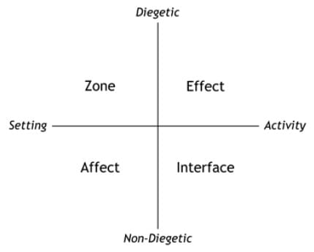
Modern video games allow players to have wider decision making and are not constrained to a set path. So, games have moved past linear storytelling and there is more variety of storytelling methods, into non-linear narrative, which recently has grown in popularity. Thus, audio has also evolved into non-linear, giving the players a dynamic experience. To accomplish a dynamic audio experience in games, Sander Huiberts has analysed how
Figure 1 - Visual rapreseantion of the IEZA Frame Work, divided into the 2 dimension

game audio has been utilized and developed through the “IEZA” framework [22].
The “IEZA” framework builds on Michel Chion three sounds categories, uses 4 sections divide between 2 dimensions [22]; The first dimension ‘diegetic’ and ‘non-diegetic’ sounds can be heard by the player and character or just the player. The second dimension is ‘Setting’ and ‘Activity’, to make sure, the player hears sounds that have a cause or just sounds that are happening naturally within the VE. Between the two dimensions, lies four categories, which ranges from ‘zone’, ‘effect’, ‘affect’ and ‘interface’. Each of these categories represent audio happening internally or externally of the gameplay.
Zone:
‘Zone’ sounds exist in the game world but are not caused by the player.
These audio cues are external and diegetic, however serve as an aid to illustrate and describe the surrounding area. This section is linked with ambient sounds, these are sounds happening in the game world, that the player and character can hear, an example of this would be raindrops and wind.
Effect:
This category of sound is linked with audio sources that are caused by the player or other non-player characters. These audio sequences are usually connected with real life audio sounds, to mimic and create a sense of realism. For example, gunshots. Not all games use realistic audio and tend to lean more towards synthesised sounds to super-impose the effect.

Affect:
These are sounds that are external and non-diegetic. These sounds happen on the ‘affect’ side of the framework and are used to shape and guide the players emotion across the gameplay. The main audio methods are music and scores, which builds tension, mood and pacing. Since these are non-diegetic sounds, these do not affect the gameplay since these cannot be heard by the character of the game.

Interface:
This section of the framework, are sounds that are internal and non-diegetic. These are linked with the game system, meaning sounds that are happening within the heads-up display. These sounds have nothing to do with the sound environment but are linked with what the player is doing. For example, if the player is low in health there will be an audio queue warning the player. Depending on where the sounds are happening, it allows sounds to have a deeper 3D surround experience, it grants the players to understand where sounds are coming from and their purpose.
The ‘IEZA’ provides an organisation to apply sounds within a game which can reinforce the players actions, interactions, shape the mood and guide their emotions.
Good uses of sound design can be effective not just from one of the categories and dimension. But the designer’s creativity in assigning each sound and stacking, mixing to elevate one another. This careful balance can alter the shape of the gameplay and correctly can enhance the overall immersive experience.

3.6 – Conclusion
Both models by Michel Chion and Sander Huiberts, serve similar functions, using sounds to convey emotions and information. However, videogames need a more dynamic approach to audio as it requires a vast sound system when it comes to the player interaction and immersion.
To support Immersion and Presence, VE and SD must work in tandem, creating a fulfilling experience. Visuals events must be linked with audio in timing. When the VE and SD are aligned it helps the player to interpret the game world without confusion.
Compared to Michel Chion’s audio model, which is a direct approach to sounds in film, the IEZA framework, develop by Sander Huiberts, offers a new approach and dynamically measures user experience as to how videogames sound should be viewed and utilised. The framework serves as a central tool for videogame sound designers, helping to engage and immerse the player within the VE.

4. Methodology

4.1 - Introduction

The project’s aim is to create a game/scenario which will illustrate the compositions of audio and how sound design can create an immersive experience for the participants.
The chapter will outline the methodology used during the practical work, on sound and environment working together to create immersion within a good against evil theme.
The practical project was to construct an environment taking inspiration from the ruined monastery of Neath Abbey built in 1130 (The good scenario) [23] which incorporates sounds associated with the building.
The project starts from a forest environment with a figure following a floating globe leading to the abbey. This sets a supernatural feeling linked with forest sounds. At the Abbey the figure hears a mysterious voice, ‘Callidus’ (1), telling it to find and collect the seven deadly sins (2) represented as skulls. Once all the skulls are collected, the player must bring these to the alter completing the immersion. This starts the next level of the game, the outcome lays the foundation for further development of the story.

4.2 – Sound Creation

This reflection of reality with environmental sound design, means that the audio assets must mimic real life, capturing and recording these into the game. The task required a creative solution, leading to recorded sounds, mixed with internet sources. Nearly all the elements of this project were recorded, synthesised and a minority taken from the internet. This allowed the players immersion within the virtual environment.
Using the IEZA framework [22], to elaborate a structure and a sound list, created the four categories: Ambient/Background Sound, Sound Effects, Folley Sound and Music. These achieved a sense of abandonment mixed with a sacred presence, good and evil.

The audio equipment included three microphones, all reaching and recording different wavelengths.
- The first microphone was the ‘Zoom H1n’, a stereo recorder, with two-capsule placed 90 degrees from each other and capturing spatial audio, providing depth and spatial location [24].
- The second is the ‘Handy H2n’ microphone, a multipurpose recorder. Capable to switch between 4 modes: XY for spatial recording, MS (Mid-Side) to capture sound on a mono channel, 2ch and 4ch to recorded surround sound [25]. This was used to record a wide range of environmental recordings.
- The third is the ‘Rode VideoMic 2 Shotgun Microphone’, this captures isolated sound over long or close distances, allowing for more refined audio [26].
Processing the audio was carried out in Ableton Live 12 [27] for its editing and Reaper for its detailed filtering clean up [28].

4.3 – Sound integration

The collected audio was rendered and categorised into assets; it was imported into ‘Unreal Engine 5’ for integration. This engine enables control over the audio, allowing the user to mix, position and adjust real time sounds into the scene to match with the environment.
Audio serves as the link between player, game and environment, with auditory elements that can shape mood and consolidate the area. This requires a technical and creative approach allowing players to recognise its spatial context, making it essential for environmental immersion.
Unreal Engine 5 [29] was selected for its optimal development into sound integration and for vast documentation on audio implementation [30], which improved workflow, integrating sound with the blueprint system. Additionally, Meta Sounds, provides a more flexible approach to sound design and control over the audio cues in charge over the environment.

4.4 – Construction method for Neath Abbey

Figure 2 Up view of Neath Abbey monastery

Developing Neath Abbey involved conventional 3D modelling techniques to create an array of assets. After consultation, Photogrammetry was the suggested method to achieve a realistic environment. This allowed the creation of a realistic environment, adding to the immersive experience.
Photogrammetry is a technique that allows the virtual reconstruction of real-life objects or places [31] [32]. First with lidar scanning, which measures the target with an array of illuminating laser, which measures the reflection [31]. This approach allows defined and accurate scans, making it a realistic 3D model. The drawback is the cost of external hardware and high-level technical expertise [31].
Secondly, capturing high-quality photos process these through a program such as ‘Reality Scanner’ [31]. The software aligns, combines and triangulates all the images, creating a 3D textured model. This method is not as accurate as lidar scanning. However, it creates a representation of the model, which with refinement and polishing using Blender and Substance Painter to correct the texture.
These methods only require a camera or phone and not requires high end hardware. This process created 31 assets.
In addition to creating the assets, this has also captured the state of Neath Abbey with photogrammetry, contributing to the digital preservation of the site and surrounding environment.

4.4 – Questionnaire
Questionnaires provide an effective method to gather data across a broad range of users, which gathers a variety of responses, to study and comprehend their answers.
Designing a questionnaire is to support the research and reinforce the base of the argument presented to ensure the data gathered during an interview, either through an online pool or face to face is correct. The questionnaire can incorporate different types of questions, qualitative and quantitative elements. Qualitative questions focus more on users’ perspective and investigate their own beliefs and interaction [33]. Quantitative questions are the process of collecting numerical data [34]. This is to understand if a pattern emerges which confirms or declines possible theories [35].
The questionnaire used for this study was designed for players. The overall design incorporates qualitative and quantitative questions to capture their data and their personal insight on sound design and sounds immersion. However, it is also encouraged users to reflect whether the use of sounds created a better immersive experience, also to improve quality of the game.

4.5 - Questionnaire findings
The questionnaire presented to players, consists of 25 questions, incorporating a mix of question types. Open-ended question, to understand the player experience with sound and how or not its effect’s theme. Closed-ended question to understand more precisely how a player uses sounds. Reflective questions for an answer with more depth on the matter of sound and immersion. This mix supports quantitative and qualitive data, and to have broader and more in-depth research. The questionnaire was divided into six sections, each having a specific focus.

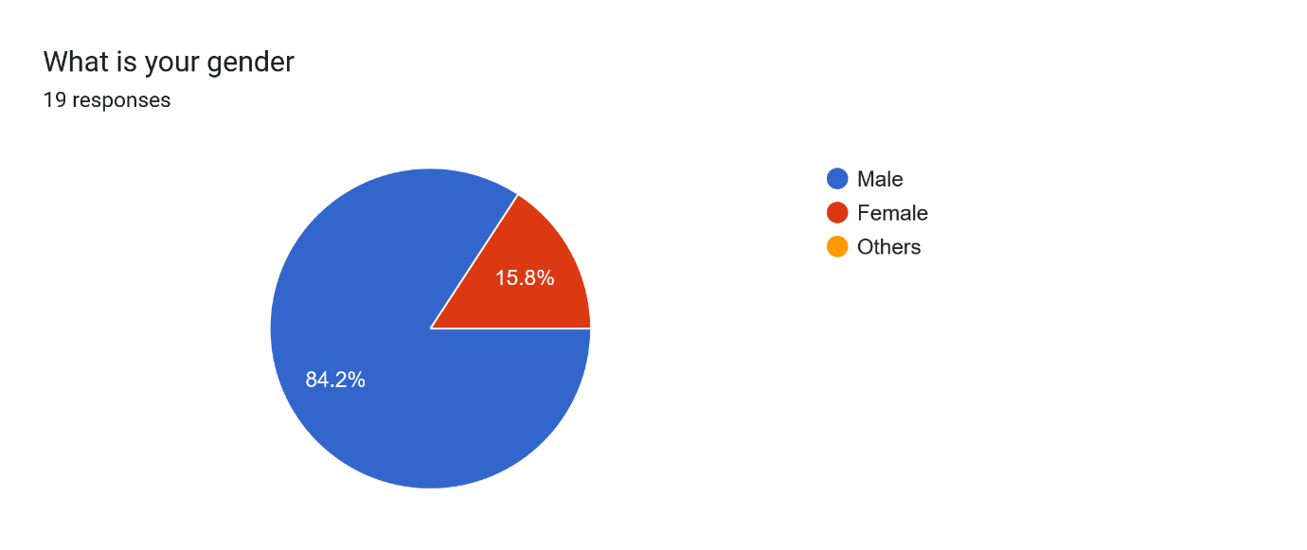
- The first section is related to demographics, with 84.2% being male and 15.8% female. (See appendix 1)
Figure 3 Graph showing demographics among the participants

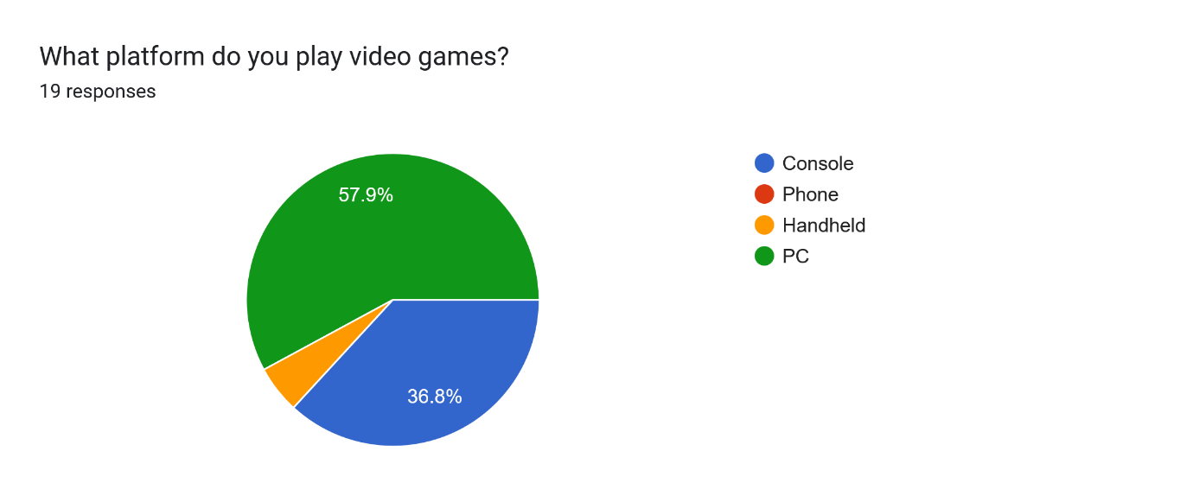
- The second section examines the users preferred gaming platform and genre.
57.9% of players reported playing on pc, followed by a 36.8% playing on consoles and smaller group 5.6% playing on handheld devices. Additionally, when choosing their favourite genres were broad in the responses, with all the genres being pick at least more than 2-3 times.
Figure 4 Graph showing participants favourite gaming platform

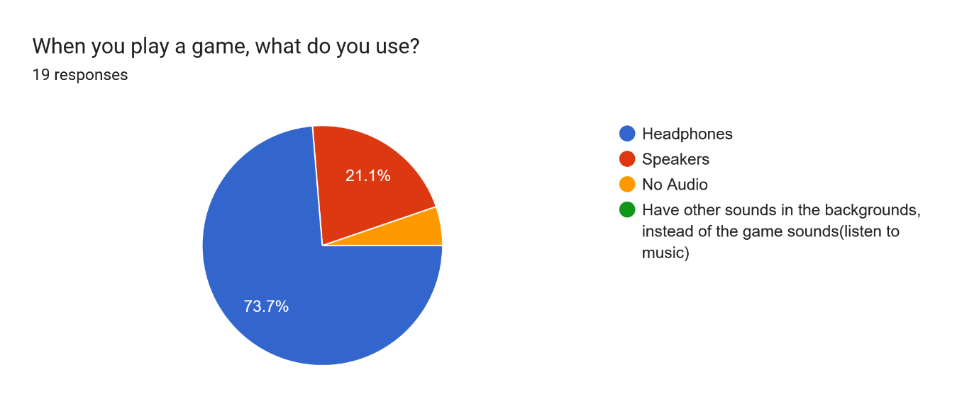
- The third section was to understand how the players would engage with game audio. Accordingly, an overall majority of participants 73.7% used headphone when playing. 21.1% using speakers and 5.3% not using sounds at all. Several questions ask the participants if sounds have an overall effect on the enjoyment of the game, with the majority agreeing that audio improves gameplay.
Figure 5 Graph showing favourite audio consumption method

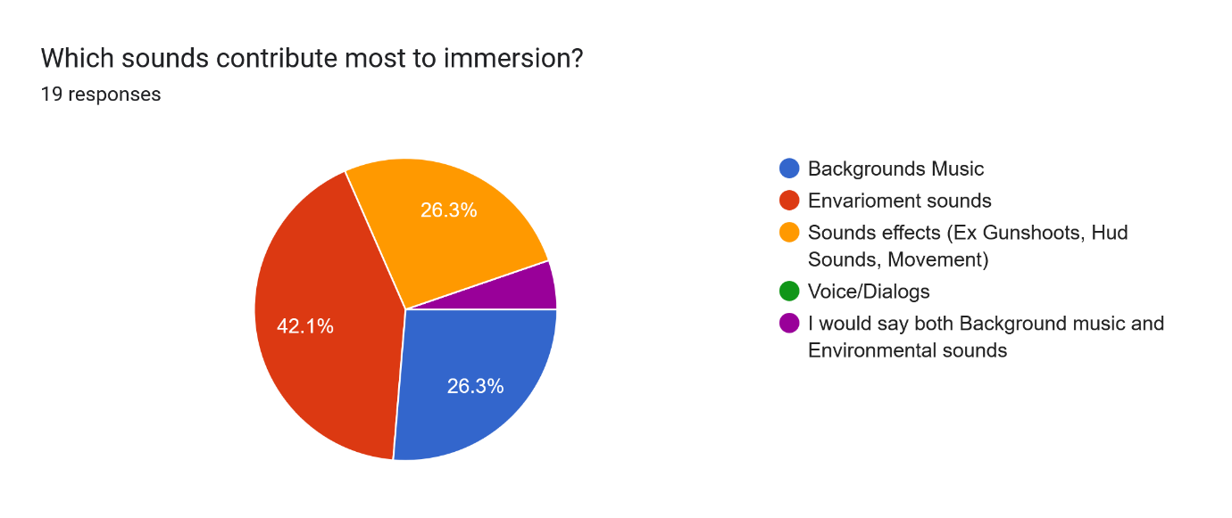
- The fourth section explores the relationship between immersion and audio. The majority agrees that sound is an important asset for immersion, with the quality of the sounds playing a major role. A significant proportion of participants 44.4% has selected that poor sound quality can break immersion.
According to the data to understand what sounds contributes more to immersion, an overall mix of answers was selected with background and sound effect’s having a 26.3% and environments sounds with 42.1%. However, when it comes to understand if sound is a better immersion tool compered to graphics, gameplay mechanics or all the above, the majority chose all the above.
This shows that sounds are not the singular tool to form immersion but is integrating with all the aspects that create immersion.
Figure 6 Graph showing the participates view on sound and immersion

- The fifth section focuses about the participants opinion on sounds, using qualitive question. Players were asked what sound improves immersion and briefly give a reason why.
The participates gave detailed answers to this question, with a lot of constructive responses. Giving broad and clear understanding of why sound helped with immersion. One the example given by the participants was, ‘Phasmophobia. The game uses audio depending on the map environment which makes it more immersive and makes the horror elements more effective. The sound effects of objects and items help with immersion and also with gameplay as it helps to find where the ghost is and what it is doing. The game uses sound effects to indicate when certain things are happening and to give clue towards the ghost type. overall audio helps with both immersion and gameplay.’
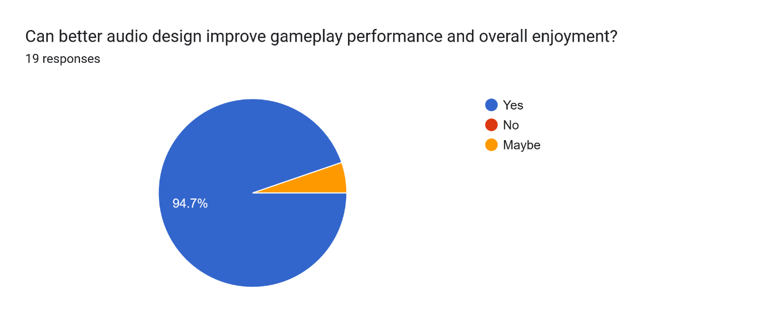
- The sixth section analysed players awareness of spatial sound during gameplay, through qualitive questions. With the results showing that 78.9% are aware, and 21.1% were unsure.
Secondly, they were asked if high quality sounds design can improve gameplay performance and boost performance.
94.7% of the participants strongly agreed.
These results indicate that sounds have a significant role in immersion, suggesting that sound design can additionally add to players performance and engagement.
Figure 7 Graph showing participants view if sound is better for an immersive experience

The results gathered, shows that players who play on a PC and console use headphones, improving the audio quality which in turn improves players immersion and elevates gameplay enjoyment.
The questionnaire’s aim to investigate if sound was the major contributor to immersion, data suggest that this is not the case.
Out of the 19 participating users, 16 players agrees that a combination of Graphics, gameplay mechanics and sound contributes to immersion.

4.6 – conclusion of all the above
By creating the sounds elements, the outcome achieved in the Abbey a cohesive soundscape, representing an abandoned, sacred presence.
The IEZA framework contributes to providing a clear structure, ensuring that each sound plays it part on the overall experience.
The integration of sounds in Unreal Engine 5, provides a dynamic control allowing to achieve spatially aware audio.
The questionnaire showed that sound design plays a central integrated role when creating player immersion within an environment.

5 - Case Studies

5.1 – Tom Clancy: Rainbow Six Sieg
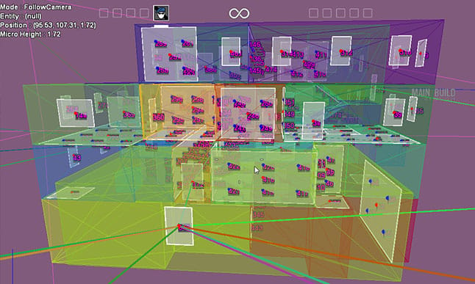
Rainbow Six Sieg (RSS) [3], released in 2015 by Ubisoft, is a competitive tactical 5v5 shooting game. Two teams, ‘attackers’ and ‘defenders’, compete with the objective to protect or destroy the bombs site. On both teams have 39 operators, each offering a unique set of skills and abilities.
What sets RSS apart, is its integration of sound and environmental design. These two design having an intertwined symbiotic relationship, helping the gameplay to add depth, replayability and player engagement.
The environment design within, is a complex structure, allowing players a multi optional entry when breaching into the opponent’s territory. This unique core of the environment design creates a constant variation on how the matches can unfold.
The first key feature of the game is destructibility. It allows players to destroy surfaces like walls and windows, allowing player to build their own strategy around the game, making each round unique gameplay.
The second key function of the environment design it’s how it effects the sounds played. Players relay on sounds cues to hear player movement and events happening around them. These semiotic sounds allow players to understand the opposite teams action, ranging from reloading weapons, individual charters footsteps and breaching, playing a big strategy role within gameplay making sounds a critical role, for gameplay and competitivity.
According to Louis Philippe Dion, the audio director of RSS, the teams aim was to achieve a level of realism when it came to sounds [36]. The sound system put in place is designed to simulate real life sounds behaviour, providing at the same time player tactical information.
The game base audio system is based on classical sound usage like; Directional audio allows player to hear the sound direction, Action feedback illustrates every action through its distinct audio cue. These allow spatial awareness and positioning.
When analysing the game’s sound anatomy, it shows a dynamism in its complex structure during gameplay.
Sound engineers extended these parameters to mimic how sounds work in real life, like reflection, absorption, diffraction [37].
These sounds are defined by variables within the environment;
Like diffraction, which is called it obstruction [37], a term used when audio travel from its sources to the listeners, in this case RSS uses nodes to calculate if the sound is traveling directly to the player or through a destructible surface. It also calculates if sounds reach the players [37].
They also use absorption-occlusion [37]. This determines if a sound must be distorted by the surrounded environment. This gives a defined location of where sounds are coming from without giving too much information.
Lastly, they use reflection-reverberation [37]. This is known to create a realistic acoustic of a room or environment.
This intertwined partnership of environment and sounds is central for the gameplay experience.
Rainbow Six Siege is admiral demonstration of how environment and sound design can work together. This alignment is the drive for a long-term enjoyment with a new immersion depth.
Figure 8 Showing the sound development in Rainbow Six Seige

5.2 - God of War (2016)
God of War, developed by Santa Monica Studio, released in 2018, redefined their franchise through its cinematic gameplay, unfolding narrative and sound design creativity. The main focused on this game is immersion by utilising sounds and environments to support the gameplay.
The core principles of the sound design were the use of diegetic sounds, audio generated within the game world. This utilisation gives a strengthen sense of realism by adding sounds that are linked with the environment and directly linked with the action happing on screen. This resulted to a more cohesive and realistic world, adding to the immersive experience.
To keep the players attention the game uses adaptive audio techniques to guide the player across the environment.
Music is used to signal changes in gameplay and to shape the tone of the scene. Increasing the emotional intensity and making the player more focused. In contrast, silence highlights key narrative moments, focusing the player to the dialog [38].
Sound is used to further improve character design, for example Kratos, uses a deep voice, signalling his strength and authority [38]. Atreus, Kratos’s son, uses a high pitch voice, reflecting his youth, his curiosity and emotional depth [38]. This gives a contrast between the two characters personality but also objectives within the game. The vocal performances help to shape unique character and their individuality, resulting in an unfolding narrative and immersive experience.
This collaboration of sounds and environment produces excellent storytelling capabilities that can control the players emotion and guide them through the levels. Environments in God of War have been designed in a way that guides the player passively at the same time it tells the player that they are in a Norse mythological game. These Nordic symbols are spread throughout the architecture, landscape and the characters themselves.
The integrations of these elements demonstrate how sounds can enhance players immersion and guide their attention through the environment by a combined efforted.

These two examples illustrate how sound enhances immersion.

6 - Discussion
Immersion and Presence are closely linked concepts. Sound contributes to both events but cannot work independently. The questionnaire indicated that 88.9%, consider sound as a major contributor to immersion. However, most users reported, sound is not the only source that can create immersion. Immersion is shaped through a mix of sounds design, game mechanics and narrative gameplay for a full immersive experience. However, the idea that sound can initiate immersion alone is limited when considering multiple factors.
A pattern emerges in the relationship between sound and presence correlating to each other. As discussed in previous sections, presence is a constructed from the interaction between sound and environment [12]. Sound is typically related to a precise source, tied to the game world, reinforcing spatial awareness and the senses of being within the environment.
This argument is further supported in the case studies of ‘God of War’ [4] and ‘Rainbow Six Sieg’ [3], both have a great utilisation of sound designs, but remain grounded through the environment and characters-based sources. The audio cues are connected to actions, space and events happening within the game. Both games demonstrates that sound contributes to immersion but is more effective when visuals and interactable events.
The findings indicates that the creation of immersion and presence is through the interaction of sound and environment design, intertwined to one another. These elements function as a dynamic system. Sounds allow players to understand the spatial awareness and the events happing around. Environment, in turn, aids by adding visual elements that are linked to the sound, giving an identifiable source and strengthening the player’s understanding of spatial area and events.
As finding of this result, it has contributed to the development of the practical project. With the added help of the IEZA framework [22], provides a clear structure providing a firm structure and a guideline, improving a consistency across the project. Additionally, setting a religious theme to the project has defined the overall atmosphere and mood of the environment.
As sound design is not the sole factor in creating immersion, the way it used can improve the creation of an immersive experience and the creation of presence.

7. Conclusion
As people, we have five senses to relied upon to; sight, hearing, touch, smell and taste. These help to make sense of the surrounding areas and what is happening.
When it comes to videogames, the senses we use the most are sight, hearing and touch. Since the very first game developed, SD has come a long way and has grown [39].
Modern developers have refined the arts and techniques, of visuals and audio systems, which has allowed an improved engagement and continuous gameplay, keeping a close attention to the VE and sounds. This begs to revies the question propose at the beginning: “The cohesive integration of sound and environment design: To a furtherance the players immersion?”.
This dissertation is set to uncover how the integration of sound and environment contributes to immersion. The research findings shows that sound is a critical component to immersion, but it doesn’t work with just itself. Immersion is a conjugation of audio, visuals and interaction witch the player can do.
The literature reviews highlight’s Michel Chions, Sander Huiberts significant of sensory input in achieving presence and immersion. With sound as established as a continuum for information which contributed to operating the visuals. This was explained by analysing and comparing sound models, ranging from Michel Chion’s model and Sander Huiberts IEZA farmwork. Showing the traditional sound use for films can be used as a base for games, BUT it requires a higher dynamic level. Thus, the IEZA framework is a suitable tool for sound designers to structure sounds in a interactable environment, giving a clear understanding of how different audio are been used during gameplay
The case studies have provided evidence, in both Rainbow Six Siege [3] and God of War [4], which illustrates how the use of sounds tightly linked to the environment design combined with player interaction. This functionality informs players about their decisions, improving narrative delivery and a reinforced spatial awareness. The examples illustrate high quality sound design method, improving both immersion and gameplay.
The questionnaire, primary results add a new perspective on how players interact and use sound during gameplay, which reinforces the findings. The questionnaire contributes that most players recognise sound as an immersive experience. However, the results also showed that sound on its own is not sufficient to create an immersive experience. This adds to the fact that immersion needs a system of interaction, unfolding narrative and gameplay mechanics to maximise the immersive experience.
The practical project becomes a tool to put all these theories and method together. The development of the environment of Neath Abbey, guided by the IEZA framework, has resulted in a controlled and believable soundscape. This practical project demonstrates the value of aligning the sound elements with the environment and associate them with the surrounding context.
The overall dissertation is illustrating that sound design is a core pillar to achieve an immersive experience. Its effectiveness changes upon the quality of the integration within the environment and gameplay system. Aligning these components can form an improved experience boosting player engagement.

8. Bibliography
[1] N/A, “Immersion in Games,” FutureLearn, Oct. 25, 2022. https://www.futurelearn.com/info/courses/fundamentals-of-creative-technologies-and-interactive-experiences/0/steps/449996
[2] N/A, “What is Presence in Virtual Reality (VR),” IxDF - Interaction Design Foundation, Nov. 22, 2023. https://ixdf.org/literature/topics/presence (accessed Jan. 08, 2026).
[3] Ubisoft, “Tom Clancy’s Rainbow Six Siege | Ubisoft (UK),” www.ubisoft.com. https://www.ubisoft.com/en-gb/game/rainbow-six/siege
[4] Sony, “God of War,” PlayStation. https://www.playstation.com/en-gb/god-of-war/
[5] Y. Zhang and Y. Song, “The Effects of Sensory Cues on Immersive Experiences for Fostering Technology-Assisted Sustainable Behavior: A Systematic Review,” Behavioral Sciences, vol. 12, no. 10, p. 361, Sep. 2022, doi: https://doi.org/10.3390/bs12100361.
[6] Faith, “The role of sound design in immersive experiences and installations,” HeavyM, Jun. 06, 2023. https://www.heavym.net/the-role-of-sound-design-in-immersive-experiences-and-installations/
[7] Samuel Taylor Coleridge, “Samuel Taylor Coleridge. Sibylline Leaves,” Voewood Rare Books, 2023. https://voewood-books.myshopify.com/blogs/welcome-to-voewood-rare-books/samuel-taylor-coleridge-sibylline-leaves.
[8] Jonathan Rosenbaum, “Audio-Vision: Sound on Screen | Jonathan Rosenbaum,” jonathanrosenbaum.net, Mar. 17, 2023. https://jonathanrosenbaum.net/2023/03/review-of-michel-chions-audio-vision-sound-on-screen-tk/
[9] K. Shepard, “Immersion Through Video Games - USC Viterbi School of Engineering,” USC Viterbi School of Engineering - USC Viterbi School of Engineering, May 03, 2003. https://illumin.usc.edu/immersion-through-video-games/?utm_source=chatgpt.com
[10] K. Cheng and P. Cairns, “Behaviour, Realism and Immersion in Games.”
[11] R. Nordahl and N. C. Nilsson, “The Sound of Being There: Presence and Interactive Audio in Immersive Virtual Reality,” N/A, Jan. 01, 2014. https://www.researchgate.net/publication/262223173_The_Sound_of_Being_There_Presence_and_Interactive_Audio_in_Immersive_Virtual_Reality
[12] D. Mestre, “Immersion and Presence,” Mar. 2006. Available: http://www.ism.univmed.fr/mestre/pub/Pres_2005.pdf
[13] Y. Denisyuk, “The Role of Sound Design in Immersive Gaming Experiences | Pingle Studio,” Pingle Studio, Sep. 20, 2024. https://pinglestudio.com/blog/the-role-of-sound-design-in-immersive-gaming-experiences
[14] S. Kench, “What is Sound Design for Film? Definition and Examples,” StudioBinder, Aug. 03, 2020. https://www.studiobinder.com/blog/what-is-sound-design-for-film/
[15] C. Ma, “The History of Foley,” Boom Box Post, Oct. 17, 2023. https://www.boomboxpost.com/blog/the-history-of-foley
[16] A. csondrini, “Week 3 - Sound Techniques Used in the Silence of the Lambs (1991),” ENG 225 - Intro to Film, Nov. 21, 2014. https://csondrini.wordpress.com/2014/11/21/week-3-sound-techniques-used-in-the-silence-of-the-lambs-1991/
[17] P. Moore, “How Music Shapes the Emotional Impact of Films!,” Medium, Sep. 04, 2025. https://medium.com/@seamless-entertainment/how-music-shapes-the-emotional-impact-of-films-04af9a35c4d8
[18] N/A, “Foley and Ambience Sounds in Film’s Sound Design,” Ashik Satheesh, Feb. 07, 2020. https://iashik.com/foley-and-ambience-sounds-in-films-sound-design/
[19] S. Woltmann, “Diegetic vs. Non-Diegetic Sound: What’s the Difference?,” Backstage.com, Sep. 28, 2022. https://www.backstage.com/magazine/article/diegetic-vs-non-diegetic-sound-guide-75566/
[20] N. LaJeunesse, “A deep dive into diegesis,” Videomaker, Jun. 27, 2024. https://www.videomaker.com/featured/a-deep-dive-into-diegesis/
[21] M. Chion and C. Gorbman, Audio-vision : sound on screen. New York: Columbia University Press, 1994.
[22] Sander Huiberts, “IEZA: a Framework for Game Audio,” Game Developer, Jan. 23, 2008. https://www.gamedeveloper.com/audio/ieza-a-framework-for-game-audio
[23] N/A, “Neath Abbey | Cadw,” Gov.wales, 2023. https://cadw.gov.wales/visit/places-to-visit/neath-abbey
[24] Isaac, “Zoom H1n Review - Academic Transcription Services,” Academic Transcription Services, Jul. 09, 2018. https://weloty.com/zoom-h1n-review/
[25] N/A, “Zoom H2n: Pro Tips and Tricks | CodeJam,” CodeJam, 2021. https://www.codejam.info/2021/09/zoom-h2n-pro-tips-and-tricks.html (accessed May 06, 2026).
[26] N/A, “RØDE VideoMic GO II review: a hassle-free Means of Capturing high-quality Sound to Go with Your Visuals,” MusicTech, 2022. https://musictech.com/reviews/studio-recording-gear/rode-videomic-go-ii-review/.
[27] Ableton, “Ableton Live,” Ableton.com, 2019. https://www.ableton.com/en/live/
[28] N/A, “REAPER | Audio Production Without Limits,” www.reaper.fm. https://www.reaper.fm/
[29] Epic Games, “Unreal Engine | The most powerful real-time 3D creation tool,” Unreal Engine, 2025. https://www.unrealengine.com/en-US.
[30] N/A, “Working with Audio in Unreal Engine | Unreal Engine 5.7 Documentation | Epic Developer Community,” Epic Games Developer, 2026. https://dev.epicgames.com/documentation/unreal-engine/working-with-audio-in-unreal-engine
[31] E. Champion, Virtual Heritage : a Guide. London: Ubiquity Press, 2021.
[32] J. J. Kim, “What Is Photogrammetry?,” NVIDIA Blog, Jun. 07, 2023. https://blogs.nvidia.com/blog/what-is-photogrammetry/
[33] UKRI, “Qualitative Research,” www.ukri.org, Mar. 31, 2022. https://www.ukri.org/who-we-are/esrc/what-is-social-science/qualitative-research/
[34] P. Slater and F. Hasson, “Quantitative Research Designs, Hierarchy of Evidence and Validity,” Journal of Psychiatric and Mental Health Nursing, vol. 32, no. 3, pp. 656–660, Dec. 2024, doi: https://doi.org/10.1111/jpm.13135.
[35] National University, “What is qualitative vs. quantitative study?,” National University, 2023. https://www.nu.edu/blog/qualitative-vs-quantitative-study/
[36] N/A, “Tom Clancy’s Rainbow Six Siege – Sound Propagation – Community Corner #3 [EUROPE],” www.youtube.com, Nov. 03, 2015. https://www.youtube.com/watch?v=fI4YfurxVZU
[37] G. DeveloperStaffJanuary 18 and 2017, “Game Design Deep Dive: Dynamic audio in destructible levels in Rain,” Game Developer, Jan. 18, 2017. https://www.gamedeveloper.com/design/game-design-deep-dive-dynamic-audio-in-destructible-levels-in-i-rainbow-six-siege-i-
[38] N/A, “The Sound Design for ‘God of War,’” Gdcvault.com, 2019. https://gdcvault.com/play/1026054/The-Sound-Design-for-God
[39] K. Collins, Game Sound. MIT Press, 2008.
[40] Nick Rothwell, “Ableton Live 12,” www.soundonsound.com, Feb. 2024. https://www.soundonsound.com/reviews/ableton-live-12
[41] A. Ltd, “What Is Immersive Gaming?,” Arm | the Architecture for the Digital World. https://www.arm.com/glossary/immersive-gaming
[42] F. Farhan, “Sounds in User Experience: The Invisible Power of Auditory Design,” Medium, Sep. 21, 2023. https://medium.com/@faresfarhan/sounds-in-user-experience-the-invisible-power-of-auditory-design-3eb024911385
[43] C. Heckmann, “Diegetic Sound — Storytelling For Your Ears,” StudioBinder, Nov. 06, 2022. https://www.studiobinder.com/blog/what-is-diegetic-sound/
[44] StudioBinder, “Ultimate Guide to Diegetic Vs Non-Diegetic Sound — Definitions, Examples, & How to Break the Rules,” www.youtube.com, Nov. 07, 2022. https://www.youtube.com/watch?v=2vlwm4VyyTc
[45] N/A, “H1n,” None. https://zoomcorp.com/en/gb/handheld-recorders/handheld-recorders/h1n-handy-recorder/
[46] N/A, “H2next Recorder.”
[47] D. Schloss, “Rode VideoMicro II Review: Tiny Mic, Big Sound,” PetaPixel, Jan. 19, 2023. https://petapixel.com/2023/01/19/rode-videomicro-ii-review-tiny-mic-big-sound/

9. Appendices

Appendix 1
Survey results


