Report Effective Team Working for Team Success

Student Name: Nicoleta Baltaret
Student ID: 2107487
Module Name: Effective Team Working and Communication
Module Code: BMSW 4002
Lecturer Name: Richmond Lamptey

Table of Contents

Effective Team Working for Team Success…………………………………………………..1
Table of content…………………………………………………………………………………………..2
Introduction………………………………………………………………………………………………..3
Main body…………………………………………………………………………………………………..4
Conclusion …………………………………………………………………………………………………7
References ………………………………………………………………………………………………..8

Introduction

In this report I will explain how students can develop an effective team, the impact of working in an effective team for its success and its barriers. I will also talk about the essentials roles that helps to create an effective team.

According to Leigh L Thompson (2008), a team is defined as a group of people with specifics skills who work together to achieve a common purpose.

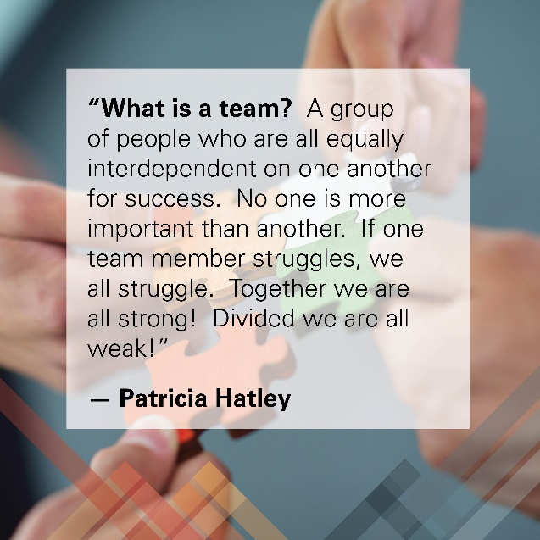
According to Chen (2019), teamwork is defined as a set of activities done by building a positive working atmosphere, supporting each other in a same direction to achieve an objective.
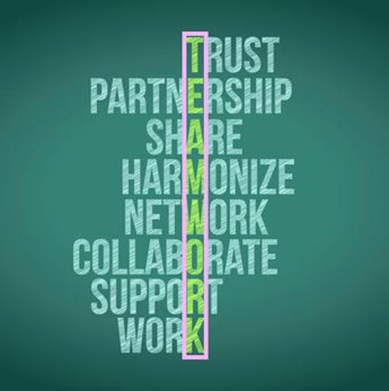
All those activities will help to build an effective team in an organisation, which is used to create effective communication.
This will help the team member to build a strong relationship which helps them to achieve the established goal.

Main body

A group of people that are working together and with the same vision and are inspired to achieve that vision to life is defined as an effective team.
An effective team must have high communication skills, quality of work and productivity, a clear goal, leadership skills, also a good support and trust to each other. All these skills will help to create success of an organisation which will help to achieve all objectives. The team goal needs to be accepted and appreciated by the team.
An effective team can be created by using Tucman’s theory.
In 1965 Bruce Tuckman has given this theory. This theory is very productive in evolution and conduct of the team. This theory deduces that working in a team will show the connection between group relationship, maturity and potentiality. Tuckman’s theory it’s used to identify a problem at different level of its evolution. Tuckman’s theory helps students to accelerate the process and reduce difficulties.
There are five stages in Tuckman’s theory:
Forming: This first stage helps students to discover skills and split the teams depending on the task (Bucata and Rizescu, 2017).
Storming: This is the second stage where team members know the fact and implication of the work.
It is natural to have different vision and conclusions which may lead to argue and disagreements between team members. That’s why the leader of the team will solve their conflicts between them by giving them individual tasks.
Norming: In this third stage the members of the team solve their problems in an innovative way. and complete their given task. Also, they can make professional relation with everyone, in this way they can develop efficient innovative ideas. This will help them to succeed in achieving their goal.
Performing: This stage is about motivation to work with the team. In this stage the leader makes effort to inspire team members to succeed in achieving the goal, in a positive manner.
Adjourning: In this final stage, the team goals are achieved, and members of the team feels proud for their achievement.
The impact of effective team working can have for team success

According to Mac Wolfe, (2017), all the members of the team who support each other will help to succeed in achieving their goal.

There are various impacts of effective team working:
Increment in the productivity: When member of a team works together, are more motivated and productive approaching their goal. They can have different point view of problem solve, which will produce new ideas and solution and success of the team.
Strong relationship: To build a strong connection between members of the team it is necessary to work with the team.
Simplifies conflict resolution: A effective team is when members of the team cooperate with each other.
Greater motivation and morale: According to Kononenko and Sushko, (2020), the success of a team is given by motivation and morale.

Barriers to effective teamwork

Team conflict: Lack of communication lead to delay on tasks process and generate issues at the workplace.
Communication challenge: The productivity of a team can be low when ideas and thoughts are nor recognized by the team members. Also, can create misinterpretation and confusion between team members. Effectless communication is one of the barriers of effective team building.
Team management issue: According to Kang and Hwang, (2021), team management issue happens when there is an insufficiency trust, ambiguous goal, unpredictability role which lead to poor efficiency of the team and its members.
Lack of discipline and punctuality: According to Abrams and Greenhawt, (2020), there are two most important quality that are required to perform to workplace to build the reputation in work environment.

Types of roles that are needed to create an effective team

To establish strengths and weakness in the workplace we can use Belbin’s team roles.
There are nine Belbin team roles:
Resource investigator: According to Yamin, (2017), this role is for people who are confident socially, who can investigate various opportunities and develop contacts. This role helps students to improve them ability to create new contacts, as well in discovering new opportunities.
Teamwork: This role is for people who are gentle and friendly by nature. They can make a team to function well, and they are very good listeners. Students will be more efficiently in interacting with different people and manage unpredictable situation.
Coordinator: This role is for people who have excellent communication skills and can help everyone guide them in the right direction. Students who apply this role can allocate tasks very effectively. Also, they will be very good listeners and very calm persons.
Plant: According to Roatmam le Grange and Retief, (2018), this role is for people who are the best in solving difficult and complex problems. Students in this role have capacity to produce original ideas, have innovative suggestions of doing things. Also, they are always successful when dealing with team challenges.
Monitor evaluator: This role is for people who are better at strategic planning and critical thinking. People in this role are humourless which are very supportive in examining all problems.
Specialist: According to Kim, Kim and Lee, (2017), the people in this role have the ability to understand what is necessary to get the job done. Students who are highly skilled specialisations are suitable for this role.
Shaper: This role is for people who are enjoying questioning the standards to find the best plan of action. Students who work in this role are always helping members of the team and push them when there are deadlines for a given task. People who are working in this role are extremely positive, and that’s help them to motivate the team members.
Implementer: This role is for people who are self-control and discipline, who like to shape and support the good atmosphere of the team. The persons in this role are the top determinate of organisation, who makes sure that the tasks are being completed efficient and in time.
Completer finisher: People in this role are the one who verify that the tasks are being completed properly with no error and in time.
According to Ferguson, Wallace and Chandler, (2018), all the appliances will help to identify the strengths and weakness of a team. As well, will help to comprehend and value the contribution of every team member of the team, and build a successful team.

Conclusion

In conclusion, effective teamworking is very important for team success in every organisation.
Every member of the team must collaborate to each other, having the same goal to accomplish the objective of an organisation.
This can be shaped by applying Tuchman’s theory, which is used to implements all the difficulties and understanding different problems at every stage.
It also describes several good impacts of teamworking, which increase the productivity of the team, and several roles of team by using Belbin’s theory which helps teams to become successful team.

In Abdul’s scenario, I believe that Abdul can develop an effective team by using Tuckman’s theory, applying all five steps on his team.
As well, Abdul can apply Belbin’s team role to create an effective team.
By applying those theories and role’s, Abdul will be able to deliver the community event with local stakeholders, commercial businesses, and voluntary organisations, without loosing any members of the project team.
With those theory’s applied, Abdul will have an successful team.

References

Abram’s, E.M. and Greenhawt, M, 2020. Risk communication during COVID-19. The Journal of Allergy and Clinical Immunology: In practice, 8(6). Pp.1791-1794.
Bucata, G. and Rizescu, A. M., 2017. The role of communication in enhancing work effectiveness of an organisation. Land Forces Academy Review, 22(1), pp. 49-57.
Chen, E.T., 2019. Improving Virtual Team Effectiveness. In Handbook of Research on Strategic Communication, Leadership, and Conflict Management in Modern Organization (pp. 411-425). IGI Global.
Ferguson, D. P., Wallace, J. D. and Chandler, R. C., 2018. Hierarchical consistency of strategies in image repair theory: PR practitioners’ perceptions of effective and preferred crisis communication strategies. Journal of Public Relations Research, 30 (5-6), PP.251-272.
Kang, E, and Hwang, H. J., 2021. Quantitative Analysis: Team management for Better Employee Performance in the US Retail Supply Chain. Journal of Distribution Science, 19(7), pp. 19-27.
Kim, S. Y., Kim, W. D. and Lee, S. M., 2017. The relation of communication types of nurses, satisfaction on nursing services and intend to revisit the hospital perceived by patients admitted to comprehensive nursing care service. Journal of the Korea Academia- Industrial cooperation Society, 18(11), pp. 321-331.
Kononenko, I. and Sushko, H., 2020, September. Creation of a Software Development Team in scrum Prejects. In Conference on Computer Science and Information Technologies (pp). 959-971. Springer, Cham.
Mac Wolfe, R., 2017. Ninth-Grade Content Teams: Should School Districts Invest Time and Resources in Team Building for Ninth-Grade Content Teams? (Doctoral dissertation, University of La Verne).
Rootman-le Grange, I. and Retief, L., 2018. Action research: Integrating chemistry and scientific communication to foster cumulative knowledge building and scientific communication skills. Journal of Chemical Education, 95(8), pp. 1284-1290.
Yamin, A.B., 2017. Impact of digital marketing as a tool of marketing communication: a behavioural perspective on consumers of Bangladesh. American Journal of Trade and Policy, 4(3), pp. 117-122.

