BMIH6007
International Meetings Management for the
Hotel Industry

Speaker Notes
On
Assignment 1

Student ID: 2127560
Student Name: Alina Grigore
Lecturer Name: Kathryn Flynn

Introduction
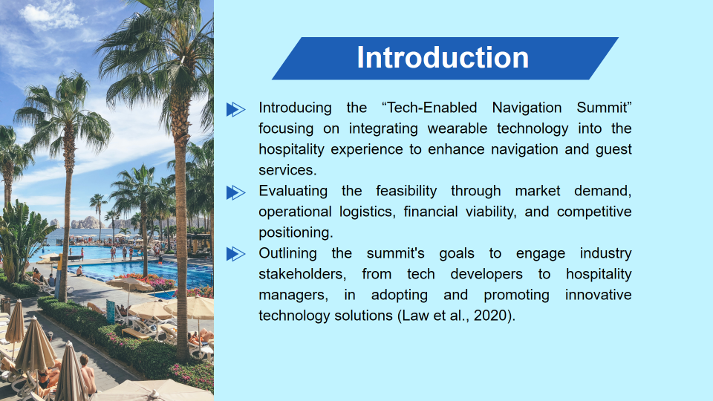
Tech-Empowered Navigation Summit is our journey into how smart wearable devices for guests are the realization of the next wave of exploration in hospitality as a means of driving the world of hospitality services and simplifying navigation in hotel premises. Our analysis will focus on the feasibility of the plan including the strengths of the current market setup, the availability of corresponding operational infrastructure and the overall financial viability of our proposal for this state-of-the-art wearable device. In our case, we are going to prove that this kind of technology significantly changes the habits of people and influences their lives. We plan to involve a wide spectrum of stakeholders including tech enthusiasts as well as those with a future-orientated approach when it comes to managing the hospitality industry, and they are the ones who will be at the forefront of adopting and popularizing these innovations (Law et al., 2020). This summit creates a perfect place where we can share and push technological progress in the hospitality industry as well.

Market Factors: Target Market
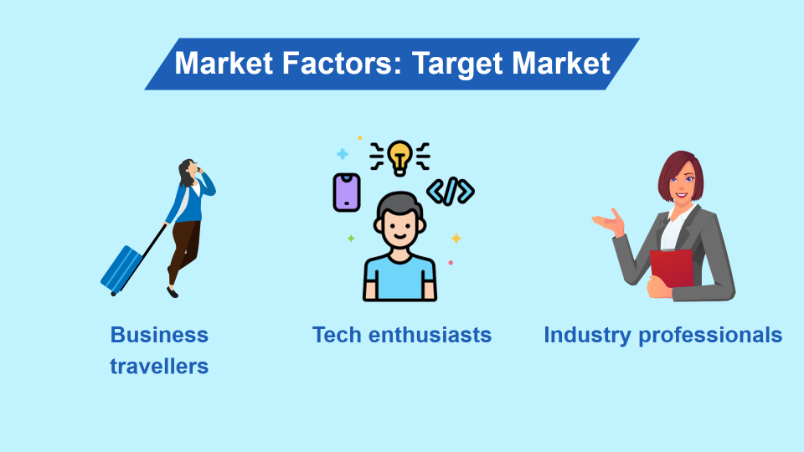
This segment dives deep into the central audience of our summit which belongs to the business travellers and technology enthusiasts. Such clients are the category who not only go on trips often but also accept the newest technologies instantly (Cai et al., 2019). So, we find them the best targets for connected wearables in hospitality. Youth people have a high degree of zeal and curiosity towards anything new, which is a powerful force that persuades market trends and velocity of the adoption of new tech, thus these youngsters become the primary influencers in the spread of innovative products (Hudson, 2017).
Our secondary market focuses on professionals who are continuously searching for advanced functionalities to make the guest experience better. This critical segment, consisting of the early adopters, will give us traction among the tech-savvy that will ultimately bring widespread incorporation (Bowen and Whalen, 2017). This is a core consideration because as practitioners in their organizations, they are game changers, and they have the potential to develop large-scale customized systems that will be integrated into their diverse range of services through our technologies.

Market Factors: Demand and Supply
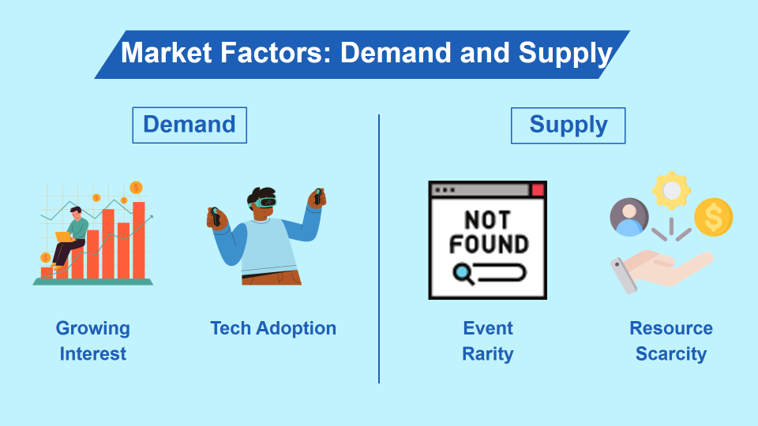
Through combining technology with the hospitality industry, is not just a trend existing right now, but it is an important transformation that helps actualise guests’ experiences and operational efficiency. The trend of high-tech innovation is one of the latest issues in the Travel and Hospitality Industry as the number of surveys and studies on this topic grows. This is far beyond simply the introduction of technology for any reason. It is about making use of innovation to answer the evolving necessities of tech-savvy visitors and sustain competitiveness within the quickly changing environment (Buhalis et al., 2019). The demands of travelers and professionals to be bright-eyed and move in the more effective strategies indicate a well-built niche market for our wearable technology.
The demand side, on the other hand, presents a completely contrasting image when analyzed. The number of events and meetings, dedicated solely to wearable technologies in hospitality, is surprisingly less. This still gives a good scope for the challenges and the opportunities. For us, this specialty of concept ideas is the exclusive privilege of taking the initiative in terms of forming the viewpoint and approach about this narrow sphere (Çeltek, 2022). On the one hand, the shortage of essential things and available services in the industry points to the gap zone, which we have to fill with our wearable technology proposal.

Market Factors: Competition
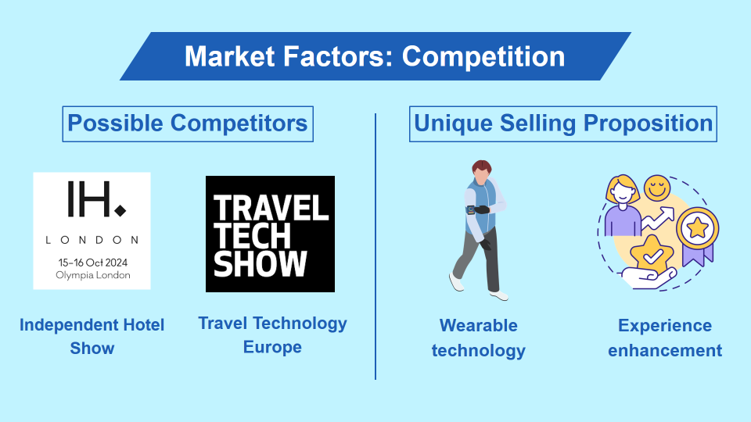
Among the various activities of assessing the competitive landscape are: existent brands such as the Independent Hotel Show and Travel Technology Europe (TTE). TTE, which takes place in London in particular, has a special place among these summits. It becomes a platform that gathers a vast array of technologies for the travel and hospitality industries, which also are future capabilities such as wearable technology (Independent Hotel Show, 2024). This is not only a strong competitor but also a touchstone, thus giving us an idea of what should be done to beat the competition. Based on TTE potential, it is possible to consider how our activities can be framed to match the existing gap.
Our unique selling proposition sets us apart in that we are the pioneers and the only event to focus exclusively on wearable technology that implicitly improves the direction of roadside services and clearly defines the guest experience (Suryandari, 2020). This narrowing of the focus lets us get into the specifics of the wearable tech talk right down to every detail of the operation, giving rise to more actionable and practical insights than a multi-themed tech conference would. We stand this focus, to create a summit which is not only a technology event but a decisive meeting where the future concepts of hospitality technology are shaped.

Operational Factors: Venue and Logistics
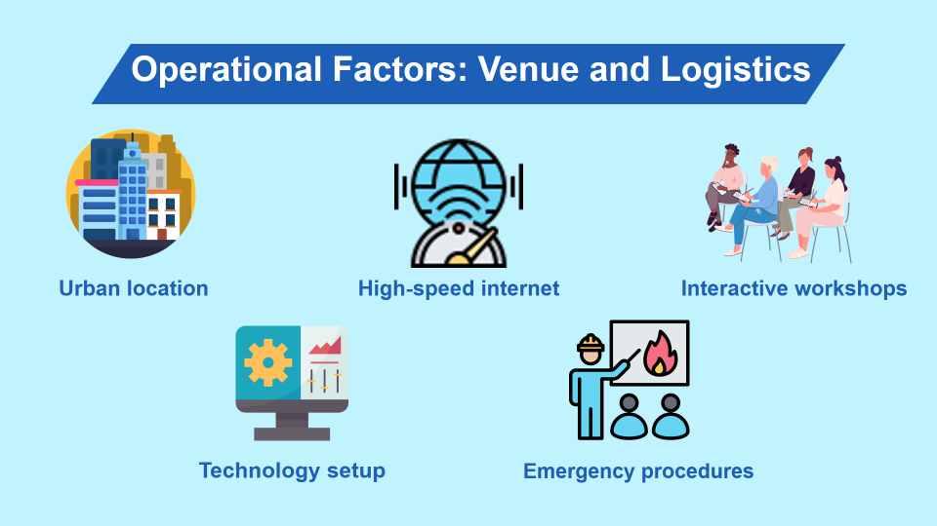
The location selection is pivotal to the event as a whole so that the Tech-Enabled Navigation Summit is successful. We primary promoters of tech-oriented conference halls in major cities and thus are easily reachable to a worldwide community of people who can stay glued to the live streams (Mair and Weber, 2019). These venues are handpicked to serve the purpose of hosting hi-tech lineups such as tech exhibits, holding workshops and ensuring the availability of broadband or high-speed internet services. They will strengthen the experience provide for the perfect integration of the wearables that we are exhibiting, and give additional attention considering the demanding nature of sessions (Fox et al., 2014).
On the part of the planning, and organizational elements, it is very precise. We have spent much time drawing up a comprehensive technology setup plan, making sure every piece of equipment is set at its best for live demonstrations and interactions (Getz and Page, 2019). Furthermore, we are thoughtfully plotting the visitor flow in which we can prevent fluidic disturbances and optimize the client journey. Additionally, the protocols for emergency incidents have been completely defined to guarantee safety and fast response capabilities.

Operational Factors: Skills and Resources
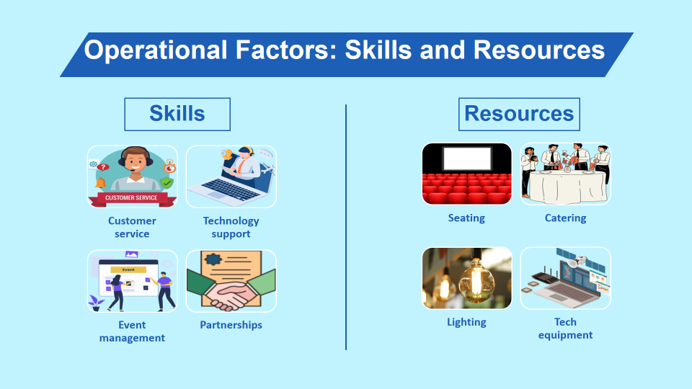
To ensure the effectiveness of the Tech-Enabled Navigation Summit, we have to make sure that our team is capable deal with the challenge. These can be accomplished by employing skills for technology support, event management, and customer care which are among the notable specializations (Egeli and Kurgun, 2021). They play the role of synergizing the hard work of the wearable techs to ensure that everything flows and visits fell satisfactory to its attendees and the smooth running of the conference’s logistic demands. That is also the reason why our team members would be collaborative with other specialists who come with their unique wisdom and resources, making the event run smoothly (Cobanoglu et al., 2021).
Resourcing is another key element as well. The catering will be topnotch and impressive to the guests and we cannot do without the lighting to showcase demonstrations and workshops while good arrangements for the seating will have to be ensured. The tech support equipment, which is the core of our summit, supports the wearable technologies which are at the root of our summit. It will be a productive event, assuring we have the latest equipment we can work with available (Navio-Marco et al., 2019).

Financial Factors: Budget Overview
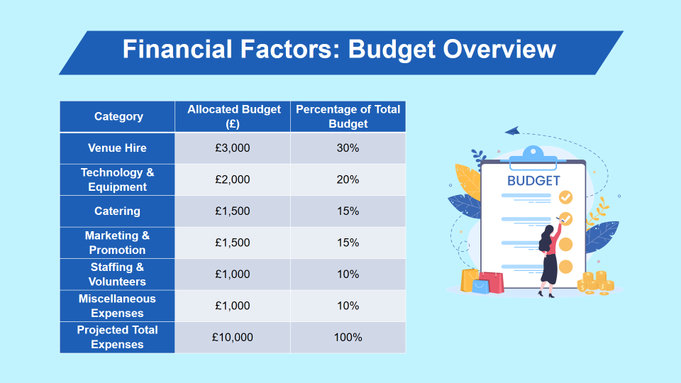
To design a budget for a Navigation Summit of £10,000, we thoughtfully avoid any overpricing and allocate the whole amount among the most crucial categories so that the whole plan will turn out properly. The interval expenditure on the renting of the venue is the largest one for us accounting for 30% of the total budget which is £3,000. For this purpose, we will fulfil rental fees for a conferring area, which is furnished in a way that one can use it for high-tech displays and attendee interactions, which are essential for a successful event (Kapiki, 2021). On the other hand, by technology and equipment, at best up to 20% of this budget will be consumed. This involves the essential technology and support facilities, which are essential to enabling the summit attendees to appreciate the intricacies of wearable technology.
We also provided budgets for catering, marketing, staffing and miscellaneous items that are essential in accomplishing the main event's aim for the client. It is 15% of the budget which caters to marketing and promotion and toward superior and successful food services and marketing strategies to draw and keep the goal crowd. Staffing expenses and miscellaneous expenses are 20% of the residual part. Through financial strategy, we are equipped to produce at a higher standard and to achieve all objectives.

Financial Factors: Revenue and Funding
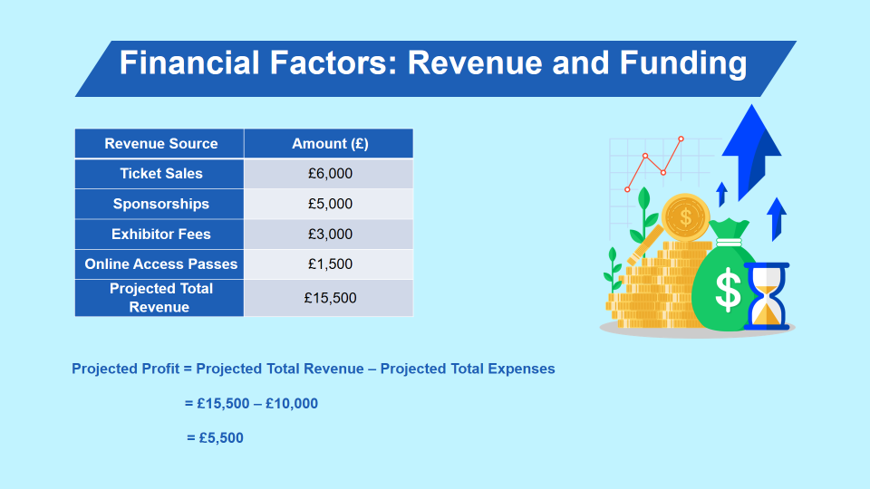
The finances of the Tech-Enabled Navigation Summit we have planned are focused on two key aspects, it first satisfies all expenses and secondly, positions the event for profitability, the very foundation of its sustainability and future growth (Rogers and Wynn-Moylan, 2022). The overall revenue of £15,500 that we foresee comes from multiple revenue-generating streams. The estimated sales of tickets are £6,000 which is greatly assisted by a sophisticated revenue model which is targeting on accessibility while maintaining excellent quality. We expect sponsorships, which are to be primarily targeted towards the leading tech firms, would generate another £5,000 during the year.
Stands charge fees that amount to £3,000, which many organisations actively seek to occupy in order to showcase the innovative and cutting edge of their technologies to the audience that is practically involved and relevant to their services. More importantly, we now launched the online access passes which are expected to bring in revenue of £1,500 and enable our penetration into a wider market. This revenue is not only lessened to cover our projected costs of £10,000 but also gives an additional £5,500 to our profit margin. The surplus is designated for the summits' future endeavours.

Implications of the Tech-Enabled Navigation Summit
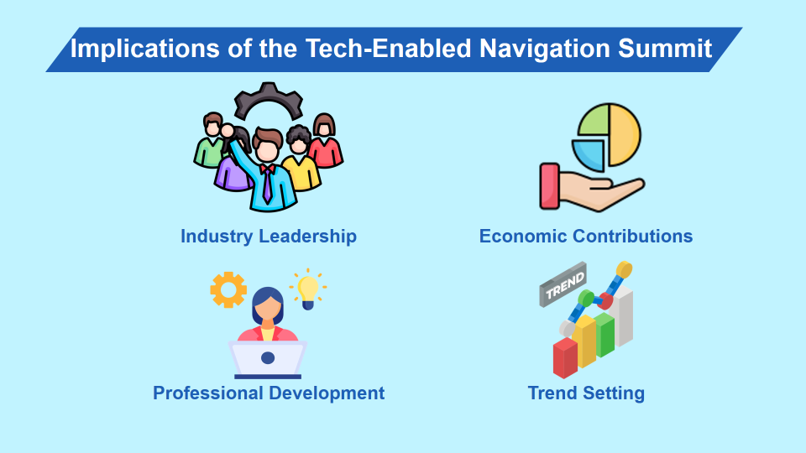
The Tech-Enabled Navigation Summit wants to be the trailblazing hub that brings together the heavyweights of hospitality and technology innovators, to exchange information and display wearable technology that improves guest experience through adding tech-guided enhancements (Li et al., 2021). Being advertised as an important event, apart from attracting professionals from across the world, it also increases the economic benefits the host city receives by increased demand for local services such as accommodation, dining, and transport as attendants come from various regions (Ukpabi and Karjaluoto, 2017). Furthermore, the summit is a milestone in professional growth and hosts a set of training programs and workshops to improve the techniques and skills of people in the hospitality industry. This pursuit of personal growth and development is a vital link-up between the present and future that pulls the industry towards more progress and improved technologies (Tussyadiah et al., 2018). These points and the comments provided after the summit are key, they help modify product lines.

Conclusion
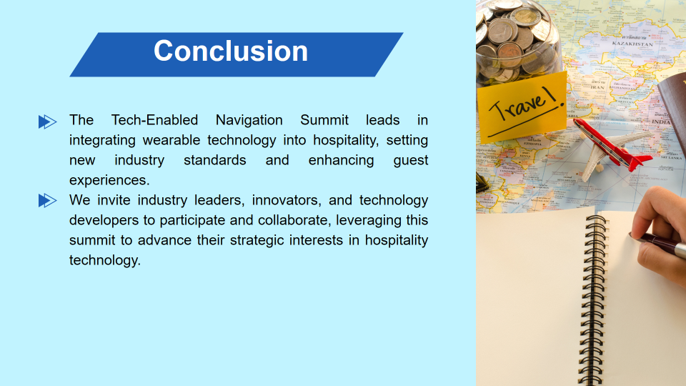
The Tech-Enabled Navigation Summit revolutionizes the state of the art, otherwise known as industry standards, via the use of navigation simplifying wearable device for the development in the hospitality industry, and by making guest experiences unprecedented. By now we've elaborately summarized the sustainability of this event and its critical strategic benefits. Thus, the ideal partners for this groundbreaking campaign are cutting-edge technology developers, forward-thinkers, and industry leaders. It would be great to commit and cooperate in bringing fully to the forefront the strategic interests of the summit to influence the future of hospitality technology. It commences with meetings, securing the venue, followed by the campaign focusing on the targeted market and key aspects of the industry.

References
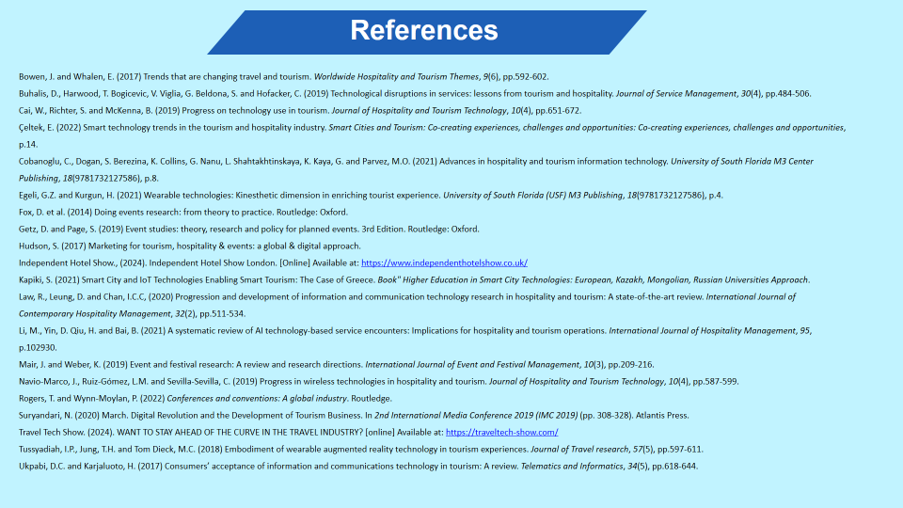
Bowen, J. and Whalen, E. (2017) Trends that are changing travel and tourism. Worldwide Hospitality and Tourism Themes, 9(6), pp.592-602.
Buhalis, D., Harwood, T. Bogicevic, V. Viglia, G. Beldona, S. and Hofacker, C. (2019) Technological disruptions in services: lessons from tourism and hospitality. Journal of Service Management, 30(4), pp.484-506.
Cai, W., Richter, S. and McKenna, B. (2019) Progress on technology use in tourism. Journal of Hospitality and Tourism Technology, 10(4), pp.651-672.
Çeltek, E. (2022) Smart technology trends in the tourism and hospitality industry. Smart Cities and Tourism: Co-creating experiences, challenges and opportunities: Co-creating experiences, challenges and opportunities, p.14.
Cobanoglu, C., Dogan, S. Berezina, K. Collins, G. Nanu, L. Shahtakhtinskaya, K. Kaya, G. and Parvez, M.O. (2021) Advances in hospitality and tourism information technology. University of South Florida M3 Center Publishing, 18(9781732127586), p.8.
Egeli, G.Z. and Kurgun, H. (2021) Wearable technologies: Kinesthetic dimension in enriching tourist experience. University of South Florida (USF) M3 Publishing, 18(9781732127586), p.4.
Fox, D. et al. (2014) Doing events research: from theory to practice. Routledge: Oxford.
Getz, D. and Page, S. (2019) Event studies: theory, research and policy for planned events. 3rd Edition. Routledge: Oxford.
Hudson, S. (2017) Marketing for tourism, hospitality & events: a global & digital approach.
Independent Hotel Show., (2024). Independent Hotel Show London. [Online] Available at: https://www.independenthotelshow.co.uk/
Kapiki, S. (2021) Smart City and IoT Technologies Enabling Smart Tourism: The Case of Greece. Book" Higher Education in Smart City Technologies: European, Kazakh, Mongolian, Russian Universities Approach.
Law, R., Leung, D. and Chan, I.C.C, (2020) Progression and development of information and communication technology research in hospitality and tourism: A state-of-the-art review. International Journal of Contemporary Hospitality Management, 32(2), pp.511-534.
Li, M., Yin, D. Qiu, H. and Bai, B. (2021) A systematic review of AI technology-based service encounters: Implications for hospitality and tourism operations. International Journal of Hospitality Management, 95, p.102930.
Mair, J. and Weber, K. (2019) Event and festival research: A review and research directions. International Journal of Event and Festival Management, 10(3), pp.209-216.
Navio-Marco, J., Ruiz-Gómez, L.M. and Sevilla-Sevilla, C. (2019) Progress in wireless technologies in hospitality and tourism. Journal of Hospitality and Tourism Technology, 10(4), pp.587-599.
Rogers, T. and Wynn-Moylan, P. (2022) Conferences and conventions: A global industry. Routledge.
Suryandari, N. (2020) March. Digital Revolution and the Development of Tourism Business. In 2nd International Media Conference 2019 (IMC 2019) (pp. 308-328). Atlantis Press.
Travel Tech Show. (2024). WANT TO STAY AHEAD OF THE CURVE IN THE TRAVEL INDUSTRY? [online] Available at: https://traveltech-show.com/
Tussyadiah, I.P., Jung, T.H. and Tom Dieck, M.C. (2018) Embodiment of wearable augmented reality technology in tourism experiences. Journal of Travel research, 57(5), pp.597-611.
Ukpabi, D.C. and Karjaluoto, H. (2017) Consumers’ acceptance of information and communications technology in tourism: A review. Telematics and Informatics, 34(5), pp.618-644.

