Tutorial 5: Organisational Culture
https://youtu.be/qQqGKMU5_NM

https://youtu.be/K_BzyhIvlbE

https://youtu.be/qQqGKMU5_NM

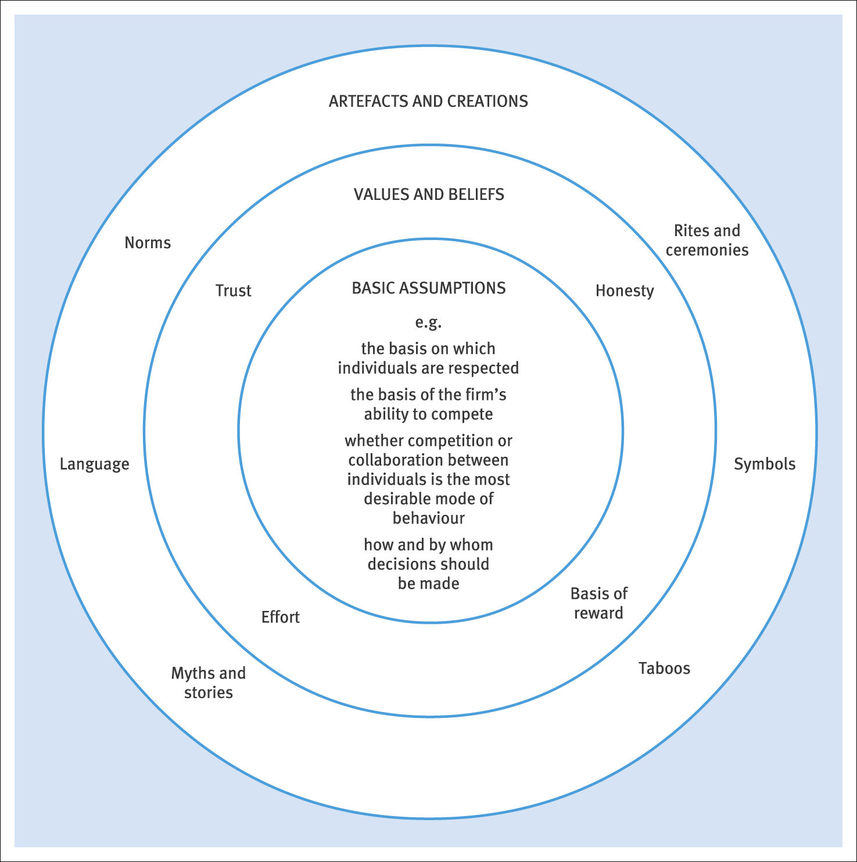
Schein’s layers of culture (Rollinson, 2008)

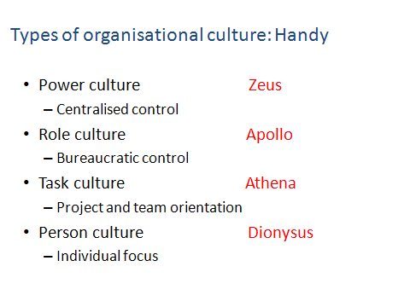

Exercise 1: Socialisation into your course and UWTSD
As first year students, you joined the last course last September for induction , a week before the remainder of the students returned, and before teaching commenced.
Working in small groups:
- Discuss the role and purpose of an induction programme for new starters.
- What key things (formal and informal) did you learn about how the course/School/Faculty/University works day to day:
- From the speaker sessions
- From one another
- From your ‘social’ induction on visits/Fresher’s fortnight/other students
- Based on your experiences, how would you describe the organisational culture of UWTSD? (use one of the models if it helps)
- What in your view is the best way to ‘learn how things are done’ in a new organisation you’ve just joined?

Exercise 2: Different organisations have different cultures
Suggest, with supporting reasons, which of either the Handy or the Deal and Kennedy
typologies you would try to foster if you were appointed as a senior manager in any three of the following organisations:

• wheel-clamping contractor;
• research laboratory;
• naval submarine;
• private hospital;
• second-hand car business;
• high-fashion clothing store;
• fast-food chain;
• advertising agency.

Exercise 3: Socialisation in the Army
Read the following and answer the questions which follow
One of our summer school students was an overseas student who joined our programme having completed his compulsory military service. Over coffee at the start of the programme he told us about it.

‘First you have your hair cut, even though it might already be short enough, and then you get
issued with your kit, which you have to put on immediately. You catch sight of yourself in the
mirror and you know you’re in the Army – all your individuality has gone and you look just like
everybody else. You get given a bunk with army-issue bedding and a cupboard, which looks like
all the rest – you can’t even fill it up as you want, there’s an order for how you put your gear in it.
You sit on your hard bed and look around at all the others – the people you’ll be spending at least the next six months with, whether you like it or not. Their expression mirrors yours: “We knew we’d have to do it sometime, we just have to get through it with as little hassle as possible” ’.

‘The next few weeks merge into a blur of following often apparently illogical orders. Your life
becomes dominated by Senior NCOs shouting at you, bells and klaxons ruling your every move
from when you get up to the time you have to go to bed. You have to change uniforms at the
drop of a hat for no reason and go through mindless drills and marching at all hours of the day
and night. If you dare to question anything you end up peeling potatoes, cleaning out baking tins
or painting the stones around the parade ground. You even get used to the terrible food.
Throughout it all, you have to wear your uniform and stay on the base, you get a pass-out only
when you’ve finished basic training’.

‘Eventually that day arrives and you get your next set of orders. Even then you probably won’t
get what you asked for. I’m a computer programmer so for my first posting I was put in the
kitchen. As you march out of training camp for the last time you notice the next batch arriving.
You look them over and catch yourself saying, “look at that lot – he’ll have to get his hair cut,
that one will have to stand up straighter, he’s going to get a rude awakening . . . what a shower!”
You pull yourself up short and suddenly you realise you are the Army – it’s crept up on you . . . .’

- Discuss how you see where the role of socialisation fits in here.

- What examples of socialisation can you share with colleagues?

Exercise 4: Socialisation in a University (for a new lecturer)
Read the example below and answer the questions which follow:

Anne was appointed to a teaching position in the Engineering Department of Midshires
University and on 1st September, that year she duly reported for work. Having gone through the
required two days’ induction she then set about trying to settle in to the job. Six days later she
would finally get an office (but no computer or telephone as yet) and three weeks later (just as
term was about to start) she would finally been given her teaching schedule, although she had
not been able to make contact with the relevant course managers because they were still on
holiday. It was certainly a far cry from industry and she had not found people to be particularly
helpful; it was not deliberate, she thought, but everyone seemed wrapped up in their own little
worlds.

On the first day of term she donned a smart business suit from her industry days and went in to
teach her first class. She was surprised to see that her colleagues were dressed in the same way as they had been in the summer except that the shorts had been replaced by a variety of jeans and cord trousers (invariably baggy) and that trainers or loafers had replaced sandals. Here and there a tie was in evidence but it was of the knitted variety last seen outside academia thirty years ago. As the first semester drew on, baggy corduroy jackets appeared against inclement weather. ‘This lot are so scruffy’ Anne thought, ‘I’m not going to let myself get like them – I think we’ve got a professional status to uphold and one of the ways to do it is to look smart’.

She was determined to retain what she thought of as her image, even though she was aware of
the nickname given to her by both students and colleagues – in fact she was quite flattered to be called Mrs Thatcher. The first semester was drawing to an end and Anne found herself unconsciously replacing her jackets with comfortable sweaters. By the end of the second semester she was to be found in leggings and baggy T-shirts. At a meeting called to discuss a new degree she found herself sitting next to a man in a business suit and tie. ‘You can tell he comes from the Business School’, she thought as she drove off in the second-hand Citroën 2CV, which had recently replaced her BMW.

- Using the above as an example, discuss the process of socialisation of new people into an organisation in order to induct them and get them to adopt cultural norms.

- How does the process at Midshires University differ from the Army example?

