`
- STUDENT NAME: Kwakye Boatey
- STUDENT ID: 2520439
- LECTURES’S NAME: Dr Martin Svejda
- UNIVERSITY NAME: University of Wales Trinity Saint Davis
- DATE: 21/03/2026

ACCA4026

In this presentation, I will explain what e-commerce website builders are, why they are important for businesses, and some examples of popular platforms used today.

Drop shipping is a method used by online stores and traditional shops to deliver products to customers. In this method, the shop sends the customer’s order to a manufacturer or supplier. Then the manufacturer or supplier sends the product directly to the customer. The retailer pays them an agreed price.
Drop shipping has some benefits for retailers. They do not need to store many products, and they spend less money on storage and handling. But there are also some disadvantages. The cost for each product can be higher. If a customer orders products from different suppliers, the items may arrive at different times. Delivery may take longer, and managing orders can cost more.
In this study, we create two inventory models called (Q, R) models. These models help retailers use drop shipping when they run out of stock. In the first model, customers wait for the product if it is not available. In the second model, the sale is lost if the product is out of stock. We also test these models with examples and data analysis [1].
The supplier picks, packs, and ships the product directly to your customer, handling all logistics while maintaining your store's branding. This streamlined process eliminates the need for you to manage inventory or shipping operations, though you remain responsible for customer service and order tracking.

This article talks about Shopify and Amazon and how online shopping has changed because of COVID-19 and new technology. These changes have created a new stage for online business, including both B2B and B2C sales. As online shopping grows, supply chains also need to improve to keep up with the demand.
I believe this is an important topic because people will continue to rely more on technology in the future. COVID-19 showed us that many problems can be solved using technology. In this essay, I discuss what these changes mean, what the future of e-commerce might look like, and what business owners should think about before starting an online business.
For this essay, I interviewed four people. The first was the co-founder of Commence, an online women’s clothing store that earns about $3 million each month. The second was the co-founder of Douhu, a shipping company that works with Shopify and Amazon and has more than 20 years of experience. I also spoke with the Senior Regional B2B Director at Yuntu, one of the world’s large cross-border e-commerce logistics companies. Finally, I interviewed Fiona Lin, a logistics specialist who has worked with companies using Shopify and Amazon [2].
When building your product line, take advantage of Shopify's ecosystem which supports integration with suppliers through third-party apps. As you develop your product strategy, carefully align your offerings with supplier capabilities. For example, creating bundles using products from a single supplier helps avoid split shipments and simplifies order fulfilments. This strategic approach to product selection and supplier partnerships helps create an efficient, scalable drop shipping business.



Today I will present my mind map of contemporary software applications. Contemporary software applications are modern digital tools that people and businesses use every day to complete different tasks.

This paper looks at how the idea of a Network Picture is defined and used in Industrial Marketing research. A network picture is a simple way to show how businesses are connected, often using diagrams or maps. These pictures help both researchers and business professionals understand relationships between companies.
The paper explains three ways to look at network pictures. The first is the representational view, where networks are shown as diagrams or visual maps. This approach is very common in business-to-business research. The second is the mental view, which focuses on how people think about and understand networks in their minds. This idea is often used in strategic management and has recently become more common in industrial marketing research.
However, these two views do not always agree with each other. Because of this, the paper suggests another approach called the situated view. This view focuses on how network pictures are used in real business situations.
In the end, the paper explains that using this situated approach can help researchers and business professionals better understand business networks and make better decisions [3].
Some people believe that the way business schools teach may not fully help students develop important thinking skills. These skills include connecting ideas, thinking critically, and solving complex problems. In this study, researchers used Mind Mapping to look at this issue.
Undergraduate students, MBA students, and business schoolteachers were asked to create mind maps about a complex problem. The results showed that students often struggled to connect different ideas. Many undergraduate and MBA students organized their knowledge into separate areas, and their understanding of the topics was not very deep.
On the other hand, business schoolteachers created more detailed mind maps. Their maps showed stronger connections between different ideas and concepts.
The study also found that undergraduate students usually organized ideas based on business subjects, while MBA students mainly focused on Strategic Management and paid less attention to other areas. Overall, the teachers showed deeper knowledge and better ability to connect ideas compared to the students [4].

A mind map is a modern software tool used to help with everyday business or organisation tasks. In (Fig 1) you can see the usage of a mid-map in contemporary software applications.

Accounting Software
Communication Software
E-commerce Platforms
Marketing & Analytics
Customer Relationship Management
Enterprise Resource Planning
Office Productivity Software
contemporary software applications

FIGURE 1: A mind map looks like a tree with many branches. These branches can grow as you add more ideas. Each branch shows a topic and smaller ideas related to that topic. The person who creates the mind map groups ideas together and shows how they are connected.

Today I will present a few Microsoft apps explaining them and their usage for business operations (Fig 2)


This Photo by Unknown Author is licensed under CC BY-NC
This Photo by Unknown Author is licensed under CC BY-NC
This Photo by Unknown Author is licensed under CC BY-NC-ND
This Photo by Unknown Author is licensed under CC BY-SA

POWERPOINT WORD MICROSOF ACCESS EXEL
FIGURE 2
Office Applications are for creating, storing, presenting, and analysing information/data

Task. A
MS WORD
In the article expedience at implementation of economic specialities by complex student’s project on Informatics and Computer Sciences is grounded on creation of business plan by modern information technologies, and methodical recommendations are presented on implementation of this project [5].
The only negative thing about Ms Word that is not suitable for complex data analysis large documents with heavy formatting may become slow limited database management capabilities.

POWERPOINT
The authors studied how business schoolteachers use Microsoft PowerPoint in different subjects in a business program. They looked at how often teachers use PowerPoint and which features they use in their presentations.
They also asked students what they think about the effectiveness of PowerPoint in different business courses, such as Accounting, Economics, Management, business law, and marketing.
After reviewing the results, the authors shared some useful tips on how teachers can use PowerPoint more effectively in their classes [6].
This study uses Visual Grammar Theory to analyse students’ Microsoft PowerPoint slides in a Business English class. The researchers studied how students create meaning in their presentations.
They looked at 160 images using numbers and data and closely examined two images in detail. The results showed that students express their environmental values through the design of their PowerPoint slides. They use different visual elements like images, text, and layout to communicate their ideas.
The study also found that students’ environmental values follow the idea of living in balance with nature. This idea supports diversity, harmony, interaction, and peaceful coexistence between people, society, and the natural environment [7]. PowerPoint has been the go-to tool for presentations for decades—but is it keeping up with today’s fast-paced, AI-driven world? PowerPoint makes it easy to take ideas to slides, whether you’re pitching a big idea, running a QBR meeting, developing your next marketing campaign, launching a new product, teaching a course, or showcasing your latest project.

Microsoft Excel
This text explains the useful and new features of Microsoft Excel 2010 that help students create professional worksheets and perform different types of calculations.
The book also teaches several important skills. It explains how to use basic Excel tools to solve problems, use statistical tools to analyse data, and create charts to display information clearly. It also shows how Excel can help with decision making by using logical formulas.
In addition, the text explains how to find and organise data for analysis, study the financial effects of loans and investments, and test different situations using what-if analysis. It also introduces tools like Solver to support better decision making and teaches how to fix problems in workbooks and create useful Excel applications [8].
Microsoft Excel is a popular spreadsheet program developed by Microsoft. It is a part of the Microsoft Office suite, which includes other productivity software such as Word, PowerPoint, and Outlook. Excel is designed primarily for creating, organizing, analysing, and manipulating data in a tabular format known as a spreadsheet.

Microsoft Access
The book Introductory Relational Database Design for Business teaches students how to design relational databases using Microsoft Access. It explains the topic step by step, using many small and realistic examples that become more detailed as students’ progress.
These examples help readers understand how database technology works and how it can be used in real business situations and other fields. This approach allows students to clearly see common problems and learn how to solve them.
By using this textbook, students can gain practical knowledge of database technology and learn useful skills that are valuable in the job market. They will also improve their analytical thinking and problem-solving abilities, because database design requires understanding different parts of a situation and how they are connected.
Although the book does not focus on building very large database systems, it gives students a strong foundation and enough knowledge to create useful database systems with several tables and apply these skills in real-life situations [9].
Microsoft Access is a relational database program, and a typical database includes tables, queries, forms, and reports. With Microsoft Access, you can easily organize, store and retrieve data.

Task. B
Excel is a useful tool for organising data. I used it to work faster, including using VLOOKUP to match drinks with prices (Fig3).
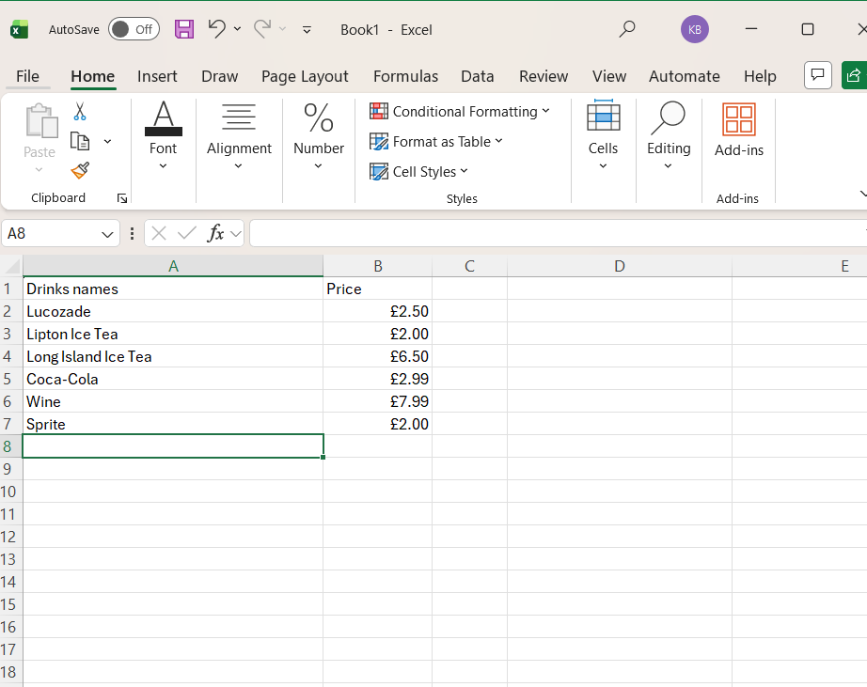
FIGURE 3
Microsoft Excel is a useful tool for organising and working with data. I have used Excel in a practical way to complete tasks more efficiently, including using functions like VLOOKUP I listed the drinks with the prices.

I used Excel by setting up columns for drinks and prices and using VLOOKUP (fig4).

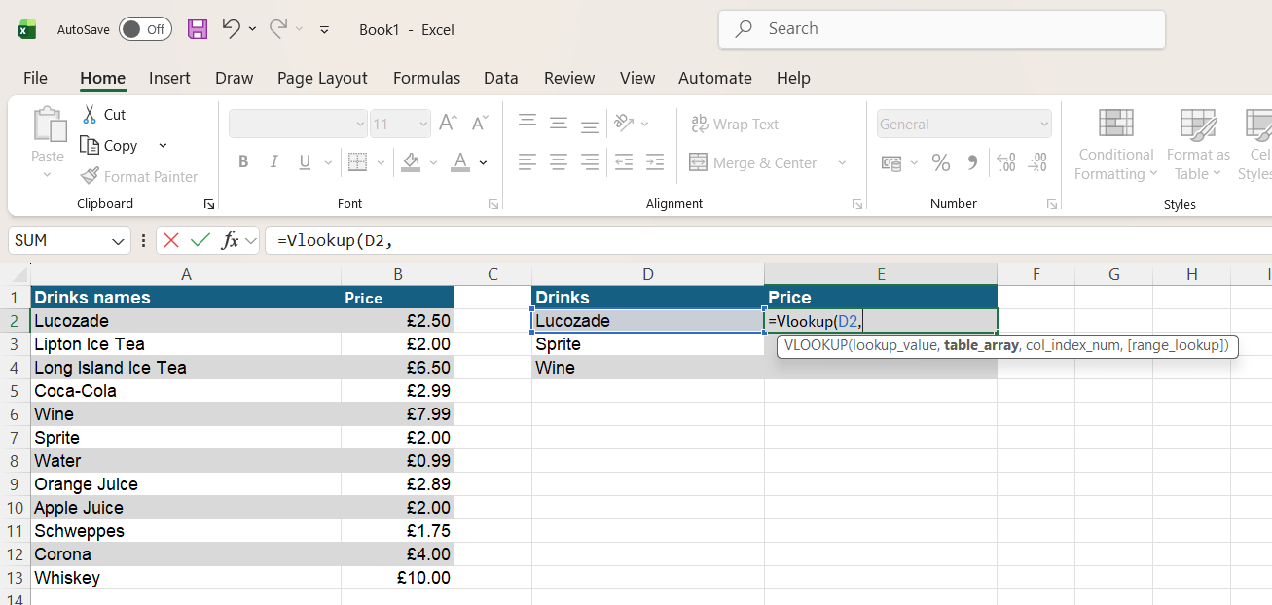
FIGURE 4
I have used Excel in a practical way to I designed it how I like it, and I also added a second collum and it says drinks and prices I added = so I can start the formula with VLOOKUP.

I used Excel by adding a formula and selecting the left column so VLOOKUP can calculate the prices (fig5).
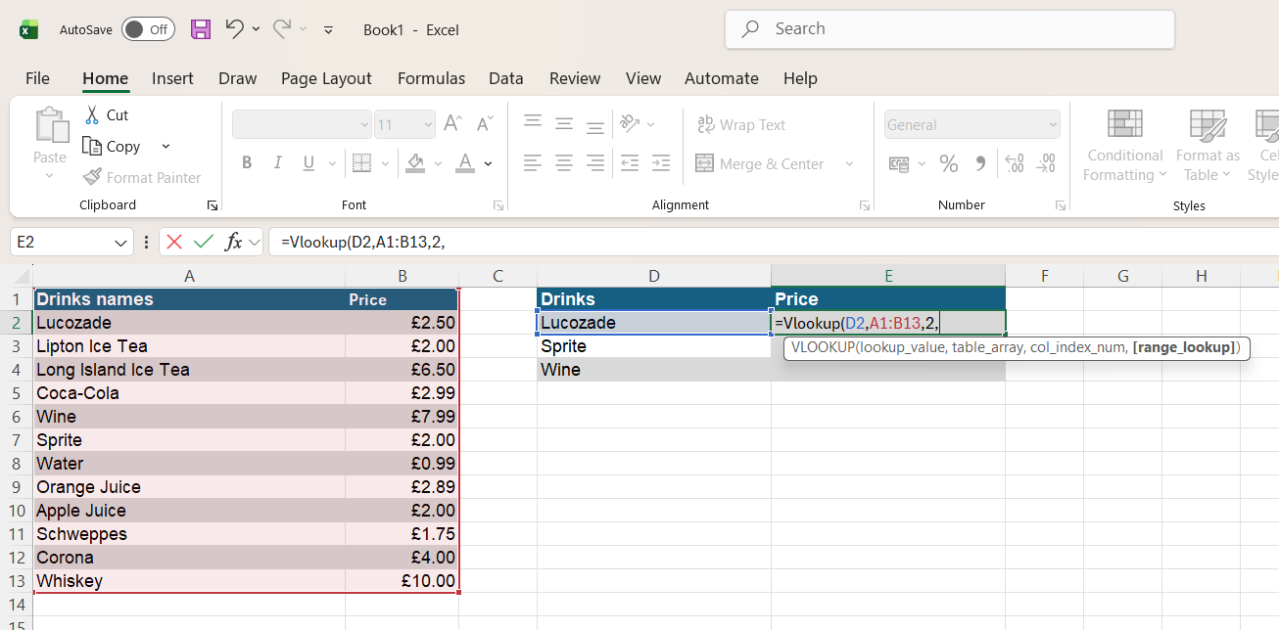
FIGURE 5
I have used Excel in a practical, I’ve added the formula, and I highlight the left collum so VLOOKUP can calculate the prices.

This is the result after using the correct formula, where Excel used VLOOKUP to add the prices (fig6).
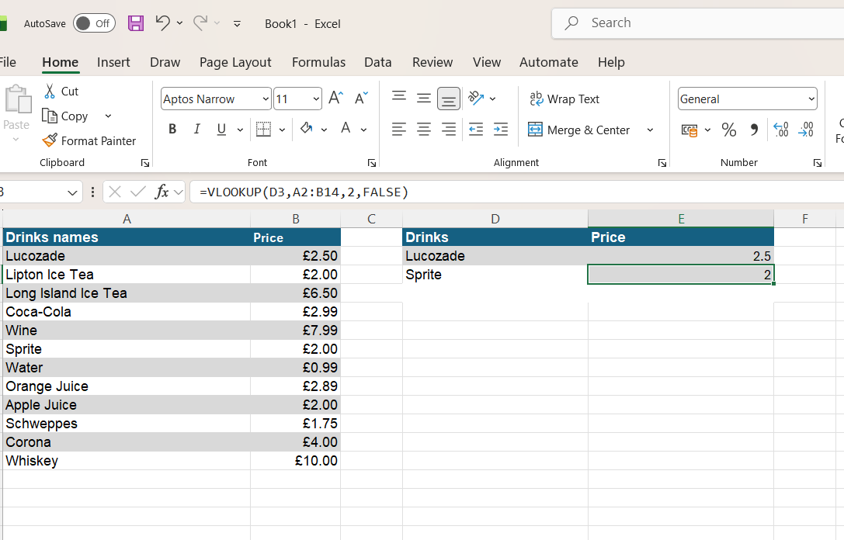
FIGURE 6
Result after using the correct formula and this is the finished product the computer added both prices using VLOOKUP.

In (fig 7) I listed the expenses and prices in the correct places.
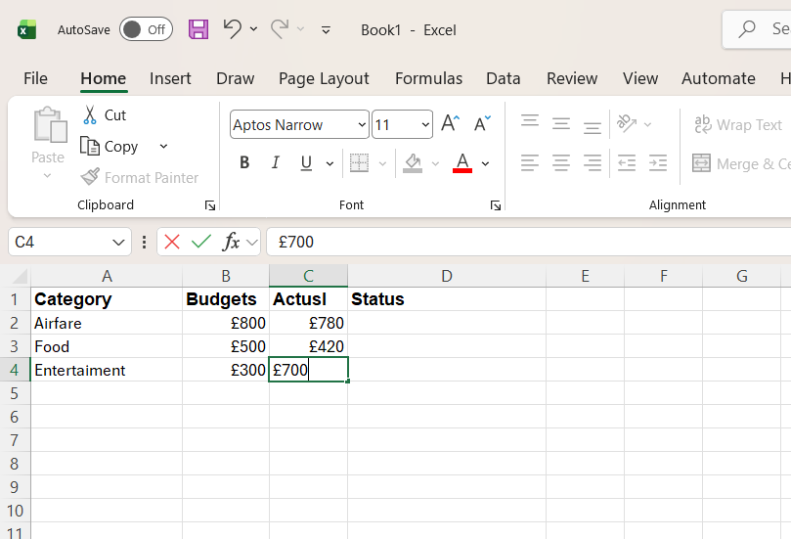

FIGURE 7
I wrote down the expenses with the activities.

In (fig8) I selected insert and I was looking for the if option then I pressed ok.

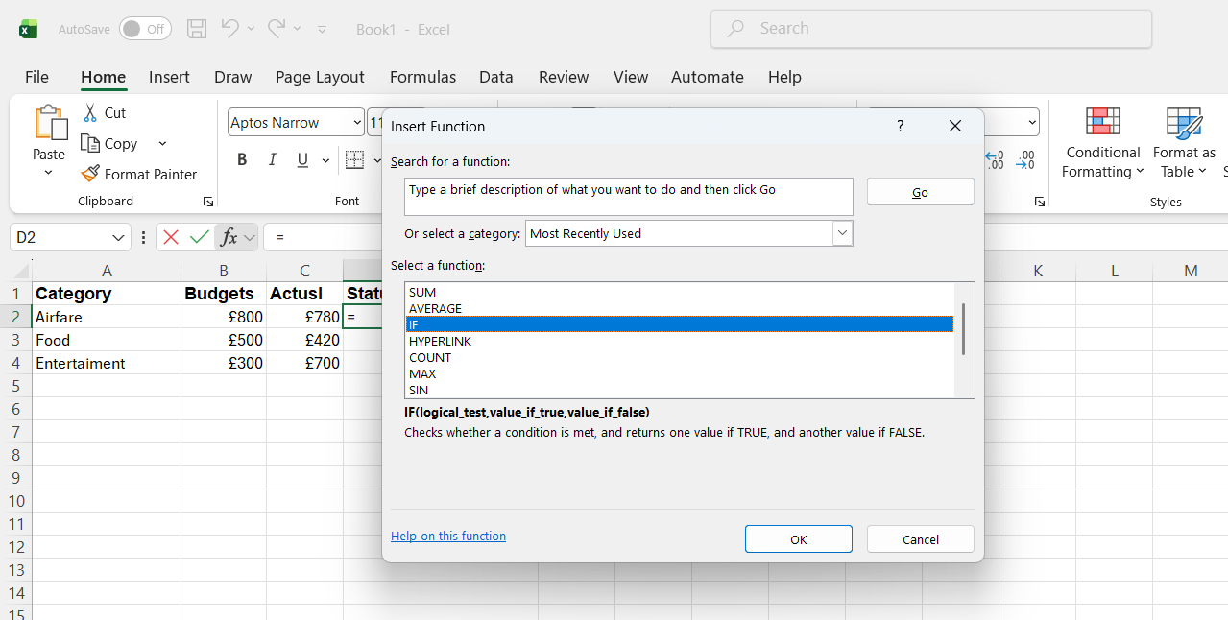

FIGURE 8
I Insert the if function.

After I pressed OK, I can enter my own words, and the computer will check if they are correct or wrong (fig9)

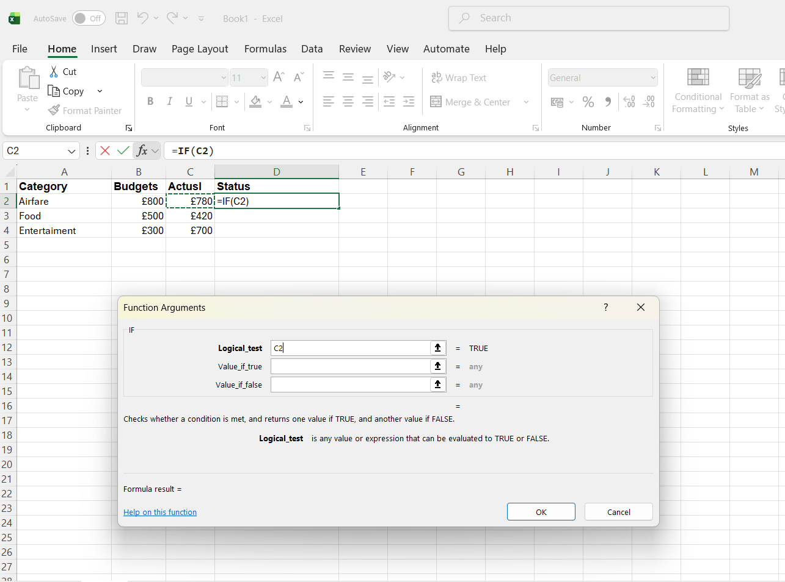

FIGURE 9
After I pressed ok, I can input the words of my choose and the computer will be able to detect and input the correct or wrong answers.

In (fig 10) Clicking the small square to check if it’s correct or wrong.

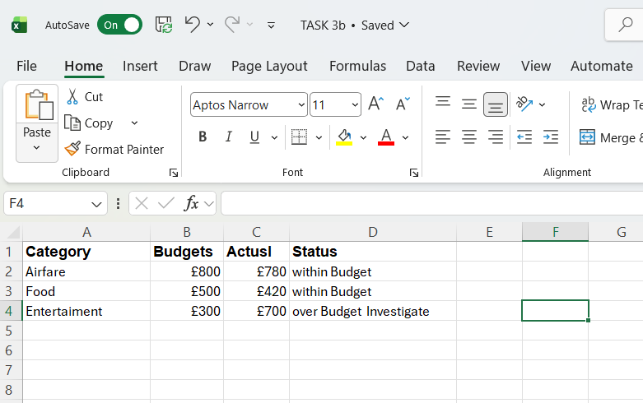

FIGURE10
By pressing the small square, it will automatically detect the correct or wrong statement.

Communication and Collaboration applications


11


12
This Photo by Unknown Author is licensed under CC BY

SharePoint
In today’s very competitive business world, companies need to use the data they already must understand their customers better. By analysing this data, businesses can find useful information, measure performance, and learn what helps create successful customer interactions.
The book Pro SharePoint 2013 Business Intelligence Solutions explains how businesses can use Microsoft SharePoint 2013 to build business intelligence systems and gain valuable insights from their data. To understand these tools, readers first learn the basic concepts of business intelligence in Microsoft SQL Server. The first part of the book focuses on these important fundamentals.
After that, the book explains several SharePoint tools used for business intelligence, such as Visio Services, Excel Services, SQL Server Reporting Services, Business Connectivity Services, Power View, and PerformancePoint Services.
The authors explain these tools with clear examples and practical activities so readers can learn how to use them in real business projects. Because it is not always easy to find people who understand both SharePoint and SQL Server, this book helps readers develop the skills needed to work with these powerful business intelligence solutions [10].
SharePoint is an online content management tool. It enables users to store files in the cloud for sharing and collaboration. It can help users create sites and subsites to declutter tasks from different teams or individuals.

Microsoft Teams
As online work became more common, Microsoft created a virtual workplace called Microsoft Teams. In just one year, the number of daily users grew quickly from 13 million to 75 million people.
The book Microsoft Teams for Dummies gives a detailed introduction to the latest version of the app. It explains the many ways people can use Microsoft Teams to chat, make calls, join meetings, work remotely, and collaborate with others in real time.
Microsoft Teams can be used as a single tool for working from home or as support for work in a physical office. It can be used as a separate application or as part of Microsoft 365, and it works smoothly with many other Microsoft applications [11].

Task B
SharePoint is a tool to store, organise, and share files online. I opened Google, searched SharePoint, and logged in with my university details (fig13)
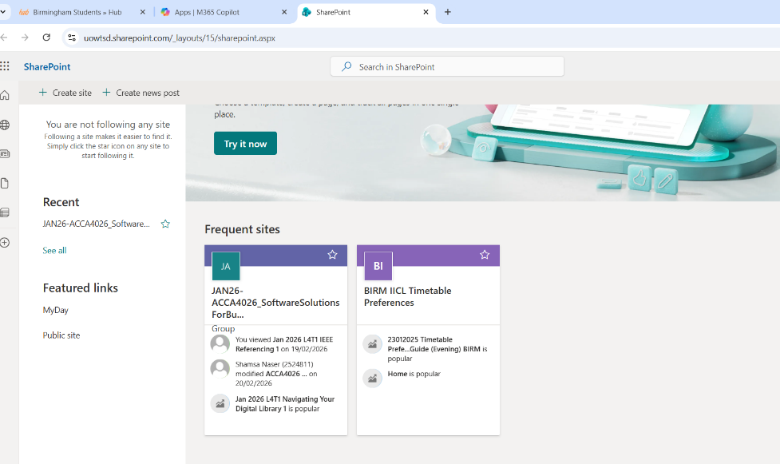
FIGURE 13
SharePoint is a tool used to store, organise, and share files online. It helps people work together and access documents from different Locations I pressed the google icon and I typed SharePoint and I logged into the app using my university credentials.

Explain what’s the purpose of the app and how you can share you work with you teacher or work colleagues (fig14)
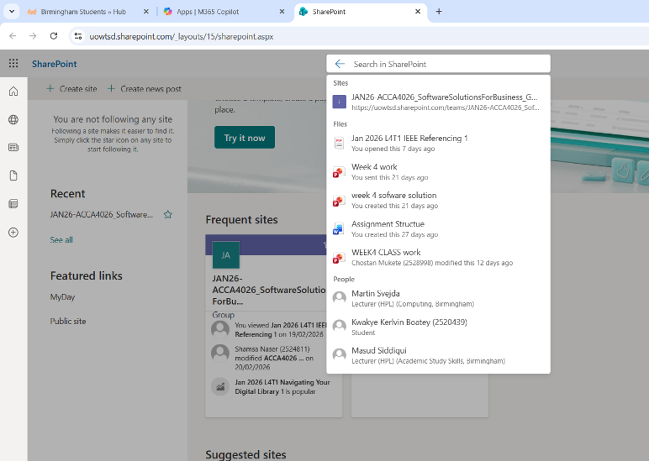

FIGURE 14
By pressing the search option, you can look for your files or people in the organisation where you work and all the sites.

Microsoft Teams is an online app used for communication and teamwork. It allows people to send messages, join video meetings, and share files (fig15)

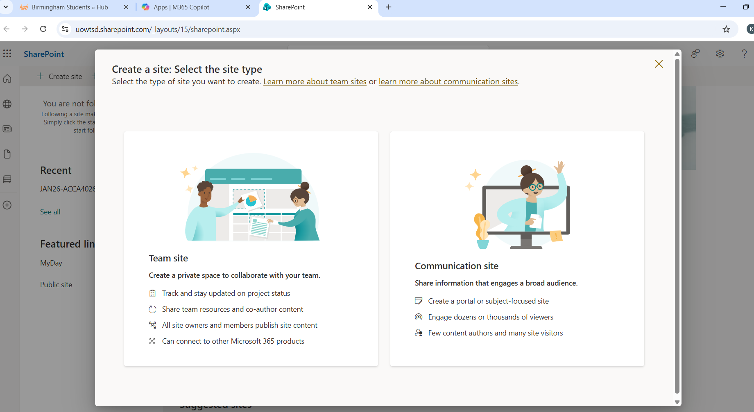

FIGURE 15
By pressing create site you will see this options, the difference between them are, A team site in SharePoint is designed for collaboration that’s where member come together, and you can share, edit, and work together on documents and projects, but when it comes to the communication site, on the other hand, is meant for broadcasting information to a wider audience.

Before using Microsoft Teams, I need to go to the Birmingham student hub and select the app (fig 16)
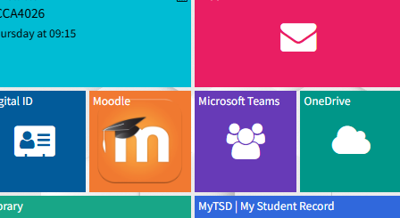
FIGURE 16
Before accessing Microsoft teams, I will have to access my Birmingham student hub and select the app.
After pressing Microsoft Teams I was able to access the app and I had to log in, has I logged in I was ready to use the app.

After logging in, you can search to message people or find files (fig18).
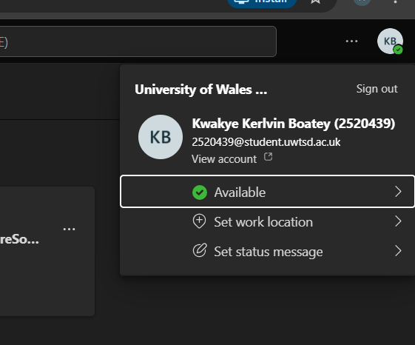
FIGURE 18
After logging into the app, I insert search with Microsoft Teams you can message or look for people, files and more.

In (fig19) With Microsoft Teams, you can check activity, chat, join meetings, schedule months ahead, make calls, access OneDrive, and download the app for free.
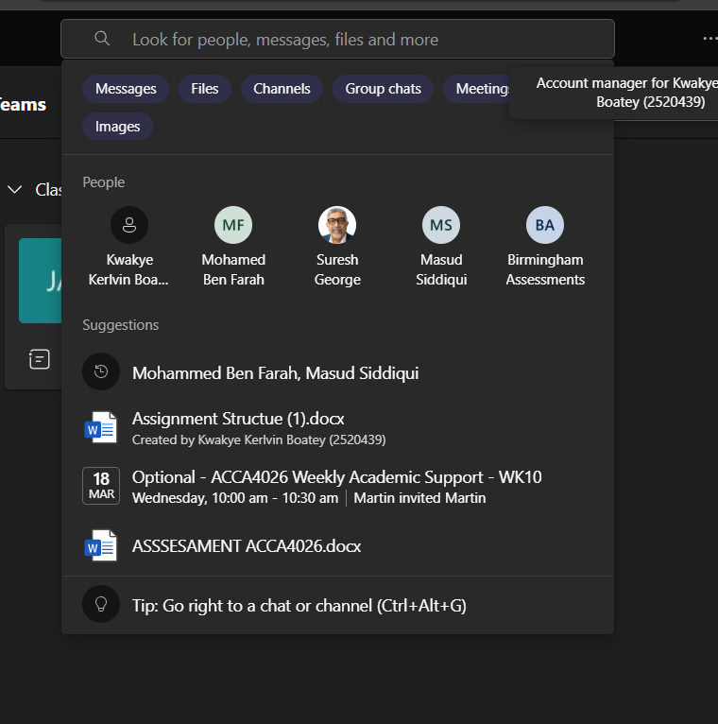
FIGURE 19
With Microsoft teams you can check your activity, chat with you colleagues or classmates, have meetings, you can schedule your moths beforehand, make calls, you can access your OneDrive, and you can download app free of charge using Microsoft Teams.

references

[1]
M. Khouja and A. C. Stylianou, “A ( Q , R ) inventory model with a drop-shipping option for e-business,” Omega (Oxford), vol. 37, no. 4, pp. 896–908, Aug. 2009, doi: 10.1016/j.omega.2008.07.002.
[2]
K. Lin, “A comparative analysis for emerging e-commerce business owners: Shopify & Amazon,” SHS web of conferences, vol. 151, p. 1033, 2022, doi: 10.1051/shsconf/202215101033.

[3]
S. Geiger and J. Finch, “Networks of mind and networks of organizations: The map metaphor in business network research,” Industrial marketing management, vol. 39, no. 3, pp. 381–389, Apr. 2010, doi: 10.1016/j.indmarman.2007.08.009.
[4]
M. J. Somers, K. Passerini, A. Parhankangas, and J. Casal, “Using mind maps to study how business school students and faculty organize and apply general business knowledge,” The international journal of management education, vol. 12, no. 1, pp. 1–13, Mar. 2014, doi: 10.1016/j.ijme.2013.11.001.
[5]
Y.B. Samchinska, “INTEGRATION OF ECONOMIC AND COMPUTER SKILLS AT IMPLEMENTATION OF STUDENTS PROJECT «BUSINESS PLAN PRODUCING IN MICROSOFT WORD»,” Informat͡s︡iĭni tekhnolohiï v osviti, no. 12, pp. 83–93, July 2012, doi: 10.14308/ite000320.
[6]
L. A. Burke, K. James, and M. Ahmadi, “Effectiveness of PowerPoint-based lectures across different business disciplines: An investigation and implications,” Journal of education for business, vol. 84, no. 4, pp. 246–251, Mar. 2009, doi: 10.3200/JOEB.84.4.246-251.
[7]
W. Qi and Y. Hu, “A Multimodal Ecological Discourse Analysis of Presentation PowerPoint Slides in Business English Class,” Journal of language teaching and research, vol. 13, no. 6, pp. 1341–1350, Nov. 2022, doi: 10.17507/jltr.1306.23.
[8]
D. Gross, F. Akaiwa, and K. Nordquist, Succeeding in business with Microsoft Excel 2010 : a problem-solving approach. Boston: Course Technology Cengage Learning, 2011.
[9]
J. Eckstein and B. R. Schultz, Introductory relational database design for business, with Microsoft Access. Hoboken, New Jersey: Wiley, 2019.
[10]
M. Singh, S. Anandan, S. Malik, S. Sistla, S. Wright, and W. LLC, Pro SharePoint 2013 business intelligence solutions, 1st ed. 2013. New York: Apress, 2013. doi: 10.1007/978-1-4302-5894-0.

[11]
R. Withee, Microsoft Teams, 2nd edition. Hoboken, NJ: John Wiley & Son, Inc., 2022.

