DS 1 Template

My Screenshots/Photos
- Please add 4–6 screenshots or photos of your digital life.
- You can use your phone or laptop.
- For each screenshot, write one or two sentences explaining what it shows.

Screenshot/Photo 1
[Insert Photo/Screenshot below]
This is a hyperlink. This makes it easier for me to get to the website needed.
This also shows I can screenshot images and copy and paste.

Screenshot/Photo 2
[Insert Photo/Screenshot below]

This shows my knowledge of the university library and that I am aware of this and how to use this to my advantage when searching for information.

Screenshot/Photo 3
[Insert Photo/Screenshot below]
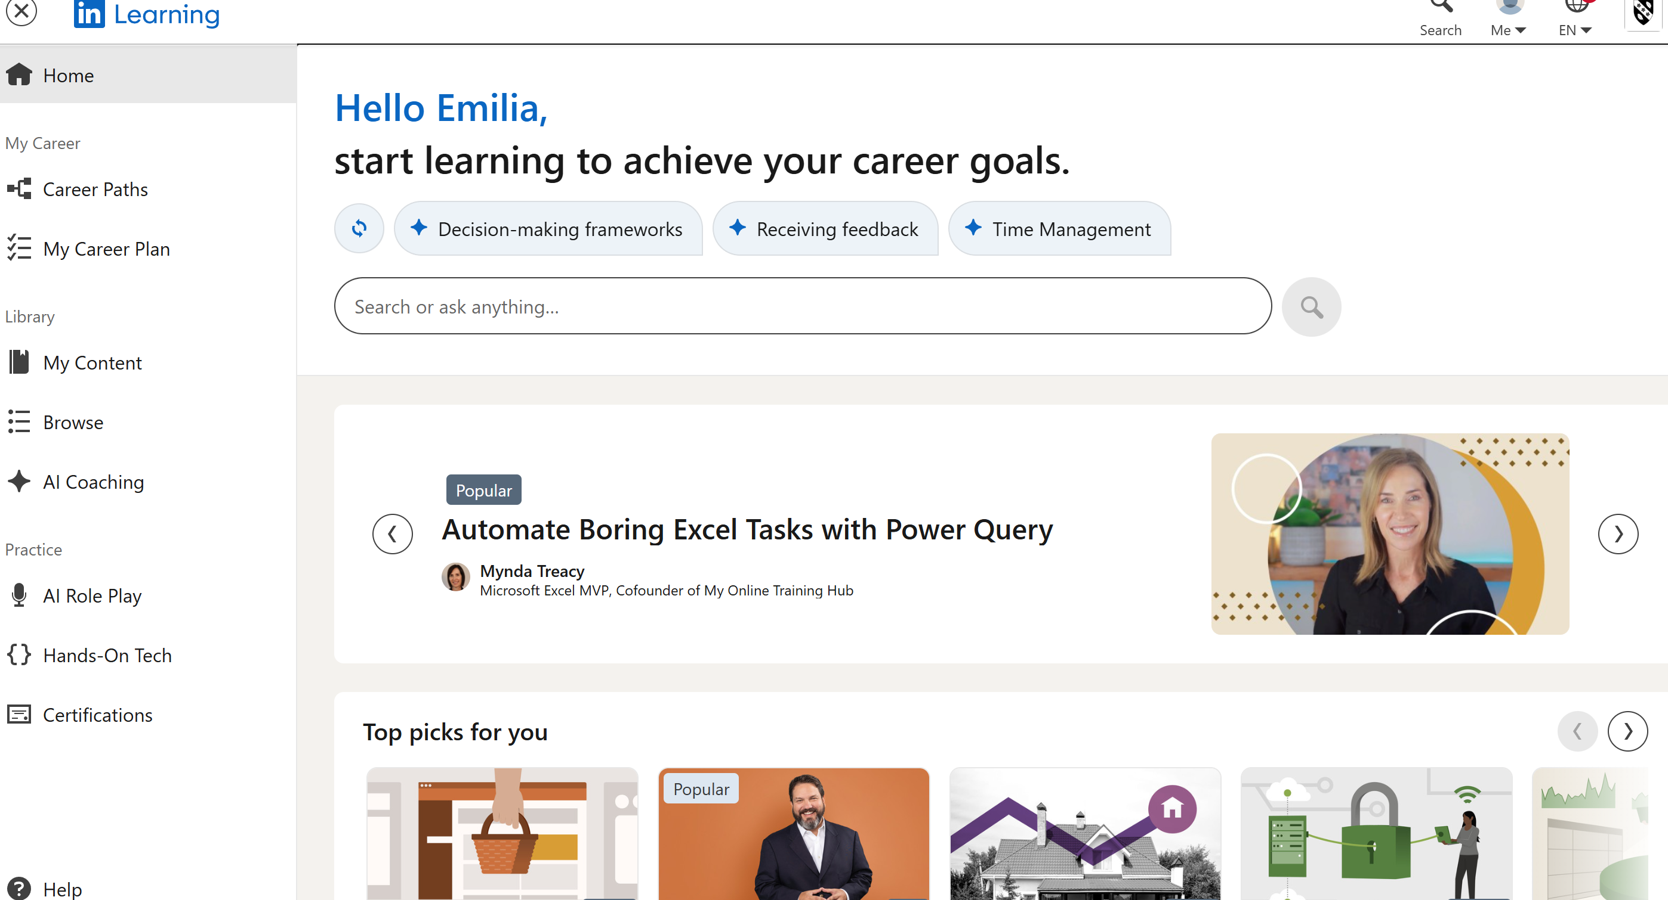
This is a screen shot using linked in to search for possible career goals. This also shows my use of screen shotting and cropping an image to size.

Screenshot/Photo 4
[Insert Photo/Screenshot below]

Here we have an online new paper where I can find the latest around the world.
I found this by searching in the web browser and click on the link below.

Screenshot/Photo 5
[Insert Photo/Screenshot below]

Here is a post about food and percentages and low custom Nower days. This again shows my skill using screen shotting and also cropping the image again. Also I have fact checked information provided to.

Screenshot/Photo 6
[Insert Photo/Screenshot below]
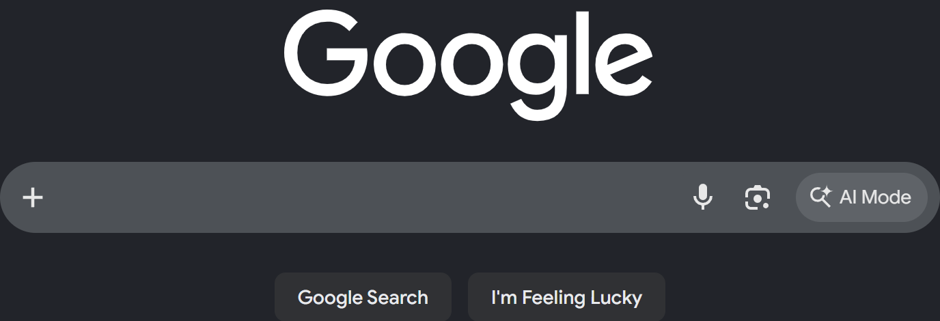
This is me using the web browser to find google in which I can use this search engine to find anything with the key words I use. This shows I can use search engine to find information I need.

My Short Reflection
- Write 5–8 simple sentences about your digital life.
- You can use the sentence starters below if helpful.
I use digital skills to find information I’m in need of.
I feel confident when I have help and support with classmates as its motivating.
I want to improve on my social skills and digital skills overall.
I often use these tools at home on my phone when looking for things.
I sometimes feel nervous about how to upload things to my assignments.
I hope this module will help me to understand further about computer skills.
Digital skills are important for me because my course revolves around computers and deep understanding of how they work.

Sentence starters
- I use digital tools to …
- I feel confident when I …
- I want to improve …
- I often use these tools: …
- I sometimes feel nervous about …
- I hope this module will help me …
- Digital skills are important for me because …
You can write more if you want.

Submission Checklist
Before you submit, please check:
​​​ ☐ I added 4–6 screenshots
☐ I wrote short sentences for each screenshot
☐ I wrote my short reflection
☐ My work is my own
☐ My file opens correctly
​​☐ My file opens correctly

