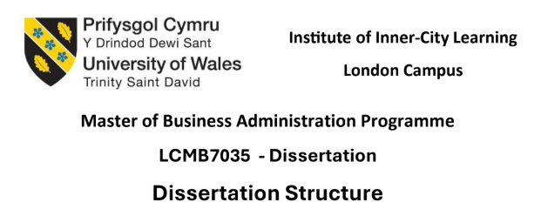

EVALUATING THE EFFECTIVENESS OF SUSTAINABILITY MARKETING IN BUILDING BRAND EQUITY: A CASE STUDY OF ADIDAS
Student name: Rikul Rana
Student ID: 2427668
Supervisor name: Thomas Adeyemi
Date of submission : 27 -01-2026

Abstract
Marketing sustainable sportswear is nowadays a very significant strategic instrument of global sportswear companies as consumers are getting more environmental aware and demanding of corporate sustainability proclamations. This paper considers the success of sustainability marketing in creating brand equity on the case of Adidas. The study will attempt to analyse the effects of sustainability marketing on consumer awareness, trust, brand perception, loyalty, and recommendation behaviour.
The research design embraced in the study is quantitative research based on the philosophy of positivism and the deductive methodology. The primary data were gathered using structured online questionnaire in which 118 respondents who were conversant with Adidas products and sustainability initiatives were used. Data were analysed in SPSS where descriptive statistics, correlation analysis, regression analysis, reliability testing, t-test, and chi-square analysis were used.
The results show that sustainability marketing by Adidas has a good impact on consumer-based brand equity. The respondents were found to be very aware and communicate clearly on sustainability initiatives. The findings also prove that perceived transparency and authenticity of sustainability claims have a strong influence on consumer trust, which subsequently has an affirmative impact on brand perception, repeat purchase intention, and recommendation via the word of mouth. Nevertheless, the researchers also conclude that the awareness is not a sufficient factor that can lead to the increase of loyalty, and that credibility and consistency are of utmost importance in the sustainability communication.
The paper ends with the conclusion that sustainability marketing should be provided with clear practises and with the realorganisational commitment. The results can be used in the existing literature as well as the findings in the article have produced empirical evidence on the importance of sustainability marketing in enhancing brand equity in the sportswear sector and also contribute to the practical implications of enhanced sustainable brand strategies.
Table of Contents
Chapter 1: Introduction 7
1.1 Research Background 7
1.2 Problem Statement 7
1.3 Research Aim, Objectives, and Questions 8
1.3.1 Research Aim 8
1.3.2 Research Objectives 8
1.3.3 Research Questions 8
1.4 The Rationale of the Study 9
1.5 Research Methodology 9
1.6: Dissertation Structure 10
Chapter 2: Literature Review 11
2.1 Chapter Introduction 11
2.2 Key Concepts of Sustainability Marketing and Brand Equity 11
2.3 Theoretical Review 13
2.4 Thematic Reviews 15
2.5 Empirical review 18
2.6 Literature Gap 21
2.7 Summary 21
Chapter 3: Methodology 22
3.1 Chapter Introduction 22
3.2 Research Philosophy 23
3.3 Research Approach 23
3.4 Research Design 24
3.4.1 Quantitative 24
3.5 Research Strategy 24
3.5.1 Survey 24
3.5.2 Case Study Context: Adidas 25
3.6 Data Collection Method 25
3.6.1 Primary Data Collection 25
3.6.2 Questionnaire Structure 25
3.6.3 Data Collection Procedure 26
3.7 Population and Sampling 26
3.7.1 Target Population 26
3.7.2 Sampling Method 26
3.7.3 Sample Size 27
3.8 Data Analysis Method 27
3.8.1 Descriptive Statistics 27
3.8.2 Data Presentation 27
3.9 Variables and Measurement 28
3.9.1 Independent Variables 28
3.9.2 Dependent Variables 28
3.9.3 Measurement Scales 28
3.10 Reliability and Validity 28
3.10.1 Reliability 28
3.10.2 Validity 29
3.11 Ethical Considerations 29
3.11.1 Informed Consent 29
3.11.2 Confidentiality and Anonymity 29
3.11.3 Ethical Data Handling 29
3.12 Methodological Limitations 30
3.12.1 Limited Depth 30
3.12.2 Sampling Limitations 30
3.12.3 Self-Reported Data Limitations 30
3.13 Chapter Summary 30
Chapter 4: Findings, Analysis and Discussion 31
4.1 Introduction 31
4.2 Overview of findings 31
4.3 Presentation of Findings 33
4.4 Demographic Characteristics of Respondents 46
4.5 Descriptive Analysis of Sustainability Marketing perceptions 46
4.6 Reliability Analysis 48
4.7 Correlation Analysis 49
4.8 Regression Analysis 49
4.9 Chi-Square and T-Test 50
4.10 Research questions, hypotheses testing and evidence from analysis 51
4.11 Discussion of Findings 55
4.11.1 Sustainability marketing awareness and consumers' understanding 55
4.11.2 Demographic diversity and sustainability perception 56
4.11.3 Education, Transparency and Authenticity Perception 56
4.11.4 Sustainability Marketing, Trust, and Brand Perception 56
4.12 Chapter Summary 57
Chapter 5: Conclusion and Recommendation 58
5.1 Introduction 58
5.2 Conclusion 58
5.3 Recommendations 60
5.4 Limitations 60
5.5 Future Scope 61
5.6 Final Remarks 61
References 62
Appendices 73
Appendix 1: Survey Link 73
Appendix 2: Results 73
Appendix 3: Correlation table 73
Appendix 4: Regression analysis 79
Appendix 5: Coefficients 79
Appendix 6: T-test 81

Chapter 1: Introduction

1.1 Research Background
Global branding has been a strategic concern of global brands in the previous years, specifically in the sportswear industry, where environmental impact of the production and materials, supply chains, etc. have been put into greater focus (Jaworek et al. 2021). The consumers have been becoming more environmentally conscious and they require brands to be genuinely interested in sustainability. Consequently, marketing has come to be based less on traditional performance-based messaging and more on sustainability-based marketing (Jusuf and Nuttavuthisit, 2023). Adidas, in particular, has initiated the strategies like recycling, carbon-neutral production goals, and collaboration with the activities that promote the use of environmentally friendly consumption (Hakovirta, 2024).
These attempts are communicated through sustainability marketing, to influence positive consumer attitudes and build on the long-term relationship (Jaworek et al. 2021). Despite this trend, the actual effectiveness of sustainability marketing on trust and loyalty as well as brand preference is a disputable matter. The reason why these campaigns impact consumer behaviour and actually lead to brand equity is important to organisations, which are interested in achieving a balance between commercial objectives and sustainability issues.

1.2 Problem Statement
Although sustainability marketing has currently evolved into a major necessity of sportswear companies, whether these marketing practices are viable in all respects to establish consumer trust, brand loyalty and the overall brand equity is a question that is yet to be answered (Jismarket al. 2025). The sustainability message is disseminated by most organisations, though consumers tend to question the truthfulness of the statement because they are concerned about greenwashing or transparency (Bhagat, 2024). This ambiguity will compromise the desirable effectiveness of sustainability-based campaigns. In the case of Adidas, although the company has invested heavily in their sustainable materials and environmental operations, it is not evident that whether the company is in fact creating a brandequity, or simply doing what the industry needs (Riquet and Lachenaud, 2024).
The available literature has covered sustainability practice and consumer dispositions, but not in a deeper understanding of how sustainability marketing has a direct influence on brand perception in the sportswear sector (Vizcaino and Kettunen, 2023). The issue thus is the disjuncture between the marketing operations in the area of sustainability and the measurable consumer response gained out of the marketing operations. The current study will address this research gap through the evaluation of the actual impact of sustainability marketing on the consumer perception and loyalty of Adidas consumers.

1.3 Research Aim, Objectives, and Questions

1.3.1 Research Aim
This study aims to evaluate the success of sustainability marketing in creating brand equity in the case of Adidas, primarily by focusing on how the sustainability driving campaign influences consumer trust, brand perception and loyalty.

1.3.2 Research Objectives
- To explore how organisations in the sportswear industry are incorporating the sustainability values and messages in sustainable marketing campaigns.
- To assess the effects of sustainability marketing on the perception of consumers and brand loyalty.
- To determine the issues and constraints to applying the sustainability marketing strategies in the sportswear industry.
- To recommend effective Strategies for the organisation in improving the effectiveness of its sustainability marketing in strengthening brand equity and customer engagement

1.3.3 Research Questions
- How are organisations in the sportswear industry incorporating sustainability values and messages in sustainable marketing campaigns?
- What is the impact of sustainability marketing on the perception of consumers and brand loyalty?
- What are the issues and constraints to applying the sustainability marketing strategies in the sportswear industry?
- What are the recommended strategies for the organisation in improving the effectiveness of its sustainability marketing in strengthening brand equity and customer engagement?

1.4 The Rationale of the Study
The research paper is significant as the aspect of sustainability has become part of competitive strategy in the sportswear sector, and its impact on brand equity is not well known. To Adidas, sustainability is considered to be not only a corporate responsibility initiative, but also a strategic branding instrument aimed at distinguishing the company among the many competitors in the market (Riquet and Lachenaud, 2024). However, consumers’ rising expectations for transparency mean that merely promoting sustainability may not be enough to build trust or loyalty. Therefore, examining whether the sustainability marketing of Adidas genuinely shapes positive consumer perception is essential to evaluate the effectiveness of its current branding approach.
The study also provides value to the industry stakeholders through recognising obstacles faced by organisations, such as cost implications, credibility issues, and communication challenges in implementing sustainability marketing (Tinonetsana and Musariwa, 2024). Overall, the study in general provides timely information on how to enhance sustainable-driven communication in order to increase brand equity and long-term customer relationships.

1.5 Research Methodology
The current study uses a quantitative research method because this approach is structured and objective in nature for measuring consumer perceptions, attitudes, trust, and loyalty towards sustainability marketing used by Adidas (Ghanad, 2023). The survey has been conducted via a structured online survey in the form of closed-ended questions and Likert scale items to allow reliability and facilitation of statistical data analysis. Adidas consumers have been sampled, especially those who have been involved in sustainability programs, to ensure the acquisition of relevant information. Positivism research philosophy and deductive research approach have also been employed in the research (Ali, 2024). Through using thematic analysis, the collected information has been analysed.

1.6: Dissertation Structure
The Introduction provides the aim and objectives of the research, and also include background, problem statement, and rationale.
The Literature Review critically analyses the available literature about sustainability marketing, green consumer behaviour, and brand equity. A gap in literature has been also mentioned that make the research more significant.
The Research Methodology describes the research methods from collection of data to interpret the result. It is included quantitative method, sampling, collection of data and the ethical concern.
The chapter of Data Analysis and Discussion describes the statistical results and explains the impact of sustainability marketing on consumer trust, perception, and loyalty.
Lastly, the Summary, conclusion and recommendation is to summarise the main insights, present practical recommendations to Adidas, and identify limitations as well as areas of future research.

Chapter 2: Literature Review

2.1 Chapter Introduction
The literature review has explored existing theoretical and empirical research on sustainability marketing, green consumer behaviour and brand equity in the effort to give a full background on the impact of the sustainability-led campaigns on consumer perception about Adidas. As sustainability becomes a strategic agenda in the global sportswear brands, there has been an increased scholarly interest in assessing how well the green marketing initiatives create trust, loyalty, and brand preference (Jung, 2024). The review starts with an exploration of principles of green marketing and how companies can communicate environmental values to consumers. It also examines the reaction of consumers to the assertions of sustainability with special attention to its credibility and authenticity and perceived value. Moreover, the review explores the Brand Equity Theory to learn how the sustainability messages can help in brand associations, trust, and long-term loyalty. Through a combination of the findings generated by these fields, the literature review shows some important debates, gaps, and opportunities which serve to inform the research questions.

2.2 Key Concepts of Sustainability Marketing and Brand Equity
Sustainability Marketing
In sustainability marketing approach a brand or organisation focuses on the environmental and social impact of their products or services. It is a structural approach to reduce carbon footprint, integrate sustainability in the supply chain and promote long-term adaptability. According to Schreiber et al. (2025), in the footwear industry, this marketing strategy involves sourcing eco-friendly raw materials, sustainable product design, reducing waste and greenhouse emissions, consumer engagement and ethical labour practices.
Adidas, the largest footwear manufacturer in Europe, takes some sustainability initiatives which enhance its core value as well as increase brand value. According to Adidas (2024), their sustainability goals involve reducing carbon emissions by 9% by 2025 and achieving net zero emissions by 2050. They take several initiatives, like designing sustainable footwear, FUTURECRAFT.LOOP and recycled ocean plastic by making a partnership with Parley according to Bartle, (2021). The company also organises many sustainable campaigns, such as "End Plastic Waste", "Made with Recycled Products", for circular fashion. These campaigns and take back programmes demonstrate Adidas's marketing strategy and also motivate their consumers to participation in their sustainability effort. Reid et al. (2024) stated that, the brand also values all stakeholders' expectations by promoting sustainability throughout its operations and being transparent about its annual sustainability report.
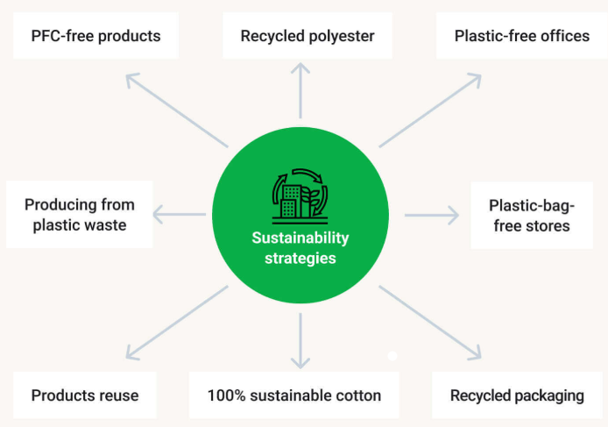
Figure 2.1: Adidas’s Sustainable strategies
(Source: HelpfulPapers, 2024)
By maintaining all these things, Adidas can achieve its sustainability goal and gain a competitive advantage in the global footwear industry. Zulfikar (2024) stated that, brand can also strengthen its core value, improve brand image and attract environmentally conscious consumers through its sustainable initiatives. Not only establish them as a leading footwear brand, but Adidas also acts as an environmental innovator that reforms itself according to systematic change (Patras, 2021).
Brand Equity
Brand equity is an added value beyond its functional attributes, which a company achieve through its product or service. Brand association, consumer perception, and their emotional bond with the company, trust, and loyalty are all components of brand equity. A company establish a positive brand equity by making its product sustainable, easily accessible and recognisable. According to Sutanto and Kussudyarsana(2024), when a company build positive brand equity, customers are ready to pay a high amount for its product even if they get the same product in less price from another brand. It can enhance the brand's loyalty, expand the product line, and maintain long-term success.
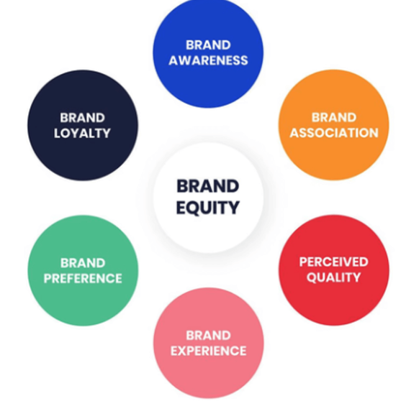
Figure 2.2: Components of Brand Equity
(Source: Qualtrics, 2019)
In the global sports footwear industry, Adidas has nurtured a strong and positive brand equity through its innovative product design, cutting-edge design, high-performance athletic shoes, and recommendations by famous athletes, according to Saviolo, (2025). The iconic three-step logo, strategic sports partnerships and collaboration with fashion designers and high face value celebrities help this brand to build a substantial brand equity. Moreover, by incorporating sustainability into its marketing strategy, Adidas can boost its brand equity by attracting eco-conscious consumers. By promoting transparency in sustainable raw material sourcing, reducing carbon emissions, and fostering ethical labour practices, the brand can enhance its brand image according to Riquet and Lachenaudy (2024).

2.3 Theoretical Review
The theoretical framework is the scholarly foundation on which the current research examines the viability of sustainability marketing in developing trust, perception, and loyalty of consumers to the brand, and eventually brand equity of Adidas.
Green Marketing Theory
Green Marketing Theory is the first pillar of this study. Stoica (2021) explained that this theory is applied in explaining how organisations incorporate environmental values in their marketing, product development, and communication strategies to appeal to consumers who prefer products that are ethically and sustainably made. It explains that the consumers will form other more positive attitudes towards the brand once the itfulfils their beliefs in the environmental matters such as reduction of wastes, recycling or reduction of carbon as explained by Nguyen and Mogaji (2022). The Green Marketing Theory helped the research by exploration of how Adidas conveys the message concerning their environmentally-friendly practices, such as recycled plastics, recycled plastics, or circular manufacturing, and how this message is perceived by a customer as a responsible person or organisation (Nguyen and Mogaji, 2022).
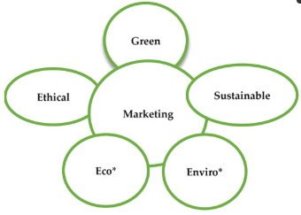
Figure 2.3: Green Marketing Theory
(Source: Bhardwajet al. 2023)
It is also with the assistance of this theoretical lens that credibility of the message, transparency and authenticity are given. There is a risk that consumers will feel the problem of greenwashing is being exaggerated or deceived, and this may have a negative impact on the trust (Senyapar, 2024). Hence, the theory helps to study the good and the potential bad consequences of sustainability marketing.
Brand Equity Theory
The second theory is the Brand Equity, which is on the concept of actualise values generated by a brand through consumer associations, perceived quality, trust, and loyalty, which are evaluated by Mukhtar et al. (2024). In this theory, brand equity is high when the perception towards the consumers is favourable, differentiation value achieved and attachment towards the brand is created. The Brand Equity Theory was applied to this research and evaluated the potential of sustainability marketing to provide some value to the brand equity of Adidas (Ahmadian et al. 2023). Particularly, it tested the relationship between sustainability messages and the key dimensions of the brand equity including brand trust, brand perception, and brand loyalty. The theory assisted in comprehending the impact that sustainability programmeshave to brand trust and strengthen consumer association with brand values and repeat buying behaviour (Ahmadian et al. 2023).
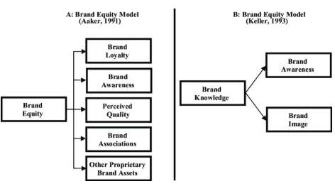
Figure 2.4: Brand Equity Theory
(Source: Atilganet al. 2009)
These theories together gave a holistic approach to understanding the way in which sustainability marketing is a brand-building strategic tool. The independent variables that are explored with the help of Green Marketing Theory include sustainability messaging, environmental initiatives, and perceived authenticity (Stoica, 2021). The theory is the Brand Equity Theory, which directs the analysis of the dependent variables, such as consumer trust, consumer perception and loyalty (Supiyandiet al. 2022). Moreover, this combined framework places the research in the context of the current academic arguments. Prior literature often examines sustainability initiatives or brand equity independently, whereas little literature has directly connected sustainability marketing to the brand equity context in the sportswear category. Through the utilisation of the two theories, this study has added to the existing information and at the same time filled this gap.

2.4 Thematic Reviews
Integrating Sustainability Values and Messaging into Sustainable Marketing Campaigns of Adidas
According to Jung (2024), in the sportswear industry, many global organisations are incorporating sustainability values and launching several sustainability marketing campaigns, as nowadays social and environmental responsibility has become a key factor for motivating consumer choices. Adidas spread sustainability through their product promotion and digital storytelling. A company has partnered with Parley to produce eco-friendly footwear that is made from ocean-recycled plastic (Adidas, 2019). This campaign reflects its commitment to achieving the sustainability goal and influencing consumers' purchase decisions. In the modern digitalised era, Digital Marketing also plays a crucial role in promoting sustainability.
Transparency helps the company to attract consumers and make emotional bonds, and enhance credibility. Jestratijevic et al. (2022) stated that, by disclosing data about carbon footprint, greenhouse emission and supply chain improvement sportswear brand can increase their transparency. Conversely, those companies that are accused of greenwashing damage their reputation and lose customers. According to Abu-Bakar and Almutairi (2024), by incorporating the Circular Economy Principle in their sustainability marketing, Adidas can increase consumer trust in the company's sustainability goal. For this finding, researchers are used Partial Least Squares Structural Equation Modelling (PLS-SEM) and non-parametric statistical methods.
Evaluate the impact of sustainability marketing on consumer perception and brand loyalty.
According to Dubey et al. (2025) Sportswear brands like Adidas, which are transparent about their sustainability campaign, like recycling process, eco-friendly packaging, or ethical sourcing, strengthen consumer trust and show empathy. This approach also helps the company to make them unique respective to other traditional sportswear brands and represent itself as a leader in sustainability. Adidas sets its mission and vision, which aligns with consumers' personal choice, especially environmentally conscious consumers, and its commitment to sustainability, boosts customer satisfaction, and can lead to better engagement. By using both primary and secondary data analysis, Dhinessh Kumar (2025) stated that, many consumers are ready to pay an extra price for any particular product just because of Adidas's brand value. Nonetheless, sometimes organisations fail to meet their sustainability goals, which may damage brand reputation and can lead to consumer dissatisfaction. Şenyapar (2024) argued that when the company to not transparent about their sustainable report or recycling practices, consumers feel let down, which may lead to trust issues and diminish loyalty, through qualitative analysis that employs a thematic analysis of greenwashing and its impact.
Jaworek et al. (2021) established that, Sustainability marketing is an important factor to enhance Brand Loyalty by developing brand image, increasing consumer trust, and contributing to transparent communication by primary data analysis using official statistical sources such as Statista and EquityRT. By applying this method, the researcher has found that marketing strategy demonstrates social and environmental duties of the brand, which appeal to Gen Z and Millennials consumers in particular, as they are environmentally conscious. By increasing brand loyalty, Adidas establishes itself as a leading sportswear brand and remains competitive in the global market.
Complications and Limitations in Implementing Sustainability Marketing in the Sportswear Industry
Although sustainability marketing has several advantages and is significant for shaping consumer perception and building brand image, for a larger sportswear company like Adidas, the implementation is quite tricky due to it has limitations and complications. In a detailed analysis, Mukherjee and Bharti (2025) discovered that due to the fact that Adidas is a global company, and outsources almost all its production, it is quite difficult to guarantee a coherent level of sustainability, such as lessening wastefulness, recycling products across the various chain of supply.
Since sustainability is a worldwide issue, in some instances, like reporting on annual reports or issuing a policy on deforestation, they are not entirely transparent, identified by Hakovirta (2024) through the process of analysing secondary data. This weakness causes the attitude of greenwashing and mindful consumers that question their authenticity, damaging brand loyalty and affecting their credibility. Furthermore, sustainable production requires high investment. According to Lodhi et al. (2024), for producing sustainable products and promoting these things, Adidas needs to incorporate proper infrastructure, new technologies, and proper research that is cost-effective and directly impacts business profitability. Researches employed a series of case studies to find these findings. As a result, sustainable products become high in price compared to other conventional products, which can limit their accessibility, especially for price-sensitive customers.
As the global sportswear market is super competitive, Adidas faces intense competition from its competitors like Nike and Puma. It is also a concern for Adidas, which may affect its profitability. According to Chakravarty et al. (2024), sportswear industry is volatile and there is no switching cost, eco-conscious consumers are easily shifting their choice to sustainable products.
Recommendation for Improving Sustainability Marketing
To mitigate the above risks and improve the effectiveness of sustainability marketing in strengthening brand equity and consumer engagement, Adidas should adopt some strategies. Through secondary data analysis, Tolegenov et al. (2024) stated that, the company should be transparent about its sustainability initiatives, focusing on authenticity and digital promotion. They can create a 3D video about their entire process from ethical sourcing to product innovation, which enhances consumer trust. The brand should create blogs, reels, and 3D videos of complex environmental issues and how they solve these (Murugesanet al. 2024). This strategy increases Adidas’s long-term loyalty as well as create an emotional bond with consumers. Instead of just sharing facts, use engaging stories and visuals to reflect the positive impact of sustainability initiatives on the environment. According to Rathore (2023), sportswear Company can also introduce robust data analytics and Artificial Intelligence to know consumer preferences through their website. Reward programme, attractive offers or discount for returning used products for recycling and exchange service is another effective strategy for improve sustainable marketing.

2.5 Empirical review
Integrating Sustainability Values and Messaging into Sustainable Marketing Campaigns of Adidas
Shee Weng (2024) has employed case study analysis of both European Union and Asia. Through this study, he explores that, initiatives like sustainable supply chain, ethical sourcing, “End plastic waste” campaign, recycled raw materials and renewable energy consumption are taken by Adidas to influence young eco-conscious consumers, increase trust and long-term brand loyalty. Through qualitative data analysis and Triple Bottom Line approach Moshood et al. (2022) found that, material Innovation is the most common approach, where a brand focuses on using recycled, renewable, and biodegradable products.
Vemuri et al. (2024) have employed quantitative data analysis through a survey questionary to gather data on 200 Indian consumers, to explore the role of several social media platforms, influencer marketing, and celebrity promotion to promote sustainability and enhance consumer awareness. By using this marketing strategy, sportswear industry strengthens its reputation and achieve long-term loyalty. Transparency and Authenticity are other significant factors to promote sustainability. Gonçalves and silva (2021) has employed qualitative research methodology in their research and found that stated, sportswear brands like Adidas must be transparent about their annual carbon report, sustainability report, and third-party certifications. Nazarian et al. (2025) have employed a quantitative research methodology. They have collected 201 consumers’ data through questionnaire method and found that clear and transparent communication enable any sportswear company to build strong emotional attachment with their consumers who value authenticity.
Evaluate the impact of sustainability marketing on consumer perception and brand loyalty.
Rastogi et al. (2024) have adopted a mixed method research method approach incorporating descriptive and casual methods was used. They collected data from 302 participants. Through this research, researchers are found that, sustainability marketing has taken center stage in the current business environment, empowers the perception of consumers and brand loyalty positively through a stronger brand loyalty in the long-run, greater trust, and emotional connections with young customers who are environmentally conscious. Kothari et al. (2025) have employed a quantitative approach for these findings. A total of 500 valid responses were subjected to exploratory and confirmatory factor analysis, and the hypotheses were tested via structural equation modelling.They found thatCredibility and authenticity of a brand about sustainability messages is a key determinant of Consumer Perception.
By employing a quantitative survey methodology to gather data from 50 respondents, Rahman (2025) found that, sustainable promotion through social media, increase repeat purchase are retain consumers. When an individual believes that brands are transparent about its commitment towards sustainability, they are more likely to remain loyal and create an emotional bond with the brand. Through a qualitative case study analysis, Wu (2025) found that, sportswear companies also mitigate greenwashing through their authenticity and consumer relationship. Moreover, according to Borah et al. (2023) sustainability initiatives also improve Adidas's product quality and value, as consumers who are worried about pollution, directly associated with the company's sustainable innovation. The findings based on primary data analysis by using a structured questionnaire and engaging 259 manufacturing firm.
Complications and Limitations in Implementing Sustainability Marketing in the Sportswear Industry
By analysing over 150 peer-reviewed articles and industry report, Esan et al. (2024) found that, one of the significant challenges for this company is maintain and control a diverse supply chain and ensure ethical labour practice consistently. Adanma and Ogunbiy (2024) have employed a combination of systematic literature review and content analysis, they scrutinises peer-reviewed articles, policy documents, and reports from 2014 to 2024. The methodology encompasses a structured search strategy across major databases, applying specific inclusion and exclusion criteria. The findings revealsthat, differences in regulatory compliance, economic policies and political environments also hamper company’s capacity to promote sustainability.
Another obstacle to the sustainable marketing of the sportswear industry is consumer distrust and greenwashing claims. Santos et al. (2024) have employed a survey design using cross-sectional primary data from 420 Portuguese consumers who identified and recognized brands engaged in greenwashing. They stated that, if a company’s marketing claimnotalign with their operational performance, it may be perceived as a greenwashing and have adverse effect on brand image. Moreover, balancing between sustainability and efficiency is another challenge for Adidas. Through bibliometric analysis of 545 studies on sustainable material published in between 1999-2023, Popescu et al. (2024) stated that, some sustainable materials still endeavour to match their performance level with conventional synthetic products, which have high durability and longevity.
Recommendation for Improving Sustainability Marketing
To overcome the challenges and strengthen sustainability marketing, sportswear companies are adopt some strategies. By employing mixed method research approach, Jain and Mitra (2025) stated that, by using third-party certifications like Fair Trade and Global Recycled Standard, Adidas can validate sustainability claims. These findings also reveal the significance of standardised global guidelines, personalised support and transparency. By employing quantitative research of 311 samples collected from tourism and hospitality firms in Taiwan, Liu and Dong (2021) found that, technological advancement is playing significant role in improving sustainability marketing. By using digital storytelling, production videos and behind-the-scene documentaries, companies areenhance their green marketing. According to Gong et al. (2023) have employed primary data analysis through a self-administrated questionnaire was distributed to 393 potential purchasers. They explore that sportswear companies can enhance consumer engagement and involve customers in its sustainability campaign, ultimately improving its long-term loyalty.

2.6 Literature Gap
Despite the useful information presented by current literature on sustainability, branding, and consumer behaviour, there are still a number of research gaps in the knowledge on how effective sustainability marketing is in the context of the sportswear industry. In the previous studies, the elements of brand success are identified, like innovation and global visibility (Jaworek et al. 2021), but there is a small amount of analysis on how sustainability messages specifically influence consumer trust and loyalty. The literature of sustainable business strategies also noted that environmental orientation needs to be consistent with organisationalbehaviour (Jusuf and Nuttavuthisit, 2023), although the authors do not investigate the relationship between these strategies and the brand equity results in consumer markets. Similarly, research on carbon-neutral business models focuses on organisational practices rather than consumer perceptions (Hakovirta, 2024).
Although the latest literature provides determinants of customer loyalty within the sportswear sector (Jismarket al. 2025), it does not assess sustainability as a core driver. Further, researchers also warn that greenwashing affects credibility, but the empirical data on the role of authenticity in the brand equity of Adidas is limited. Therefore, there is a definite gap in the research on the connection between sustainability marketing and perception, trust, and loyalty in a single brand setting.

2.7 Summary
It is concluded that, at present, sustainability marketing is essential in the footwear industry. Larger Sportswear Companies like Adidas have integrated sustainability through using recycling products, ethical sourcing and labour practices and numerous campaigns. It is proven that authenticity in sustainable marketing strengthens its brand equity as well as consumer perception, while greenwashing leads to scepticism and damages brand image. Nevertheless, this marketing approach also faces challenges regarding high investment cost, need for advanced infrastructure, and supply chain complexity. To overcome all these barriers and improve effectiveness, Adidas should be transparent and foster community engagement.

Chapter 3: Methodology

3.1 Chapter Introduction
This chapter states the methodological framework that was used in the assessment of the effectiveness of sustainability marketing in the establishment of brand equity in the case of Adidas. Since the research aims to gain insights aboutthe consumer perception, trust, loyalty and awareness about the sustainability initiatives of Adidas, there is a need to use a research methodology that can give reliable and quantifiable results. The chapter starts by explaining the research philosophy and approach used in the research study, and then explains the research design and strategy. It goes further to discuss the target population, sampling procedure, methods of data collection and methods of analysis. Focus is placed on the measured variables of the study, the actions that were taken to maintain reliability and validity, and the ethical issues that were used to guide the research.
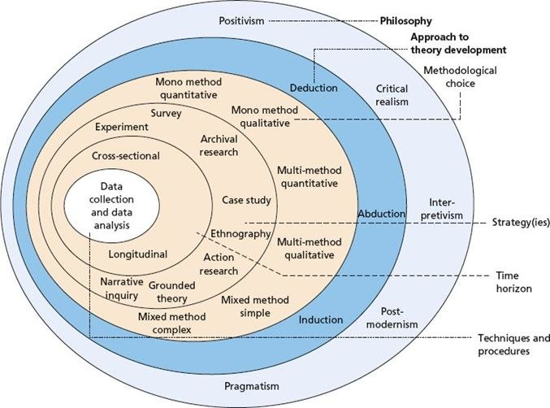
Figure 3.1: Saunders’ Research Onion
Source: Saunders et al., (2019, p. 108)
The research onion by Saunders is a stratified model that demonstrates the steps that a researcher has to take in the form of philosophical, methodological and procedural decisions when creating a research methodology.

3.2 Research Philosophy
Positivism also aims at objective laws by using quantitative data whereas interpretivism aims at subjective meaning by using qualitative methods. This study embraces the critical realism in order to examine the structures behind the observed organisational phenomena.
This study is based on a positivist research philosophy since it focuses on observable, measurable and objective realities. As the purpose of the dissertation is to analyse the consumer perception of the sustainability marketing of Adidas and the connexion between its perception and brand equity, the philosophical position, which justifies the use of numerical data and organised processes, is the most suitable. Positivism presupposes that such social phenomena as consumer trust, awareness, and loyalty can be measured and studied with the help of systematic tools (Ali, 2024).
This approach is consistent with this philosophy, where structured questionnaires allow data to be presented in the form of numbers and analysed with the help of descriptive statistics. Another assumption that positivism agrees with is that respondents would give correct and truthful answers to the standardised questions, and accordingly, the researcher is able to establish common patterns and trends among the sample. The positivist approach ensures that the study is grounded in objectivity, measurements, and empirical observation, all of which are the key elements of the quantitative design. The application of positivism is explained by the aim of the research, which is to discover the general patterns of behaviour and not to examine the subjective experiences.

3.3 Research Approach
Inductive approach constructs theory based on particular observations whereas deductive approach tests theory based on obejctives. This research work will utilise deductive methodology in order to empirically test the hypothetical construct.
In this research, the research methodology embraced is that of deductive research that starts with already accepted theories and proceeds to empirical tests. The reviewed literature in the earlier chapters has indicated the applicability of the Green Marketing Theory and Brand Equity Theory in explaining the connection between sustainability messaging and consumer behaviour. These theoretical foundations can be used in constructing the questionnaire through a deductive approach and direct the overall direction of the research. Deduction is hence suitable since it allows the researcher to investigate the relationship between the real consumer behaviour and the already established theories in the sportswear industry.
Application of deduction is also considered to be reasonable since the objective of the study is not to formulate new theories but rather to experiment with the current concepts in a particular brand environment (Pearse, 2021). The structured and quantitative objectives of the study would not be compatible with an inductive approach, which entails the construction of new theories with the help of qualitative data.

3.4 Research Design

3.4.1 Quantitative
The study uses a quantitative research design due to the fact that the research aims at collecting numerical information that will be able to describe the perceptions and behaviour of consumers. A quantitative design enables the organised data gathering by online survey, using which it is possible to transform the data into frequencies, percentages and the average values (Kent, 2020). This technique is especially effective in the case of consumer-based constructs like trust, satisfaction, awareness and loyalty, which can be operationalised and quantified. The quantitative type of design adopted by the study is appropriate since it will be possible to analyse the findings in a systematised and objective way.
Moreover, quantitative studies facilitate the identification of tendencies in a fairly vast sample, which makes it appropriate for consumer behaviour research. The quantitative design has been appropriate because the study focuses on descriptive analysis. Quantitative research enables the respondent to give prompt responses after a series of structured questions, unlike qualitative research, where interviews last a long time, and they have to undergo a thematic analysis.

3.5 Research Strategy

3.5.1 Survey
The research methodology embraced is a survey approach with the help of an online structured questionnaire as a data collection tool. In quantitative research, the use of surveys is very common, since it can be used to efficiently gather information on a vast and varied population of participants. The online survey will be especially suitable to reach consumers who already know about Adidas, its environmentally friendly marketing, and give them the opportunity to fill out the questionnaire when they find it convenient to do so. Closed-ended questions are used so that responses are consistent and the chances of the researcher biasing the study are minimised (Baburajan, Silva and Pereira, 2020). The survey method is also economical and time-saving, which renders it appropriate for academic research. Besides, surveys are anonymous, and this means that participants will be free to present their perceptions as they are, hence making the data more reliable.

3.5.2 Case Study Context: Adidas
In spite of the fact that the survey was conducted among a broad group of consumers, the study has a case study focus on Adidas. The reason why Adidas was selected is due to its proactive engagement in the marketing of sustainability, especially with its campaigns like the “End Plastic Waste” and the “Made to Be Remade” ones. A case study research method will enable the study to concentrate on only one organisation, yet use quantitative measures. Such emphasis will make the findings more relevant, and as such, the study will be able to examine the impact of sustainability marketing on brand equity in a brand in particular that has heavily invested in environmental responsibility.

3.6 Data Collection Method

3.6.1 Primary Data Collection
The structured online questionnaire that was administered via social media channels, email, and messaging software was used to collect primary data. Primary data will also be used to ensure that the findings are based on the contemporary understanding of consumer perceptions of sustainability marketing in Adidas, as opposed to secondary data (Gannon, Taheri and Azer, 2022). Objectivity is also facilitated by the collection of primary data since all the respondents respond to the same set of structured questions.

3.6.2 Questionnaire Structure
The questionnaire was divided into five parts, and each was to measure various aspects of the research objectives. The demographic data included in the first section consisted of age, gender, and level of education. The second part evaluated both the general awareness of the respondents on the topic of sustainability and the level of familiarity with the sustainability campaigns of Adidas. The third part encompassed perceptions of sincerity, openness and possible greenwashing issues. The fourth part discussed consumer trust, perceived quality and brand image. The last measure consisted of brand loyalty and brand equity. Most of the questions have been framed on a five-point Likert scale, which gives the respondents an opportunity to state the extent to which they agree or disagree in a measurable manner (Alabiand Jelili, 2023).

3.6.3 Data Collection Procedure
Data collection was done within a specified time frame in which the online survey link was distributed through various online platforms (Newman et al., 2021). A concise introduction was given on the purpose of the research, and assurances of anonymity and confidentiality were given to the respondents. The questionnaire took a short number of minutes to complete, and this likelihood enhanced participation. The data collection was beneficial because it is online; this aspect was quite handy considering the convenience it offers and the prevalence of online communication. When the necessary number of responses was achieved, the data was collected and made ready to be analysed.

3.7 Population and Sampling

3.7.1 Target Population
The target group of the study will be the consumers who have tried Adidas products or are aware of the sustainability efforts of the brand. This entails people of varying ages, sex, educational background and environmental awareness. Targeting real or possible Adidas customers would guarantee that respondents possess a significant level of perception regarding the sustainability campaigns of the brand, and their responses to the research questions would be applicable to the research goals. The population that will be used is suitable since the study focuses on consumer-based brand equity to a population that is well aware of the brand (Pina and Dias,2021).

3.7.2 Sampling Method
The sampling is non-probability, a convenient sampling where the respondents who are selected are those who are conveniently available and willing to take part. The convenience sampling is suitable as the overall number of Adidas consumers is very large and scattered, and random or stratified sampling would be very difficult. Furthermore, some elements of purposive sampling were incorporated since the study population had a certain level of familiarity with Adidas or the sportswear industry. Non-probability sampling can reduce representativeness, but in exploratory research, where the interest is to make an observationof a general pattern instead of statistical generalisation, non-probability sampling is appropriate.

3.7.3 Sample Size
The number of respondents that was considered a target sample was 118 respondents. This sample size is supported by various factors: it is suitable to a typical sample size of survey-based, exploratory business research at the level of analytical stability; it was enough and reasonable to obtain meaningful descriptive and comparative analyses across the key demographics subgroups (age, frequency of purchase, etc.); it is a reasonable and attainable target under the conditions of the study and non-probability sample.
Other, more statistically-based justification:
The target population size was 118 respondents. This size is realistically adequate to give steady estimates and substantive patterns, in accordance with rules of thumb in minimum subgroup analysis (e.g. 20-30 cases per broad demographic group). This is also within the resources and time scale of the study.

3.8 Data Analysis Method
In this research, SPSS analysis will be employed to summarise the data through computing counts, percentages, and means. The distributions obtained will be provided in frequency pie charts to determine the most recurrent responses and patterns amongst respondents.

3.8.1 Descriptive Statistics
The study solely uses descriptive statistics in order toanalyse the data taken. The descriptive analysis involves the calculation of frequency, percentages, and mean values to summarise the answers of respondents. Descriptive statistics enable the possibility of identifying the most frequent answers, the degree of agreement or disagreement of the answers given by the respondents, and depicting demographic distributions. As an illustration, frequency analysis can be used to demonstrate the number of respondents who have heard about the sustainability campaigns of Adidas, and the mean scores may demonstrate the mean extent of confidence in the brand.

3.8.2 Data Presentation
The findings will be displayed using tables, bar charts, and pie charts, based on the type of data to be summarised. Frequency tables will contain clear numerical summaries, whereas charts will illustratively show the pattern of responses. Such a way of presentation enables better readability and allows presenting trends in a simplistic way. All tables or charts will have narrative explanations of the main findings and their relationship with the research objectives.

3.9 Variables and Measurement

3.9.1 Independent Variables
The independent variables of the research pertain to issues of sustainability marketing, such as knowledge of sustainability promotions of Adidas, attitude to authenticity, and exposure to efforts to promote environmental responsibility. These variables capture the marketing processes that have been adopted by Adidas as it attempts to create brand equity and influence consumer behaviour.

3.9.2 Dependent Variables
The dependent variables are the consumer trust, brand image, brand loyalty, and the overall brand equity. These are the variables that sustainability marketing is meant to affect. The research is able to quantitatively measure these variables and find out the consumer response in relation to sustainability messaging and the extent to which it depicts a good brand association.

3.9.3 Measurement Scales
The five-point Likert scale enables the measurement of perceptions, attitudes and behavioural tendencies across respondents to be consistently measured. The use of Likert scales is appropriate in such research due to the fact that this research type offers ordinal data, which can be transformed into mean scores and percentages. Demographic variables (gender and age) were measured on a nominal scale so that their frequencies could be easily analysed.

3.10 Reliability and Validity

3.10.1 Reliability
To improve reliability, the questionnaire was designed well and piloted. The questions were also designed clearly and tried on a limited number of people before being distributed to the entire population in order to maintain uniformity in interpreting them. This pilot testing has also enabled the removal of the ambiguous or unclear items, hence enhancing the reliability of the final instrument. Although the reliability constructs, including Cronbach's alpha, were not calculated by using statistical software, the steps followed in the methodology included internal consistency.

3.10.2 Validity
There were several ways of attaining validity. The adequate content validity was achieved by the creation of the questions in the questionnaire on the premise of thorough reviews of literature conducted in other chapters. This has made sure that the questions are representative of the researching constructs, including trust, authenticity and loyalty. Face validity was confirmed through the opinions of academic supervisors and peers who interpreted the clarity and relevance of every question. The construct validity was established by linking the questionnaire items with the theoretical theories, like the Brand Equity Theory and the Green Marketing Theory. A combination of these measures is important to make sure that the instrument measures the variables as intended.

3.11 Ethical Considerations

3.11.1 Informed Consent
The research process was mainly based on ethical considerations. The participants were made aware of the study project, and they were also informed that their participation would be voluntary. They were also told that they could leave whenever they wanted without an excuse. Digital consent was received, and then the participants filled out the questionnaire.

3.11.2 Confidentiality and Anonymity
Personalization, like names, addresses, and contacts, was not gathered in the survey, and the information remained anonymous. All the answers were confidential and were used only for academic purposes. The storage of the data was also in a digital format to avoid access by unauthorised agents.

3.11.3 Ethical Data Handling
Everything in the sphere of data manipulation met the university's ethical standards. The researcher made sure that the data gathered was appropriate and without falsification. All the sources used in the research were referenced and acknowledged appropriately to prevent plagiarism.

3.12 Methodological Limitations

3.12.1 Limited Depth
The limitation of this methodology is that the descriptive statistics do not reflect the intensity of personal experiences and driving forces. Although the descriptive analysis is efficient in summarising the trends, it is incapable of examining the complicated reasoning behind consumer behaviours.

3.12.2 Sampling Limitations
The findings can only be generalised to a small extent with the adoption of convenience sampling. The sample is not necessarily representative of all Adidas consumers because the respondents were chosen on the basis of availability.

3.12.3 Self-Reported Data Limitations
Self-reporting data can also be prone to biases like social desirability, where the respondent will give socially desirable answers instead of giving an honest answer. Accuracy might also be influenced by the misconception of the ideas of sustainability.

3.13 Chapter Summary
This chapter has described the research methodology to be applied in the analysis of whether sustainability marketing can help to create brand equity for Adidas. The research philosophy, deductive approach, and quantitative research design embraced in the study are positivist, deductive, and have a survey strategy. The instrument used to collect the data was an online structured questionnaire that was administered to a convenience sample of consumers of Adidas. The study uses only descriptive statistics such as frequencies and percentages to analyse the data. Methodological constraints and ethical considerations were also mentioned. This methodological background sets the stage for Chapter 4, in which the data will be gathered, analysed, and organised.

Chapter 4: Findings, Analysis and Discussion

4.1 Introduction
This chapter contains a detailed analysis and discussion of the major data gathered to assess the usefulness of sustainability marketing in creating brand equity, specifically in respect to Adidas. It is analysed on the basis of the responses obtained with the help of structured questionnaire and analysed with the help of SPSS. According to the approach described in Chapter 4, both descriptive and non-descriptive statistical findings were used, such as frequency analysis, correlation, regression, reliability testing, t-tests, and chi-square analysis.
The chapter will seek to discuss how the research objectives may be fulfilled by exploring the consumer perception of the sustainability programme of Adidas, its authenticity and transparency, the degree of trust, and the effect of the sustainability marketing on the brand loyalty and advocacy. Findings are critically discussed based on Green Marketing Theory and Brand Equity Theory, the empirical and theoretical knowledge presented in Chapter 3.

4.2 Overview of findings
This section of the research significantly summarises the findings from the 118 survey responses gathered from consumers about the effectiveness of sustainability marketing in developing brand equity in the case of Adidas. In terms of general distribution, it has been identified that the demographic profile of respondents indicated a relatively balanced distribution of gender, with male respondents forming the largest group, followed closely by female and non- binary participants. The sample was significantly dominated by individuals between 25 and 44 years, indicating that the finding mainly highlighted the view of economically active customers who are more likely to engage with branded sportswear brands like Adidas. In terms of education, a range of major respondents held undergraduate and postgraduate qualifications that highlighted or reasonably informed consumers about Adidas. Moreover, in the case of purchasing behaviour, most of the respondents reported that they actively purchased from Adidas either sometimes or often, highlighting an exciting level of engagement with the brand. The awareness of Adidas’s sustainability initiative is significantly high, with a substantial portion of respondents highlighting themselves as extremely aware of their campaign, such as recycled materials and End Plastic Waste.
The collected responses indicated that Adidas’s sustainability messaging has gained notable market visibility. The findings related to communication effectiveness indicated that a clear majority of respondents significantly agreed that Adidas communicates its sustainability initiative more clearly and that its messages are easy to understand by customers. At the same time, many of the respondents reported frequently noticing environmental sustainability promoted by the brand in their advertisements and campaigns. The perception of authenticity and transparency is significantly promoted by the company and considered a positive aspect, with most of the participants believing that Adidas’s sustainability claims and campaign are genuine and that the organisation is using transparent sustainability initiatives. In terms of brand equity outcomes, the collected results highlighted an effective and positive association between the sustainability marketing and outcomes trust, as well as brand loyalty.
Furthermore, the sustainability efforts have been found to have a positive influence on behaviour intention among consumers, as many of the respondents stated that they are more likely to continue purchasing Adidas products and recommending the brand to others. Overall, the findings of this research suggested that Adidas’s sustainability marketing significantly plays an essential and meaningful role in improving consumer-based brand equity.

4.3 Presentation of Findings
1. Gender
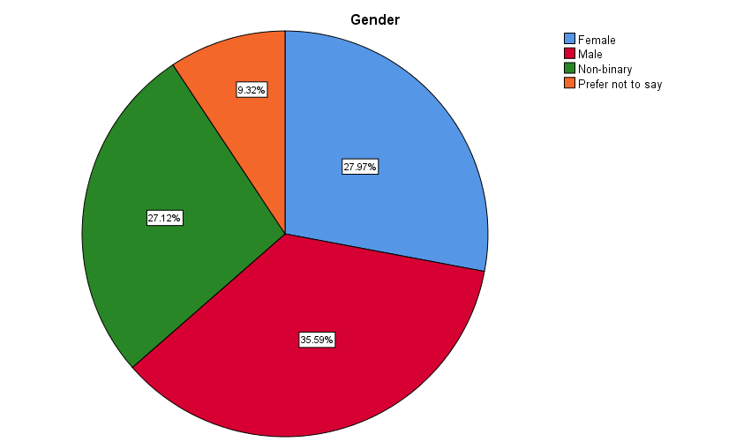

Figure 4.1: Gender
(Source: Survey, 2025)
The gender distribution of respondents highlighted is relatively different, and the closing sample as male respondents constituted the largest group of 35.59%, followed by female respondents with 27.97%. Moreover, a significant proportion of participants with 27.12% identified as non-binary, while 9.32% preferred not to disclose their gender. The distribution highlighted the perception that Adidas's sustainability marketing is significantly drawn from a different range of gender identities rather than being nominated by a single group. Such diversity is valuable in consumer behaviour research as attitudes toward sustainability and brand equity can differ across gender identity.
2. Age group
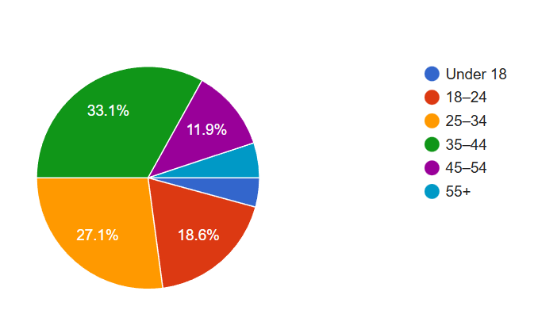
Figure 4.2: Age group
(Source: Survey, 2025)
The age profile of selected respondents highlighted that the majority fall within the economically active and consumption age brackets. In this regard, the majority proportion of respondents has been aged 35-44 (33.1%), followed by those aged 25-34 (27.1%), and 18–24 (18.6%). In this regard, together, these groups mainly account for around 79% of the sample, highlighting a strong representation of young and middle-aged consumers. Moreover, the smaller proportions have been observed aged 45-44 (11.9%). This distribution highlighted that the finding mainly reflects the perceptions of customers who are most engaged with sportswear brands like Adidas.
3. Highest level of education
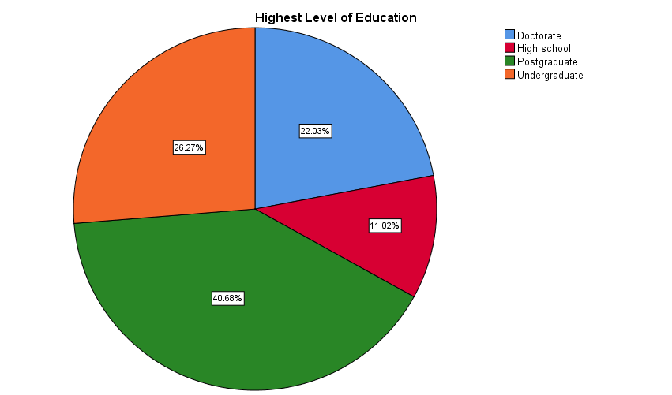
Figure 4.3: Highest level of education
(Source: Survey, 2025)
The educational profile of the respondents highlighted a highly educated sample, as graduate degree holders formed the largest group at 40.68%, followed by undergraduate respondents with 26.3%. Moreover, 22.03% of participants have from doctoral qualification. At the same time, only 11% of respondents had completed High school as their highest level of education. This indicated that the majority of respondents significantly possess an advanced educational background that may impact higher awareness and critical evaluation of sustainability marketing. Therefore, a highly educated sample is specifically an element for sustainability-focused research, as such customers are more likely to understand environmental issues and assess the credibility of corporate sustainability claims.
4. How often do you purchase Adidas
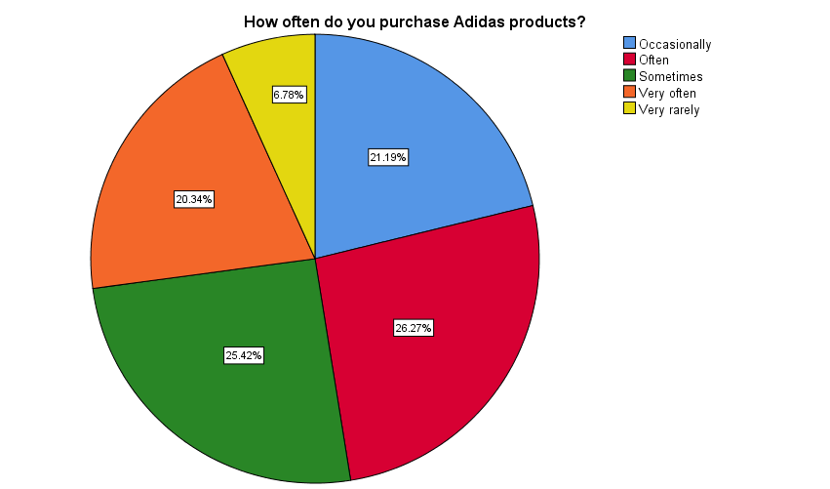
Figure 4.4: How often do you purchase Adidas
(Source: Survey, 2025)
As per Figure 5.4, the findings from the collected responses indicated a relatively high level of engagement with Adidas products among the selected respondents. It has been found that a combined 46.6% of participants indicated strong purchasing of Adidas products, often 26.3%, or very often with 20.3%, indicating an effective brand usage with familiarity. Additionally, around 25.4% respondents indicated that they purchased Adidas products sometimes, while 21.2% purchased occasionally. Only a small portion of respondents have regular or repeated interactions with the brand, making them a good position to evaluate Adidas’s sustainability market efforts and their influences on trust and equity.
5. Aware of Adidas’s sustainability initiatives
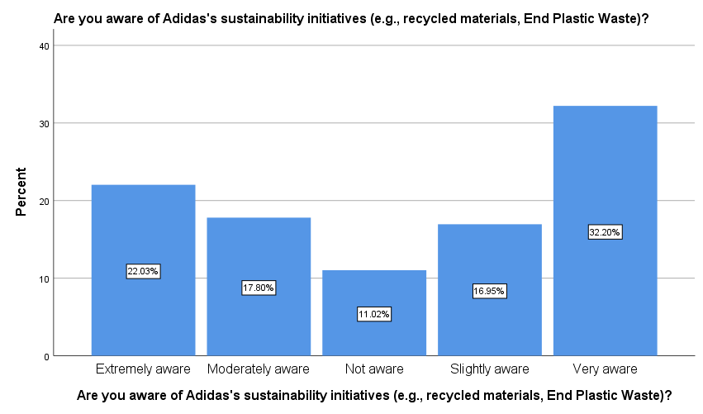
Figure 4.5: Aware of Adidas’s sustainability initiatives
(Source: Survey, 2025)
According to Figure 5.5, the results highlighted a generally higher level of awareness about Adidas’s Sustainability initiatives. It has been found that a substantial proportion of respondents highlighted that they are very aware, with 32.20%, or extremely aware, with 22.03% of the initiatives such as recycling materials and the Plastic Waste campaign. On the other hand, around 11.02% of participants stated that they were not aware of Adidas’s sustainability campaign. The above findings suggested that Adidas’s sustainability initiatives have gained considerable visibility among consumers.
6. Adidas clearly communicates its sustainability initiatives through marketing campaigns
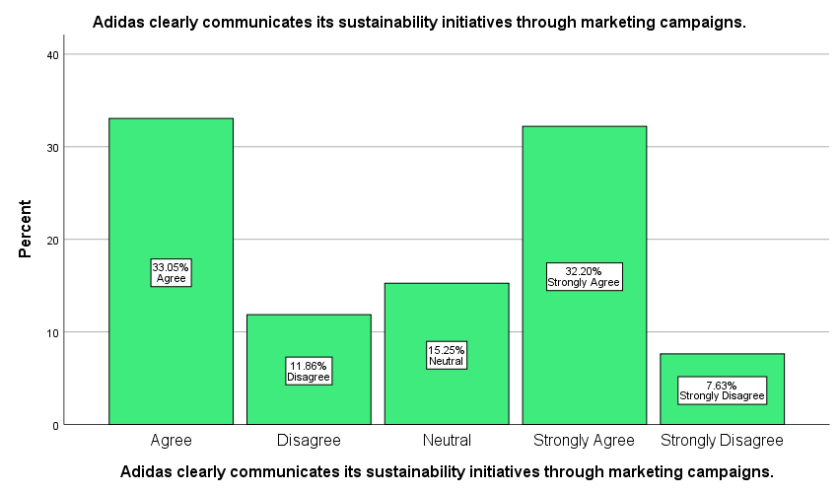
Figure 4.6: Adidas clearly communicates its sustainability initiatives
(Source: Survey, 2025)
As per Figure 5.6, the responses related to clarity of Adidas’s sustainability communication have been predominantly positive. It has been found that a combined 65.3% of respondents agree with 33.05% and 32.20% stated that they strongly agreed with the fact that Adidas clearly communicated their sustainability initiatives. In contrast, around 15.25% stated neutral, while a smaller proportion indicated disagreed (11.86%) and strongly disagreed (7.63%). The findings highlighted that most of the customers perceived Adidas’s sustainability messaging as clear and effective.
7. Adidas’s sustainability messages are easy to understand
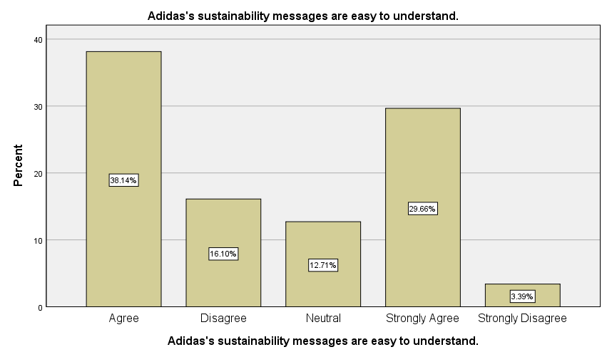
Figure 4.7: Adidas’s sustainability messages are easy to understand
(Source: Survey, 2025)
According to Figure 5.7, the findings highlighted that sustainability messages by Adidas are largely perceived as easy to understand by consumers. As per the responses, it has been found that 38.1% participants stated agreement, and 29.7% indicated strong aggrade with this statement, suggesting Adidas communicates its sustainability initiatives in a clear and accessible manner. On the other hand, 12.7% of respondents highlighted a neutral position, while 6.1% disagreed, and a small minority strongly disagreed. The collected results imply that although the majority of consumers comprehend Adidas’s sustainability messaging, a notable proportion remain uncertain.
8. I frequently notice Adidas promoting environmental responsibility in its advertisements
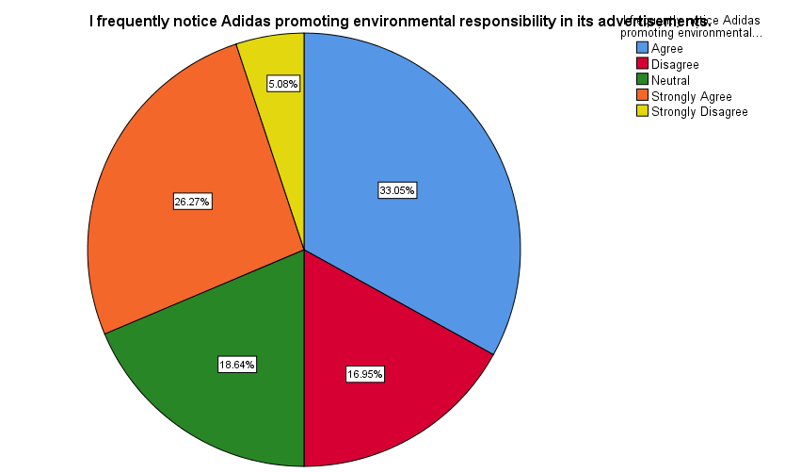
Figure 4.8: Frequently notice Adidas promoting environmental responsibility
(Source: Survey, 2025)
The collected responses related to the visibility of environmental responsibility in the advertisement of Adidas have been generally positive. In this regard, 59.4% of respondents agreed (33.05%) and strongly agreed (26.27%) that they frequently notice Adidas promoting environmental responsibility. On the other hand, 18.64% of respondents remained neutral, while 16.95% and a small proportion strongly disagreed with the fact. This highlighted that sustainability messaging clearly presented Adidas's advertising strategies.
9. I believe Adidas’s sustainability claims are genuine.
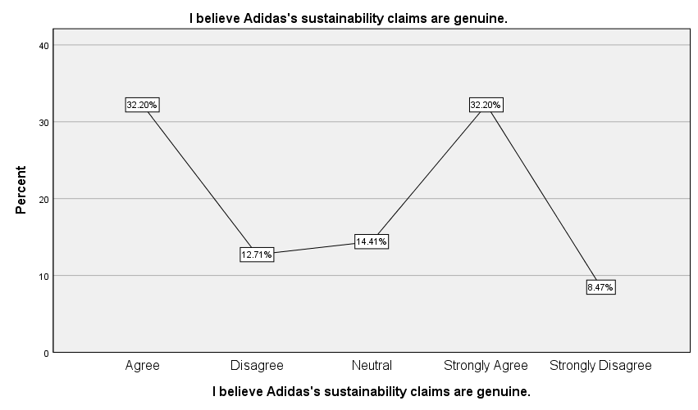
Figure 4.9: Adidas’s sustainability claims are genuine
(Source: Survey, 2025)
The Collector results, as per 5.9, highlighted generally positive perceptions about Adidas’s sustainability claims being transparent and genuine. It has been found that around 32.20% responded and 32.20% strongly agreed that Adidas’s sustainability claims are genuine, indicating a relatively high level of perceived authenticity. In contrast, 14.41% of respondents reported neutral views, while 12.71% disagreed and 8.47% strongly disagreed. This suggests that although most consumers trust Adidas’s sustainability messaging, it promotes transparency and evidence-based communication.
10. Adidas is transparent about its environmental practices
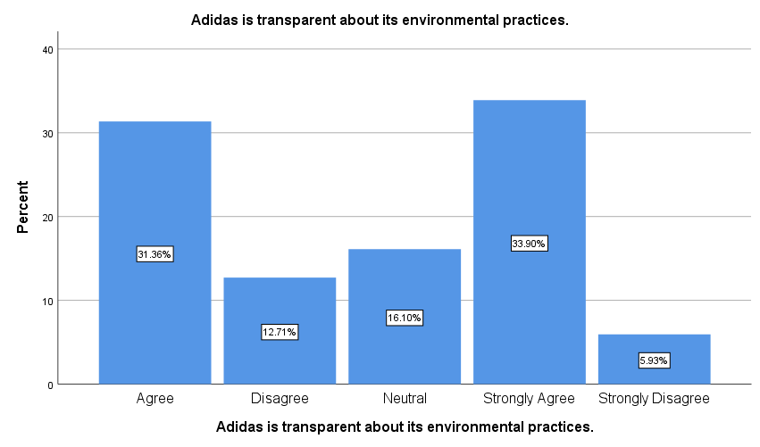
Figure 4.10: Adidas is transparent about its environmental practices
(Source: Survey, 2025)
According to Figure 5.10, the results highlighted that respondents generally perceive Adidas as transparent about their environmental practices. In this case, a range of 31.4% of participants indicated agreement and 33.9% strongly agreed with the statement, suggesting that Adidas’s sustainability disclosures are viewed positively by consumers. On the other hand, 16.1% of respondents highlighted neutral views about the fact, while 12.7% and a small portion strongly disagreed with the fact. These findings indicated that transparency is largely recognized by consumers in Adidas’s sustainability campaign.
11. Adidas’s sustainability marketing increases my trust in the brand
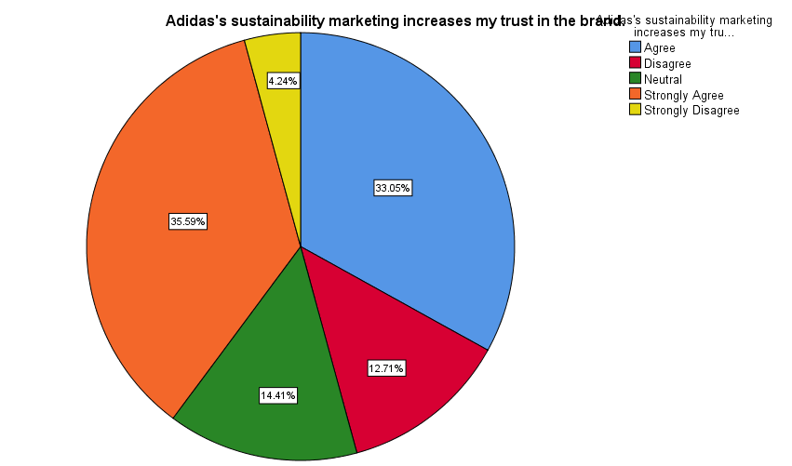
Figure 4.11: Adidas’s sustainability marketing increases my trust in the brand
(Source: Survey, 2025)
The findings demonstrated an effective positive connection between Adidas’s sustainability marketing and consumers' trust. As per Figure 5.11 mentioned that a total of 68.7% of respondents agreed (33.1%) and agreed (35.6%) that sustainability marketing significantly increases their trust in the brand. In comparison, around 14.4% remained neutral, while 12.7% disagreed, and only a small proportion strongly disagreed with the fact. This highlighted that sustainability-focused messages contributed toward increasing consumer trust in the brand.
12. Adidas’s sustainability initiatives improve my overall perception of the brand
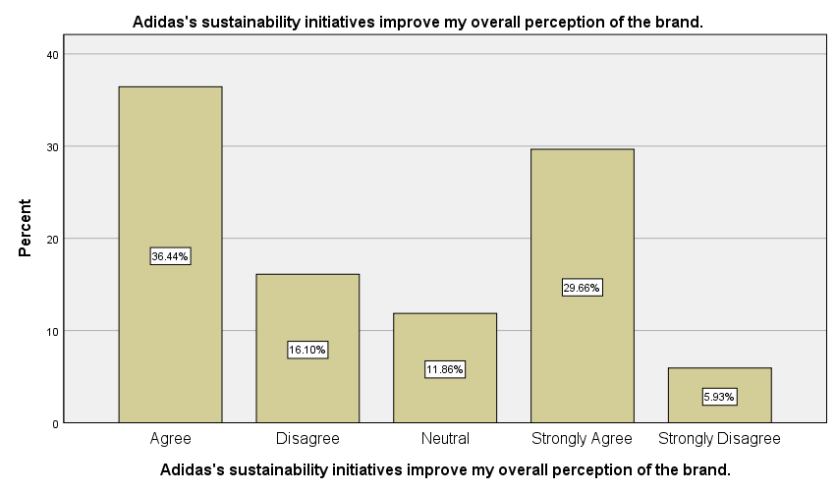
Figure 4.12: Adidas’s sustainability initiatives improve my overall perception of the brand
(Source: Survey, 2025)
The findings indicate that the sustainability initiatives of Adidas positively influence the overall brand image and perception. In this regard, a total of 36.4% responded, and 29.7% strongly agreed with the fact that sustainability initiatives improve my overall perception of the brand. On the other hand, only 11.9% participants stated neutral, and 16.1% disagreed with the above fact. The collected findings based on the survey suggested that sustainability initiatives contributed meaningfully toward improving Adidas’s brand image.
13. I associate Adidas with environmental responsibility
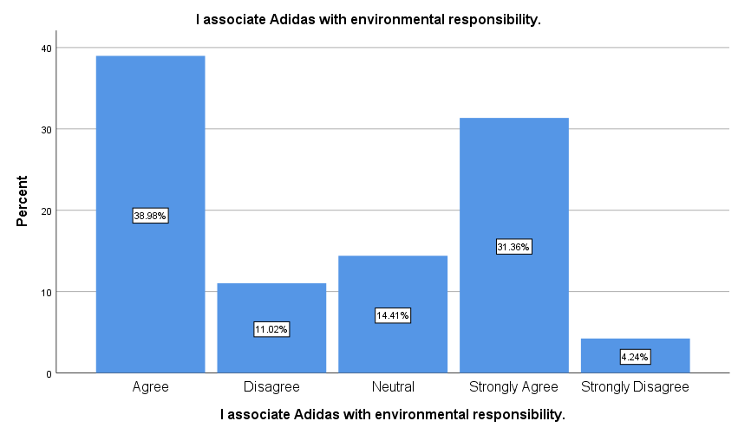
Figure 4.13: Associate Adidas with environmental responsibility
(Source: Survey, 2025)
The findings highlighted a strong Association between Adidas and environmental responsibilities based on the collected responses from the survey. In this case, 39% of participants agreed, and 31.4% strongly agreed with the fact that they associate Adidas based on its environmental responsibilities. This indicates that the sustainability initiative and positioning of Adidas are clearly integrated with consumers' perception. Meanwhile, 14.4% of participants highlighted more than neutral feelings, and only 11% stated that they highlighted minimal negative perception. Overall, the results indicated that Adidas has successfully cultivated an environmentally responsible brand image.
14. Adidas’s sustainability efforts make me more likely to continue buying its products
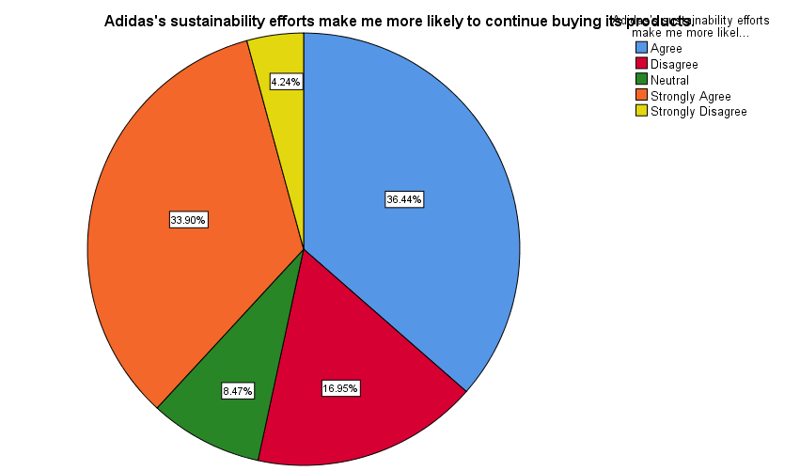
Figure 4.14: Sustainability efforts make me more likely to continue buying its products
(Source: Survey, 2025)
The collected results, as per Figure 5.14, show that Adidas’s sustainability efforts positively impacted consumers' intentions toward continuing to purchase its product. A combined 70.3% responded to an upgrade (36.4%) and strongly agreed (33.9%) that integrating sustainability initiatives increases the likelihood of consumers' repeat purchase. In contrast, around 16.9% disagreed, and 8.5% remained neutral, suggesting that sustainability is not the primary purchasing aspect for all customers. These findings highlighted that sustainability plays an essential role in promoting customer loyalty for Adidas
15. I would recommend Adidas to others because of its sustainability initiatives
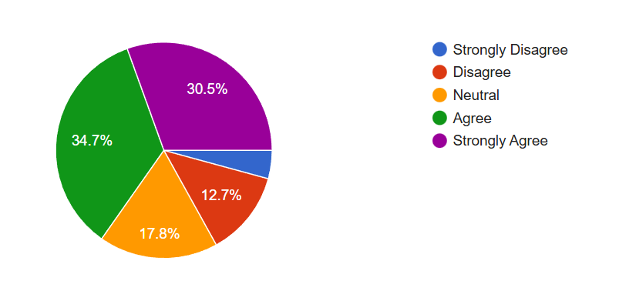
Figure 4.15: Recommend Adidas to others
(Source: Survey, 2025)
As per Figure 4.15, the findings indicate that Adidas’s sustainability initiative positively impacted consumers' willingness to recommend the brand to others. A total of 34.7% stated they agreed and 30.5% strongly agreed that they would recommend Adidas due to its sustainability efforts. Meanwhile, 17.8% of participants were neutral, indicating moderated uncertainty, and 12.7% disagreed with the fact. Overall, this suggested that sustainability contributed positively toward word-of-mouth advocacy of Adidas’s products.

4.4 Demographic Characteristics of Respondents
One hundred and eighty-eight valid responses were analysed. Gender breakdown of respondents was fairly balanced, as most of the males were noted to be the biggest group then the female and non-binary respondents. This diversity implies that the views on sustainability marketing were also found to be represented within a large scope of gender identities.
Concerning age, the majority of the respondents fell into the 25-44 age bracket meaning that the results are more representative of the perceptions of economically active customers who have more chances of being interested in branded sportswear products. Most respondents were of undergraduate or postgraduate qualification at the education level and this indicates a fairly well-informed sample that is able to critically assess the sustainability-related assertions. In addition, the acquisition of frequency data showed that a significant percentage of the respondents have bought Adidas products frequently or very frequently, and therefore, are well acquainted with the brand and its marketing efforts.

4.5 Descriptive Analysis of Sustainability Marketing perceptions
Descriptive Statistics
 | N | Minimum | Maximum | Mean | Std. Deviation
Sex | 118 | 1 | 4 | 2.18 | .949
Age Group | 118 | 1 | 6 | 2.70 | 1.283
Highest Level of Education | 118 | 1 | 4 | 2.71 | 1.087
How often do you purchase Adidas products? | 118 | 1 | 5 | 2.65 | 1.215
Are you aware of Adidas's sustainability initiatives (e.g., recycled materials, End Plastic Waste)? | 118 | 1 | 5 | 3.19 | 1.581
Adidas clearly communicates its sustainability initiatives through marketing campaigns. | 118 | 1 | 5 | 2.69 | 1.411
Adidas's sustainability messages are easy to understand. | 118 | 1 | 5 | 2.44 | 1.350
I frequently notice Adidas promoting environmental responsibility in its advertisements. | 118 | 1 | 5 | 2.53 | 1.325
I believe Adidas's sustainability claims are genuine. | 118 | 1 | 5 | 2.72 | 1.420
Adidas is transparent about its environmental practices. | 118 | 1 | 5 | 2.70 | 1.373
Adidas's sustainability marketing increases my trust in the brand. | 118 | 1 | 5 | 2.65 | 1.367
Adidas's sustainability initiatives improve my overall perception of the brand. | 118 | 1 | 5 | 2.53 | 1.394
I associate Adidas with environmental responsibility. | 118 | 1 | 5 | 2.51 | 1.388
Adidas's sustainability efforts make me more likely to continue buying its products. | 118 | 1 | 5 | 2.53 | 1.388
I would recommend Adidas to others because of its sustainability initiatives. | 118 | 1 | 5 | 2.57 | 1.349
Valid N (listwise) | 118

The descriptive results show that the attitude towards the sustainability marketing efforts of Adidas is mostly positive. Moderate-high awareness about the sustainability activities of Adidas, such as recycled materials, the campaign End Plastic Waste, etc. was reported. It means that the sustainability messages conveyed by Adidas have attained a significant market presence.
On the issue of effectiveness of communication, most of the respondents accepted that Adidas effectively conveys its sustainability efforts and that the messages are easy to comprehend. This observation indicates that the brand has managed to reduce the complicated environmental challenges into easy-to-understand promotional messages, which endorse the values of Green Marketing Theory.
Authenticity and transparency were also perceived to be mostly favourable. A majority of the respondents were convinced that Adidas is actually sustainable and the company is open with its environmental policies. Yet, a significant proportion of the respondents showed no or moderate opinion, which suggests that the issue of greenwashing is still relevant among a certain segment of the consumers.

4.6 Reliability Analysis
Case Processing Summary
 |  | N | %
Cases | Valid | 118 | 100.0
Cases | Excluded ª | 0 | .0
Cases | Total | 118 | 100.0
a. Listwise deletion based on all variables in the procedure.

Reliability Statistics
Cronbach's Alpha | N of Items
.701 | 6

A reliability analysis was done to determine the consistency of the questionnaire items used to measure the sustainability perception construct and brand equity constructs. The Alpha of Cronbach was found to be 0.701, an amount that is higher than the acceptable value of 0.70 in social scientific studies. This finding supports the study that the measurement scale is reliable and the items are always dependable to measure the constructs of sustainability perception, trust and brand and related outcome.

4.7 Correlation Analysis
The Pearson correlation analysis was used to test the relationships between the variables of sustainability marketing and brand equity dimensions (see appendix 3). The findings reveal a number of positive statistically significant correlations. It is important to note that, transparency and authenticity in the sustainability practises registered strong positive correlations with consumer trust. In a similar way, trust displayed good relationships with overall brand perception, repeat purchase intention and recommendation behaviour.
These results show that sustainability marketing is not a stand-alone system, but it directly impacts brand equity indirectly via trust and perception (see appendix 3). The findings are quite consistent with the Brand Equity Theory that focuses on trust and positive brand associations as essential leverage points of loyalty and promotion.
Interestingly, recognition of sustainability efforts also demonstrated that there was a strong correlation with repeat purchase intention, which implies that informed consumers have more chances to develop a long-term relationship with the brand.

4.8 Regression Analysis
A multiple regression model was used to test the predictive effects of the sustainability marketing variables on consumer recognition of the sustainability initiatives of Adidas. The model itself was statistically significant, and the R2 is 0.231, which means that the selected predictors explain the sustainability awareness variance by approximately 23.1%.
Model Summary
Model | R | R Square | Adjusted R Square | Std. Error of the Estimate
1 | .481ª | .231 | .175 | 1.436

ANOVAª
Model |  | Sum of Squares | df | Mean Square | F | Sig.
1 | Regression | 67.716 | 8 | 8.464 | 4.104 | .000^{b}
1 | Residual | 224.801 | 109 | 2.062
1 | Total | 292.517 | 117

Some of the predictors which were shown to be significant were the clarity of their sustainability communication and the frequency of buying Adidas products. This implies that consumers that are in close contact with the brand and have a clear idea about its sustainability messages are likely to be aware of its sustainability activities. All other variables, like trust and transparency, although positively correlated, failed to come out as important predictors in the regression model.
This finding demonstrates that the role of regular exposure and direct communication plays a crucial role in the motivated growth of sustainability awareness, which supports the communication-specific features of the Green Marketing Theory.

4.9 Chi-Square and T-Test
Chi-Square Tests
 | Value | df | Asymptotic Significance (2-sided)
Pearson Chi-Square | 47.850ª | 16 | .000
Likelihood Ratio | 45.891 | 16 | .000
Linear-by-Linear Association | 10.865 | 1 | .001
N of Valid Cases | 118
a. 16 cells (64.0%) have expected count less than 5. The minimum expected count is .55.

Group Statistics
 | Are you aware of Adidas's sustainability initiatives (e.g., recycled materials, End Plastic Waste)? | N | Mean | Std. Deviation | Std. Error Mean
How often do you purchase Adidas products? | Extremely aware | 26 | 3.31 | .970 | .190
How often do you purchase Adidas products? | Moderately aware | 21 | 2.76 | 1.261 | .275
Adidas's sustainability messages are easy to understand. | Extremely aware | 26 | 2.85 | 1.488 | .292
Adidas's sustainability messages are easy to understand. | Moderately aware | 21 | 2.95 | 1.244 | .271
I believe Adidas's sustainability claims are genuine. | Extremely aware | 26 | 3.15 | 1.347 | .264
I believe Adidas's sustainability claims are genuine. | Moderately aware | 21 | 2.67 | 1.494 | .326
Adidas's sustainability marketing increases my trust in the brand. | Extremely aware | 26 | 3.04 | 1.341 | .263
 | Moderately aware | 21 | 2.86 | 1.195 | .261
I associate Adidas with environmental responsibility. | Extremely aware | 26 | 2.96 | 1.455 | .285
I associate Adidas with environmental responsibility. | Moderately aware | 21 | 2.67 | 1.278 | .279

Independent sample t-tests were also performed to find out whether significant differences were observed between the consumers who were different in their degree of sustainability awareness. The findings showed no significant differences (statistically significant) in terms of trust, perception, or loyalty between moderately and extremely aware consumers. This is an implication that awareness in itself might not be enough to significantly change consumer attitudes unless it is backed by credible and transparent communication.
The chi-square test also confirmed that there is a statistically significant correlation between sustainability awareness and consumer behavioural reactions which supported the essential concern of sustainability marketing in influencing consumer decision making process.

4.10 Research questions, hypotheses testing and evidence from analysis
The research questions were then converted to testable hypotheses in accordance with deductive research approach that has been adopted in this study. Individual analysis of each hypothesis was done by applying relevant statistical methods. In this section, the analysis of data clearly shows the way the research questions are answered.
Research Question 1
RQ1: How do organisations in the sportswear industry integrate sustainability values and messages in sustainable marketing campaigns?
Method applied:Descriptive statistics (frequencies, percentages, mean scores).
Key variables analysed:
- Knowledge of sustainability efforts of Adidas.
- Understandability of sustainability reporting.
- Sustainability visibility in advertisement.
Findings:According to the descriptive analysis, there is a high degree of consumer awareness and awareness of the sustainability initiatives performed by Adidas. Most of the respondents stated that Adidas effectively communicates its sustainability initiatives and, in most cases, its advertising campaigns often popularize environmental responsibility.
Conclusion:RQ1 is resolved by means of descriptive analysis, which will prove that Adidas is incorporating values of sustainability by visible, transparent, and consistent sustainability-related marketing campaigns.
Research Question 2
RQ2: How sustainability marketing influences consumer perception and brand loyalty?
The hypotheses that were tested to answer this research question are the following:
- Hypothesis 1 (H1)
H1: Sustainability marketing positively influences the consumer trust in Adidas.
Test used:
- Pearson correlation analysis.
Result:There was a statistically significant positive association between the factors of sustainability marketing (transparency and authenticity) and the level of consumer trust.
Decision:
- H1 accepted
- Hypothesis 2 (H2)
H2: Sustainability marketing is positively connected with overall brand perception.
Test used:Correlation analysis

Result:Brand perception and environmental brand associations were found to be positively related to sustainability efforts.
Decision:
- H2 accepted
- Hypothesis 3 (H3)
H3: Sustainability marketing has a positive effect on brand loyalty and behavioural intentions.
Test used:Correlation analysis
Result:It was also determined that sustainability marketing had significant positive relationships with repeat purchase intention and recommendation behaviour.
Decision:
- H3 accepted
Conclusion:The testing of the hypothesis establishes the hypothesis to be true and valid that sustainability marketing has a positive effect on the trust, brand perception and brand loyalty. Hence, RQ2 is empirically responded to.
Research Question 3
RQ3: What are the problems and limitations of using sustainability marketing strategies in the sportswear market?
Method applied:
- Independent sample t-test
- Chi-square test
Key findings:moderately aware and extremely aware consumers statistically did not differ on the basis of the t-test results on the trust, perception, and loyalty. This shows that awareness is not a significant driver to increased loyalty or trust. The fact that there are neutral responses also indicates continued consumer cynicism.
Conclusion:The answer to RQ3 is that the research has revealed several significant limitations, including the lack of credibility, there might be issues with greenwashing, and regular and open sustainability communication is required.
Research Question 4
RQ4: Which strategies can enhance the sustainability marketing effectiveness in enhancing brand equity and customer interactions?
Method applied:
- Hypothesis testing synthesis of the findings.
Findings:It is established that sustainability marketing works best when there is creation of transparency and authenticity in building trust but not basing on awareness alone. The strategic recommendations given in Chapter 5 are as a result of these insights.
Conclusion:The evidence-based recommendations based on the empirical findings will answer RQ4.
Hypothesis | Hypothesis Statement | Analysis Method | Key Result | Decision
H1 | Sustainability marketing positively influences consumer trust in Adidas | Pearson correlation | Significant positive relationship between sustainability transparency/authenticity and trust | Accepted
H2 | Sustainability marketing positively influences overall brand perception | Pearson correlation | Positive correlation between sustainability initiatives and brand perception | Accepted
H3 | Sustainability marketing positively influences brand loyalty | Pearson correlation | Significant positive relationship with repeat purchase and recommendation intention | Accepted
H4 | Consumer trust mediates the relationship between sustainability marketing and brand loyalty | Correlation pattern analysis | Sustainability marketing → Trust → Loyalty relationships observed | Accepted (conceptually)
H5 | Higher sustainability awareness leads to significantly higher brand loyalty | Independent sample t-test | No significant difference between moderately and extremely aware consumers | Rejected

4.11 Discussion of Findings

4.11.1 Sustainability marketing awareness and consumers' understanding
The empirical finding highlighted a higher level of awareness and understanding of Adidas’s sister company's ability initiatives that strongly align with the research. In this regard, as per the survey responses, particularly 32.2% of respondents reported being very aware and 22% extremely aware of Adidas’s sustainability initiatives, while 67.8% agreed or strongly agreed that Adidas’s sustainability initiatives' messages are easy to understand. This supports the perspectives of Jung (2024) mentioned in the literature review section, indicating that sustainability-driven storytelling and transparent communication improve consumers' awareness in the sportswear sector. However, the presence of 11% of respondents who reported no awareness significantly contrasts with Schreiber et al. (2025), who argued that Global brands with higher digital wealth needed to gain near Universal sustainability awareness. The above discrepancy indicates an implementation gap, indicating that while Adidas’s sustainability campaigns are visible, they are not fully penetrated by all consumer segments. Therefore, the findings partially aligned with the literature section, reinforcing the significance of continuous and targeted communication strategies used by organisations like Adidas to communicate about their sustainability initiatives.

4.11.2 Demographic diversity and sustainability perception
The Demographic profile of selected respondents or participants perfectly aligned with prior research on ethical consumption. In this regard, the male respondents accounted for 35.6%, female respondents for 28% and non-binary respondents for 27.1%, indicating a highly diverse sample. Similarly, Schreiber et al. (2025) mentioned in the literature section that the sustainability attitude differs across gender identities, reinforcing the significance of a heterogeneous base in sustainability research. Apart from this, the distribution supports the alignment as 29% of respondents aged between 18 and 44, highlighting environmentally conscious and economically active consumers. This finding corroborates Jaworek et al. (2021), who analyse millennials and Gen Z as the most responsive group towards sustainability marketing in the sportswear sector.

4.11.3 Education, Transparency and Authenticity Perception
The survey highlighted highly educated respondents who actively supported sustainability initiatives before purchasing a product from Adidas. Through empirical observation, it has been found that 65.3% of respondents agreed or strongly agreed that Adidas has transparent environmental practices, while 54.4% perceived its sustainability claims as genuine and understandable. These findings strongly align with Gonçalves and Silva (2021), who highlighted that transparency is a key aspect and mechanism for navigating issues like greenwashing scepticism. However, the existence of neutral and negative perceptions, with 20% contrast with Nazarian et al. (2025), who reported higher consumer confidence in the transparent brand development. This comparison suggested that despite Adidas’s disclosure toward its sustainability efforts, some customers remained cautious, indicating the persistent risk of perceived greenwashing discussed by Şenyapar (2024) in the literature section.

4.11.4 Sustainability Marketing, Trust, and Brand Perception
As per the finding that has been found, trust emerged as one of the most effective outcomes of the sustainability market in the empirical analysis. In this regard, around 68.7% of respondents significantly agree that the sustainability marketing of Adidas increases their trust and brand loyalty, and 66% stated that the sustainability initiative improves their overall perceptions towards Adidas’s products. On the other hand, Tiep Le et al. (2023) argued in the literature that sustainability initiatives significantly support the brand equity that improves sales and consumer base. The results also align with Tiep Le et al. (2023), who identified trust as a mediator between sustainability initiatives as well as long-term value development. However, the presence of neutral responses with 14.4% significantly supports Kussudyarsana (2024), who highlighted that “when a company builds positive brand equity, customers are ready to pay a high amount for its product even if they get the same product at a lower price from another brand”. Overall, this indicated partial rather than absolute dependence on sustainable development that shapes the brand perception.
Overall, the empirical findings highlighted and strongly support the theoretical and empirical literature review as sustainability marketing indicated opposite influences toward brand awareness, trust and behavioural intention. However, the presence of neutral and sceptical responses confirms that sustainability alone is insufficient to guarantee universal consumer loyalty. Therefore, the findings both validate and extend existing research by serving context-specific insights into Adidas’s sustainability marketing effectiveness.

4.12 Chapter Summary
This chapter analysed and discussed the findings of SPSS analysis of primary data. The findings show that the sustainability marketing of Adidas is effective and has a positive impact on consumer-based brand equity by increasing the trust, perception, and loyalty as well as promotion by advocacy. Although the awareness rates are not that low, the results indicate that clarity, transparency, and authenticity are still very important in enhancing long-term success of sustainability marketing strategies. These observations form a solid basis on the findings and comments offered in the following chapter.

Chapter 5: Conclusion and Recommendation

5.1 Introduction
This chapter presents the concluding discussion of the study by summarising the key findings in relation to the research objectives and the addressing the overall research aim. It assesses the role of sustainability marketing in building brand equity in the sportswear industry through Adidas as a corporate case study. Based on the empirical results, some practical suggestions are made to improve the effectiveness of sustainability marketing approaches and to increase the level of consumer trust, loyalty, and brand equity. The chapter also presents the shortcomings of the research and proposes areas for further study. Finally, it offers final remarks that reflect on the theoretical and managerial implications of sustainability marketing in a more and more sustainability-driven competitive environment.

5.2 Conclusion
This study aimed at evaluating the effectiveness of sustainability marketing in building brand equity in the sportswear industry using Adidas as a case study. The conclusions are presented according to the respective research objectives and followed by an overall conclusion about the research aim.
The first research objective was to find out how organisations in the sportswear industry incorporate sustainability values and messages in marketing campaigns. The results showed that Adidas has been able to incorporate sustainability into its branding and marketing communications. Most respondents felt that they had moderate to high levels of awareness of the sustainability efforts of Adidas, such as the use of recycled materials and environmental production practises. The results also show that sustainability messages communicated by Adidas are generally perceived to be clear and easy to understand. This would make Adidas to have been effective in identifying sustainability as a core component of its marketing strategy and communication of complex environmental concepts in an accessible manner.
The second objective of this research aimed at measuring the impacts of sustainability marketing on consumer perceptions and brand loyalty. The findings show that sustainability marketing has a positive impact on consumer perceptions towards Adidas especially in terms of brand credibility, trust, and overall brand image. Statistical analysis showed significant positive correlations of perceived transparency, authenticity of sustainability claims with consumer trust. Trust was also found to be highly linked to repeat purchase intentions and recommendation behaviour. However, the results also show that awareness of sustainability does not end up necessarily increasing loyalty or advocacy. Consumers do not seem to respond only to the mere presence of sustainability messaging, but instead consider the reliability and consistency of sustainability claims.
The third research objective was aimed at identifying the issues and constraints that are related to implementing sustainability marketing strategies in the sportswear industry. The results underscore the importance of consumer scepticism as a major challenge, and this is mainly due to concern around green washing. The finding of no significant difference in the trust and loyalty between moderately and highly aware consumers indicates that over-assertion or unsubstantiated sustainability claims may result in a lack of trust. Additionally, a significant risk to consumer trust and brand equity was determined to be inconstancies between marketing communication and actual organisational practices. These findings highlight the importance of authenticity, transparency and consistency in sustainability marketing.
The last aim of the research was to recommend ways to make sustainable marketing more effective in order to strengthen brand equity and customer engagement. The results suggest that sustainability marketing works best when backed by clear communication, verifiable sustainability practice and consumer education. Integrating sustainability initiatives into customer relationship and loyalty programmes may also make further inroads into repeat purchase intentions and positive word-of-mouth behaviour, thus boosting consumer-based brand equity.
Overall, the study concludes that sustainability marketing plays a significant role in the construction of brand equity in the sportswear industry. In the case of Adidas, sustainability marketing has a positive impact on the trust, brand perception, loyalty, and advocacy of consumers, provided that the marketing is perceived as authentic and transparent. However, sustainability marketing cannot be used efficiently as a stand-alone promotional tool. Its success requires a genuine organisational commitment and matching between marketing messages and operational practices. By having a sustainability focus in its core business values and by communicating it credibly, Adidas can build long-term relationships with consumers and maintain a sustainable competitive advantage in an increasingly environmentally conscious global market.

5.3 Recommendations
As per the results of this paper, one can make several recommendations to enhance the efficiency of the sustainability marketing concept of Adidas and enhance brand equity.
To begin with, Adidas needs to further improve its sustainability communication. Clarity and information on the environmental practices, sourcing of materials and recycling can be employed to strengthen consumer trust and curb scepticism. Transparency enables consumers to cheque the claims of sustainability and reinforces the perceptions of authenticity which is essential in brand equity in the long-term (Bhagat, 2024).
Second, Adidas needs to pay more attention to consumer education about sustainability efforts. Though the awareness level is quite high, the results indicate that understanding and clarity is an important factor in developing positive perceptions (Dubey et al. 2025). To do this, Adidas needs to streamline complex sustainability content and convey it using the transformative digital content, narrative, and visual presentation. This can be achieved by educating the consumers on the environmental effects of sustainability initiatives that will create stronger emotional bonds and brand loyalty.
Third, alignment of the sustainability communication with operational performance should continue being a strategic focus. Any difference between the marketing messages and the reality will result to lessening of trust and eroding of brand equity (Torresan, 2024). Since Adidas operates globally, it is important to sustain similar sustainability levels in any supply chain and market. To reduce the impression of greenwashing and boost brand credibility, it is possible to ensure that sustainability communication and confirmed organisationalpractises are aligned.
Moreover, Adidas is advised to incorporate sustainability into its customer relationship and retention programmes. The results suggest that sustainability has a positive impact on the repeat purchase intention and recommendation behaviour (Wu, 2025). The inclusion of incentives related to sustainability like recycling programmes or the provision of incentives to be environmentally responsible in their consumer behaviour can also be used to further foster loyalty and also help strengthen the sustainability positioning Adidas has.

5.4 Limitations
This study has a number of limitations despite the contributions made. The convenience sampling approach restricts the generalisation of the results to the larger population of Adidas consumers. The use of self-reported information can also be associated with bias related to the responses because the participants might give socially desirable responses. Besides, the research mainly used descriptive and relational statistical methods, which restricts to ability to draw causal relationships between the sustainability marketing and brand equity outcomes.

5.5 Future Scope
These limitations can be resolved in future research by use of probability sampling methods in order to enhance generalisability. Longitudinal studies may be used to analyse the way perceptions towards sustainability marketing change during a period. Furthermore, quantitative and qualitative methods used as mixed would be an option that would give more insight into the consumer motivation and attitudes. The comparative analysis of a variety of sportswear brands could also provide a deeper insight into the contribution of sustainability marketing to creating brand equity at the industry level.

5.6 Final Remarks
To sum up, this research paper has shown that sustainability marketing is a powerful strategic instrument that can be used to enhance brand equity in the sportswear business. Sustainability marketing can be applied to Adidas to increase brand equity through bolstering consumer trust, brand perception, and loyalty and advocacy. The sustainability marketing performance, however, relies on authenticity, transparency, and consistency. Through the integration of sustainability into fundamental business processes and articulating the same in a credible manner, Adidas will be able to deepen relationships with the long-term consumers and maintain its competitive edge in an ever-sustainable world.

References
Bhagat, C., (2024). Greenwashing vs. genuine efforts: The role of transparent communication in building corporate credibility. Journal of Jurivox, 1(2), pp.51-62. https://researchcorridor.org/index.php/jj/article/download/178/169
Bloodhart, B. and Swim, J.K., (2020). Sustainability and consumption: what's gender got to do with it?.Journal of Social issues, 76(1), pp.101-113. https://www.researchgate.net/profile/Brittany-Bloodhart/publication/338794970_Sustainability_and_Consumption_What%27s_Gender_Got_to_Do_with_It/links/6019c94ba6fdcc37a8fc1514/Sustainability-and-Consumption-Whats-Gender-Got-to-Do-with-It.pdf
Gong, X., Wang, C., Yan, Y., Liu, M. and Ali, R., (2020). What drives sustainable brand awareness: Exploring the cognitive symmetry between brand strategy and consumer brand knowledge. Symmetry, 12(2), p.198. https://www.mdpi.com/2073-8994/12/2/198/pdf
Pham, H., (2025). The Influence of Corporate Social Responsibility (CSR) on Brand Equity: From Sustainable Marketing Perspectives. https://www.theseus.fi/bitstream/handle/10024/892153/Pham_Huong.pdf?sequence=2
Rachmawati, E. and Akbar, H., (2025). Brand Awareness and Sustainability in Shaping Promotion Strategies in Indonesia. JurnalManajemenBisnis, 16(1), pp.89-110. https://journal.umy.ac.id/index.php/mb/article/download/24545/11375
Sun, W., (2020). Toward a theory of ethical consumer intention formation: Re-extending the theory of planned behavior. AMS Review, 10(3), pp.260-278. https://link.springer.com/content/pdf/10.1007/s13162-019-00156-6.pdf
Tariq, A., 2024. Ethical Considerations in Financial Decision-Making: Balancing Profitability and Integrity. Frontiers in Business and Finance, 1(2), pp.172-187. https://sprcopen.org/index.php/FBF/article/download/61/61
Tiep Le, T., Ngo, H.Q. and Aureliano-Silva, L., (2023). Contribution of corporate social responsibility on SMEs' performance in an emerging market–the mediating roles of brand trust and brand loyalty. International Journal of Emerging Markets, 18(8), pp.1868-1891. https://www.researchgate.net/profile/Leonardo-Aureliano-Silva/publication/353351033_Contribution_of_corporate_social_responsibility_on_SMEs%27_performance_in_an_emerging_market_-_the_mediating_roles_of_brand_trust_and_brand_loyalty/links/60f877c6169a1a0103ab1bd7/Contribution-of-corporate-social-responsibility-on-SMEs-performance-in-an-emerging-market-the-mediating-roles-of-brand-trust-and-brand-loyalty.pdf
Torresan, S., (2024). How to Properly Communicate Sustainability: Redefining Claim Credibility with a PLS-SEM Approach. https://unitesi.unive.it/bitstream/20.500.14247/1344/1/868559-1278632.pdf
Abu-Bakar, H. and Almutairi, T., (2024). Integrating Sustainability and Circular Economy into Consumer-Brand Dynamics: A Saudi Arabia Perspective. Sustainability, 16(18), p.7890. DOI: https://doi.org/10.3390/su16187890
Adanma, U.M. and Ogunbiyi, E.O., 2024. A comparative review of global environmental policies for promoting sustainable development and economic growth. International Journal of Applied Research in Social Sciences, 6(5), pp.954-977. Available at:
https://www.researchgate.net/profile/Monica-Uwaga/publication/380768077_A_comparative_review_of_global_environmental_policies_for_promoting_sustainable_development_and_economic_growth/links/67c37e82461fb56424edfd2d/A-comparative-review-of-global-environmental-policies-for-promoting-sustainable-development-and-economic-growth.pdf
Adidas (2019). adidas. [online] Adidas.com. Available at: https://www.adidas.com/us/go/campaign/impact/planet [Accessed 20 Nov. 2025].
Adidas (2024). Metrics and Targets - adidas Annual Report 2024. [online] adidas Annual Report 2024. Available at: https://report.adidas-group.com/2024/en/group-management-report-sustainability-statement/esrs-e1-climate-change/metrics-and-targets.html.
Ahmadian, S., Sahraei, B. and Khosro, S.K., (2023). Brand attachment, brand experience, brand image, perceived quality, perceived value, and brand loyalty. Journal of Humanities Social Sciences And Business (JHSSB), 3(1), pp.257-269. Available at: https://d1wqtxts1xzle7.cloudfront.net/120823685/758-libre.pdf?1736884027=&response-content-disposition=inline%3B+filename%3DBrand_Attachment_Brand_Experience_Brand.pdf&Expires=1763562739&Signature=Uz1EgZBAuJnYY8sMLpWlzcriEYOuTkbulnrhcSFtzRMP8caNazFJIpCbFgWz6XKFWDX3m5jtGi7nhCvoZQrk2rAzVYi4~SVBzctue02bD-a2uOqV0ZJjJGNb3tvnLISiGRNDYGGg2cXE~d9ORRNU7DcWvLrufBUowkUEIcArBSMT2EOTUnjpUM
Ali, I. M. (2024). A guide for positivist research paradigm: From philosophy to methodology. Idealogy Journal, 9(2). DOI: https://doi.org/10.24191/idealogy.v9i2.596
Atilgan, E., Akinci, S., Aksoy, S. and Kaynak, E., (2009). Customer-based brand equity for global brands: A multinational approach. Journal of Euromarketing, 18(2), pp.115-132. Available at: https://www.researchgate.net/figure/Alternative-Conceptualizations-of-Brand-Equity_fig1_228676317
Bartle, P.N., (2021). The Adidas Futurecraft Loop: a product innovation challenging the attitude-behavior gap in sustainable footwear consumption (Master's thesis, UniversidadeCatolica Portuguesa (Portugal)). Available at: https://www.proquest.com/openview/4cd2bf590dd8de52efe8b511a1130f5c/1?pq-origsite=gscholar&cbl=2026366&diss=y
Bhagat, C., (2024). Greenwashing vs. genuine efforts: The role of transparent communication in building corporate credibility. Journal of Jurivox, 1(2), pp.51-62. Available at: https://researchcorridor.org/index.php/jj/article/view/178
Bhardwaj, S., Nair, K., Tariq, M.U., Ahmad, A. and Chitnis, A., (2023). The state of research in green marketing: a bibliometric review from 2005 to 2022. Sustainability, 15(4), p.2988. DOI: https://doi.org/10.3390/su15042988
Borah, P.S., Dogbe, C.S.K., Pomegbe, W.W.K., Bamfo, B.A. and Hornuvo, L.K., (2023). Green market orientation, green innovation capability, green knowledge acquisition and green brand positioning as determinants of new product success. European Journal of Innovation Management, 26(2), pp.364-385. DOI: https://doi.org/10.1108/EJIM-09-2020-0345
Chakravarty, D., Satpathy, I. and Patnaik, B.C.M., (2024). Embellishing Fashion with Sustainable Goals: Challenges in Fashion Supply Chain. In Illustrating Digital Innovations Towards Intelligent Fashion: Leveraging Information System Engineering and Digital Twins for Efficient Design of Next-Generation Fashion (pp. 179-202). Cham: Springer Nature Switzerland. Available at: https://link.springer.com/chapter/10.1007/978-3-031-71052-0_6
Dhinessh Kumar, A., (2025). Factors that Influence Customer Intention to Buy Adidas Product. DOI: https://doi.org/10.64229/4m31qy83
Dubey, D.K., Kumar, S. and Yadav, A.K., (2025), January. Exploration of adoption of eco-friendly materials in the manufacturing industry. In AIP Conference Proceedings (Vol. 3233, No. 1, p. 020023). AIP Publishing LLC. DOI: https://doi.org/10.1063/5.0234071
Esan, O., Ajayi, F.A. and Olawale, O., 2024. Supply chain integrating sustainability and ethics: Strategies for modern supply chain management. World Journal of Advanced Research and Reviews, 22(1), pp.1930-1953. DOI: https://doi.org/10.30574/wjarr.2024.22.1.1259
Ghanad, A., (2023). An overview of quantitative research methods. International journal of multidisciplinary research and analysis, 6(08), pp.3794-3803. Available at: https://www.researchgate.net/profile/Anahita-Ghanad/publication/373370007_An_Overview_of_Quantitative_Research_Methods/links/67b28ffc645ef274a48341a1/An-Overview-of-Quantitative-Research-Methods.pdf
Gonçalves, A. and Silva, C., (2021). Looking for sustainability scoring in apparel: A review on environmental footprint, social impacts and transparency. Energies, 14(11), p.3032. DOI: https://doi.org/10.3390/en14113032
Gong, Y., Xiao, J., Tang, X. and Li, J., (2023). How sustainable marketing influences the customer engagement and sustainable purchase intention? The moderating role of corporate social responsibility. Frontiers in Psychology, 14, p.1128686. DOI: https://doi.org/10.3389/fpsyg.2023.1128686
Hakovirta, M. (2024). Sustainable business models driving carbon neutrality. In Carbon Neutrality: Follow the Money (pp. 51-64). Cham: Springer Nature Switzerland. Available at: https://link.springer.com/chapter/10.1007/978-3-031-45202-4_4
HelpfulPapers. (2024). Adidas Case Study: 👟 Marketing Plan, Social Media Analysis, Adidas Vs. Nike Comparison. [online] Available at: https://helpfulpapers.com/blog/adidas-case-study-best-ideas-for-the-real-fans/ [Accessed 19 Nov. 2025].
Jain, V. and Mitra, A., (2025). Navigating Environmental Regulations in Digital Marketing: Ensuring Compliance While Promoting Green Claims. In Regulatory Frameworks and Digital Compliance in Green Marketing (pp. 125-164). IGI Global Scientific Publishing. Available at: https://www.igi-global.com/chapter/navigating-environmental-regulations-in-digital-marketing/380386
Jaworek, M., Karaszewski, W. and Kuczmarska, M., (2021). Source of success of the most valuable sportswear brands in the world. Journal of Physical Education and Sport, 21, pp.1050-1056. Available at: https://efsupit.ro/images/stories/aprilie2021/Art%20131.pdf
Jestratijevic, I., Uanhoro, J.O. and Creighton, R., (2022). To disclose or not to disclose? Fashion brands' strategies for transparency in sustainability reporting. Journal of Fashion Marketing and Management: An International Journal, 26(1), pp.36-50. DOI:
https://doi.org/10.1108/JFMM-09-2020-0182
Jismark, F., Bylin, T. and Rudenlöv, S., (2025). Factors Influencing Customer Loyalty in The Sportswear Industry: An Analysis of Key Determinants in Brand Selection. Available at: https://www.diva-portal.org/smash/record.jsf?pid=diva2:1964058
Jung, S., (2024). The impact of eco-friendly marketing by sportswear brands in response to climate change awareness on the intention to continue use: The mediating effects of social value and corporate reputation. Journal of Asian Scientific Research, 14(3), p.341. Available at: https://www.proquest.com/openview/5e9441f829a4ea1d4ffdea1e2f098320/1?pq-origsite=gscholar&cbl=1786340
Jung, S., 2024. The impact of eco-friendly marketing by sportswear brands in response to climate change awareness on the intention to continue use: The mediating effects of social value and corporate reputation. Journal of Asian Scientific Research, 14(3), p.341. Available at: https://www.proquest.com/openview/5e9441f829a4ea1d4ffdea1e2f098320/1?pq-origsite=gscholar&cbl=1786340
Jusuf, K. and Nuttavuthisit, K., (2023). Going from attitude to action: Analyzing how the orientations of sustainable food businesses influence their business strategies. Business Strategy and the Environment, 32(7), pp.4371-4381. DOI: https://doi.org/10.1002/bse.3370
Kothari, H., Choudhary, A., Jain, A., Singh, S., Prasad, K.D.V. and Vani, U.K., 2025. Impact of social media advertising on consumer behavior: role of credibility, perceived authenticity, and sustainability. Frontiers in Communication, 10, p.1595796. Available
at: https://www.frontiersin.org/journals/communication/articles/10.3389/fcomm.2025.1595796/full
Liu, C.H.S. and Dong, T.P., 2021. Discovering the relationship among knowledge management, sustainability marketing and service improvement: the moderating role of consumer interest. International Journal of Contemporary Hospitality Management, 33(8), pp.2799-2816. DOI: https://doi.org/10.1108/IJCHM-12-2020-1468
Lodhi, S.K., Gill, A.Y. and Hussain, H.K., (2024). Green innovations: artificial intelligence and sustainable materials in production. BULLET: JurnalMultidisiplinIlmu, 3(4), pp.492-507. Available at: https://www.researchgate.net/profile/Shahrukh-Khan-Lodhi-2/publication/386321260_Green_Innovations_Artificial_Intelligence_and_Sustainable_Materials_in_Production/links/674cd0a9876bd177783551c7/Green-Innovations-Artificial-Intelligence-and-Sustainable-Materials-in-Production.pdf
Moshood, T.D., Nawanir, G., Mahmud, F., Mohamad, F., Ahmad, M.H. and AbdulGhani, A., (2022). Biodegradable plastic applications towards sustainability: A recent innovations in the green product. Cleaner Engineering and Technology, 6, p.100404. DOI: https://doi.org/10.1016/j.clet.2022.100404
Mukherjee, A. and Bharti, L., (2025). Present Challenges and Future Opportunities of Sustainable Retailing in the Apparel Industry. In Sustainable Apparel Retailing (pp. 59-95). Cham: Springer Nature Switzerland. Available at: https://link.springer.com/chapter/10.1007/978-3-031-83875-0_4
Mukhtar, M., Khan, Z.U., Ahmad, M.B. and Irfan, M., (2024). The impact of perceived quality and brand loyalty on venture’s equity: the mediating role of customer trust. Journal of Entrepreneurship and Business Venturing, 4(1). Available at: https://www.jebv.pk/index.php/JEBV/article/view/53
Mukhtar, M., Khan, Z.U., Ahmad, M.B. and Irfan, M., (2024). The impact of perceived quality and brand loyalty on venture’s equity: the mediating role of customer trust. Journal of Entrepreneurship and Business Venturing, 4(1). Available at: https://www.jebv.pk/index.php/JEBV/article/view/53
Murugesan, B., Jayanthi, K.B. and Karthikeyan, G., (2024). Integrating Digital Twins and 3D Technologies in Fashion: Advancing Sustainability and Consumer Engagement. In Illustrating Digital Innovations Towards Intelligent Fashion: Leveraging Information System Engineering and Digital Twins for Efficient Design of Next-Generation Fashion (pp. 1-88). Cham: Springer Nature Switzerland. Available at: https://link.springer.com/chapter/10.1007/978-3-031-71052-0_1
Nazarian, A., Benar, N., Milasi, S.F. and Saeedi, F., 2025. Fostering Sustainable Relationships in Sportswear: Insights into Customer Experience, Social Media Marketing, and Relationship Quality. Asian Journal of Sport History & Culture, pp.1-24. DOI: https://doi.org/10.1080/27690148.2025.2499444
Nguyen, N.P. and Mogaji, E., (2022). A theoretical framework for the influence of green marketing communication on consumer behaviour in emerging economies. In Green marketing in emerging economies: a communications perspective (pp. 253-274). Cham: Springer International Publishing. Available at: https://link.springer.com/chapter/10.1007/978-3-030-82572-0_11
Patras, V., (2021). Sustainability in the shoe market: Adidas on a move to sustainability. Available at: https://www.theseus.fi/handle/10024/511091
Popescu, C., Dissanayake, H., Mansi, E. and Stancu, A., (2024). Eco Breakthroughs: Sustainable Materials Transforming the Future of Our Planet. Sustainability, 16(23), p.10790. DOI: https://doi.org/10.3390/su162310790
Qualtrics (2019). The Ultimate Guide to Brand Equity in 2023 - Qualtrics. [online] Qualtrics. Available at: https://www.qualtrics.com/en-au/experience-management/brand/brand-equity/ [Accessed 19 Nov. 2025].
Rahman, M.S., (2025). The Use of Social Media Platforms in Customer Relationship Management: An Analysis of Adidas (Doctoral dissertation, University of Wales Trinity Saint David). Available at: https://repository.uwtsd.ac.uk/id/eprint/3909/
Rastogi, T., Agarwal, B. and Gopal, G., 2024. Exploring the nexus between sustainable marketing and customer loyalty with the mediating role of brand image. Journal of Cleaner Production, 440, p.140808. DOI: https://doi.org/10.1016/j.jclepro.2024.140808
Rathore, B., (2023). Integration of Artificial Intelligence& It’s Practices in Apparel Industry. International Journal of New Media Studies (IJNMS): Vol. ISSN. Available at: https://www.researchgate.net/profile/Bharati-Rathore-2/publication/368837157_Integration_of_Artificial_Intelligence_It's_Practices_in_Apparel_Industry/links/63fcae850cf1030a5657c5b8/Integration-of-Artificial-Intelligence-Its-Practices-in-Apparel-Industry.pdf
Reid, A., Ringel, E. and Pendleton, S.M., (2024). Transparency reports as CSR reports: motives, stakeholders, and strategies. Social Responsibility Journal, 20(1), pp.81-107. DOI: https://doi.org/10.1108/SRJ-03-2023-0134
Riquet, C. and Lachenaud, C., (2024). The Impact of Adidas Sustainable Marketing and Corporate Social Responsibility on Brand image and Responsible Sustainable Consumer Behavior. Available at: https://www.theseus.fi/handle/10024/820744
Riquet, C. and Lachenaud, C., (2024). The Impact of Adidas Sustainable Marketing and Corporate Social Responsibility on Brand image and Responsible Sustainable Consumer Behavior. Available at: https://www.theseus.fi/handle/10024/820744
Santos, C., Coelho, A. and Marques, A., 2024. The greenwashingeffects on corporate reputation and brand hate, through environmental performance and green perceived risk. Asia-Pacific Journal of Business Administration, 16(3), pp.655-676. DOI:
https://doi.org/10.1108/APJBA-05-2022-0216
Saviolo, S., (2025). The Power of Connection: The new Brand Strategy for Fashion, Beauty and Lifestyle Companies. EGEA spa. Available at: https://books.google.co.in/books?hl=en&lr=&id=uSB1EQAAQBAJ&oi=fnd&pg=PT8&dq=In+the+global+sports+footwear+industry,+Adidas+has+nurtured+a+strong+and+positive+brand+equity+through+its+innovative+product+design,+cutting-edge+design,+high-performance+athletic+shoes,+and+recommendations+by+famous+athletes&ots=t7w16Js9LK&sig=lxgGoMnyR0FfLJgUiwaiiejKuzg&redir_esc=y#v=onepage&q&f=false
Schreiber, D., Martins, M.A.M. and Schmidt, S., (2025). The relevance of green purchasing and ecodesign for the consolidation of green manufacturing in footwear production. International Journal of Procurement Management, 24(1), pp.55-75. DOI: https://doi.org/10.1504/IJPM.2025.147998
Şenyapar, H.N.D., (2024). Unveiling greenwashing strategies: A comprehensive analysis of impacts on consumer trust and environmental sustainability. Journal of Energy Systems, 8(3), pp.164-181. Available at: https://dergipark.org.tr/en/pub/jes/issue/87210/1436875
Shee Weng, L., (2024). Circular Economy in Action: Case Studies of Transformative Supply Chain Practices. Circular Economy in Action: Case Studies of Transformative Supply Chain Practices (November 14, 2024). Available at: https://papers.ssrn.com/sol3/papers.cfm?abstract_id=5152884
Stoica, M. (2021). Green Marketing Communication Strategies: An Integrative. The Annals of the University of Oradea. Economic Sciences, 30(1st). Available at: https://www.researchgate.net/profile/Mihai-Stoica-2/publication/353433837_GREEN_MARKETING_COMMUNICATION_STRATEGIES_AN_INTEGRATIVE_LITERATURE_REVIEW/links/61044f250c2bfa282a10917d/GREEN-MARKETING-COMMUNICATION-STRATEGIES-AN-INTEGRATIVE-LITERATURE-REVIEW.pdf?_sg%5B0%5D=started_experiment_milestone&origin=journalDetail
Supiyandi, A., Hastjarjo, S. and Slamet, Y., (2022). Influence of Brand Awareness, Brand Association, Perceived Quality, and Brand Loyalty of Shopee on Consumersâ€™ Purchasing Decisions. CommIT (Communication and Information Technology) Journal, 16(1), pp.9-18.
Sutanto, W.D.R. and Kussudyarsana, K., (2024). The role of brand trust, brand image, brand equity on repurchase intention. DOI: https://doi.org/10.37641/jimkes.v12i1.2395
Tinonetsana, F. and Musariwa, P., (2024). Integration of sustainability marketing into business strategies: Challenges during adoption. International Journal of Research in Business and Social Science, 13(2), pp.23-30. Available at: https://www.proquest.com/openview/69cff49a5e82571e372babe46ef1cabc/1?pq-origsite=gscholar&cbl=2032017
Tolegenov, B., Rafif, K., Rafi, M., Herawati, R., Abdullah, A. and Sari, L.K., (2024). Digital Transparency and Consumer Awareness: Digital Platforms for Educating Consumers about Product Origins and Sustainability. AL-MUZARA'AH, 12(2), pp.277-287. DOI: https://doi.org/10.29244/jam.12.2.277-287
Vemuri, S., Jahnavi, P., Manasa, L. and Pallavi, D.R., (2024) . The Effectiveness of Influencer Marketing in Promoting Sustainable Lifestyles and Consumer Behaviours. Exploring Sustainability Through, 5, p.206. Available at: https://www.researchgate.net/profile/Mala-Dani-2/publication/383910146_UNDERSTANDING_THE_ADOPTION_OF_PAPERLESS_PAYMENT_SERVICES_A_FOCUS_ON_WORKING_WOMEN_IN_THE_BANKING_INDUSTRY/links/66e042dafa5e11512cb0dded/UNDERSTANDING-THE-ADOPTION-OF-PAPERLESS-PAYMENT-SERVICES-A-FOCUS-ON-WORKING-WOMEN-IN-THE-BANKING-INDUSTRY.pdf#page=213
Vizcaino, N. and Kettunen, E., (2023). How do the Female Attitudes Towards Sustainable Branding Influence Purchase Intention in the Sportswear Industry: A qualitative study of women aged 20-50. Available at: https://www.diva-portal.org/smash/record.jsf?pid=diva2:1763924
Wu, J., (2025). The Impact of Greenwashing on Corporate Performance in the Apparel Industry Under the Dual Carbon Policy: A Case Study of Lululemon. In SHS Web of Conferences (Vol. 218, p. 04024). EDP Sciences. DOI: https://doi.org/10.1051/shsconf/202521804024
Zulfikar, I., (2024). Sustainable marketing strategy: Building brand image and customer loyalty in the eco-friendly era. Jurnal Ekonomi, 13(03), pp.1737-1750. Available at: https://www.ejournal.seaninstitute.or.id/index.php/Ekonomi/article/view/5410
Alabi, A. T., and Jelili, M. O. (2023). Clarifying likert scale misconceptions for improved application in urban studies. Quality & Quantity, 57(2), 1337-1350. https://link.springer.com/article/10.1007/s11135-022-01415-8
Ali, I. M. (2024). A guide for positivist research paradigm: From philosophy to methodology. Idealogy Journal, 9(2). https://www.idealogyjournal.com/ojs/index.php/idealogy/article/view/596
Baburajan, V., e Silva, J. D. A., and Pereira, F. C. (2020). Open-ended versus closed-ended responses: A comparison study using topic modeling and factor analysis. IEEE transactions on intelligent transportation systems, 22(4), 2123-2132. https://ieeexplore.ieee.org/abstract/document/9288903
Gannon, M. J., Taheri, B., and Azer, J. (2022). Contemporary research paradigms and philosophies. In Contemporary research methods in hospitality and tourism (pp. 5-19). Emerald Publishing Limited. https://www.emerald.com/books/edited-volume/15352/chapter-abstract/86537319/Contemporary-Research-Paradigms-and-Philosophies?redirectedFrom=fulltext
Kent, R. (2020). Data construction and data analysis for survey research. Bloomsbury Publishing. https://www.google.co.in/books/edition/Data_Construction_and_Data_Analysis_for/2SFHEAAAQBAJ?hl=en&gbpv=1&dq=A+quantitative+design+enables+the+organised+data+gathering+by+online+survey,+using+which+it+is+possible+to+transform+the+data+into+frequencies,+percentages+and+the+average+values&pg=PR1&printsec=frontcover
Newman, A., Bavik, Y. L., Mount, M., and Shao, B. (2021). Data collection via online platforms: Challenges and recommendations for future research. Applied Psychology, 70(3), 1380-1402. https://iaap-journals.onlinelibrary.wiley.com/doi/abs/10.1111/apps.12302
Pearse, N. (2021). Guidelines for theory development using qualitative research approaches. Electronic Journal of Business Research Methods, 19(2), pp95-103. https://academic-publishing.org/index.php/ejbrm/article/view/2512
Pina, R., and Dias, Á. (2021). The influence of brand experiences on consumer-based brand equity. Journal of brand Management, 28(2), 99-115. https://link.springer.com/article/10.1057/s41262-020-00215-5
Saunders, M.N.K., Lewis, P. and Thornhill, A. (2019) Research Methods for Business Students. 8th Edition, Pearson, New York. https://www.researchgate.net/figure/Research-onion-Saunders-et-al-2019-p-108_fig1_349083776

Appendices

Appendix 1: Survey Link
https://docs.google.com/forms/d/14lKjFtQJWjpuKeeUg9r1pWNT8qmzRTMowemsykGNHdo/edit

Appendix 2: Results

Appendix 3: Correlation table
Correlations
 |  | How often do you purchase Adidas products? | Are you aware of Adidas's sustainability initiatives (e.g., recycled materials, End Plastic Waste)? | Adidas clearly communicates its sustainability initiatives through marketing campaigns. | Adidas's sustainability messages are easy to understand. | I frequently notice Adidas promoting environmental responsibility in its advertisements. | I believe Adidas's sustainability claims are genuine. | Adidas is transparent about its environmental practices. | Adidas's sustainability marketing increases my trust in the brand. | Adidas's sustainability initiatives improve my overall perception of the brand. | I associate Adidas with environmental responsibility. | Adidas's sustainability efforts make me more likely to continue buying its products. | I would recommend Adidas to others because of its sustainability initiatives.
How often do you purchase Adidas products? | Pearson Correlation | 1 | -.280** | .062 | .016 | -.059 | .102 | .030 | -.032 | -.058 | -.062 | -.018 | .174
How often do you purchase Adidas products? | Sig. (2-tailed) |  | .002 | .503 | .864 | .526 | .273 | .748 | .730 | .534 | .508 | .851 | .060
How often do you purchase Adidas products? | N | 118 | 118 | 118 | 118 | 118 | 118 | 118 | 118 | 118 | 118 | 118 | 118
Are you aware of Adidas's sustainability initiatives (e.g., recycled materials, End Plastic Waste)? | Pearson Correlation | -.280** | 1 | -.295** | -.241** | -.217* | -.181* | -.190* | -.221* | -.245** | -.209* | -.394** | -.305**
 | Sig. (2-tailed) | .002 |  | .001 | .009 | .018 | .050 | .040 | .016 | .008 | .023 | .000 | .001
 | N | 118 | 118 | 118 | 118 | 118 | 118 | 118 | 118 | 118 | 118 | 118 | 118
Adidas clearly communicates its sustainability initiatives through marketing campaigns. | Pearson Correlation | .062 | -.295** | 1 | .210* | .303** | .209* | .403** | .250** | .226* | .285** | .379** | .083
 | Sig. (2-tailed) | .503 | .001 |  | .022 | .001 | .023 | .000 | .006 | .014 | .002 | .000 | .373
 | N | 118 | 118 | 118 | 118 | 118 | 118 | 118 | 118 | 118 | 118 | 118 | 118
Adidas's sustainability messages are easy to understand. | Pearson Correlation | .016 | -.241** | .210* | 1 | .384** | .292** | .371** | .371** | .307** | .358** | .336** | .373**
Adidas's sustainability messages are easy to understand. | Sig. (2-tailed) | .864 | .009 | .022 |  | .000 | .001 | .000 | .000 | .001 | .000 | .000 | .000
Adidas's sustainability messages are easy to understand. | N | 118 | 118 | 118 | 118 | 118 | 118 | 118 | 118 | 118 | 118 | 118 | 118
I frequently notice Adidas promoting environmental responsibility in its advertisements. | Pearson Correlation | -.059 | -.217* | .303** | .384** | 1 | .494** | .454** | .518** | .490** | .474** | .413** | .403**
 | Sig. (2-tailed) | .526 | .018 | .001 | .000 |  | .000 | .000 | .000 | .000 | .000 | .000 | .000
 | N | 118 | 118 | 118 | 118 | 118 | 118 | 118 | 118 | 118 | 118 | 118 | 118
I believe Adidas's sustainability claims are genuine. | Pearson Correlation | .102 | -.181* | .209* | .292** | .494** | 1 | .545** | .302** | .356** | .350** | .275** | .392**
I believe Adidas's sustainability claims are genuine. | Sig. (2-tailed) | .273 | .050 | .023 | .001 | .000 |  | .000 | .001 | .000 | .000 | .003 | .000
I believe Adidas's sustainability claims are genuine. | N | 118 | 118 | 118 | 118 | 118 | 118 | 118 | 118 | 118 | 118 | 118 | 118
Adidas is transparent about its environmental practices. | Pearson Correlation | .030 | -.190* | .403** | .371** | .454** | .545** | 1 | .573** | .399** | .403** | .360** | .382**
Adidas is transparent about its environmental practices. | Sig. (2-tailed) | .748 | .040 | .000 | .000 | .000 | .000 |  | .000 | .000 | .000 | .000 | .000
Adidas is transparent about its environmental practices. | N | 118 | 118 | 118 | 118 | 118 | 118 | 118 | 118 | 118 | 118 | 118 | 118
Adidas's sustainability marketing increases my trust in the brand. | Pearson Correlation | -.032 | -.221* | .250** | .371** | .518** | .302** | .573** | 1 | .581** | .346** | .349** | .506**
 | Sig. (2-tailed) | .730 | .016 | .006 | .000 | .000 | .001 | .000 |  | .000 | .000 | .000 | .000
 | N | 118 | 118 | 118 | 118 | 118 | 118 | 118 | 118 | 118 | 118 | 118 | 118
Adidas's sustainability initiatives improve my overall perception of the brand. | Pearson Correlation | -.058 | -.245** | .226* | .307** | .490** | .356** | .399** | .581** | 1 | .285** | .364** | .490**
 | Sig. (2-tailed) | .534 | .008 | .014 | .001 | .000 | .000 | .000 | .000 |  | .002 | .000 | .000
 | N | 118 | 118 | 118 | 118 | 118 | 118 | 118 | 118 | 118 | 118 | 118 | 118
I associate Adidas with environmental responsibility. | Pearson Correlation | -.062 | -.209* | .285** | .358** | .474** | .350** | .403** | .346** | .285** | 1 | .486** | .360**
I associate Adidas with environmental responsibility. | Sig. (2-tailed) | .508 | .023 | .002 | .000 | .000 | .000 | .000 | .000 | .002 |  | .000 | .000
I associate Adidas with environmental responsibility. | N | 118 | 118 | 118 | 118 | 118 | 118 | 118 | 118 | 118 | 118 | 118 | 118
Adidas's sustainability efforts make me more likely to continue buying its products. | Pearson Correlation | -.018 | -.394** | .379** | .336** | .413** | .275** | .360** | .349** | .364** | .486** | 1 | .410**
 | Sig. (2-tailed) | .851 | .000 | .000 | .000 | .000 | .003 | .000 | .000 | .000 | .000 |  | .000
 | N | 118 | 118 | 118 | 118 | 118 | 118 | 118 | 118 | 118 | 118 | 118 | 118
I would recommend Adidas to others because of its sustainability initiatives. | Pearson Correlation | .174 | -.305** | .083 | .373** | .403** | .392** | .382** | .506** | .490** | .360** | .410** | 1
 | Sig. (2-tailed) | .060 | .001 | .373 | .000 | .000 | .000 | .000 | .000 | .000 | .000 | .000
 | N | 118 | 118 | 118 | 118 | 118 | 118 | 118 | 118 | 118 | 118 | 118 | 118
**. Correlation is significant at the 0.01 level (2-tailed).
*. Correlation is significant at the 0.05 level (2-tailed).

Appendix 4: Regression analysis
Model Summary
Model | R | R Square | Adjusted R Square | Std. Error of the Estimate
1 | .481ª | .231 | .175 | 1.436
a. Predictors: (Constant), How often do you purchase Adidas products? , Adidas's sustainability messages are easy to understand. , Adidas clearly communicates its sustainability initiatives through marketing campaigns. , I would recommend Adidas to others because of its sustainability initiatives. , I associate Adidas with environmental responsibility. , Adidas is transparent about its environmental practices. , I frequently notice Adidas promoting environmental responsibility in its advertisements. , Adidas's sustainability marketing increases my trust in the brand.

ANOVAª
Model |  | Sum of Squares | df | Mean Square | F | Sig.
1 | Regression | 67.716 | 8 | 8.464 | 4.104 | .000^{b}
1 | Residual | 224.801 | 109 | 2.062
1 | Total | 292.517 | 117
a. Dependent Variable: Are you aware of Adidas's sustainability initiatives (e.g., recycled materials, End Plastic Waste)?
b. Predictors: (Constant), How often do you purchase Adidas products? , Adidas's sustainability messages are easy to understand. , Adidas clearly communicates its sustainability initiatives through marketing campaigns. , I would recommend Adidas to others because of its sustainability initiatives. , I associate Adidas with environmental responsibility. , Adidas is transparent about its environmental practices. , I frequently notice Adidas promoting environmental responsibility in its advertisements. , Adidas's sustainability marketing increases my trust in the brand.

Appendix 5: Coefficients
Coefficients
Model |  | Unstandardized Coefficients |  | Standardized Coefficients | t | Sig.
 |  | B | Std. Error | Beta | t | Sig.
1 | (Constant) | 5.735 | .487 |  | 11.770 | .000
1 | Adidas is transparent about its environmental practices. | .103 | .130 | .089 | .794 | .429
1 | I frequently notice Adidas promoting environmental responsibility in its advertisements. | -.041 | .130 | -.034 | -.313 | .755
1 | Adidas's sustainability marketing increases my trust in the brand. | -.066 | .135 | -.057 | -.488 | .627
1 | I associate Adidas with environmental responsibility. | -.064 | .116 | -.057 | -.556 | .579
1 | I would recommend Adidas to others because of its sustainability initiatives. | -.207 | .125 | -.177 | -1.655 | .101
1 | Adidas's sustainability messages are easy to understand. | -.116 | .114 | -.099 | -1.022 | .309
1 | Adidas clearly communicates its sustainability initiatives through marketing campaigns. | -.268 | .106 | -.240 | -2.520 | .013
1 | How often do you purchase Adidas products? | -.316 | .114 | -.243 | -2.775 | .006
a. Dependent Variable: Are you aware of Adidas's sustainability initiatives (e.g., recycled materials, End Plastic Waste)?

Appendix 6: T-test

Group Statistics
 | Are you aware of Adidas's sustainability initiatives (e.g., recycled materials, End Plastic Waste)? | N | Mean | Std. Deviation | Std. Error Mean
How often do you purchase Adidas products? | Extremely aware | 26 | 3.31 | .970 | .190
How often do you purchase Adidas products? | Moderately aware | 21 | 2.76 | 1.261 | .275
Adidas's sustainability messages are easy to understand. | Extremely aware | 26 | 2.85 | 1.488 | .292
Adidas's sustainability messages are easy to understand. | Moderately aware | 21 | 2.95 | 1.244 | .271
I believe Adidas's sustainability claims are genuine. | Extremely aware | 26 | 3.15 | 1.347 | .264
I believe Adidas's sustainability claims are genuine. | Moderately aware | 21 | 2.67 | 1.494 | .326
Adidas's sustainability marketing increases my trust in the brand. | Extremely aware | 26 | 3.04 | 1.341 | .263
 | Moderately aware | 21 | 2.86 | 1.195 | .261
I associate Adidas with environmental responsibility. | Extremely aware | 26 | 2.96 | 1.455 | .285
I associate Adidas with environmental responsibility. | Moderately aware | 21 | 2.67 | 1.278 | .279

Independent Samples Test
 |  | Levene's Test for Equality of Variances |  | t-test for Equality of Means
 |  | F | Sig. | t | df | Sig. (2-tailed) | Mean Difference | Std. Error Difference | 95% Confidence Interval of the Difference
 |  |  |  |  |  |  |  |  | Lower | Upper
How often do you purchase Adidas products? | Equal variances assumed | .408 | .526 | 1.677 | 45 | .100 | .546 | .325 | -.110 | 1.201
How often do you purchase Adidas products? | Equal variances not assumed |  |  | 1.631 | 36.942 | .111 | .546 | .335 | -.132 | 1.224
Adidas's sustainability messages are easy to understand. | Equal variances assumed | 6.985 | .011 | -.261 | 45 | .795 | -.106 | .406 | -.925 | .712
Adidas's sustainability messages are easy to understand. | Equal variances not assumed |  |  | -.266 | 44.932 | .791 | -.106 | .399 | -.909 | .697
I believe Adidas's sustainability claims are genuine. | Equal variances assumed | .803 | .375 | 1.174 | 45 | .247 | .487 | .415 | -.349 | 1.323
I believe Adidas's sustainability claims are genuine. | Equal variances not assumed |  |  | 1.161 | 40.810 | .253 | .487 | .420 | -.361 | 1.335
Adidas's sustainability marketing increases my trust in the brand. | Equal variances assumed | 1.411 | .241 | .483 | 45 | .631 | .181 | .375 | -.574 | .937
 | Equal variances not assumed |  |  | .490 | 44.524 | .627 | .181 | .370 | -.565 | .928
I associate Adidas with environmental responsibility. | Equal variances assumed | 3.071 | .087 | .729 | 45 | .470 | .295 | .405 | -.520 | 1.110
I associate Adidas with environmental responsibility. | Equal variances not assumed |  |  | .739 | 44.651 | .464 | .295 | .399 | -.509 | 1.099

