ECEY4001/C – Human Development.
Contents:
Component 1 – Infographic exploring Maslow’s model.
Component 2 – Exploring holistic development with links to Maslow’s model and other thoeries.
Component 3 – Three examples from early years practice that link to Maslow’s model.

AI aknowledgment: I aknowledge I have used IA for proofreading only.

Component 1 – Infographic exploring Maslow’s model. Words: 1020.

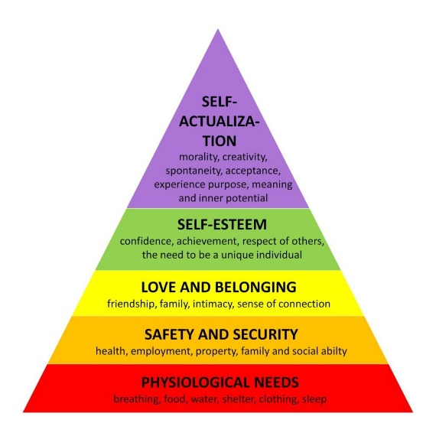
Maslow's Hierarchy of needs.
Abraham Maslow was a psychologist who developed the idea of a ‘whole child.’ From this, the term ‘self-actualisation’ occured. Following this, it is evident that self actualisation stems from the ability to develop through healthy lifestyle, and surroundings.
Accordingly, the hierarchy of needs was created, which further displayed the necessities needed for a child's development to obtain self-actualisation.
Physiological Needs.
Physiological needs are the essentials for any person for survival. As a result, food, water, shelter, sleep, and oxygen are vital. Without these, the body would simply not be able to survive. Consequently, a mother is expected to have a good diet during pregnancy to not starve the foetus of nutrition. Through physiological development, children can obtain gross and fine motor skills. Jean Piaget had a concept within cognitive development that meant children could obtain fine and gross motor skills through physiological needs being met. Gross motor skills are the ability to use larger body muscles for an individual to crawl, walk, run, and so on. Fine motor skills are developed slightly further on within development, which allows a child to grasp smaller objects, i.e., spoons and crayons. As a result of these standards being met, the four stages of Piaget’s development can continue. These being, sensorimotor, preoperational, concrete operational and formal operational. Bordie. (2018), emphasises the importance of cognitive development through displaying the cognitive abilities children can obtain when physiological needs are met, as well as providing activities for parents in order to allow one’s child develop cognitive abilities.
Safety and security.
Safety and security come under many topics for a child's development. These being the child's health, the employment of the parents, the house which the child lives within, and the ability for a child to be social. Though genes and hereditary preconditions have an impact on a child's development, it is also vital that a child's nutrition and emotional well-being are sufficient for development. Many theorists strongly argue that a family's income has a strong impact on the child's safety and security since it impacts all topics within safety and security itself. Firth. (2018), describes how low income families will not be able to afford holidays or general days out with children, sustainable food for the child to develop properly, a house where there is heating and electricity, or possibly a house that is not breaking down. Through this evidence provided, poverty may have a severe impact on a child's development. In brief, poverty within a household also has an impact on all of Maslow's stages throughout the hierarchy of needs, further expressing the importance of a sustainable household within child development.
Love and belonging.
Love and belonging are to have a sense of connection with friends and family. Many studies have shown that intimacy is vital for a child’s development, which is why it is so important to many theorists. During a child’s early years, it is essential that the parents have physical connection with the child. As a result, the child will start to gain a sense of belonging and love. Bowlby was a theorist that developed the concept of attachment. Attachment can be an issue for many parents, consequently, a child can gain many issues and slow one’s development. This ongoing problem can run through adulthood, affecting said person’s daily life. There are many reasons for children struggling with attachment. Abuse and neglect, or even pre-natal trauma and undiagnosed issues. When a child has issues with attachment, it means that they lose safety and security within the family, therefore slowing down or stopping a child’s development further. If the sense of loving and belonging is not prominent, they will lack self-esteem and as a result, will struggle with self-actualisation. Bowlby. (1982), expresses how a child’s need for love is just as vital as one's need for food. This is evident in the consequences that children not having a sense of love gain throughout development, safety, and security.
Self-esteem.
Self-esteem is the ability to be confident, respectful, and unique. Froebel was the creator of kindergarten and had the idea that children can learn to be independent and unique using outdoor play. His idea was to create a safe environment where children can learn at their own pace. Through this, children could be creative and curious individuals, which would develop their understanding through the world around them, using their senses. Sight, smell, touch, and hearing. This is also why Froebel believed that outdoor play was essential to a child's development. As a result of all of this, children could develop personal relationships with others and learn empathy.
The use of kindergarten allowed children to become independent while carers were there to guide them. Froebel had the idea that if children were free to learn independently, they were able to allow children to do challenging things for themselves, discipline themselves, and move freely indoors and outdoors.
Using this, self-esteem can be developed. Without self-esteem, children will struggle to bond with other people, develop social skills, and find a sense of self.
Self-actualisation.
The idea behind self-actualisation came from Maslow himself, the original name started as ‘whole adult’ until Maslow decided self-actualisation was a better term to use. It was apparent that for children to obtain self-actualisation, there were certain criteria that had to be met. As a result, the hierarchy of needs was made. For a child to achieve self-actualisation, they needed physical needs, safety, security, love, and self-esteem. Without these, a child would lose a sense of themselves, be dependent, and much more. Consequently, Maslow strongly emphasised that without self-actualisation, individuals would not have a sense of self-worth, eat healthy, or sleep well. Put simply, individuals would not be as happy or perform as well as they should without self-actualisation. Maslow’s hierarchy of needs has been criticised due to it not considering culture or an individual’s social surroundings. As a result, many theorists have adjusted the hierarchy of needs to include those subjects. Dukes and Smith included another stage to the hierarchy however, the general format is still highly valued to this day, displaying the value it has had throughout the years.

Reference list:
Brodie, K. (2018) The Holistic Care and Development of Children from Birth to Three: An Essential Guide for Students and Practitioners. Oxford: Taylor & Francis Group.
Fulton, D. (2018) Advanced Work-based Practice in the Early Years. Advanced Work-based Practice in the Early Years. New York: Taylor & Francis group.
Bowlby, J. (1982) Attachment and loss. 2nd edn. New York: Tavistock Institute of Human.
Tovey, H. (2020) Froebel’s principles and practice today. London: Froebel trust.
Weinberg, D.R. (2012) Montessori, Maslow, and Self-Actualization. New York: American Montessori Society.
McLeod, S (2024) Maslow’s hierarchy of needs. Available at: https://www.simplypsychology.org/maslow.html (Accessed: 28 November 2024).

Component 2 - Exploring Holistic development with links to Maslow’s model and other thoeries.
Words: 1061.
What is holistic development?
Holistic is the idea of multiple strands of something coming together to make it whole. New Zealand had the idea that holistic child development was comparable to a spider web, due to the nature of different forms of development within the child crossing over each other, making the child holistic. Many countries, i.e. New Zealand, Germany, and Denmark believed that holistic care had a large impact on how a child developed. As a result, Maslow’s Hierarchy of needs was created. The idea behind the ‘spider web’ and the hierarchy of needs is related, due to them having the same concept of developmental learning and growth to become self-actualised, meaning the ability to be a whole person. Brodie. (2018), explains how children do not choose to learn one skill within a day, however, children take sections of everything they are learning, which allows them to develop faster and creates the ‘spider web’ effect.
How did the concept of holistic development start?
Holistic development was likely first thought of in the nineteenth century, when Froebel started to question what children needed to develop efficiently. Froebel had argued that preschool was more impactful than school itself. It follows that kindergarten was created because of Froebel’s concept. An article by Helen Tovey. (2020), explained Froebel wanting to allow children to think freely and become independent. Using children exploring freely, they were able to engage with nature, self-reflect, and become unified with other children. As a result, kindergarten was created. This enabled children to learn a wide variety of skills all at once, due to the use of outdoor play and allowing independence, further demonstrating the importance of holistic development.
How is holistic development obtained?
Holistic development occurs when a child has access to all the needs stated by Maslow’s hierarchy of needs. As mentioned above, these needs are physiological, safety and security, love and belonging, and self-esteem. One important topic that was not largely covered largely by Maslow, was social development. While love and belonging briefly talks about a child’s ability to be social and have friends, Maslow does not discuss the difference in social structure within different countries, which can have a significant impact on how a child develops. It is evident through an article from Queen Margeret University, that there are 3 key stages to holistic development. These being biological, cognitive, and social development. Further expressing the importance of social development for holistic development to be obtained.
Social development.
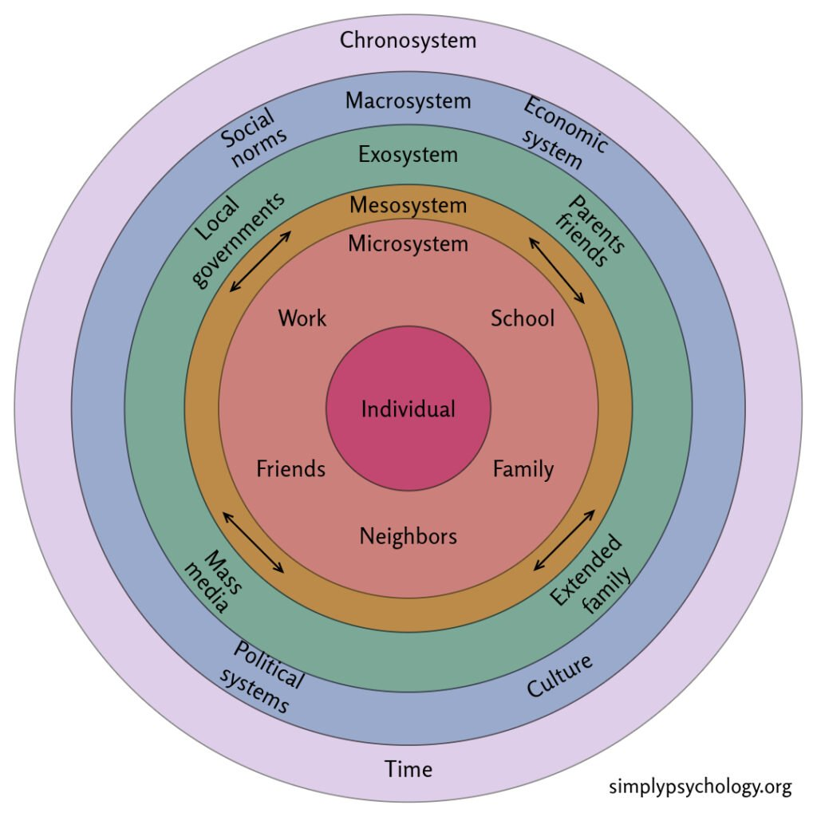
Bronfenbrenner was a theorist who went into large detail on how social development can have such a large impact on a child’s development. The theorist displayed different microsystems to show how the environment changes, consequently impacting the child’s development. Bronfenbrenner included the impact of schools, work, friends, family, culture, and even the media and placed them into named categories.
The microsystem would be the individuals that have a direct influence on a child’s life i.e. family, friends, neighbours, and so on.
The mesosystem belongs to the group of people that would interact with family or friends. These are outside of the microsystem group, however, have a further impact on the child’s development, i.e. parents, that are involved in a child’s academic setting. The exosystem refers to the individuals or factors that do not directly interact with the child, but still have an influence on the individual. This could be the parent’s work schedule and friendships. Macrosystems refer to the political and cultural aspects that children are surrounded by during the early years of one’s life. Gender beliefs, family structures, and so on. As society changes its cultural views now more than ever, macrosystems are believed to have one of the larger impacts on a child’s development. The final system is named the chronosystem. This refers to environmental changes within a child’s lifetime, these can be predictable, i.e. a child going to nursery, or non-predictable, for example, a child’s parent’s going through a divorce.
Currently, many children can be severely impacted by the chronosystem as technology has been introduced and lowers the child’s ability to socialise and connect with other individuals, also displaying the importance of this system having an impact on a child.
Similarly to Maslow, Bronfenbrenner’s concept of holistic development allowed all the systems displayed to be intertwined, meaning without one functioning system, the others would fail to be produced. However, as stated by Sadownik. R. A. (2023), all factors within Bronfenbrenner’s concept were considered, the most important factor being time. As a result, the idea of social and environmental change within a child’s lifetime was included within the concept. This differs from Maslow’s concept within the hierarchy of needs, as the necessities are always stated, which will not change within early years, i.e food, water, warmth, and shelter. However, societal or environmental factors were not considered, which evidently have a large impact on a child’s process to becoming whole.
Physiological development.
Piaget’s schemas were a large topic for holistic development. The ability to obtain fine and gross motor skills for child development was significant for holistic development to be obtained. Maslow’s hierarchy of needs links to this using physiological, safety, and security needs being met to develop further. Without these needs being met, it was unlikely children could develop fine and gross motor skills efficiently. Piaget believed that there were 4 stages of cognitive development. As stated previously, these stages include sensorimotor, preoperational, concrete operational, and formal operational.
Sensorimotor skills were obtained from birth up until 24 months, making physiological development vital within Piaget’s concept. Within this stage, children are able to gain basic motor skills, meaning that they are able to pick up objects or simply lift themselves from the floor. During a child’s early years, there are many situations where a nurse checks a baby for reflexes, sight, hearing, and so on. This is to make sure that the baby is developing properly for the preoperational stage to take place. Without the child being able to develop properly from birth, there are detrimental impacts on the child’s further development. For example, it is recommended when a child is born that there is skin-on-skin contact. When providing this child’s need, there is not only physical development, but there is the ability for the child to gain object permanence. This allows for a baby to realise that objects around them still exist even when they cannot be seen.

Reference list:
Brodie, K. (2018) The Holistic Care and Development of Children from Birth to Three: An Essential Guide for Students and Practitioners. Oxford: Taylor & Francis Group.
Tovey, H. (2020) Froebel’s principles and practice today. London: Froebel trust.
Queen Margaret University. (2022) Nurturing Holistic Development in Early Childhood. Available at: https://online.qmu.ac.uk/blogs/nurturing-holistic-development-in-early-childhood/ (Accessed: 28 November 2024).
Sadownik, R. (2023) Bronfenbrenner: Ecology of Human Development in Ecology of Collaboration. Western Norway University of Applied Sciences: Norway.
Berk, E, L. (2018) Development through the lifespan. 7th edn. Illinois: Pearson.
Weinberg, D.R. (2012) Montessori, Maslow, and Self-Actualization. New York: American Montessori Society.
Evans, O (2024) Bronfenbrenner’s ecological systems theory. Available at: https://www.simplypsychology.org/bronfenbrenner.html (Accessed: 28 November 2024).

Component 3 – Three examples from early years practice that link to Maslow’s model.
Words: 929.
Safety and security.
A video from the BBC about a case originating from a Romanian orphanage in the 1900s expresses just how important safety and security are when developing as a child. A victim of the neglect describes the issues that occurred and how that had such a large impact on the development of the individual’s childhood, consequently affecting the person’s daily life as an adult. The individual expressed how poorly lit, heated, and unsecure the environment was to be in. Within the video, it displays children eating poorly with few manners and making a mess of themselves, further showing how much the children were neglected. It is stated by the victim that the children, including himself, were ‘treated like animals that needed to be caged.’
The orphanage had such an impact on this the victim, it resulted in them being uncertain of what to do with life after they had been adopted at age 11. He states how he was much he was unable to adjust and wanted to go back to the orphanage since that was what he had grown to know.
Evidently, the care officers being incapable of making the children feel safe and secure had a severe impact on many children as they had no sense of self-worth or self-identity. Through the victim’s statements, it is evident that he is still struggling to adapt to the world around him since he notices when walking past homeless individuals in a poor state that they are almost always from an orphanage. He expresses himself that if he had not left the orphanage when he did, he would have either been homeless or deceased. The individual also emphasised that he still misses the orphanage sometimes since it is where he grew up and considered it his home. This further shows how an individual can be so largely impacted by their upbringing, as it will stay with the person for the rest of their life.
Overall, it was clear that the victim only knew poor safety and security. As a result of this, the individual was left most of their life questioning their meaning, what to do with their life, and unable to adjust to the world around them. When experiencing love for the first time, it was so unfamiliar that the victim wanted to leave.

Self-esteem
Vygotsky believed that all individuals have ‘tools of the mind’ in which children could develop the ability to remember and think better. Vygotsky argued that children could adapt and change these ‘tools’ to extend one's natural capability. It was believed that teachers must arm children with the tools for children to develop efficiently. Without this, children would not develop at a healthy pace. Consequently, if children could not obtain these skills, it would not be possible to learn at a steady pace or be able to focus.
Role play enabled these tools and allowed children to develop further with self-esteem. Vygotsky gave many examples of how children can develop using the tools of the mind. One example was when a child had written a story about being scientists in space. When the teacher asked if the work needed to be ‘edited’ for grammatical errors, the child put on ‘editor glasses’ and noticed more mistakes in their work after entering the role of the editor.
It is clear through this example that when children use the tools of the mind, they can gain confidence and earn a sense of achievement for what one has accomplished.
Through the many examples given by Vygotsky, it is evident that children are unlikely to develop efficiently since it allows individuals to problem-solve and remember.
Physiological needs.
It is evident that physiological needs within the early years need to be met, due to the amount that health visitors occur after an individual has given birth. This is due to health visitors needing to make sure that the baby is developing properly. Health practitioners use a wide variety of tools to make sure that the baby is developing properly as well as give advice to make sure that the development continues to go well.
The health visitors check for breastfeeding development to make sure that the baby is getting all the nutrients it needs. There are also alternatives if the mother is unable to breastfeed, such as infant formulas, which provide almost the same amount of nutrients that breast milk can. The weight of the baby is checked after birth, and many months after the birth, the nurses make sure that the baby is healthy and not too malnourished.
The reflexes of the baby are also checked to make sure that there is nothing wrong with the development. If the baby does not respond the way that it should to a reflex check, it means that there is something wrong with the development of the baby and it should be further investigated.
There are also checks for any suspicious marks on the body of the baby, either for neglect, abuse, or general disorders that could affect the child’s development. The hearing and sight of a baby are also checked, since if they are unable to use these senses efficiently, it could mean slower development for the child and they would need to gain aids that would allow the baby to continue development.
Through all the tests that are taken on a baby just after birth and much later. It is evident that a child’s physiological needs are likely one of the most vital for further development. This is also why physiological needs are at the bottom of Maslow’s hierarchy.

References:
Bodrova, E. Leong, J, D. (2007) Tools of the mind: The Vygostkian approach to early childhood Education. 2nd edn. New Jersey: Pearson education.
BBC News. (2016) Growing up in a Romanian orphanage – BBC News. Available at: https://www.google.com/search?client=opera&sca_esv=41165fec71bc817d&sxsrf=ADLYWIL2fveJ3-GhsYQwl70jngrGmzZgEA:1732710774847&q=romanian+orphanage+neglect+case&udm=7&fbs=AEQNm0Aa4sjWe7Rqy32pFwRj0UkWd8nbOJfsBGGB5IQQO6L3JyJJclJuzBPl12qJyPx7ESIf1S9KobXMZccIxNeT1A6IAoJ6on36O4CcUqg9LoORVVLnD-wJYzFphzfb_mzdyxR_HH1LPukhKeqmYSiiHOgrIHvSc_S8t2FIgLytF0E_FPexFHjJVGlGHGFhcQMN0jPorJxZ&sa=X&ved=2ahUKEwiNyO7RwvyJAxXMS0EAHS6YJdcQtKgLegQIExAB&biw=1482&bih=730&dpr=1.25#fpstate=ive&vld=cid:44bb63c5,vid:VCeWr8OFuEs,st:0 (Accessed 27 November 2024).

