

Software Engineering Design & Testing
Software Engineering Principles and Testing (ACCB5030)

Kawam de Oliveira (2412430)
2412430@student.uwtsd.ac.uk

Table of Contents

1. Introduction 3
2. Design Evaluation 4
2.1 Overview and Evaluation of the Battleships Application Design 4
2.2 Reflection on the Team Design Process 4
2.3 Strengths of the Produced Design 5
2.4 Weaknesses and Areas for Improvement 5
2.5 Evaluation of the Design Artefacts as a Coherent Set 5
2.6 Battleships Interfaces Wireframes 6
2.6.1 User Interface 6
2.6.2 Admin Interface 6
3. User Stories and User Story Mapping 7
3.1 The Role of User Stories in Agile Requirements Analysis 7
3.2 Overview of the Developed User Story Maps 8
3.3 Evaluation of Selected User Stories 9
3.4 The Importance of the Benefit Statement 10
4. CRC Cards 10
4.1 CRC Cards as a Collaborative Design Technique 10
4.2 Evaluation of the Produced CRC Cards 11
4.3 Responsibilities and Collaborators 12
4.4 Do the CRC Cards Support Implementation? 12
4.5 Relationship Between CRC Cards, Acceptance Criteria and Class Diagram 12
5. Software Testing Evaluation 13
5.1 Importance of Software Testing 13
5.2 Black Box Testing 13
5.3 White Box Testing 14
5.4 The Two Approaches Compared 14
5.5 Testable Code and Why It Matters 14
6. Application Tests and an Investigation of Unit Testing 14
6.1 Black Box Tests 14
6.2 White Box Tests 15
6.3 Test Cases 15
6.4 Principles of Unit Testing 16
6.5 Applying Unit Testing to the Proposed White Box Tests 16
7. Conclusion 17
8. References 18

1. Introduction

Effective software engineering depends on more than producing code that appears to function correctly. It involves turning requirements into a clear design, representing system behaviour in a logical way, and ensuring that the resulting system can be tested with confidence throughout development. For that reason, design and testing should not be treated as separate concerns. Decisions made during early modelling often shape how easy the software will be to implement, maintain and test later on [1], [2], [3].
This report presents an individual evaluation of design and testing through a set of artefacts produced collaboratively during team activities, reflecting an agile approach to requirements and design. These include a user story map, Class Responsibility Collaborator (CRC) cards, a class diagram and a sequence diagram. Together, they provide a basis for examining how well requirements were translated into a structured design and whether that design supports clear behaviour, appropriate responsibility allocation and testability. Although the proposed Battleships application provides the context for the discussion, the report is concerned mainly with the quality of the software engineering decisions reflected in the artefacts.
The discussion is therefore analytical rather than descriptive. It considers how far the artefacts support traceability between requirements and design decisions, whether responsibilities are distributed appropriately across classes, how clearly behaviour is represented, and how well the proposed system lends itself to testing. This approach is important because critical evaluation offers stronger evidence of software engineering understanding than description alone [4], [5].

2. Design Evaluation

2.1 Overview and Evaluation of the Battleships Application Design
The Battleships application was designed as a web adaptation of the traditional two player game, incorporating the two amended mechanics specified in the assessment scenario. The system supports:
- Ship placement on a 10x10 grid;
- Horizontal, vertical and diagonal positioning;
- Validation of ship placement before play begins;
- Turn attacks across two boards;
- Feedback for four possible outcomes, namely hit, miss, near miss and destroy;
- A single use drop bomb that destroys an entire ship when it strikes any part of that vessel;
- A counter manoeuvre that allows a player to move a ship by one square in any direction.

The design extends beyond the core rules of gameplay. In addition to the main game mechanics, the artefacts include:
- Game mode selection;
- Difficulty levels;
- Rematch and forfeit options;
- Draw negotiation;
- In-game chat;
- Account management;
- Accessibility features and an administrative area for monitoring live games, support tickets and
reports.

This broader scope is appropriate because the application must address user identity, persistent data, system feedback and administrative control alongside gameplay logic, reflecting how requirements representations are most useful when they organise wider stakeholder needs rather than focusing only on core functionality [1].
Together, these complementary artefacts provide a structured representation of the system’s organisation and behaviour, reinforcing the links between requirements, structure and behaviour [2], [3].

2.2 Reflection on the Team Design Process
The collaborative production of the design materials was both a strength and a source of inconsistency, as expected in an agile context where requirements develop through discussion. The team used several models, each bringing a different aspect into focus. User stories defined user needs, CRC cards supported thinking about responsibilities, class diagrams showed structural relationships, and sequence diagrams traced interaction over time [1], [2], [3].
At the same time, parallel development creates inconsistency. Similar concepts are not always labelled the same way, some elements appear only partially developed, and not all components are carried uniformly across the models. These issues do not invalidate the design but suggest closer alignment, in line with UML research showing that internally coherent models with consistent detail are easier to understand [4], [5].

2.3 Strengths of the Produced Design
A main strength is the traceability between requirements and later modelling decisions. The design develops through a sequence of linked representations rather than moving directly from user needs to formal diagrams, reflecting a staged approach to requirements [1]. Including both player and administrator perspectives strengthens it, showing that operational concerns were considered early rather than introduced later.
A second strength is that the design represents both the static structure and the dynamic behaviour of the system. UML research suggests that class and interaction diagrams are more effective when used together, because they support different forms of reasoning [3], [5]. The project combines structural and behavioural modelling rather than relying on a single view, providing a broader picture of how the application is organised and operates.
A third strength is the evidence of object-oriented thinking. The models distribute responsibilities across the system rather than treating it as a single block of logic [1], giving a stronger basis for later refinement and implementation.

2.4 Weaknesses and Areas for Improvement
The main weaknesses in the design relate to uneven detail, concentrated responsibility, and limited modelling of alternative scenarios.
Uneven detail becomes apparent when the user story map is compared with the more formal models. Although the map reflects a broad range of administrative concerns, these are reduced in the class diagram to a single Admin class with limited operations, weakening traceability between stakeholder needs and the structural model [1].
Concentrated responsibility is also evident in Player and Game. Player covers placement, attack, special actions and game decisions, while Game manages turns, session control, victory detection and outcome presentation. This may make the classes harder to maintain and test, since classes with too many responsibilities are often harder to test [6], [7].
Another weakness is that the sequence diagram mainly represents successful scenarios and does not show how the system responds to invalid actions such as overlapping placements, repeated use of single-use actions, invalid movement during the counter manoeuvre, or repeated attacks on the same coordinate. Sequence diagrams are more useful when they include conditional behaviour and alternative paths [3], [8], so the current model explains rule following but gives less detail on how rule-breaking is handled.
Other aspects also remain conceptually underdefined.

2.5 Evaluation of the Design Artefacts as a Coherent Set
Taken together, the design materials show a credible progression from requirements to modelling, although coherence remains incomplete. The strongest sign of consistency is that key domain concepts such as Player, Board, Game, Ship and Bomb recur across the main models, suggesting the team identified the central elements of the system and carried them forward with reasonable continuity.
Alignment is weaker, however, at a more detailed level. Some components appear in certain models but not others, and not all interactions implied by the structural design are reflected in the behavioural modelling. The models therefore agree more on what the system contains than on how its parts work together [1], [3].
On balance, the design shows methodological competence and a meaningful attempt to apply object-oriented thinking, alongside the inconsistencies and uneven detail typical of early collaborative modelling [4], [5].

2.6 Battleships Interface Wireframes

2.6.1 User Interface
The wireframe addresses the core gameplay requirements with clear coverage of the main interface features. It includes:
- Game status panel;
- Game log panel;
- Two 10×10 boards;
- Attack coordinate input field;
- Ship legend;
- Board symbol legend;
- Support information panel.

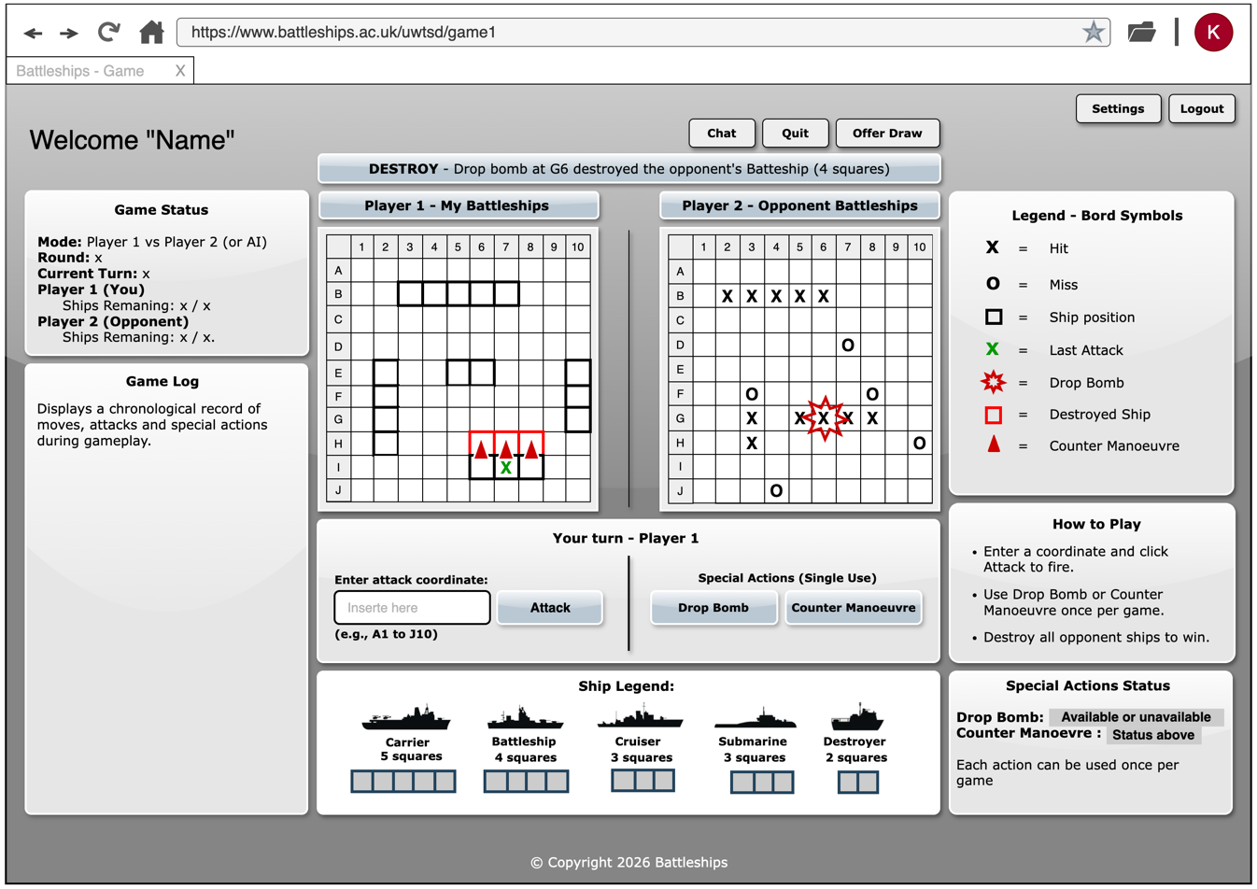
Figure 1. Wireframe for the Battleships user interface (developed by author on the Draw.io platform).

Its main strength is making key rules visible rather than implied. The drop bomb, counter manoeuvre and game-status information are presented in a way that supports player understanding and makes interface behaviour easier to assess. The Game Log and notification banner are particularly useful, exposing outcomes rather than relying on hidden logic.

2.6.2 Admin Interface
The admin wireframe reflects the main administrative stories with reasonable clarity. It includes sections for:
- User account management;
- Game management;
- Site management;
- Support requests;
- Statistics and reporting.

These correspond closely to the main areas identified in the user story map, which strengthens traceability between the admin stories and the proposed interface. Bringing these functions together within a single screen also makes the administrative scope of the system clearer at interface level.

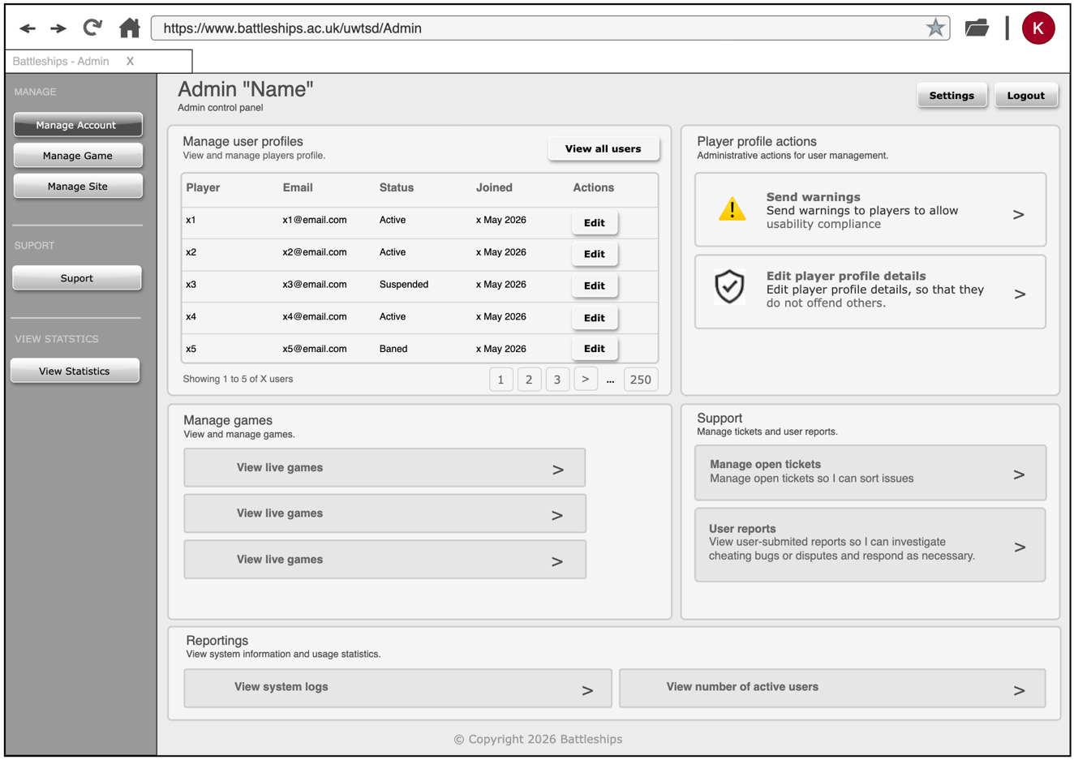
Figure 2. Wireframe for the Battleships admin interface (developed by author on the Draw.io platform).

Its main strength is translating the main administrative stories into visible interface sections rather than leaving them at a conceptual level. The profile management, support and reporting panels are particularly useful, making administrative actions more explicit and easier to assess. The wireframe remains simplified, however, and would need further refinement before the full range of administrative actions could be considered fully specified.

3. User Stories and User Story Mapping

3.1 The Role of User Stories in Agile Requirements Analysis
User stories play an important role in agile requirements engineering by shifting attention from fixed documentation towards discussion, refinement and shared understanding. Rather than defining every requirement in detail upfront, agile teams use stories as concise statements of user intent that support later clarification, since requirements evolve as the team’s understanding deepens [2], [9], [10]. As shown in Fig. 3, the format combines the stakeholder role, the action required and the value expected from that action.

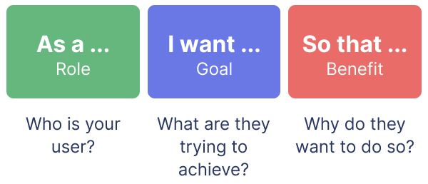
Figure 3. Agile user story format [11].

This format prevents requirements from collapsing into simple feature labels. Without the role or benefit, the story fails to explain why the requirement matters, while all three elements together help the team discuss, prioritise and refine the requirement against the value it is expected to deliver [10], [12], [13]. Research on user story quality also confirms that clearly stated user value improves usefulness during later development [10], [12].
Even so, following the expected format does not guarantee an effective story; it may still be vague, broad or hard to estimate, and requirement quality directly influences project outcomes [10], [14]. In Battleships, weak stories propagate to unclear responsibilities, classes or methods, so user story quality should be treated as a design concern rather than only a documentation concern [1].

3.2 Overview of the Developed User Story Maps
The user story map organises requirements along a horizontal sequence of user activity, distinguishing user-facing and administrative areas. Beneath each high-level activity, a second layer identifies the main tasks and a third holds the individual stories that support those tasks. The map also uses colour coding for activities, tasks, standard stories and Minimum Viable Product (MVP) stories, with a visible boundary marking the MVP.
This structure makes the stories more useful than a flat list. A list shows what the system does, while a story map also shows how each requirement fits into the wider user journey [2], [9], [13]. The MVP boundary is particularly useful because it makes prioritisation visible to the team rather than leaving it as an unspoken decision.

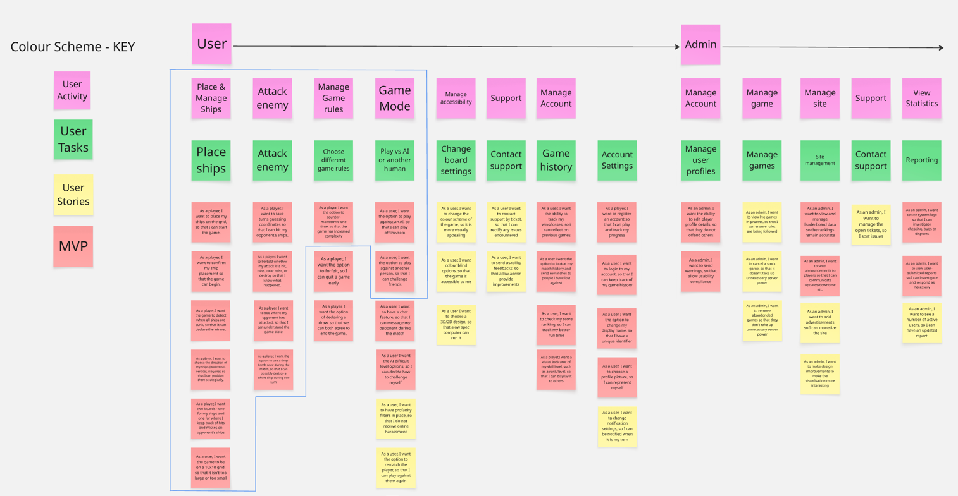
Figure 4. User and admin story map developed by Team 4 on the Miro platform for the Battleships project.

The map in Fig. 4 has two clear strengths. First, the user side activities (“Place & Manage Ships”, “Attack enemy”, “Manage Game rules”, “Game Mode”, “Manage accessibility”, “Support” and “Manage Account”) show awareness that the application must do more than enforce game rules [10], [12]. Second, the Admin lane with five activity columns shows that operational governance was considered, and story maps representing multiple roles make team discussions easier to organise [15].
As an artefact, the map is stronger than some of the individual stories. Several stories are well formed in the canonical role-action-benefit format, but the Quality User Story (QUS) framework reveals recurring weaknesses [10], [13].

3.3 Evaluation of Selected User Stories
Some gameplay stories apply the canonical format effectively. “As a player, I want to place my ships on the grid, so that I can start the game” is clear and focused, linking a specific role and single action to a meaningful benefit, and is specific enough to guide modelling without dictating implementation [1], [10].

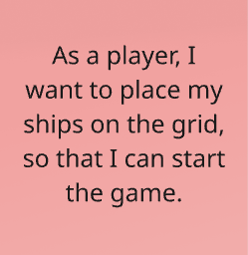
Figure 5. Example of a well-formed gameplay user story
developed by team 4 on the Miro platform.

Administrative stories apply the format equally well. “As an admin, I want to view live games in process, so that I can ensure rules are being followed” identifies a role, action and benefit linked to oversight [2], [9], [15].

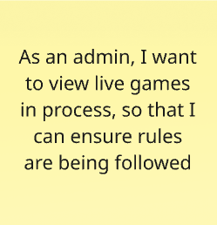
Figure 6. Example of a well-formed administrative user story
developed by Team 4 on the Miro platform.

Three weaknesses can be identified. The first is atomicity. “As a player, I want two boards, one for my ships and one for where I keep track of hits and misses on the opponent’s ships” combines two separate requirements, making it harder to estimate and test independently [10].
The second is ambiguity. “As an admin, I want to see a number of active users, so that I can have an updated report” leaves “active” undefined, since users could be currently online, in live games, or logged in during a period. Each interpretation gives a different implementation and tests, and unclear terms in requirements often lead to unclear design decisions [12], [14].
The third is a lack of uniqueness. “As a user, I want to change the colour scheme of the game” and “As a user, I want colour blind options” both touch visual accessibility and may overlap unless the distinction is made more explicit.

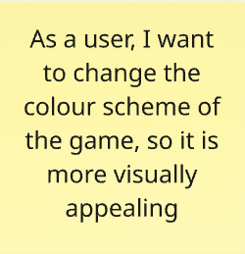
Figure 7. User stories conceptual overlap between accessibility requirements
develop by Team 4 on the Miro platform.

A further issue is inconsistent stakeholder labels. Some stories use “player”, others “user”, with no visible distinction in the map. Since the role is a key element of a user story, this reduces the precision of the requirements [13].

3.4 The Importance of the Benefit Statement
Of the three components of a user story, the benefit clause carries the greatest analytical weight, articulating the rationale behind the requirement. The role identifies who has the need and the action specifies what is required, but only the benefit explains why either should matter. Without it, the story drifts into a bare feature description and ceases to function as a requirement that can be reasoned about or weighed against alternatives [10], [11], [12].
Several examples in Battleships connect action and benefit effectively. “As a player, I want to place my ships on the grid, so that I can start the game” works because ship placement is a precondition for play, and the clause makes that dependency explicit. The administrative story on live-game monitoring is similarly effective, framing the activity as rule oversight rather than passive observation.
Clarity of this kind also bears on prioritisation. Agile planning literature treats stakeholder value as a central criterion when sequencing work [16], [17], so the question is not whether a benefit clause exists but whether it is specific enough to guide decisions. Several Battleships stories meet that threshold, particularly those linked to gameplay or administrative duties; others fall short because their benefits remain too vague. The weakest cases justify a feature on the grounds that it would make the system “more interesting”, which offers little basis for anyone weighing competing items.
Benefit clauses therefore deserve sustained attention during refinement. The team understood the canonical format, but the quality of the benefit statements remains uneven, and a later pass would need to sharpen the vaguer clauses, make them more observable, and connect them more firmly to the judgements stakeholders make when deciding the order of implementation [10], [11], [13].

4. CRC Cards

4.1 CRC Cards as a Collaborative Design Technique
CRC cards are a lightweight technique for identifying candidate classes, allocating responsibilities and tracing the collaborations through which those classes deliver system behaviour [18], [19]. Originally a pedagogical device for teaching object-oriented thinking, they now belong to the wider design toolkit because they encourage reasoning about object interaction at a stage where formal modelling would be premature [18], [20].
In practice, the cards prompt three questions about what each class is expected to know, what it must do, and which other classes it depends on. These fit Battleships well, where requirements expressed as user stories still need to be translated into object-oriented abstractions. The cards provide an intermediate stage in which classes and behaviours can be proposed, challenged and refined collectively, keeping responsibilities visible while the design remains flexible and reducing the risk of committing too early to an unsuitable structure [18], [19].

4.2 Evaluation of the Produced CRC Cards
The CRC set represents a substantive attempt to translate the functional requirements of the Battleships project into an object-oriented design. The team identifies several core domain concepts, including:
- Player;
- Board;
- Game;
- Ship;
- Bomb;
- AI_Player;
- Counter_Manoeuvre;
- Admin;
- Notification.

This range shows the team moved beyond a purely functional view to think in terms of interacting classes with distinct responsibilities, fulfilling CRC modelling role as a bridge between informal requirements and the more formal artefacts that follow [18], [20].
The set also reflects the wider scope of the system, covering gameplay control, special actions, administrative oversight and user communication rather than gameplay alone. Even so, the quality of a CRC set is judged not by the number of classes but by whether they are conceptually appropriate and whether the responsibilities assigned to them represent a credible interpretation of the requirements [19], [20].
Closer inspection shows the artefact is incomplete. One card is left entirely blank, and several collaborators on the cards (“Users” and “Statistics” among them) have no corresponding class definition, weakening internal coherence since each collaborator should denote an identifiable class. The cards in Fig. 8 give a serviceable starting point but would need a further round of refinement before forming a complete design representation.

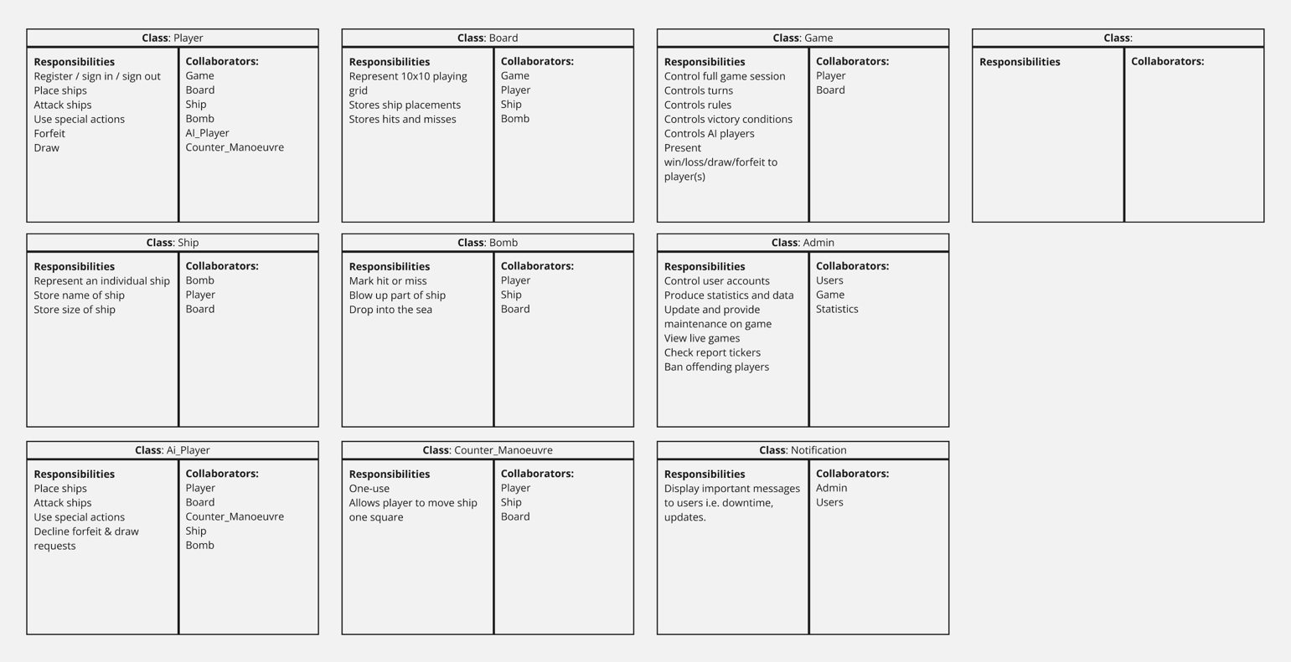
Figure 8. CRC cards developed by team 4 for the Battleships project.

4.3 Responsibilities and Collaborators
The value of any CRC set depends on how clearly responsibilities and collaborators are allocated. In a well-constructed model, responsibilities should distinguish one class from another, while collaborators should point to meaningful interaction between classes [18], [19]. On that basis, Player, Board and Game in Fig. 8 map convincingly onto the core problem domain and would likely remain central in any later revision.
The responsibilities are not expressed with equal precision. Several entries describe stored data or constraints rather than behaviour. The Ship card lists “Store name of ship” and “Store size of ship”, which are more attributes than responsibilities, and Counter_Manoeuvre treats “One-use” as a responsibility when it is a usage constraint. The set also shows overloading. Player combines registration, sign-in/out, ship placement, attacking, special actions, forfeit and draw, while Game concentrates session and turn management, rule enforcement, victory conditions, AI handling and outcome notification. The Player/AI_Player relationship is also unclear, whether specialisation, polymorphism or duplication.
Taken together, the CRC set identifies the principal objects with reasonable confidence but would benefit from a further pass to distinguish attributes, constraints and behaviours more clearly - for example by moving account-related responsibilities out of Player into a dedicated UserAccount or Account class, reducing Player’s burden.

4.4 Do the CRC Cards Support Implementation?
The cards in Fig. 8 give a useful intermediate basis for implementation, though they fall short of a complete coding blueprint. Their main contribution is helping designers reason about which classes are needed, what responsibilities they hold and how behaviour is distributed [18], [20]. For Battleships this is valuable, since the exercise turns user stories into candidate design elements ready for later formalisation.
That support remains only partial, however. Responsibilities on the Board, Bomb and Notification cards are precise enough to guide formalisation almost as written, while others remain too broad or imprecise to translate into methods without further interpretation. The blank card is the most obvious sign of incompleteness, with subtler issues such as undefined collaborators and lexical inconsistency (“check report tickers”, almost certainly intended as “tickets”). A further pass would need to recast broader responsibilities as specific methods and ensure every collaborator denotes a class also represented in the class diagram.

4.5 Relationship Between CRC Cards, Acceptance Criteria and Class Diagram
The CRC cards also bind requirements to the structural modelling that follows. User stories set out what the system should achieve, while the cards suggest how behaviour is distributed across classes. When a story has clear acceptance reasoning, such as valid placement, overlap rejection or winner detection, the cards help identify the responsible classes. Clear responsibilities therefore imply observable, testable behaviours [1], [18], so validating ship placement supports acceptance criteria for valid placement, overlap rejection and boundary checking, each translatable into black box and unit tests.
Comparing the cards with Fig. 9 makes this clearer. Major concepts such as Player, Board, Game, Ship, Bomb, Admin, AI_Player, Counter_Manoeuvre and Notification recur across both, suggesting continuity in the team’s modelling. The class diagram cannot, however, resolve weaknesses already present in the cards, so imprecise responsibilities, undefined collaborators or overloaded classes leave its behavioural justification weak.

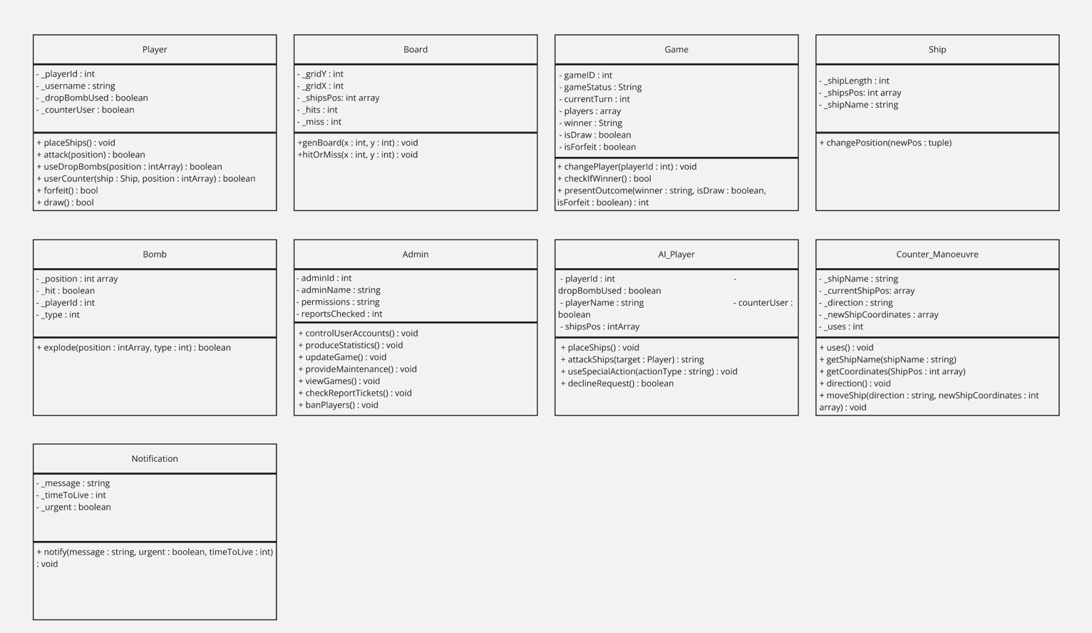
Figure 9. Class diagram for the Battleships project.

5. Software Testing Evaluation

5.1 Importance of Software Testing
Software testing is a cornerstone of software engineering, providing a structured way to check whether a system behaves as intended and whether faults remain in the implementation [21]. In Battleships, minor defects in turn handling, ship placement, attack resolution or game state updates could quickly become user-visible failures and undermine confidence in the system. The breadth of features in the earlier artefacts further widens the range of behaviours, states and interactions that testing must address.
A design that appears coherent at the modelling level may still contain faults once implemented, and a system that passes a small number of nominal tests may still fail under boundary or invalid conditions. Testing therefore complements design modelling by checking whether the implemented system behaves as intended [21], [22], continuing the design process rather than standing apart from it.

5.2 Black Box Testing
Black box testing examines a system through its externally observable behaviour, deriving test cases from requirements and expected input/output relationships rather than from the underlying code [22]. It suits user-visible functionality under normal, boundary and invalid conditions, applying in Battleships to ship placement, attack coordinates, game-mode selection and confirming that the game ends correctly once all ships are destroyed.
The technique aligns closely with user stories and acceptance reasoning, since Battleships requirements describe what players and administrators expect, and black box tests check whether those expectations are met. Its main limitation is structural. When two code paths produce the same visible output, the technique cannot distinguish between them, so defects behind apparently correct results may remain undetected until conditions change [21], [22].

5.3 White Box Testing
Where black box testing treats the system as a closed object, white box testing assumes familiarity with the code, deriving tests from internal structure and execution paths to exercise branches, conditions and loops [22]. In Battleships it suits logic-heavy components - validating board positions, hit/miss resolution, ship state updates, drop bomb, counter manoeuvre and win detection - and can expose faults black box testing misses, including overly complex control logic and branches not exercised by the suite [21], [22].
The technique has its own structural limitation, however. Exercising internal paths does not show that the resulting behaviour satisfies the user requirements, since correct execution of code is not the same as correct fulfilment of intent. White box testing is therefore best used alongside black box testing rather than as a substitute for requirement-based validation.

5.4 The Two Approaches Compared
A single example shows how the two techniques complement one another. For ship placement validation, a black box test supplies coordinates and checks whether the resulting board state matches what a player would expect, with in-bounds ships accepted, overlaps rejected and invalid coordinates not allowed, regardless of how validation is implemented.
A white box test of the same feature instead examines the validating method itself, exercising each branch in turn (valid placement, overlap detection, out-of-bounds rejection and repeated-coordinate handling) so that no path is left untested. The two perspectives can diverge. A method may pass every black box scenario while concealing an untested branch with a latent fault, and full structural coverage cannot guarantee the visible behaviour matches user expectations. Both perspectives are therefore necessary in Battleships, since defects in either dimension can compromise the game [21], [22].

5.5 Testable Code and Why It Matters
The value of any test suite is bounded by the testability of the code it examines, or how well a system’s design supports examining its own behaviour [23]. A class with clearly defined responsibilities, limited coupling and predictable behaviour is easier to test than one tied to a dense network of collaborators or accumulating too much logic in one place [6], [7]. Design quality and testability are therefore closely related aspects of the same concern.
The implication for Battleships is direct. The concentrated responsibilities observed in the Player and Game cards (Fig. 8) are precisely what would make the relevant behaviour hardest to isolate during testing. The redistribution recommended in Section 4.3 would therefore improve testability and reduce the impact of any single change [6], [7], [23]. Testable code deserves attention not only at implementation but during modelling, where structural decisions largely determine what can later be verified.

6. Application Tests and an Investigation of Unit Testing

6.1 Black Box Tests
Black box tests for Battleships should follow directly from the externally observable behaviour set out in the user stories and the story map [22]. Their value is twofold. They validate the gameplay surface players will encounter and safeguard it against the regressions that incremental change can introduce [21], [22].
The most suitable area is input validation and rule enforcement. The application should accept valid ship placements and reject overlaps, out-of-bounds positions or any breach of the placement rules. It should likewise accept valid attack coordinates, reject repeats on the same location, and return the appropriate outcome such as hit, miss, near miss or destroy for the current game state. From the administrator’s perspective, black box tests can also confirm that viewing live games, reporting active users and accessing support features behave correctly at interface level.

6.2 White Box Tests
White box tests should target methods whose correctness depends on conditional behaviour, branching or internal state transitions [22]. In Battleships this points to a small but significant group. Such methods include validating ship placement, resolving hits and misses, updating ship state, managing the drop bomb and counter manoeuvre, and detecting when a player has won.
The purpose is to examine the path taken through the code rather than only the final on-screen result. A move-validation method should therefore be exercised across each branch - valid placement, overlap detection, out-of-bounds rejection and diagonal placement where the rules permit it - so that no path is left untested. A winner-detection method should likewise be tested under each materially different game state (no ship destroyed, one ship remaining, all ships sunk). The drop bomb and counter manoeuvre deserve especially close attention, since their additional conditions, edge cases and single-use restrictions can hide faults behind apparently correct outputs [21], [22].

6.3 Test Cases
Table 1 presents a representative selection of tests. Six black box cases target behaviour visible to players and administrators, and five white box cases focus on individual methods whose internal branches require coverage.

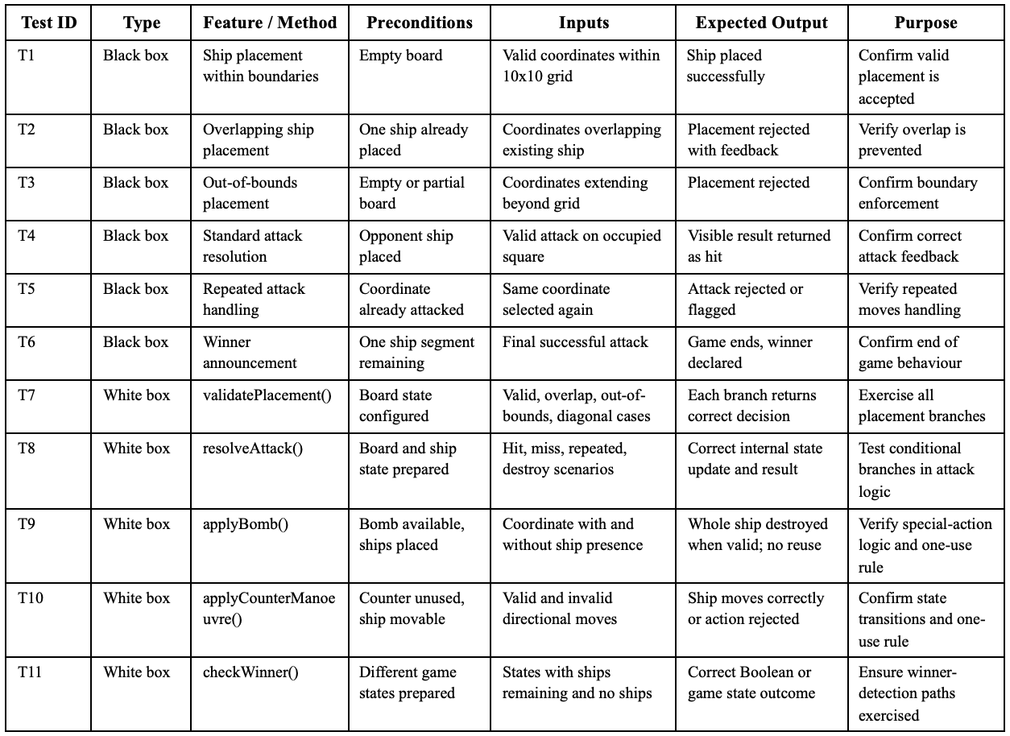
Table 1. Black box and white box tests for the Battleships project.

Several features cross the distinction. Ship placement appears externally in T1-T3 and internally in T7, attack resolution in T4-T5 and T8, and winner detection in T6 and T11. Only the drop bomb and counter manoeuvre (T9 and T10) appear solely as white box, reflecting how single use restrictions and conditional state changes resist user-level testing [21], [22].

6.4 Principles of Unit Testing
Unit testing focuses on small, isolated parts of the software, usually individual methods or classes, checking they behave correctly under controlled conditions. Its defining traits are isolation, repeatability, fast execution, clear assertions and minimal external dependence [6], [7]. A well-constructed unit test identifies a fault quickly and with minimal ambiguity. By contrast, tests with too many collaborators or unstable external state become hard to interpret [6].
The technique fits object-oriented systems where responsibilities are distributed. Modular, separated designs allow units to be tested independently, while concentrated or tightly coupled designs make unit tests harder to construct [7], [23]. Unit testing also contributes most when tests are meaningful, achieving real structural coverage and exposing genuine faults rather than nominal coverage [24], [25].

6.5 Applying Unit Testing to the Proposed White Box Tests
The white box tests in Section 6.2 can be translated into unit tests where the implementation is organised around discrete methods and classes. validatePlacement() lends itself to a range of unit tests using different board configurations and coordinate inputs, each checking the validity result. resolveAttack() can be treated the same way, using prepared board states for hit, miss, repeated attack and destroy. Such tests meet the criteria for unit testing because they isolate one logical behaviour at a time and can be repeated under controlled conditions [6], [7].
The same principle applies to the amended rules. A unit test for applyBomb() should verify that it destroys an entire ship only when used validly, cannot be reused once activated, and updates state consistently, applyCounterManoeuvre() should confirm a valid one-square move and rejection of invalid moves, checkWinner() should distinguish reliably between partial damage and complete destruction. The feasibility of such testing depends on classes being separated clearly enough for each unit to be observed and controlled in isolation, returning the discussion to the design-quality and testability link in Section 5.5 [7], [23], [24].

7. Conclusion

This report has evaluated the Battleships design by examining how requirements were translated into a structured object-oriented solution. The analysis shows a credible progression from requirements representation to modelling, supported by user story maps, CRC cards, a class diagram and a sequence diagram. Together, these artefacts indicate that the team moved beyond a purely functional description and began to reason in terms of classes, responsibilities, interactions and implementation-oriented structure.
The evaluation has identified consistent strengths. The project shows broad functional coverage, recognises both player and administrative perspectives, and maintains conceptual recurrence of the central domain entities across all four artefacts. The user stories were particularly effective in representing scope and stakeholder needs, while the behavioural modelling helped to show how selected gameplay interactions may unfold over time.
The analysis has also identified weaknesses to address before the design is implementation ready. Story quality is uneven in atomicity, ambiguity and uniqueness. In addition, the CRC cards include a blank entry and undefined collaborators, Player and Game are overloaded, and the sequence diagram lacks exception paths.
These do not invalidate the design but mark specific points where refinement would improve readiness.
The discussion of testing extended this by linking design quality to testability. The concentrated responsibilities observed in Player and Game would directly hinder unit testing, so the design weaknesses identified earlier propagate into the testability of the eventual implementation. The Battleships project therefore stands as a methodologically sound example of collaborative software design, illustrating that the value of design artefacts depends on how coherently they connect requirements, structure, behaviour and testability across the development lifecycle.

8. References

[1] M. Kassab, “An Empirical Study on the Requirements Engineering Practices for Agile Software Development,” 2014 40th EUROMICRO Conference on Software Engineering and Advanced Applications, Aug. 2014. [Online]. Available: https://doi.org/10.1109/seaa.2014.77 [Accessed: May 4, 2026].

[2] F. Dalpiaz, P. Gieske, and A. Sturm, “On deriving conceptual models from user requirements: An empirical study,” Information and Software Technology, vol. 131, p. 106484, Mar. 2021. [Online]. Available: https://doi.org/10.1016/j.infsof.2020.106484 [Accessed: May 4, 2026].

[3] C. Gravino, G. Scanniello, and G. Tortora, “Source-code comprehension tasks supported by UML design models: Results from a controlled experiment and a differentiated replication,” Journal of Visual Languages & Computing, vol. 28, pp. 23–38, Jun. 2015. [Online]. Available: https://doi.org/10.1016/j.jvlc.2014.12.004 [Accessed: May 4, 2026].

[4] A. Nugroho, “Level of detail in UML models and its impact on model comprehension: A controlled experiment,” Information and Software Technology, vol. 51, no. 12, pp. 1670–1685, Dec. 2009. [Online]. Available: https://doi.org/10.1016/j.infsof.2009.04.007 [Accessed: May 4, 2026].

[5] M. Torchiano, G. Scanniello, F. Ricca, G. Reggio, and M. Leotta, “Do UML Object Diagrams Affect Design comprehensibility? Results from a Family of Four Controlled Experiments,” Journal of Visual Languages & Computing, vol. 41, pp. 10–21, Aug. 2017. [Online]. Available: https://doi.org/10.1016/j.jvlc.2017.06.002 [Accessed: May 4, 2026].

[6] M. Bruntink and A. van Deursen, “An empirical study into class testability,” Journal of Systems and Software, vol. 79, no. 9, pp. 1219–1232, 2006. [Online]. Available: https://doi.org/10.1016/j.jss.2006.02.036 [Accessed: May 4, 2026].

[7] M. Zakeri-Nasrabadi, S. Parsa, and S. Jafari, “Measuring and improving software testability at the design level,” Information and Software Technology, vol. 174, p. 107511, 2024. [Online]. Available: https://doi.org/10.1016/j.infsof.2024.107511 [Accessed: May 4, 2026].

[8] J. A. Cruz-Lemus, M. Genero, D. Caivano, S. Abrahão, E. Insfran, and J. A. Carsí, “Assessing the influence of stereotypes on the comprehension of UML sequence diagrams: A family of experiments,” Information & Software Technology, vol. 53, no. 12, pp. 1391–1403, Dec. 2011. [Online]. Available: https://doi.org/10.1016/j.infsof.2011.07.002 [Accessed: May 4, 2026].

[9] E. M. Schön, J. Thomaschewski, and M. J. Escalona, “Agile Requirements Engineering: A systematic literature review,” Computer Standards & Interfaces, vol. 49, pp. 79–91, Jan. 2017. [Online]. Available: https://doi.org/10.1016/j.csi.2016.08.011 [Accessed: May 4, 2026].

[10] G. Lucassen, F. Dalpiaz, J. M. E. M. van der Werf, and S. Brinkkemper, “Improving agile requirements: the Quality User Story framework and tool,” Requirements Engineering, vol. 21, no. 3, pp. 383–403, 2016. [Online]. Available: https://doi.org/10.1007/s00766-016-0250-x [Accessed: May 4, 2026].

[11] Stories On Board Blog, “How to Write Agile User Stories,” Mar. 13, 2024. [Online]. Available: https://storiesonboard.com/blog/agile-user-stories [Accessed: May 4, 2026].

[12] M. A. Kuhail and S. Lauesen, “User Story Quality in Practice: A Case Study,” Software, vol. 1, no. 3, pp. 223–243, Jun. 2022. [Online]. Available: https://doi.org/10.3390/software1030010 [Accessed: May 4, 2026].

[13] G. Lucassen, F. Dalpiaz, J. Martijn, E. Van Der Werf, and S. Brinkkemper, “The Use and Effectiveness of User Stories in Practice”. [Online]. Available: https://webspace.science.uu.nl/~dalpi001/papers/luca-dalp-werf-brin-16-refsq.pdf [Accessed: May 4, 2026].

[14] L. Montgomery, D. Fucci, A. Bouraffa, L. Scholz, and W. Maalej, “Empirical research on requirements quality: a systematic mapping study,” Requirements Engineering, vol. 27, Feb. 2022. [Online]. Available: https://doi.org/10.1007/s00766-021-00367-z [Accessed: May 4, 2026].

[15] T. Sporsem, T. Dingsøyr, and K.-J. Stol, “User stories as boundary objects in agile requirements engineering: A theoretical literature review,” Journal of Systems and Software, vol. 233, 2026, Art. no. 112693. [Online]. Available: https://doi.org/10.1016/j.jss.2025.112693 [Accessed: May 4, 2026].

[16] D. Greer and G. Ruhe, “Software release planning: an evolutionary and iterative approach,” Information and Software Technology, vol. 46, no. 4, pp. 243–253, Mar. 2004. [Online]. Available: https://doi.org/10.1016/j.infsof.2003.07.002 [Accessed: May 4, 2026].

[17] R. V. Anand and M. J. Dinakaran, “Handling stakeholder conflict by agile requirement prioritization using Apriori technique,” Computers in Human Behavior, vol. 61, pp. 126–136, 2017. [Online]. Available: https://doi.org/10.1016/j.compeleceng.2017.06.022 [Accessed: May 4, 2026].

[18] K. Beck and W. Cunningham, “A laboratory for teaching object oriented thinking,” ACM SIGPLAN Notices, vol. 24, no. 10, pp. 1–6, Oct. 1989 [Online]. Available: https://doi.org/10.1145/74878.74879 [Accessed: May 4, 2026].

[19] Jürgen Börstler, “Using Role-Play Diagrams to Improve Scenario Role-Play,” Lecture Notes in Computer Science, Jan. 2010. [Online]. Available: https://doi.org/10.1007/978-3-642-17322-6_14 [Accessed: May 4, 2026].

[20] A. Haug and L. Hvam, “CRC cards to support the development and maintenance of product configuration systems,” International Journal of Mass Customisation, vol. 3, no. 1, p. 38, 2009. [Online]. Available: https://doi.org/10.1504/ijmassc.2009.021660 [Accessed: May 4, 2026].

[21] P. D. Coward, “A review of software testing,” Information and Software Technology, vol. 30, no. 3, pp. 189–198, Apr. 1988. [Online]. Available: https://doi.org/10.1016/0950-5849(88)90065-1 [Accessed: May 4, 2026].

[22] P.-L. Poon, T. H. Tse, S.-F. Tang, and F.-C. Kuo, “Contributions of tester experience and a checklist guideline to the identification of categories and choices for software testing,” Software Quality Journal, vol. 19, no. 1, pp. 141–163, Aug. 2010 [Online]. Available: https://doi.org/10.1007/s11219-010-9109-4 [Accessed: May 4, 2026].

[23] V. Garousi, M. Felderer, and F. N. Kılıçaslan, “A survey on software testability,” Information and Software Technology, vol. 108, pp. 35–64, Apr. 2019. [Online]. Available: https://doi.org/10.1016/j.infsof.2018.12.003 [Accessed: May 4, 2026].

[24] A. Tosun, M. Ahmed, B. Turhan, and N. Juristo, “On the Effectiveness of Unit Tests in Test-driven Development,” 2018. [Online]. Available: https://bura.brunel.ac.uk/bitstream/2438/16116/1/FullText.pdf [Accessed: May 4, 2026].

[25] A. Schwartz, H. Goldstein, and A. E. Hassan, “Investigating faults missed by test suites achieving high code coverage,” Journal of Systems and Software, vol. 144, pp. 106–120, Oct. 2018. [Online]. Available: https://doi.org/10.1016/j.jss.2018.06.024 [Accessed: May 4, 2026].

Draw.io, private communication, 2026. [Online]. Available: https://app.diagrams.net/. [Accessed: May 4, 2026].

Google Translate, private communication, 2026. [Accessed: May 4, 2026].

OpenAI’s ChatGPT, private communication, 2026. [Accessed: May 4, 2026].

