Maze Pathfinding Implementation
  - Advanced Software Development



This Photo by Unknown Author is licensed under CC BY-SA

Software Engineering

Kayleigh Davies
Student Number: 2316137
Table of Contents

Introduction 3
Dijkstra’s Algorithm 3
A* Algorithm 4
Comparison 4
Search Strategies 4
Use of Heuristics 5
Accuracy 5
Memory Usage 5
Quality and Performance 5
Implementation 6
Ideas for Further Development 10
Conclusion 10
References 11

Introduction
The purpose of this report is to evaluate the Dijkstra and A* pathfinding algorithms by examining their implementation, performance, similarities, and differences.
Pathfinding is the process of establishing the optimal path from a given start position to a target while avoiding obstacles within a grid-based environment, a problem commonly encountered in domains such as robotics and game development [1]. The performance of algorithms is determined by factors including execution time, path length, the number of expanded nodes, and the total number of grid cells traversed [1].
The second part of the report will focus on developing a C++ program to automatically solve a maze while minimising grid exploration and unnecessary player movement. The maze is represented as a 20x20 grid with fixed start and end positions, while the layout of obstacles varies from maze to maze. The pathfinding methods used for the task are explained throughout the report, along with suggestions for enhancements to improve the program's efficiency and overall performance.
Pathfinding Algorithms
The Dijkstra and A* algorithms are commonly used for pathfinding as they identify the shortest path between nodes in a graph, from one point to another [2,5]. Path planning algorithms are key to AI, robotics, video games, and navigation systems, as they support efficiency and optimisation in decision-making [1,2].
The following section provides a detailed explanation of Dijkstra’s Algorithm and the A* Algorithm, followed by a comparison of the two approaches.

Dijkstra’s Algorithm
Dijkstra's algorithm is a graph search algorithm implemented to identify the shortest path between the start and end points of a weighted graph [2,5]. It is also known as a greedy algorithm because it uses edges with the smallest weights to generate a path that reaches the target [2,5]. The algorithm will continue to check the surrounding nodes until the shortest path is found, updating the distances between the neighbours and the nodes that have been visited to reconstruct the path [5].
Dijkstra's algorithm is optimal in finding the shortest path but has high time complexity and memory usage when applying the adjacency matrix method. This is due to the unnecessary nodes the algorithm stores during its search, even though they do not contribute to finding the final path in the graph data structure, resulting in significant memory usage [4].
As suggested in [4], the performance of the Dijkstra application can be improved by applying limits to restrict the search area for the algorithm and by optimising the storage structures used to contain information from nodes during the navigation phase [4]. However, this can affect the accuracy of identifying the actual shortest path, as the algorithm may return an approximate shortest path when some graph information is restricted [4].

A* Algorithm
The A* algorithm is a search algorithm designed to improve efficiency by estimating the cost to reach the destination from each node using heuristic functions [5]. The heuristic function improves the efficiency of the algorithm as it prioritises using nodes that provide a better solution rather than exploring all possible nodes by applying priority queues [2].
For example, the priority queue explores nodes with the lowest cost to generate the shortest path [5]. Due to the efficiency and flexible nature of the A* algorithm, it is suitable for solving various map shapes and sizes [3,5].
One of the main drawbacks of the A* algorithm is that it can generate paths with numerous turns, which can increase communication costs and reduce execution efficiency [3]. Furthermore, the algorithm’s overall performance is highly dependent on the choice of heuristic, and an inappropriate heuristic may lead to unnecessary detours and reduced efficiency [3].

Comparison
As explained, Dijkstra’s algorithm and the A* algorithm are designed to find solutions to shortest path problems in weighted graphs, yet their accuracy, search strategies, performance and efficiency differ.

Search Strategies
Dijkstra’s search strategy evaluates all surrounding nodes to find a path, but it does not consider the target location, leading to unnecessary exploration. In contrast, the A* algorithm uses the target position during navigation to select only nodes likely to lead to the target in the final solution [5].

Use of Heuristics
The A* algorithm uses heuristic functions to estimate the cost to reach the target. This enables the algorithm to minimise the number of explored nodes by focusing on those closest to the target. Both the A* and Dijkstra's algorithms use priority queues to determine the next node to analyse. However, Dijkstra's algorithm relies on accumulating path cost to find the best solution, while A* combines the path cost with the heuristic estimates to determine the remainder of the search.

Accuracy
The Dijkstra algorithm is guaranteed to find the optimal solution when the entire graph is available. Similarly, the A* algorithm can identify the best possible outcome; however, its accuracy depends on the heuristic used. If an inappropriate heuristic is chosen, the algorithm's accuracy may be compromised.

Memory Usage
A* algorithm typically requires less memory than Dijkstra's algorithm because it explores fewer nodes by using heuristic functions. As a result, A* stores less information, whereas Dijkstra's algorithm often needs more memory, particularly when using an adjacency matrix, since it evaluates a larger portion of the graph.

Quality and Performance
Dijkstra's algorithm determines the shortest path between nodes of a graph based on the node costs. However, Dijkstra's algorithm takes more time in its searching process.
The A* method increases performance and flexibility, but it may result in generating pathways with more turns, reducing execution efficiency in practical applications. In addition, if the heuristic functions are inadequately selected, the A* algorithm may exhibit performance like Dijkstra’s algorithm.

Implementation
This section focuses on the development process of a C++ program that automatically solves any maze. Before creating code to solve the maze, the player and target positions were identified, along with the directions the player could move and the grid size.
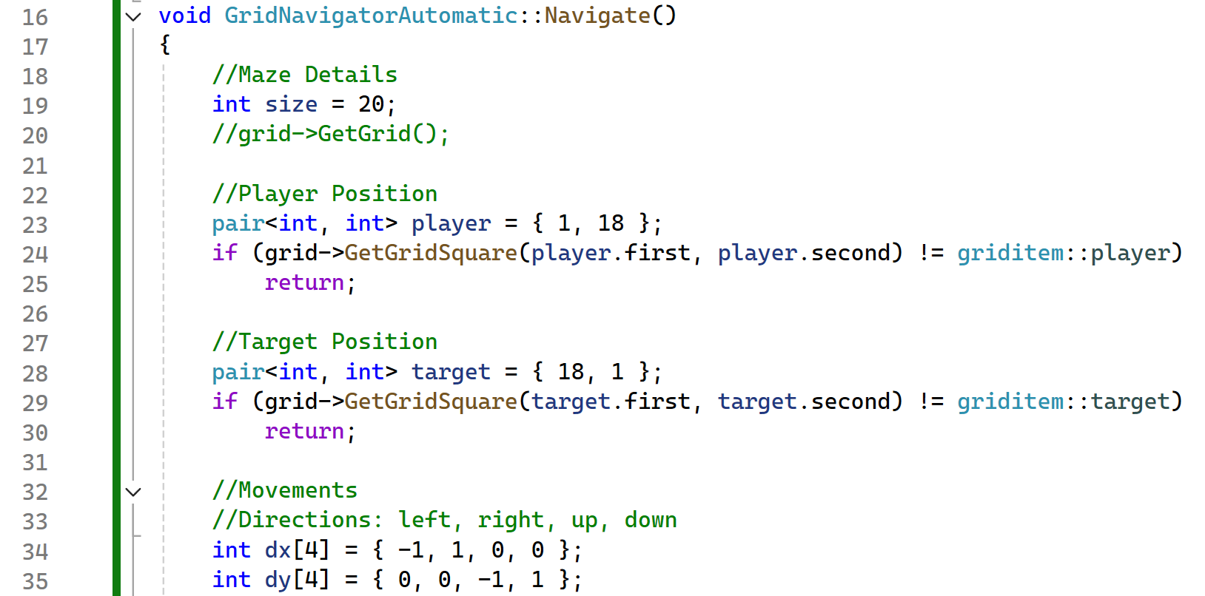
  - Maze Conditions
Understanding these conditions is essential to ensure the pathfinding algorithm operates correctly within the maze's constraints and produces a valid, optimal solution.
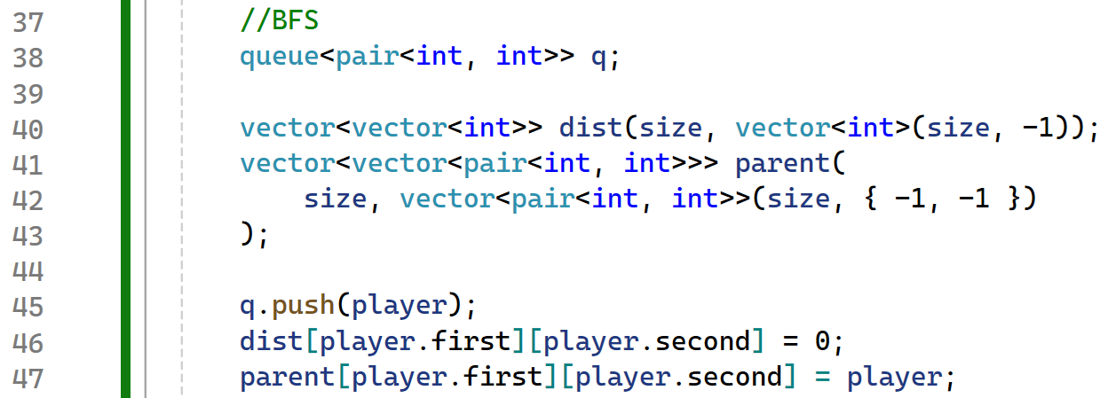
After incorporating these conditions into the program, the Breadth-First Search algorithm was configured to traverse the nodes of the maze and determine the optimal path for the player to reach the target.

  - Breadth First Search Set Up
The breadth-first search algorithm was applied for the implementation because of its simplicity in generating the shortest path. Plus, it is a good starting point for defining a working solution before trying more complex algorithms such as Dijkstra and A* for pathfinding and navigation.
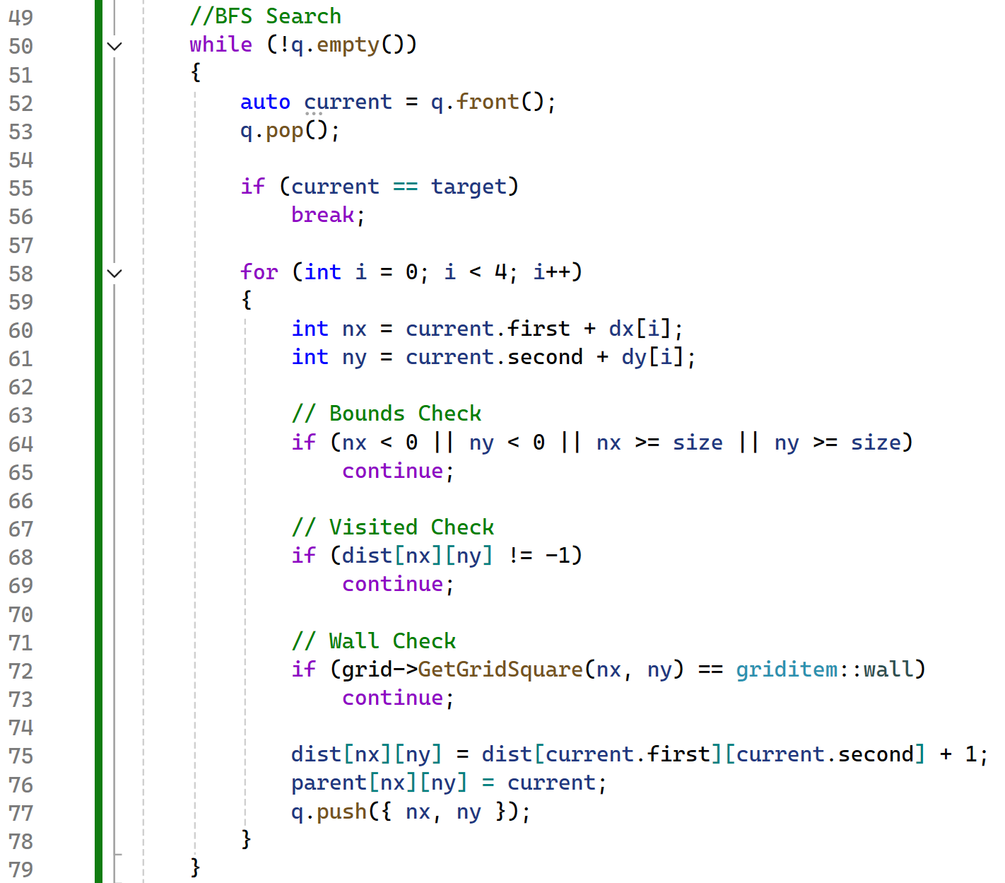
  - Breadth First Search

After implementing the remaining breadth-first search steps in the script, additional checks were applied to ensure the player's movements avoided hitting walls, moving out of bounds, or moving to previously visited nodes.
Applying these validation methods to the program ensures that the player can only move into empty spaces and within the boundaries of the grid, preventing the algorithm of storing unnecessary information of nodes beyond the limits of the grid. For example, storing the coordinates of a wall in the visited memory.
The GridNavigatorAutomatic.cpp file was assessed to determine the output when solving the maze automatically. Both the automatic and benchmarking methods were evaluated to understand how shortest path lengths, grid accesses, and efficiency differ between them.
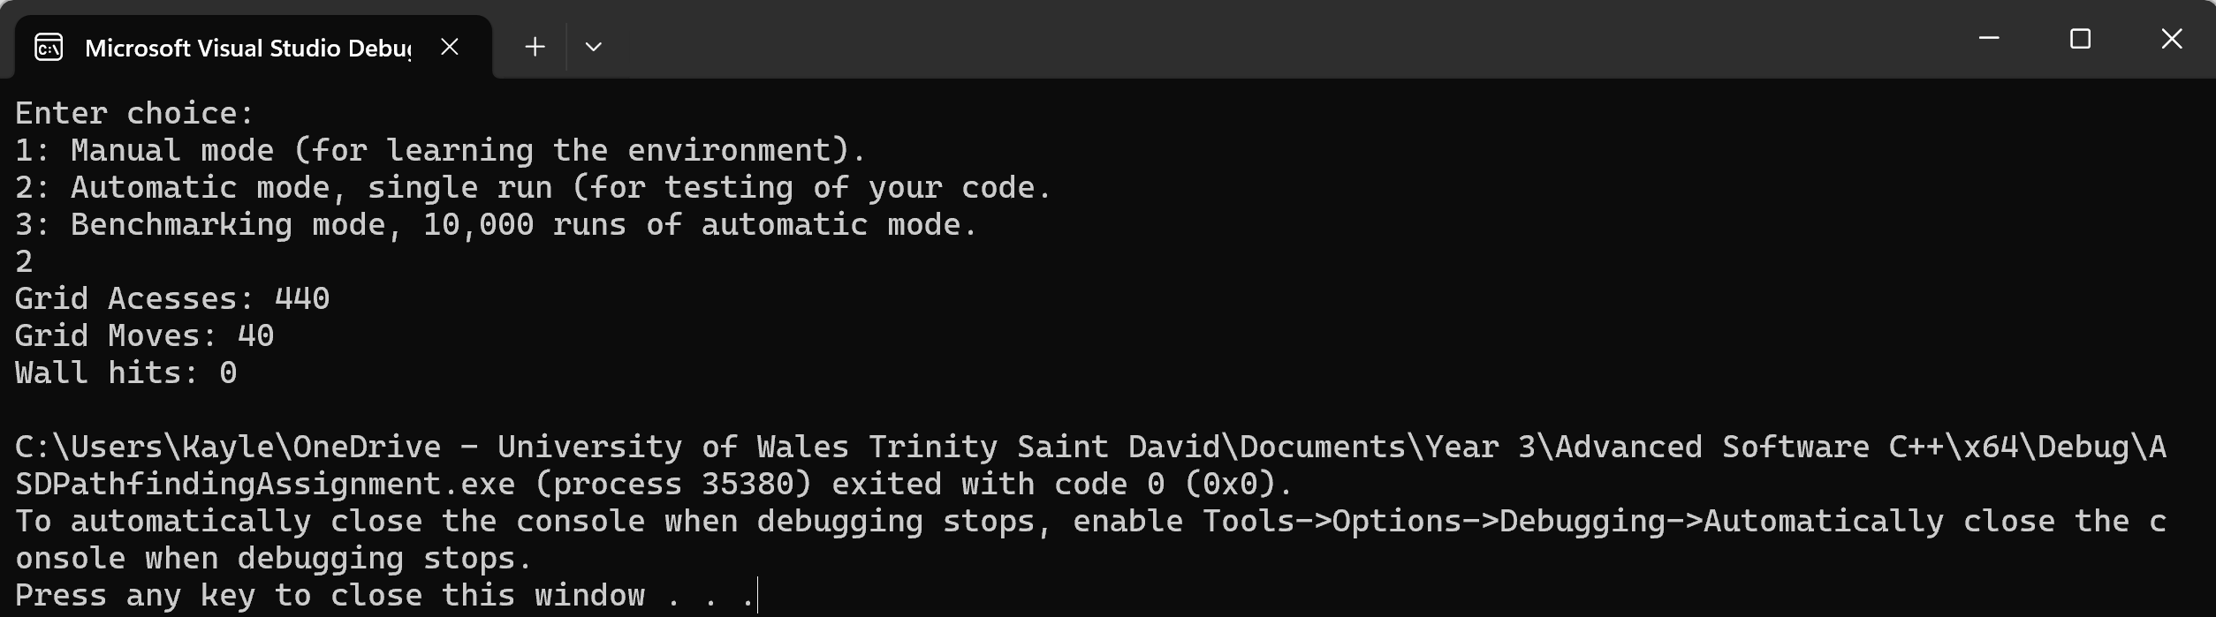
  - Automatic Mode Output
The output above shows the results of testing the script in automatic mode. This indicates that the grid was accessed 440 times and the player moved 40 times to reconstruct the path found during the breadth-first search navigation. This suggests that the number of visited nodes could be reduced using other search algorithms, thereby reducing the memory and grid access requirements of the breadth-first search.
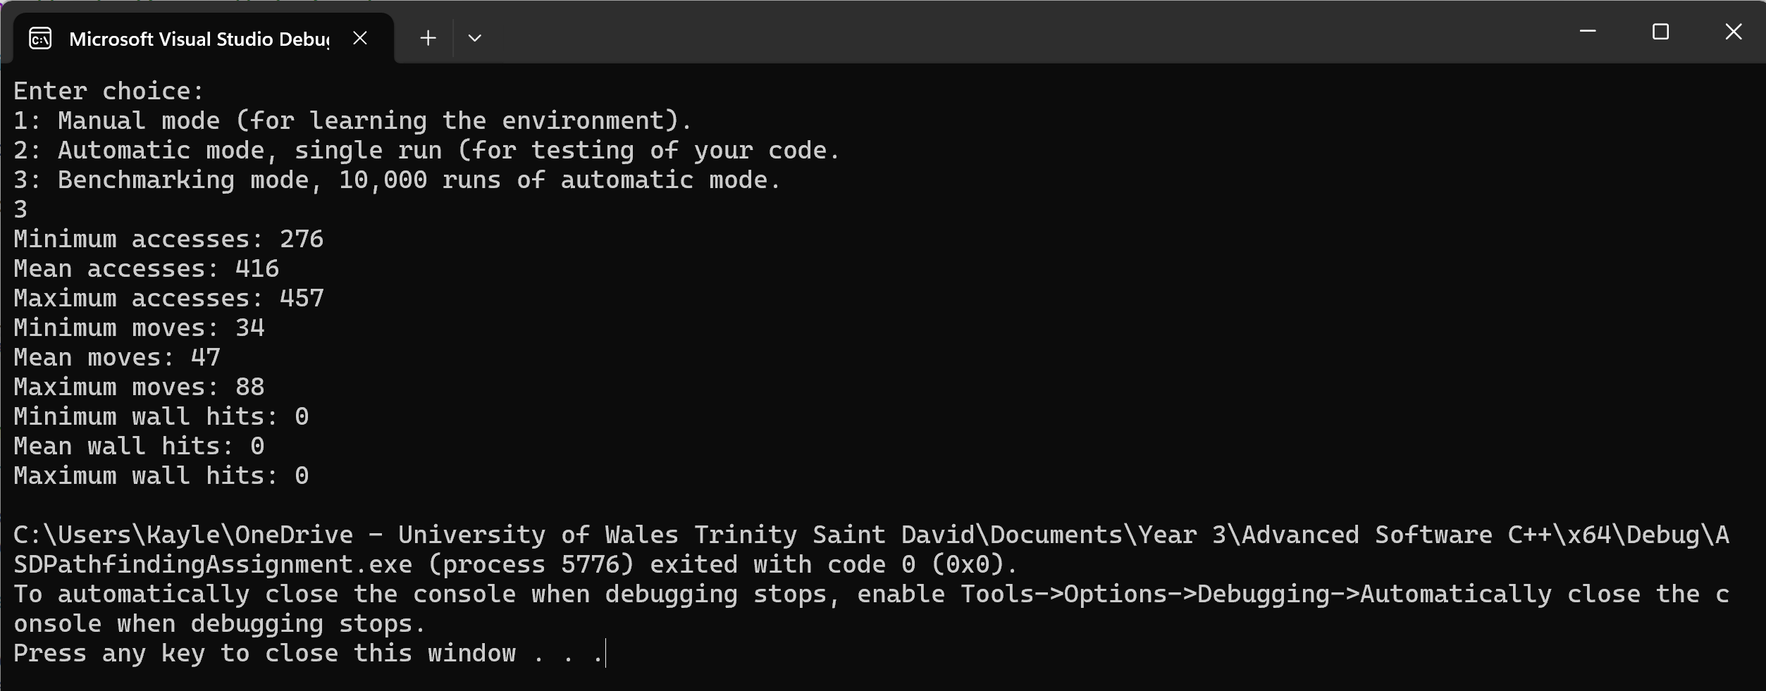
  - Benchmarking Mode Output
The script was assessed in benchmarking mode to determine the minimum and maximum values for grid accesses and player movements required to reconstruct the path. The results show that the maze can be completed in 34 movements, with the grid accessed fewer than 300 times, indicating that the algorithm is suggesting solutions for the shortest paths as expected.

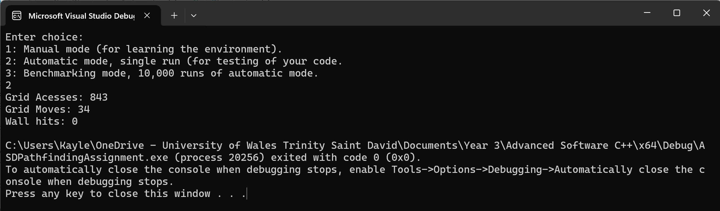
  - Automatic Mode Output Using “grid->GetGrid()”
The script was then tested again in automatic mode, calling grid->GetGrid(); to view the maze before attempting to identify the shortest path to the end goal. Looking at the details above, the maze was solved in 34 moves, with the grid accessed 843 times, meaning 409 squares were checked before finding the final solution. This emphasises that the additional nodes the algorithm checks do not affect the shortest path but increases the time required to calculate it.

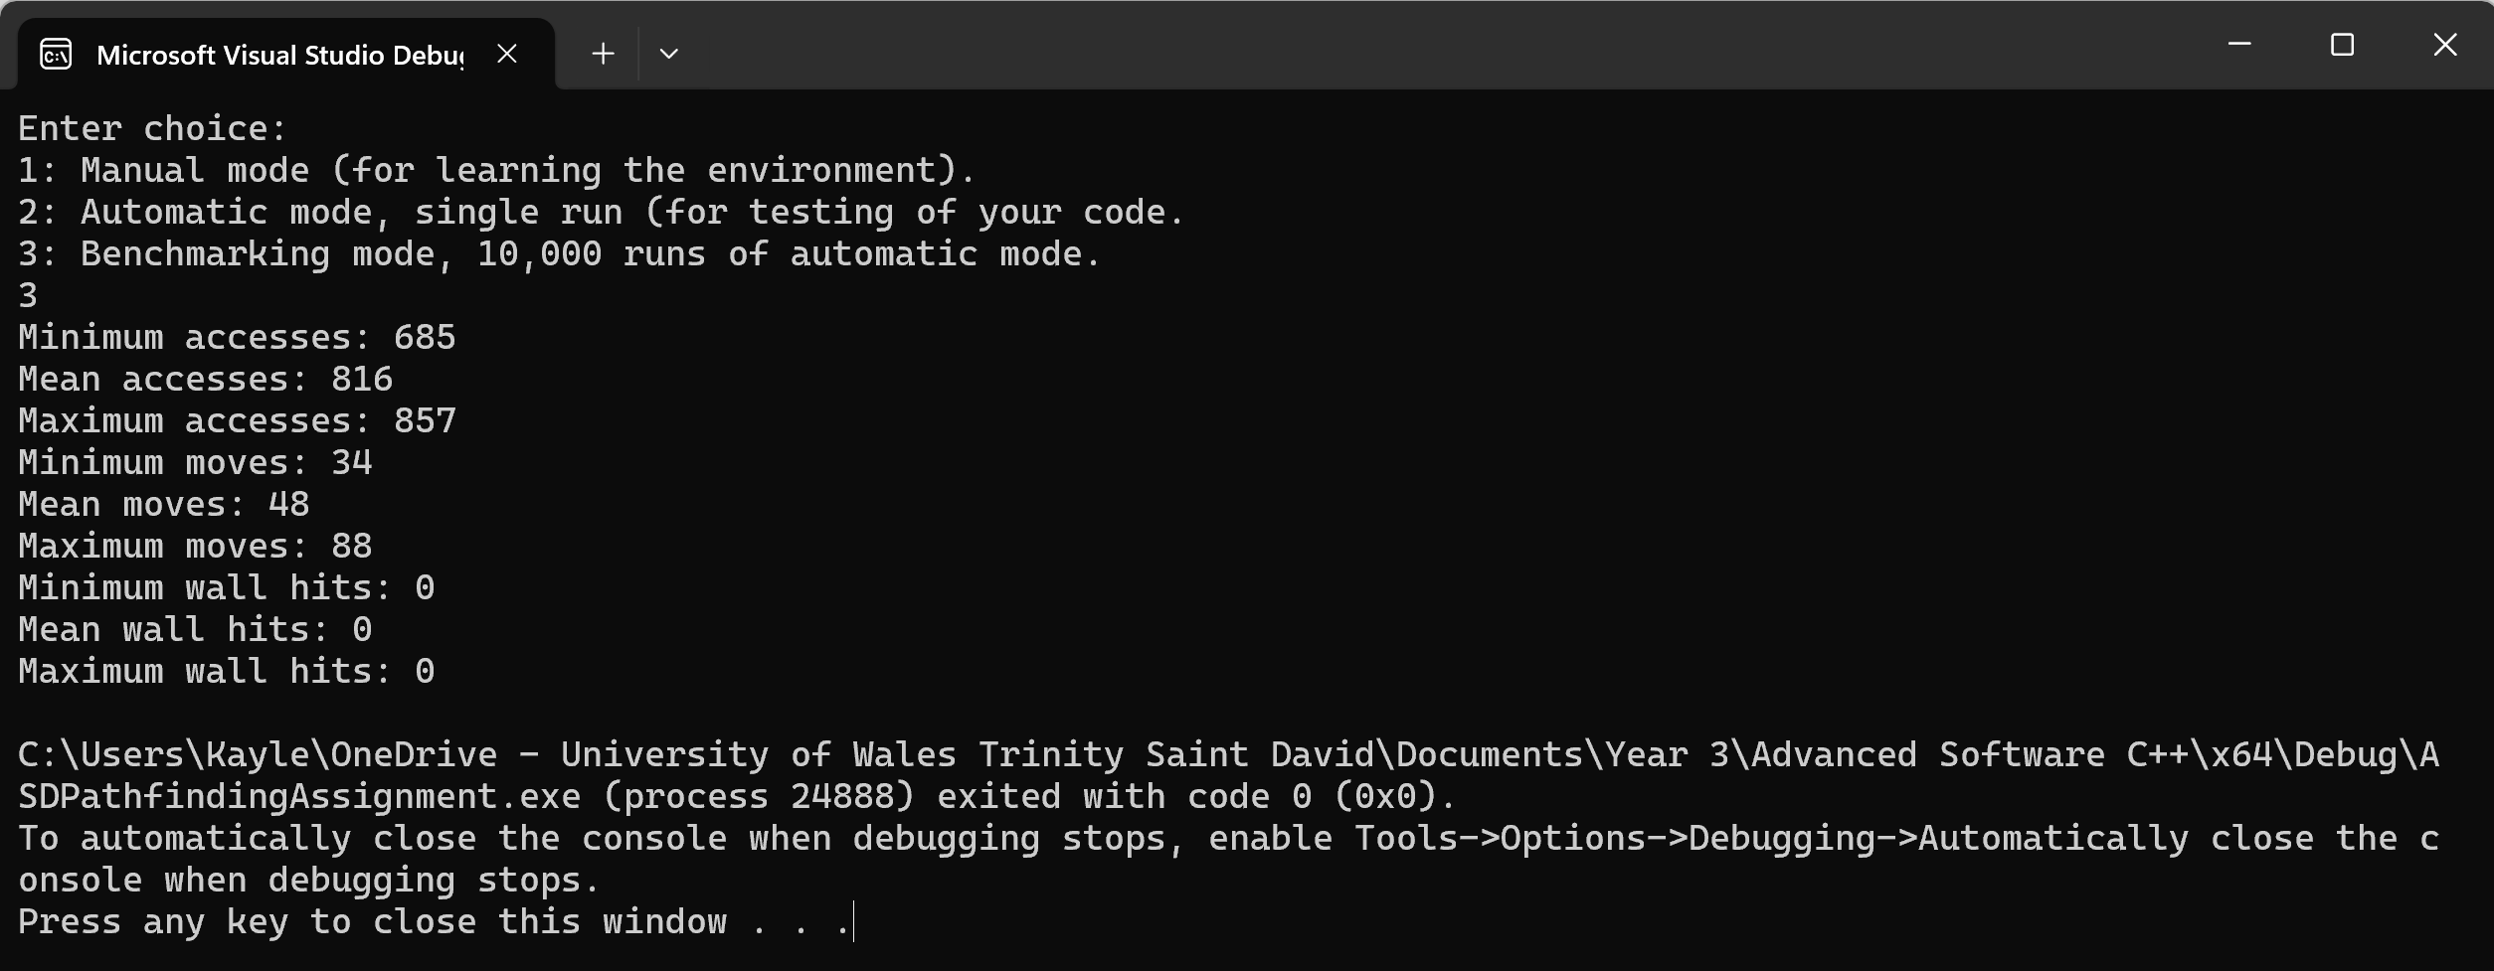
  - Benchmarking Mode Output Using “grid->GetGrid()”
The benchmarking mode was then reviewed to understand how calling the grid->GetGrid(); method within the script would affect the number of times the grid was accessed before solving the maze. After observing both outputs from the script, it's clear that limiting views to avoid unnecessary grid access is beneficial for the performance and efficiency of the program, as accessing the full grid before navigating the maze doesn’t improve the final results.

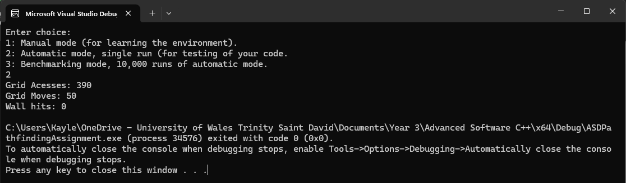
  - Missing “Maze Complete!” Text
The program has reconstructed the path found during the BFS and navigated the player through the maze, avoiding collisions with walls. The maze has reached its end, but the program doesn’t display the “Maze Complete!” message.
This suggests that the pathfinding has worked as intended, as it’s moving the player through the maze, but there is an implementation error as it hasn’t reached the target or confirmed that the maze has been solved successfully, highlighting areas that require further adjustments.

Ideas for Further Development
To identify the most efficient pathfinding solution for the maze, implementing Dijkstra’s and A* algorithms to compare performance with the breadth-first search method will demonstrate the strengths and weaknesses of the algorithms while providing optimal shortest-path solutions.
Also, applying more constraints to the maze, such as solving in fewer than 50 or 100 moves and adding diagonal movements could be an idea for further development, along with testing these algorithms on larger grids to understand how performance reacts with maze size.

Conclusion
This paper compares the Dijkstra and A* algorithms as effective path selection techniques, evaluating their performance and efficiency in terms of path length, the number of expanded nodes, and the total number of grid cells traversed.
A maze-solving program was constructed using the breadth-first search method. While the results demonstrate that breadth-first search is effective for determining the shortest paths, it requires thorough exploration of the maze, resulting in more grid accesses.
Applying Dijkstra’s and the A* algorithms to future pathfinding tasks presents the opportunity to reduce unnecessary exploration and improve the program to support more complex maze environments.

References
[1] A. Kherrour, M. Robol, M. Roveri, and P. Giorgini, “A multi-algorithm pathfinding method: Exploiting performance variations for enhanced efficiency: A multi-algorithm pathfinding method: Exploiting performance,” Annals of mathematics and artificial intelligence, vol. 93, no. 4, pp. 569–588, 2025, doi: 10.1007/s10472-024-09957-3.
[2] D. Rachmawati and L. Gustin, “Analysis of Dijkstra’s Algorithm and A Algorithm in Shortest Path Problem,” Journal of physics. Conference series, vol. 1566, no. 1, p. 12061, 2020, doi: 10.1088/1742-6596/1566/1/012061.
[3] Z. Zhang and Z. Zhao, “A Multiple Mobile Robots Path planning Algorithm Based on A-star and Dijkstra Algorithm,” International Journal of Smart Home, vol. 8, no. 3, pp. 75–86, May 2014, doi: https://doi.org/10.14257/ijsh.2014.8.3.07.
[4] D. Fan and P. Shi, “Improvement of Dijkstra’s Algorithm and Its Application in Route Planning,” 2010.
[5] GeeksforGeeks, “Difference Between Dijkstra’s Algorithm and A* Search Algorithm,” GeeksforGeeks, Jun. 21, 2024. https://www.geeksforgeeks.org/dsa/difference-between-dijkstras-algorithm-and-a-search-algorithm/ (accessed Jan. 03, 2026).
[6] R. Świdziński, Modern CMake for C++ : effortlessly build cutting-edge C++ code and deliver high-quality solutions, Second edition. Birmingham, UK: Packt Publishing Ltd., 2024.
[7] W3Schools, “C++ Data Structures and STL,” W3schools.com, 2024. https://www.w3schools.com/cpp/cpp_data_structures.asp (accessed Jan. 01, 2026).
[8] GeeksforGeeks, “C++ STL Cheat Sheet,” GeeksforGeeks, Jun. 19, 2023. https://www.geeksforgeeks.org/cpp/cpp-stl-cheat-sheet/ (accessed Jan. 01, 2026).
[9] GeeksforGeeks, “Shortest path in grid with obstacles,” GeeksforGeeks, Aug. 06, 2023. https://www.geeksforgeeks.org/dsa/shortest-path-in-grid-with-obstacles/ (accessed Jan. 01, 2026).

