Marketing Fundamentals
Module Code: LCBB4004

Assessment 1
Blogging to communicate
Student name: Gabriel Mezo
Student number: 2030169

Table of Contents
Introduction 3
Blog 01 4
Blog 02 5
Blog 03 6
Blog 04 7
Blog 05 9
Blog 06 10
Conclusion 11
References 12

Introduction
This paper includes a series of blog posts that mainly includes the concepts of basic marketing like the process of segmentation, targeting, and positioning. It also includes the concepts of the different marketing mixes. I have chosen Coca-Cola company for this assignment. The purpose of these blog posts is to ensure proper communications with the consumers. Blog posts are also helpful for creating awareness among the consumers about the different aspects of the company (Arab, 2018). In this era of digital marketing, blog posts play an important role to connect with consumers (Chu, 2020).

Blog 01
Blog Title: Porter’s Five Forces model.
Porter’s Five Forces model is a well-known framework for companies to determine the competitive environment of the industry within which they operate (Hollensen, 2018). The five forces are (i) Threat of New Entrants, (ii) Threat of Substitutes, (iii) Rivalry among existing companies in an industry, (iv) Bargaining Power of Buyers, and (v) Bargaining Power of Suppliers (De Villiers et al., 2020).

This model helps companies to understand the main competitive forces in an industry. For example, for a company like Coca-Cola, the threat of new entrants is medium. The entry barriers in the beverage industry are low, but the kind of brand recognition Coca-Cola enjoys is a threat for newcomers (Melton et al., 2017). Similarly, the threat of substitutes is also in medium to high pressure. Because there are a lot of similar products offered by many companies at the same price range. Besides, the bargaining power of buyers and the bargaining power of suppliers are also low for Coca-Cola company. Because no individual buyer pressurizes Coca-Cola to reduce the price (Talukder, 2019). On the other hand, Coca-Cola is one of the biggest customers for suppliers, as a result, the bargaining power of suppliers is also low. In contrast, the rivalry among the beverage industry is high. Pepsi is one of the biggest competitors of Coca-Cola (Jewel et al., 2020).

Blog 02
Blog Title: The process of Segmentation, Targeting, and Positioning
STP (Segmentation, Targeting & Positioning) marketing is very effective for a business. Because there are a lot of advantages of STP marketing. It has three-step methods that help organizations to create a targeted and actionable marketing strategy (Hollensen, 2018). Segmentation means dividing the dis-similar market into small similar groups. As a result, companies can focus on the specific expectations and needs of a particular group or segmentation. Moreover, segmentation helps companies to allocate their resources more effectively. Companies can segment their targeted customers based on their geography, demographics, psychographics, lifestyles, commitment levels, etc (Jain, 2017).

At this point, companies are more specific about their targeted consumers. So, after completing the segmentation process, a company should target which segment is worth pursuing and focus on that specific segmentation (Talukder, 2019). Some companies follow the same targeting strategy for all segmentation, some use a different strategy for different segmentation. Finally, in the positioning process, companies try to meet the desire of the targeted segmentation. As a company knows its targeted market’s needs and wants properly, it can position its products accurately according to the consumer’s demand (Jewel et al., 2020). Proper positioning also helps companies to develop a unique selling strategy for the right segmentation at a right time (Melton et al., 2017). So, to sum up, we can say that, with proper segmentation, targeting, and positioning companies can have a great impact on the market.

Blog 03
Blog Title: Coca-Cola Company’s STP Marketing Strategy:
In the previous blog, we have described STP marketing in detail. From there we have already known that segmentation, targeting, and positioning have a great impact on the success of a company. Because STP marketing strategy enables a company to know who are their customers, what they want, and how to provide products according to the consumer’s preference (Jewel et al., 2020). Coca-Cola company is also very efficient in STP marketing. They have segmented their targeted customers based on certain criteria and then serve the targeted customers according to their preferences. This is the secret strategy of Coca-Cola’s long-term success.
Segmentation

Make Sense of the Market
Targeting

Decide the best Segment to serve
Positioning

Stand out from Competitors

Here in this blog, we will discuss the STP strategies in detail:
Segmentation: The purpose of segmentation is to divide the market into groups of potential customers with similar interests. As a result, companies can focus on the customer’s needs and wants for each group (Talukder, 2019). Coca-Cola Company has used this strategy properly. As a result, Coca-Cola Company has segmented its worldwide market based on the geography, demography, and consumption behaviors of the different places (Jewel et al., 2020).
Targeting: After the segmentation process, it is necessary to target a proper segment to serve. Different segments are targeted by Coca-Cola with different approaches (Melton et al., 2017). Coca-Cola mainly targets young people and secondarily middle-aged people. Besides, Coca-Cola company offers both strong flavors for the one segment of people who want it and diet cola and its variations for another segment of people who are health conscious. So, to target the health-conscious segment of the market Coca-Cola company uses non-cola beverages. Moreover, Coca-Cola offers different flavors for different segments of people. For example, Coca-Cola company offers Sprite focusing the teens and college-going youth consumers and Limca for the young working people.
Positioning: Coca-Cola positions its products as refreshing and thirst-satisfying (Jewel et al., 2020). Coca-Cola advertises its products in a way that gives a conception to the consumers that Coca-Cola products are the means of joy and happiness. Their latest tagline “Little drops of joy” also conveys this message. So, the products offered by the Coca-Cola company are related to having fun with friends and family, as well as enjoying everyday life (Jain, 2017).

Blog 04
Blog Title: Marketing mix of Coca-Cola company
This blog describes the 4 Ps of the marketing mix of the Coca-Cola company. A business’s foundation model is stated as a marketing mix (De Villiers et al., 2020). Companies use a marketing mix, a collection of marketing techniques, to accomplish their marketing purposes in a target marketplace (Melton et al., 2017). The 4 Ps of marketing include Product, Price, Place, and Promotion. The 4 Ps of marketing enables a company to define various marketing options in terms of price, product, place, and promotion (Sultan et al., 2019). So, let’s discuss Coca-Cola’s marketing mix:
Product Strategy:
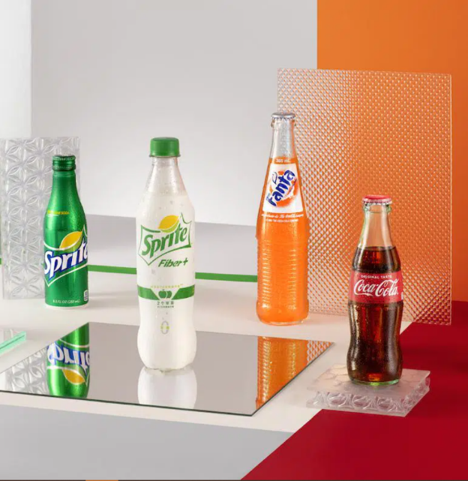
Coca-Cola has significantly expanded its product line throughout the time. The company's portfolio includes 500 sparkling and still beverage brands. In all, there are about 3,900 beverage variations in the product mix of Coca-Cola company (Jain, 2017). Among all products, there are some famous products of Coca-Cola. They are:
- Coca-Cola
- Sprite
- Fanta
- Coca-Cola Zero
- Diet Coke

Price Strategy:
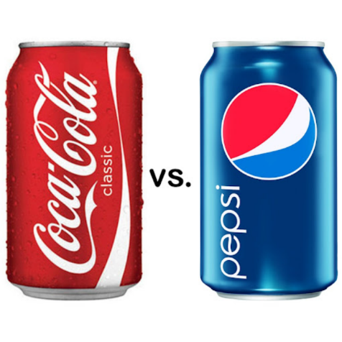
Price discrimination strategy is used by Coca-Cola company in its price marketing mix. It means that different prices are charged by Coca-Cola in different segments (Jain, 2017). In the beverage industry, Coca-Cola enjoys an oligopoly (De Villiers et al., 2020). Because in this market there are only a small number of sellers like Coca-Cola, Pepsi, etc. But in contrast, there are a large number of purchasers. In the beverage industry, Coca-Cola and Pepsi are the two biggest competitors (De Villiers et al., 2020). So, Coca-Cola company always tries to price its products similar to Pepsi products in the same segment.
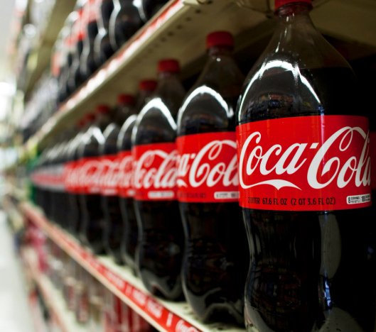
Place and Distribution Strategy:
Coca-Cola started its business more than 130 years ago and at present, it operates in more than 200 countries around the world (Melton et al., 2017). This huge network has enabled Coca-Cola to distribute its products across the world easily. Coca-Cola products are available in every retail shop and supermarket. Besides, their products are also distributed in many hotels and restaurants as well (De Villiers et al., 2020).

Promotion Strategy:
A new benchmark for advertising and branding has been developed by the Coca-Cola company. Coca-Cola company follows an aggressive marketing strategy. They mainly use media like TV, online ads, print media, sponsorship, etc (Sultan et al., 2019).

Blog 05
Blog Title: Coca-Cola Marketing Strategy
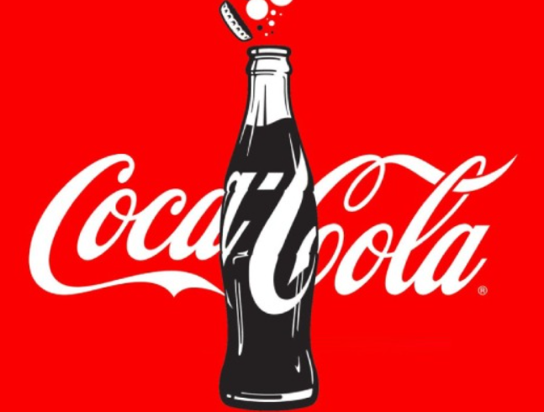
A brand is known as a promise of satisfaction (Chu, 2020). A good marketing strategy ensures the reputation of a company and creates strong brand loyalty among the consumers. There are a few companies in this world like Coca-Cola that has achieved this kind of brand loyalty. Coca-Cola follows an aggressive branding strategy to advertise its products (Lacy-Nichols et al., 2020). As a result, it has become a widely known brand. This strong brand loyalty has become one of the biggest competitive advantages of Coca-Cola. So, Coca-Cola has been effective in developing brand loyalty among its customers. From the very beginning of the 20th century, Coca-Cola is following a sustainable marketing or branding strategy that involves innovative marketing strategies apart from the usual advertising methods. Coca-Cola focuses more on the colleges and universities and this increased their sales and spread the brand name (Melton et al., 2017). By using its huge network and a combination of both central and local marketing functions Coca-Cola has achieved the maximum marketing and distribution effectiveness. By using this strategy Coca-Cola maintains its global brand while introducing the local elements as well (Sultan et al., 2019).

Blog 06
Blog Title: Unique Advertising Strategy of Coca-Cola
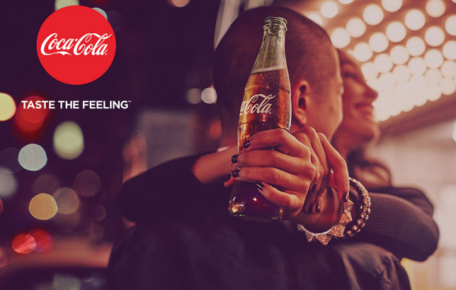
Coca-Cola is famous as a soft drink of the world (Arab, 2018). It has strong customer loyalty around the world. Behind this strong customer loyalty, the unique advertising strategy of the company is responsible. Coca-Cola has used every available medium of advertising (Hollensen, 2018). Starting from radio advertisements, TV advertisements, online ads, print media, digital media, etc. every medium is used by the company. In these mediums, Coca-Cola always tries to present them as pleasurable and refreshing drinks (Jain, 2017). The company has successfully launched many famous advertisement campaigns like “The Coke adds life” and “Have a Coke and smile”, “Can’t beat the feelings” etc (De Villiers et al., 2020). So, I can say that the innovative and creative marketing or advertising strategy has enabled Coca-Cola to reach today’s position.

Conclusion
This paper includes a series of blog posts. These blogs describe different concepts of marketing. Some of them are the process of segmentation, targeting, and positioning. Besides, it also describes the different marketing mixes of Coca-Cola company. Finally, in the end, it describes the unique and innovative marketing strategies of Coca-Cola. So, after finishing this paper learners will get an idea of the basic concepts of marketing.

References
Arab, N., 2018. Relationship between dimensions of Brand Equity and 4Ps of Marketing Mix- Place, Product, Promotion, & Price: Coca Cola-Consumer Based Qualitative Survey.
Chu, B., 2020, November. Analysis on the Success of Coca-Cola Marketing Strategy. In 2020 2nd International Conference on Economic Management and Cultural Industry (ICEMCI2020) (pp. 96-100). Atlantis Press.
De Villiers, R., Tipgomut, P. and Franklin, A., 2020. International Market Segmentation across Consumption and Communication Categories: Identity, Demographics, and Consumer Decisions and Online Habits.
Hollensen, S., 2018. Marketing-Strategie und Marketing-Mix. In Einführung in das Bildungs- und Kulturmanagement (pp. 31-44). Ziel-Zentrum für interdisziplinäres erfarungsorientiertes Lernen GmbH.
Jain, R., 2017. BRAND PERSONALITY AND BRAND LOYALTY. CLEAR International Journal of Research in Commerce & Management, 8(6).
Jewel, M.M.H. and Kalam, K.K., 2020. The Importance and Level of Adaptation of STP Strategies for Growth in Foreign Markets: In the Case of Soft Drinks Company. Asian Journal of Economics, Business and Accounting, pp.13-23.
Lacy-Nichols, J., Scrinis, G. and Carey, R., 2020. The evolution of Coca-Cola Australia’s soft drink reformulation strategy 2003–2017: A thematic analysis of corporate documents. Food Policy, 90, p.101793.
Melton, A., Damron, T. and Vernon, J., 2017. A Marketing Strategy from Corporate Social Responsibility: Lessons from Unilever and Coca-Cola Enterprises.
Sultan, K., Akram, S., Abdulhaliq, S., Jamal, D. and Saleem, R., 2019. A Strategic Approach to the Consumer Perception of Brand on the Basis of Brand Awareness and Brand Loyalty: A Comparative Analysis of Coke & Pepsi Brands in Erbil KRI. International Journal of Research in Business and Social Science (2147-4478), 8(3), pp.33-44.
Talukder, O., 2019. Impact of Corporate Social Responsibilities on Revenue Generation: A case study of Coca-Cola (Doctoral dissertation, University of East London).

