Callum Bailey (2307997)

Introduction to Web and Database concepts
Developing an MS Access Database for Coastal Tourism Management
Table of Contents
Section A 2
Q1. 2
Q2. 2
Q3 3
Q4. 3
Q5 3
Q6. 6
Q7.a 7
Q7.b 7
Q8 8
Section B 8
Reference List 9

Section A

Q1.
After my initial investigation, there are a few users who I feel might access the DBMS. The first would be tourists or consumers. A tourist would be the primary user of the DBMS this type of user would use the DBMS to discover information about holidays and make bookings, they would need to access information such as locations, prices, booking information, and reviews. Another user might be an employee, they would also have regular use of the DBMS but instead, they might use this to find further information on potential packages, manage bookings, and store consumers' information, payment details, etc, their interface may be different from that of the consumer due to the lack of need for advertisement/what packages are available. Finally, the third user that I feel might use the database is the database administrator, their use of the database would be to update information, the overall look of the database and to use the information stored to analyse data through reports and calculations.

Q2.
The two main departments that I feel would present in Coastal Getaways would be the sales department, which may take customers' information and place it into the DBMS, but their primary focus would be securing the sale and would use the DBMS to display reviews/information on hotels and local amenities and therefore may use the DBMS to relay information to the customer. The second department would be the customer relations department which would handle the customer's information and payments after the initial sale has been made, they would use the CMTS to ensure any payments are made, handle any queries after the sale, and any complaints or refunds. They may also need the DBMS to access information on holidays, but the primary focus would be the customer and their information.

Q3. Shown below is the Entity Relationship Diagram that was produced for Coastal Tourism Management, it includes various notations such as single, multi, derived, and complex attributes.
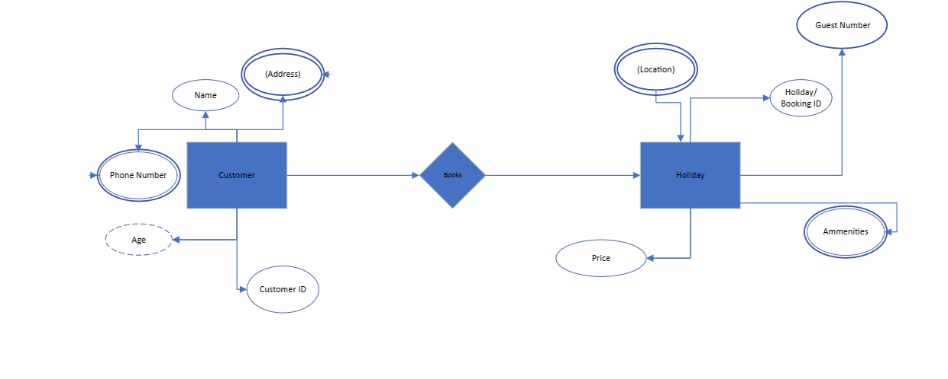
I decided to place, phone number, and amenities as multi-valued attributes as there may be multiple values that occur in the DBMS. I decided to place address and location as complex attributes due to the ability to separate their information into smaller pieces of information, such as a postcode instead of the full address. Age was the only value I placed as a derived attribute this was because someone's age can be calculated from someone’s date of birth or vice versa. Finally, the rest of the values I placed as single-valued attributes this is because they would only hold a single value for each entity.

Q4. Below is a screenshot of my relational database schema based on my ERD shown earlier, I tried to identify all the information that would be required to have a complete database, I also investigated different keys, these were represented by bold and italic and underlined writing.

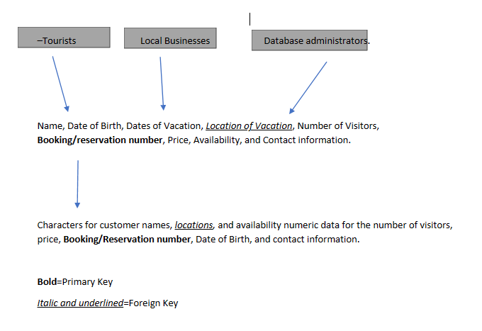
Q5. Below is a variety of screenshots from my database created for the assignment.
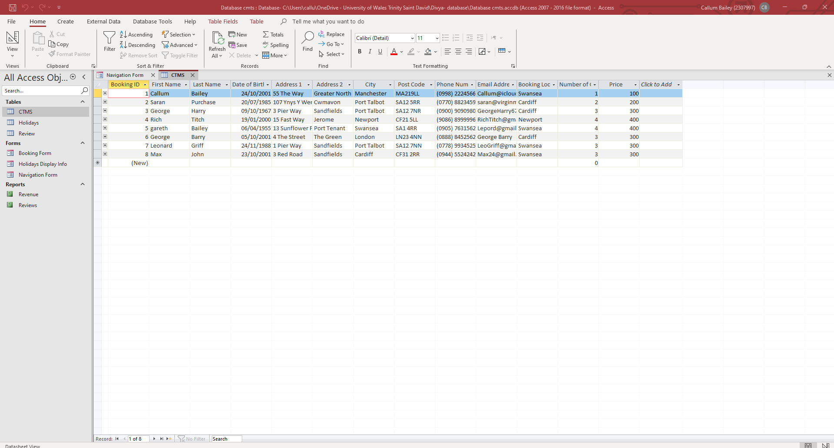
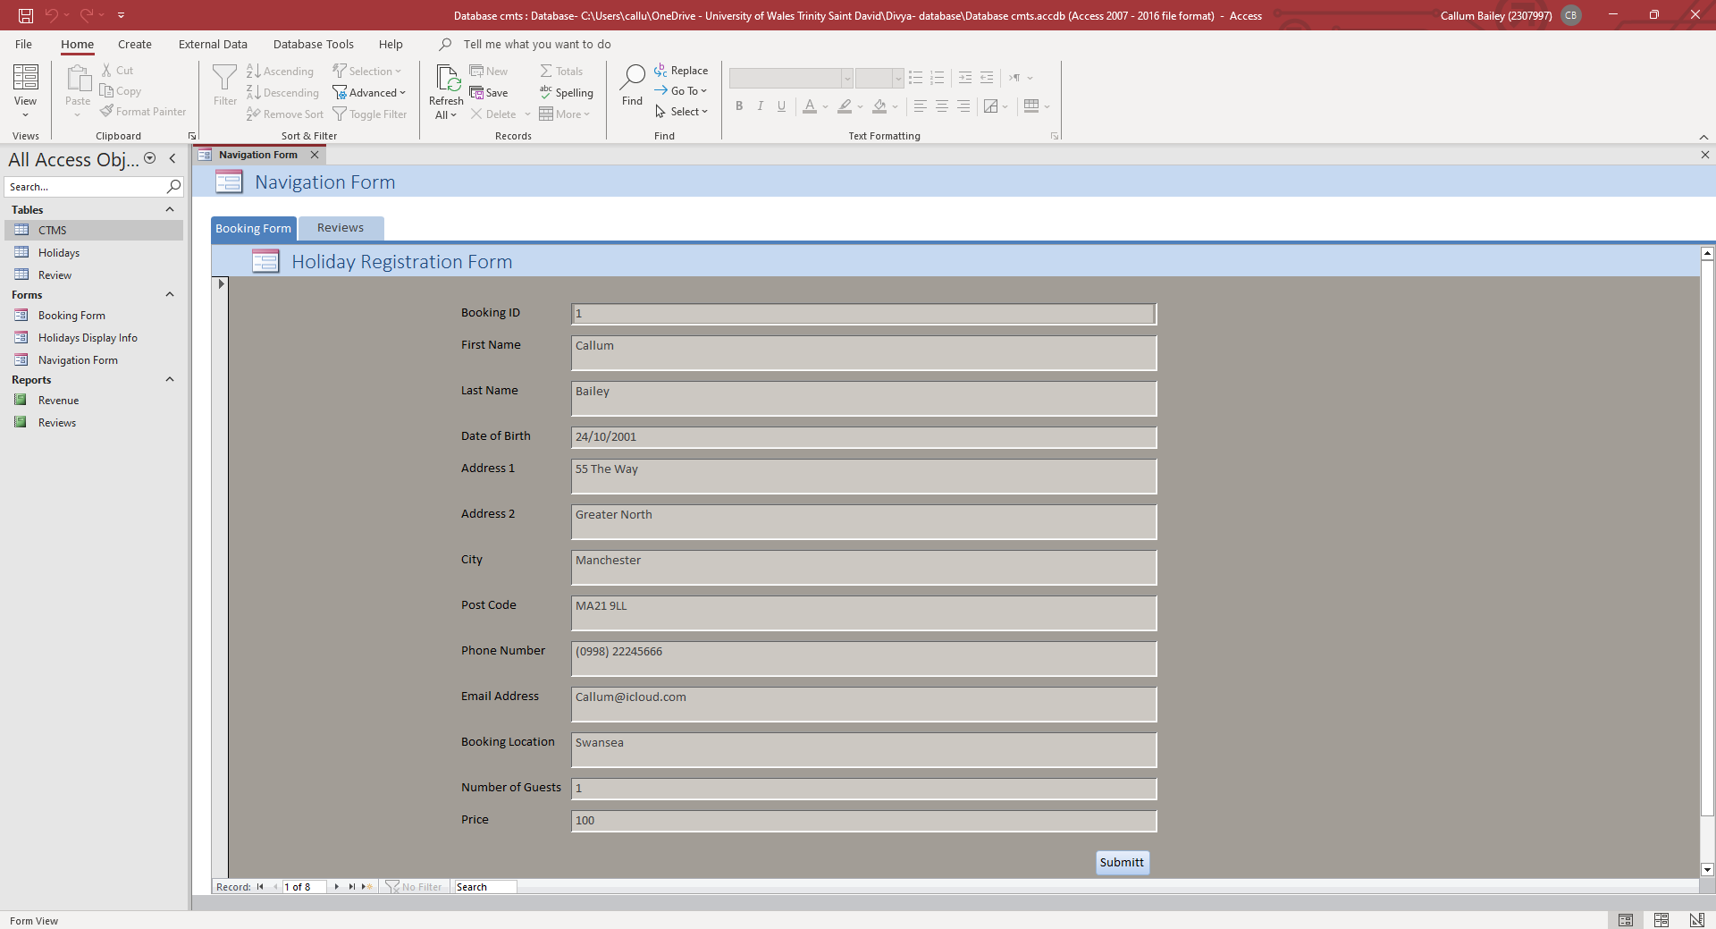


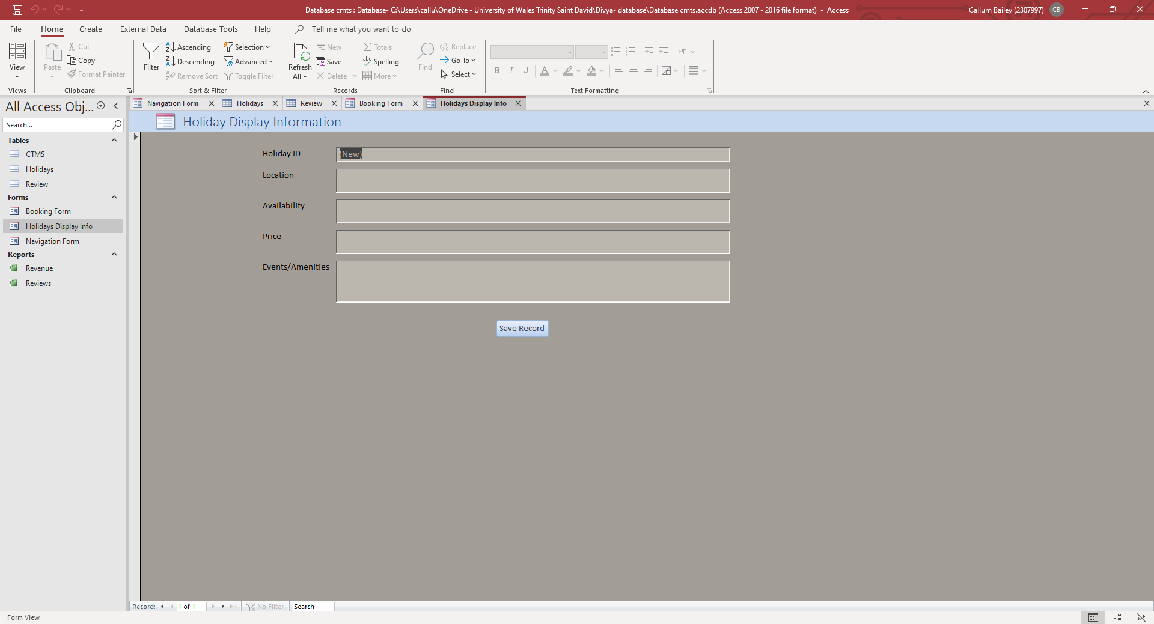

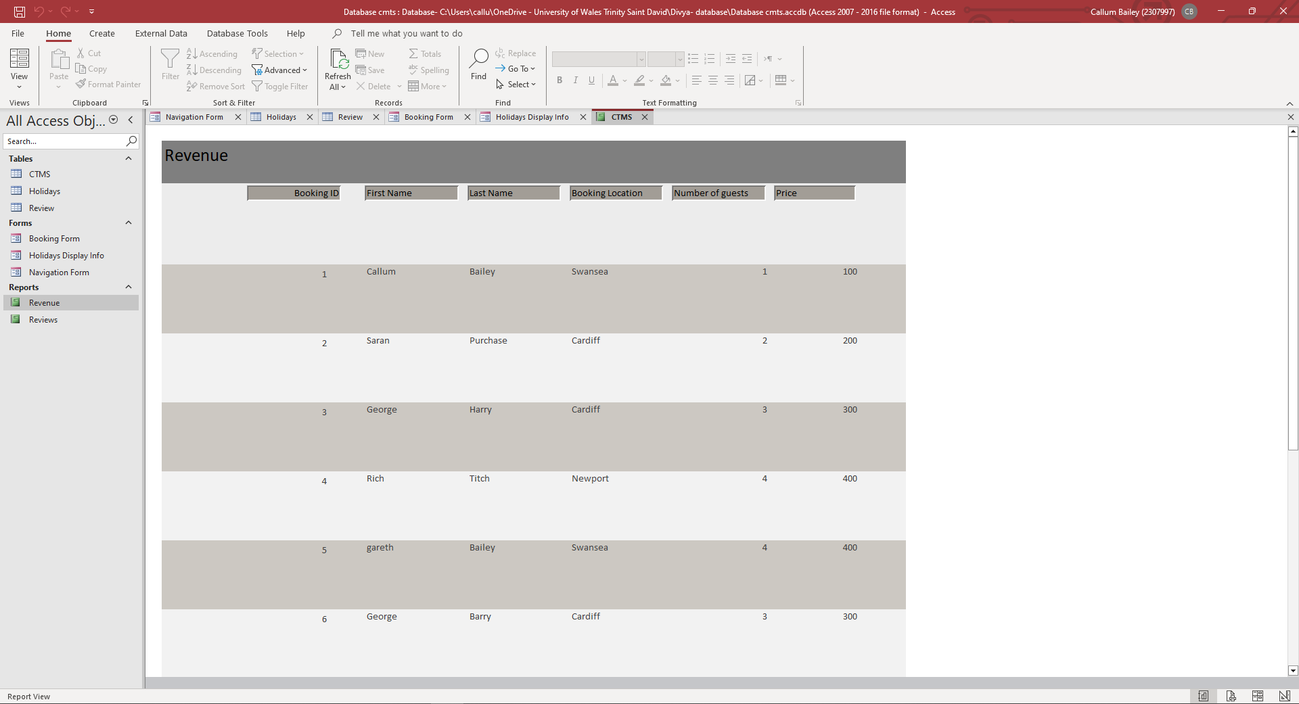
Q6. Please see below my reports produced for Q6 A and B.
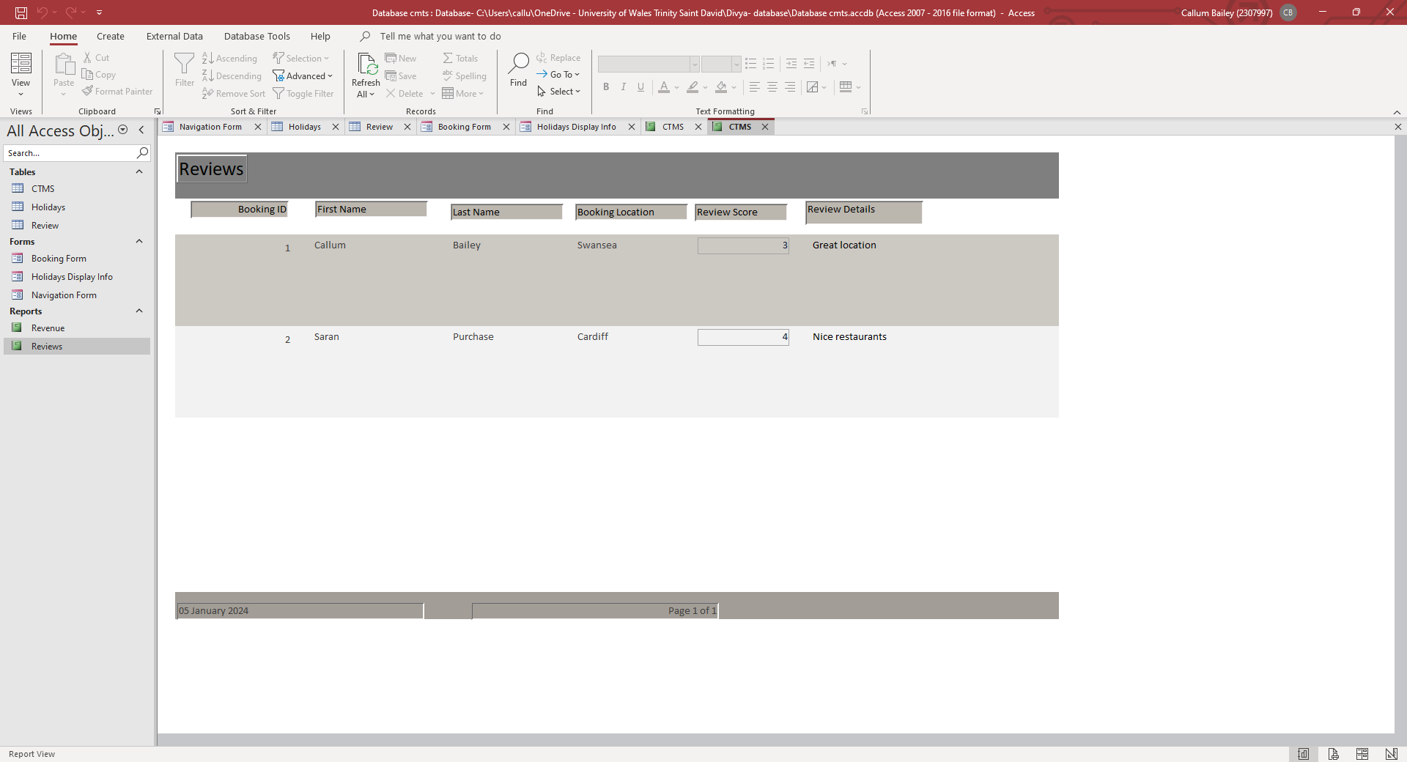

Q7.a
Below is my form produced to allow tourists to make reservations, I included all information related to the customer, the date of visit, the number of visitors, and the price. I included rules such as only being able to enter postcodes and dates in a certain format to keep data accurate, made a calculated field to allow price to be generated based on number of visitors, and an auto-producing booking ID for the tourist to refer to, there is also a Submit button which saves the record to the main CTMS table.

Q7.b
The screenshot below shows my answer to Q7.b this form allows the local businesses to update information on their events which will then be relayed to the customer either through advertisement or the sales department.
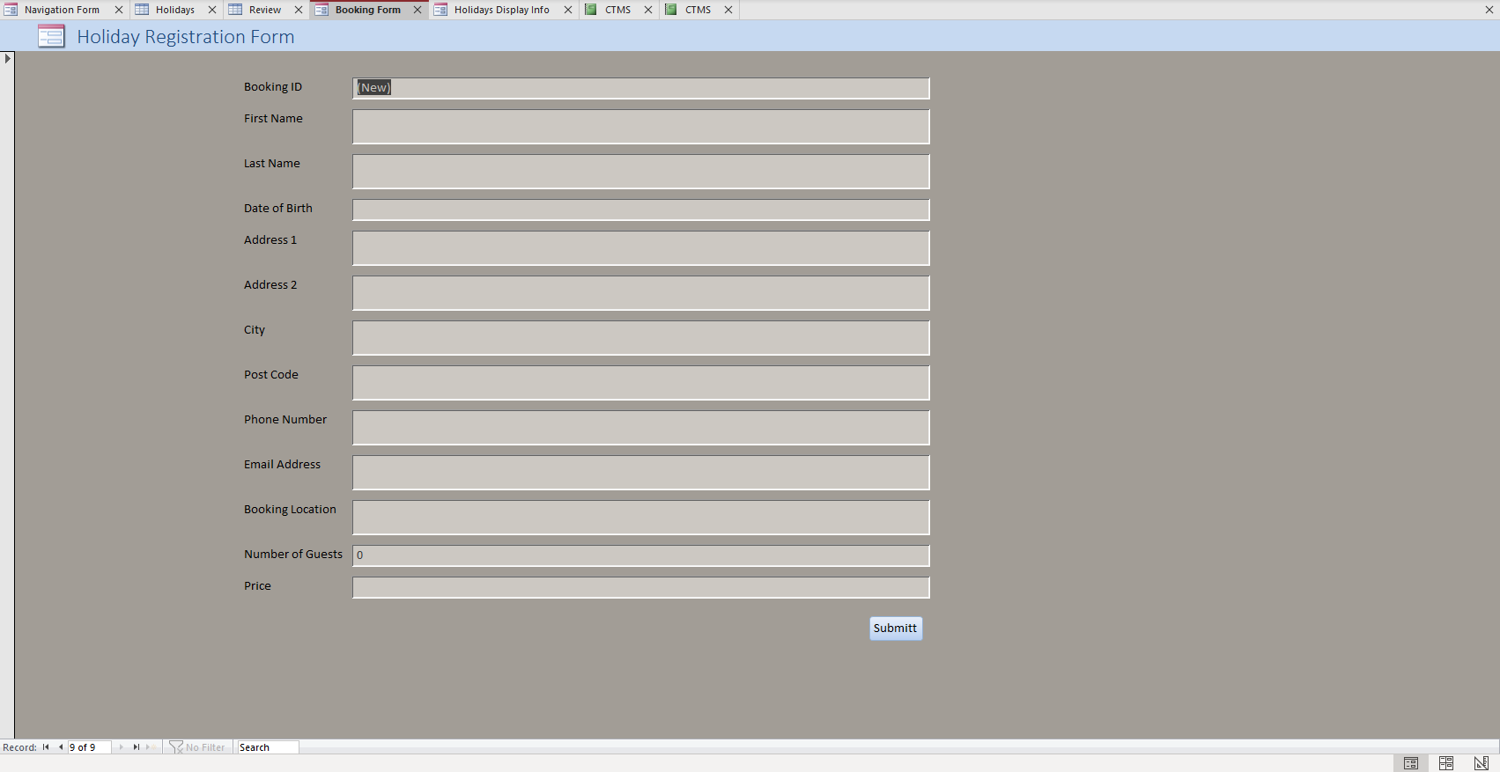

Q8. To allow users to navigate the system I produced a navigation form displayed bellow which allows users to easily select tabs based on their needs of the system, I also formatted this to open first when opening the database for the first time.
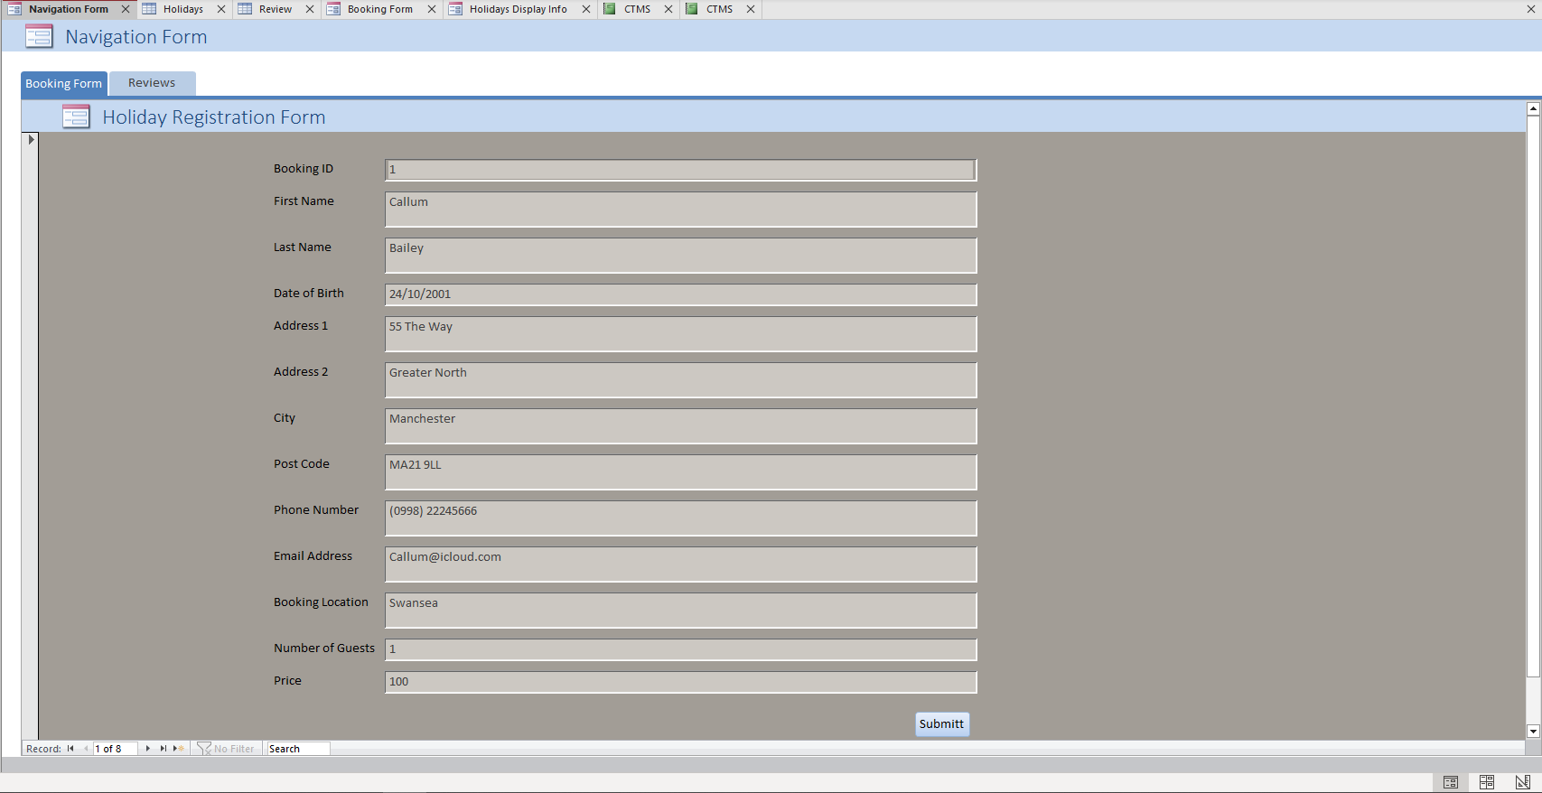

Section B

Q9.
Developing a database can be an important task for any business, it can help in a variety of ways including but not limited to, reducing time spent on managing data, allowing you to perform data analysis easily, and enhancing your consistency with data. [1] When specifically looking at coastal tourism management I believe that the development of an MS Access database will help improve efficiency by first of all allowing customer information to be held in easy to interpret format that can be retrieved with ease, this will allow employees at Coastal Tourism to spend less time retrieving information and instead perform their job role, which in turn will increase efficiency and aid customer service. Another way that having a database will benefit the company is by allowing access to local businesses to update their information on the events and amenities they offer, this would again improve the efficiency of the company as employees would need to spend less time with business owners, and information presented to customers would be up to date. Overall benefits are abundant, however, the main benefits of developing a database for coastal tourism would look at making the management of the data more efficient and effective due to the increase in simplification of the data and the ability to access it with ease.

Q10.
Although there are many benefits from moving from a manual data management system to a computerised system, there are some drawbacks and potential obstacles to overcome, the first one that comes to mind this the security of data. Whilst operating a manual database it can be quite a simple task to keep the data safe, for example, you might place the paper or files in a locked cabinet or room. When transitioning to a computerized system you may find that it may become more difficult to monitor people’s usage of the data and therefore potentially compromising its security. Developing the DBMS correctly can help elevate these risks Hackread states ‘Embracing a least-privilege approach is a must if you’re experiencing database security issues.’ [2] This could mean providing less access to those on customer-facing levels and more access to the database administrators or those at senior levels. When looking at the benefits of changing to a computerised system, the main benefit includes reducing the number of resources needed to manage data. Reducing the amount of time collating and managing the data frees up room for the business to perform more analysis this may include the business performance, profit margins, and amount of repeat customers. [3] performing an analysis of the business can be beneficial to any business and therefore transitioning to this format will allow Coastal Tourism to see their business more objectively and make improvements where needed.

Reference List
[3] “Benefits of databases,” Benefits of database development, https://www.nibusinessinfo.co.uk/content/benefits-database-development#:~:text=Database%20benefits&text=reduce%20the%20amount%20of%20time,information%20into%20a%20valuable%20resource (accessed Jan. 6, 2024).
[2] byOwais Sultan et al., “5 common database management challenges & how to solve them,” Hackread, https://www.hackread.com/5-common-database-management-challenges-how-to/ (accessed Jan. 6, 2024).
[1] J. Edmondson, “Advantages of databases: Why are databases important to businesses?,” Businesstechweekly.com, https://www.businesstechweekly.com/operational-efficiency/data-management/databases-advantages-benefits/ (accessed Jan. 6, 2024).

