Module: Foreign Languages & Cultural Awareness
Module code: BMIH5003
Lecturer Name: Antoinette Milne
Student Name: Elena Boboc
Student ID:2206217

Intercultural Competence Report

Table of Contents
1 Introduction 3
2 Differences among England’s and Germany’s culture and customs 3
3 Germany 4
4 Switzerland 6
5 Challenges of intercultural leadership in the hospitality industry 7
6 Recommendations 8
7 Conclusion 8
8 References 9

Introduction
In order to open hotel in Germany, there is need to provide knowledge about social and cultural differences between Germany and other countries, e.g., England, to foster positive perceptions of guests. This paper discusses these cultural differences, with a more in-depth emphasis on the German culture, and provides strategies regarding how to properly accommodate and satisfy both domestic and international visitors in the context German market.

England and Germany culture differences
England is more formal, with limited personal space and indirect communication. Germany leans informal, and directness is prized. Food reflects this as well, with England's menu being simpler and Germany's including robust regional delicacies. Work-life balance varies as well. Germany has fewer hours, longer holidays, and an organized attitude to spare time. England has a longer workweek and places less importance on planned holidays. Even celebrations differ. Christmas is more of a celebration in Germany, but in England, family gatherings take precedence. National identification is greater in Germany, although English individuals may identify more with their region. These are only a few examples, but recognizing the distinctions might help negotiate interactions with people from any nation (Walters et al., 2021; Tan et al., 2021).

Germany
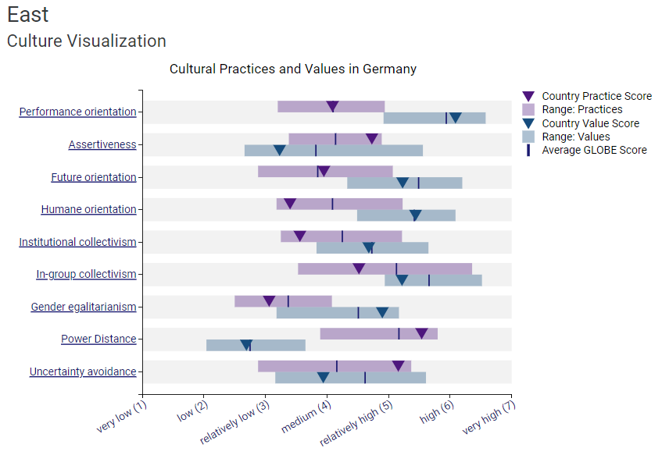
Figure 1: Culture Visualization of Germany
Globe Project, 2024a

Efficiency and performance are typically medium valued by Spanish that the score reflects this. Spanish leaders are typically more relationship- and present-driven and they stablish a nice atmosphere and building strong human ties, which are appreciated just as much as outcomes. In Spain, communication can be politer and indirect as even while assertiveness is necessary, harmony-keeping and conflict avoidance might take precedence. An average score for future direction reflects this. Group loyalty is valued by Spanish, however not as highly as it is in some other cultures (Parte and Alberca, 2021).
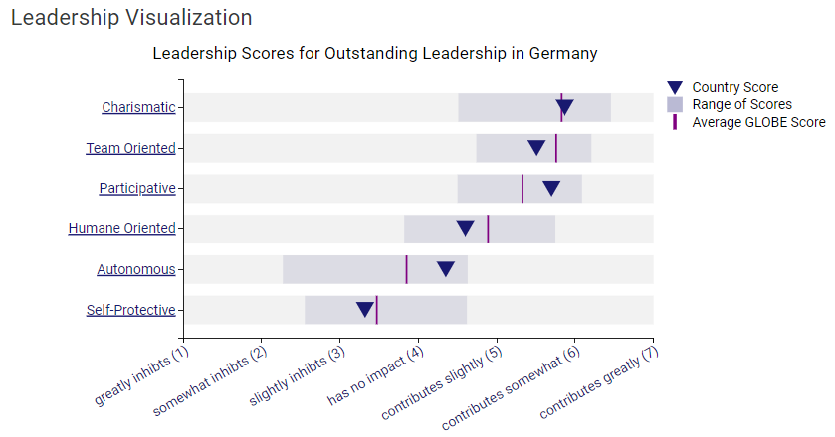
Figure 2: Leadership Visualization of Germany
Globe Project, 2024

Leaders in Germany are supposed to treat their staff members fairly and impartially. It is expected of German leaders to be friendly and cooperative. Fairness, collaboration, and equality are important to Germans in the workplace. A high score for humane orientation reflects this. It is required of German executives to show their staff members respect and support. An excellent assertiveness score reflects this. It is expected of German leaders to communicate in an acerbic and straightforward manner. It is required of German managers to be flexible and receptive to new concepts. In general, German culture is egalitarian. A low score for power distance indicates this. It is expected of German leaders to be friendly and cooperative. This is reflected in an average score for gender egalitarianism. German leaders are expected to be fair and unbiased in their treatment of employees. Traditionally, Spanish businesses have a clear hierarchy, with decisions flowing top-down. Leaders are expected to be decisive and hold a position of respect due to their experience and personal qualities. This can sometimes come across as a more authoritarian style (Aldehayyat, 2021).

Switzerland
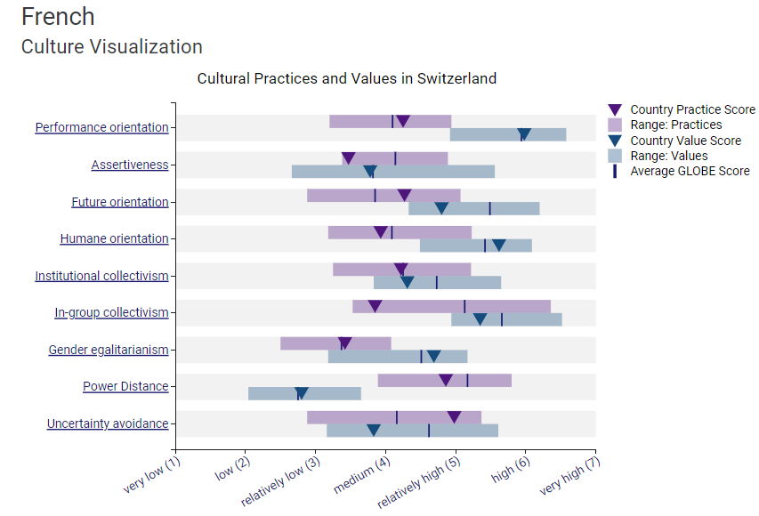
Figure 3:Culture Visualization of Switzerland
Globe Project, 2024
Swiss culture places a high value on success, efficiency, and quality. This is evident in their well-known watchmaking sector, which emphasizes innovation. While the Swiss are forthright and self-assured, they also respect collaboration and harmony. This is evident in their well-known neutrality policy and tendency to seek common ground. The Swiss are noted for their long-term planning and commitment to sustainability. This is reflected in their robust social safety net and dedication to environmental conservation. This is seen in their strong sense of social responsibility and large overseas aid programmes. The Swiss believe strongly in the rule of law and institutions. They cherish order, predictability, and adhering to the rules. Switzerland scores high on gender equality, with women having equal rights and opportunities in most aspects of life (Milton, 2024).

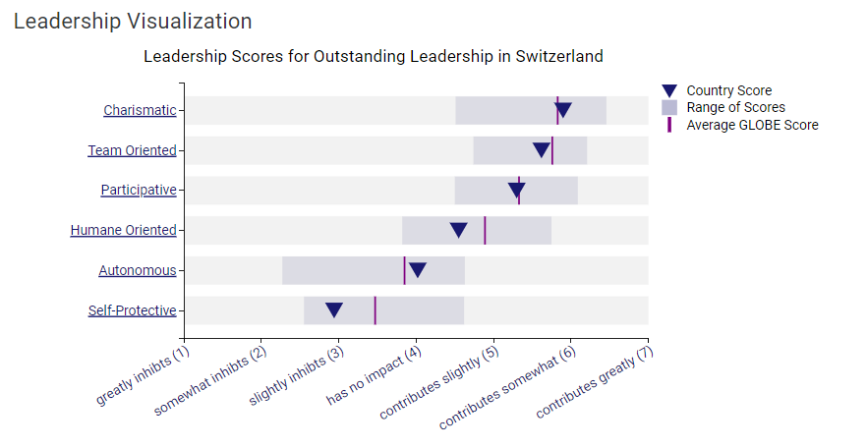
Figure 4: Leadership Visualization of Switzerland
Globe Project, 2024

A balance between directness and collaboration might be ideal. Leaders who can be clear and confident while still valuing teamwork and consensus-building could be effective in Swiss. Leaders with a long-term vision and a dedication to sustainability are aligned with Swiss ideals. Leaders who support the rule of law and establish a stable, predictable environment may be seen favorably. Leaders who include people in decision-making may foster a feeling of ownership and support, while leaders who demonstrate compassion and concern for their followers can foster trust and loyalty in Switzerland (Reidhead, 2020).

Challenges of intercultural leadership in the hospitality industry
Intercultural leadership in hospitality presents unique challenges. Leaders manage a diverse workforce and guest base, requiring them to navigate cultural sensitivities (Lockwood and Pyun, 2020). Germans are known for their directness, although guests from other cultures may prefer a gentler approach. Germans prioritise vacations, which might lead to scheduling problems that make it difficult for employees to remain on the job. Employees can receive adequate rules enforcement and tough behaviour from their visitors. There may be a barrier between visitors, managers, and staff due to communication, service, and preference issues (Daskalaki, 2020).

Recommendations

The recommendations are as follows:
- The hotel should implement eco-friendly practices like energy-efficient lighting, water-saving fixtures, and recycling programs and offer locally sourced, organic food and aim for green certifications like Green Key.
- Another recommendation is to incorporate traditional German design elements with modern amenities and include local cultural motifs and provide high standards of service and comfort to meet German expectations.
- The hotel can hire multilingual staff and train them in cultural sensitivity and offer international cuisines and amenities to accommodate diverse guests and ensure a welcoming environment for all.

Conclusion
People who live in Germany are well aware of the fact that to open and maintain a hotel they have to take into consideration several essential factors. There are simple ways such as practicing environmental management, combining the architectural and décor designs with German influence and incorporation of the classic modern comfort, and training employees who can work properly in regard to the cultural differences. Hence, tackling these cultural factors not only increases the amenity of the hotel guests, but also ensures that the hotel company is socially sensitive to the German culture and takes a responsible stand for the rights of the foreign guests, covered in a competitive hotel market of Germany.

References
Aldehayyat, J., 2021. The role of corporate social responsibility initiatives, error management culture and corporate image in enhancing hotel performance. Management Science Letters, 11(2), pp.481-492.
Daskalaki, E., 2020. Cultural Diversity and Indicated Intercultural Implications in the Hotel Working Environment in the United Kingdom: Underpinning the Employee’s Perspective. The Market: International Journal of Business, 1, pp.91-107.
Globe project. 2024. Spain. [Online]. Available at: https://globeproject.com/results/countries/ESP%3Fmenu=list.html#list [Accessed on June 4, 2024]
Globe project. 2024a. Germany. [Online]. Available at: https://globeproject.com/results/countries/DEU%3Fmenu=list.html#list [Accessed on June 4, 2024]
Lockwood, A. and Pyun, K., 2020. Developing a scale measuring customers’ servicescape perceptions in upscale hotels. International Journal of Contemporary Hospitality Management, 32(1), pp.40-59.
Milton, T., 2024. Artificial Intelligence Transforming Hotel Gastronomy: An In-depth Review of AI-driven Innovations in Menu Design, Food Preparation, and Customer Interaction, with a Focus on Sustainability and Future Trends in the Hospitality Industry. International Journal for Multidimensional Research Perspectives, 2(3), pp.47-61.
Parte, L. and Alberca, P., 2021. Business performance and sustainability in cultural and rural tourism destinations. Mathematics, 9(8), p.892.
Reidhead, C., 2020. Impact of organizational culture on employee satisfaction: A case of Hilton hotel, United Kingdom. Journal of Economics and Business, 3(1).
Tan, Y., Jamshidi, A., Hadi-Vencheh, A. and Wanke, P., 2021. Hotel performance in the UK: The role of information entropy in a novel slack-based data envelopment analysis. Entropy, 23(2), p.184.
Walters, G., Huck, L., Robinson, R.N. and Stettler, J., 2021. Commercial hospitality in tourism: A global comparison of what culturally matters. International Journal of Hospitality Management, 95, p.102939.

