

Student Name: PRAJAPATI JIGARKUMAR YOGESHBHAI

Student ID:2430810

Module Name: Dissertation

Module Code: LCMB7035

Lecturer’s Name: ANDRY RAKOTOVOLOLONA

THE IMPACT OF SUSTAINABLE PACKAGING PERCEPTIONS ON BRAND LOYALTY IN THE UK FOOD AND BEVERAGE INDUSTRY

Table of Contents
1. Introduction 5
1.1 Background of the Study 5
1.2 Problem Statement / Research Gap 7
1.3 Research Aim 8
1.4 Research Objectives 8
1.5 Research Questions 8
1.6 Significance of the Study 9
2. Literature review 10
2.1 Sustainable Packaging Perceptions 10
2.3 Brand Loyalty 10
2.4 The Relationship between Sustainable Packaging Perceptions and Brand Loyalty in the UK Food and Beverage Industry 11
2.5 Theoretical Framework 11
2.6 Empirical Studies 12
2.7 Research Gap 13
2.8 Conceptual Framework 13
3. Methodology 15
3.1 Research Philosophy 15
3.2 Research Approach 15
3.3 Research Strategy 15
3.4 Research Design 15
3.5 Data Collection Method 16
3.6 Target Population 16
3.7 Sampling Method 16
3.8 Sample Size 16
3.9 Data Analysis Techniques 17
3.10 Reliability and Validity 17
3.11 Ethical Considerations 17
4. Expected Findings 18
5. Limitations 18
6. Conclusion 18
7. Timeframe 20
Referenecs 21

1. Introduction

1.1 Background of the Study
The food and beverage industry has experienced considerable changes and transformation in the last decade as environmental sustainability is an emerging strategic issue for companies and the consumer (Wandhekar et al., 2026). Organizations have increasingly shifted towards environmentally responsible practices across their operations due to rising awareness of climate change, plastic waste, excessive packaging waste, and dwindling natural resources (Farzana et al., 2023). Of these efforts, sustainable packaging has become one of the most prominent environmental programs, given the fact that packaging is the first consumer touch point with a product. With the growing awareness of environmental issues, consumers are becoming more conscious of the use of packaging materials, recyclability, biodegradability, reusability, and environmental impact of packaging when buying products (Farzana et al., 2023).
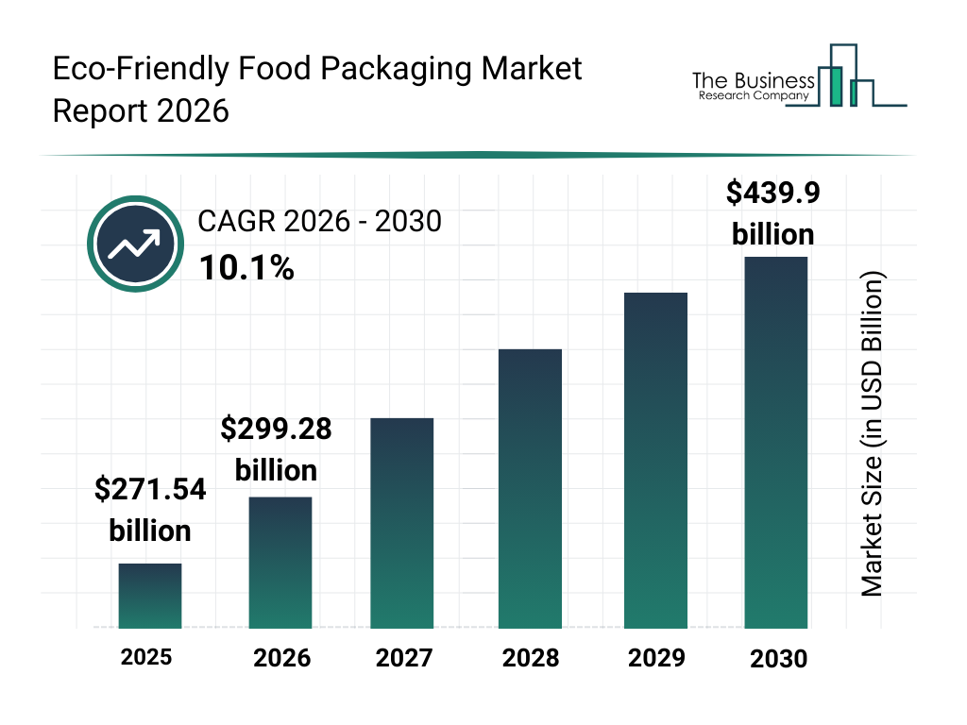
Figure 1: Global Eco-Friendly Food Packaging Market Size Forecast (2025–2030)
(Source: Adapted from The Business Research Company (2026), Eco-Friendly Food Packaging Market Report 2026.)
This rising significance is reflected in the global eco-friendly food packaging market. In 2025, the market is estimated to be valued at USD 271.54 billion, and by 2030, it is anticipated to reach close to USD 439.90 billion with the CAGR of 10.1%. This significant expansion is attributed to a surge in consumer concern for the environment, advancements in technology, governmental regulations, and business sustainability efforts, reflecting the growing importance of sustainable packaging within the global food and beverage industry (The Business Research Company, 2026).
The United Kingdom is one of the biggest and most competitive food and beverage markets in Europe, where an increasing number of consumers value brands that are environmentally responsible and operate within ethical boundaries (Vuk et al., 2026). Therefore, food and beverage firms have been putting in a lot of effort and investment to develop recyclable, biodegradable, compostable, and reusable packaging materials to meet consumer expectations, including the development of sustainable packaging, and comply with environmental regulations that are getting more stringent.
Today, sustainable packaging is not just about environmental responsibility but also about a vital marketing tool that can enhance a brand's reputation, customer confidence, and long-term brand loyalty (Bih, 2026). Often consumers link green packaging to quality, responsible corporate behaviour and ethics. These positive perceptions can foster emotional connections with brands, drive repeat purchases, and boost customer loyalty, ultimately giving organizations a significant competitive edge in saturated markets (Bih, 2026).
Although there has been an increasing interest in sustainable packaging, the term is still an emerging concept in the UK food and drinks industry as consumer expectations, packaging technologies, and environmental laws and policies are still rapidly developing (Anquez et al., 2022). Sustainable packaging can have varying meanings for different consumers, depending on various packaging characteristics like recyclability, biodegradability, transparency of the packaging material, or eco labelling. Thus, there is a need for more empirical research to gain insight into the impact of sustainable packaging on consumer brand loyalty towards food and beverage items in the UK market (Anquez et al., 2022).

1.2 Problem Statement / Research Gap
Food and beverage firms globally have turned sustainability to the environment to a key issue on their agendas. As a result of growing environmental awareness, regulatory requirements and consumer demands, organizations are increasingly looking to minimize plastic waste, make it easier to recycle, and consider environmentally friendly packaging materials. As a result, sustainable packaging has become an integral part of the sustainability strategy in the whole UK food and beverage sector (Wandhekar et al., 2026).
The impact of sustainable packaging on consumer purchasing has been widely studied in literature and has been linked to purchase intention, consumers' environmental attitude, perceived quality of the product, green brand image, and purchasing behavior (Amani, 2024). Research findings to date have found that green design packaging has a positive impact on purchase willingness and brand preferences for responsible brands. Sustainable packaging is investigated in the context of other sustainable concepts such as eco-labelling, corporate social responsibility and green marketing for cosmetics, hospitality and retail sectors (Siuda et al., 2025).
However, there is relatively limited empirical evidence that specifically focuses on how consumer perceptions of sustainable packaging directly affect brand loyalty in the context of the UK food and beverage sector (Watson et al., 2024). Many of the existing studies address purchase intention only and not later purchase behavior such as repurchasing, customer retention, emotional involvement or brand loyalty. The connection between the two is still not widely investigated as brand loyalty is one of the most important factors in achieving long term profitability and competitive advantage (Bih, 2026).
Additionally, a lot of prior research has been carried out abroad or has investigated sustainable packaging alongside other green marketing elements, making it challenging to separate the impact of sustainable packaging perceptions on brand loyalty (Ho-dac et al., 2025). UK's sustainability landscape is thus changing rapidly, and there is a need to have updated, empirical evidence to capture the evolving consumer expectations and environmental regulations (Nguyen Quoc et al., 2025).
This study aims to fill these gaps by focusing specifically on how the perception of sustainable packaging influences brand loyalty among UK food and beverage consumers.

1.3 Research Aim
To examine the impact of sustainable packaging perceptions on brand loyalty in the UK food and beverage industry.

1.4 Research Objectives
1.To identify the key dimensions of consumers' perceptions of sustainable packaging in the UK food and beverage industry.
2.To examine the relationship between consumers' perceptions of sustainable packaging and brand loyalty in the UK food and beverage industry.
3.To identify the most influential sustainable packaging perception factor affecting brand loyalty among consumers in the UK food and beverage industry.
4.To provide recommendations for food and beverage companies to strengthen brand loyalty through sustainable packaging strategies.

1.5 Research Questions
- What are the key dimensions of consumers' perceptions of sustainable packaging in the UK food and beverage industry?
- What is the relationship between consumers' perceptions of sustainable packaging and brand loyalty in the UK food and beverage industry?
- Which sustainable packaging perception factor has the greatest influence on brand loyalty among consumers in the UK food and beverage industry?
- What recommendations can be provided to food and beverage companies to strengthen brand loyalty through sustainable packaging strategies?

1.6 Significance of the Study
This study is relevant as it will enhance a theoretical understanding of sustainable packaging perceptions and the relationship between sustainable packaging perceptions and brand loyalty as well as provide practical insights for managers in the food and beverage sector of the UK. Academically, the study contributes to the literature by examining consumers' perceptions of sustainable packaging directly as a predictor of their longer-term brand loyalty rather than only examining their purchase intentions or even their attitudes toward the environment. The findings contribute to filling the relevant literature gap with up-to-date empirical evidence in the fast-developing research areas of green marketing, sustainable consumer behaviour, and relationship marketing (Bih, 2026; Ho-dac et al., 2025).
On a practical level, the study provides food and beverage manufacturers, brand managers, marketers, retailers and packaging designers with insights into how to build consumer loyalty by implementing packaging initiatives that are good for the environment. By understanding consumers' sustainable packaging perceptions, organizations can create packaging strategies that boost brand image, consumer trust, repeat purchases and long-term customer relationships. The results could also be useful for policy makers and environmental associations, providing evidence of the business potential for sustainable packaging and promoting sustainable consumption and national sustainability goals. Finally, the study contributes to organizations striking a balance between being environmentally responsible and achieving long-term marketing performance and competitive advantage in the UK food and beverage industry (Nguyen Quoc et al., 2025).

2. Literature review

2.1 Sustainable Packaging Perceptions
Sustainable packaging perceptions include consumers' beliefs, evaluations, and attitudes about packaging that has reduced impact on the environment using recyclable, biodegradable, reusable, or renewable materials and that preserves product quality and functionality. Consumers' perceptions are driven by their environmental consciousness, packaging design, sustainability claim credibility, convenience, and product safety (Kozik-Kołodziej, 2026). In the context of the Food and Beverage industry, where consumers are increasingly mindful of environmental impact in their buying habits, sustainable packaging is now a key competitive strategy (Herbes et al., 2024).
Studies have shown that consumers generally perceive sustainable packaging to be a sign of an environmentally responsible company, better product quality and higher trust in companies but there are also concerns about sustainable packaging, such as price, durability and functionality (Anquez et al., 2022). Likewise, consumers consider packaging not just from their environmental aspects but also for their food quality assurance, freshness and convenience aspects (d'Astous et al., 2021). The latest systematic reviews summarize that there are strong social determinants of consumer attitudes and purchase intentions that are linked to perceptions of sustainable packaging, with food being one of the key sectors (Kozik-Kołodziej, 2026).

2.3 Brand Loyalty
Brand loyalty is the tendency of a customer to keep buying a brand and recommend it to others even when other brands are available in the market. It can be measured by behavioural loyalty, which is when customers repeat purchases, and attitudinal loyalty, which is when customers feel emotionally attached and have positive word of mouth (Trinh et al., 2020). Strong brand loyalty can give a business long-term competitive advantages, as it helps to retain customers, lower marketing expenses, and boost profits (Sunday et al., 2023).
Prior research shows that there are multiple factors that affect brand loyalty, including product quality, customer satisfaction, brand awareness, trust, perceived value and corporate social responsibility (Asri et al., 2026). In the food and beverage sector, sustainability efforts are emerging as a new source of customer engagement and loyalty, as consumers are becoming more aware of the importance of purchasing goods that are good for the environment (Watson et al., 2024).

2.4 The Relationship between Sustainable Packaging Perceptions and Brand Loyalty in the UK Food and Beverage Industry
As more consumers are becoming environmentally conscious and this is starting to influence buying decisions, the link between Sustainable Packaging Perceptions and brand loyalty has become a topic of great interest. The perception of being ‘good for the environment' is likely to drive positive attitudes towards the packaging brand, which in turn can lead to greater brand trust, satisfaction, and repurchase intention (Dixit et al., 2024). Sustainable packaging improves brand perception by conveying firm communication of environmental responsibility and ethics, thus motivating customers to build enduring customer relations with brands that are environmentally conscious (Bih, 2026).
Experimental research also shows that green packaging impacts customers' brand evaluation, intention to purchase, and recommendation of the brand to others (Siuda et al., 2025). In the UK food and beverage sector, sustainability standards and consumer environmental awareness are on the rise, making sustainable packaging one of the key elements that adds to improved customer loyalty and competitive advantage (Ho-dac et al., 2025).

2.5 Theoretical Framework
This study is grounded in the Theory of Planned Behaviour (TPB) developed by Ajzen (1991).
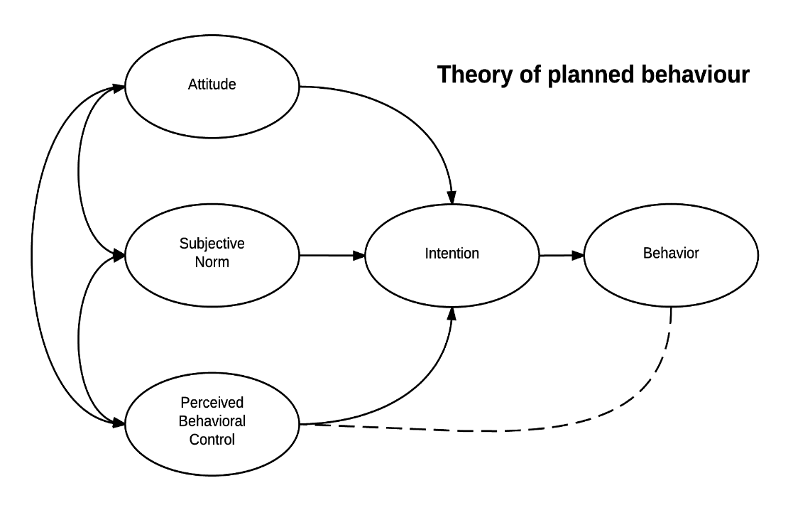
Figure 1: Theory of Planned Behaviour (TPB)
TPB suggests that individuals' behavioural intentions are determined by their attitudes, subjective norms, and perceived behavioural control. In the context of sustainable packaging, consumers who develop positive attitudes towards environmentally friendly packaging are more likely to form favourable purchase intentions and remain loyal to brands that consistently demonstrate sustainable practices (Jyväskylä University, 2025). The theory is about how positive perceptions of sustainable packaging influence individuals' behavioural intentions, and in turn, encourage ongoing brand loyalty in the food and beverage sector (Espineda et al., 2026).

2.6 Empirical Studies
Empirical studies have shown that there is a positive correlation between sustainable packaging perceptions and consumer behavior in recent years. Likewise, Hallez et al. (2025) showed that sustainable packaging has a positive impact on consumers' food perception and food purchasing. Dixit et al. (2024) found that Packaging plays a crucial role in fostering customer satisfaction and trust, which in turn reinforces their loyalty and intention to repurchase, thereby bolstering their relationship with the brand. Moreover, Bih (2026) supported that sustainable packaging positively influences the brand loyalty because it generates more confidence from the consumers about brands that are environmentally conscious. According to Nguyen Quoc et al. (2025), the adoption of green packaging and eco-labelling strategies also have a significant positive impact on consumer perceptions and brand relationships in the food and beverage sector.

2.7 Research Gap
While some previous studies have shown sustainable packaging to have a positive association with several consumer behavioural outcomes, there are some gaps in the research. Numerous studies discussed in the literature are based on the variables of purchase intention, green consumption behaviour, or brand image instead of the direct examination of brand loyalty as the primary outcome variable (Kozik-Kołodziej, 2026). The empirical evidence mostly comes from developing countries or the general consumer market, and only a few studies are dedicated to the specific UK food and beverage sector, where sustainability expectations and regulations are very divergent (Ho-dac and Mulder-Nijkamp, 2025). In addition, there are few studies that take into account consumers' perception of the sustainable packaging as the key factor associated with brand loyalty, which is also a topic to be explored in the context of the current study (Watson et al., 2024).

2.8 Conceptual Framework
Based on the reviewed literature, this study assumes that the independent variable is Sustainable Packaging Perceptions and the dependent variable is Brand Loyalty. The conceptual framework indicates that if the perception of the consumer becomes positive regarding the packaging, they will be willing to show greater loyalty to the food and beverage brand with heightened repeat purchase intentions, trust, and commitment, as well as positive word-of-mouth (WOM) suggestions (Bih, 2026; Dixit et al., 2024). This framework helps to lay the theoretical groundwork for an empirical assessment of the effect of sustainable packaging perceptions on brand loyalty within the UK F&B sector.
Figure 2: Conceptual Framework
Independent variable (Sustainable Packaging Perceptions)
Dependent variable

Perceived Recyclability

Brand Loyalty
Eco-label and Environmental Information

Packaging Functionality (Convenience)

(Source: Developed by author)

3. Methodology

3.1 Research Philosophy
The research philosophy of positivism is used in this study because it is assumed that knowledge can be gained by making an objective observation and taking empirical measurement. The study quantitatively investigates the relationship between sustainable packaging perceptions and brand loyalty therefore positivism is an appropriate philosophy. This philosophy is useful for hypothesis testing and statistical analysis that can lead to objective and reliable findings (Saunders et al., 2023).

3.2 Research Approach
The study is based on a deductive research approach since it is based on the theories and literature and tested through quantitative data. This deductive method allows the researcher to statistically analyse and provide empirical evidence of the significant impact that sustainable packaging perceptions have on the brand loyalty of consumers within the United Kingdom (Saunders et al., 2023).

3.3 Research Strategy
A survey research approach is used to obtain standardized information from many consumers in an economical and efficient manner. Survey is considered suitable due to the ability to measure respondents' perceptions and brand loyalty by structured questions and to detect relations among variables statistically (Bryman, 2021).

3.4 Research Design
The design of this research is quantitative research with the type of research being cross sectional research. The cross-sectional design is one that gathers data from the respondents at only one period of time and the quantitative methods are those that permit the variables to be measured in numbers. This design is suitable for exploring the existing link between sustainable packaging perceptions and brand loyalty within the UK food and beverage sector (Saunders et al., 2023).

3.5 Data Collection Method
Primary data collection will be done by structured online questionnaire. The questionnaire contains close-ended items which are measured on a five-point Likert ranging from strongly disagree to strongly agree. Conducting surveys online is an effective, affordable and convenient way of gathering data from UK consumers (Bryman, 2021).

3.6 Target Population
The target group includes consumers in the United Kingdom who buy food and beverage products. These consumers are chosen because they engage with product packaging on a regular basis and are able to assess sustainable packaging traits and impact on brand loyalty. Their answers share the relevant information that can be used for the research objectives (Nguyen Quoc et al., 2025).

3.7 Sampling Method
Simple random sampling is used to give all consumers an equal chance to be included in the survey. Probability sampling method is used because it makes the selection of the respondents not biased and makes the result of the research more representative, thus the findings of the research are more reliable and can be generalized (Saunders et al., 2023).

3.8 Sample Size
The study includes 100 respondents from the UK food and beverage consumer market. This sample size is suitable to perform descriptive analysis, correlation analysis, and multiple regression analysis and is deemed to be sufficient to analyze the relationship between sustainable packaging perception and brand loyalty (Hair et al., 2022).

3.9 Data Analysis Techniques
Collected data will be analysed by using IBM SPSS statistics. Respondents' perceptions and demographic characteristics will be summarized with descriptive statistics such as frequencies, percentages, means and standard deviations. The relationship and strength between sustainable packaging perceptions and brand loyalty will be examined through correlation analysis. Multiple regression analysis will then be conducted to assess the relationship between the sustainable packaging perceptions and brand loyalty, and to test the research hypothesis. The results will be examined at a level of significance of 5% (p < 0.05) to determine if there is a statistically significant relationship between the stated relationship (Hair et al., 2022).

3.10 Reliability and Validity
Cronbach's Alpha will be used to determine the reliability of the questionnaire, with a value greater than 0.70 being considered acceptable. The respondents in the pilot test will also be a limited number that will be used for the main survey, to determine the questions that are ambiguous and to increase the clarity, validity, and reliability of the research instrument used (Hair et al., 2022).

3.11 Ethical Considerations
The research ethics guidelines of the University will be strictly followed in the research process in this study. Data collection will only be undertaken after obtaining ethical approval from the relevant University ethics committee. All participants will complete a questionnaire, and informed consent will be obtained. There will be no consequences to withdrawing from the study at any point of participation. Participants' anonymity and confidentiality will be fully maintained and no personally identifiable data will be gathered. All of the data will be solely for academic purposes, will be securely stored and will be treated in accordance with the University's ethical requirements and data protection guidelines.

4. Expected Findings
It is expected that there will be a strong positive correlation between sustainable packaging perceptions and brand loyalty in the UK food and drink sector. It is assumed that consumers who consider the packaging to be "green", "recyclable", "biodegradable" and "ethically designed" will show more trust, satisfaction, repeat purchases and commitment to a food or beverage brand. The study results are also likely to reveal that sustainable packaging enhances brand perception and fosters customer loyalty. These outcomes will offer real world evidence of how environmentally responsible packaging can be successfully applied as a marketing tool, to improve customer loyalty and market competitiveness in the UK.

5. Limitations
The study only involves 100 UK consumers, and is a cross-sectional survey that only reflects perceptions at a single moment. The results are self-reported and do not necessarily reflect the views of all UK consumers. Hence, the study results might not be broadly applicable.

6. Conclusion
This study explores the influence of sustainable packaging perceptions on brand loyalty in the food and beverage sector of the UK. The study adopts a quantitative survey method to gain empirical insights into the relationship between consumers' perceptions of environmentally responsible packaging and their long-term brand loyalty. The results are expected to not only add to the understanding of academics but also provide actionable advice for food and beverage companies to build stronger customer relationships with sustainable packaging solutions, helping them to remain competitive and environmentally responsible.

7. Timeframe
Activity / Week | 1 | 2 | 3 | 4 | 5 | 6 | 7 | 8 | 9 | 10 | 11 | 12
Discuss with the supervisor
Introduction
Literature review
Develop questionnaire
Data collection
Data analysis
Prepare draft submission of first three chapters
Prepare final draft
Submission final dissertation

Referenecs
Amani, D., 2024. Is ethical packaging the right way to go? The impact of green packaging on consumer legitimacy in the cosmetics industry. Cogent Social Sciences, 10(1).
Anquez, E., Raab, K., Cechella, F.S. and Wagner, R., 2022. Consumers’ perception of sustainable packaging in the food industry: An online experiment. Revista Direitos Culturais, 17(41), pp.251–265. https://doi.org/10.20912/rdc.v17i41.728
Asri, M.R. and Cahyani, L. (2026) ‘The influence of product quality on customer loyalty at Groei Coffee Bandung in 2026’, Eduvest – Journal of Universal Studies, 6(4), pp. 4793–4809. Available at: https://doi.org/10.59188/eduvest.v6i4.53052.
Bih, F.B., 2026. The effect of sustainable packaging on brand loyalty. Journal of Scientific Research and Reports, 32(2), pp.383–389. https://doi.org/10.9734/jsrr/2026/v32i23988
d'Astous, A. and Labrecque, J., 2021. The impact of responsible food packaging perceptions on naturalness and healthiness inferences, and consumer buying intentions. Foods, 10(10), p.2366. https://doi.org/10.3390/foods10102366
Dixit, P. and Singh, P.B. (2024) ‘The role of sustainable packaging in shaping consumer loyalty and repurchase behavior’, Commerce Today, 19(1), pp. 129–137. Available at: https://www.researchgate.net/publication/392670427_The_Role_of_Sustainable_Packaging_in_Shaping_Consumer_Loyalty_and_Repurchase_Behavior.
Espineda, M.N., Banocnoc, A.H. and Cababahay, J.C. (2026) ‘An empirical study on the influence of sustainable packaging on consumer behavior’, Discover Sustainability, 7, Article 379. Available at: https://doi.org/10.1007/s43621-026-02886-7.
Farzana, S. and Pheettschomphuu, V., 2023. The impact of sustainable packaging in the food and beverage industry on consumer purchasing behaviour: A study at Siam University. In: Proceedings of the International Conference on Economics, Business and Interdisciplinary Studies (ICEBIS 2023), Bangkok, Thailand. https://doi.org/10.14458/SIAM.res.2023.30
Hallez, L., Boen, F. and Smits, T. (2025) ‘Message in a bottle: How sustainable packaging shapes consumers’ food perceptions and non-hypothetical choices’, Journal of Foodservice Business Research. Available at: https://doi.org/10.1080/15378020.2025.2537077
Herbes, C., Mielinger, E., Krauter, V., Arranz, E., Cámara Hurtado, R.M., Marcos, B., Poças, F., Ruiz de Maya, S. and Weinrich, R. (2024) ‘Company views of consumers regarding sustainable packaging’, Sustainable Production and Consumption, 52, pp. 136–150. Available at: https://doi.org/10.1016/j.spc.2024.09.014
Ho-dac, L.M. and Mulder-Nijkamp, M., 2025. Brands in transition: Balancing brand differentiation and standardization in sustainable packaging. Sustainability, 17(6), p.2381. https://doi.org/10.3390/su17062381
Jyväskylä University, 2025. Sustainable food packaging and consumer purchase intentions: A systematic literature review from a Theory of Planned Behaviour perspective. Master’s Thesis. School of Business and Economics, Jyväskylä University.
Kozik-Kołodziej, N. (2026) ‘Consumer attitudes and perceptions toward sustainable packaging: A systematic literature review’, Sustainability, 18(3), p. 1235. Available at: https://doi.org/10.3390/su18031235.
Nguyen Quoc, T., Nghiem Phuc, N. and Duong, N.H., 2025. Examining green packaging, branding, and eco-labeling strategies: The case of young consumers’ perceptions and responses in the food and beverage industry. Cleaner and Responsible Consumption, 16, p.100258.
Sañosa, A.R., Gumacial, D. and Yamagishi, K., 2026. Behavioral spillover from sustainable consumption to customer citizenship behavior in biomaterial packaging use within the food industry. Cleaner and Responsible Consumption, 22, p.100439.
Siuda, D. and Grębosz-Krawczyk, M., 2025. The role of pro-ecological packaging in shaping purchase intentions and brand image in the food sector: An experimental study. Sustainability, 17(4), p.1744. https://doi.org/10.3390/su17041744
Sun, K.A. and Moon, J., 2026. Relationship between food healthiness, price fairness, and loyalty with moderating roles of temperature, personalization, and eco-friendly packaging at Subway. Foods, 15(5), p.841. https://doi.org/10.3390/foods15050841
Sunday, A.O. and Olubiyi, T. (2023) ‘The impact of brand awareness on customer loyalty in selected food and beverage businesses in Lagos State, Nigeria’, Jurnal Multidisiplin Madani, 3(3), pp. 541–551. Available at: https://doi.org/10.55927/mudima.v3i3.3095.
Trinh, G. and Dawes, J. (2020) ‘A comparison of brand loyalty between on-the-go and take-home consumption purchases’, Journal of Retailing and Consumer Services, 53, p. 101968. Available at: https://doi.org/10.1016/j.jretconser.2019.101968
Vuk, A. and Bauerné Gáthy, A., 2026. Environmental impacts of food packaging materials: Systematic review of life cycle assessments from 2018 to 2025. Cleaner Waste Systems, 14, p.100523.
Wandhekar, S., Kshirsagar, R.B., Shaikh, A.M., Patil, B.M., Shinde, S.T., Agarkar, B.S. and Kovacs, B., 2026. The futuristic trend of edible and biodegradable food packaging, its impact and need: A review. Discover Food, 6, Article 169.
Watson, A., Perrigot, R. and Dada, O., 2024. The effects of green brand image on brand loyalty: The case of mainstream fast food brands. Journal of Consumer Behaviour, 33(2), pp.806–819.

