February 21,2020
Adina Ghita (1914431)
University of Wales Trinity Saint David
Professional Career Development

Table of Contents:
Introduction.................................................................................1
Findings.......................................................................................2
Conclusion....................................................................................8
References....................................................................................9
Appendices ..................................................................................10

Introduction:

Professional development is connected at all the times with the personal development which means that before I am thinking to build up my career I need to know exactly where I am classified as person. To do that I analyse myself, and my beliefs about academic and career achievements.

“Knowing yourself is the beginning of all wisdom”. - Aristotle

According to self-awareness, I am a very organised and a positive person, I am patient and a good listener towards everyone, but followed by my weaknesses which is my confidence regarding all my knowledge, specially about my writing skills and anxiety to speak in front of people.
For myself-development , I attended the Higher Education Skills for the Workplace course at University of Wales Trinity Saint David , which will help me to gain more experience, this will reflect on myself every time which is a vital sign for my goal achievement , to be more positive and sociable and to start growing my career as a HealthCare Manager due to my qualification as General Nurse which made me be a cautious person, who analyses each step in her personal and professional development, achieving my academic opportunities will give me the chance to achieve my future goals.
Due to my profession as a Nursing Assistant ( General Nurse) during the years I gained experience in teamwork, I learned that in a team you need a leader who is working permanently with the employees and takes care of their welfare, I have often experienced I lack of work from colleagues in result of their poor performance I am unable to complete my role efficiently.
Starting a new chapter on my life since I start the new course in the University, involved a new domain I have never dealt with, I was quite anxious when I attended the first lesson, but with the help of my lecturer I gained step by step my confidence and I realised that everything is beneficial to reach my goal.
In this report I will highlight my strengths and weaknesses helped by different theories, analysis and questionnaires acquired from the course, which make me understand and start thinking of my next step in my personal and professional development.

“Time is not the main thing. It is the only thing.”- Miles Davis

Findings:

Analysing self-awareness and self-development ,guided by my profession of General Nurse and Nursing Assistant in Mental Health Care sector I managed to find out the features that define me as a person looking after other people, but the real moment to start looking to gain my goal to be a Health Care Manager was this year when I attended the academic course “Higher Education Skills for the Workplace” at University of Wales Trinity Saint David.
As I said this was the impact when my life changed so from the first lesson, I managed to identify my present stance.
According to Albert S. Humphrey SWOT analysis, I discovered that I possess some valuable strengths like my nursing degree, work experience, time keeping and last but not least that I am a very organised and positive person. As well I was looking at my weaknesses and I noticed that the lack of confidence and anxiety when I am meeting new people play an important role on achieving my goal so to repair that I began to be prompt in my strategy , I am starting to trust myself more then before, I will socialise, especially now when I have the opportunity to be a student in the University and that will help me to convert my weaknesses of being anxious into a strength the same with my confidence that will be regained due to experiences and new things learned. Other people experiences will help me to improve my performance and to grow in my career, to become an important part as a manager for the Nursing Home where I am working.

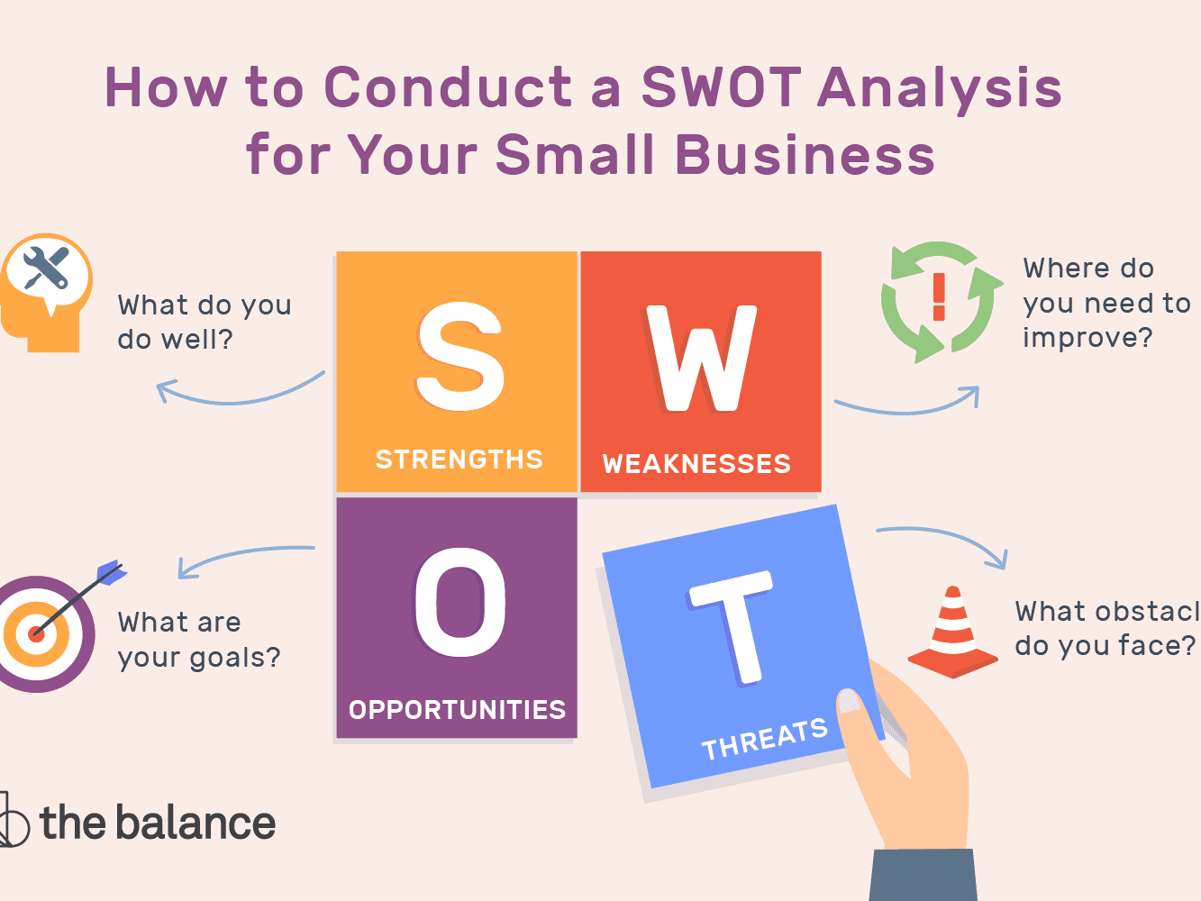

I do not need to wait anymore so I start to learn every day, to attend more trainings which will increase my chance to achieve my goal obtaining experience and developing my academic skills. Until the end of the course I enrol in I should be able to meet requirements which were part of a domain unknown before.
The main thing is to be more focused and patient in moving forward in my career and converting my weakness of being impatient into a strength as it is important for my role by having experience, I will shadow other managers to use their knowledge and experience towards my self-awareness about my capability to control my patience.

Improving my skills will help me to become a leadership for my team and also to manage any good or bad situation and that will mean that according to Abraham Maslow`s Theory of Needs (1943) which is a motivational theory in psychology classified as a pyramid with five levels , I will build myself up to self-actualization which is the last tier starting from the second tier, the comfort zone in which I rank, where all my safety needs are met and I am feeling protected and stable at this moment in my life.

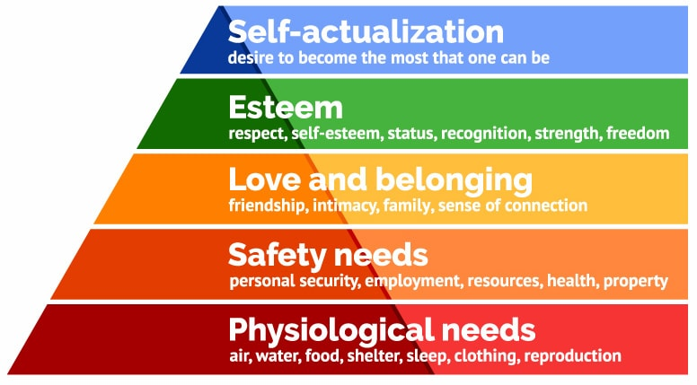

Following my skills audit , receiving the feedback from my family, friends and colleagues, my technical skills-medical skills, team work and empathy was rating as very strong skills for my current job as well my self-management, communication skills ( writing skills) and creativity were classified somewhere between which made me start to work out and to find the best way to learn because those skills I consider to be very important for my future career. Communications skills are one of the basic skills that any business professional possess and need to improve on continuous basis due to diverse working culture (Cenere et.al.,2015).
Reflective writing is based on formal and informal summarisation on the respective literature, using thoughts and memories. It is a mental process which uses thoughts and opinions so that learning experiences can be written down (Knaflic,2015).
Attending the classes at University my writing skills will be the first one involved and implementing the Johari`s Window (1950), I will develop my academic writing based on the feedback received from my lecturer and colleagues. From this moment helped by Johari`s Window ( Blind Area) I will understand when somebody can notice a thing about myself which I do not know and I will find out the right solution to resolve or improve any new aspect in my life. Actually, blind area means that the information in the blind spot can be positive or negative and can be seen by others, but the individual does not know nothing about them (G.G, 2013).

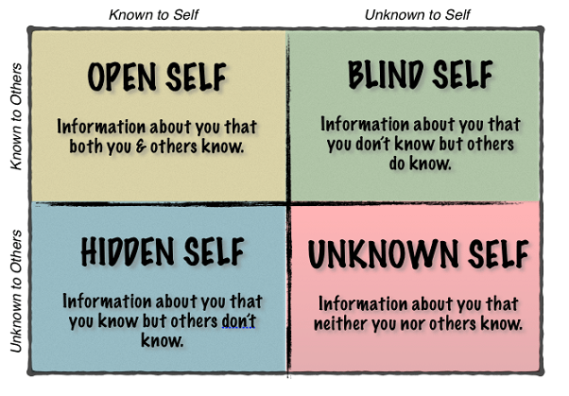

According to Kolb`s learning cycle my experience started couple of years ago when I went for the first time at Nursing University to obtain the Degree as General Nurse. For three years I welcomed very good or bad situations, dealing with people and this was the period which make me become a very strong person and as well I think will be the strong strength in my future career. When I graduated the University I moved from Romania to Wales , I took the oportunity, very positive, knowing it would be one of the most important experiences of my life.
Since 2015 I am working in a Nursing Home , a building that has become HOME for many elderly people suffering from dementia, in many cases advanced dementia. As an employee and team leader my priority is my patients and their well-being is what makes me happy. To meet all their needs I am attending all the trainings and courses, I am reading all the time new information to help them to improve their quality of life. For me those people , are not just “ elderly people who I am looking after” they are my family and I am their family as well. My job description include every thing from personal care to administration of medication, notice any changes on their health, take the best decision on their best interest and make sure that they received the best treatment at a higher standard of care and for them and myself I am constantly improving my skills.

“Learning is the process whereby knowledge is created through the transformation of experience”(Kolb,1984)

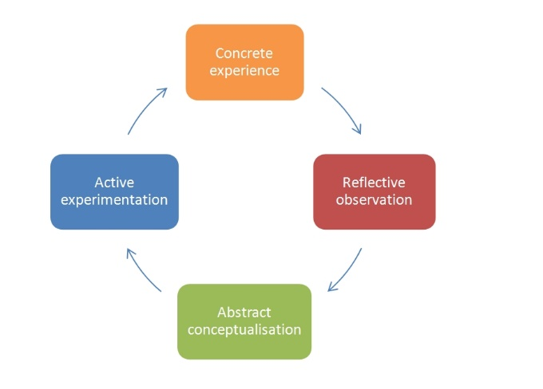

Following and completing Peter Honey and Alan Mumford questionnaire I observed that one of my learning style is Pragmatist style which means and is exactly right that the best way for me to learn is to be involved in discussions, problem solving, to watch case studies and to apply learning in real life. As pragmatist I am getting straight to the point in a realist manner, but I am not interested 100% on basic principles.
Another learning style questionnaire result confirmed that my strategy of learning is Kinaesthetic Study Strategy which means that I preferred to use all my senses like hands-on approaches and applications to achieve my goal.
Based on VARK learning style, I will start to learn more from other people experiences, I will attend trainings and projects which will build up my knowledge and development for my actual goal.
Another step very important to achieve my goal was to understand my personality type and I decided to complete The Keirsey Questionnaire which helped me to identified my personality type and I find out that I am a warm-hearted person with good interpersonal skills, which need harmony and always is doing something nice for people, who is working best with encouragement and is playing an important role on people`s lives.

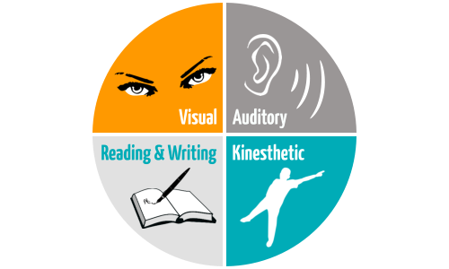

Personal Development Plan

Development Objective | Specific actions | Blockers and how they will be removed | Support required | How I will know when I have achieved the objective
Communication skills (writing skills) | I will start to read and write regularly to develop confidence and quality. | Time can be an obstacle on improving my skill so for that I will make sure that every day I will allowed 2h-3h to read books and make notes. | Focus on my goal, room class attending regularly, trainings and guidance. | When I will be extremely confident to write essay, reports and notes.
To develop my technical skills (medical skills) | As I am a pragmatist based on Honey & Mumford learning style, I will develop this skill by attending more trainings and group discussions based on the subject. | Barrier-lack of experience. I will take opportunity to lead group discussions in the class. | Continuous learning process to become more professional and improving my skills. | I will know that I achieved my objective when I will be able to understand, identified problem and find solutions to resolve them.
Management Skills | This skill is the important one for the business professional part which help me to manage every situation at the right point. | Because is a new domain will be plenty of new information which I never heard about before, but to achieve my goal I will attend the classes at University, I will listen to my lecturer and I will ask for advices. | I will take opportunity to shadow other managers and learn from the experiences to start to be a valuable part of my team and to make sure that everyone will feel confident as long we are working together. | The moment when I will feel under pressure during my hours work and I will be relaxed with any situation I will deal with; I will understand that I achieve my goal and my skill is improved.
Conclusion:

As per this discussed report it can be summarised that professional development is closely linked with personal development and every person should analyse their self-awareness and self-development because this is the moment when they will fully know themselves and will know based on the analysed theories what skills need improvement and how and what qualities can be exposed to reach their final goal.
To achieving my goal, I will work hard, I will do my best to go beyond my limits, I will learn everything which is topical at the moment from the academic and medical field and I will never give up on my dreams.
To be a nurse is an important part for the National Hearth Service which contain 3 important elements: health promotion, disease prevention and caring for sick people.
I am extremely determined to gain more experience and knowledge and I hope that at the end on the course I will know that I achieved my objective.
“The nurse is temporarily the consciousness of the unconscious, the love of life for the suicidal, the leg of the amputee, the eyes of the newly blind, a means of locomotion for the infant, the knowledge and confidence of the young mother and a voice for those too weak to speak”.-Virginia Henderson

References:

Cenere, P. et. al., (2015). Communication Skills for Business Professionals 7. Cambridge University Press
Cherry, K. (2019, Nov 27) Overview of VARK Learning Styles at: https://www.verywellmind.com/vark-learning-styles-2795156 (Accessed: 16th February 2020)
Cook, C.L. (1985) Line by Line: How to edit your own writing. Houghton Mifflin Company, Boston
Duval, T.M. et al., (2012) Self-awareness & Causal Attribution.
Gruber, G. (2013, Aug 26) Discovering the 4 Panes of the Johari Window for 360 Degree Feedback at: https://www.explorance.com (Accessed: 16th February 2020).
Knaflic, C.N., 2015. Storytelling with data: A data visualization guide for business professionals. John Wiley & Sons.
Kolb, D.A. (1984). Experiential learning: Experience as the source of learning and development (Vol.1). Englewood Cliffs, NJ: Prentice-Hall.
Maund, A. (2017) Certificate in Higher Education: Skills for the Workplace Student Yearbook. SAGE Publications Ltd.
McLeod, S.A. (2017, Oct 24) Kolb – learning styles. Simply psychology at: https://www.simplypsychology.org/learnkolb.html (Accessed : 16th February 2020)
Morgan, P. (2017) The Business Student`s Guide to Study and Employability. SAGE Publication Ltd.

Appendices:
Appendix A
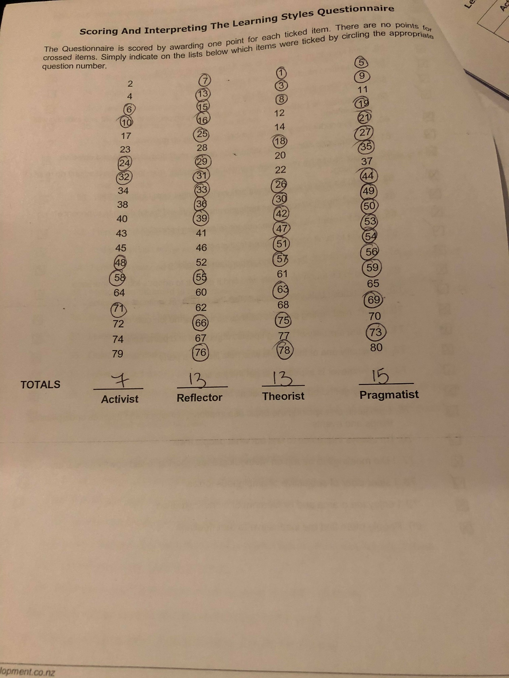

Appendix B
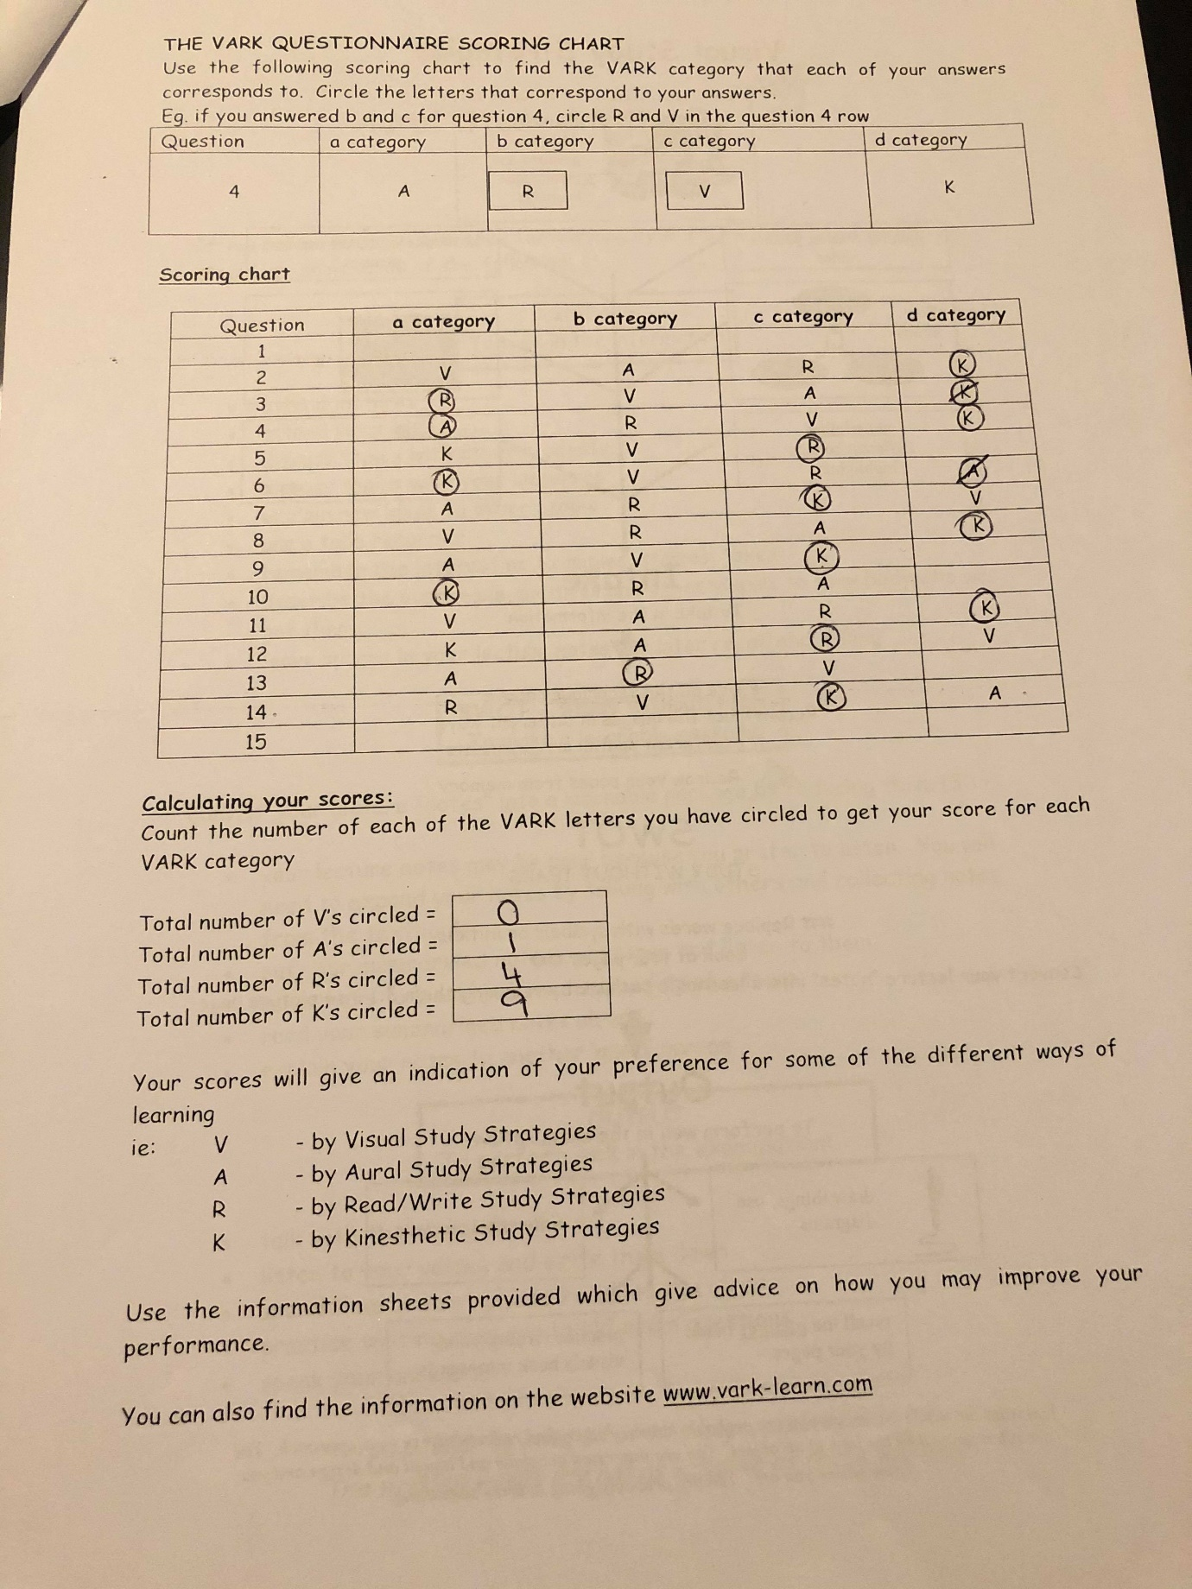

Appendix C


