HER task
Briefing
Bobby Ball, Programme Manager at ASW, has been asked by Greenfield Consultants to undertake an initial scoping assessment of the heritage interests for a small development site south of Burton on Trent. You have been asked to review the Historic Environment Record for the area to help assess whether there are known heritage interests which might lead to refusal of planning permission, and whether there may be potential heritage features that would require evaluation. You should consult the HER data for four nearby sites and review the evidence presented.
You have 30 minutes after which we will compare our results.

Proposed development at Sandy Lane, Netherseal, Derbyshire
427050 313057 (SK 27050 13057)

https://www.fishergerman.co.uk/residential-property-sales/development-site-for-sale-in-sandy-lane-netherseal-swadlincote-derbyshire-de12/32348

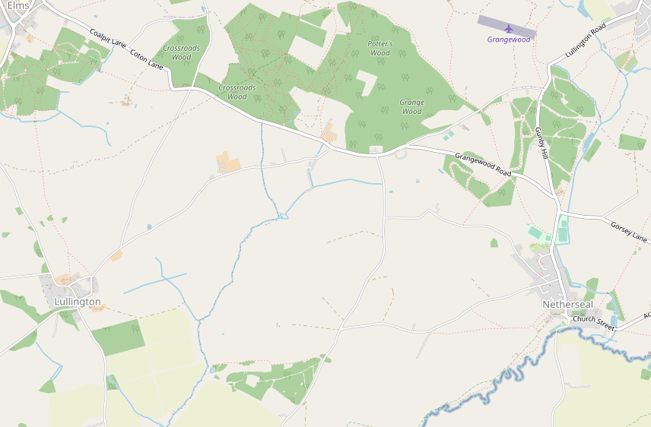

Go to: https://her.derbyshire.gov.uk/map
Zoom to area south of Burton On Trent between Cotton in the Elms, Netherseal and Lullington
Choose four of the nearby sites/areas and look at the detailed description and note:
What value would you assign to it? A = national importance, B = regional importance, C= local importance, D = minor importance, E= no importance
Does the proximity of this site to the development affect the likelihood of archaeological features within the development area?

Check the Listed Buildings layer- are any of the LBs relevant?

Monument record number | Type | Period | Reliability | Value | Affect likelihood?

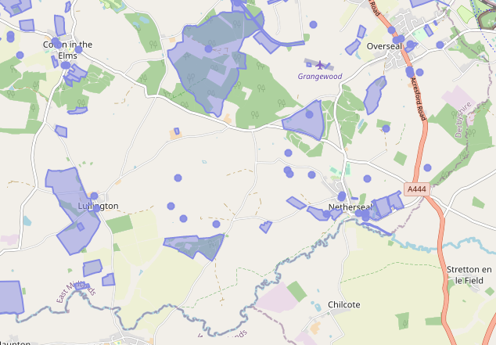

Monument record | Type | Period | Notes
MDR14914 | Burnt Mound | Prehistoric | (weak sourcing)
MDR7132 | Windmill (site of)
MDR7133 | Quarry
MDR7137 | Fish pond | Post medieval
MDR7139 | Field boundary (cropmark)
MDR7140 | Cropmark
MDR7141 | Ridge and furrow |  | (ploughed out)
MDR7143 | Ridge and furrow
MDR7144 | Ridge and furrow
MDR7145 | Enclosure | (medieval) | (?dating)
MDR7146 | Barrow (cropmark)

Listed Building: Woodfields Farmhouse (late 18th)

