

Assessment Component 1
Case Study-Norfolk

Children Young People and Families
Student Name: Modou Mbacke
Student ID: 1916151
Module Name: Children Young People and Families
Module code: (BMHP5004_LON)
Lecturer Name: Bianca Sanfilippo

Table of contents
Introduction --------------------------------------------------------------------------------------------------2
Case Study ----------------------------------------------------------------------------------------------------3-4
Analysis --------------------------------------------------------------------------------------------------------5-6
Evaluation And Result -------------------------------------------------------------------------------------6-7
Reference -----------------------------------------------------------------------------------------------------8

Introduction
This report will be focusing on children and young people and families especially children’s young people and families. This report will use Holly’s case to identify which vulnerability can face children, young people, and family. According to H, Hayden & C, Jenkins. (2014) troubled families are characterised as those who have problems and cause problems to those around them. Analyse will be made to analyse Holly’s situation and explain what relevant policies and healthcare agencies is has done to her case and what is the process of intervention of this Holly’s case. Furthermore, evaluation will be made to evaluate the work of this healthcare agencies and what they should have done to Holly’s case. All this case study, analyse and evaluation will be referenced using reliable sources. Holly 37 years old, single mum of three children. This report will identify the risk factors family are facing and why Holly’s family is in vulnerable position. Furthermore, will analysis and evaluate the family situation. According to UNICEF (2021) child is anyone under the age of 18. In this report reference will be used to obtain reliable data from relevant sources.

Case Study

Holly and her family have a history of domestic abuse which it may be the main cause of Holly situation now. Holly is suffering from panic attack, anxiety, and alcohol addiction which is a huge problem for her and her children. In addition, Holly is a single mum of three Sarah (13), Mark (9) and Kylie (2) which make this family vulnerable. According to NSPCC (2021) most parents or carers who drink or use drugs do it in moderating and are not a risk to their children. However, if their drinking or drugs use becomes harmful, this is, and its substance misuse and it can stop them providing safe care for their children. Holly alcohol abuse put high risk to her children because Holly is not able to provide basic need for her children. Holly does not able to resolve these problems within her family due to her mental problem. Long history of domestic violence in the family may contribute to a family vulnerability and current situation it may affect the children behaviour for now and in the future. According to NSPCC, (2021) being exposed to domestic abuse has serious consequences for children and young people; and it can affect how they feel, think, and behave in harmful way. The reason why the children school attendance is very low because Holly is neglecting her children due to alcohol abuse and domestic violence she is facing. Her domestic violence situation severely affecting her children. “Around 1 in 5 children been exposed to domestic abuse. children never just ‘witness’ domestic abuse, the law now recognises they can be victims. Exposure to domestic abuse is child abuse, and it can have a significant impact on a child’s development, health and wellbeing” (NSPCC 2021). Holly cannot take care of herself and her children at moment this why child protection plan need to be set it up to help Holly to improve her situation and give better care to herself and her children.

Family protection agencies need to encourage Holly to change her behaviour toward alcohol and family anti-social behaviour.
This why Holly’s had a referral to seek help from the healthcare agencies to help her change her situation. The families Unit has worked intensively in the last 11 months to help Holly improve her situation. The manage to find a new house for the family which is huge step forward to improve Holly’s family life condition. The Families Unit helped Holly’s Family has significant progress to reduce their anti-social behaviour make it possible for them to move into a new property the agency has supported Holly to leave her violent relationship and Holly’s change on her social behaviour make her realise why she frequently found herself in abusive and violent relationship. Holly did not have a self-esteem this was the main reason she been regularly emotionally and physically abused.
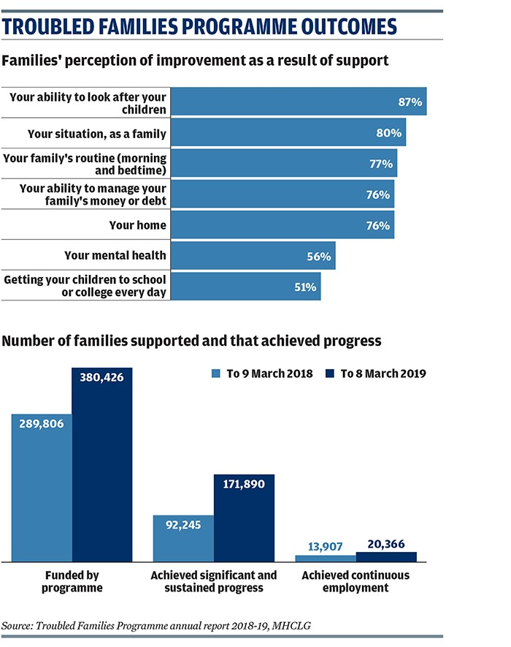
According to winchesterhospital.org, (2021) emotional abuse involves doing saying things to make someone feel badly about herself or himself. It often results in low self-esteem, fear helplessness, and guilt. Which is exactly happened to Holly. Holly was giving guidance and support about boundary setting with her children, and it has improved her parenting. Following the agency mediation with the school to tackle bullying Sarah school attendance is improved from 6 to 96 per cent which is a big step to improve her children education and their future. Following the agency interventions holly is life is improved she also access to a nursery place for Kylie her youngest child who is two years old. The agencies work made a significant improvement to Holly’s self-esteem and confidence and improved the children right to education, housing, health, and finance. ‘Every child has the right to an education. Primary education must be free and different form of secondary education must be available to every child. Discipline in schools must respect children’s dignity and their right’ UNICEF article 28, (2021).
” The government has a clear responsibility to safeguard children from violence under the United Nation Convention on the Right of child (UNCRC 2021). Article 19 of the convention states that children should be protected from all form of physical and mental violence, injury abuse, and neglect, while Article 6 states that every child has an inherent right of life” (NSPCC TEENAGERS AT RISK 2019). According to this convention the government have clear responsibility the help Holly and her children because some their right has been lost and the government is a guarantor of everyone right in UK. UK government trough ministry of housing, communities and local Government set up program call Troubled Families Program to fund to help troubled families like Holly’s Family. There is some result about the program and what the program achieved and progress in year 2018 to 2019 explained on the charter in the page 4.
Analysis
Holly’s living environment severely contributed to the family situation because domestic abuse and substance misuse is one of the main risk factors to the families and young people in UK. If she was not in abusive relationships, she may be able to take care of herself and her children. The abusive relationship affected her mental health, anti-social behaviour and contributed to her substance misuse. According to womensaid.org.uk, (2020) it is now well accepted that abuse (both in childhood and in adult life) is often the main factor in development of depression, anxiety, and other mental health disorders, and may lead to sleep disturbances, self-harm, suicide, and attempted suicide, eating disorder and substance misuse. Healthcare agencies has done a great job to help Holly and her children to improve their situation however it should be done long time ago because the agency and her social should be aware of Holly’s situation before it getting to this point. It may be caused by the agencies lack of funding due to government austerity plan which has cut a funding to different healthcare agencies specially in Norfolk. However, the healthcare agencies stepped to help, and they manage to encourage Holly to gain self-esteem which has hugely contributed to Holly’s change and children’s situations. If the agencies did not step in to help Holly’ the situation may end up worsen which can lead to suicide or heavy mental health issues. Holly did not have an esteem to change her situation because base on her case study there is no one there in her family to help her. She maybe does not have any relationship with her parent or any other person who may help her to improve her life.
Furthermore, she maybe does not want to involve other people in her life, or her violent partner stop her to talk to other about her situation because he does not want other people aware about, he is physical and emotionally abusing Holly. Police should be involved to stop the domestic violence against Holly while before it getting to this point because Holly maybe has been knowing by law enforcement agencies due to her anti-social behaviours. However, the healthcare agencies done great job to help Holly because her situation is completely changed, and she is live a normal life like any other normal family. Regarding to Holly’s case you can learn culturally, financially, and environmentally can affect family situation and the situation maybe vary to other country. “Every child has the right to the best possible health. Government must provide good quality health care, clean water, nutritious food, and a clean environment and education on health and well-being so that children can stay healthy “(UNCRC 2021). However, this article maybe not work in developing countries because it’s very difficult for their government to provide this basic need like clean water, good healthcare and clean environment to their children and population in general.
Evaluation And Result Holly’s situation has change since she had a referral to the healthcare agencies. Furthermore, she also contributed to her life changing. However, the healthcare agencies, schools and law enforcement services should react earlier to help Holly because she has been into this situation for so long and no one has referred her to any healthcare agencies or law enforcement unit which is not normal in the country like United Kingdom. Regarding to Holly’s case the government need to put more funding to the social services and law enforcement agencies to deal with cases like Holly’s case. However, regarding to huge achievement they made for last 11 months to help Holly and her family you can see what they can achieve when the multi agencies are working together. You can see the change in the family now the children school attendance is good, they moved to a new house, she significantly reduce alcohol and they stop their anti-social behaviour which can contributed to family wellbeing and happiness her children now are happy and enjoying their normal family which every child deserve to live.

This change can also contribute to her children future because they are attending a school and the youngest one has the place in the nursery which can lead to the children success in the future and avoid going through what they mother has been through.
The government should change some legislation to allow this health care agency to react quickly when a case like Holly has been rise to them. And the legislation should protect more the family especially young families and try whatever they can change some parents’ behaviour instead to take away child if they parents is in vulnerable situation because it can contribute to worsen the situation and resolve it. Government have a programme call Troubled Families Programme (TFP) this programme is aim to help troubled families in England.” Clear the programme was initially driven by national political priorities, in context of economic crisis and riot but the TFP is developing to be much more than this” (C, Hayden & C, Jenkins 2014) Example of Holly is a great example the multi agencies preferred to help Holly quit her violent partner and stop substance misuse instead of blaming her for her family situation. Furthermore, Holly gains more respect from her family, friends and neighbours and people seen her differently because her change of behaviours. Additionally, Holly may start to think about back to work because her children are all in the education system now Holly have more time and self-confident to find a job and build her financial situation better to support her children.

Reference

C, Hayden & C Jenkins(2014) ‘troubled families programme in England: ’wicked problems’ and policy based evidence’ policy studies 35 (6) 28 Taylor and Francis Online [online] available at: https://scholar.google.co.uk/scholar?q=troubled+families+evaluation+uk&hl=en&as_sdt=0&as_vis=1&oi=scholart#d=gs_qabs&u=%23p%3D9z-oMjSVUpcJ (accessed 20 August 2021)
NSPCC (2021) how do alcohol and drugs affect parenting available at https://www.nspcc.org.uk/keeping-children-safe/support-for-parents/alcohol-drugs-parenting/ (accessed 10 august 2021).
NSPCC (2021) domestic abuse available at https://www.nspcc.org.uk/what-is-child-abuse/types-of-abuse/domestic-abuse/ (accessed 11 august 2021).
NSPCC (2021) teenager at risk available at https://www.nspcc.org.uk/about-us/news-opinion/2020/report-risk-abuse-teenagers-children/ ( accessed 15 August 2021).
UNICEF (2021) child definition available at https://www.unicef.org/child-rights-convention/convention-text-childrens-version (accessed 09 august 2021).
UNICEF (2021) what is the UNCRC available at https://www.unicef.org.uk/what-we-do/un-convention-child-rights/ ( accessed 15 August 2021).
Winchesterhospital.org (2021) emotional abuse: Bruises on Your Sense-of-Self available at https://www.winchesterhospital.org/health-library/article?id=14277 (accessed 13 August 2021).
Womensaid.org.uk (2020) domestic abuse and your mental health available at https://www.womensaid.org.uk/the-survivors-handbook/domestic-abuse-and-your-mental-health/ (accessed 17 August 2021)

