The impact of politics on the police and their partners in the UK
The evolution of contemporary policing; a macro and micro analysis. Will policing ever be devolved in Wales?
BMPO 7003 Policing and the Political Landscape
Lecturer: Mike Durke

Abstract
This paper and accompanying presentation examines the history of policing in the UK and how politics has played a crucial role in shaping contemporary policing. It examines the macro and micro involvement of politics in policing, whilst analysing the issue of justice and policing being devolved to the Welsh Government. At a time when public confidence in policing is at an all-time low, can greater political involvement restore trust in UK Policing?

Andrew Hayes, 2117217
11th of July 2023
Word Count: 2655
(Excl. Title Page, Contents Page, Headings, Diagrams & References)

Table of Contents
Introduction 2
Objective 2
Scope 3
Main Body 4
The History of Policing and Politics 4
Politics and Policing at a macro level 6
Conclusion 12
The argument for more political influence 12
The argument for less political influence 12
References 13

Introduction

Objective

British policing has undergone momentous and necessary changes in the last century due to political appetite, public opinion and confidence. The report seeks to understand the government's authority and control on policing and the growing tendency (from various actors) to scrutinise and hold policing accountable for every decision or indecision.

The report aims to explore the evolution of contemporary policing and how politicians have influenced not only the geographical boundaries but also the functions of policing and how this has affected public perception. The development of key legislation will be discussed to understand how the United Kingdom has attained the current police-government operating model. The report will focus on the vital role the police play in maintaining law and order and how policing and politics have historically been intertwined, and considers if the ambivalent relationship will ever change.

Scope

In addition to the legislation, the report will focus on the macro impact of politics, including creating the tripartite structure, the democratic elected Police and Crime Commissioners (PCCs) and how developments have impacted the trust, confidence and legitimacy of policing. Due to adherence to word count, the report will not explore granular detail of the tripartite structure, PCCs or public trust, confidence and legitimacy. The report is accompanied by a short presentation that expands on the above headings, explores the micro influence of politics and policing in Wales, and investigates the topic of policing being devolved.

Main Body

The History of Policing and Politics

The rise in crime and disorder in the 19th century resulted in the then Secretary of State, Sir Robert Peel, establishing a full-time professional police force for Greater London by enacting the Metropolitan Police Bill of 1829. Notably, this was placed immediately under the control of the Secretary of State. The vision was to act as an exemplar and reform policing in other parts of the country. During the early 19th century, the development of policing and the establishment of police forces in rural counties was rapid. There were around 13,000 police in England and Wales by 1851 (UK Parliament, 2023).

Policing became a condition across England and Wales through the enactment of The Country and Borough Police Act of 1856; funding was provided by the treasury and granted to the local government. Additionally, the central inspectorate of constabulary was established to analyse the effectiveness of the many constabularies. However, an implication was that the inspectorate would report to the Home Secretary. Not until the Police Act of 1946 did the UK see another great shift in policing where smaller forces merged, leaving one hundred and seventeen constabularies (UK Parliament, 2023).

Further developments occurred on the publication of the Royal Commission in 1962, chaired by Henry Willink, considered one of the leading architects of modern-day policing. The commission recommended no single national police force, and the Police Act of 1964 established police authorities, defined the independence of police from politics, required the chief constable to complete an annual report, but bestowed greater powers to the Home Secretary. Finally, the legislation merged several smaller forces. By 1966 the one hundred and seventeen constabularies were reduced to forty-seven until further amalgamations following the Local Government Act 1972, resulting in the UK now comprising forty-five territorial forces (Inc. Police Scotland and Police Service Northern Ireland) and three special police forces in the UK (Oliver, 1987; Rawlings, 2014; UK Parliament, 2023).
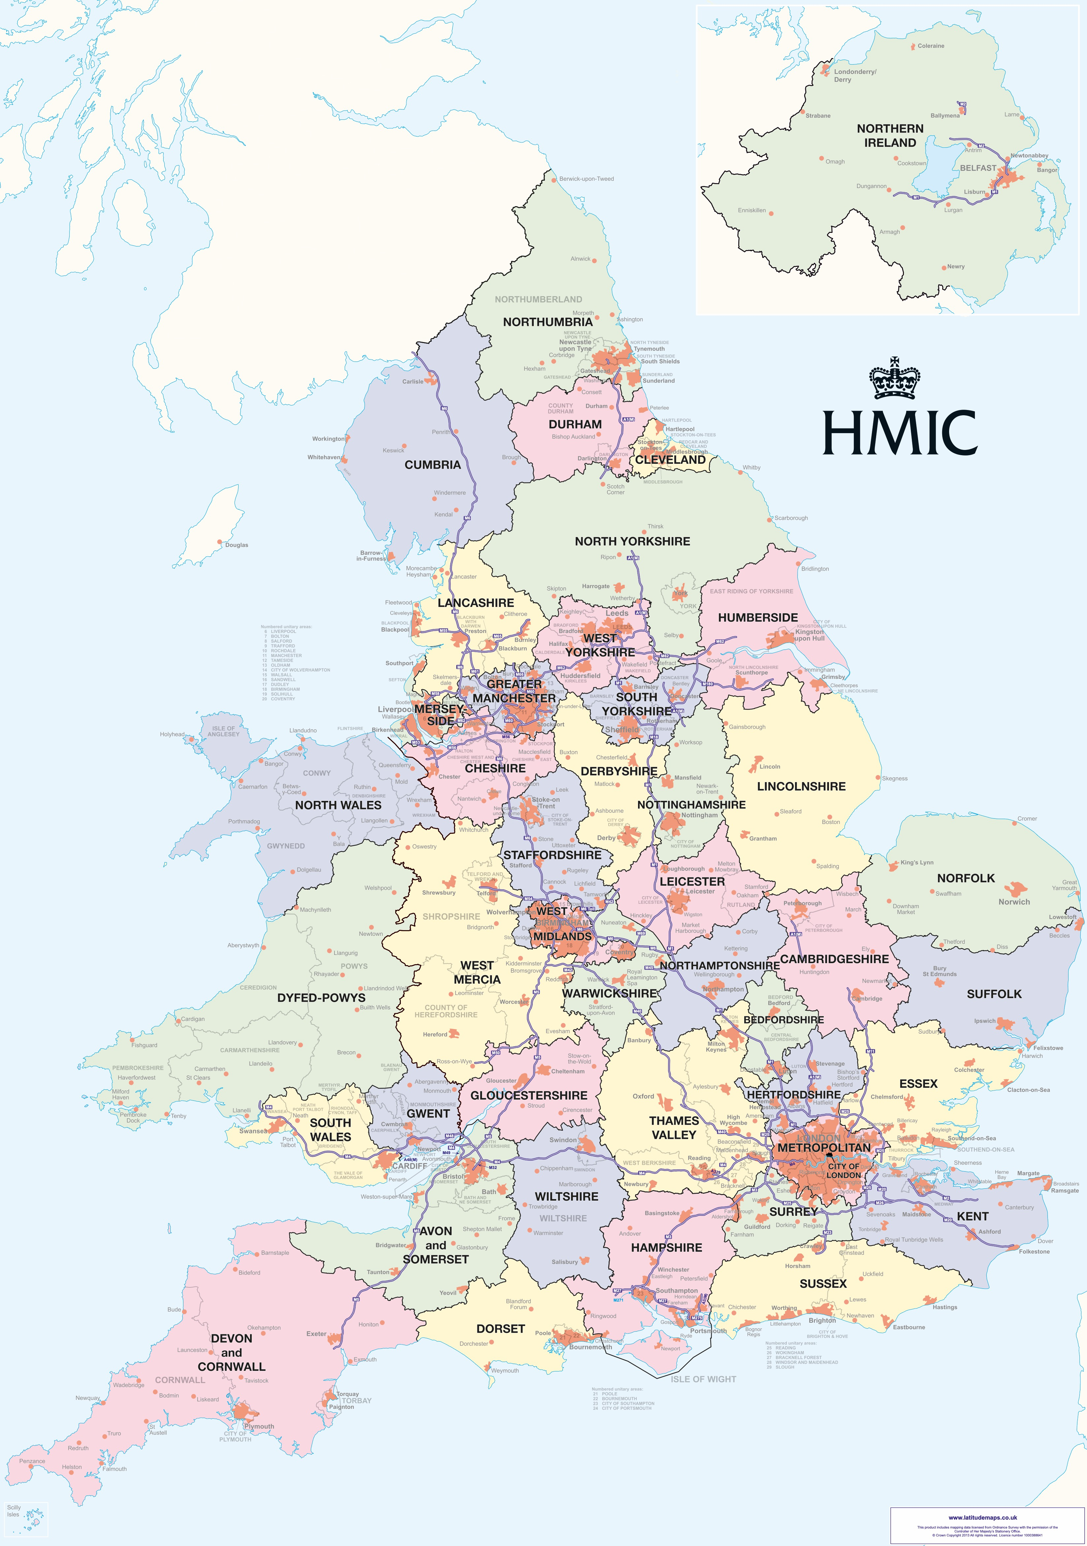
Image Credit: Justice Inspectorates, Police force map, undated
The Prosecution of Offences Act 1985 removed the police from prosecuting except for minor road traffic offences. The responsibility was transferred to the Crown Prosecution Service (CPS), an independent agency that prepares and presents criminal prosecutions in England and Wales. However, the Director of Public Prosecutions, as the head of the CPS, is appointed by the Attorney General and remains accountable to Parliament. Furthermore, the CPS have gained greater power over the last decade, but His Majesty’s Crown Prosecution Service Inspectorate is responsible for assessing and reporting on the performance of the CPS (Lewis, 2012). Therefore, despite policing being removed from the decision to prosecute in most cases, CPS has gained increasing powers but remains closely aligned to policing and is still funded and accountable to the government; one may ask how much political influence exists within the criminal justice arena?

The Police and Magistrates Court 1994 Act, consolidated by the Police Act 1996, provided national objectives to police authorities and ensured the policing plan would include national objectives (measurable and published). Ultimately placing pressure on police authorities to fire or not rehire if the chief constable failed to produce. Furthermore, the act proclaimed police authorities as a separate legal entity and defined the membership of the police authority, reducing councillors from sixteen to eight, with the remainder being independent. The Home Office moved grant funding from the local authority to the police authority, which at the time demonstrated the de facto control of the Home Office. The Police Reform Act 2002 intensified the political power and authority of the Home Secretary to intrude directly into forces considered failing and direct Police authorities to suspend or dismiss the chief constable (Lister, 2013).

Politics and Policing at a macro level

Jones, Newburn and Smith (1996) suggest that the police are an extension of political power because the police exercise power and control over society to uphold the legislation that politicians and lawmakers created. This is supported by Newburn (2012), who highlights the momentous influence central government has had within the institution of British policing. Likewise, Fitch (2014) suggests politicians are often required to justify to their constituents how the police use public funds and resources. Therefore, it stands to good reason police accountability is inevitably entwined in politics.

The Tripartite structure distributes power and responsibilities to deliver policing to the chief constable, the police and crime commissioner (previously police authority) and the Home Office. This arrangement was introduced following the 1962 Royal Commission and has been upheld by passing various legislation. Arguably, the role of the chief constable is the most scrutinised and subjected to significant oversight. It is questionable to what extent the scrutiny and oversight interfere with the operational independence of the chief constable. Whilst it has been recognised the chief constable is a servant to the law and should be free from political direction (Lord Denning, 1968 in the case of R. v. Metropolitan Commissioner of Police, ex parte Blackburn). The current arrangements limit independence and increase political oversight and control (Stenning, 2004; Mawby & Wright, 2008).

It has been debated that scrutiny and accountability of policing are required as there remains (even more recently) consternation about the role and power of policing. This is evident from a variety of scandals, corruption and breaches of public trust and confidence, including Operation Countrymen (White, 2008), the Angiolini Inquiry (2023), and the Casey Report (2023). It is clear policing is an integral part of societal order, yet police authority and legitimacy are in a constant state of flux and a precarious position. Worden and McLean (2017) describe legitimacy as a verdict society makes about the standing of the police as an authority that issues directives and expects such commands to be obeyed. In many ways, legitimacy, public consent, trust and confidence are united.

The Peelian principles articulate how the authority of the police is dependent on public consent rather than the state's power. Police legitimacy derives from applying the law fairly and impartially and using minimal force when the law permits. Police cannot be influenced by public opinion or political favour and should operate transparently and in line with the professional body's code of ethics (College of Policing, 2014; Tudor, 2023). According to Tyler (2006), procedural justice, police effectiveness, and distributive justice are key ingredients to police legitimacy and cooperation with the police.

Procedural justice has a greater influence on legitimacy than other allied factors (Gau et al. 2012; Farrow, 2022). Furthermore, key events such as the COVID-19 pandemic, where the police played a key role in the enforcement of the legislation and regulations whilst also simultaneously managing rising community tension and social division across the country, are examples of how police legitimacy fluctuates but also advances the notion that the directives from the government can and have influenced the trust and confidence in policing. That said, as Wolfe et al, (p.2, 2016) state, “The police can enhance their legitimacy by ensuring procedural fairness during citizen interactions”. One may argue this was evident in how police forces interpreted regulations and took a pragmatic approach to enforcement during the pandemic.

In May 2014, the then Home Secretary for State restricted the use of Section 60 Criminal Justice and Public Order Act 1994 due to the reported controversy and disproportionality of Black Minority Ethnic (BME) communities being stopped and searched. However, in May 2022, the Home Secretary for State (Patel) lifted such restrictions (rank to authorise, ‘may’ anticipate violence and no requirement to communicate authorisation in advance) due to the rising number of deaths involving knives (Badshah, 2022)

Jones and Harris (2020) examined direct and vicarious police stops on urban youths and their attitudes and perceptions of the police. The study identified direct and vicarious stop search lower such attitudes and perceptions, whilst procedural fairness has a positive relationship. However, this is dependent on the level of intrusiveness during such stops. Again, these instances highlight the influence of politics on policing as the issues were published by the media and subsequently debated in Parliament. Policing was expected to reduce crime and increase public safety whilst simultaneously seeking to maintain the trust and confidence of minority communities.

Of late, one may argue the greatest threat to police legitimacy and public confidence has been high-profile cases such as Wayne Couzens, David Carrick and Operation Hotton. The media highlight all these instances, commented on in the commons, and ultimately sway the countless directives from the Home Office and the consciousness of the UK public. According to Gau, et al (2012), police legitimacy (perception) is further impacted by socio-structures, but concentrated disadvantages are marginally significant and impactive on procedural fairness. Therefore, it is reasonable to conclude police effectiveness is the least impactive factor, whilst distributive justice has greater consequences for police legitimacy. How the police interact with the public, especially victims, will have a greater bearing on public opinion and how politicians perceive police effectiveness.

The Police Reform and Social Responsibility Act 2011 introduced in most areas the democratically elected Police and Crime Commissioners (PCCs). They are charged with the duty to secure an effective and efficient police force, scrutinising force performance, holding the chief constable to account, setting the annual budget (including the precept), and commissioning criminal justice services in the local area. PCCs are held to account by the electorate, Police and Crime Panels (PCPs), and Home Secretary. Although, according to Loveday, (2015); Newson, (2023) PCPs remain largely impotent. Bailey (2017) recognised political influence as a potential problem and concluded the election cycle for PCCs offered limited public accountability, and there was a need for urgent reform of the governance model; to date, this has not happened.

Lister (2013) predicted the interrogation of the constitutional operational independence (Policing Protocol, 2011) between the PCCs and the chief constable was of great importance. It was highly likely this would be resolved at a local level. Still, it would be magnified when questions arose to define the difference between strategic and operational decisions and especially every four years due to the election cycle. Lister acknowledged how political differences between the old police authorities and chief constables were highlighted when deciding on the use of resources and styles of policing. One must ask whether introducing the PCCs tempered the interference and disagreements based on political ideologies. Gilmore (2012) identified that many felt PCCs should not be affiliated with a political party, and cynicism prevailed on the impact the PCCs would have on fighting crime.

Bayley and Stenning (2017) determine that police chiefs are subordinates to politicians, yet that does not mean they do not tirelessly defend their entitlement to constitutional independence. The dynamics and precarious position are why we see police chiefs acting with greater sensitivity, consideration and remaining steadfastly focused on conformity whilst building and maintaining relationships. In contrast, politicians may not be so concerned as their remit may be broad, they are likely to have a limited understanding of policing, and with some keen to advance their political careers, their oversight of policing may be rather brief. Therefore, it is possible that politicians may not feel so constrained and be willing to behave differently. Politicians and police chiefs mainly collaborate effectively, and both remain content that public safety can be delegated to policing and that public accountability is, in the main, remitted to politicians.

In summary, generations of governments have created laws to maintain law and order. These are often instigated by public feedback, events or media attention. The Home Office, through the tripartite framework and various levels of governance, directs policing towards action. If police chiefs fail to conform, they will likely need a valid and rationalised reason for not following the directives. Police chiefs ultimately find mechanisms to maintain operational independence but are astute and shrewd individuals. That said, keeping the separation between government and policing is becoming a greater challenge, and it may be argued over many decades, governments have advanced their control through both clandestine and bold actions.

Conclusion

The argument for more political influence

Trust and confidence in the police are probably at an all-time low. This relates to a small cluster of incidents, but they have all been publicised in the media and repeated for several news cycles. The argument would be the police require greater scrutiny and to be held accountable for the actions of officers. The government have the central mechanisms, arms lengths bodies and democratically elected commissioners to ensure the police are held to account and taken to task when issues are not addressed to the public's or ministers' satisfaction.

Police budgets remain a contentious issue, and with greater scrutiny of public money, oversight is required to ensure policing offers value for money and remains effective and efficient when deciding on priorities and allocation of resources. The public has no choice about what police force maintains law and order in their locality. However, the public can decide who represents their interests and who holds policing accountable. If the people are to hold elected officials accountable for the local police service, then elected officials must have an opportunity to influence policing to benefit their constituents.

The argument for less political influence

British policing should be proud of the firewall that protects against the perception of police being state-owned or having ministers in charge of the police. Policing cannot be seen as a political actor. A sterile corridor must remain and be independent of government. The office of the constable is there to upload the law and is answerable to the law only. Whilst the operational independence of the chief constable is often softly challenged, maybe now is the time to revisit the Police Reform and Social Responsibility Act 2011 and provide greater clarity to strengthen the firewall between politics and policing.

In modern policing, it is a fair assumption that policing welcomes scrutiny and is becoming more transparent, despite how the media portray the institution. That said, how much scrutiny is required and to what extent is the policing protocol of 2011 being ignored? The line between accountability and the chief constable’s operational independence is blurred. Therefore, one might argue less political influence would free up resources and allow staff to focus on the core functions of policing. That said, contemporary policing has evolved, and the continued political influence is a consequence of some failures, public perception, and media impact.

In conclusion, politics and policing are forever intertwined, there is unlikely to be any disentanglement of this historical relationship, and policing will likely see greater political influence for many years.

References
Angiolini , E. (2023) The Angiolini Inquiry, The Angiolini Inquiry. Available at: https://www.angiolini.independent-inquiry.uk/ (Accessed: 08 July 2023).
Badshah, N. (2022) ‘Priti Patel lifts restrictions on police stop and search powers’, The Guardian, 16 May. Available at: https://www.theguardian.com/law/2022/may/16/restrictions-on-police-stop-and-search-powers-permanently-lifted (Accessed: 23 June 2023).
Bailey, R.J. (2017) Policing the Police and Crime Commissioners An evaluation of the effectiveness of Police and Crime Panels in holding Police and Crime Commissioners to account, https://pure.port.ac.uk. Available at: https://pure.port.ac.uk/ws/portalfiles/portal/8423720/Roy_Bailey_thesis_final_28th_August_2017.pdf (Accessed: 24 June 2023).
Bayley, D.H. and Stenning, P.C. (2017) Governing the police: Experience in six democracies. Abingdon, UK: Routledge.
Brown, J. (2021) Policing in the UK - house of commons library, https://commonslibrary.parliament.uk. Available at: https://commonslibrary.parliament.uk/research-briefings/cbp-8582/ (Accessed: 11 June 2023).
Casey, B. (2023) Baroness Casey Review final report - metropolitan police, https://www.met.police.uk. Available at: https://www.met.police.uk/SysSiteAssets/media/downloads/met/about-us/baroness-casey-review/update-march-2023/baroness-casey-review-march-2023a.pdf (Accessed: 11 June 2023).
Farrow, K.F. (2022) Conference Briefing Legitimacy & Confidence in Policing - Cumberland Lodge, https://www.cumberlandlodge.ac.uk. Available at: https://www.cumberlandlodge.ac.uk/sites/default/files/legitimacy_confidence_in_policing_-_briefing_document.pdf (Accessed: 23 June 2023).
Fitch, B.D. (2014) Law enforcement ethics: Classic and contemporary issues. Thousand Oaks, CA: SAGE Publications.
Gau, J.M. et al. (2012) ‘Examining macro-level impacts on procedural justice and police legitimacy’, Journal of Criminal Justice, 40(4), pp. 333–343. doi:10.1016/j.jcrimjus.2012.05.002.
Gilmore, M. (2012) ‘Poll reflects public concerns about police and crime commissioners’, The RUSI Journal, 157(5), pp. 12–15. doi:10.1080/03071847.2012.733095.
Harris, J.W. and Jones, M.S. (2020) ‘Shaping youths’ perceptions and attitudes toward the police: Differences in direct and vicarious encounters with police’, Journal of Criminal Justice, 67. doi:10.1016/j.jcrimjus.2020.101674.
Innes, M. (2005) ‘Why “soft” policing is hard: On the curious development of reassurance policing, how it became neighbourhood policing and what this signifies about the politics of police reform’, Journal of Community &amp; Applied Social Psychology, 15(3), pp. 156–169. doi:10.1002/casp.818.
JONES, T., NEWBURN, T. and SMITH, D.J. (1996) ‘Policing and the idea of democracy’, British Journal of Criminology, 36(2), pp. 182–198. doi:10.1093/oxfordjournals.bjc.a014081.
Lewis, C. (2012) ‘The evolving role of the English Crown Prosecution Service’, The Prosecutor in Transnational Perspective, pp. 214–234. doi:10.1093/acprof:osobl/9780199844807.003.0016.
Lister, S. (2013) ‘The New Politics of the Police: Police and Crime Commissioners and the “operational independence” of the police’, Policing, 7(3), pp. 239–247. doi:10.1093/police/pat011.
Loveday, B. (2015) Evidence to the Committee on Standards in Public Life: concerning public accountability structures of the police in England and Wales, https://assets.publishing.service.gov.uk. Available at: https://assets.publishing.service.gov.uk/government/uploads/system/uploads/attachment_data/file/414822/Police_Accountabillity__Evidence_A_-_D.pdf#page=61 (Accessed: 11 June 2023).
Mawby, R.C. and Wright, A. (2008) ‘The Police Organisation’, Handbook of Policing [Preprint]. doi:10.4324/9780203118238.ch10.
Newburn, T. (2012) ‘Police and crime commissioners: The Americanization of policing or a very British reform?’, International Journal of Law, Crime and Justice, 40(1), pp. 31–46. doi:10.1016/j.ijlcj.2011.09.005.
Newson, N. (2023) Police and crime panels: Structure, purpose and powers, https://lordslibrary.parliament.uk. Available at: https://lordslibrary.parliament.uk/police-and-crime-panels-structure-purpose-and-powers/ (Accessed: 11 June 2023).
Oliver, I. (1987) ‘The Royal Commission on the police 1962’, Police, Government and Accountability, pp. 8–34. doi:10.1007/978-1-349-18557-3_2.
Rawlings, P. (2014) Policing: A short history. London, UK: Routledge.
Rogers, C. and Gravelle, J. (2013) Policing Powers: In Working Group Capacity, Accountability and Powers: http://www.law.cardiff.ac.uk. Available at: http://www.law.cardiff.ac.uk/ukcu/papers/05/Chapter%206-%20Policing%20Powers.pdf (Accessed: 10 June 2023).
Stenning, P. (2004) The idea of the political ‘independence’ of the police: International ..., Research Gate. Available at: https://www.researchgate.net/profile/Philip-Stenning/publication/237334554_The_idea_of_the_political_independence_of_the_police_international_interpretations_and_experiences/links/5996cd70458515017eb0ccc9/The-idea-of-the-political-independence-of-the-police-international-interpretations-and-experiences.pdf (Accessed: 24 June 2023).
Tudor, S. (2023) Police standards and culture: Restoring public trust, https://lordslibrary.parliament.uk/. Available at: https://lordslibrary.parliament.uk/police-standards-and-culture-restoring-public-trust/ (Accessed: 11 June 2023).
Tyler, T.R. (2006) Why people obey the law. Princeton, UK: Princeton University Press.
UK Parliament (2023) Creating the nation’s Police Force, Parliament UK. Available at: https://www.parliament.uk/about/living-heritage/transformingsociety/laworder/policeprisons/overview/nationspoliceforce/ (Accessed: 30 June 2023).
UK Parliament (2023) Metropolitan police - UK parliament. Available at: https://www.parliament.uk/about/living-heritage/transformingsociety/laworder/policeprisons/overview/metropolitanpolice/ (Accessed: 01 June 2023).
White, J. (2008) London in the Twentieth Century: A city and its people. London, UK: Vintage.
Wolfe, S.E. et al. (2016) Is the effect of procedural justice on police legitimacy ..., https://core.ac.uk. Available at: https://core.ac.uk/download/pdf/270047358.pdf (Accessed: 23 June 2023).
Worden, R.E. and McLean, S.J. (2017) ‘Police legitimacy’, Mirage of Police Reform: Procedural Justice and Police Legitimacy, pp. 42–68. doi:10.1525/luminos.30.c.

