DS 1 Template

My Screenshots/Photos

Screenshot/Photo 1
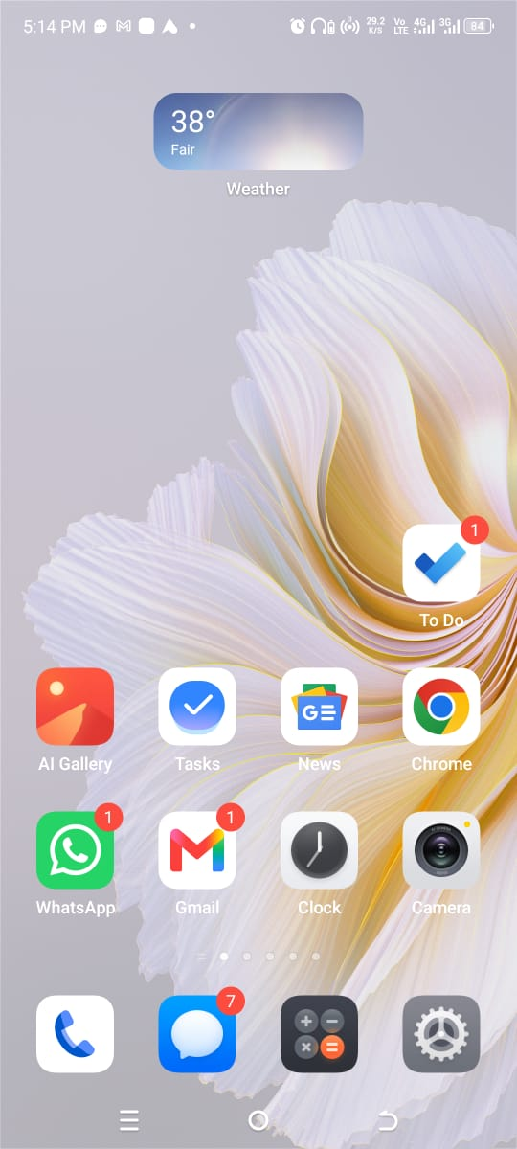
This is my home screen on the mobile and I can have handy applications like Gmail, WhatsApp, Chrome and To Do at the same spot. My phone is used to talk to people, locate information and arrange daily activities, which also aid my studies.

Screenshot/Photo 2
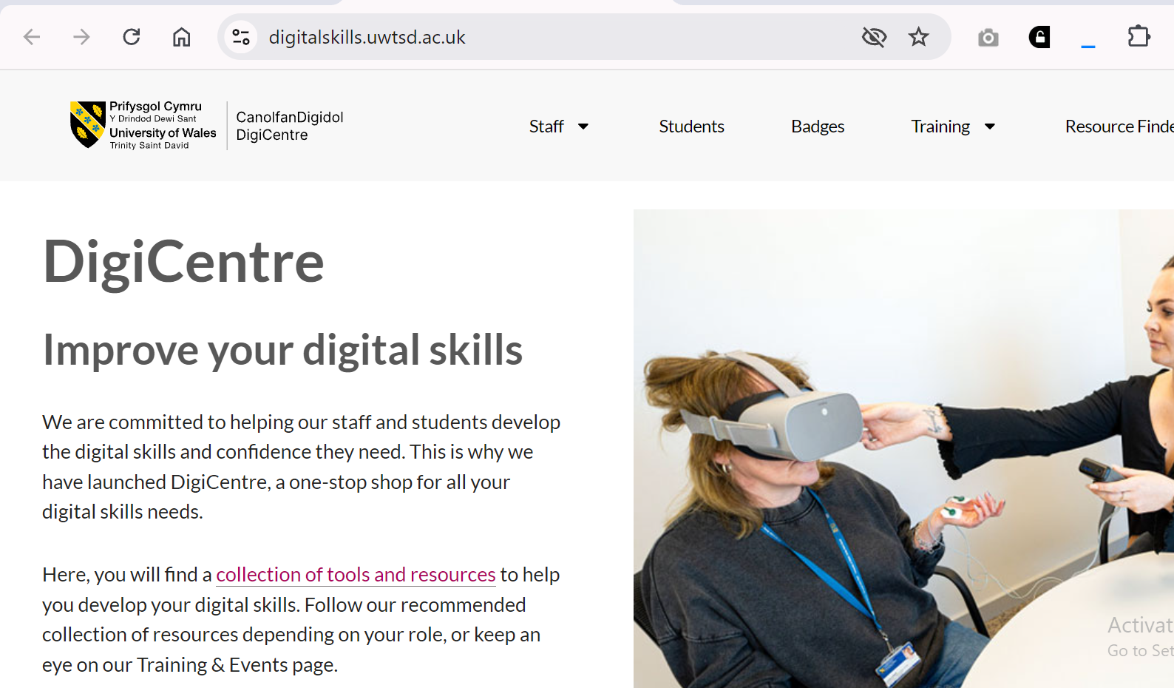
This is a screenshot of the University DigiCentre that I use to locate digital-skills tools, training and learning resources. It makes me better at using technology and become capable of working with the technology and the skills that will be helpful in the university and in the workplace.

Screenshot/Photo 3
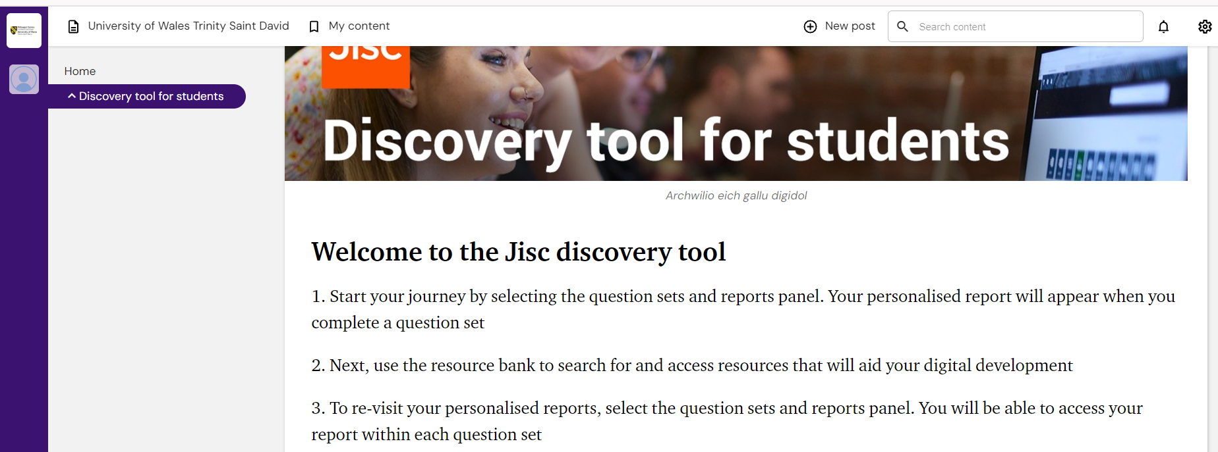
This is a screenshot of the Jisc Discovery Tool that I use to evaluate my digital capabilities and determine the areas to work on. The personalised reports and resource bank make me realize my strengths and select helpful resources to continue their development.

Screenshot/Photo 4
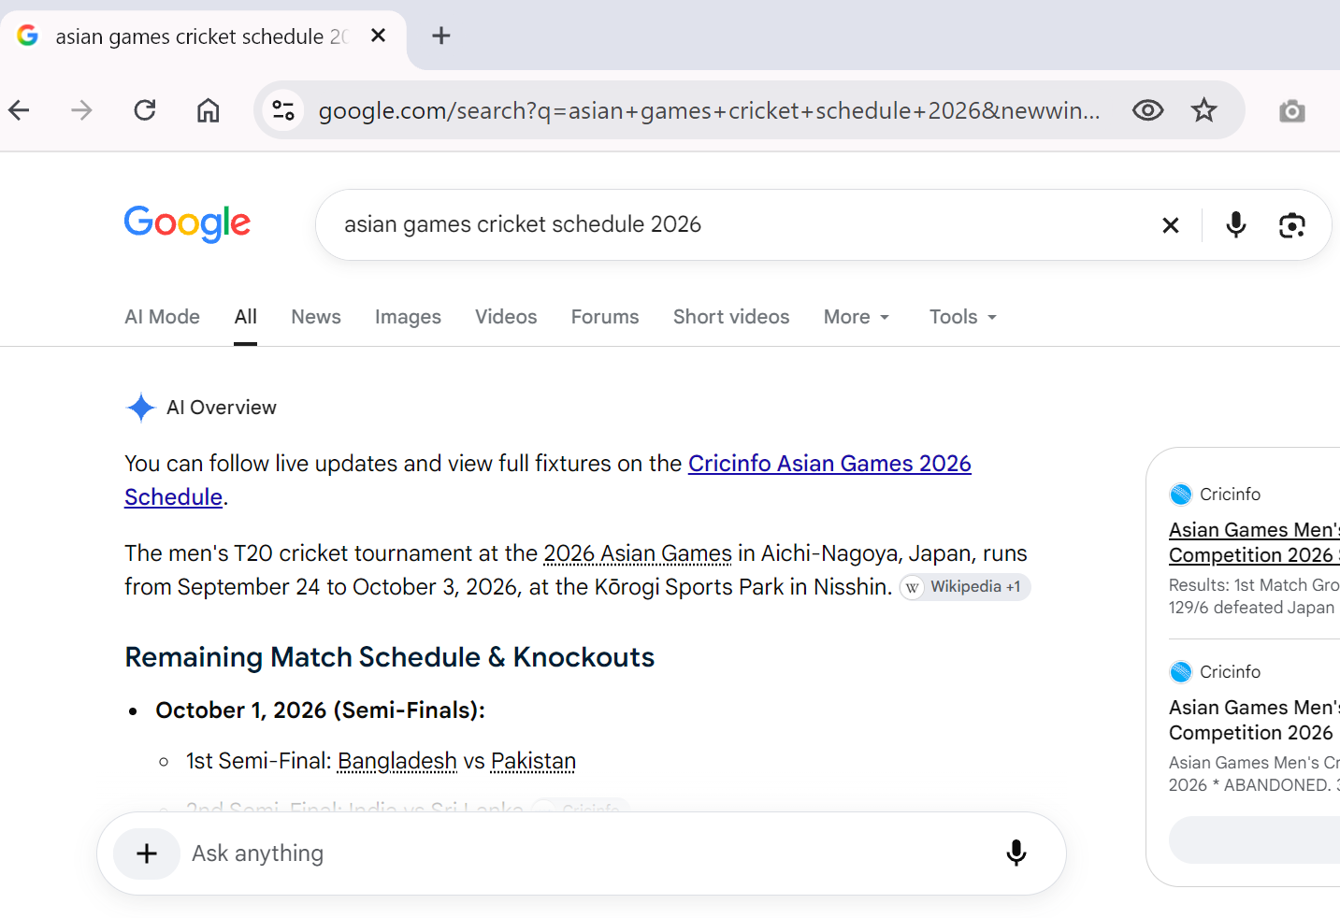
This screenshot depicts me using Google on my laptop to find out information about the Asian Games schedule of the cricket game. Online search tools help me to quickly locate information, however, I must also consult credible sources before using information to study or work.

Screenshot/Photo 5
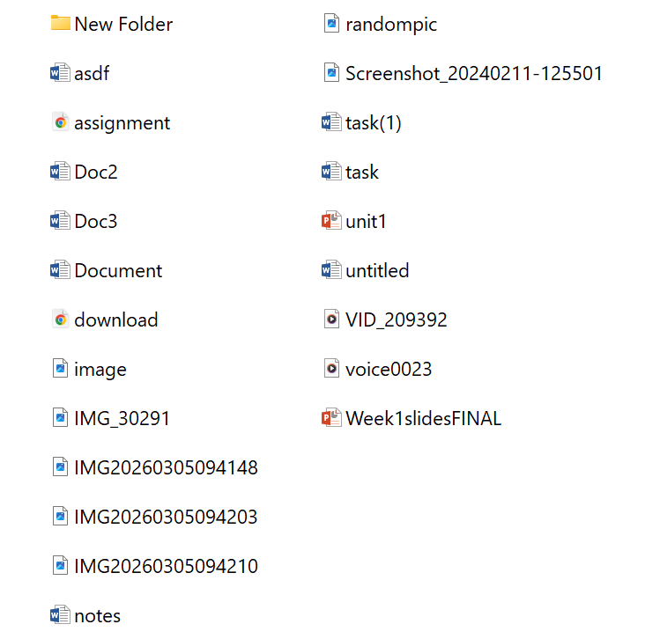
In this screenshot, you can see that the files saved in the past had irregular names and had no uniform folder structure. It also enabled me to realise that I could make my work easier to locate and operate in better file names and organised folders.

Screenshot/Photo 6
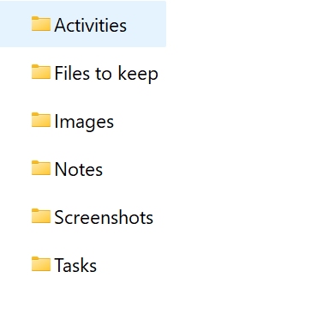
In this screenshot, I have created a new folder with the help of which I managed to arrange my digital work into Activities, Files to keep, Images, Notes, Screenshots and Tasks. This simplifies locating my files and is an improvement in my management of digital information.

My Short Reflection
I am an active user of digital tools daily, on my phone, and the laptop, such as Gmail, Chrome, To Do, the University DigiCentre and the Jisc Discovery Tool. I am self-confident in communication with my phone, I can find information and track all the daily activities. I apply the University DigiCentre and Jisc Discovery Tool to learn my digital competences and locate the sources that can assist me in changing. Using Google I can easily get information online but I understand that I must verify that it is a reliable source before using it in university work.
My habit was to store files with ambiguous names and locations hence hard to locate. Having organised files, I made distinct folders of Activities, Files to keep, Images, Notes, Screenshots and Tasks, and my work is more manageable. I am now determined to do even better through having easy to understand file names and maintain the same order system within each module. These online skills not only allow me to study more effectively but will also come in handy in the workplace where effective communication and organisation of files is a key consideration.

Submission Checklist
Before you submit, please check:
☒ I added 4–6 screenshots
☒ I wrote short sentences for each screenshot
☒ I wrote my short reflection
☒ I My work is my own
☒ My file opens correctly

