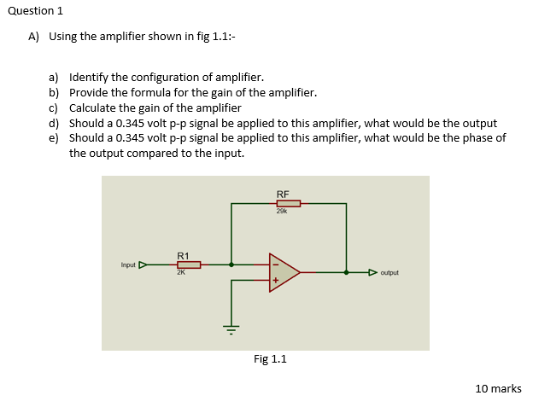
- Inverting amplifier
- Gain = -RF/R1
- $-\frac{29000}{2000}=-14.5$
Gain = 14.5 dB
- 14.5*0.345V=5.0025V
- The output would be 180° out of phase with the input since it’s an inverting amplifier.

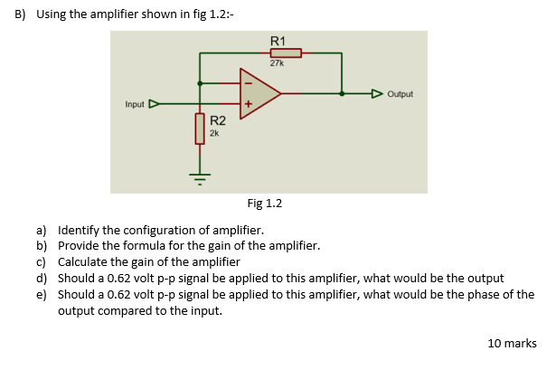
- Non-inverting amplifier
- Gain = 1+ R1/R2
- $1+\frac{27000}{2000}=14.5$
Gain=14.5 dB
- 14.5*0.62V=8.99V
- Output would be in phase with the input due to it being a non-inverting amplifier.

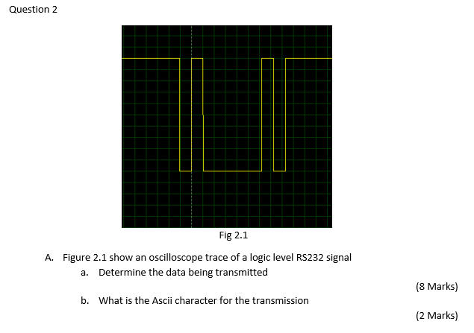
- 0 1000 0010 1
= 0100 0001
=4 1
- ASCII character “A”

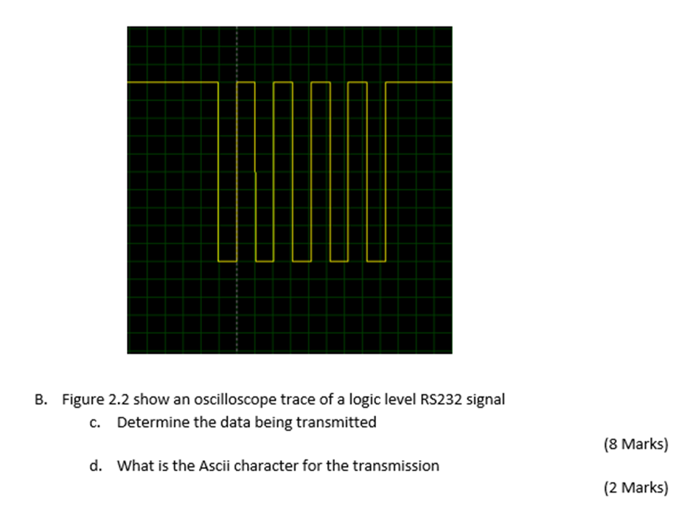
- 0 1010 1010 1
=0101 0101
=5 5
- ASCII Character “U”

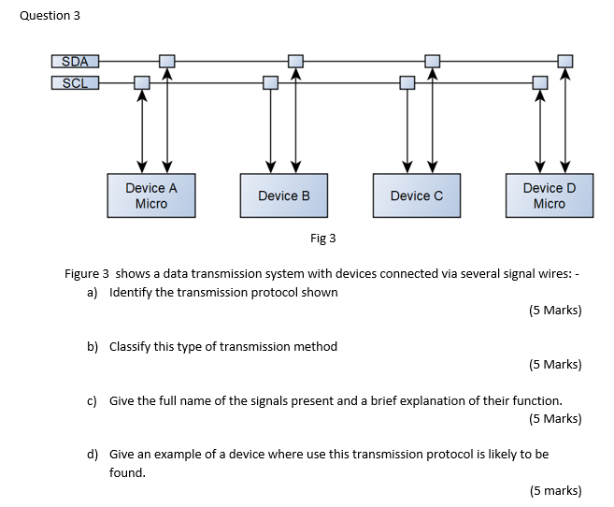
- I²C (Inter-Integrated Circuit)
- Serial Transmission Protocol
- SDA = Serial Data. The line used for data to be sent between the slave and the master.
SCL = Serial Clock. The line carries the clock signal (controlled by the master) to synchronise the output of bits to the sampling of bits.
- Can be used anywhere where ease of implementation and cost are more important than speed of data transfer, for example in a small phone to control the LCD screen.

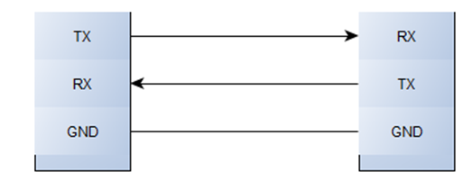
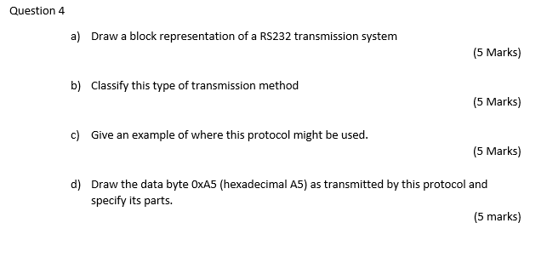
- Representation of RS232:
- Serial Transmission Protocol
- Was used very commonly to connect computers to peripheral devices over short distances, to allow for serial data exchange between the systems. For example, between a computer and a printer. Nowadays computers mostly use USB/wireless transmission, but RS232 can still be found in industrial and specialist applications, like in networking equipment and scientific instruments, where short range and low speed are good enough. This is because RS232 is very simple and was previously ubiquitous in computing, so allows for greater compatibility with legacy systems.
- A 5
= 1010 0101
= 0 1010 0101 0
Stop Bit
Start Bit
Data Bits

