3. Methodology

3.1 Introduction
This methodology chapter is crucial in determining whether the research conducted on the link between domestic abuse exposure in childhood and criminality is reliable and valid. It lays out a structure for how the research should be undertaken in order to maintain consistency throughout choosing techniques, tools, and philosophy (Swarooprani, 2022). During this, it will aim to answer the three research objectives:

Objective 1: To explore explanations as to why children and young people commit crime in England and Wales.
Objective 2: Identify the prevalence and effects of domestic abuse exposure in childhood and how this may increase the chances that a child or young person will be involved in crime.
Objective 3: Evaluate the public's perception on the effects of domestic abuse and the link between childhood exposure and criminality.

To conclude this chapter, limitations on the research study will be stated to strengthen the overall research, as well as demonstrating a better understanding for the researcher and the reader.

3.2 Research onion
The construction of a research methodology can be based off a theoretical context named the research onion. Saunders, Lewis and Thornhill (2007) proposed this theory and they presented the foundations on the theory behind how the research will be designed, the approach taken when conducting the research, the specific research strategy and the type of the data that will be used, the timescale of the study and lastly the techniques to examine the practicality of the research. To summarise, the six layers of the research onion are: philosophy, approach to theory development, methodological choice, strategy, time horizon and lastly techniques and procedures (Melnikovas, 2018).

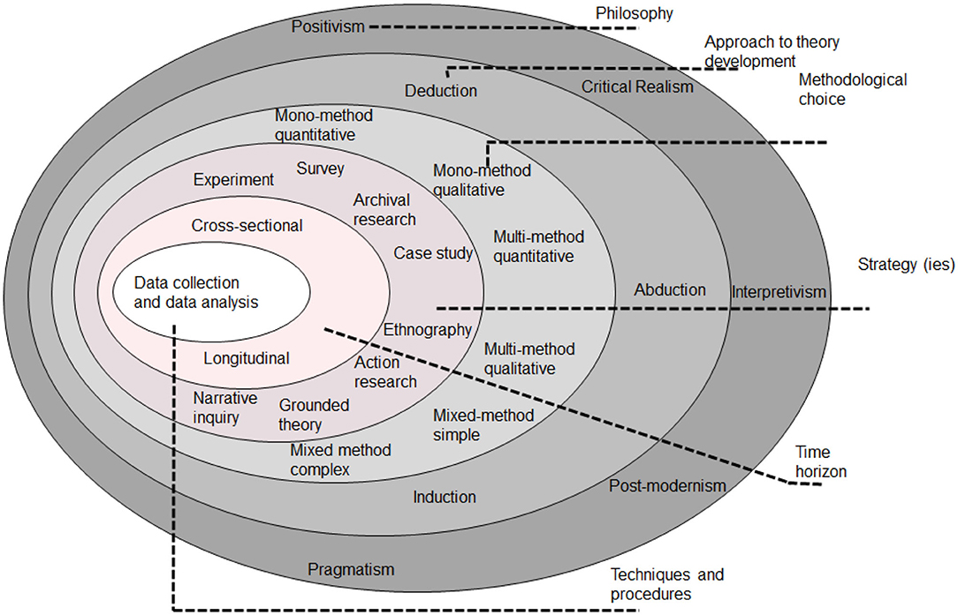
Figure 1. ‘The Research Onion’ (Saunders, Thornhill & Lewis, 2019).

3.3 Research Philosophy
This is situated at the outer layer of the research onion and explains the assumptions made about different contexts and the engagements between people (ontological) and the reflection on the assumptions about knowledge and what people can know (epistemological) (Bianchi, 2021). Within this, there is both positivism and pragmatism but in this specific research study, interpretivism will be applied as it takes into account everyone’s thought processes and how different social and cultural factors can affect humans. This is essential as this study is aiming to ascertain a variety of opinions on the subject matter (Koralage, Kulatunga & Ingirige, 2024).

3.4 Research Approach
This refers to the wider method the study will use to inform the decisions on data collection and data analysis choices. An inductive approach will be adopted because this research is aiming to generate theories from the research question. Following this, there is a review of literature to understand what research has already been undertaken and this will assist in testing the theory as well as building upon the theory through further research (Mardiana, 2020). The two alternative approaches are deductive and abductive, but they are not suitable as they look to start off with the theory as the foundation (Gul, 2019).

3.5 Methodological Choice
There are two fundamental research methods named qualitative and quantitative, and these allow for either a mono, mixed or multi method approach (Borgstede & Scholz, 2021). A mixed method approach is the most appropriate for this research as it uses both qualitative and quantitative methods to firstly investigate people’s opinions and feelings on the subject matter through open ended questions but to also to gather numerical data by collating numbers and statistics together through closed questions (Dharmadasa et al, 2024). This therefore produces a varied data sample that can be analysed to answer the research objectives thoroughly. On the contrast, a mono approach defines as only using one data type and a multi-method approach uses two or more different types of research methods (Ojebode et al, 2018).

3.6 Research strategy
The main purpose of this layer is to understand how the research is going to be carried out when considering different factors such as the expectations of the research, who is involved within the research and the specific timeframe of the study (Abdelhakim & Badr, 2021). Due to the research adopting a mixed method approach, results in the most effective strategy being a survey as it allows for both numerical and descriptive data to be produced. With the sample target needing to be 100 responses, surveys can reach a wide range of people and this assists in solidifying a representative sample that can be analysed effectively in correspondence with the research objectives (UK Government, 2020).

3.7 Time Horizon
This refers to the time frame in which the study is expected to be completed by and for this research, it will be May 2025 (Hossain et al, 2024). A cross sectional time horizon suits this study as it is asking the sample varied questions at that one specific time. This is due to the time limit and data collection being confined to a shorter time period.

3.8 Techniques and Procedures
This layer is the core of the onion, and the main purpose is to focus on data collection and data analysis (Wisenthige, 2023). Firstly, when relating to data collection, a survey will be constructed by forming a range of questions that link with the three research objectives, with an aim of providing answers and reasonings behind them. The questions will be designed to allow the sample to provide numerical answers which have an enhanced reliability due to them producing uniform data. In addition, they will be written in a specific way so the participant can form their own opinion and response on the matter (Fink, 2024). This is essential when answering objective three as this relates to the public’s perception on the effects of domestic abuse and the link between child’s exposure and criminality. Whilst in the process of constructing the questions, it is important to understand who the sample will be. The sample will over 18 years old due to the sensitivity of the topic and the participants will remain anonymous throughout the research which will increase the likelihood of honest responses (Kang & Hwang, 2023). In order to make it an efficient process, convenience sampling will be utilised as the researcher can choose a sample based on their availability and willingness to participate. This is because the questions will be shared via the researcher’s social media accounts meaning everyone in the sample is known to the researcher making them more likely to participate (Golzar, Noor & Tajik, 2022).
Data analysis is the process of extracting and summarising data for the purpose of interpretation to highlight any possible relationships, patterns and trends (Islam, 2020). When analysing the data that will be produced from the open-ended questions in particular; thematic analysis will be applied. It can be defined as identifying and analysing any patterns within a data set (Leer et al, 2023). Thematic analysis is comprised of six stages which list as: familiarisation, codes formulation, generation of themes, themes review, defining and naming themes and report formulation (Aslam & Rana, 2022). It is important for it to be used within this research due to it having the flexibility of analysing large data sets and the varied answers that will be produced by identifying key features and excluding anomalies (Sovacool, Iskandarova, Hall, 2023).

3.9 Limitations
One limitation which relates to data collection is that the sample could be limited due to it being shared only through the researchers existing social media account. Problems arise when wanting to gather information from people above the age of 70 as they stereotypically have a weaker knowledge on how to navigate social media which therefore discourages them to have it (Momeni et al, 2018). People from this age group may be able to provide different viewpoints and knowledge on domestic abuse exposure and criminality and this could be compared to present information on the subject (Oudat & Bakas, 2023).
Secondly, even though the sample will be known to the researcher, they may find it quite distressing because of the nature of the topic and may not want to participate. They might have had the same or a similar experience during childhood and they don’t want to trigger their past feelings. People that do participate despite the sensitivity could answer dishonestly due to having feelings of embarrassment (Ibbet et al, 2023). Overall, there is a lack of limitations within this study as precautions have been taken and before undertaking any research, a proposal form and ethics form were filled in to make sure it was suitable to proceed.

3.10 Conclusion
Despite the limitations, conducting the study still provides major value as it is determining whether there is a link between domestic abuse exposure in childhood and criminality. This can aid future services including the police, as children who are exposed could receive better help, support and guidance on different coping mechanisms which therefore could prevent them being involved with criminality (Millar et al, 2021). Furthermore, the study provides information on domestic abuse as a whole, allowing the participants to learn something which could lead them to spot early signs of exposure, in order to stop the link with criminality (NSPCC, 2024).

References
Abdelhakim, A.S., Badr, R.M. (2021) ‘Adopted Research Designs by Tourism and Hospitality Postgraduates in the Light of Research Onion’, International Journal of Tourism and Hospitality Management, 4(2). Available at: 10.21608/ijthm.2021.206774
Aslam, A., Rana, I.A. (2022) ‘The Use of Local Climate Zones in the Urban Environment: A Systematic Review of Data Sources, Methods, and Themes’, Urban Climate, 42. Available at: https://doi.org/10.1016/j.uclim.2022.101120
Bianchi, L. (2021) ‘Exploring Ways of Defining the Relationship Between Research Philosophy and Research Practice’, International Journal of Tourism and Hospitality Management, 4(2). Available at: https://www.ase.org.uk/system/files/Bianchi.pdf
Borgstede, M., Scholz, M. (2021) ‘Quantitative and Qualitative Approaches to Generalization and Replication–A Representationalist View’, Frontiers in Psychology, 12. Available at: https://doi.org/10.3389/fpsyg.2021.605191
Dharmadasa, K.H.K., Kulatunga, U., Thayaparan, M., & Keraminiyage, K.P. (2024) ‘Assessment of Community Disaster Resilience in Sri Lanka: Methodological Approach in Developing an Index’, in Sandanayake, Y.G., Waidyasekara, K.G.A.S., Ranadewa, K.A.T.O, & Chandanie, H. (Eds), Proceedings of the 12th World Construction Symposium. University of Moratuwa: Department of Building Economics, pp. 227-239. Available at: https://doi.org/10.31705/WCS.2024.18
Fink, A. (2024) ‘How to Conduct Surveys: A Step-by-Step Guide’. California: Sage Publications. Available at: https://books.google.co.uk/books?hl=en&lr=&id=fTMyEQAAQBAJ&oi=fnd&pg=PT9&dq=forming+a+survey+&ots=OoDqo1btDi&sig=4nrj7hxLelp3QC21ioP0XzN2Wb8&redir_esc=y#v=onepage&q=forming%20a%20survey&f=false
Golzar, J., Noor, S., Tajik, O. (2022) ‘Convenience Sampling’, International Journal of Education & Language Studies, 1(2). Available at: https://doi.org/10.22034/ijels.2022.162981
Gul, W (2019) ‘Strategy: Can a Research Methodology Be Proposed from Islamic Sources of Knowledge?’, International Business Research, 12(7). Available at: https://doi.org/10.5539/ibr.v12n7p83
Hossain, M.I., Teh, B.H., Tabash, M.I., Chong, L.L., Ong, T.S. (2024) ‘Unpacking the Role of Green Smart Technologies Adoption, Green Ambidextrous Leadership, and Green Innovation Behaviour on Green Innovation Performance in Malaysian Manufacturing Companies’, FIIB Business Review. Available at: https://doi.org/10.1177/23197145231225335
Ibbet, H., Dorward, L.J., Kohi, E.M., Jones, J.P.G., Sankeni, S., Kaduma, J., Mchomvu, J., Mawenya, R., St John, F, A.V. (2023) ‘Topic Sensitivity Still Affects Honest Responding, Even When Specialised Questioning Techniques Are Used’, Conservation Science and Practice, 5(6). Available at: https://doi.org/10.1111/csp2.12927
Islam, M. (2020) ‘Data Analysis: Types, Process, Methods, Techniques and Tools’, International Data on Data Science and Technology, 6(1). Available at: DOI:10.11648/j.ijdst.20200601.12
Kang, E. & Hwang, H. (2023) ‘The Importance of Anonymity and Confidentiality for Conducting Survey Research’, Journal of Research and Publication Ethics, 4(1). Available at: doi: http://dx.doi.org/10.15722/jrpe.4.1.202303.1
Leer, J.V.D., Calven, A., Glad, W., Femenias, P., Sernhed, K. (2023) ‘Energy Systems in Sustainability-Profiled Districts in Sweden: A Literature Review and a Socio-technical Ecology Approach for Future Research’, Energy Research & Social Science, 101. Available at: https://doi.org/10.1016/j.erss.2023.103118
Millar, A., Saxton, M., Overlien, C., Elliffe, R. (2021) ‘Police Officers Do Not Need More Training; But Different Training. Policing Domestic Violence and Abuse Involving Children: A Rapid Review’, Journal of Family Violence, 37. Available at: https://doi.org/10.1007/s10896-021-00325-x
Momeni, M., Hariri, N., Nobahar, M., Noshinfard, F. (2018) ‘Barries and Challenges Experienced by Seniors in Using Online Social Networks: A Phenomenological Study’, Middle East Journal of Rehabilitation and Health Studies, 5(1). Available at: DOI:10.5812/mejrh.65310
NSPCC (2024) ‘Protecting Children From Domestic Abuse’. Available at: https://learning.nspcc.org.uk/child-abuse-and-neglect/domestic-abuse (Accessed: 25 January 2025).
Koralage, M.B., Kulatunga, U. and Ingirige, B. (2024) ‘Building Community Resilience to Economic Impacts of Climate Change on Livelihoods: The Methodological Perspective’, in Sandanayake, Y.G., Waidyasekara, K.G.A.S., Ranadewa, K.A.T.O, & Chandanie, H. (Eds), Proceedings of the 12th World Construction Symposium. University of Moratuwa: Department of Building Economics, pp. 318-329. DOI: https://doi.org/10.31705/WCS.2024.25.
Mardiana, S. (2020) ‘Modifying Research Onion for Information Systems Research’, Solid State Technology, 63(4), pp 1202-1210. Available at: https://www.researchgate.net/profile/Siti-Mardiana/publication/359542575_Modifying_Research_Onion_for_Information_Systems_Research/links/62432dc07931cc7ccf033406/Modifying-Research-Onion-for-Information-Systems-Research.pdf
Melnikovas, A. (2018) ‘Towards an Explicit Research Methodology: Adapting Research Onion Model for Futures Studies’, Journal of Futures Studies, 23(2). Available at: DOI:10.6531/JFS.201812_23(2).0003
Ojebode, A., Ojebuyi, B.R., Oladapo, O.A., Oyedele, O.J. (2018) ‘Mono-Method Research Approach and Scholar-Policy Disengagement in Nigerian Communication Research’, in Mutsvairo, B. (Eds), The Palgrave Handbook of Media and Communication Research in Africa. Switzerland: Palgrave Macmillan, pp. 369-383. Available at: DOI:10.1007/978-3-319-70443-2_20
Oudat, Q, Bakas, T. (2023) ‘Merits and Pitfalls of Social Media as a Platform for Recruitment of Study Participants’, Journal of Medical Internet Research, 25. Available at: doi:10.2196/47705
Saunders, M., Lewis, P. and Thornhill, A. (2007) Research Methods for Business Students’. 4th Edn. Financial Times Prentice Hall, Edinburgh Gate, Harlow.
Saunders, M., Lewis, P. and Thornhill, A. (2019) ‘Research Methods for Business Students’. 8th Edn. London: Pearson. Available at: https://www.pearson.com/nl/en_NL/higher-education/subject-catalogue/business-and-management/Research-methods-for-business-students-8e-saunders.html
Sovacool, B.J., Iskandarova, M., Hall, J. (2023) ‘Industrialising Theories: A Thematic Analysis of Conceptual Frameworks and Typologies for Industrial Sociotechnical Change in a Low-carbon Future’, Energy Research & Social Science, 97. Available at: https://doi.org/10.1016/j.erss.2023.102954
Swarooprani, K. (2022) ‘The Study of Research Methodology’, International Journal of Scientific Research in Science, Engineering and Technology, 9(3). Available at: DOI: https://doi.org//10.32628/IJSRSET2293175
UK Government (2020) ‘Guidance: Mixed Methods Study’. Available at: https://www.gov.uk/guidance/mixed-methods-study (Accessed: 20 January 2025)
Wisenthige, K. (2023) ‘Social Research Methodology and Publishing Results: A Guide to Non-Native English Speakers’. England: IGI Global, pp. 74-93. Available at: https://www.igi-global.com/chapter/research-design/320212#:~:text=DOI%3A%2010.4018/978%2D1%2D6684%2D6859%2D3.ch006

