University of Wales
Trinity Saint David

Student: Dominic Artiom
ID: 2027538

Module – Software Development
ACCB4017_LON

Type of Assignment: Report
Reference Standard: IEEE
Professor: Renuga Jayakumar
Data: 11/01/2022

Table of Contents
Introduction 3
User-defined function. 4
Exercise 1 5
Logical stages 5
Exercise 2. 8
Logical Stage 8
Checking for correct input 9
Checking for incorrect input 9
Exercise 4 11
Logical stage 11
Reference 15

Introduction

[1] list is the structure of data, which contained regulate order of elements in other words stores a sequence of elements. It’s easier to imagine when you are going to shopping and mum gives you list of products, difference is in Python list there is one line with comma after every single element. Python will recognize list only if all elements will be inside square brackets [Pic.01], after that you can work with list, items can be removed or added, List is – modified data type.
[ Pic.01 ]
From [Pic.0.1] we can see both variable and list, but what is the difference between them? As I mention previously list can be modify and variable cannot. List can be changed, variable changed inside the list, but variable will not change, to create variable need to use « = ».[2] List have got interesting function, take a closer look to them, to see all list of function just write « Help(list) » and there will come up function with description, let’s see few of them, append() [Pic.0.2] and extend() [Pic.0.3] method. They are doing almost the same, both add element in the end of list, append only one extend multi.[3]
[ Pic.02 ]
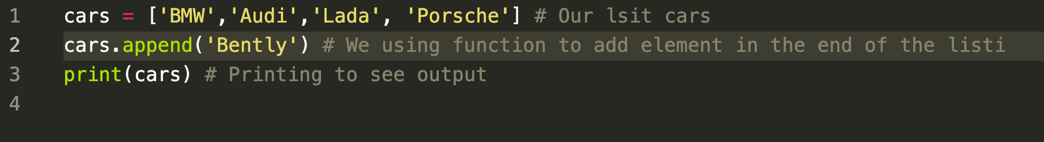
[Pic.03]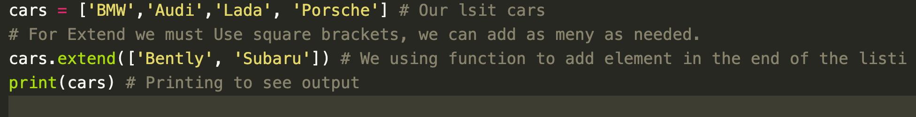

Next two function are min/max() they are simple, to find min[Pic.4] or max[Pic.5] number in our example is price.

[Pic.04]
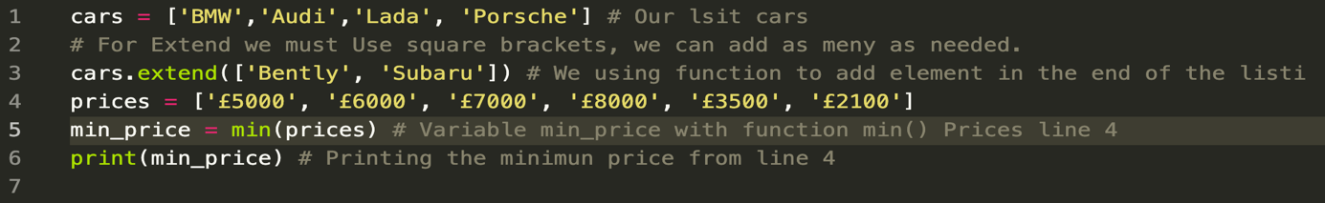
[Pic.05]
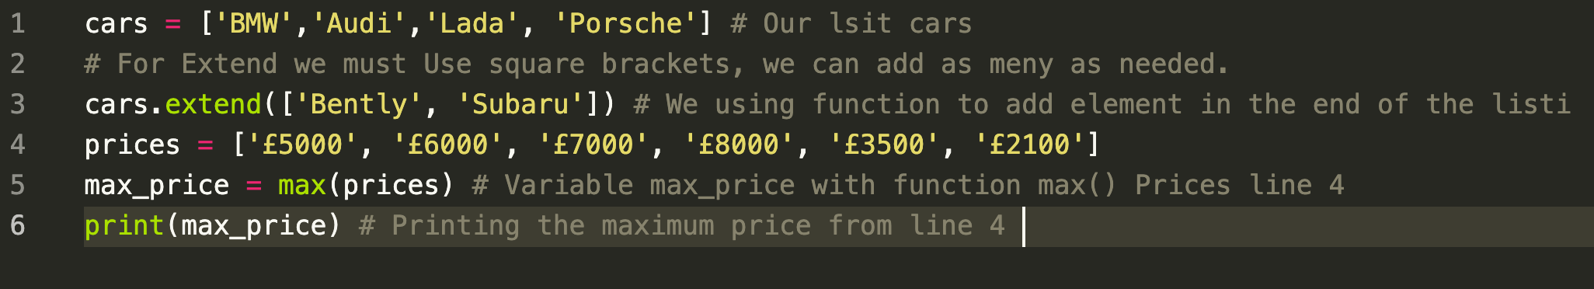
The len() function [Pic.6] can help as to count how many in our example cars. Function shows how many numbers of elements in a list.
[Pic.06]
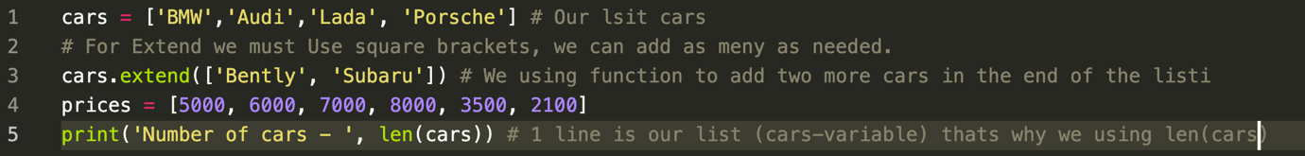

User-defined function.

User-defined functions permit software engineers to make their own schedules and methodology that the computer can follow[4]; it is the fundamental structure square of any program and furthermore vital for seclusion and code reuse since a developer could make a user-defined capacity which does a particular interaction and essentially consider it each time it is required.
The most compelling motivations for including functions generally boil down to one truth: functions permit you to break a program into more manageable pieces. At the point when you do this, your program becomes less complex to manage, more straightforward to test, and able for reuse.
The name must follow the same naming rules as with variables so it cannot start with number or math operator, also very important after creating def so the editor indented the next line with four spaces
[Pic.07]
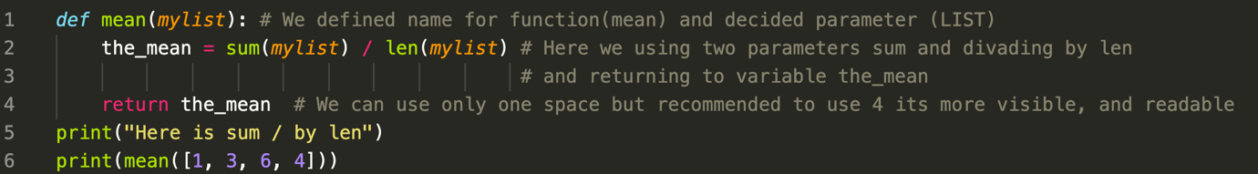
Something to point out is that when your function doesn’t have a return statement it return None object which means nothing. We can also use instead return print it will work but None will appear, because Python checking line by line code it will calculate second line, we will see output and after will be looking for return it won’t find it and output is going to be None.

[Pic.08]
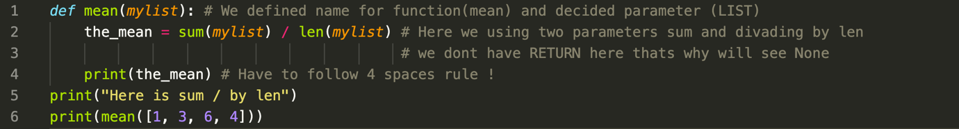
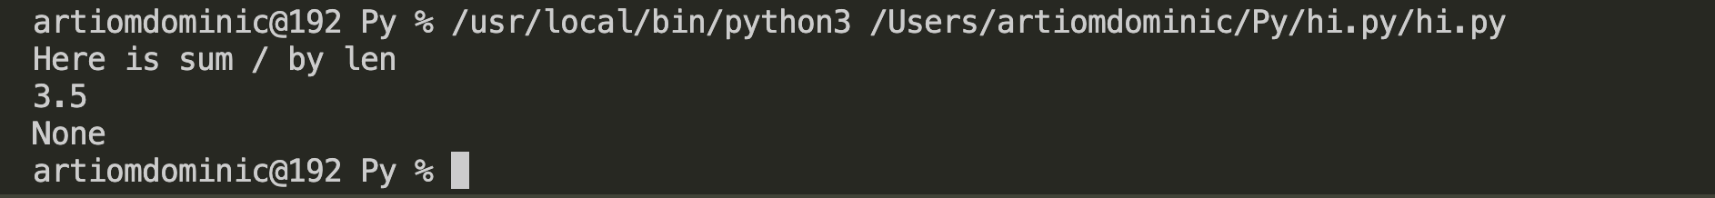

Exercise 1
Write a programme to allow the user to input these values and then display them on the screen.

Logical stages

- Creating 4 variables with different data type!
- For Car Make adding additional cycle While!
because entered user requirement is string
- Validating right input.
- Car model just creating input function because input can be string or float.
- Creating Variable Car Miles with input function
and cycle while to check for right input (float)
and error for str.
- Input function for Car Doors, with while checking for input only int, otherwise Error.
- Displaying users’ values.
- # Write a programme to allow the user to input these values and then display them on the screen
- carMake = input('Enter Car make : .\n') # User enters base.
- # Following all reading code rules(Spaces to make code more readable)
- while(True): # creating while cycle, to validate that input is only (str)
- flag = True
- # Flag is independent. OF output is string, all good and line 15 will let as go.
- for i in range(len(carMake)):
- if carMake[i].isdigit(): # checking if input symbols are digits !
- print('Error: you can not enter digits. Try again.') # When digits was found will print Error ( line 9-10)
- print('Please enter car make again.')
- carMake = input() # And will ask user to enter base again, as many time as needed
- flag = False # if digits was recognized, its automatic is gonna be Fauls.
- break

- if flag: # This line is for Flag. to brake while, and let user to move forward ! Either True / False
- break # Finishing with while block

- carModel = input('Input car model\n') # Simple input as we know default output is str, we don't do any validation here !
- carMiles = input('Input car miles.\n') # Input, User required to enter digits or float !

- while (True):
- flag = True # Using same tehnic

- for i in range(len(carMiles)):
- if carMiles[i].isalpha(): # checking every single symbol for letters.
- print('Error: you can not enter letters. Try again.')
- print('Please enter car miles again.')
- carMiles = input()
- flag = False
- break

- if flag: # It can't be False because while is infinite until is not True
- carMiles = float(carMiles) # we allow int or float
- break # braking the while cycle for if !

- carDoorNum = input('Input door amount\n') # Input for user !
- while True: # We create while to validate input !
- if not carDoorNum.isdigit(): # checking input for not digits
- print('Error. Car doors is not a digit.') # if not digits find will print this error!
- carDoorNum = input('Type again:\n') # Asking user again for Entering base
- else:
- carDoorNum = int(carDoorNum) # Letting go if there is int !
- # Printhig below all Variables (output from user ) Displaing values !
- print("Car Mark", carMake,"Car Model", carModel, "Mileges", carMiles, "Car Doors", carDoorNum)

checking for correct input!
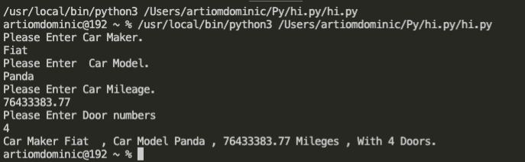

Checking for incorrect input!
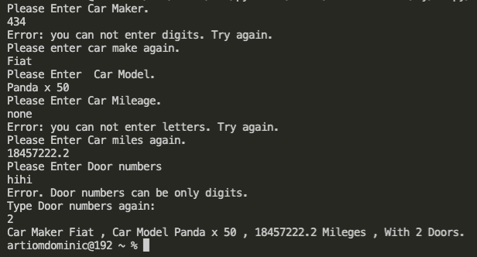

Exercise 2.

Logical Stage

- Create the program that allow users to calculate radius of the circle
- Create a function which will calculate area using formula A = 3,14 * Radius * * 2.
- Identify Radius of each area
- Identify each area of the circus
- Find out all areas shaded (red, black, blue)
- Using difference between areas we can find out shaded area
- Print result Area (1,2,3) number, calculation of it
- Print (Blue, Black, Red) area shade
def area(radius):
return 3.1416 * radius ** 2

def input_radius(radiusNumber, lessThen, error ):
R = int(input("Enter the Radius " + str(radiusNumber) + " "))
if R <= lessThen:
R = int(input(error))
return R

R1 = input_radius(1, 0, error= "Radius can not be zero or less then zero. Try again below.\n")
R2 = input_radius(2, R1, "Radius can not be less then Radius-1. Try again below.\n")
R3 = input_radius(3, R2, "Radius can not be less then Radius-2. Try again below.\n")
print("Value for Radius 1 :", R1,"Value for Radius 2 :", R2,"Value for Radius 3 :", R3)

Area1 = area(R1)
print("Area 1 is :",Area1)
Area2 = area(R2)
print("Area 2 is :",Area2)
Area3 = area(R3)
print("Area 3 is :",Area3)

blue_area = Area3 - Area2
print("Blue area : ", blue_area)

black_area = Area2 - Area1
print("Black Area :", black_area)

red_area = Area1
print("Red Area : ", red_area)

Checking for correct input

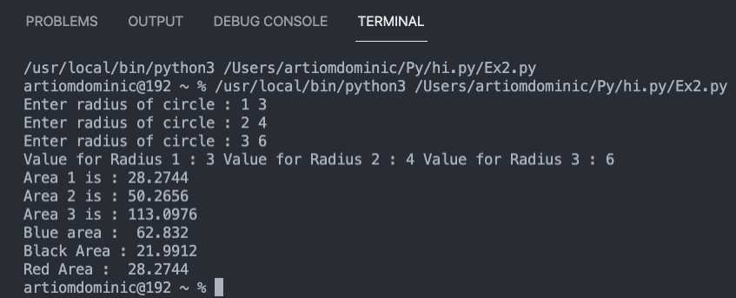

Checking for incorrect input

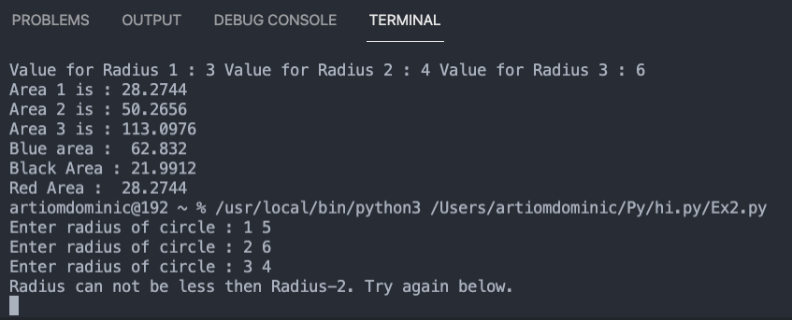

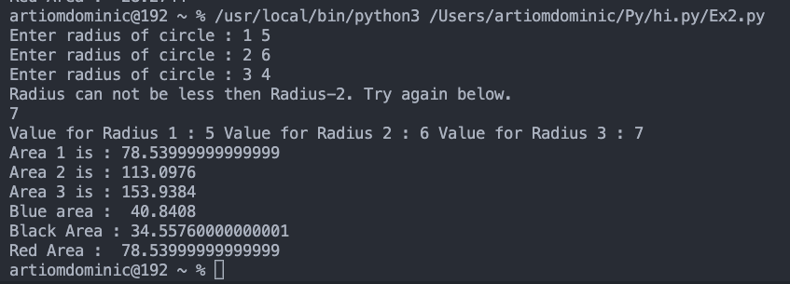

Exercise 3

- Write a program that allows user to enter data which will be displayed on the screen as a list.
- Created 5 variables with blank list []
- Asking user to Enter data using for I in range
- Printing Data in the list format
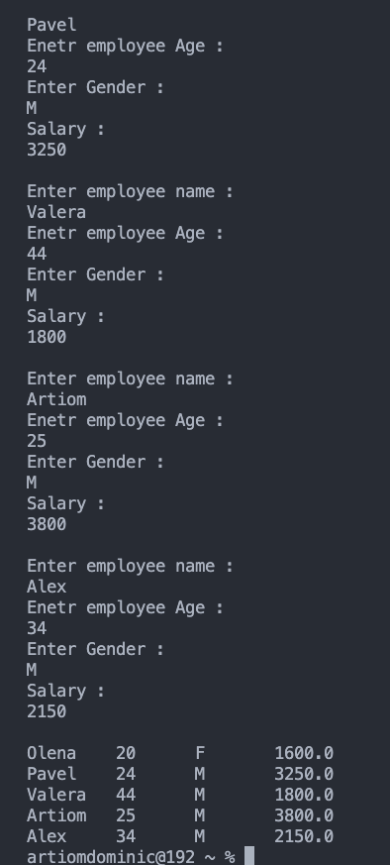

Exercise 4

Logical stage

- Develop spinning game
- Requires three random numbers from 0 to 9
- Game should start (Spin?)
- If you Win points must be saved
- Game rules are:
- The value of 5 will be treated as the “Jackpot” symbol
- Any combination of two of the same numbers will pay a bonus of 10 points e.g.
- Any three of the same numbers (excluding fives) will pay a bonus of 20 points e.g.
- Any combination of two fives will pay a jackpot of 200 e.g.
- Three fives pay out the big jackpot of 2000 points.
- import random
- #Spinning games
- score = 0 # by defalut score 0
- # Function to find out if user Entred data and check if numbers converge
- def win_points(f, s, t, sc): # F first, S = Second, t=Third, sc score
- if (f == s and f == t):
- if (f == 5 and s ==5 and t ==5 ):
- print("You win, your points are ", 2000 + sc)
- return 2000
- print("You win", 20 + sc) # if you won points saved
- return 20

- if (f==s or s==t or t==f):
- if (f==s and f==5) or (f==t and f==5) or (s==t and s==5):
- print("You win, your points are :", 200 + sc)
- return 200
- print("You Win, your points are : ", 10 + sc)
- return 10

- print("You Lose, your points are :", 0 + sc )
- return 0

- #Cycle while checking for True
- while(True):
- print("Spin? ")
- answer = input()
- if answer.lower() != "yes":
- break
- random1 = random.randint(0,9)
- random2 = random.randint(0,9)
- random3 = random.randint(0,9)
- ##random3 = 5
- ####andom2 = 5
- ####random1 = 5
- print(random1,random2,random3)
- # score = score + win_points(...)yes
- score += win_points(random1,random2,random3,score)
- print(score)
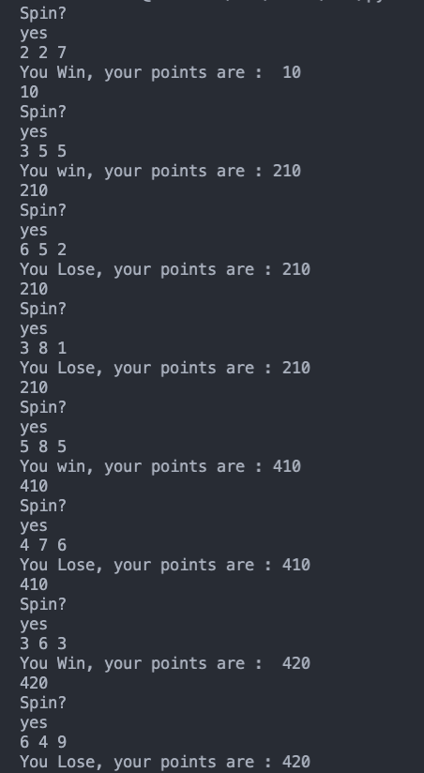

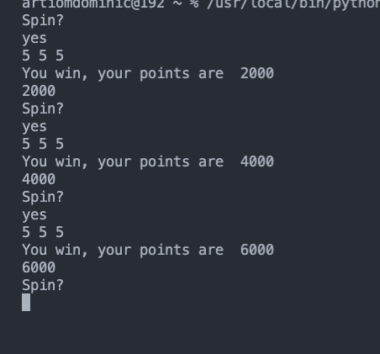

Reference

[1] E. Matthes, Python Crash Course, 2nd Edition, 2nd ed. pp. 40-70.
[2]A. Sweigart, Automate the Boring Stuff with Python, 2nd Edition, 2nd ed. San Francisco: No Starch Press, Incorporated, 2019, pp. 10-15.
[3]P. Barry, "Monty Python: A Chronology, 1969-2012 (2nd edition)", Reference Reviews, vol. 29, no. 2, pp. 50-60, 2015. Available: 10.1108/rr-08-2014-0248.
[4]C. Milliken, Python Projects for Beginners. Berkeley, CA: Apress, 2020, p. 55.

