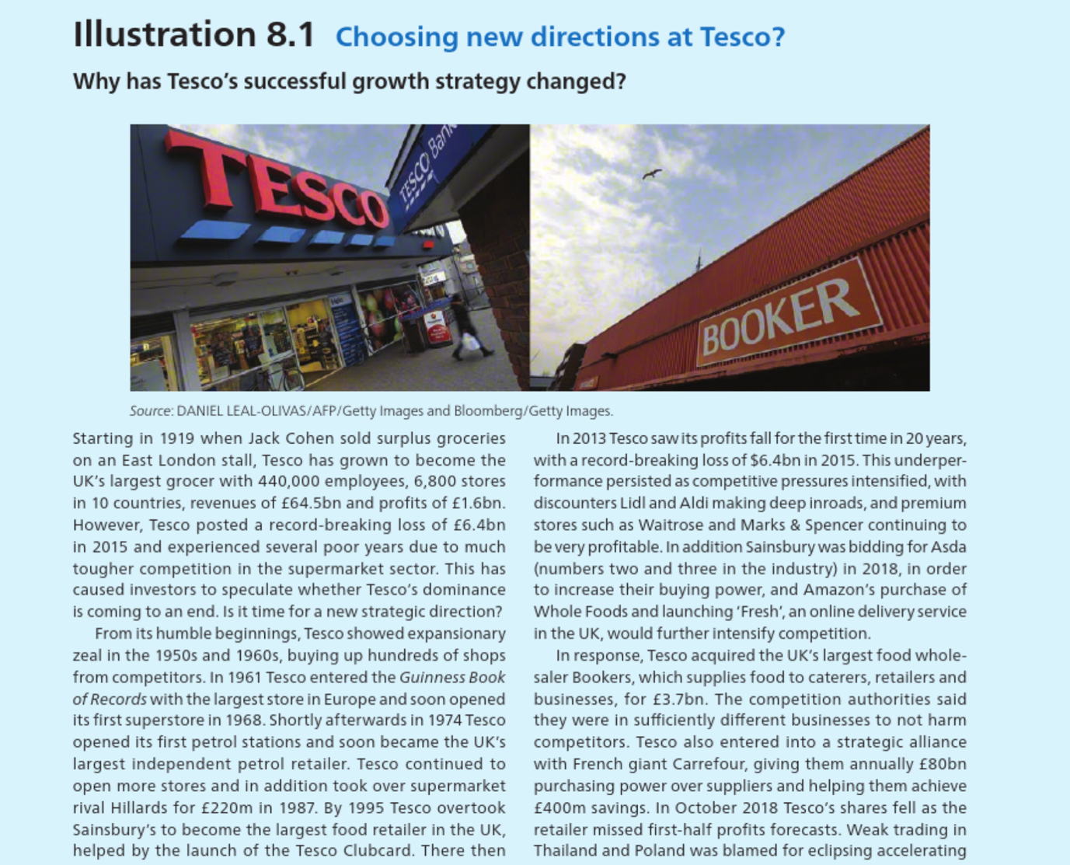
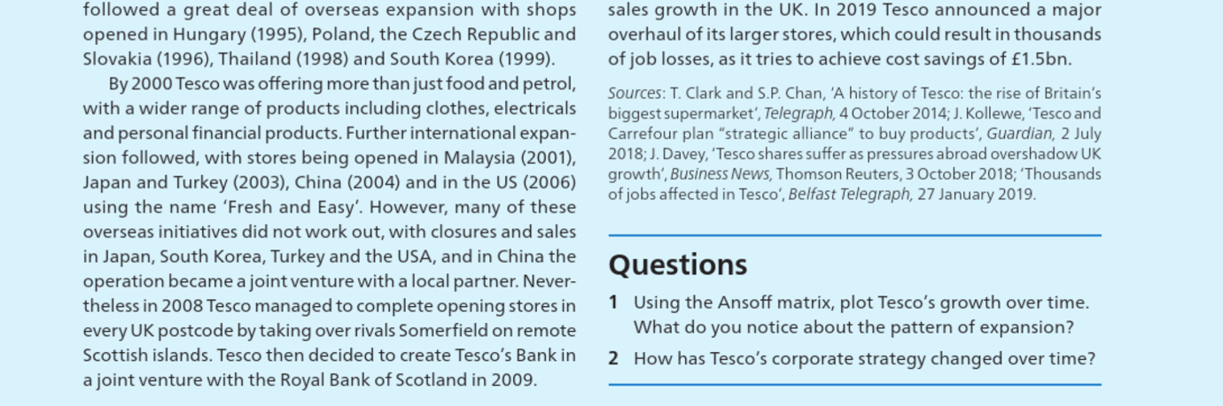

Reference: Whittington, R. et al. (2020) Exploring strategy: text and cases. Twelfth Edition. Harlow: Pearson.

