4/28/2026
University of Wales Trinity Saint David
London campus
Code Link: https://github.com/joalntap/Final-Assessment-5036.git

Module Name: Scripting and Programming Concepts
Module Code: ACCA 5036

Student Name: Jolanta Pacek
Student ID:2413830

Lecturer’s Name: Koushik Modak

SPC Assignment on
Student Equipment Booking System

Table of Contents
Introduction 2
Main Body 4
1. Analysis 4
2. Software Design and Development 7
Design 8
Implementation Decisions 12
Source Code 15
3. Testing and Debugging Report 20
3. Evaluation 22
Challenges Faced: 23
Future Improvements: 23
Self-Reflections 24
Conclusion 24
References 25
Appendices 25

Introduction

This report critically examines the analysis, design, development, implementation, testing and evaluation of a Student Equipment Booking System created for Bright Minds Academy, a small private educational institution that provides personalised academic support to learners of different ages and abilities. The organisation currently relies on a manual, paper-based method of managing bookings of shared classroom resources such as laptops, projectors, tablets and cameras. Although this approach may have been sufficient during the early stages of the academy’s operation, it has become increasingly inefficient, unreliable and phone to human error as organisational demands have expanded.
The existing system generates a range of operational challenges commonly associated with manual administrative processes. These include duplicate bookings, incomplete or misplaced records, difficulty determining equipment availability and limited accountability regarding the return of borrowed resources. Such as weaknesses have a direct negative impact on teaching and learning activities. For example, tutors may plan lessons that depend on specific devices, only to discover that the required equipment has already been allocated elsewhere. Consequently, lesson delivery may be disrupted, reducing both instructional effectiveness and the overall quality of the learning environment.
A further limitation of the current approach is the absence of an organised and searchable record management process. Locating previous bookings often requires staff to review multiple paper records or rely on informal communication with colleagues. This creates unnecessary administrative workload, wastes valuable time and reduces overall productivity. In addition, manual systems of a limited opportunities for monitoring usage trends, analysing demand, or supporting informed resource planning.
In response to these challenges, this project aims to design and implement a simple, efficient and user-friendly digital solution using the Python programming language. Python was selected due to its readability, flexibility and suitability for the rapid
development of small-scale business applications [1] [2] [3]. The proposed system enables staff to add new equipment, register students, create booking for specific dates, view all booking records and perform search operations based on student names or equipment items.
Furthermore, validation features have been incorporated to reduce errors such as duplicate reservations.
The system has been intentionally developed without the use of a database, instead relying on fundamental Python data structures such as lists and dictionaries [1] [2]. This design decision ensures that the solution remains low-cost, accessible and easy to maintain making it particularly appropriate for a small organisation with limited technical infrastructure or financial resources.
The development process follows the key stages of the Software Development Life Cycle ( SLDC), including analysis, design, implementation, testing and evaluation. The analysis stage identifies the core business requirements and applies computational thinking techniques such as abstraction and decomposition to define the scope of the system. The design and development stage present presents the system structure using algorithms, flowcharts, pseudocode and justified implementation decisions. This is followed by a comprehensive testing and debugging phase, in which the system is evaluated under normal, boundary and exceptional conditions. Finally, the evaluation stage reflects critically on the effectiveness of the final product, the challenges encountered during development and potential future improvements.
In conclusion, this report demonstrates how structured and methodical approach to software development can successfully transform an inefficient and error-prone manual process into more reliable, organised and scalable digital solution tailored to the operational requirements of Bright Minds Academy. Moreover, it highlights how even a relatively small software system can deliver significant improvements in efficiency, accuracy and service quality when developed using sound software engineering principles.

Main Body
- Analysis
The analysis stage is a fundamental part of the Software Development Life Cycle (SDLC), as it identifies the weaknesses of the current system and defines the requirements for the proposed solution. According to Sommerville, effective analysis is essential because poorly specified systems may operate technically but fail to meet organisational needs [4] For this reason, the current booking procedures at Bright Minds Academy were examined before development began.
At present, the academy uses a manual paper-based system to manage bookings for shared classroom resources such as laptops, projectors, tablets and cameras. Although this process may have been suitable when the organisation was smaller, it has become increasingly inefficient as demand has grown. Staff must manually check availability, update records by hand and search through paper files for previous bookings. This creates risks such as duplicate reservations, missing records and delays in accessing accurate information. Dennis, Wixom and Roth state that effective information systems should improve efficiency, control and accessibility of data [5]. Since the current system fails to provide these benefits, a computer-based solution is required.
To simplify the project, abstraction was applied by focusing only on the core entities necessary for successful operation: equipment items, students and booking records. More advanced features such as payment processing, maintenance scheduling and network access were excluded from the initial scope to keep the solution realistic and manageable. This reflects good software engineering practice, where essential requirements should be prioritised before optional enhancements [4] [6].
Furthermore, the problem was decomposed into smaller functional modules to support structured development and improve system organisation. These modules include:
- equipment management
- booking management
- record viewing
- search functionality
- validation
Decomposition improves maintainability because each module can be developed and tested independently [4] [6].

Functional Requirements
The functional requirements define the core capabilities that the system must provide to address the identified problem and support the day-to-day activities of the organisation.
Equipment Registration
The system should allow staff to register new equipment items such as “Laptop 1” or “Projector A”. Each item must be unique to ensure record keeping, organisation and traceability of resources [5].
Booking Management
The system must enable users to allocate a specific item of equipment to a student for a selected date. This represents the primary function of the application and replaces the existing manual booking process. Digitising this process, the system improves accuracy and reduces reliance on manual record-keeping [1].
Booking Record Display
Users should be able to view all current and future bookings in a clear and organised format. This functionality supports transparency and allows staff to quickly determine equipment availability across different dates.
Search and Retrieval Functionality
The system should provide a search feature allowing staff to locate booking records by entering a student name or equipment name. Fast retrieval of information improves productivity and reduces time spent checking paper records [5].
Booking Conflict Prevention
The system must incorporate validation routines to prevent duplicate bookings. It should reject any attempt to assign the same item of equipment to more than one user on the same date. This ensures data consistency and reliability [4].
Availability Alerts
Where equipment availability falls below a predefined threshold, the system should notify users. This enables proactive planning and helps ensure sufficient resources remain available for teaching activities.
User-Friendly Interface
The system should provide a simple, menu-driven interface with clear prompts and readable output. Since users may have limited technical knowledge, usability is essential for effective adoption and reduced training requirements [5].
Future Expandability
The system should be designed in a modular and flexible manner so that additional features, such as persistent data storage, editing functions, or a graphical user interface, can be introduced in future versions without major redevelopment [4].

Non-Functional Requirements

In addition to functional capabilities, the system must satisfy a range of non-functional requirements that define its overall quality.
Reliability
The system must consistently produce accurate booking records. Validation should prevent incorrect or duplicate data. Reliability is a fundamental characteristic of high-quality software systems [4].
Performance
The system should provide fast responses when processing input and retrieving booking data. Given the relatively small dataset, Python’s built-in data structures provide sufficient efficiency without requiring a database [1].
Data Integrity and Protection
The system must protect data from corruption or invalid input through structured validation. Ensuring data integrity is essential for maintaining trust in the system [5].
Accessibility
The system should be easy to use, with clear instructions and readable output. This is particularly important in environments where users may have varying levels of technical experience [5].
Maintainability
The code should be structured, readable and modular to allow future updates to be implemented efficiently. Maintainability is recognised as an important factor in long-term software success [4].

Scalability
The system should continue to perform effectively if the number of users, bookings or equipment items increases over time.
In conclusion, the analysis stage identified the major limitations of the current paper-based system and established the need for a structured, digital booking solution. By applying abstraction and decomposition, the problem was simplified into manageable components, enabling a clear system design.
The defined requirements ensure that the proposed solution addresses the key operational challenges faced by Bright Minds Academy while also supporting reliability, usability and scalability. This provides a strong foundation for the design and implementation stages that follow.

Software Design and Development

Design
The proposed system follows a modular, menu-driven design in which each function performs a specific task. This approach improves readability, maintainability and logical organisation of the codebase [4]. Users interact with the system through a simple text-based interface, ensuring accessibility to staff with limited technical experience. Such a structured approach reflects recognised software engineering principles, including modularity and separation of responsibilities [4] [6].
The design stage translated the system requirements identified during analysis into a practical technical solution. A menu-driven console application was selected because it has low hardware requirements, minimal deployment complexity and is highly suitable for small organisations with limited budgets. Although graphical user interfaces may enhance visual usability, a command-line solution is appropriate for demonstrating programming logic, validation techniques and structured development [4] [1].
A further reason for selectin a console-based interface was maintainability. Future developers can understand the programme logic more easily because the structure remains transparent and is not dependent on complex interface framework. For educational and small-case business projects, clarity, simplicity and reliability are often more valuable than unnecessary visual complexity [6].
Flowcharts
The flowchart below illustrates the overall system logic and user interaction process. It demonstrates how users navigate through the main menu and select different system functions of the system.
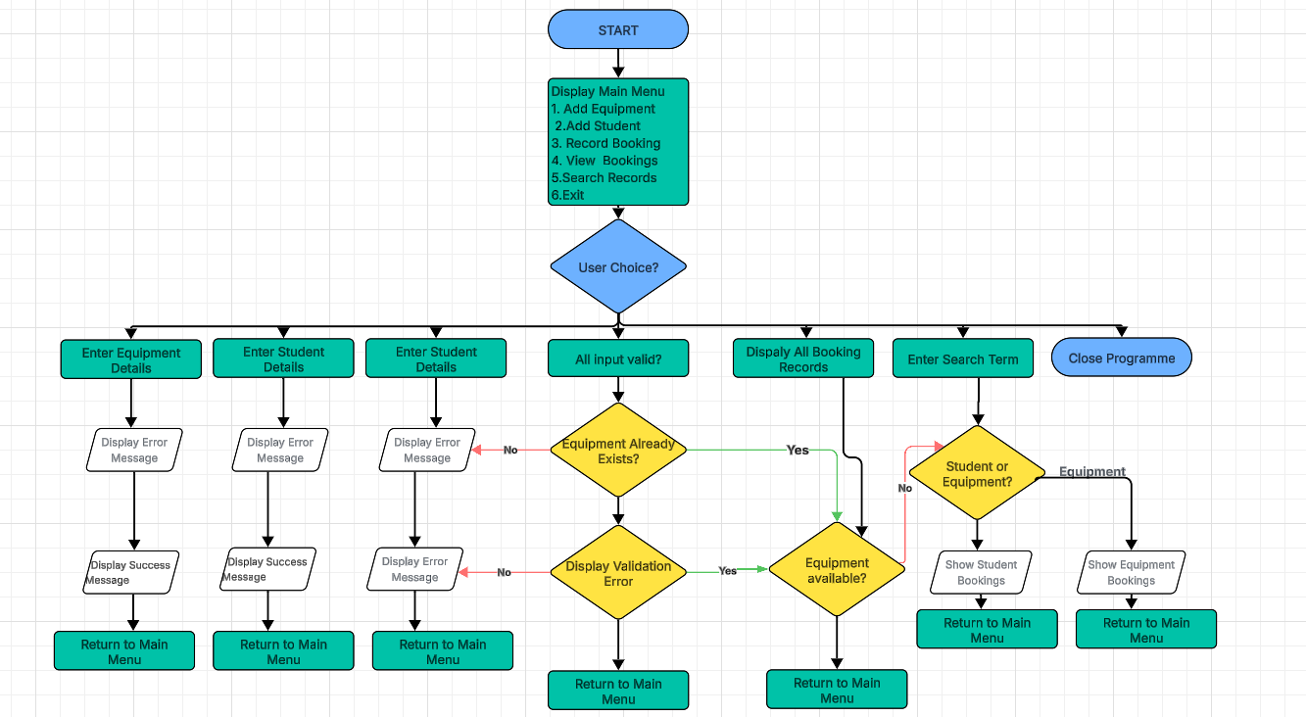
Figure 1. Flowchart of Student Equipment Booking System.

Flowchart explanation.
The flowchart begins with the start of the programme, followed by the display of the main menu. The user is then prompted to select one of the available options. Based on the selected input, the system performs the corresponding operation, including:
- adding new equipment
- adding a new student
- recording a booking
- viewing all booking records
- searching records by student or equipment
- exiting the system
When required, the system applies validation checks to ensure that data entered is accurate and complete. For example, when recording a booking, the system verifies that the selected equipment exists, that all required information has been entered correctly and that the equipment is available for the chosen date. If validation fails, an appropriate error message is displayed.
After each completed action, the system returns to the main menu, allowing the user to continue interacting with the programme. This loop continues until the user selects the exit option. The decision-based structure improves usability, supports efficient navigation and reflects standard software principles such as modularity and logical control flow [5].

Pseudo-code
The system was implemented using the Python programming language, following a modular and structured design approach. The programme operates as a menu-driven application, allowing users to interact with the system through a series of clearly defined options. This design improves usability and ensures that the system can be easily understood and operated by users with limited technical knowledge [4].
The overall structure of the programme was influenced by basic list-based management systems, in which data is stored and manipulated using Python’s built-in data structures. However, the final implementation was specifically adapted to meet the requirements of an equipment booking system, rather than a generic student management application. This ensures that the completed solution is tailored to the operational needs of Bright Minds Academy.
The pseudocode below illustrates the logical structure of the system before full implementation in Python.
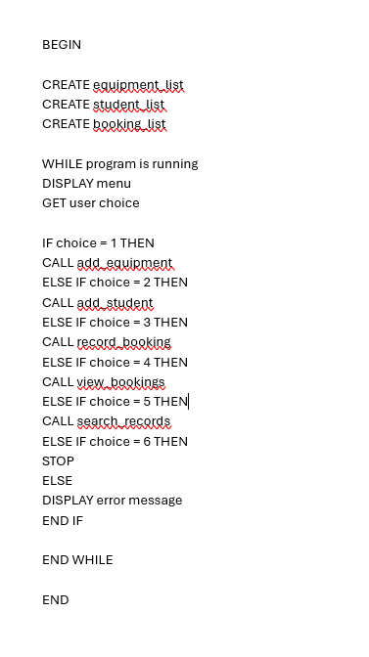
Figure 2. Pseudocode.

The pseudocode demonstrates the core logical structure of the system. It shows how the programme begins by creating the required data lists, then repeatedly displays the main menu and processes user selections. A loop is used to keep the application running until the user chooses to exit. Conditional statements determine which function should be executed, while invalid choices trigger an error message. This structured approach improves maintainability, readability and logical control flow [4] [7].

Implementation Decisions

The implementation of the Student Equipment Booking System was guided by the need to produce a solution that is simple, reliable and suitable for a small educational organisation. As the project requirements did not require the use of a database the system was developed using Python’s built-in data structures and standard programming constructs. This approach ensured that the final application remained accessible, easy to understand and appropriate for the scale of Bright Minds Academy.
The design of the system reflects the practical need of the organisation. A menu-driven structure was selected because it provides a clear and intuitive interface for users with limited technical knowledge. In addition, a modular approach was adopted so that each major task could be managed through a separate function. This improves readability, maintainability and testability, which are recognised as important principles of effective software engineering [4].
Data Structures
The selection of data structures was an important implementation decision because the system needed to store several types of related information in a structured and manageable way. Three main lists were used within the programme: one for equipment, one for students and one for bookings.
The equipment_list stores all equipment items available in the system, such as laptops, projectors and tablets and camera. Each equipment item is stored as a string. A list was chosen because it is simple to use, supports easy addition of new items and is appropriate for managing a relatively small number of records.
The student_list stores the names of students who may book equipment. Each student name is also stored as a string. This allows the system to verify whether a student exists before a booking is recorded.
The booking_list stores all booking records. Unlike the equipment and student lists, each booking is represented as a dictionary. Each dictionary contains three key-value pairs: the student’s name, the equipment name on the booking date. This structure was selected because each booking consists of multiple related data items that must be stored together in a meaningful and organised form. Dictionaries therefore improve readability and simplify record management [2] [3].
An example of the main data structures is shown below.
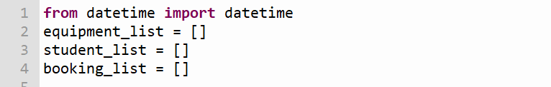
Figure 3. Initial data structures used in the booking system.

Several variables were also used throughout the programme to support user input and validation. For example, student_name stores the entered name of the student, equipment_name stores the chosen equipment item and booking_date stores the selected date for the reservation. The variable choice is used in the main menu to determine which operation the user has selected. These variable names were intentionally chosen to be descriptive and meaningful, which improves code readability and reduces ambiguity.

Programming Constructs
A range of programming constructs was used to ensure that the programme could perform all required functions in a clear and structured manner. These included selection statements, iteration, user-defined function and basic error handling.
Selection statements such as if, elif and else were used extensively throughout the system. They were particularly important in the menu system, where the user’s input determines which function should be executed. They were also used in validation routines, for example to check whether a field was left empty, whether a student or equipment item exists or whether a booking conflict is present. Such decision-making structures are essential in interactive systems because they allow the software to respond appropriately to different inputs [4].
Iteration was implemented using while and for loops. The while loop is used in the main programme to keep the application running until the user chooses to exit. This is appropriate for a menu-driven system because it enables multiple operations to be completed in a single session. The for loop was used when searching bookings records and displaying stored data. For example, it is used to check whether equipment has already been booked for a selected date to display all booking records in an organised format.
User-defined functions were used to modularise the solution. Each major task was placed in a separate function, such as add_equipment(), add_student(), record_booking(), view_booking(), search_by_student() and search_by_equipment(). This modular approach improves maintainability because individual components can be updated without affecting the entire programme [5].
Basic error handling and input validation were also included to improve system reliability. For instance, the programme checks that important fields are not left empty, validates the booking date format and prevents duplicate bookings. These controls reduce the risk of inaccurate data and improve the quality of the application [4] [6].
Python Modules and Libraries
Only one built-in Python module was required for this project: the datetime module. This module was used to validate booking dates entered by the user. Rather than accepting any text as a date, the system checks whether the date follows the format YYYY-MM-DD.
This improves consistency within booking records and reduces the likelihood of invalid data being stored.
The datetime module was chosen because it is part of Python’s standard library, highly reliable and provides an efficient solution to a common validation problem [1].
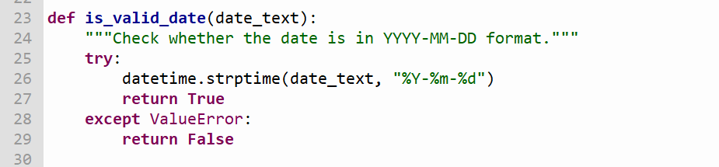
Figure 4. Date validation function using datetime module.

Source Code

The source code for the Student Equipment Booking System was developed in Python and organised using a modular structure. The completed code is stored in a version-controlled GitHub repository, the link which is provided on the title page of this report. GitHub was selected because it enables secure storage version tracking and easy access for assessment purposes.
The code was written according to recognised programming best practices. Consistent indentation and spacing were applied to make the structure of the code clear. Comments were also included to explain the purpose of key sections and functions. These practises are important because they make the programme easier to understand, test and maintain [4].
The programme begins by importing the required module and defining the three main lists. The menu system is then displayed through a dedicated function, after which the main programme loop processes user input and calls the appropriate function.
This section of the code demonstrates the use of lists to store the system’s main data. As discussed earlier, lists were chosen because they are sufficient for small -scale data management and do not require the added complexity of a database. Another important section of the programme is the menu function:
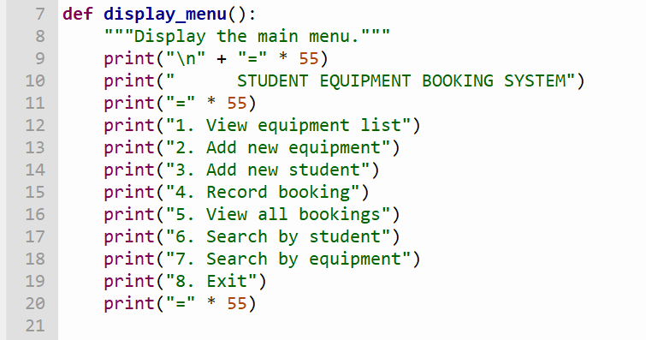
Figure 5. Main menu function of the system
This function improves usability by presenting all available options clearly. It supports the menu-driven design described earlier in the report and ensures that the system remains accessible to users without advanced technical knowledge.
The add_equipment() function allows users to register new equipment items while preventing duplicate entries. This ensures that all resources are uniquely recorded within the system and improves the accuracy of equipment records.
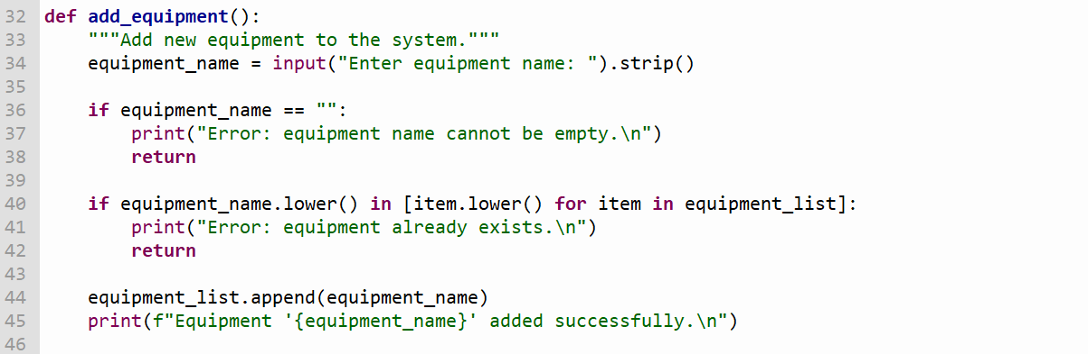
Figure 6. Add equipment function

The booking function is one of the most important parts of the system because it includes several layers of validation. This section demonstrates how the programmes prevent invalid booking attempts before requesting further input. The function then continues by checking that the student exists, the equipment exists, the date is valid and that the equipment has not already been reserved for the same date.
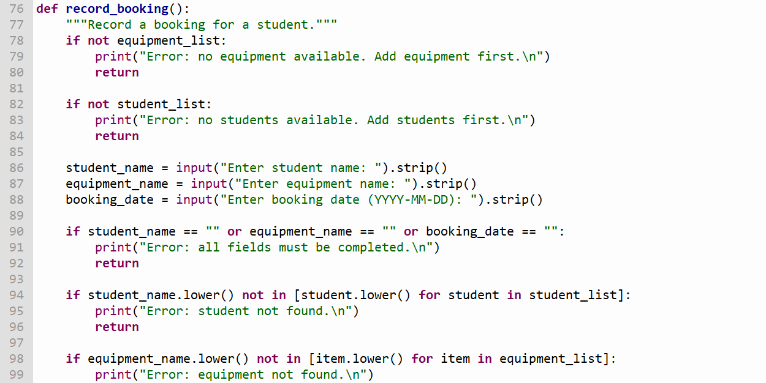
Figure 7. Booking function input and validation logic.

The duplicate booking check is particularly important because it prevents the same item of equipment from being assigned to more than one student on the same date.
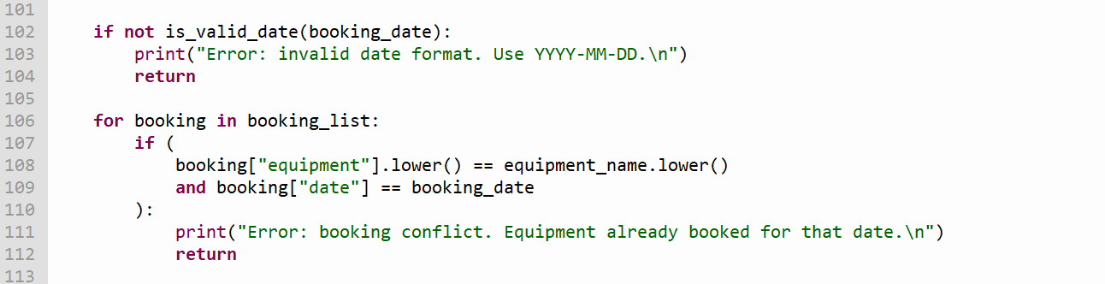
Figure 8. Duplicate booking prevention logic.
This logic directly addresses the main business problem identified in the analysis section. By preventing duplicate bookings, the system improves reliability and ensures that the same equipment cannot be assigned to more than one user on the same date.
The programme also uses a date validation function to ensure that booking is entered in the correct format.
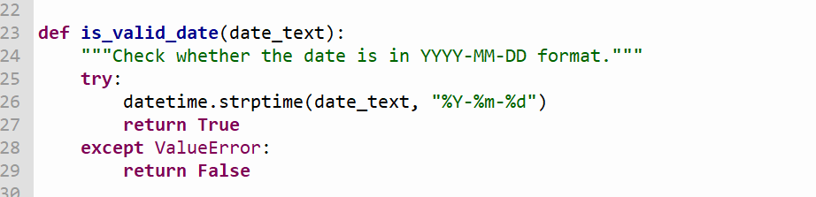
Figure 12. Date validation function using datetime module.

This function demonstrates good practice by isolating validation logic into a reusable and clearly named function. This makes the code more modular and easier to test.
The system also includes a search function that allows to locate booking records by entering a student name.

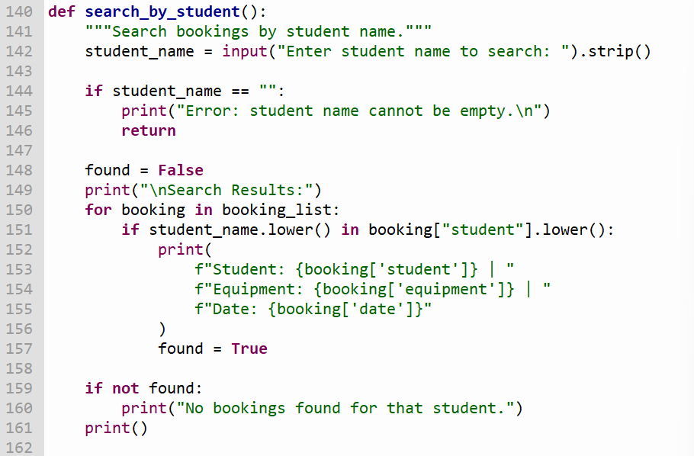
Figure 10. Search by Student Function.

The search routine demonstrates the use of iteration and conditional logic to locate matching records quickly and accurately. Users may also search booking records using the equipment name. This allows staff to quickly identify reservations linked a specific resource and improves day-to-day equipment management.
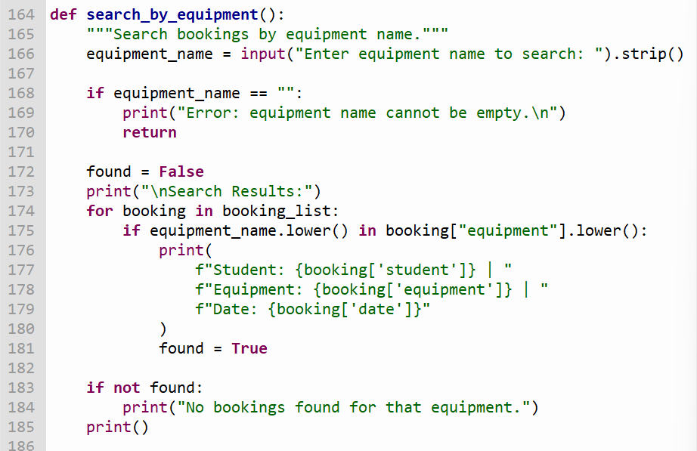
Figure 11. Search by equipment function.

Overall, the source of code reflects a practical and well-structured implementation of the proposed system. It demonstrates the use of lists, dictionaries, functions, control structures, validation and built-in Python module in a way that is appropriate to the needs of bright Minds Academy.

.

3. Testing and Debugging Report
Testing was carried out continuously throughout the development process using an incremental approach. Each function was tested individually before being integrated into the complete system. This reduced debugging complexity, made faults easier to isolate and improved overall reliability. Both valid and invalid inputs were tested to ensure that the system behaved correctly under normal and unexpected conditions.
Software testing is essential because it provides evidence that systems requirements have been achieved and reduces the risk failure after deployment [4] [6] [8]. Even relatively small systems can create significant disruption if inaccurate data is produced. For Bright Minds Academy, an unreliable booking system could still result in missing equipment, timetable disruption, or reduced teaching efficiency. For this reason, testing was treated as a critical stage of development rather than an optional activity.
Three main testing approaches were applied during development:
- Unit testing: individual functions such as add_equipmnet(), record_booking() and search_by_student() were separately.
- Integration Testing: Functions were tested together through the menu system to ensure that the complete workflow operated correctly.
- User Acceptance Style Testing: Realistic scenarios were used to simulate how staff members would interact with the final system.
Types of Errors and Debugging
During development, different types of programming errors were identified and corrected.
- Syntax Errors
These occur when Python code does not follow correct language rules, for examples missing brackets, quotation marks, or colons. Python detects these immediately and displays an error message.
- Logical Errors
These occur when the programme runs successfully but produces incorrect results. For example, an early version of the system allowed duplicate bookings for the same equipment on the same date. This was corrected by adding a validation loop.
- Runtime Errors
These occur while the programme is running, such as invalid conversations or missing data. Input validation was added to reduce the risk of runtime failures.
When faults were discovered, debugging followed a structured process: reproduce the issue, isolate the relevant function, inspect variables, correct the logic, retest and confirm that no additional errors had been introduced. This disciplined method is more effective than random trial-and-error changes.
Boundary and Negative Testing
Negative testing was particularly important because users may enter incorrect or incomplete information. Rather than only testing valid input, the system was deliberately tested using:
-blank student names
-blank equipment names
invalid dates
-duplicate bookings
-unknown search terms
-menu options outside the valid range
This ensured that the system remained stable and user-friendly when mistakes when mistakes were made.
Test Cases
TEST CASE ID | TEST DESCRIPTION | INPUT DATA | EXPECTED RESULT | ACTUAL RESULT | STATUS
TC01 | Add new equipment | Printer 1 | Equipment added successfully | Equipment added | Pass
TC02 | Add duplicate equipment | Laptop 1 | Error Message displayed | Duplicate rejected | Pass
TC03 | Add new student | Marta Kowalska | Student added successfully | Student added | Pass
TC04 | Add duplicate student | Anna Nowak | Error message displayed | Duplicate rejected | Pass
TC05 | Valid booking | Anna Nowak, Laptop 1, 2026-06-01 | Booking recorded | Booking created | Pass
TC06 | Duplicate booking | Laptop 1, same date | Error message displayed | Booking rejected | Pass
TC07 | Invalid date format | 01/06/2026 | Error message displayed | Invalid date rejected | Pass
TC08 | Search by student | Anna Nowak | Matching bookings displayed | Correct results shown | Pass
TC09 | Search by equipment | Projector A | Matching bookings displayed | Correct results shown | Pass
TC10 | Exit system | Option 8 | Programme closes | Closed successfully | Pass

Evaluation
The Student Equipment Booking System successfully met the main objectives established during the analysis stage. The final solution allows users to add equipment, register students, create booking, search records and prevent booking conflicts through automated validation. Compared with the original paper-based process used by Bright Minds Academy, the completed system provides greater speed, consistency and reliability.
Administrative tasks that previously required manual checking can now be completed more efficiently with a reduced risk of human error.
Challenges Faced:
Several challenges were encountered during the development of the project. One of the main difficulties were designing effective validation logic. It was necessary to ensure that blank fields, invalid dates and duplicate bookings were all rejected correctly. This required careful use of conditional statements and repeated testing. The issue was addressed by implementing clear validation routines and testing different incorrect inputs until the system behaved as expected.
Another challenge that I faced involved preventing duplicate bookings. The system needed to compare both the equipment name and the booking date to ensure that the same resource could not be allocated twice on the same day. This was solved by using loops to search existing booking records before confirming a new reservation. Maintaining an organised programme structure also became more challenging as additional features were added. To solve this problem, functions were used to separate tasks such as adding equipment, recording bookings and searching records. This modular approach made the code easier to understand and maintain.
Future Improvements:
Although the current version meets the core requirements, several improvements could be introduced in future versions of the software:
1. Add permanent storage using text files or an SQLite database.
2. Develop a graphical user interface using Tkinter.
3. Introduce login accounts for staff users.
4. Add edit and delete booking features.
5. Include automatic reminders or email confirmations.
6. Generate reports showing equipment usage statistics.
7. Enable cloud synchronisation for access across multiple devices.
8. Add maintenance tracking for damaged or unavailable equipment.
These improvements would increase functionality and make the system more suitable for long-term real-world use.

Self-Reflections

From a personal development perspective this project significantly improved understanding of Python programming. I developed stronger skills in using lists, dictionaries, loops, functions and validation techniques. I also learned how to structure a programme logically using modular design principles. A further lesson was the importance of planning before coding. Creating flowcharts, pseudocode and clear requirements made implementation easier and reduced confusion later in my project.

Conclusion
The Student Equipment Booking System successfully addresses the inefficiencies of Bright Minds Academy ‘s paper-based booking process. Through structured analysis, careful design, effective Python implementation and through testing, the project delivered a practical software solution capable of managing equipment and reservations accurately.
The final programme is intentionally simple yet highly effective. It uses appropriate structures, clear validation rules and maintainable functions to provide dependable performance without unnecessary technical complexity. This demonstrates that valuable software solutions can be created through good planning and effective problem solving.
Testing confirmed that the system performs correctly under both valid and invalid conditions. Duplicate bookings are prevented, incorrect dates are rejected and search functions operate as intended. These features reduce administrative workload and improve confidence in booking accuracy.
With future enhancements such as persistent storage, authentication and graphical interface, the system could be developed into a more advanced real-world application. Overall, the project demonstrates how software can improve organisational efficiency, reduce human error and support better day-to-day operations.

References
[1] Python Software Foundation, “Python Documentation.” [Online].
[2] K. A. Lambert, "Fundamentals of Python: First Programs, Boston, MA, USA:" Cengage, 2020,
[3] M. Downey, "Think Python: How to Think Like a Computer Scientist, 2nd ed. Sebastopol, CA, USA: O’Reilly Media," 2016,
[4] "I. Sommerville, Software Engineering, 10th ed. Harlow, UK:" no. Pearson, 2015,
[5] A. Dennis, B. H. Wixom, and R. M. Roth, ", Systems Analysis and Design, 7th ed. Hoboken, NJ," no. Wiley., USA, 2015,
[6] R. S. Pressman and B. R. Maxim, ", Software Engineering: A Practitioner’s Approach, 8th ed. New York, NY, USA:" no. McGraw-Hill Education, 2014,
[7] S. McConnell, "Code Complete, 2nd ed. Redmond, WA, USA," no. Microsoft Press, 2004,
[8] ] IEEE, "Computer Society, Guide to the Software Engineering Body of Knowledge (SWEBOK), Version 3.0. Los Alamitos, CA," no. USA: IEEE, 2014., 2014,

Appendices
•Append to the report relevant supplementary information.

