Title Page
Module Name:
AI and Machine Learning (ACCA6011)
Assignment Title:
Teronix AI/ML Appraisal
Student Name & Number:
Adam Williams (2008159)

Contents
Title Page 1
Abstract 2
Introduction 2
Literature Review 3
Role of A.I and Machine Learning in the Supermarket Sector 3
Machine Learning 4
Different Forms of Data in Machine Learning 7
Time Series Data 7
Demo (make subtitle for methods and resutlts) 8
Methods 8
Conclusion 11
References 12

Abstract
This assignment is to deliver a report to Teronix demonstrating the viability of deploying AI and Machine Learning techniques to better understand the data held by Teronix Online.

Introduction
This is my report for Teronix on the forms of Machine Learning, and which ones I think Teronix should implement into their business. I will be covering the three types of machine learning, and the different algorithms that fall under each type. I will describe each algorithm and explain their usual use. This Report also includes practical demonstration.

Literature Review

Role of A.I and Machine Learning in the Supermarket Sector
Utilizing AI and machine learning in the supermarket sector can provide lots of advantages in different areas. According to [1] the most common uses of AI in the retail industry during 2020 were customer care, quality control and inventory management as shown in the graph below.
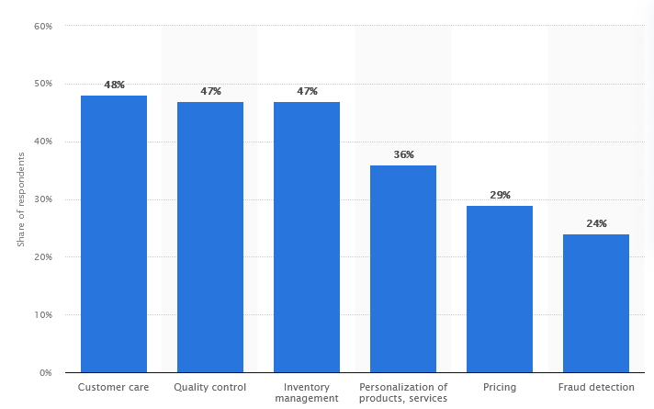
*Graph from [1].
When it comes to inventory management stores can face issues. These issues come in the form of products not being re-stocked in time, or products not being sold and passing their expiry date. Some of these issues stem from human error, since when a human oversees a large inventory system without additional help it can be easy to simply miss something. A well-made AI could enhance inventory management by being given a set of data and being able to output the best-selling products, worst-selling products and use predictive analysis on past sales to see which products are soon to likely run out of stock. These systems can be used to help the employee be aware of certain things they may miss due to human error.
Another example would be User-based promotions. When online shopping websites such as amazon will try to predict and suggest the user products they may like using the user’s previous search and purchase history to make the predictions. Systems such as this will increase sales as the user will more often come across products that they are interested in.

Machine Learning
Machine learning is an application of AI. Machine learning is the process of using data to help a computer learn without direct instructions. This allows the computer system to learn on its own, and improve its decisions based on experience and data given to it.
There are 3 types of machine learning, and they are as follow:
- Supervised learning
- Unsupervised learning
- Reinforcement learning

Supervised Learning
Supervised learning is defined by its use of labelled datasets. These labelled datasets are used to train algorithms to classify data or predict outcomes accurately. [2] suggests that supervised learning make use of a training set. They go on to explain that these training sets teach models to yield the desired output. The training sets includes inputs and correct outputs, this then allows the model to learn over time and improve its accuracy. A loss function is then used to measure the model’s accuracy.
There are some things to be careful about when training the algorithm as [3] claims that the training data used for the models must be balanced, cleaned and have good diversity of data. They state that the data must be balanced and cleaned as garbage or duplicate data can cause the AI’s understanding to be skewed. They also state that the diversity of the data will determine how well the AI will perform.
Supervised learning can be split into two types of methods, classification algorithms and regression models. Classification is used to sort inputs into given categories or classes based on the data it was trained on. Whilst regression tasks expect the find a numerical relationship between the input and output then make predictions based on what is finds.
Examples of classification algorithms are as follows:
- Linear classifiers
- Decision trees
- Random Forest
- Naïve Bayes
Examples of regression modules are as follows:
- Linear regression
- Logistic regression
- Neural networks
- Decision trees
Linear Regression
Linear regression is a type of regression analysis. It is utilised to spot the relationship between the dependent variable and independent variables. This relationship between the variables is used to make predictions about future outcomes. When there is only one independent variable it is know as “simple linear regression” and when there are multiple independent variables it is known as “multiple linear regression.” Linear regression is typically used for sales forecasting and risk assessment which is can be relevant to Teronix.
Decision Trees
Decision trees can be used for both classification and regression. Decision trees are split into nodes and branches. Within these nodes there are 3 different types. Firstly there is the root note which starts the graph, it usually evaluates the variable that best splits the data. Then there is the intermediate nodes which evaluate the data, but are not the final nodes where predictions are made. Then finally there are the leaf nodes, these are the final nodes where predictions of a category or a numerical value are made. Decision trees are typically used for predictive analytics and pricing which could be relevant to Teronix as a retailer.
Logistic Regression
Logistic regression is a type of regression analysis. Logistic regression is used to predict the likelihood of a binary event happening. A binary event is an event with only two outcomes, for example yes or no. Logistic regression uses a set of independent variables to predict its binary outcomes. Some examples of practical uses of logistic regression would be detecting if in coming emails are spam or not, or predicting if some credit card transactions are fraudulent or not.
Neural Networks
Neural networks is an algorithm that tries to recognise the underlying relationship within a data set. It tries to achieve this through a process that mimics the human brain. Neural networks are useful as they can adapt to changing inputs, so it can still maintain accurate answers without a need to redesign the output criteria. Neural networks are typically used for finance forecasting, marketing research, fraud detection, and risk assessment.
Random Forest
Decision trees are the building block of the random forest model. The random forest algorithm consists of a large number of separate decision trees that operate as a group. Each tree within the group gives a class prediction, and the class that was predicted the most becomes the model’s prediction. Random forest is typically used in banking, stock trading and the e-commerce industries.

Unsupervised learning
The difference between supervised and unsupervised learning is that the training set given to the algorithm is unlabelled. Since there are no correct output values the algorithms just detect patterns and similarities in the data, without thinking about a “correct output.” This is what allows the algorithms to complete the main goal of unsupervised learning algorithms which is to find unexpected or interesting patterns or similarities within the data that humans may not consider looking for.
There are two types of unsupervised learning algorithms clustering and association rules as stated by [4]. They later on explain how unsupervised learning can be used in recommendation engines and personalized adds. They explain that the model can take inputs such as the user’s purchase history and search history and use it to find trends or predictions within the data. The trends and predictions found can be used to make effective selling strategies or targeted adds. This is relevant to Teronix as these as common methods used in online shopping and can help Teronix.

Reinforcement learning
In a article about reinforcement learning [4] describes reinforcement learning as an approach that falls between supervised and unsupervised learning. They attribute this to the fact that it is not as heavily supervised due to it not relying on labelled training data, but it is not unsupervised either as it includes a reward signal that the agent will try to maximize. This will lead the agent to do the job a certain way to maximize the “right” signal.
The agent achieves this by making the decision on what action to take at each time step. It factors in the reward signal, the agents observed environment, and the history into the decision.

Different Forms of Data in Machine Learning
Within machine learning there are 4 types of data that can be used in a dataset. These 4 types of data are:
- Numerical Data
- Categorical Data
- Time Series Data
- Text Data

Numerical Data
Numerical data is any form of data that is measurable such as your height, weight, or cost of your watch. Discrete numbers are whole numbers such as number of customers, whilst continuous numbers are not fixed such as someone’s weight or height.

Categorical Data
Categorical data is grouped by defining characteristics. These defining characteristics can include, gender, ethnicity, or country of your customers. Categorical data is useful as it allows you to group individuals based on their attributes.

Time Series Data
Time series data is data that are indexed at points in time. This data allows people to compare data from different periods of time such as one week compared to another, or one month compared to another. The key difference between time series data and numerical data is that time series data has a starting and end point, whilst numerical data is just raw numbers which aren’t rooted in a period of time.

Text Data
Text data is simply words or sentences that give context to the data. An example of this would be product name or description. This data can be analyzed by machine learning models, but it will be difficult.

Demo (make subtitle for methods and resutlts)
The program I have decided to use is Orange. Orange is an open-source software that allows for data visualization, machine learning, and data mining. This software has all the features required to complete the task.

Methods
To visualise the current data held within the dataset. Within Orange I connected the file to a data table then connected the data table to a scatter graph as shown below. 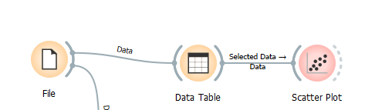
The file is linked to the Teronix data spread sheet and uses the settings shown below. 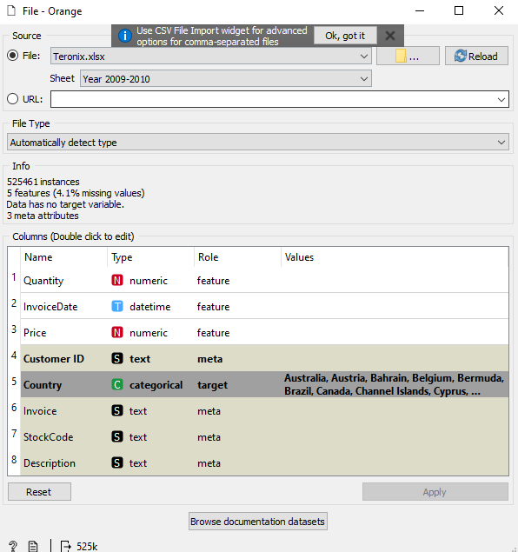

Within the scatter plot I put the date of invoice on the X axis, and the quanity of products sold on the Y axis, on top of this the dot’s colour is decided by country the product was purchased from. These settings shows the amount of products being sold to which countries at what time of year. The data shown below is without highlighting any specific parts of data.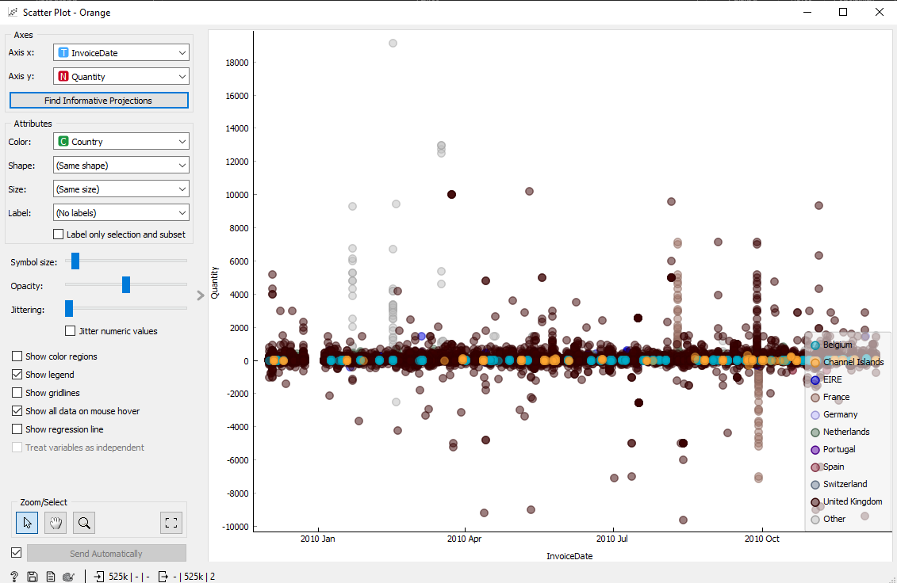
With the scatter graph being connected to the data table this allows the user to highlight certain parts to only be shown on the graph. 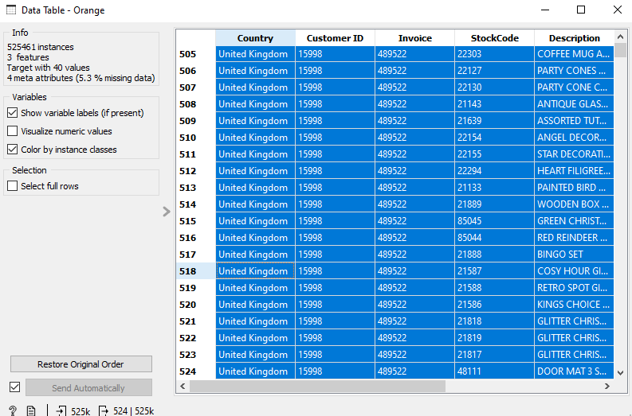 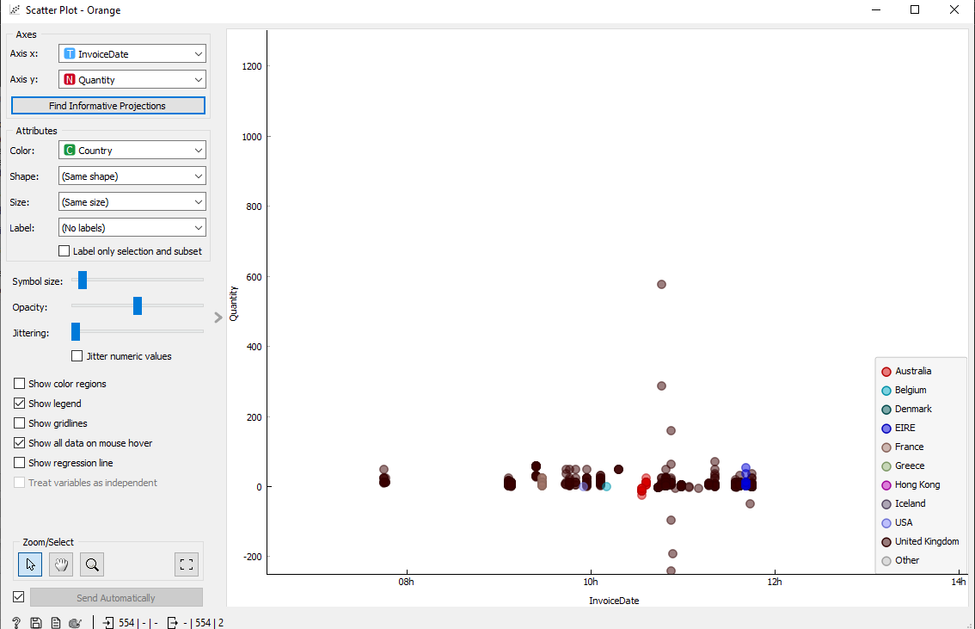This is the scatter graph when only highlighting the first 500 entries of the data table. This can be useful to Teronix as it will allow them to high certain time frames and have a deep dive look at the data within the time frame. With having the program do this for the user it will allow Teronix staff to save time on processes such as sorting this data into the scatter graph themselves as the program does it for them after simply highlight what they want to look at.

Conclusion
In conclusion I think that machine learning can help Teronix in multiple ways. Supervised learning algorithms such as “Linear Regression” and “Decision Trees” can be beneficial to Teronix as they are commonly used in areas relevant to Teronix. With linear regression being useful for sales forecasting and decision tress being used for predictive analytics and pricing these tools can be used for Teronix. Firstly linear regression being used for sales forecasting can help Teronix predict which products are going to be popular and will need to be stocked up. Decision trees can help Teronix make decisions about product pricing with the use of them. The only drawback is that the AI will take time to learn, but that will also become their strength the longer they are used as they will be able to predict with higher accuracy.

References
[1]
B. Thormundsson, “AI usage consumer goods and retail worldwide 2020,” Statista, Mar. 17, 2022. https://www.statista.com/statistics/1197958/ai-use-cases-consumer-goods-retail-global/ (accessed Jan. 23, 2023).
[2]
IBM, “What is Supervised Learning? | IBM,” www.ibm.com. https://www.ibm.com/uk-en/topics/supervised-learning
[3]
D. Peterson, “What is Supervised Learning?,” SearchEnterpriseAI, Mar. 2021. https://www.techtarget.com/searchenterpriseai/definition/supervised-learning (accessed Jan. 23, 2023).
[4]
A. Allmang, “What is unsupervised machine learning? | Linedata,” www.linedata.com. https://www.linedata.com/what-unsupervised-machine-learning (accessed Jan. 23, 2023).
‌

