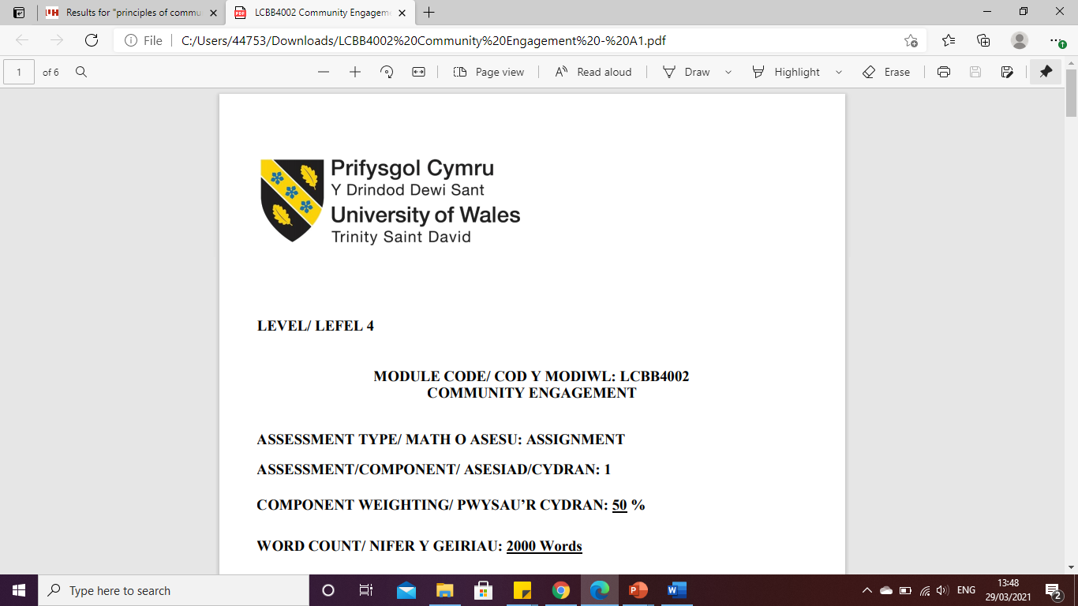

LEVEL 5

Current Trends of Business
Intelligence
MODULE CODE: LCBB5000
DATA HANDLING & BUSINESS INTELLIGENCE

ASSESSMENT TYPE: ASSIGNMENT
ASSESSMENT/COMPONENT: 1
COMPONENT WEIGHTING: 25%
WORD COUNT: 1243 Words
SUBMISSION DETAILS:
Name: Cosmin Adrian Mitu
Student Number: 2021613
Table of Contents

1. Introduction 3
2. Cloud Analytics 4
3. Unified data management and analytics 5
4. Data discovery and data security 6
5. Business activity monitoring 8
6. Augmented analytics 9
7. Conclusion 11
References 12

Table of Figures
Figure 1: Cloud Analytics 4
Figure 2: Unified data management and analytics 5
Figure 3: Data discovery and data security 6
Figure 4: Business activity monitoring 8
Figure 5: Augmented analytics 9

Introduction
The report will be based on several technologies and tools that are related to Business Intelligence. Business Intelligence which is abbreviated to BI is known as the set of strategies and technologies which includes data mining, data analytics, data infrastructure and tools, data visualisation and many more (Paradza and Daramola, 2021). This helps companies to make decisions that are data-driven by managing the business information. There are many features in business intelligence such as data management, mobile BI, data integration, data visualisation, advanced analytics, user-specific security, predictive analytics and more. Among them, five of the tools and technologies will be discussed in this report with the help of some examples. The way these tools and technologies can be helpful for companies will also be described. Thus, the importance of business intelligence and its tools in companies will be known from this report.

Cloud Analytics
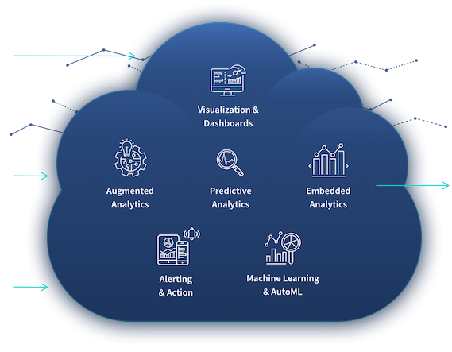
Figure 1: Cloud Analytics
Source: (Ding et al., 2021)
Cloud analytics is the procedure of analysing the stored data in the cloud and then using the data to have them for extracting business insights. Cloud analytics and its algorithms are used and applied for large amounts of data collection in order to identify patterns, predict possible future results and also produce the information that could be useful for the decision-makers of the companies. Cloud analytics is a very effective tool of business intelligence that gets benefited from the scalability of the business operations along with the cost savings and service models of cloud computing. In a cloud computing model, a company can rent IT services and infrastructure that is in need on demand from the cloud service provider instead of buying its own data centres. Therefore, it becomes very much efficient for the companies as it involves the required IT infrastructure like storage, software, databases, data sharing and storage, servers, networking and more. For example, NetApp is a cloud analytics provider which is used for improving the management and protection of business data. This offers IT solutions through NetApp Cloud Volumes where file service is offered that supports SMB and NFS protocols. The companies that use this, have achieved high performance of their Input and Output system, efficiency and protection in their data storage and also high availability. Other than that, they have got some advanced attributes like clones and snapshots (NetApp, 2022).

Unified data management and analytics
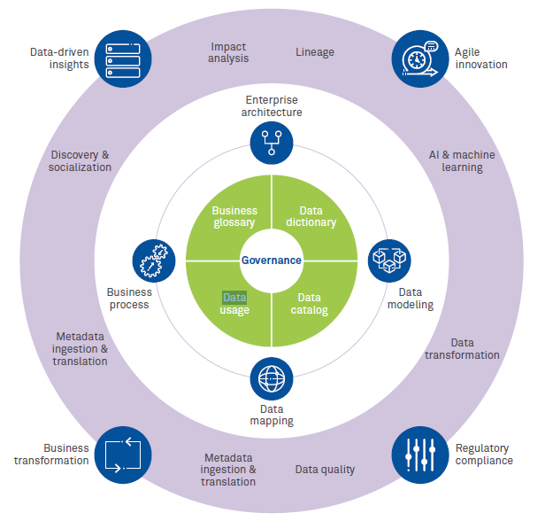
Figure 2: Unified data management and analytics
Source: (Wipro, 2022)
Unified Data Management is the procedure in which some contrasting data is merged together to make it a whole for creating a single source of data that is stored in a data warehouse. Most companies in recent times follow data silos which means that every department would manage and protect the information about the company and there will be nil to very less correlation among the silos. Thai results in increased cost, lack of access to the needed data, unhealthy workplace culture and loss of business insights. However, using Unified Data Management and Analytics the companies can gather the information in a unified system. Through this, data integration is initialised and using a data integration tool a single system can be optimised which would be distributed through the whole company. Companies need this business intelligence tool in order to make effective strategies and for improving business management. Through Unified Data Management, companies can make the management more data-driven which would result in a better business outcome. Other than that, it also helps in governance, compliance, business transformation and integration.

Data discovery and data security
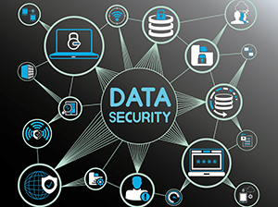
Figure 3: Data discovery and data security
Source: (Rezig et al., 2020)
Data discovery is the process of locating and identifying the regulated or sensitive data for protecting or removing it securely. It is important for the companies to use as they can audit confidential data with the help of this business intelligence tool by locating it (Rezig et al., 2020). The security teams of the companies can protect the sensitive information and in this way, the CIA triad of data such as Confidentiality, Integrity and Availability can be ensured. On the other hand data security is the technique of safeguarding some digital data by protecting it from any leaking, corruption, theft and any unauthorised actions. There are many techniques involved in data security such as backup and recovery, data encryption, cyber insurance, data masking, promotion of compliance and transparency and many more (Yang et al., 2020). Along with that, there are some strategies that companies can use like access management and controlling the access process, backing up data more often, using security for the servers and educating the employees on how to use the sensitive data properly. For example, the UK-based company Ocado uses data security where all the authorised members have encrypted card numbers and for their financial data management, they use Blowfish Encryption (Ocado, 2022).

Business activity monitoring
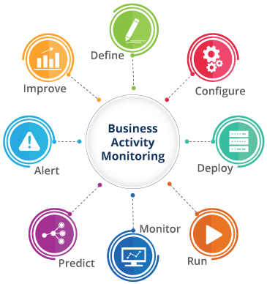
Figure 4: Business activity monitoring
Source: (Roell and Barth, 2021)
Business Activity Monitoring is a business intelligence tool that helps a company to manage and monitor the business activities that are already incorporated into the computing systems. That is the set of tools through which companies can manage the alerts, aggregations and profiles for monitoring some business metrics which is known as the KPIs or Key Performance Indicators (Roell and Barth, 2021). With the help of this tool, some technologies can be implemented that can enable the companies to analyse the business performance indicators and increase the level of situation awareness. This also benefits them in enhancing the effectiveness as well as the speed of business processes. Using Business Activity Monitoring keeping track of the business operations can be done. Along with that, issues can be identified which helps to solve them faster. For example, Oracle uses this tool to monitor their business services using Oracle BAM 12c which is supported for active and tactical dashboards (Oracle, 2022).

Augmented analytics
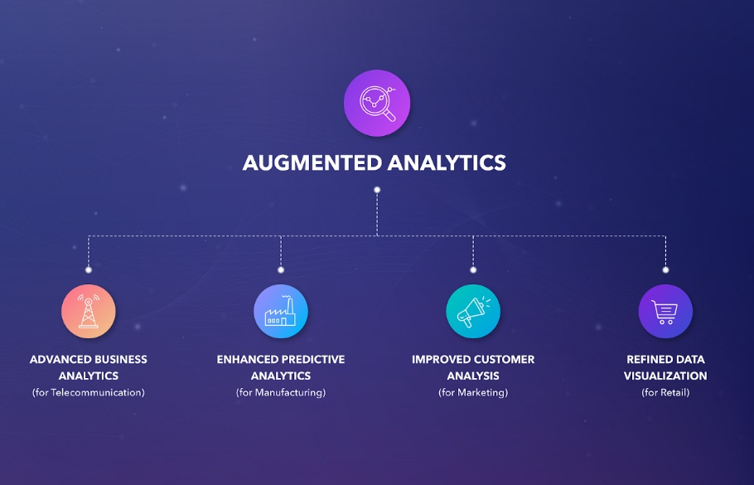
Figure 5: Augmented analytics
Source: (Crowell, 2022)
Augmented analytics is a part of data analytics in which the use of machine learning takes place along with natural language processing for automating the analysis processes which are generally done by data scientists. Here, the use of advanced technology is enabled in which Artificial Intelligence and machine learning are used. Through this, the assistance in data preparation, and insight explanation after generation is done. By using this business intelligence tool, the companies can explore and also analyse the data that are in the BI platforms (Crowell, 2022). This helps companies in cleaning, examining, filtering and shaping data to have a more accurate analysis. For example, Coca-cola used augmented analytics along with image recognition which was AI-driven that increased their click-through rate by four times. Thus, it can be seen that, with the help of this tool, the company has managed to increase their business and profitability (Unscrambl, 2021).

Conclusion
The above report has discussed some business intelligence tools and technologies which can be used by companies for improving their business processes. It has been known from the discussion that there are many kinds of business intelligence technologies and tools through which several aspects like embedded software applications, comprehensive platforms, self-service software, and data visualization can be done. Thus, some of the significant tools in this have been described with some examples. Here in the report cloud analytics, data discovery and security, Unified Data Management and analytics, augmented analytics and business activity monitoring have been explained along with their help in today’s businesses.

References

Crowell, B., 2022. Blockchain-based Metaverse Platforms: Augmented Analytics Tools, Interconnected Decision-Making Processes, and Computer Vision Algorithms. Linguistic and Philosophical Investigations, 21, pp.121-136.
Ding, J., Minhas, U.F., Chandramouli, B., Wang, C., Li, Y., Li, Y., Kossmann, D., Gehrke, J. and Kraska, T., 2021, June. Instance-optimized data layouts for cloud analytics workloads. In Proceedings of the 2021 International Conference on Management of Data (pp. 418-431).
Holubová, I., Svoboda, M. and Lu, J., 2019, November. Unified management of multi-model data. In International Conference on Conceptual Modeling (pp. 439-447). Springer, Cham.
NetApp, 2022. What is cloud analytics? NetApp. Available at: https://www.netapp.com/cloud-services/what-is-cloud-analytics/ [Accessed August 2022].
Ocado, 2022. Security policy. Ocado. Available at: https://www.ocado.com/webshop/content/information3/securitypolicy#:~:text=We%20store%20your%20payment%20details,%2C%20called%20'Blowfish%20Encryption'. [Accessed August 2022].
Oracle, 2022. Oracle Business Activity Monitoring. Oracle . Available at: https://www.oracle.com/middleware/technologies/business-activity-monitoring.html [Accessed August 2022].
Paradza, D. and Daramola, O., 2021. Business Intelligence and Business Value in Organisations: A Systematic Literature Review. Sustainability, 13(20), p.11382.
Rezig, E.K., Vanterpool, A., Gadepally, V., Price, B., Cafarella, M. and Stonebraker, M., 2020. Towards Data Discovery by Example. In Heterogeneous Data Management, Polystores, and Analytics for Healthcare (pp. 66-71). Springer, Cham.
Roell, U.K. and Barth, T., 2021. How to structure a company-wide Business Activity Monitoring Adoption.
Unscrambl, 2021. 7 augmented intelligence examples & industry use cases. Unscrambl. Available at: https://unscrambl.com/blog/7-augmented-intelligence-examples-and-industry-use-cases/ [Accessed August 2022].
Wipro, 2022. Unified Data Management (UDM) platform - efficient framework. Wipro. Available at: https://www.wipro.com/analytics/why-we-need-unified-data-management/ [Accessed August 2022].
Yang, P., Xiong, N. and Ren, J., 2020. Data security and privacy protection for cloud storage: A survey. IEEE Access, 8, pp.131723-131740.

