

Community Engagement
Component 1: Portfolio
Module code and name: LCBB4011_BIRM: Community Engagement

Student Name: Maria- Magdalena Tanase
Student Number: 2310348
Lecturer Name: Ibrahim Rufai
Table of Content
Introduction 2
Overview of the Big Local Initiative 2
Main Body 3
Best practices of the Big Local 3
Community engagement model 3
Principles of the Big Local 4
Planning and design 6
Assessment of the community needs 8
Standards 8
Modes of communication 9
Evaluation and Impact 9
Skills help in steering and managing the project 10
Recommendations 12
Conclusion 13
References 14
Appendices 16
Appendix: CPD Log 16

Introduction
The report discusses a community project in the UK which is named the Big Local Initiative, and it is a national program which is in association with the Lottery community fund. The report discusses the program which will include the principles on which the community exist and the planning which is a foundation for the successful program and address how the community make a positive impact on society. The whole report focuses on the community-based practices which foster community engagement and discusses the skills which help in effectively managing the project. The skills which are used in the community-based project are discussed which is outlined in the CPD logs and specify the learnings and how the learnings will help shortly.

Overview of the Big Local initiative
The Big Local is an initiative which is committed to serving 200 million people and it is a successful fund initiative which is supported by different local and partner organizations. The Big Local Community adapt various approaches to improve the community and provide employment to the people to prevent them from doing anti-social activities and conduct different activities for the youngsters. The Big Local also received the funding of 1 million to serve the 150 communities across the UK (Big Local, 2024). The funding is given so that the Big Local can develop plans to consistently serve the communities and provide the necessary support and guidance to the individuals for 10-15 years.

Main Body

Best Practices of the Big Local
The Big Local has adopted various practices in which the process is to identify the needs of the communities and fulfil the needs to make a difference in the lives of the people (Moallemi et al., 2020). They work with the other communities and the service provider to cater for the training needs of the people to be ready for employability. The community takes care of the well-being and mental health of the employees and encourages people to adopt healthy eating habits and start physical activities to maintain health and prevent health issues. The Activities are conducted which provide leisure and pleasure to the people and benefit the local communities. The Workshops have been conducted regarding the crime activities which are increasing day by day such as cybercrime, fraud, etc. and aware the people about the safety protocols.

Community Engagement Model
The Big Local is a Community Engagement Model which works as a community and serves the purpose of meeting the needs of the local community and arranging the resources required. The Community is driven by the group members, and it emphasizes the importance of empowering the residents and community members to pave the way for managing a successful project (Ordonez-Ponce et al., 2021). The Big Local fosters a sense of ownership among the communities and the community direction is determined by the project decisions and successful outcomes. The strength of the model is due to focusing on sustainability initiatives which helps to achieve long-term success in the project plan by identifying the issues and addressing the needs of the people locally. The Big Local believes in fostering people engagement which results in collaboration and strengthens the relationships of the community members by building trust and loyalty among the members. However, there are some challenges in the model as the long-term participation and cooperation from the residents are challenging. It is very difficult to ensure that every resident's needs are fulfilled, and that effective training and continuous support are needed to manage complex projects simultaneously.
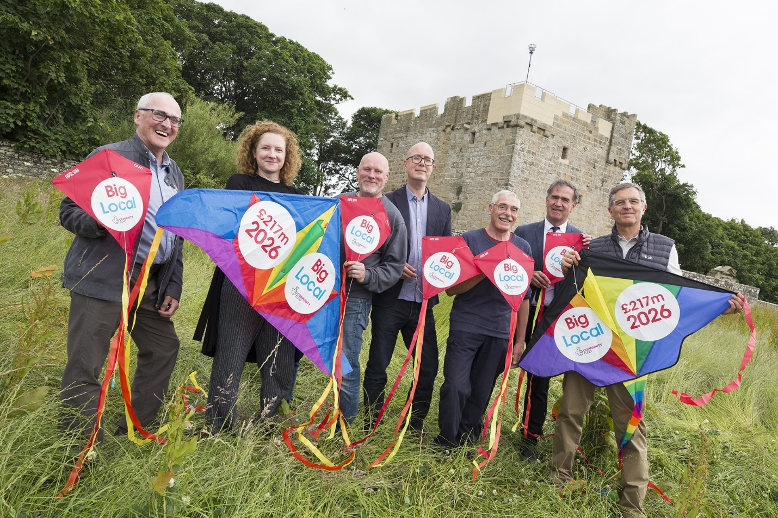
Figure 1: Big Local 2024

Principles of the Big Local
There are various principles on which the Big Local are based which include:
Inclusivity – Inclusivity ensures that the people in the community are respected regardless of their age, religion and ethnicity. The principles foster a sense of community and promote diversity among the community members (Bell and Reed, 2022). It also ensures the fulfilment of the resources and facilities is available to everyone so that everyone gets access, and no one is left to avail of the program benefits.
Transparency – The Big Local is widely popular because of the transparency in their outreach and community activities and they have clear and defined goals and mission which allows them to consistently communicate with the local authorities, partners and other organizations which fosters credibility and ensures that their activities align with the mutual expectations (Bell and Reed, 2022).

Accountability – Accountability is an important principle that fosters a sense of ownership among individuals and allows them to make informed decisions which improve the lives of individuals (Bell and Reed, 2022). It also fosters a sense of community which enables them to direct their efforts on behalf of the community to meet the program requirements.
Decision Making – Decision Making is an important principle which allows the community to analyze the decisions based on the different alternatives available before concluding (Rijal, 2023). It also holds the person to be accountable for their decisions and the actions they take and fosters accountability.
Social Capital – The Social Capital Principles establish a network of relationships among the groups which allow them to work together to achieve the shared goal in this way, The Big Local can successfully establish the communities to foster community engagement and interdependence and as a result, The organization can community which is more connected and engaged (Bell and Reed, 2022).
Communication – Communication is an important principle of the Big Local communities in the UK as it is the foundation for the network and positive relationships (Rijal, 2023). They serve their main purpose by fulfilling all the basic principles and the mission and work are communicated among the members by involving in community meetings and engaged with the workforce and the people by connecting with the social media platforms. Transparency is maintained and achieved by utilizing various tools such as surveys and feedback forms which help to know about the people's concerns and opinions about something.
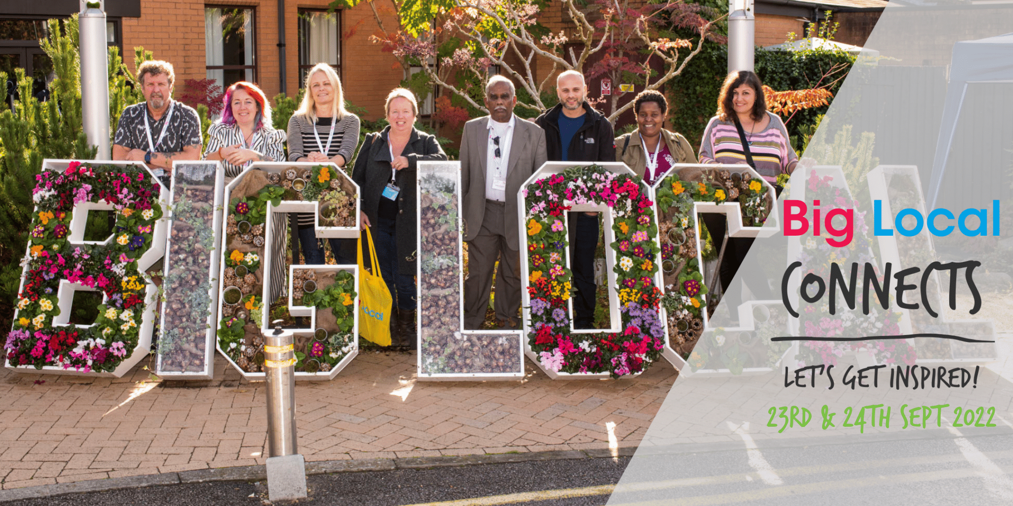
Figure 2: Big Local Principles

Planning and Design
There are many stages involved in the planning and design of the project which include –
- Initial Consultation – The initial consultation involves consulting the needs and the people's priorities and the plan is implemented by various methods. The Big Local communities in the UK understand the people's needs through discussion and involving the people to collect the views and opinions of the people (Cunningham and Smith, 2020). The interaction of the people is done by engaging in local events or being a part of the community clubs and taking part in various activities. The views are collected through methods of formal consultation such as conducting community meetings or filling the questionnaires from the local people.
- Assessment Phase – In this phase, the Big Local initiative focus on understanding the community needs and partnerships are done and encouraged to identify the issues which exist and the potential issues which may arise the surveys are conducted, the community meetings are conducted to learn about the opinions of others and the resident inputs hold much more importance in prioritizing their needs (Cunningham and Smith, 2020).
- Vision and Goal Setting – The assessment helps to understand the community's needs and the shared vision is developed through partnerships the specific goal is established and they aim to achieve the goals through funding and different community events (Cunningham and Smith, 2020).
- Design Phase – The design phase is an important part of the implementation of the plan and in this phase, the project plan is developed based on the different needs identified. This process is carefully analyzed by first developing the vision which includes mentioning the objectives and the budget needed to fulfil the objectives (Cunningham and Smith, 2020). The cost is to be allocated in each area of the budget or the priorities which are set, and the remaining funds are allocated for the costs which are needed for the closure of the program. Partnerships are considered for the utilization of all the funds and after the process is developed, various alternatives are to be found to conclude.
- Action Planning– The phase is implemented by conducting different activities and the goal of the Big Local community is to convert the vision into reality and the vision is outlined in the action plan. The action plan includes the different initiatives and projects in which the big local community focuses and wants to invest (Cunningham and Smith, 2020). As the Big Local got the funding for the period of 10 years so, the plan includes the actions which cover the entire period, and it is reviewed and revised periodically.
- Implementation – After developing the action plan and the plan is finalized, the Big Local is planning to implement and undergo the implementation phase (Cunningham and Smith, 2020). In this phase, the community start the project and focuses on efficient project execution and the progress is monitored towards the goals which are established in the action plan.
- Stakeholder Engagement – The Big Local initiative focuses on engaging with the stakeholders in partnership with the local business and considering the sponsorship to meet the needs of the community (McCabe et al., 2020). The Big Local is also connected with the charity, different community groups and service providers to make the project reach a wider audience and leverage resources. The Big Local plan connections with the government help to provide benefits to the people and can take the initiative of the big community development plans. The collaboration with government and local authorities provides the community with the additional funds needed or the resources which help to fulfil the community's needs.
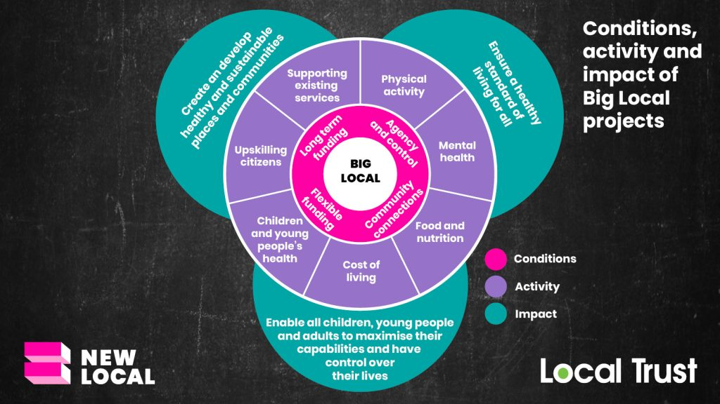
Figure 3: Big Local Action and their Impact

Assessment of the Community Needs
The assessment of the community helps to identify the issues in the community and gaps which the people lack in terms of services and the community needs are to be determined by various methods such as collecting the data and understanding the gaps in the society by communicating with the stakeholders (Witham et al., 2020). As, the Big Local community in the UK accessed the needs by using surveys, group discussions and public consultation methods. They also connect with the collaborative platforms to engage with the target people which includes stakeholders, local authorities, residents and many more to interact with them.

Standards
National Standards for Community Engagement - The Big Local project refers to the standards which include national standards for community engagement as this standard is suitable for the community and provides the outline on which the community serves the purpose (Kliskey et al., 2021). The national standards for community engagement fosters effective community engagement, promotes diversity and inclusion and ensures that the selected project meets the expectations of the community and local people.
Formal Standards – The Big Local operates within a standard framework and the focus on which the Big Local is based the community engagement (Kliskey et al., 2021). Community engagement develops and implements the approach as per the people's specific needs.
Emphasis on Guidance – The Big Local trust aims to provide guidance and the resources needed to the people and they work on different areas such as community engagement, managing different projects and adapting good governance practices (Witham et al., 2020). These practices developed the framework within which the Big Local operates.

Modes of Communication

The standards are communicated through various means such as interaction in the training sessions and through online channels. The community meetings are to be conducted to develop a plan and set of actions which align with the community objectives (Lin, 2022). Various platforms are utilized for information sharing and collaboration which involves utilizing various social media channels and already have dedicated project websites to effectively execute the plan.

Evaluation and Impact

Methods and Techniques - Communication is to be established and the progress of the project and its impact is communicated through regular updates through the community newsletters and the impact of the project is reflected in the annual reports and financial statements. The public meetings are conducted to discuss the projects and the necessary improvements in the plan (Wallerstein et al., 2020). The various tools are used to make the content informative and engaging and make it accessible to everyone in the group meetings.

Process – The Big Local focuses on the processes of evaluation which includes revisiting the developed plans or goals and the activities which are to be undertaken as an indicator for measurement of the progress (Szetey et al., 2021). The Big Local initiative emphasizes the importance of the residents' participation as their input holds much importance for monitoring the progress. The key metrics which is used to measure the impact of the project include quantitative and qualitative measurements such as the rate at which the project is completed and resident satisfaction, testimonials of the residents and many more.
Communication – The impact is communicated through various means and the Big Local Initiative in the UK provides the resources which help in creating the stories which are narrated by the residents the achievement of the projects highlights the trust of the people in the community members and their action which fosters trust and cooperation (Szetey et al., 2021). The partnership reports reflect the continuous commitment of the community to the residents, and they can be communicated by involving in community events, interacting through media and utilizing social media and digital marketing to communicate the stories and how they impact the lives of the people.
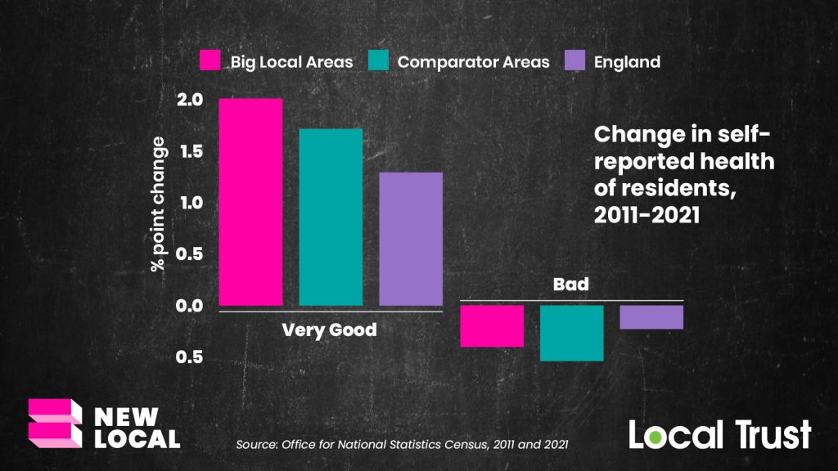
Figure 4: Big Local Measurement and Success rate

Skills help in steering and managing the project.
By understanding the Big Local approach in devising the project plan and maintaining the standards and monitoring and evaluation of the project lifecycle. I highlight my skills in the CPD Log which I learnt and helps in managing the Big Local and various projects these skills are valuable and are aligned with the needs of the community project. The skills includes:
Communication and Collaboration – The Big Local focuses on the decision making as it proves worthwhile for the residents and these skills help me to maintain open communication with colleagues the workshops which I attend ensure I can contribute effectively to the planning process and discuss the issues with the residents (Szetey et al., 2021). These techniques help me to communicate with the residents and guide them regarding their needs and assessment process and the action plan is made with the help of effective collaboration and decision-making. Communication and Collaboration prove to be valuable in managing any community-based plans and projects by fostering a sense of community where everyone can express their ideas and makes them feel engaged and involved.
Data Analysis Skills – The Big Local priorities the active participation of the residents in the decision making and my skills and expertise in data analysis skills allow me to analyze and collect the data. Due to this, I can track the project's progress and updates, and the conclusion helps to make the decision which benefits the well-being of the residents. Due to my master the data analysis skills, I can gather data and convert it into valuable and informative insights which helps to easily communicate the project impact to stakeholders (Prebanić and Vukomanović, 2021). Additionally, I also can develop the surveys and gain feedback from the residents through the survey form. Data analysis skills help me to measure the success which a particular project and help me to measure the effectiveness of the community campaigns and initiatives.
Project Management - Project Management plays an important role for the Big Local as it helps to develop and manage the short-term and long-term plan of the project. My project management skills help me to break complex projects into small tasks organize the different tasks in a time framework and monitor the progress during the whole project life cycle (Winch et al., 2022). With the help of project management skills, I develop the ability to assist the team in developing the project plan, divide the tasks and measure the project progress as per the project goals in the realistic budget and defined timelines.
People Engagement – Community engagement skills an important for The Big Local initiative as it allows the community to express their ideas and concerns clearly with the residents and pay attention to the perspectives of the diverse people. People engagement skills help me to foster open communication and help build trust and rapport with colleagues and residents (Moayerian et al., 2022). These skills help me to build confidence and gives me the opportunity to showcase empathy and kindness which helps me to adapt different communication styles as per the diversity in culture and the norms. It also helps me to take ownership and responsibility to communicate with the residents and actively find solutions to address the problems of the residents and their needs.
Strategy Making – By utilizing the time to read the stories of the Big Local Initiative in the UK, I can devise an effective strategy which is designed to meet the needs of the residents. The success story of the Big Local helps me to gain insights and perspectives regarding the importance of the systematic plan and in need for various attempts to successfully execute and reach the short-term and long-term goals (Moayerian et al., 2022). It also helps me to act which helps to overcome the challenges or setbacks and achieve the desired outcomes.

Recommendations
- The Big Local Community should focus on leveraging digital capabilities to attract the members of the community and help in brand awareness to drive growth in the community (Martínez-Peláez et al., 2023).
- The Big Local should strengthen their relationships by focusing more on collaboration or partnerships with the local organizations to gain support or resources for execution (Martínez-Peláez et al., 2023).
- The Big Local should contribute more to sustainable projects and utilize the amount of funding spent on the projects (Martínez-Peláez et al., 2023).
- 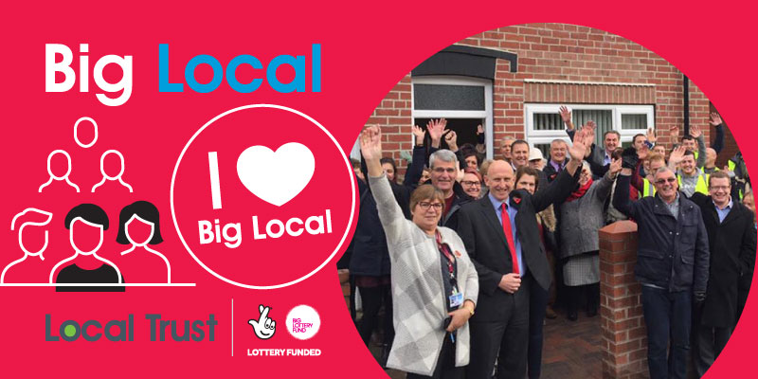
- Figure 5: Successful activities

Conclusion
The Big Local Initiative is a community which serves the residents by involving in community-based projects. The planning and design process of the Big Local fosters a sense of ownership among the communities and they cater for the needs of the project by facilitating partnerships which utilize the expertise of the team members and resources to successfully manage the project. The Big Local community operates within a framework to provide the necessary support and guide the residents which fosters community engagement. The resident participation has created a positive impact and strengthened the Big Local initiative by implementing collaboration and assessment. I can positively contribute to the Big Local Initiatives by applying diverse skills which I gained such as communication, data analysis, project management and many more. Overall, it can be said that Big Local Initiative is an effective and successful model which drives positive change and empowers the residents of the communities.

References
Bell, K. and Reed, M. (2022) The tree of participation: a new model for inclusive decision-making. Community Development Journal, 57(4), pp.595-614.
Big Local (2024) Local Trust. Big Local [Online]. Available at: https://localtrust.org.uk/big-local/about-big-local/ [Accessed: 10/07/2024]
Cunningham, H.R. and Smith, P. (2020) Community engagement plans: A tool for institutionalizing community engagement. Journal of Higher Education Outreach and Engagement, 24(2), pp.53-68.
Kliskey, A., Williams, P., Griffith, D.L., Dale, V.H., Schelly, C., Marshall, A.M., Gagnon, V.S., Eaton, W.M. and Floress, K. (2021) Thinking big and thinking small: A conceptual framework for best practices in community and stakeholder engagement in food, energy, and water systems. Sustainability, 13(4), p.2160.
Lin, Y.(2022) Social media for collaborative planning: A typology of support functions and challenges. Cities, 125, p.103641.
Martínez-Peláez, R., Ochoa-Brust, A., Rivera, S., Félix, V.G., Ostos, R., Brito, H., Félix, R.A. and Mena, L.J. (2023) Role of digital transformation for achieving sustainability: mediated role of stakeholders, key capabilities, and technology. Sustainability, 15(14), p.11221.
McCabe, A., Wilson, M. and Macmillan, R. (2020) Big Local as change agent.
Moallemi, E.A., Malekpour, S., Hadjikakou, M., Raven, R., Szetey, K., Ningrum, D., Dhiaulhaq, A. and Bryan, B.A. (2020) Achieving the sustainable development goals requires transdisciplinary innovation at the local scale. One Earth, 3(3), pp.300-313.
Moayerian, N., McGehee, N.G. and Stephenson Jr, M.O. (2022) Community cultural development: Exploring the connections between collective art making, capacity building and sustainable community-based tourism. Annals of Tourism Research, 93, p.103355.
Ordonez-Ponce, E., Clarke, A.C. and Colbert, B.A. (2021) Collaborative sustainable business models: Understanding organizations partnering for community sustainability. Business & Society, 60(5), pp.1174-1215.
Prebanić, K.R. and Vukomanović, M. (2021) Realizing the need for digital transformation of stakeholder management: A systematic review in the construction industry. Sustainability, 13(22), p.12690.
Rijal, S. (2023) The importance of community involvement in public management planning and decision-making processes. Journal of Contemporary Administration and Management (ADMAN), 1(2), pp.84-92.
Szetey, K., Moallemi, E.A., Ashton, E., Butcher, M., Sprunt, B. and Bryan, B.A. (2021) Participatory planning for local sustainability guided by the Sustainable Development Goals. Ecology & Society, 26(3).
Wallerstein, N., Oetzel, J.G., Sanchez-Youngman, S., Boursaw, B., Dickson, E., Kastelic, S., Koegel, P., Lucero, J.E., Magarati, M., Ortiz, K. and Parker, M. (2020) Engage for equity: A long-term study of community-based participatory research and community-engaged research practices and outcomes. Health Education & Behavior, 47(3), pp.380-390.
Winch, G.M., Maytorena-Sanchez, E. and Sergeeva, N. (2022) Strategic project organizing. Oxford University Press.
Witham, M.D., Anderson, E., Carroll, C., Dark, P.M., Down, K., Hall, A.S., Knee, J., Maier, R.H., Mountain, G.A., Nestor, G. and Oliva, L. (2020) Developing a roadmap to improve trial delivery for under-served groups: results from a UK multi-stakeholder process. Trials, 21, pp.1-9.

Appendices

Appendix: CPD Log:


