Product
Afan Escapes is a new purpose built adventure resort in the stunning Afan Valley area of South Wales.
The resort accommodation is bespoke boutique style log cabins, suitable for families or groups built into 20 acres of beautiful Welsh landscape. The resort has a rural feel, combining nature and adventure whilst maintaining an element of luxury. Every need is catered for from relaxing walks to exhilarating zip wires for the more adventurous holidaymaker. Afan Escapes features guided Mountain Bike riding, Zorbing, an Infinity Swimming Pool, Hot Tubs, Cinema, 4 Restaurants, Gift Shops and much more. The resort is perfect for Conferences, Team Building/Bonding Exercises, Wellness Weekends, Family time and as a base for the surrounding area. Afan Escapes is within easy reach of The Gower Peninsular, The Wye Valley and Pembrokeshire National Park. In addition, Afan Escapes is equipped with Wedding hire facilities.
Target Market
According to Kotler and Armstrong, the Target Market “consists of a set of buyers who have common and/or characteristics of those the company decides to serve……it’s necessary to define a Target Market”. (Kotler and Armstrong, 2021)
The Target Market for WTM is Business to Business Sales, Networking & Brand Awareness; Tour Operators, Travel Agents, Holistic Therapists/Spas, Schools, Medium /Large Businesses for Team Bonding sessions, Wedding Planners, Conference Planners, Training Providers, Tourism Ministers.
Afan Escapes will offer a pre-season weekend for buyers who sign up at World Travel Market, 2023.
Paying particular attention to Irish, German and American Markets.
“Over 1 million tourists come to Wales every year. The most popular origins of overseas visitors are from the Republic of Ireland, USA and Germany” (Welsh Government n.d.)
Taking advantage of this demographic trend, Afan Escapes will incorporate global heavy marketing into its marketing plan, creating a hybrid between Eurocamp, and Bluestone.
“Britain is forecast to have a tourist industry worth over £257 billion by 2025” (VisitBritain, 2019)
“The number of international trips to Wales during 2019 rose by 3.6% to 1,023,000. Visitor spending was £515 million, which was an 18.8% increase on the same time last year”. (Welsh Government, 2020)
The Target Market user for Afan Escapes guests is predominantly Families. With adult parents between the ages of 23 Years and 45 Years with children between 1 Year and 17 Years. In Britain in 2012, there was a combined total of 551, 068 parents between the ages of 20 and 34 Years of age. (Compare the Market, 2023) This age group is now meeting our marketing age range and will determine the Afan Escapes strategy.
Generation Y (Age 25 – 39 Years) and Generation Z (Age 4 – 24 Years) (LinkedIn, 2019) According to The Centre for Generational Kinetics, “Generation Z is more likely to buy a product if they can customize it” and further Gen Z expect brands to be “Fun, (Uses the internet to access entertainment) Authentic (Shows actual customers in their advertising) and Good (More likely to buy from a company that contributes to social causes)” (Jones, 2020) Whilst Gen Y is also “Tech savvy…Values flexibility…Seeks work life balance….Seeks reward and praise….Enjoys collaboration” Herrity, .J (2019)
Afan Escapes can therefore extrapolate from their customer base that their marketing needs to be, customised (Pick a package) Fun (Showing images of guests that appear like them to be enjoying themselves) and supports a clear Cause (Sustainability/Environment). Afan Escapes needs to have a strong online presence, and needs to appeal to those who value downtime. Further, marketing needs to show family unity and Children of all ages engaging in activities provided.
World Travel Market
World Travel Market 2023 takes place on 6 – 8th November and is situated at ExCel, London and has 51,000 visitors annually. WTM is attended by key decision makers from around the globe and 50% of buyers’ contracts are signed onsite at WTM. The event has links with the world’s media and is an excellent opportunity for Afan escapes to sell, influence, network and promote its brand and Wales globally.
Place Setting
Afan Escapes will join the Visit Wales Stand, at World Travel Market 2023, to promote a strong Welsh presence.
Afan Escapes will display typical cabin accommodation, surrounded with traditional Welsh foliage and plants such as Daffodils, Fern and Lavender on the stand so visitors are immersed in the ambience of the Welsh mountainside. The Afan Escapes Display Cabin can be accessed by foot or by zip wire (a photo will be taken automatically that the user can collect at the Stand). The stand will also have a fun photo booth with items of fancy dress, heavily branded with Afan Escapes logo which can be uploaded to the WTM live stream.
In addition, the use of Olfactory Marketing, by scenting the area with Fern and Lavender to promote the sense of wellbeing and nature.
“As science has proved, smell has a powerful ability to drive behaviours on both a subconscious and instinctive level”. Sullivan, N. (2021)
Further, colour branding of Red and Green staff uniforms, to maintain the Welsh element in Visitor minds. Additionally, the colour Red is synonymous with excitement and “gets people to act”, whilst the colour Green is most associated with tranquillity and “stimulates harmony in your brain and encourages a balance leading to decisiveness”. (DashBurst, 2014)
Pricing
Cost of the stand.
Goodie Bags containing Penderyn Miniature Whiskey, Calendar with key event dates for Afan Escapes and Welsh Lavender relaxation spray.
Staff Wages
Cost of transporting and setting up stand
Brochures
Social Media Campaign
Photo booth
Cost of Prizes/Giveaway Stays
Promotion
Use of Synergy,
“the concept under which a company carefully integrates and coordinates its many communications channels to deliver a clear, consistent message about the organisation and its products.” (Kotler & Armstrong, 2021)
A good example of Synergy is a Sunday Roast, without all its component parts of vegetables, meat and gravy, it would not be the tasty traditional Sunday meal of most Brits.
By creating synergy in the marketing mix with a targeted approach to the marketing demographic, psychographic, and geographic. Collaboration with other brands and sponsorship, social media campaigns and associated distribution channels, branding and approach Afan Escapes will meet the Synergy criteria and give a consistent, strong message to the consumer. The message will be; True value for money with excellent facilities and customer care.
Pictures/Photographs
Brochures/Flyers will be distributed from the WTM Stand. According to an article in Relative Marketing, Brochures are still a key marketing tool. The author claims a well-produced brochure can
“Introduce your company to potential new customers, increase and expand your visibility, cut out the noise of online to arrive directly in front of customers” (rob, 2021).
Prizes
The Afan Escapes Sales Team will offer a free 2 night stay as a prize to the 1000th visitor to the WTM Stand and simultaneously launch a social media competition to win a free stay for entrants who, like, share, comment, tag and tweet etc.
“Contest, raffles and giveaways…..attract a lot of attention for your business…they create a fanfare you can use to get media” Further “it makes you more memorable”. (Keller, W. 2016).
Sponsorship
Afan Escapes will be sponsored by Penderyn Whiskey, who will get exclusive brand use at the resort in exchange for goods and advertising.
“The dynamic of sponsorship has changed dramatically in recent years, stretching beyond the realms of sport, becoming a vital part of marketing and PR Plans”. (Legacy Communications, 2022).
Afan Escapes will collaborate with VisitWales to promote visits to Wales and invest in joint marketing for a wider spread of audience.
Covid Recovery
The UK Government has developed a Tourism Recovery Plan, they have worked with VisitBritain, who have collaborated with VisitWales to promote Wales as a destination both domestically and internationally. (Office of the Secretary of State for Wales, 2022).
Comparison & Competition
Bluestone Park in Pembrokeshire is the nearest competitor to Afan Escapes. Whilst their reputation is good, based on Trust Pilot reviews Bluestone received 3 Stars. Some issues highlighted as bad are;
Price, cleanliness, poor quality food, staff rudeness and poor customer service. (Trustpilot, 2022)
Afan escapes will provide a better than expected stay for its guests, to exceed expectation and provide true quality and customer care through staff training and empowerment. This will be their USP.
The Strategy
Start the marketing of Afan Escapes 6 months prior to opening with a Social Media campaign.
Afan Escapes will publicise through the media that it donates unused food to FareShare and cares for the environment by using responsibly sourced timber for its cabins.
Unify branding/colours/# and slogans throughout the campaign to make Afan Escapes instantly recognisable and different to its competitors.
Offer ‘pick your own package’ so guests can choose to do as much or as little as they want and control the cost of their stay.
Offer a prize for likes, tags, shares, comments and tweets on Social Media to promote Afan Escapes for free.
Produce high quality brochures to distribute to Travel agents/Tour Operators at World Travel Market.
Train all staff to the highest standard and empower them to deal with complaints swiftly and to customer satisfaction.
Work with sponsors and VisitWales to promote Afan escapes and Wales to a wider audience.
Attend World Travel Market to enhance Afan Escapes Presence within the Welsh destination market, to sell and network with Business to Business buyers. Afan Escapes will offer a free weekend to all buyers who sign up during World Travel Market.
The World Travel Market Stand will be a high impact, fun, immersive Welsh experience, manned with a fully trained sales team able to answer any questions and engage with other sellers as well as buyers. Afan Escapes will always look for ways to improve their service and collaborate with others in order to provide the best experience for their guests.

Appendix
a – Log Cabin Stand
b – Pie Chart
c – Colour wheel
d – Uniform
e – vIsitor numbers
f – Brochure example
g – Social Media Campaign

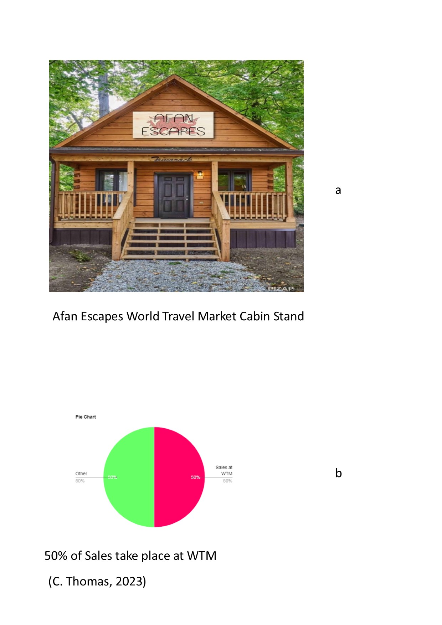

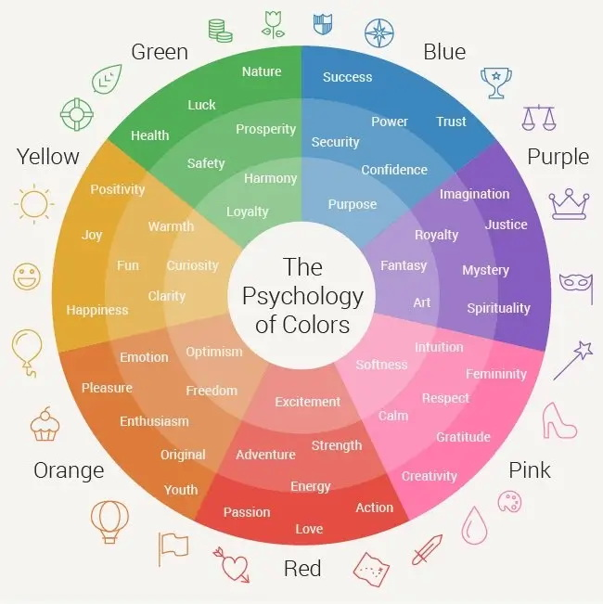
c:
(Clark-Keane, 2022)
d:
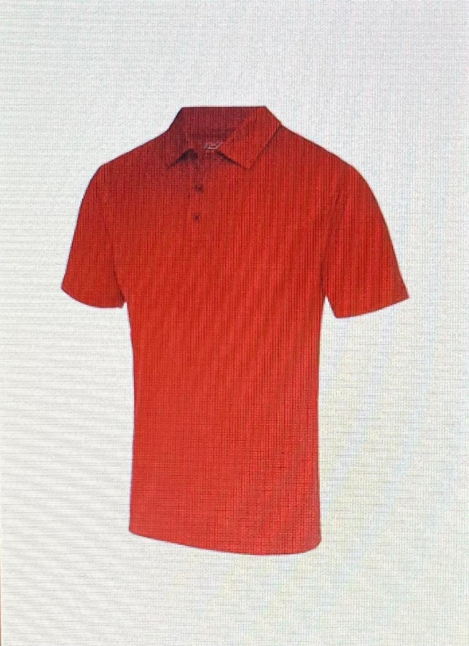
(The Work Uniform Company, 2023)
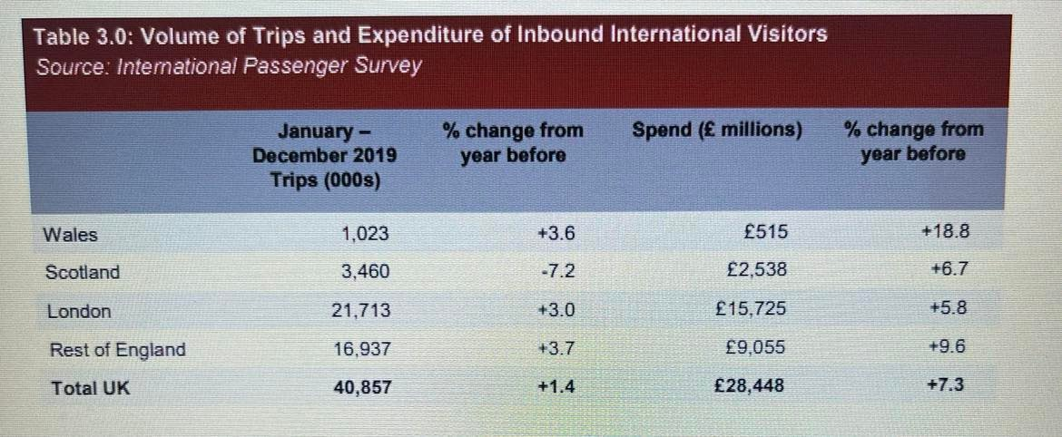
e:
(Welsh Government, 2020)
f:


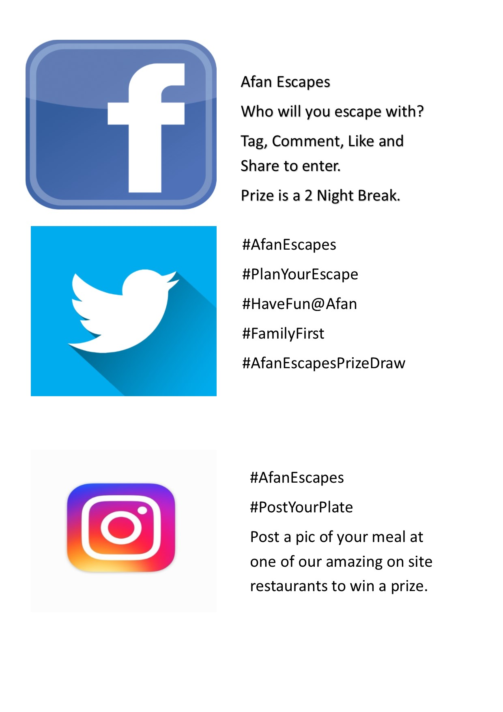
g:

Appendix Bibliography

Clark-Keane, C. (2022). 8 Ways to Use Colour Psychology in Marketing (With Examples). [online] Wordstream.com. Available at: https://www.wordstream.com/wp-content/uploads/2022/07/color-psychology-marketing-emotion-wheel.webp [Accessed 8 Jan. 2023].
The Work Uniform Company (2023). JC040 - Men’s Cool Polo. [online] The Work Uniform Company. Available at: https://workuniformcompany.co.uk/products/mens-cool-polo-shirt?variant=39512871141542 [Accessed 8 Jan. 2023].
Welsh Government (2020). Wales Tourist Performance 2019.
C, Thomas. (2023). Pie chart.
Bibliography
Compare the market (2023). Compare the Market - The Changing Age of UK Parents. [online] www.comparethemarket.com. Available at: https://www.comparethemarket.com/life-insurance/content/changing-age-of-uk-parents/ [Accessed 1 Jan. 2023].
DashBurst (2014). How to Use the Psychology of Colors When Marketing - Small Business Trends. [online] Small Business Trends. Available at: https://smallbiztrends.com/2014/06/psychology-of-colors.html [Accessed 1 Jan. 2023].
Dey, A.A. (2021). Benefits of Participating in Trade Fairs. [online] www.tatanexarc.com. Available at: https://www.tatanexarc.com/info-hub/business-expansion/what-are-the-advantages-of-participating-in-trade-fairs-190/ [Accessed 31 Dec. 2022].
Herrity, J. (2019). All About Generation Y. [online] Indeed Career Guide. Available at: https://www.indeed.com/career-advice/finding-a-job/generation-y [Accessed 1 Jan. 2023].
Jones, E. (2020). Generation Influence: Gen Z Study Reveals a New Digital Paradigm. [online] www.businesswire.com. Available at: https://www.businesswire.com/news/home/20200706005543/en/Generation-Influence-Gen-Z-Study-Reveals-a-New-Digital-Paradigm [Accessed 1 Jan. 2023].
Keller, W. (2016). How a Contest or Giveaway Can Attract Business Prospects #UGPlatformBuilding. [online] Entrepreneur. Available at: https://www.entrepreneur.com/growing-a-business/how-a-contest-or-giveaway-can-attract-business-prospects/284851 [Accessed 1 Jan. 2023].
Kirchgeorg, M., Springer, C. and Kästner, E. (2009). Objectives for successfully participating in trade shows. Journal of Business & Industrial Marketing, 25(1), pp.63–72. doi:10.1108/08858621011009164.
Kotler, P. and Armstrong, G. (2021). Principles of Marketing. 18th ed. Harlow: Pearson Education Limited.
Legacy Communications (2022). Sponsorship Benefits: How To Use Sponsorship To Grow Your Business. [online] Legacy Communications. Available at: https://legacycommunications.com/sponsorship-benefits/ [Accessed 1 Jan. 2023].
Linkedin (2019). Boomers, Gen X, Gen Y, and Gen Z Explained. [online] www.linkedin.com. Available at: https://www.linkedin.com/pulse/boomers-gen-x-y-z-explained-delamora-y-madrigal-cfe-cams-cfci/ [Accessed 1 Jan. 2023].
Office of the Secretary of State for Wales (2022). Written evidence submitted by the Office of the Secretary of State for Wales and the Department for Digital, Culture, Media and Sport (TOU0014).
Reed Exhibitions Ltd (2022). Attendee profile. [online] www.wtm.com. Available at: https://www.wtm.com/london/en-gb/about/attendee-profile.html#:~:text=VIP%20Inbound- [Accessed 31 Dec. 2022].
rob (2021). Brochures – why do we still need them? [online] Relative. Available at: https://www.relativemarketing.co.uk/blog/brochures-why-do-we-still-need-them/ [Accessed 1 Jan. 2023].
Sullivan, N. (2021). 8 Scent Marketing Examples. [online] Whole Home Scenting. Available at: https://wholehomescenting.com/8-companies-using-scent-marketing/ [Accessed 31 Dec. 2022].
Trustpilot. (2022). Bluestone is rated ‘Average’ with 3.1 / 5 on Trustpilot. [online] Available at: https://uk.trustpilot.com/review/www.bluestonewales.com [Accessed 4 Jan. 2023].
VisitBritain (2019). Britain’s visitor economy facts. [online] VisitBritain. Available at: https://www.visitbritain.org/visitor-economy-facts [Accessed 31 Dec. 2022].
Welsh Government (n.d.). Tourism in Wales | Key Stage 3 | Geography in the News. [online] www.geographyinthenews.org.uk. Available at: https://www.geographyinthenews.org.uk/issues/issue-4/tourism-in-wales/ks3/ [Accessed 31 Dec. 2022].
Welsh Government (2020). Wales tourism performance: 2019. [online] GOV.WALES. Available at: https://www.gov.wales/wales-tourism-performance-2019#:~:text=International%20Visitors%2FTravel [Accessed 31 Dec. 2022].

